EXAMPLER QUESTION PAPER
NOVEMBER 2022

GRADE 5

SUBJECT : NATURAL SCIENCES AND TECHNOLOGY
NAME OF LEARNER : _____________________________________
NAME OF SCHOOL : _____________________________________

TIME : 1.15 HOUR
MARKS : 50
This question paper consists of 10 pages
MARKS OBTAINED =

INSTRUCTIONS AND INFORMATION
1. Answer all questions.
2. Write neatly and legibly.
3. All answers must be written on this question paper.

SECTION A.

QUESTION 1.
MULTIPLE CHOICE QUESTIONS.

  - Four possible answers are given in each case. Circle the letter of the correct answer. Example 1.10.
E

1.1.1. A conductor in an electric circuit…… (1)
A. decreases a bulb’s brightness
B. prevents short circuits
C. increases the power to an appliance
D. allows the current to flow easily from one point to the other.

1.1.2. One of the following is an example of a fossil... (1)
A. Resistor.
B. Wood.
C. Conductor.
D. Insulator

1.1.3. Why will a square or triangular wheel not roll easily? (1)
A. Wheels are made up of steel, which rusts easily.
B. They are not covered with rubber.
C. Wheels need to be round to roll.
D. Wheels are generally weak.

1.1.4. Limestone is a sedimentary rock that is made from ….. (1)
A. sand
B. rock
C. clay
D. shells
1.1.5 What does all plants and animals on earth need to survive? (1)
A. sunlight, water, air and soil
B. plants, soil, air and water
C. water, air and soil
D. Sunlight, air and water
[5 x 1 = 5]
1.2 Give one word for the following statements.
1.2.1 The remains living things preserved in rock_________________
1.2.2 A light bulb changes electricity into ________________ energy.
1.2.3 A machine that produces electricity_____________________________
1.2.4 Two or more parts working together to create a function._______________
[4×1=4]
1.3. Match the descriptions in Column A with the correct letter in Column B. Write down the letter of the correct answer in the answer column.

COLUMN A | ANSWER | COLUMN B
1.3.1. Two or more cells connected together. |  | A. Circuit  B. Revolution  C. Battery  D. Rotation  E. Output energy  F. Season
1.3.2. Energy obtained from fuel, for example heat and light.
1.3.3. Movement of a planet around its own axis.
1.3.4. Movement of the planet around the sun.
1.3.5. A pathway that allows electricity to flow
or a system that allows electrical energy to move.
[5 x 1 = 5]

TOTAL SECTION A = [14]

SECTION B

QUESTION 2
2.1.1. Draw and label a simple electrical circuit using the following components: Cell; conductors; a bulb and an open switch. (4)

2.1.2. State the component that controls the energy flow in the electrical circuit? _________________ (1)
2.2. Read the paragraph and answer the questions that follow:

Fire causes loss of homes.

A 38-year old black woman was severely burned in a fire that swept through Diepsloot informal settlement, destroying sixty shacks and leaving 78 people homeless. The woman is still in hospital with severe burns to her face and body. The fire started when a woman threw a bottle of petrol into a ‘mbaula’ (coal brazier constructed out of a twenty litre steel drum) and it exploded.
Meanwhile, two people lost their shack in Gugulethu, but were not injured, after a fire destroyed it. The fire got out of control when a primus stove and the spilled paraffin caught alight.
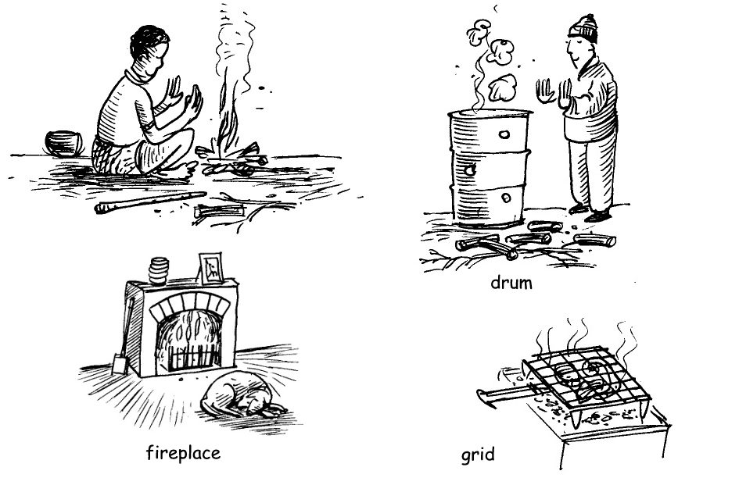

2.2.1. Write down any one use of fire (1) ______________________________________________________________________________
______________________________________________________________________________
2.2.2. Suggest two ways of preventing fire. (2)
______________________________________________________________________________
______________________________________________________________________________
2.2.3. Advice the community with two methods to extinguish or turn off fire? (2)
_____________________________________________________________________________
_____________________________________________________________________________
QUESTION 3
3.1 A jack-in-the-box is a fun toy. An object jumps out of a box when the lid is opened. Explain how it works. (2)
____________________________________________________________________________________________________________________________________________________________
3.2 Is a stretched elastic band an example of stored or released energy? (1)
____________________________________________________________________________

3.3 Compare different types of energy and fuels by completing the table below. (3)
Fuel | Input energy | Output energy
Wood | Heat | Light and heat
Light bulb | 3.3.1 | 3.3.2
Heater | Electrical | 3.3.3

3.4 Explain how energy changes when you use a gas stove. (3)
Output energy:
3.4.3_____________
Burning of fuel
Input energy:
3.4.2 _____________
Fuel:
3.4.1_____________

3.5 Identify the input and output energy in the following picture. (2)
3.5.1 An electrical fan
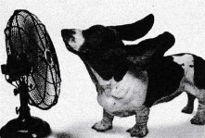
Input energy: ______________________
Output energy: _____________________

TOTAL SECTION B [21]

SECTION C
QUESTION 4
4.1 Grade 5 learners wanted to investigate how different soil particles will behsve in water. They collected soil from different areas and put it in a jar, then poured water. They left it for 2 hours to settle and recorded their observation as observed in the figure below.

4.1.1 Find out what the Grade 5 learners were investigating. (1)
____________________________________________________________________________________________________________________________________________________________
4.1.2 Explain why parts of dead plants and animals are floating on top of the water. (2)
____________________________________________________________________________________________________________________________________________________________
4.1.3 Suggest a reason why gravel is settling at the bottom of the jar. (2)
____________________________________________________________________________________________________________________________________________________________

4.2 Explain how the sun is affecting the different phases of the moon. (3)
__________________________________________________________________________________________________________________________________________________________________________________________________________________________________________
QUESTION 5
5.1 Read the passage about Early Human fossils and the Cradle of Humankind and answer the questions that follow.
There are many fossil sites in South Africa. In Gauteng is the Cradle of Humankind Maropeng Centre outside Johannesburg. Some of the world’s most famous and important fossils have been found at the Sterkfontein Caves near Johannesburg. This area is called the Cradle of Humankind. The first fossils found at the Sterkfontein Caves were the skeleton of Little Foot and the skull of Mrs Ples. It is a world Heritage Site. This means that it is protected because it has something that is very vulnerable and valuable.

5.1.1 Suggest a reason why the Cradle of Humankind is a world Heritage site. (2)
____________________________________________________________________________________________________________________________________________________________
5.1.2 Body fossils were found in the Sterkfontein caves. Give a reason to support
the statement. (2)
____________________________________________________________________________________________________________________________________________________________

5.2 Use the diagram below to write explaining how sedimentary rock is formed. (3)

__________________________________________________________________________________________________________________________________________________________________________________________________________________________________________________________________________________________________________________________________________________________________________________

TOTAL: 50 Marks

