GRADE 4

NATURAL SCIENCES AND TECHNOLOGY
NOVEMBER 2022

MARKS: 40
TIME: 80 minutes
NAME: ___________________________________________________________

SCHOOL: _________________________________________________________

SUB DISTRICT: ____________________________________________________

DISTRICT: ________________________________________________________

40

This question paper consists of 8 pages.

INSTRUCTIONS AND INFORMATION.

- Read and follow all the instructions carefully.

- This paper consists of 3 Sections: Sections A, B and C.

- Answer all questions in each Section.

- Write all your answers in the spaces provided.

- Write neatly and legibly.

SECTON B
Question 1
  - Four possible answers are given. Circle the letter next to the correct answer.
D
For example 1.1.7
    - A very quick movement of an object or its parts in the same place
- vibration
- sound
- output energy
- chemical

    - When a guitar string is plucked, the string vibrates and causes….

A. Chemical Energy
B. Heat energy
C. sound wave
D. Light energy

1.1.3 One of the following is not an output energy
A light
B sound
C chemical (Stored)
D Heat

1.1.4. Identify the type of energy shown by the boy in figure 1 below.
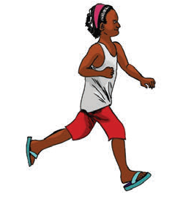
FIGURE 1

A. Movement
B. Heat
C. Light

D Sound

[4]

1.2. Write down the LETTER of the correct word in the answer column that match the corresponding statement in Column B. Write down ONLY the LETTER of your choice.

 | Column A | Column B | Answer
1.2.1 | Loud, unpleasant and harmful to ears | - pitch  - noise pollution  - phases  - orbit  - volume | 1.2.1
1.2.2 | Sounds made loud or soft | - pitch  - noise pollution  - phases  - orbit  - volume | 1.2.2
1.2.3 | Changing pattern of sunlight on the Moon | - pitch  - noise pollution  - phases  - orbit  - volume | 1.2.3

[3]

1.3 Complete the sentences below by filling in the blank spaces using words

given in a box below:

Word box

earth | sun | continent | rocket

1.3.1. The closest star to the Earth ………………. (1)

1.3.2. System used to propel vehicle into space …………………. (1)

1.3.3. It is round like a ball and is made of rock ……………………. (1)

[3]

SECTION TOTAL= 10

SECTION B

ENERGY AND CHANGE

Question 2

Answer the following questions:

2.1 Use words provided in brackets to show how energy flows.

(grass, dove, worm) (3)

Study FIGURE 2 below and answer the questions that follow.
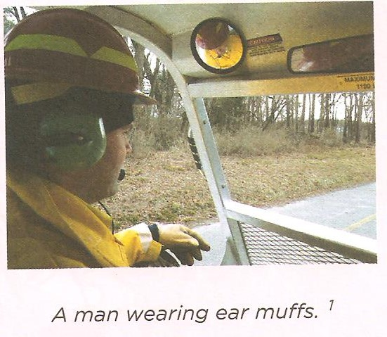
FIGURE 2

2.2 Suggest a reason why it is a health risk to expose you as a youngster to

loud music? (2)

_______________________________________________________________________________________________________________________________________________________________________________________

[5]

QUESTION 3

3.1 Study the musical instruments below and classify them as wind, string or percussion (beating or shaking sound) instrument. Indicate with the (√) the correct description of the instrument.

Instrument | Wind | String | Percussion

[3]

QUESTION 4

4.1 Identify the type of output energy in Column A, next to the relevant electrical appliance. (3)

NO | COLUMN A | COLUMN B
 | APPLIANCE | OUTPUT ENERGY TRANSFERRED
 | 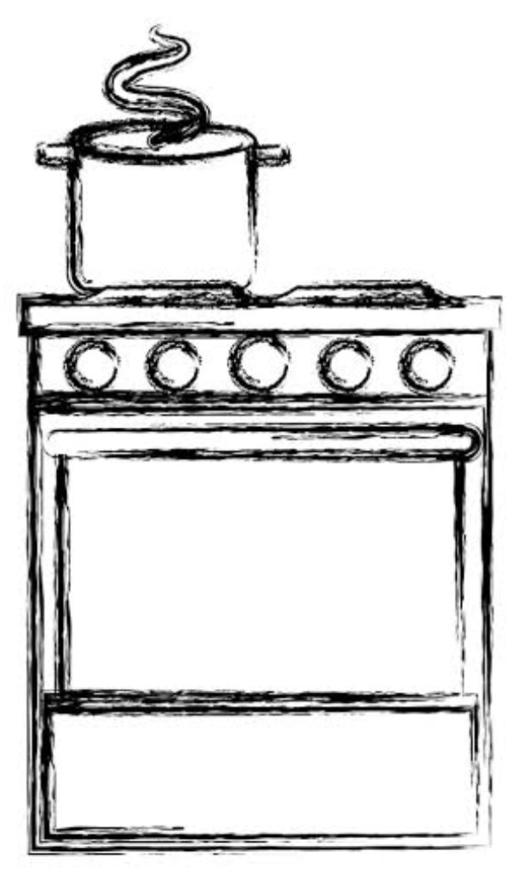 | _________________
 | 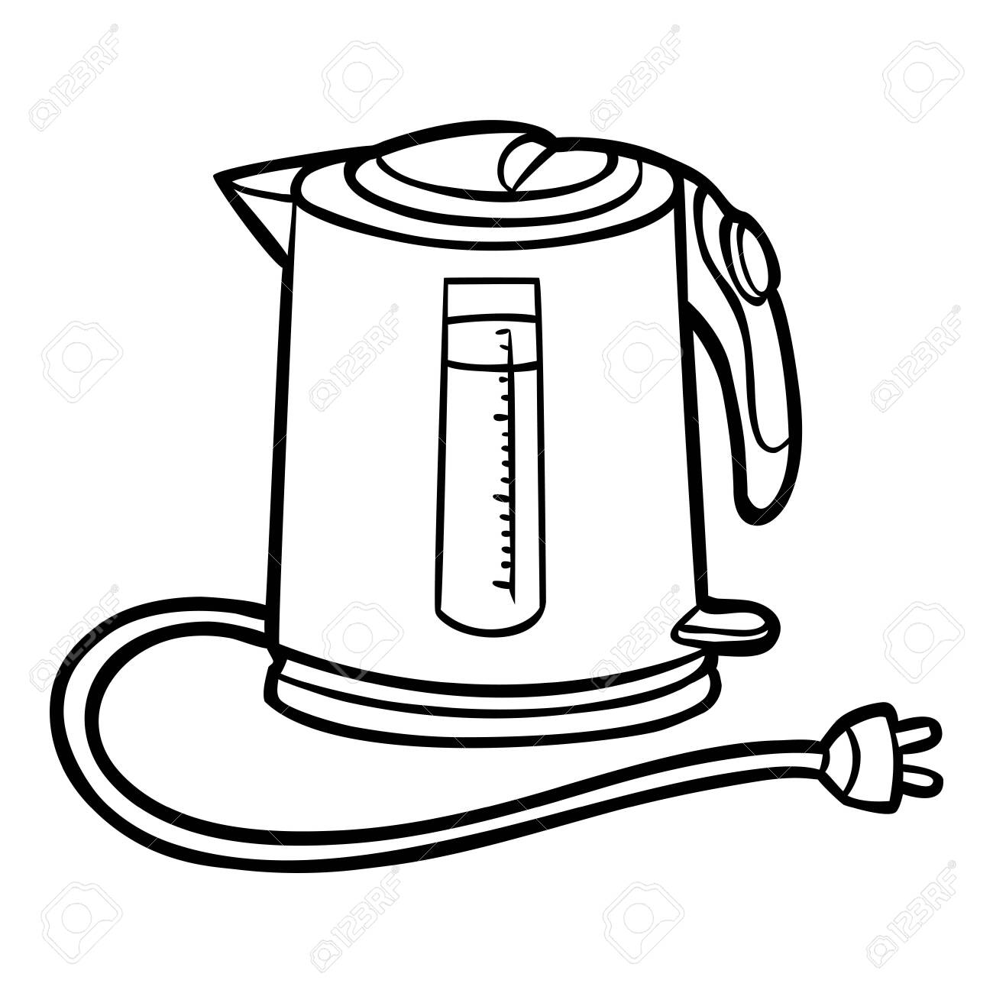 | _________________
 | 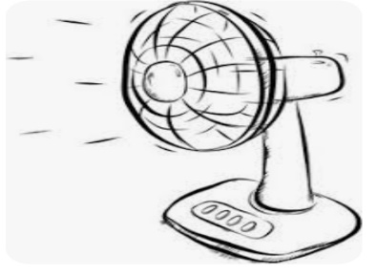

    - Read the following case study and answer the questions that follow.

The grade 4 learners conducted an investigation to observe vibration using the following materials: deep glass dish, clean film and some rice grains. They covered the bowl tightly with the clean film and place some rice grains between the middle and the edge of the clean film. One of the learner tap the clean film and repeated again by taping it harder.

    - Formulate an aim for the above investigation (2)

______________________________________________________________________________________________________________
    - Predict what will happen if the learner
- taps the film harder. (2)

__________________________________________
- taps the film softer. (2)

___________________________________________

SECTION B TOTAL= 20

SECTION C

PLANET EARTH AND BEYOND.

QUESTION 5

- What portion of the Earth’s surface is covered by water? (1)
________________________________________________________________
- Name whether most portion of the Earth’s surface is land or ocean. (1)
_______________________________________________________________
- Is Africa a continent or an island? Give a reason for your answer. (3)
________________________________________________________________________________________________________________________________
[5]

QUESTION 6
- Study the figure below showing the Earth and other planets moving around
the Sun. Answer the questions .
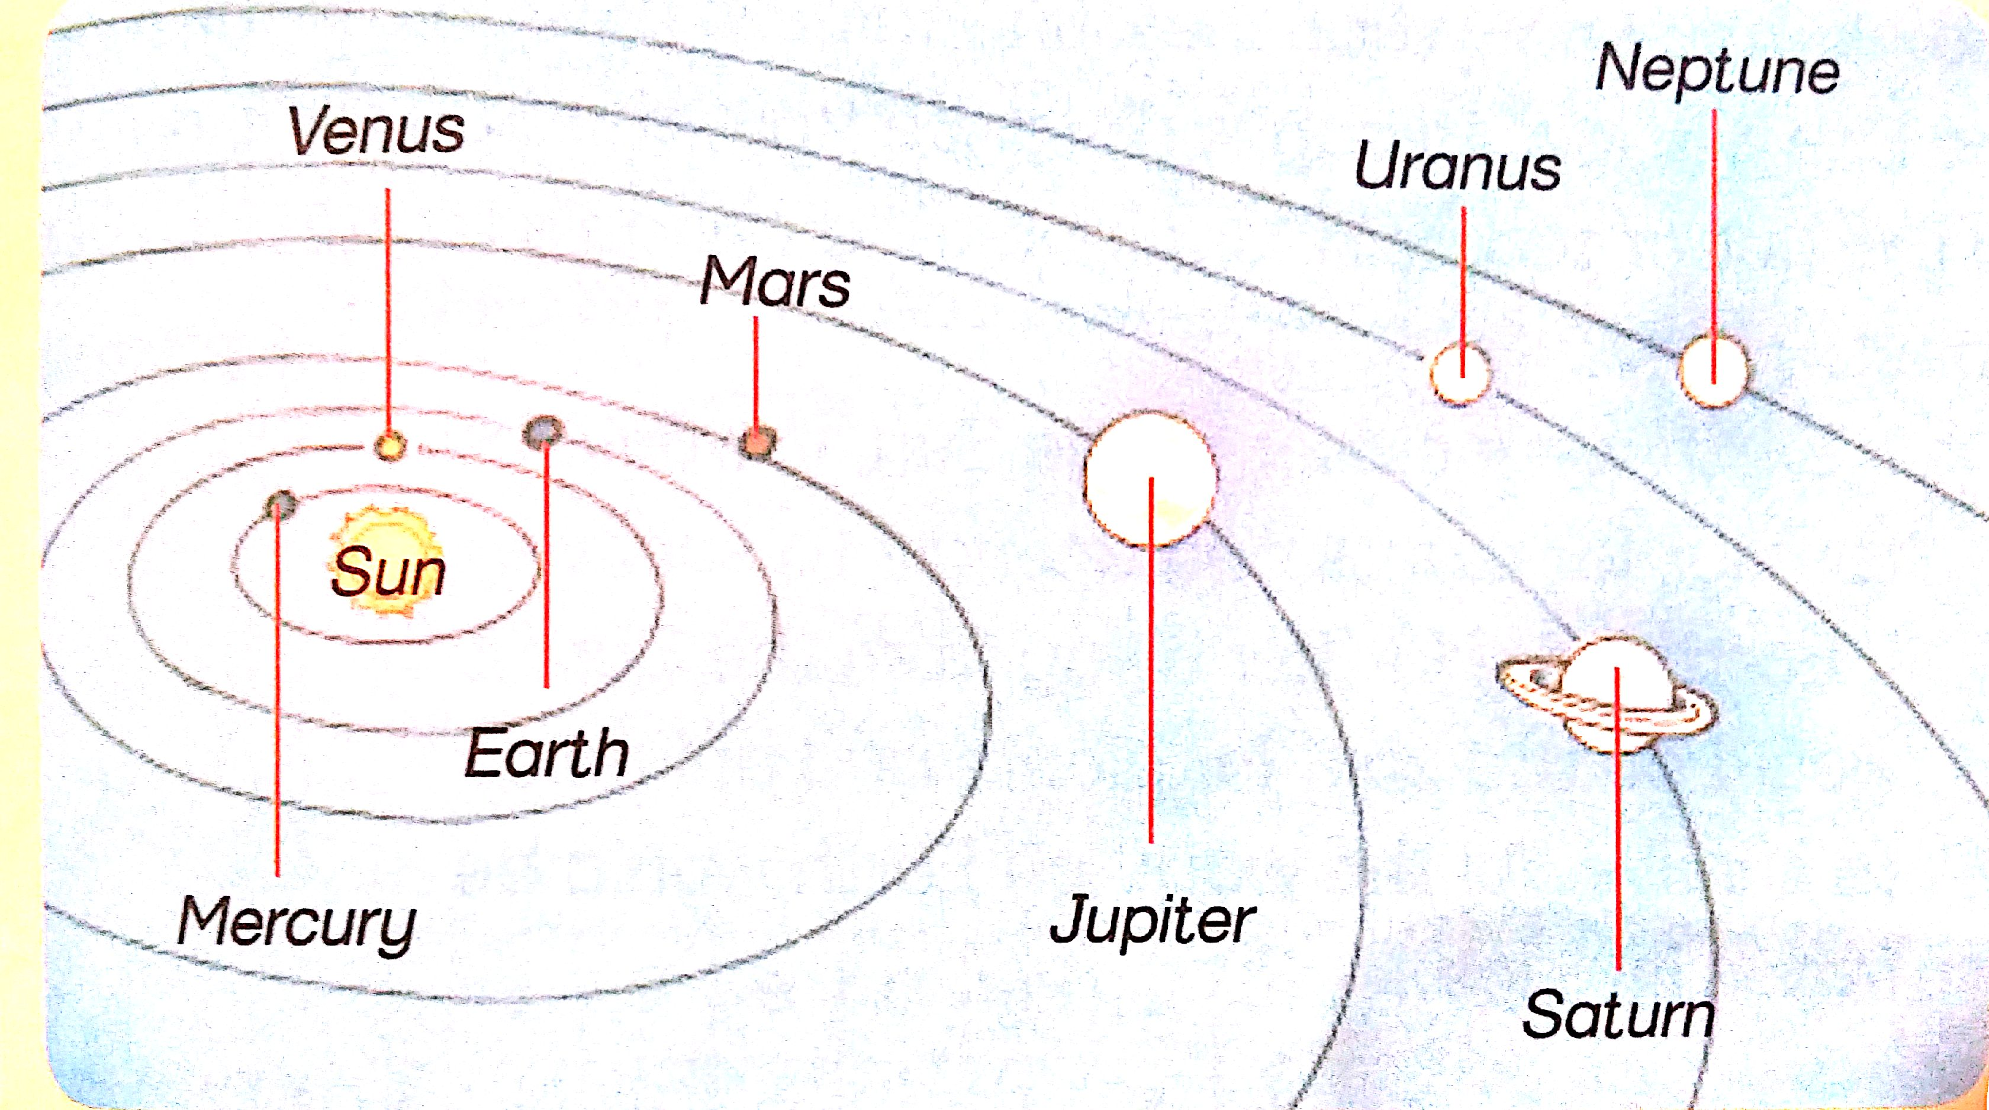
FIGURE 3

    - Compare Uranus and Earth in the FIGURE 3 above and state which one is colder? (1)
_____________________________________________________
    - Suggest a reason for your answer in 7.2.1 above. (2)
_____________________________________________________

  - Read the San story and answer the following questions:
The Moon is a man who has made the Sun angry.
According to San legend, the Moon is a man who made the Sun angry. Every month, when the Moon becomes round and rich, the Sun’s knife starts to cut away pieces of the Moon. The Moon begs the Sun to leave the last tiny piece of the Moon for his children. The Sun agrees and it is from this tiny piece that the Moon grows to become full again.
6.2.1 Name the phase in which the Moon is “round and rich”? (1)
__________________________________________________________
    - Identify the phase of the Moon that the angry Sun left for the Moon’s children. (1)
___________________________________________________________
QUESTION 7
7.1 Figure 4 below shows a rocket system which is similar to the one people
use to travel to the moon.
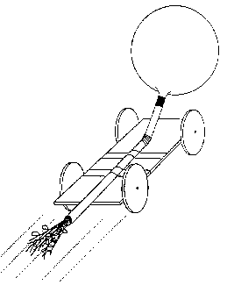
FIGURE 4

    - Briefly predict what will happen in FIGURE 4 above. (2)
____________________________________________________________________________________________________________________
SECTION TOTAL = 12

GRAND TOTAL: 40

