
GA-ISRAEL PRIMARY SCHOOL
Department of Education and Sport Development
District: Ngaka Modiri Molema
Sub-District: Mahikeng
Cluster: Central
Private Bag x2073
Mahikeng, 2745
Enq: Mr Mosweu G.L (Principal)
Tel/Fax: 0843237408/0180116696
Email:gaisraelprimaryschool@gmail.com
MATHEMATICS

STUDY AREA | MATHEMATICS
FORM OF ASSESSMENT | INVESTIGATION
ASSESSORS | MOGASHOA B
MODERATOR | MAKABANYANE B.
MARKS | 40
DURATION | ONE HOUR
DISTRICT | NGAKA MODIRI-MOLEMA
SUB-DISTRICT | MAHIKENG
CLUSTER | CENTRAL
GRADE | 6 _____
DATE | ______APRIL 2025
NAME OF LEARNER

________
40
GOOD LUCK !

This question paper consists of 8 pages.

INSTRUCTIONS TO LEARNERS
- Read all the questions carefully before you answer.
- Write all your answers in the spaces provided on the question paper.
- Show all your calculations.
- Write with a blue pen.
- Write neatly and legibly.

FRACTIONS & RECIPES
QUESTION 1
- Mrs Lara is baking a cake. Please help her determine how much of each ingredient she will need by shading in the empty measuring jugs below according to the given measurements. (4)

- $\frac{1}{2}$cup of milk b. $\frac{1 }{4}$cup of oil
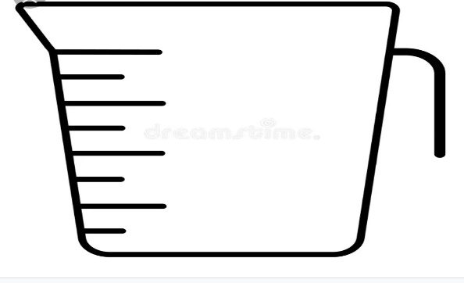

c.$\frac{3}{4}$ cup of sugar d. $\frac{2}{2 }$cup of chocolate chips
  - Mrs Lara wants to cut the cake into$\frac{1}{4}$. Help her by drawing lines across the cake where she should cut. (2)
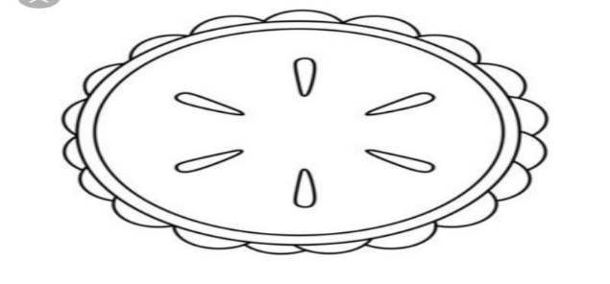
  - After cutting the cake into ¼ how many people can share the cake? _____________________________________(1)
  - Write the following fractions in words:
- $\frac{1}{2}$= ________________________________(1)
- $\frac{3}{4}$= ________________________________(1)
  - Which kind of cake (flavour) is Mrs Lara baking? ___________________(1)
[10]
QUESTION 2 : FRACTION TRAIL RECIPE
2.1 Add, subtract and simplify the following problems to find the correct amounts of each ingredient. (6)
INGREDIENTS | PROBLEM | FINAL AMOUNT
Smarties | $\frac{12 }{12}$ - $\frac{6}{12}$ | a.
Marshmallows | 3 $\frac{4}{4}$ – 3 $\frac{1}{4}$ | b.
Raisins | $\frac{1}{6}$+ $\frac{1}{6}$ | c.
Peanuts | $\frac{4}{16}$+ $\frac{4}{16}$ | d.
Biscuits | $$\frac{32}{24}$$ | e.
Chocolate | 5 $\frac{7}{8}$ - 3 $\frac{2}{8}$ | f.
2.2 Complete the table below to show the relationship between fractions, decimals and percentages of the following ingredients. (3)
Ingredients | Fractions | Percentage | Decimal
Peanuts | $$\frac{59}{100}$$ | a. | b.
Raisins | $\frac{1}{4}$ | 25 % | c.

2.3 Which percentage of the cake is shaded in the diagram below? ___________(1)
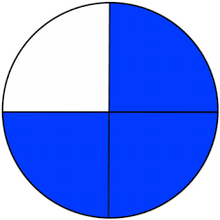
2.4 Study the fraction wall below and answer the questions that follow:
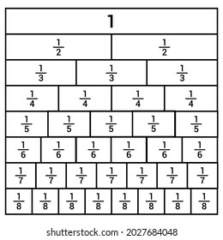

Write down the equivalent fractions of the ingredients of the Trail mix recipe. (Use coloured pencils to show that the fractions are equivalent on the fraction wall.)
2.4.1 Smarties $\frac{2}{4}$= ____________________(1)
2.4.2 Raisins $\frac{2}{6}$= ______________________(1)
[12]
QUESTION 3
A coffee shop sells coffee and different cakes in town. Help the coffee shop owner to balance his books with logistics of the items he sells.

COFFEE ( 5 Servings)
3 ½ cups of water
¼ cup of coffee

3.1 Write down the recipe for 10 servings:
a. Water: ______________________________________(1)
b. Coffee: ______________________________________(1)
3.2 The coffee shop has 100 pastry items. Complete the table below. Show your calculations. (4)
Pastry item | Part | Amount
Muffins | $\frac{1}{2}$ | (100 ÷ 2) x 1 = 50 x1=50
Doughnuts | $$\frac{1}{4}$$
Cakes | $$\frac{1}{10}$$ | (100 ÷10) x1= 10 x 1 = 10
Bread | $$\frac{3}{20}$$

[6]
QUESTION 4: Problem Solving
Solve the following problems
4.1 Sara works at the coffee shop and walks 3 kilometers to work. If she walks $\frac{1}{3}$ of the way with her friend. How many kilometres did she walk alone? (2)

4.2 Sara gets R40 a week for her job at the coffee shop. If she saves $\frac{3}{8}$of her money. How much money did she save? (2)

QUESTION 5
Study the information below and answer the questions that follow:
The case of the missing Recipe
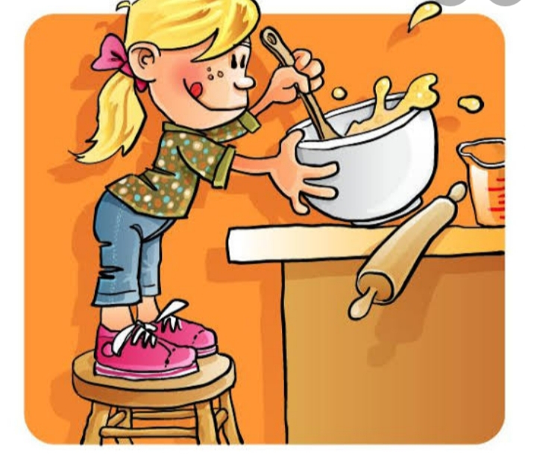
FLOUR : ¾ of a cup.
SUGAR: ½ of a cup.
CHOCOLATE CHIPS: ²/₃ of a cup.
MILK : 1 cup of milk
SCENARIO: A famous chef, Chef Julia has lost her secret recipe for her famous cookies. She left behind some clues in the form of fractions, and your task is to piece them together to find the correct recipe. Solve the clues to help Chef Julia to recover her recipe.
MIXING INSTRUCTIONS / METHOD (Clues)
- Chef Julia needs to mix ingredients in a specific order. Use these clues to determine the steps.
- The ingredient with the biggest fraction should go in first.
- Sugar is always mixed in before the chocolate chips.
- After mixing all the dry ingredients, add the wet ingredient.
- Use instructional verbs and amounts of ingredients ( Pour, Stir, Mix etc.) in your method.

5.1 Mention three utensils that you are going to mix the ingredients:
5.1.1______________________________(1)
5.1.2 _____________________________(1)
5.1.3 _____________________________(1)
5.2 Use the clues above to determine the method for Chef Julia’s recipe.
Step 1: ___________________________________________________________(1)
Step 2: ___________________________________________________________(1)
Step 3: ___________________________________________________________(1)
Step 4: ___________________________________________________________(1)
Step 5: ___________________________________________________________(1)
[8]
GRAND TOTAL = 40

