JOHANNESBURG NORTH DISTRICT

LIFE SKILLS

ASSESSMENT FRAMEWORK
TERM 3
2025
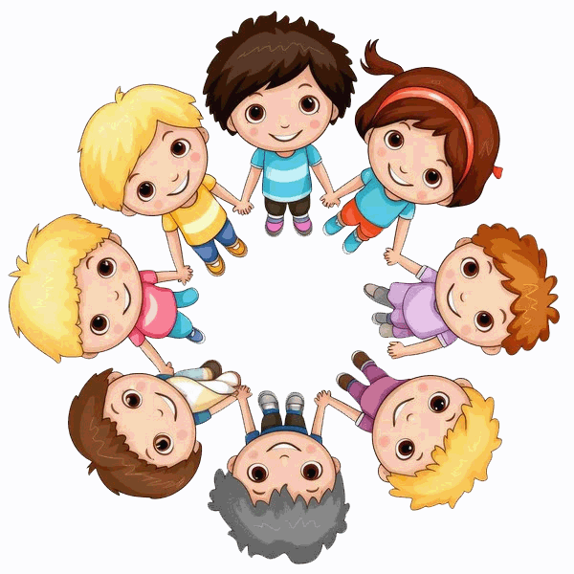
LIFE SKILLS


GRADE 1

My Body
Safety in the Home



JOHANNESBURG NORTH DISTRICT

LIFE SKILLS

ASSESSMENT FRAMEWORK
GRADE 1 TERM 3 2025
Total Mark: 65
Number | Study Area | What skills will be assessed | Weighting | Score
1 | BKPSW | My Community  - Places and people in my community.  - Looking after facilities and keeping my community clean eg public telephones, public transport and public toilets  - People in my community. People who help me. People who sell things. Other people I know  - Keeping places clean. Using bins and not littering. | 40% | 6
1 | BKPSW | Pets  - Animals we keep as pets.  - How to look after pets at home – shelter, food, water, animal cleanliness  - Treating animals appropriately | 40% | 2
1 | BKPSW | Manners and Responsibilities  - Greeting people we know and strangers  - Waiting my turn  - Listening to others  - Sharing  - Showing kindness  - Being honest  - Respecting other people and what belongs to them | 40% | 6
1 | BKPSW | Plants and Seeds  - Why we need plants – food, shade, shelter for animals  - What plants look like – roots, stem, leaves, flowers. Know the different parts of a plant . Know the different parts of a plant  - Different plants – similarities and differences  - The importance of plants . Understanding how plants grow and what they need to grow. What plants need to grow  - Seeds and where they come from. Growing a plant from a seed – such as a bean or a lentil | 40% | 6
1 | BKPSW | Food  - Foods we eat  - Where different foods come from: fruit; vegetables; dairy; meat  - Healthy Eating  - Healthy & unhealthy foods  - Healthy choices – balanced diet  - Identify food from different food groups  - Know where food products come from  - Storing food – fresh, tinned, dried, frozen |  | 6
 |  | TOTAL |  | 26
2 | Visual Arts | Create in 2D  Make paintings and drawings of real or imaginary creatures  - Line: curved, smooth, rough, thick and thin  - Shape: Geometric  OR  Make paintings and drawings of self-using in action using various modes of transport in the community.  - Colour: Primary and secondary colours  - Line: curved, smooth, rough, thick and thin  - Shape: Geometric  (contrasting big/small, long/short)  OR  Create in 3D  Make models of imaginary creature /pet using clay, playdough or recyclable materials. Add details like feathers, hairs, scales Smooth, rough and detail | 15% | 9
CHOOSE ONLY ONE ASSESSMENT ACTIVITY WHICH WILL BE USED FOR FINAL RECORDING PURPOSES USING A RUBRIC
ADDITIONAL ACTIVITIES MAY BE USED FOR INFORMAL ASSESSMENTS USING A CHECKLIST
3 | Performing Arts | Creative Games and Skills  - Mime actions showing emotions using visualization such as washing my pet, giving my pet food  Improvise and Interpret:  - Dramatizing a make a make- believe situation based on a song or a story about a plant/tree/seed /South African Song | 15% | 9
CHOOSE ONLY ONE ASSESSMENT ACTIVITY WHICH WILL BE USED FOR FINAL RECORDING PURPOSES USING A RUBRIC
ADDITIONAL ACTIVITIES MAY BE USED FOR INFORMAL ASSESSMENTS USING A CHECKLIST
4 | Physical Education | Laterality  - Hopscotch jump with non-dominant leg.  - Running and swinging a rope/ sash/ ribbon using non-dominant hand. | 30% | 21
4 | Physical Education | Rhythm  - Rope skipping, alone in groups of three, two swing and the other jumps, rotate roles. | 30% | 21
4 | Physical Education | Balance  - Play games using bean bags to balance on different parts of the body. E.g, “Simon Says"- balance the bean bag on your shoulder etc. | 30% | 21
4 | Physical Education | Co-ordination  - Hand-eye co-ordination - throw a tennis ball in the air and catch it, bounce it on the  ground and pass it to a partner  - Jumping over a swinging stocking ball | 30% | 21
4 | Physical Education | Perceptual Motor:  - Learners help to set up an obstacle course and move through the obstacle course safely- climbing on, climbing over, crawling, hanging onto bars and balancing. | 30% | 21
4 | Physical Education | Spatial orientation  - Crawl through tyres that have been set up in a line. | 30% | 21
4 | Physical Education | Locomotor  - Walk, run, using signals to change from walking to running or skipping. | 30% | 21
TOTAL FOR TASK |  |  |  | 65
PS ACTIVITIES NOT SELECTED FOR FORMAL ASSESSMENT MAY USED FOR INFORMAL ASSESSMENT FOR ALL STUDY AREAS
Study Area | BKPSW | VA | PA | PE
Mark Allocation | 26 | 9 | 9 | 21
Task Total | 65

TASK SPECIFICATION
No | What skills will be assessed |  | Possible questions | Forms of  Assessment | Assessment  Tool | Cognitive Levels | Level of difficulty | Type of question | Score
1.1 | BKPSW | My Community  - Places and people in my community.  - Looking after facilities and keeping my community clean eg Public telephones, public transport and public toilets  - People in my community. People who help me. People who sell things. Other people I know  - Keeping places clean. Using bins and not littering. | - Use the word bank to help you complete the sentences  I buy groceries at the …………………..  The ………………….. gives me medicine when I am sick.  - Circle the correct answer  A place where people live and work together is  - shop  - church  - community  - school | Oral / written | Worksheet/  Classwork/  Rubric | R  U | E | OEQ | 6
  doctor | school
  supermarket | police station
1.2 | BKPSW | Pets  - Animals we keep as pets.  - How to look after pets at home – shelter, food, water, animal cleanliness  - Treating animals appropriately | - Write two sentences on how you should look after your pet.  - Match the pictures to the correct sentence | Oral/ Written | Worksheet/  Classwork/  Rubric | R  U | E | OEQ  MCQ | 2
  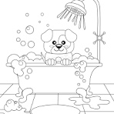 | Give food and water
  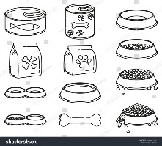 | Keep my pet clean
1.3 | BKPSW | Manners and Responsibilities  - Greeting people we know and strangers  - Waiting my turn  - Listening to others  - Sharing  - Showing kindness  - Being honest  - Respecting other people and what belongs to them | - Read the passage below and answer the questions that follow.  Jabu and Lina were friends, but Jabu was always in trouble with their teacher Miss Kay because he was always talking in class and never greeted when Principal Thembu came to the class. Jabu never liked sharing his crayons. Lina always helped pick up papers laying on the ground and shared her crayons.  - Why was Jabu always is trouble?  - How do you show respect?  - Read the poem and answer the questions  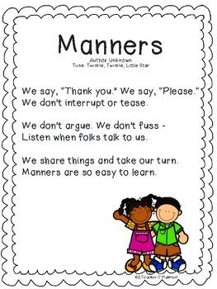  - Circle the words in the poem that show good manners | Oral / Written | Worksheet  /  Classwork book  /  Rubric | R  U | E  M | OEQ  MCQ | 6
1.4 | BKPSW | Plants and Seeds  - Why we need plants – food, shade, shelter for animals  - What plants look like – roots, stem, leaves, flowers. Know the different parts of a plant . Know the different parts of a plant  - Different plants – similarities and differences  - The importance of plants . Understanding how plants grow and what they need to grow. What plants need to grow  - Seeds and where they come from. Growing a plant from a seed – such as a bean or a lentil | - Label parts of the plant. Use the wordbank to help you.  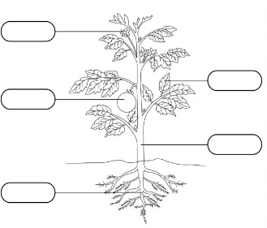  - Sequence the sentences in the correct order by wring 1 – 6 in the blocks.  - Complete the sentences  We get _______________ from plants.  Plants need ____________ to survive. | Oral/ Written | Worksheet  /  Classwork book  /  Rubric | R  U | E  M | OEQ | 6
  stem | roots | leaf
  flower | root | branch
  Place the saucer or bowl on a windowsill or in a place where
  there is enough sunlight.
  After a few days, see how your plant is growing. Water it once
  a week to keep the cotton wool damp.
  Cover 3 beans between 2 pieces of cotton wool. Put them in an empty saucer or bowl.
  Pour water over the cotton wool and make sure it is wet.
  Water your plant regularly to
  keep the soil damp. After a few weeks, you will be able to pick your own beans
  Once your plant has roots and two leaves, you can
  plant it in soft soil.
 |  | Food  - Foods we eat  - Where different foods come from: fruit; vegetables; dairy; meat  - Healthy Eating  - Healthy & unhealthy foods  - Healthy choices – balanced diet  - Identify food from different food groups  - Know where food products come from  - Storing food – fresh, tinned, dried, frozen | - Look at the pictures. Cross out the unhealthy foods and tick the healthy foods  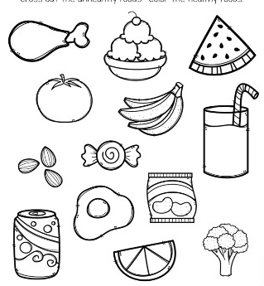 | Oral/ Written | Worksheet  /  Classwork book  /  Rubric | R  U | E  M | OEQ | 6
2 | Visual Arts | Create in 2D | Make paintings and drawings of self-using in action using various modes of transport in the community.  - Colour: Primary and secondary colours  - Line: curved, smooth, rough, thick and thin  - Shape: Geometric  ( Contrasting big/small, long short)  OR  Make paintings and drawings of real or imaginary creatures  - Line: curved, smooth, rough, thick and thin  - Shape: Geometric  OR | Observation  Practical  Demonstration | Rubric | R  C | M |  | 9
 |  | Create in 3D | Make models of imaginary creature /pet using clay ,playdough or recyclable materials . Add details like feathers, hairs, scales Smooth, rough and detail
3. | Performing Arts | Creative games and skills | - Mime actions showing emotions using visualization such as washing my pet, giving my pet food  OR | Observation  Practical  Demonstration | Rubric | R  Ap | M |  | 9
3. | Performing Arts | Improvise and Interpret | Dramatizing a make a make- believe situation based on a song or a story about a plant/tree/seed /South African Song
4 | Physical Education | Laterality | - Hopscotch jump with non-dominant leg.  - Running and swinging a rope/ sash/ ribbon using non-dominant hand. | Observation  Practical  Demonstration | Rubric | R  Ap | M |  | 21
4 | Physical Education | Rhythm | - Rope skipping, alone in groups of three, two swing and the other jumps, rotate roles. | Observation  Practical  Demonstration | Rubric | R  Ap | M |  | 21
4 | Physical Education | Balance | - Play games using bean bags to balance on different parts of the body. E.g, “Simon Says"- balance the bean bag on your shoulder etc. | Observation  Practical  Demonstration | Rubric | R  Ap | M |  | 21
4 | Physical Education | Co ordination | - Hand-eye co-ordination - throw a tennis ball in the air and catch it, bounce it on the  ground and pass it to a partner  - Jumping over a swinging stocking ball | Observation  Practical  Demonstration | Rubric | R  Ap | M |  | 21
4 | Physical Education | Perceptual Motor | - Learners help to set up an obstacle course and move through the obstacle course safely- climbing on, climbing over, crawling, hanging onto bars and balancing. | Observation  Practical  Demonstration | Rubric | R  Ap | M |  | 21
4 | Physical Education | Spatial Orientation | - Crawl through tyres that have been set up in a line. | Observation  Practical  Demonstration | Rubric | R  Ap | M |  | 21
 |  | Locomotor | - Walk, run, using signals to change from walking to running or skipping | Observation  Practical  Demonstration | Rubric | R  Ap | M
 |  | TOTAL of TASK |  |  |  |  |  |  | 65

BLOOMS TAXONOMY

40%
20%
40%

Remembering | Understanding | Applying | Analysing | Evaluating | Creating
name | summarise | classify | deconstruct | compare | design
write | categorise | predict | dissect | describe | compile
describe | describe | organise | discover | justify | explain
identify | predict | construct | examine | summarise | construct
label | explain | demonstrate | outline | define | predict
list | reorganise | develop | compare | predict | solve
match | identify | plan | arrange | compare | arrange
tabulate | compare | illustrate | investigate | determine | summarise
recognise | illustrate | sequence | organise | evaluate | develop
choose | classify | solve | categorise | deduce | compose

Types of question | Level of Difficulty:
MCQ – Multiple Choice Question OEQ - Open ended question SA – Short answer | E – Easy  M – Moderate  D - Difficult
Symbol | Cognitive Level
R | remembering
U | understanding
AP | applying
An | analysing
E | evaluating
C | creating

EXAMPLE OF CHECKLIST FOR INFORMAL ASSESSMENT
GRADE 1

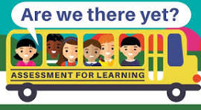

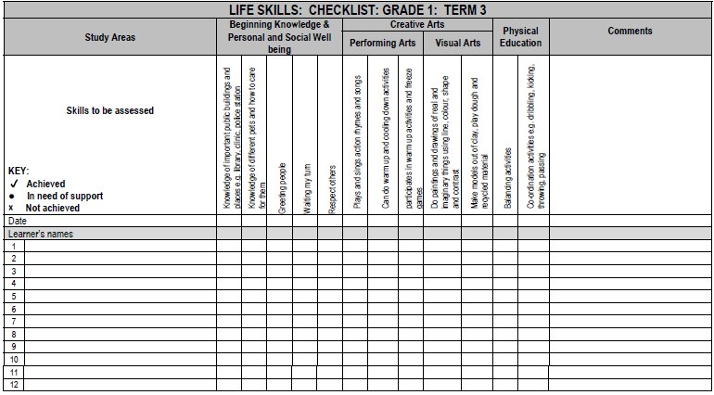

Extracted from Life SBA Guidelines Document page 13

GRADE 2

JOHANNESBURG NORTH DISTRICT

LIFE SKILLS

ASSESSMENT FRAMEWORK
GRADE 2 TERM 2 2025
Total Mark: 75
Number | Study Area | What skills will be assessed | Weighting | Score
1 | BKPSW | Soil  - Different soils – colours and textures  - Creatures that live in the soil – such as earthworms, moles  - Types and importance of soil  - What plants need to grow and the value of growing food at home | 40% | 8
1 | BKPSW | Transport  - Definition of transport  - Types of transport( land, rail, water, air)  - Uses of different kinds of transport | 40% | 6
1 | BKPSW | Road Safety  - Road safety rules (pedestrians cyclists ,passengers )  - Road signs for pedestrians and cyclists  - Scholar patrol  - How traffic officers help us | 40% | 8
1 | BKPSW | People who help us  - People who help us in our community: clinic nurse, after-care teacher, librarian, police, teacher  - How different people help me  - How I ask for information and assistance  - Good manners  - How I ask for help in an emergency ( who to contact, what information to give) | 40% | 8
 |  | TOTAL |  | 30
2 | Visual Arts | Create in 2D  Make drawings/paintings of birds, fish, insects, reptiles, etc. use oil pastels in warm colours and wash over in inks of cool colours.  - Discuss concepts like behind, in front of, underneath, etc.  - Discuss shape, texture, pattern.  - Look at and discuss famous artworks of natural world  OR  Make paintings of fantasy plants and flowers  - Discuss primary and secondary colours  - Discuss concepts like behind, in front of, underneath, etc. | 15% | 12
2 | Visual Arts | Create in 3D  Creating a simple puppet/mask using waste material eg socks  - Discuss the shapes, texture and colours  - How warm or cool colours influence the character of the puppet  OR  Use recyclable materials and papier mâché to make useful objects ( containers, plant holders etc)  - Decorate using patterns  - Discuss geometric shapes  - Cool and warm colours | 15% | 12
CHOOSE ONLY ONE ASSESSMENT ACTIVITY WHICH WILL BE USED FOR FINAL RECORDING PURPOSES USING A RUBRIC
ADDITIONAL ACTIVITIES MAY BE USED FOR INFORMAL ASSESSMENTS USING A CHECKLIST

3 | Performing Arts | Improvise and Interpret  - Create a simple puppet using waste material: sock puppets/mask, finger puppets, shadow puppets/mask.  - Create sounds and rhythms specific to the mood or character of the puppet by using voice, instruments or found objects.  - Own puppet performance based on appropriate vocal characterization and manipulation of own puppet  OR  - Simple mine o Imitating everyday activities focusing on weight and shape, such as picking up a ‘heavy rock’ or a ‘light feather  OR  Creative games and skills  - Polyrhythms using body percussion and/percussion instruments  OR  - Games focusing on numeracy and literacy such as number songs and rhymes, participatory stories, making letter shapes through movement, writing names with toes, verbal dynamics (pull, twist, stretch, bend, spin) | 15% | 12
3 | CHOOSE ONLY ONE ASSESSMENT ACTIVITY WHICH WILL BE USED FOR FINAL RECORDING PURPOSES USING A RUBRIC  ADDITIONAL ACTIVITIES MAY BE USED FOR INFORMAL ASSESSMENTS USING A CHECKLIST
4 | Physical Education | Rhythm  - Skipping with and without skipping ropes.  - Skipping on the spot and across a distance keep to the beat of the music drumming move parts of the body  - Layout swing on a jungle gym using over grasp  - Using over-grasp, swing on a horizontal bar of a jungle gym | 30% | 21
4 | Physical Education | Laterality  - In circle formation throw a ball clockwise … anti-clockwise  - Lateral trunk movements such a throw a ball sideways L/R like in rugby | 30% | 21
4 | Physical Education | Perceptual motor  - Perception games following a pattern – placing items in the correct order, i.e. running and place markers on predetermined places, using the correct order  - Free play and time to experiment with different ways of using a bean bag.  - Catching and throwing a tennis ball | 30% | 21
4 | Physical Education | Locomotor  - Obstacle course with bean bag on hand/shoulder/foot/head | 30% | 21
4 | Physical Education | Balance  - Balancing on one leg  - Balancing moves along ropes planks, balancing beams (balance on one leg; arms  - “Horse and cart”  - Hula hoop swings with arm, hips and neck | 30% | 21
4 | Physical Education | TOTAL |  | 75

PS ACTIVITIES NOT SELECTED FOR FORMAL ASSESSMENT MAY USED FOR INFORMAL ASSESSMENT FOR ALL STUDY AREAS

Study Area | BKPSW | VA | PA | PE
Mark Allocation | 30 | 12 | 12 | 21
Task Total | 75

TASK SPECIFICATION
No | What skills will be assessed |  | Possible questions | Forms of  Assessment | Assessment  Tool | Cognitive Levels | Level of difficulty | Type of question | Score
1.1 | BKPSW | Soil  - Different soils – colours and textures  - Creatures that live in the soil – such as earthworms, moles  - Types and importance of soil  - What plants need to grow and the value of growing food at home | - Look at the picture below. Use the words in the word bank to label the layers  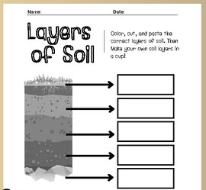  - Read the passage below. Answer the questions below  The most important part of soil for people and animals is topsoil. That is the soil in which plants grow. The roots of the plants stop the wind and rain from taking the topsoil away. Plants die when there is too little rain, or when there is a fire. They also die if there is too much rain. If there are no plants, the topsoil washes away in the rain, or the wind blows it away. This is called erosion. People also cause soil erosion. If we do not look after the soil, it cannot feed the plants that grow in it, and they start dying. As a result, soil gets washed or blown away.  - What is the most important part of soil for people and animals  _______________________________  - Life cycle of a bean plant  Complete the picture below by filling ion the correct words  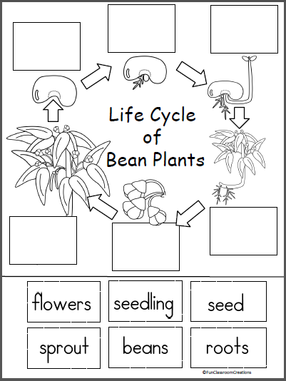 | Oral / Written | Worksheet/ Classwork | R  U  AP | E  M | OEQ  SA | 8
1.2 | BKPSW | Transport  - Definition of transport  - Types of transport( land, rail, water, air)  - Uses of different kinds of transport | - Read the poem. Answer the questions  Ride a bus or ride a train,  Take a boat or take a plane,  Take a taxi, take a car,  Maybe near or maybe far,  Ride a rocket to the moon,  But be sure to come back soon.  - Write down the different kinds of road transport you read in the poem.  ________________________  - Write down the different kinds of transport we get  ________________________________  - Classify transport. Provide pictures and words. Learners complete a table eg | Oral/ Written | Worksheet/  Classwork book | R  U  Ap | M  M | OEQ  MCQ  SA | 6
  road | air | rail | water
1.3 | BKPSW | Road Safety  - Road safety rules (pedestrians cyclists ,passengers )  - Road signs for pedestrians and cyclists  - Scholar patrol  - How traffic officers help us | - Use the word bank below to label the road signs  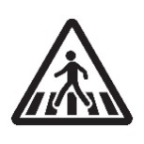  _______________ ___________  - Write down 2 safety rules you must follow when riding in a car.  _____________________________ | Oral/ Written | Worksheet/  Classwork book | R  U  Ap | M | OEQ  MCQ  SA | 8
  no parking | pedestrian crossing | children ahead
1.4 | BKPSW | People who help us  - People who help us in our community: clinic nurse, after-care teacher, librarian, police, teacher  - How different people help me  - How I ask for information and assistance  - Good manners  - How I ask for help in an emergency ( who to contact, what information to give) | - Circe the correct answer  - A _____________ works at a clinic  A . library  B. policeman  C. nurse  2. Read the sentence. Write true or false. If false write the correct answer  A librarian takes care of animals  _______________________________  3. Who am I?  I help you when you have toothache.  I show you how to look after your teeth and keep them healthy.  __________________ | Oral/ Written | Worksheet/  Classwork book | R  U  Ap | M | OEQ  SA | 8
2 | Visual Arts | Create in 2D | Make drawings/paintings of birds, fish, insects, reptiles, etc. use oil pastels in warm colours and wash over in inks of cool colours.  - Discuss concepts like behind, in front of, underneath, etc.  - Discuss shape, texture, pattern.  - Look at and discuss famous artworks of natural world  OR  Make paintings of fantasy plants and flowers  - Discuss primary and secondary colours  - Discuss concepts like behind, in front of, underneath, etc. | Practical | Rubric | R  C | M |  | 12
2 | Visual Arts | Create in 3D | Creating a simple puppet/mask using waste material eg socks  - Discuss the shapes, texture and colours  - How warm or cool colours influence the character of the puppet  OR  Use recyclable materials and papier mâché to make useful objects ( containers, plant holders etc)  - Decorate using patterns  - Discuss geometric shapes  - Cool and warm colours
3 | Performing Arts | Improvise and Interpret | - Create a simple puppet using waste material: sock puppets/mask, finger puppets, shadow puppets/mask.  - Create sounds and rhythms specific to the mood or character of the puppet by using voice, instruments or found objects.  - Own puppet performance based on appropriate vocal characterization and manipulation of own puppet  OR  - Simple mine o Imitating everyday activities focusing on weight and shape, such as picking up a ‘heavy rock’ or a ‘light feather  OR | Practical | Rubric | R  Ap | M |  | 12
3 | Performing Arts | Creative games and skills | - Polyrhythms using body percussion and/percussion instruments  OR  - Games focusing on numeracy and literacy such as number songs and rhymes, participatory stories, making letter shapes through movement, writing names with toes, verbal dynamics (pull, twist, stretch, bend, spin
4 | Physical Education | Rhythm | - Skipping with and without skipping ropes.  - Skipping on the spot and across a distance keep to the beat of the music drumming move parts of the body  - Layout swing on a jungle gym using over grasp using over-grasp, swing on a horizontal bar of a jungle gym | Practical | Rubric | R  Ap | M |  | 21
4 | Physical Education | Laterality | - In circle formation throw a ball clockwise … anti-clockwise  - Lateral trunk movements such a throw a ball sideways L/R like in rugby | Practical | Rubric | R  Ap | M |  | 21
4 | Physical Education | Perceptual Motor | - Perception games following a pattern – placing items in the correct order, i.e. running and place markers on predetermined places, using the correct order  - Free play and time to experiment with different ways of using a bean bag.  - Catching and throwing a tennis ball | Practical | Rubric | R  Ap | M |  | 21
4 | Physical Education | Locomotor | - Obstacle course with bean bag on hand/shoulder/foot/head | Practical | Rubric | R  Ap | M |  | 21
4 | Physical Education | Balance | - Balancing on one leg  - Balancing moves along ropes planks, balancing beams (balance on one leg; arms  - “Horse and cart”  - Hula hoop swings with arm, hips and neck | Practical | Rubric | R  Ap | M |  | 21

BLOOMS TAXONOMY

40 %
20 %
40 %

Remembering | Understanding | Applying | Analysing | Evaluating | Creating
name | summarise | classify | deconstruct | compare | design
write | categorise | predict | dissect | describe | compile
describe | describe | organise | discover | justify | explain
identify | predict | construct | examine | summarise | construct
label | explain | demonstrate | outline | define | predict
list | reorganise | develop | compare | predict | solve
match | identify | plan | arrange | compare | arrange
tabulate | compare | illustrate | investigate | determine | summarise
recognise | illustrate | sequence | organise | evaluate | develop
choose | classify | solve | categorise | deduce | compose

Types of question | Level of Difficulty:
MCQ – Multiple Choice Question OEQ - Open ended question SA – Short answer | E – Easy  M – Moderate  D - Difficult
Symbol | Cognitive Level
R | remembering
U | understanding
AP | applying
An | analysing
E | evaluating
C | creating

EXAMPLE OF CHECKLIST FOR INFORMAL ASSESSMENT
GRADE 2

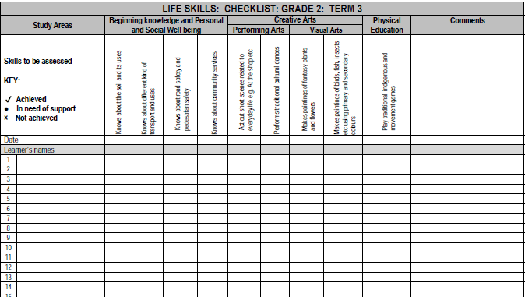
Extracted from SBA Guidelines Document Page 30

GRADE 3

JOHANNESBURG NORTH DISTRICT

LIFE SKILLS

ASSESSMENT FRAMEWORK
GRADE 3 TERM 3 2025
Total Mark: 85
Number | Study Area | What skills will be assessed | Weighting | Score
1 | BKPSW | Public Safety  - Dangerous places to play – include rubbish dumps, train tracks, roads, construction sites  - Riding trains and taxis safely  - Dangers of electricity  - Poisonous and inflammable substances  - Signs that warn us of danger  - What to do in the face of danger  - How to protect themselves from danger | 40% | 10
1 | BKPSW | Pollution  - Definition of Pollution  - Different types of pollution (water, land, air, noise ,)  - Cause and effect of pollution on the people and the environment | 40% | 10
1 | BKPSW | How people lived long ago  - Stories and experience of older family and community members (include food, clothes and transport)  - Objects used by older family and community members (tools, toys, cooking utensils)  - Selections of old pictures and photographs from family albums and books  - How people lived then and now (change and continuity )  - The effect of the change  - The importance of change in an ever-changing world | 40% | 7
1 | BKPSW | Space  - Earth from space – what it looks like (land, sea, clouds)  - Stars and planets – what they are  - Names of the planets  - Telescopes  - Space travel  - Satellites  - Understanding our world and beyond; what is it comprised of | 40% | 10
 |  | TOTAL |  | 37
2 | Visual Arts | Create in 2 D  - Pattern and printmaking in the personal world: include overlapping, border, patterns, shape within shape, repetition  OR  - Drawing and painting – exploring a wide variety of media  OR | 15% | 12
2 | Visual Arts | Create in 3D  - Craft containers for classroom using recyclable material  OR  - Pattern and surface decoration for craft objects | 15% | 12
CHOOSE ONLY ONE ASSESSMENT ACTIVITY WHICH WILL BE USED FOR FINAL RECORDING PURPOSES USING A RUBRIC
ADDITIONAL ACTIVITIES MAY BE USED FOR INFORMAL ASSESSMENTS USING A CHECKLIST

3 | Performing Arts | Improvise and interpret  - Classroom dramas: illustrate different characters through vocal and physical characteristics e.g. moving and speaking as the mother, the grandfather, the door | 15% | 12
3 | Performing Arts | Creative games and skills  - Observation and concentration skills: drama activities eg a mime sequence  - Body percussion and/or percussion instruments to accompany South African music  focusing on cyclic (circular) rhythm patterns  - Expressiveness and involvement in poetry, rhymes (poetry performances) | 15% | 12
CHOOSE ONLY ONE ASSESSMENT ACTIVITY WHICH WILL BE USED FOR FINAL RECORDING PURPOSES USING A RUBRIC
ADDITIONAL ACTIVITIES MAY BE USED FOR INFORMAL ASSESSMENTS USING A CHECKLIST

4 | Physical Education | Perceptual  - Kick a moving ball and change direction, to a target or a partner  - Throwing balls to targets and between partners with one and two hands, high and far | 30% | 24
4 | Physical Education | Rhythm  - Rope skipping – advanced movement such as cross over, double skip, etc.  - Gymnastic movement such as forward roll, backward roll, handspring, and cartwheel | 30% | 24
4 | Physical Education | Balance  - Stand and walk on tiptoe and heel  - Crawling on hand and knees  - Balance walking forward and backwards  - Climbing on a jungle gym: moving freely on balancing pole/beam  - Simple dismounts off apparatus  - Gymnastics: balancing actions such as handstand, head stand, launches, etc. | 30% | 24
4 | Physical Education | Spatial orientation  - Obstacle course that includes activities for crawling, jump and land from a certain height, agility, speed, etc.  - Partner tag; catch your partner’s tail | 30% | 24
4 | Physical Education | Locomotor  - Hopping over a distance carrying something and holding hands with a partner  - Jumping while standing ... double take-off and single take-off  - Leaping: simulating actions – kangaroo, springbuck, rabbit, etc. | 30% | 24
TOTAL |  |  |  | 85
Study Area | BKPSW | VA | PA | PE
Mark Allocation | 37 | 12 | 12 | 24
Task Total | 85
PS ACTIVITIES NOT SELECTED FOR FORMAL ASSESSMENT MAY USED FOR INFORMAL ASSESSMENT FOR ALL STUDY AREAS

TASK SPECIFICATION
No | What skills will be assessed |  | Possible questions | Forms of  Assessment | Assessment  Tool | Cognitive Levels | Level of difficulty | Type of question | Score
1.1 | BKPSW | Public Safety  - Dangerous places to play – include rubbish dumps, train tracks, roads, construction sites  - Riding trains and taxis safely  - Dangers of electricity  - Poisonous and inflammable substances  - Signs that warn us of danger  - What to do in the face of danger  - How to protect themselves from danger | - Label the following warning signs  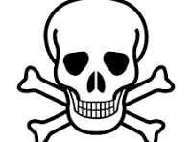 _____________  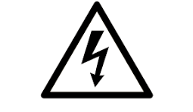____________  - Write down one flammable/ poisonous substance you may find at home  - Write down two safety rules when taking a bus or a taxi.  - Label the picture below. Write a reason why it is dangerous to play there  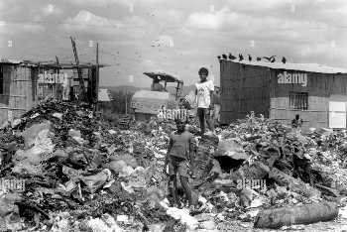  - BPKSW Reading and comprehension passage pages 75-82. Choose extracts and select questions | Written | Worksheet/ Classwork | R  U  Ap | M | OEQ  MCQ  SA | 8
1.2 | BKPSW | Pollution  - Definition of Pollution  - Different types of pollution (water, land, air, noise ,)  - Cause and effect of pollution on the people and the environment | - Name the four types of pollution  - What is pollution?  - Name two ways in which you can stop pollution  - Label the picture. What kind of pollution is this?  How can you stop this kind of pollution  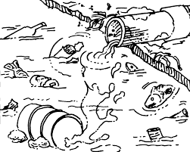  - BKPSW Reading and comprehension passages pages 83-90. Choose extracts and select questions | Written | Worksheet/  Classwork book | R  U  Ap | M | OEQ  MCQ  SA | 8
1.3 | BKPSW | How people lived long ago  - Stories and experience of older family and community members (include food, clothes and transport)  - Objects used by older family and community members (tools, toys, cooking utensils)  - Selections of old pictures and photographs from family albums and books  - How people lived then and now (change and continuity )  - The effect of the change  - The importance of change in an ever-changing world | - Look at the picture of a farmer and his family many, many years ago. Write down three ways life is different today  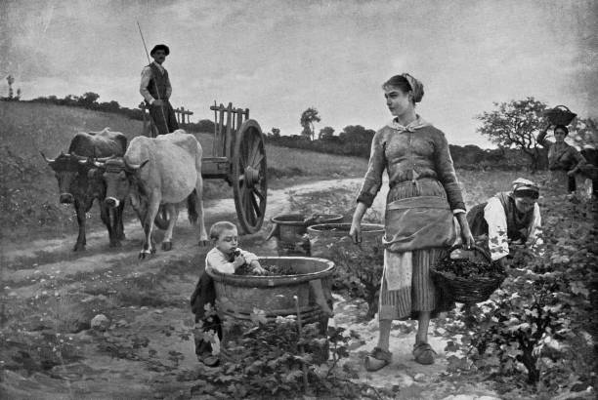  - Put tick if the statement is true and a cross X , if the statement is false. If false, write the correct answer.  - Today, we exchange tobacco and animal skins for food______  __________________________  - People use technology such as laptops, cellphones in the 16th Century ______  ___________________________  - Use the wors “past” or “present” to label the pictures below  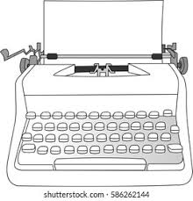 _____________  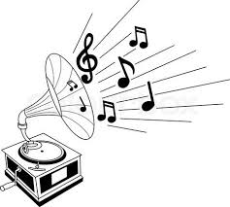________________   _________  - BKPSW Reading and comprehension passages pages 91-98. Extract passages and select questions | Written | Worksheet/  Classwork book | R  U  Ap | M | OEQ  MCQ  SA | 7
1.4 | BKPSW | Space  - Earth from space – what it looks like (land, sea, clouds)  - Stars and planets – what they are  - Names of the planets  - Telescopes  - Space travel  - Satellites  - Understanding our world and beyond; what is it comprised of | - Choose the correct answer from the list of words given below  - ___________ are chunks of ice and gas that travel in large orbits through the Solar System.  - The ____________ is a very , very hot ball of gas.  - We have 8 ___________ in our Solar System.  - _____________________ are chunks of rock.  - The____________________ is a cold, dead ball of rock and dust that revolves around the earth.  2. Classify the planets correctly in the table below  3.Circle the correct answer.  ____________ was the first South  African to orbit the earth in April 2002  - Mark Wahlberg  - Mark Shuttelworth  - Mark Zuckerberg  4. BKPSW Reading and comprehension passages  Pages 99-106  Choose a comprehension passage and select questions | Written | Worksheet/  Classwork book | R  U  Ap | M  D | OEQ  MCQ  SA | 7
  sun | comets | stars
  meteors | moon | planets
  Mercury | Earth | Saturn
  Venus | Pluto | Pluto
  Mars | Jupiter | Asteroid
  Inner Planets | Outer Planets
2 | Visual Arts | Create in 2D | - Pattern and printmaking in the personal world: include overlapping, border, patterns, shape within shape, repetition  - Drawing and painting – exploring a wide variety of media | Practical | Rubric | R  C | M |  | 12
2 | Visual Arts | Create in 3D | - Craft containers for classroom using recyclable material  - Pattern and surface decoration for craft objects.
3 | Performing Arts | Improvise and interpret | - Classroom dramas: illustrate different characters through vocal and physical characteristics e.g. moving and speaking as the mother, the grandfather, the door | Practical | Rubric | R  Ap | M |  | 12
3 | Performing Arts | Creative games and skills | - Observation and concentration skills: drama activities eg a mime sequence  - Body percussion and/or percussion instruments to accompany South African music  focusing on cyclic (circular) rhythm patterns  Expressiveness and involvement in poetry, rhymes (poetry performances) | Practical | Rubric | R  Ap | M |  | 12
4 | Physical Education | Perceptual | - Kick a moving ball and change direction, to a target or a partner  - Throwing balls to targets and between partners with one and two hands, high and far | Practical | Rubric | R  Ap | M |  | 21
4 | Physical Education | Rhythm | - Rope skipping – advanced movement such as cross over, double skip, etc.  Gymnastic movement such as forward roll, backward roll, handspring, and cartwheel | Practical | Rubric | R  Ap | M |  | 21
4 | Physical Education | Balance | - Stand and walk on tiptoe and heel  - Crawling on hand and knees  - Balance walking forward and backwards  - Climbing on a jungle gym: moving freely on balancing pole/beam  - Simple dismounts off apparatus  - Gymnastics: balancing actions such as handstand, head stand, launches, etc | Practical | Rubric | R  Ap | M |  | 21
4 | Physical Education | Spatial orientation | - Obstacle course that includes activities for crawling, jump and land from a certain height, agility, speed, etc.  - Partner tag; catch your partner’s tail | Practical | Rubric | R  Ap | M |  | 21
4 | Physical Education | Locomotor | - Hopping over a distance carrying something and holding hands with a partner  - Jumping while standing ... double take-off and single take-off  - Leaping: simulating actions – kangaroo, springbuck, rabbit, etc. | Practical | Rubric | R  Ap | M |  | 21
 |  | TOTAL |  |  |  |  |  |  | 85

BLOOMS TAXONOMY
40 %
20 %
40 %

Remembering | Understanding | Applying | Analysing | Evaluating | Creating
name | summarise | classify | deconstruct | compare | design
write | categorise | predict | dissect | describe | compile
describe | describe | organise | discover | justify | explain
identify | predict | construct | examine | summarise | construct
label | explain | demonstrate | outline | define | predict
list | reorganise | develop | compare | predict | solve
match | identify | plan | arrange | compare | arrange
tabulate | compare | illustrate | investigate | determine | summarise
recognise | illustrate | sequence | organise | evaluate | develop
choose | classify | solve | categorise | deduce | compose

Types of question | Level of Difficulty:
MCQ – Multiple Choice Question OEQ - Open ended question SA – Short answer | E – Easy  M – Moderate  D - Difficult
Symbol | Cognitive Level
R | remembering
U | understanding
AP | applying
An | analysing
E | evaluating
C | creating

EXAMPLE OF CHECKLIST FOR INFORMAL ASSESSMENT
GRADE 3

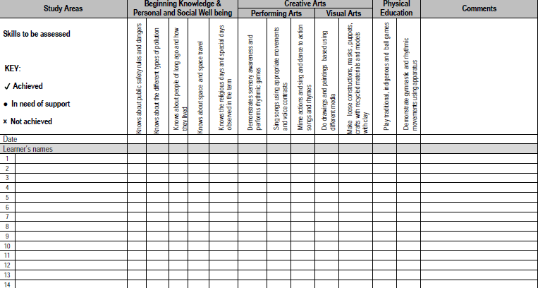

Extracted from SBA Guidelines Document page 48


EXAMPLES OF RUBRICS ONLY

DESIGN YOUR OWN !!!

VISUAL ARTS RUBRIC EXEMPLAR
Assessment Activity
Create in 2D
Makes drawings of an imaginary creature using thin and thick lines, using primary and secondary colours
Criteria | Performance Indicator/ Level Descriptors |  |  | Learner Mark
Criteria | 1 | 2 | 3
Creativity | Design lacks individuality. Has few details. Evidence of copying ideas. | Design is somewhat expressive. Has some unique features | Design is unique and displays elements that are their own. Evidence of details
Lines | Minimal effort evident to use a variety of lines. Only thin lines used | Somewhat effort made to use a variety of lines. Evidence of some thin and thick lines | Variety of thin and thick lines evident in drawing
Primary and Secondary Colours | No effort to use both primary and secondary colours. Only primary colours used. | Some use of both primary and secondary colours | Impressive usage of both primary and secondary colours
Time Management | Has difficulty focusing on the drawing most of the time. Easily distracted by others. Lacks time management skills | Needs to be motivated to complete drawing within the specified time. | Uses class time to the maximum. Always on task. Time and effort evident in the execution of the drawing
TOTAL MARK ACHIEVED |  |  |  | 12

VISUAL ARTS RUBRIC EXEMPLAR
Assessment Activity
Create 3D
Using recyclable material to create a pencil holder using patterns and shapes
Criteria | Performance Indicator/ Level Descriptors |  |  | Learner Mark
Criteria | 1 | 2 | 3
Creativity and Originality | Project lacks originality; mostly copied or incomplete. | Project has few original ideas; somewhat copied or plain. | Project shows outstanding creativity and unique design choices.
Use of shapes | Uses a wide variety of shapes effectively in the design. | Uses a few basic shapes with limited variety. | Minimal or no use of shapes in the design.
Use of patterns | Clearly and carefully uses multiple, repeating patterns. | Patterns are incomplete or inconsistent. | No clear patterns used
Craftmanship/neatness | Work is very neat, clean, and well-constructed. | Work shows some effort, but is messy in places. | Work is messy or poorly assembled
Effort and participation | Shows excellent effort; fully engaged in the project. | Some effort shown; needed reminders to stay on task. | Minimal effort; often distracted or off-task.
TOTAL MARK ACHIEVED |  |  |  | 15

PERFORMING ARTS RUBRIC EXEMPLAR
Assessment Activity
Miming an action such as waiting in line at a taxi rank

Criteria | Performance Indicator/ Level Descriptors |  |  | Learner Mark
Criteria | 1 | 2 | 3
Facial Expression | Consistently uses clear and expressive facial expressions to show emotion or action. | Sometimes uses facial expressions, but not always clear or consistent. | Rarely uses facial expressions or they do not match the mime.
Body Movement | Movements are clear, exaggerated, and match the intended action. Great use of body to tell a story. | Movements are sometimes unclear or small; more effort needed. | Movements are confusing, minimal, or do not match the action.
Creativity | Performance is highly imaginative, original, and engaging. | Performance shows limited creativity or relies on common ideas. | Performance lacks creativity or effort.
Focus and Concentration | Always stays in character and focused throughout the performance. | Sometimes breaks character or loses focus. | Frequently breaks character or seems distracted.
Use of Space | Excellent use of performance space to enhance the mime. | Limited movement or only uses a small part of the space. | Barely uses space; stays in one spot or moves without purpose.
TOTAL MARK ACHIEVED |  |  |  | 15

PHYSICAL EDUCATON RUBRIC EXEMPLAR
Criteria | Performance Indicator/ Level Descriptors |  |  | Learner Mark
Criteria | 1 | 2 | 3
Laterality  Hopscotch jump with non-dominant leg | Learners struggles to complete hopscotch sequence using non dominant leg, stops and pauses for long periods of time | Learner completes hopscotch sequence using non dominant leg , but stops and pauses a few times | Learner completes hopscotch sequence with non dominant leg without stopping or pausing
Lateral trunk movements such a throw a ball sideways L/R like in rugby | Lateral throws are haphazard and learner struggles to throw the ball sideways at any target | Learner is only able to throw the ball sideways in one direction at a given target | Lateral throws are consistent and learner is able to throw the ball sideways in both directions ( left and right) to any target
Co ordination  Throw a tennis ball in the air and catch it, bounce it on the ground and pass it to a partner | Tennis ball falls after thrown in the air. Struggles to bounce tennis ball on the ground and misses partner when tennis ball is thrown | Catches the tennis ball, bounces but misses partner when throwing the ball. | Easily and comfortably throws the tennis ball, catches, bounces and passes to partner without any mistakes
Rhythm  Skipping on the spot and across a distance keep to the beat of the music drumming move parts of the body | Struggles to skip on the spot and without any rhythm | Skips rhythmically on the spot but pauses in between | Skips rhythmically y on the spot and keep to the beat
Balance  Hula hoop swings with arm, hips and neck | Learner is only able to complete hula hoop swings on the arm | Learner is only able to complete hula hoop swings on the arm and neck | Learner is able to complete hula hoop swings on the arm, neck and hips
Simple dismounts off apparatus | Reluctant to attempt the activity | Attempts a simple dismount, but hesitates and falls after dismount | Completes a simple dismount off apparatus seamlessly without falling
Perceptual  Kick a moving ball and change direction, to a target or a partner | Kicks a ball randomly without changing any direction to a target or partner | Kicks a ball , but misses the target and partner a few times. Struggles to change direction | Kicks a moving ball consistently and changes direction easily at a target or partner
Locomotor  Leaping: simulating actions – kangaroo, springbuck, rabbit, etc | Action does not simulate the instruction provided by the teacher even after demonstration provided | Learner attempts the required leap, struggles to maintain his /her balance | Learner follows instruction and completes required leap impeccably without falling
TOTAL MARK ACHIEVED |  |  |  | 24



