

TERM 4 MARKING GUIDE

GRADE 4

SUBJECT: NATURAL SCIENCES AND TECHNOLOGY
FORMAL ASSESSMENT TASK
2021

TOTAL MARKS: 30
DURATION:

Name: ________________________________________________________

Class: __________________________ Date: ________________________

School: _____________________ Teacher: _________________________

ENGLISH FIRST ADDITIONAL LANGUAGE

NOVEMBER 2011

ENGLISH FIRST ADDITIONAL LANGUAGE

NOVEMBER 2011

30

MARKS OBTAINED =

INSTRUCTIONS
1. Read all the instructions carefully.
2. Answer all the questions in the spaces provided.
3. Write neatly and legibly.
4. Use a lead pencil to draw ___________________________________________________________________
QUESTION 1: Multiple choice questions
Underline or circle the letter of the correct answer:
  - Which form of energy is produced when a student beat a drum? (1)
- Light energy.
- Chemical energy.
- Sound energy.
- Electrical energy.
  - The planet Earth looks blue and white from space. It is called the blue planet because it is covered with ………………… (1)
- Clouds.
- Water.
- Mountains.
- Rocks
1.3 When the moon completely disappears, it is called …………. (1)
A. Full moon.
B. Crescent moon.
C. Gibbous moon.
D. New moon.
1.4 In an electric mixer, the electrical energy gets transformed into ……
A. Light energy
B. Movement energy
C. Sound energy
D. Heat energy

[4]

QUESTION 2

Match the number in Column A with the letter in Column B.
Write down the matching letter in the middle column.

COLUMN A | ANSWER | COLUMN B
2.1. Is a star at the centre of the solar system | F. | - Rotation
2.2. The type of energy that is generated by the sun. | E. | - Sound energy
2.3. The spinning of Earth on its own axis. | A. | - Noise pollution
2.4. The type of energy that you hear. | B. | - Whistle
2.5. You play it by blowing. | D. | - Solar energy
 |  | - Sun.

[5]

QUESTION 3
Choose one word from those in brackets by underlining the correct one.
3.1. A stove gives us (sound, heat) energy.
3.2. The (Sun, Earth) is a ball of very hot gas.
3.4. Machines and appliances need an (input, output) energy.
[3]
QUESTION 4
4.1
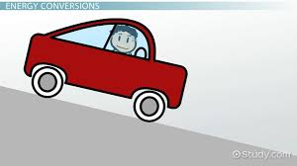
4.1 What is the output energy we observe from the diagram above?
…The output energy here is movement energy. (1)

4.2
4.3.1Explain what the boy is doing and what energy is being used.
The boy is kicking the ball. He is using movement energy. (1)
4.3.2 Explain what the girl is doing and what energy is using.
The girl is reading a book and is using light energy. (1)
[3]
QUESTION 5
TYPES OF MUSICAL INSTRUMENTS
Musicians usually group musical instruments according to how we play them. Different instruments need different types of movement as input energy. There are three main types of musical instruments that are shown below:

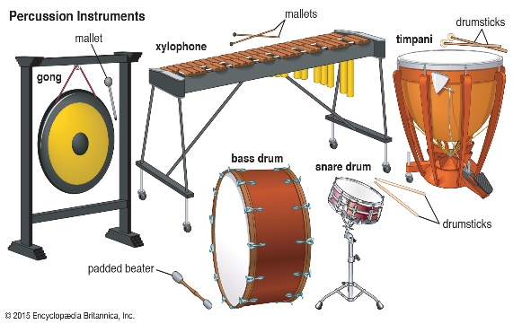
4.1 Explain how the instrument above is played?
Beating the instrument is done in order to produce sound. (1)
String instrument
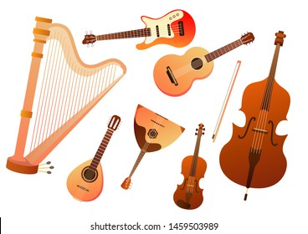
4.3 Explain how the instrument played?
It is played through touching the strings of the instrument, you may use your fingers. (1)

Wind instrument
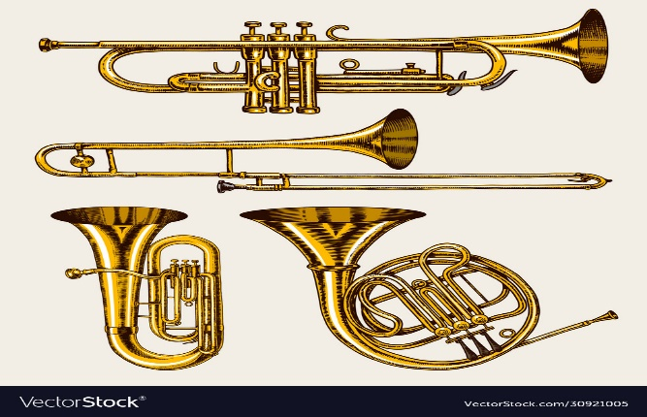
4.5 Explain how a wind instrument is played?
It is played by blowing the instrument (1)
[3]

QUESTION 6

6.1 Give the name of the star found in the centre of the above solar system. (1)
The sun
6.2 Name the planet where people, animals and plants survive and grow normally.
Planet Earth (1)
6.3. Name ANY TWO features of the planet you mentioned in 6.2.
Continents, Islands, Oceans, seas, Mountains, Rivers etc. (2)
6.4 What is the 8th planet from the sun? (1)
Neptune
6.5 What is meant by an island?
An island is a small piece of land surrounded by water (1)
6.6. The Sun is important to life on Earth. Explain.
The sun provides us with heat and light.
The Sun warms our seas, stirs our atmosphere, generates our weather
patterns,
The Sun gives energy to the growing green plants that provide the food
and oxygen for life on Earth.
[9]

QUESTION 7

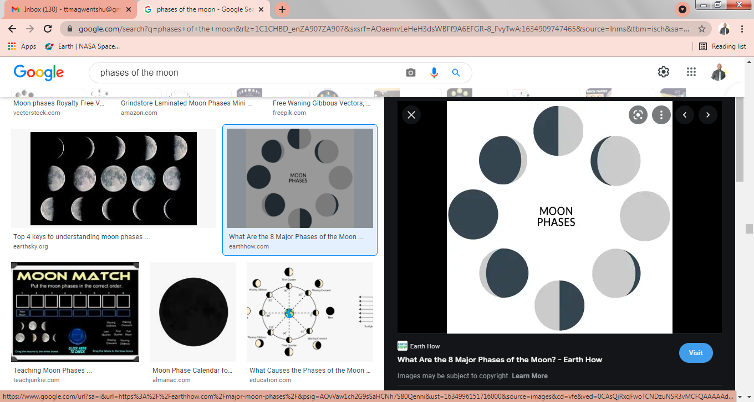
NEW MOON
FULL MOON
WANING CRESCENT
Study the above diagram and label the following moon phases:
7.1 New moon (1)
7.2 Waxing Crescent (1)
7.3 Full moon (1)
[3]

TOTAL: 40 MARKS

