
CHRIS HANI EAST - COFIMVABA CMC
UHLOLO
IZIBALO
IBANGA: 1
IKOTA: 4
AMANQAKU: 50
Amanani, i-opareyshini nolwamano.
UMBUZO 1 [3]: OKWENZIWAYO

  - Khomba elona nani likhulu kula manani mathathu. (1)

18 | 8 | 10
  - Utitshala unika umfundi izibalisi eziphathi kuka 0-50. Umfundi ubala izibalisi esiya phambili ngonye. (1)
  - Utitshala unika umfundi izibali eziphakathi kuka 0-20. Umfundi ubala izibalisi ngombini esiya phambi. (1)

Umbuzo 2: [10]: OKUBHALWAYO: [10]
2.1. nika ihafu yelinani.
20 =
2.2. phinda elinani kabini.
7 =
2.3 cazulula elinani
17= _____ +_______

2.4 UThabo unamabhastile ali-15 waze wathengisela uLihle ali-10. Mangaphi ashiyekileyo. Bonisa isivakalisi manani okanye imizobo. (2)

____________________________________________________________________

2.5. Umama unamqanda si-8. Udinga amaqanda ali-12 ukubhaka ikeyiki yakhe maqanda mangaphi amaqanda ashotayo ukwenza i-12? Bonisa isivakalisi manani okanye imizobo ukusombulula. (2)

_____________________________________________________________________

2.6. fakela inami elishiyiweyo. (1)
16 |  | 18

2.7. tshatisa isimboli neyani kunye negama lenani. (2)
14 ishumi elinanye
11 ishumi elinesine

Umbuzo 3: ULWAZI OLUQOKELWAYO: OKWENZIWAYO

3.1. Utitshala unika abafundi ibhloko zika 6 bricks. Ubanika ngoluhlobo:
10 orenji, 7 ezibomvu, 8 ezityheli, 15 ezizuba. Umfundi uyazihlela ngokwemibala. (1)
3.2. ukuphendula imibuzo yolwazi oluqokelelweyo.
3.2.1. ngomphi umbala omninzi: _________________________________________. (1)
3.2.2. zingaphi xa zizonke ibhloko: ________________________________________. (1)

Umbuzo 4: anamani, i-opareyishini nolwanamo. [10]
4.1. biyela elona nani lincinci. (1)
19 9 29 39
4.2. landelelanisa la manani uqale ngelikhulu uye kwelincinci. Bhala kwizithuba ezikwibhokisi. (1)
11 7 3 21 5
4.3. kukho ibhayisekile ezine zabafundi bebanga loku-1. Inye inamavili inamavili ama-2. Mangaphi xa ewonke amavili ezibhayisekile? Bonakalisa isivakalisi manani. (2)

___________________________________________________________

4.4. yaba iileke ezi-12 phakathi kwabahlobo abathathu. Emnye uzakufumana iilekese ezingaphi. Bonisa imizobo apha ngezantsi

Uzakufumana iilekese ezi_____________ emnye.

4.5. dibanisa la manani alandelayo. Sebenzisa umgca mania ukubonisa impendulo yakho.
9 + 4 = (2)

9
4.6 xela amanani amabini akha usibhozo. (2)

________ +___________ = 8
Umbuzo 5: umlinganiselo [4]
51. yeyiphi ethatha ixesha elide okanye elifutshane phakathi kwezi zombini. Bhala “elide/elifutshena e” ecaleni komfanekiso ochanekileyo.
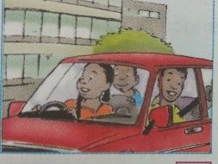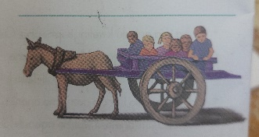
____________________ ________________________
5.2. zingaphi intsuku zeveki? (1)

______________________

5.3. biyela eyona nto inzima phakathi komntu kunye nebhaluni. (1)
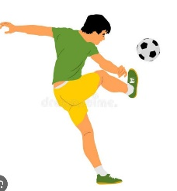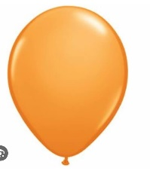
Umbuzo 6: iimilo nezithuba [3]

6.1.

________________ _____________________
6.2. zoba isikwere.

___________________________
Umbuzo 7: Amani, i-opareyshini nolwamano [7]
7.1.
Zeziphi iimali ezenza IR5 : zizobe okanye uzibhale (1)
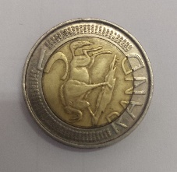 _________________________________________________
7.2 ULizo une R5. Athe iillekese ezenza R3. Yimalini itshintsi azakuyifumana. Bala ubonise impendulo yakho ebhokisini. (2)

7.3. yahlulela abahlobo abane ilekese ezi-17. Emnye uzakufumana ngaphi? Kushiyeke ngaphi. (2)_

Uzakufumana ________________ kushiyeke_____________
7.4.1. fakela inani eliphambi kuka 17. (1)
_____ 17

7.4.2. inami eliphakathi

13 |  | 14

7.5 Ezomlomo. [2]
7.5.1 ngubani inani elisemva/ elilandela u 19? Ngu:_____________ (1)
7.5.2 inani elikhu ngo 1 ku 14 ngu:__________________________ (1)
Umbuzo 8: IIPHATHENI,IFANKSHINI NEALJEBRA: OKUBHALWAYO- 3
8.1. Kuphela wandise lephatheni yamanani ilandelayo:
8.1.1. 50, ______, 60, 65, 70.
8.1.2. 26, 28,______32, 34.
8.2. yandisa le phatheni ilandelayo.

____________________________
8.3. ezomlo: [2]
8.3.1 Chaza ukuba lephatheni ibala ngobani? (1)
10, 20,30,40, 50. Ibala ngo:________________
8.3.2. kuzakulandela eyiphi imilo kule phatheni xa ugqubekeka nale phatheni? (1)

Umbuzo 9: ISITHUBA NEEMILO [3]
OKUBHALWAYO:
9.1. Zoba imilo enamacala amathathu.

_____________________________
9.2. ingaba iyatshebeleza okanye iyaqengqeleka le milo uyizobe ngentla? (1)

________________________________

9.3. EZOMLOMO
Ingaba oluto lojonge phi? Phezulu okanye ezantsi? (1)

