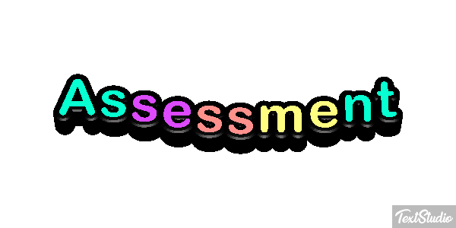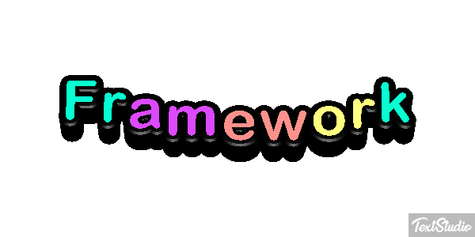

FOUNDATION PHASE: GRADES 1-3
HOME language


JOHANNESBURG NORTH - DISTRICT 10
FOUNDATION PHASE: GRADES 1-3
__________________________________________________________________________________________________________
ASSESSMENT FRAMEWORK HOME LANGUAGE GRADE 1 – TERM 3
Number | Component | What skills will be assessed | Weighting | Score
1. | Listening & Speaking:  Oral | - Talks about personal experiences, an event or theme topic.  - Sequences at least 5 pictures related to a familiar story or Theme topic by matching captions with pictures [integrated with Life Skills] | 25% | 6
 |  |  |  | 6
 |  |  |  | 12
1. | Listening & Speaking:  Oral | - Listens to instructions and announcements and responds appropriately [observed in all subjects]  - Participates in class discussions, asking and answering questions [integrated with Life Skills, Mathematics]  - Listen to stories and answer closed and open-ended questions  - Role plays characters in a story that is read or told by the teacher  - Understands and uses appropriate language for different purposes, e.g. get-well message, birthday greetings | 25%
2. | Phonics:  Oral | - Identifies letter-sound relationships of all single letters: Letter Sound Chart | 20% | 5
2. | Phonics:  Oral | - Recognises word families with short vowel sounds: -at, -ag, -am, -it, etc.  - Build 3 and 4-letter words by blending sounds [onset and rime eg p-ot]  - Uses initial consonant blends to build up and break down words such as bl-a-ck, bri-ng, sa-ng  - Recognises plurals with “s” and “es” | 20%
2. | Phonics:  Written | Spelling test:  - Word list of at least 10 words [2/3 letter words] | 20% | 5
 |  |  |  | 10
3. | Reading Comprehension:  Oral | Group Guided Reading Sessions  - Word Recognition: Assess each learner individually: on at least 40-50 sight words [Big Book, Theme, Reader] | 25% | 5
3. | Reading Comprehension:  Oral | - Asses each learner on oral reading [Graded Reader] which has at least 40-50 words  [Include the following on the Memo: Reader title, page number/s and possible questions and answers] |  | 5
3. | Reading Comprehension:  Oral | - Listening comprehension – learners respond to oral questions including higher order questions
 | Reading Comprehension:  Written | - Written Comprehension: Reading passage, reader, DBE workbook  [Include the following on the Memo: Questions and answers] |  | 3
 |  |  |  | 13
4. | Writing | - Writes the missing words in a writing frame to complete a text [at least 3 -5 sentences]. | 20% | 10
5. | Handwriting | - Forms 20 lower case letters correctly & copies and writes letters and words - Paying attention to correct letter formation, size and spacing | 10% | 5
TOTAL |  |  | 100% | 50

TASK SPECIFICATION: GRADE 1 – TERM 3
Component |  | What skills will be assessed | Possible questions | Forms of Assessment | Assessment Tool | Cognitive Level | Level of difficulty | Types of question | Score
1. | Listening & Speaking:  Oral | Talks about an event / story / personal experience | Respond to the activity by choosing one of the skills to talk about | Observation & Oral | Rubric | K/C/A | M | OEQ | 6
1. | Listening & Speaking:  Oral | Sequences pictures, matches caption with pictures | Sequencing pictures | Oral | Rubric | K | M | SA/OEQ | 6
2. | Phonics:  Oral | Identifies letter-sound relationships of most single letters | Identifies Single sounds taught | Oral | Rubric | K/C/A | M | SA | 5
2. | Phonics:  Written | Spelling test:  Word list of at least 10 words [2/3 letter words] | Spelling Test | Written | Memo | K/A | M | SA | 5
3. | Reading:  Oral | Group Guided Reading Sessions  Word Recognition: Assess each learner individually: on at least 40-50 sight words [Big Book, Theme, Reader] | Recognition of 40-50 sight words | Oral | Rubric | K/A | M | SA | 5
3. | Reading:  Oral | Oral Reading:  Asses each learner on oral reading text [Graded Reader] which has at least 40-50 words and ask questions about the text.  [Include the following on the Memo: Reader title, page number/s and possible questions and answers] | Reading for meaning – Text at least 40-50 words  Forms 20 lower case letters correctly & copies and writes letters and words - Paying attention to correct letter formation, size and spacing | Oral | Rubric/Memo | K/A | M | SA/OEQ | 5
3. | Reading:  Written | Written Comprehension:  Reading passage, reader, DBE workbook  [Include the following on the Memo: Questions and answers] | Written Comprehension | Written | Memo | K/C/A | M | SA/OEQ/  MCQ | 3
4. | Writing | Writes the missing words in a writing frame – an event, news or topic to complete a text [at least 3 -5 sentences]. | Sentence construction using a writing frame | Written | Rubric [Exercise book] | K/C/A | M | SA | 10
5. | Handwriting | Forms 20 lower case letters correctly & copies and writes letters and words - Paying attention to correct letter formation, size and spacing | Correct lower case letter formation. Writes 2 & 3 letter words with correct spacing | Written | Rubric [Exercise book] | K/C/A | M | SA | 5
TOTAL TASK MARK |  |  |  |  |  |  |  |  | 50

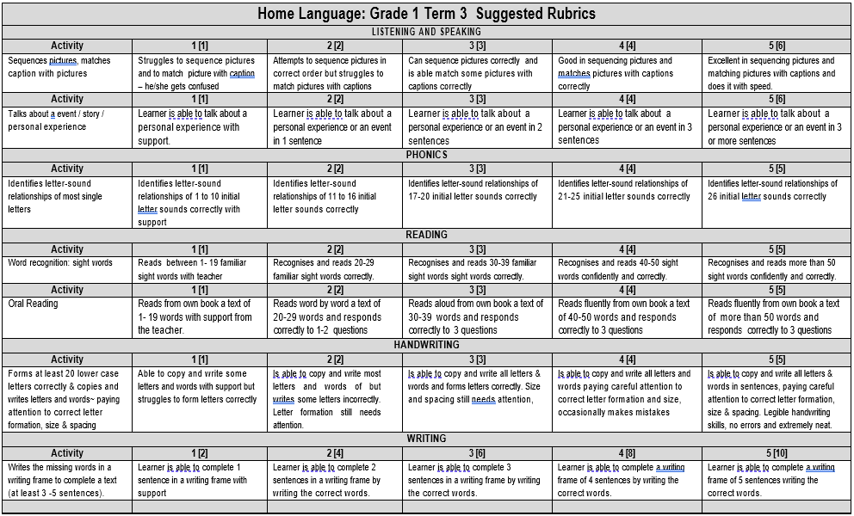
NB! Mark allocation in brackets e.g. 1. [1 mark] next to the criteria on the Rubrics

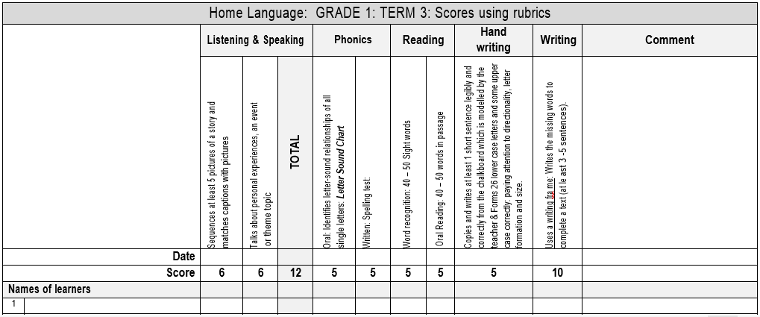
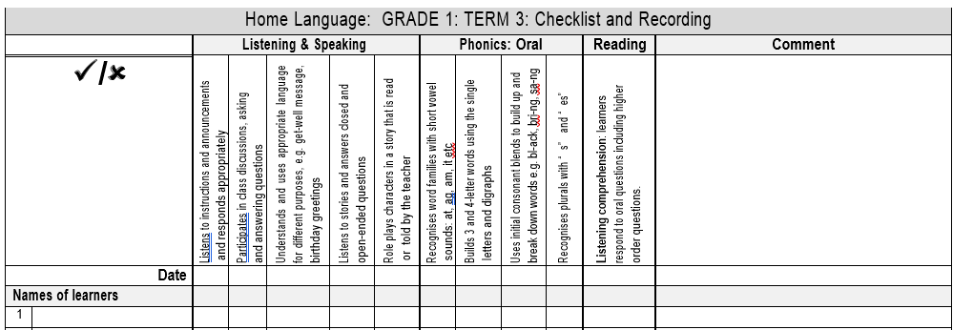

JOHANNESBURG NORTH - DISTRICT 10
FOUNDATION PHASE: GRADES 1-3
__________________________________________________________________________________________________________
ASSESSMENT FRAMEWORK HOME LANGUAGE GRADE 2 – TERM 3
Number | Component | What skills will be assessed | Weighting | Score
1. | Listening & Speaking:  Oral | - Role plays a familiar situation; performs a dialogue with a peer from a familiar story [integrated with Life Skills, Reading] | 20% | 12
2. | Phonics:  Oral | - Identifies letter-sound relationships of all single letters: Letter Sound Chart  - Revises plurals (‘s’ and ‘es’), ‘ing’ and ‘ed’ at the end of words  - Build words using the consonant and vowel digraphs, consonant blends and double consonants | 20%
2. | Phonics:  Written | Word Level and Sentence Level:  - Uses consonant blends to build up and break down words  - Revises common consonant digraphs e.g. sh, st, sw, wh, ch, th, ck at the end and beginning of words  - Recognises common double consonants such as ll, ss and zz at the end of words.  - Recognises the first sound [onset] and the last syllable [rime] in more complex patterns.  dr-eam, cr-eam, scr-eam, str-eam  - Recognises vowel digraphs and diphthongs e.g. ‘oy’, ‘oi’, ‘ay’, ‘ai’  - Write sentences using phonic words | 20% | 6
2. | Phonics:  Written | Spelling test:  - Word list of at least 10 words and 1 dictation sentence | 20% | 6
 |  |  |  | 12
3. | Reading Comprehension:  Oral | Group Guided Reading Sessions  - Word Recognition: Assess each learner individually: on at least 60-70 sight words [Flash cards, Word list] | 25% | 5
3. | Reading Comprehension:  Oral | - Asses each learner on oral reading [Graded Reader] which has at least 60-70 words and ask 3 questions related to the text [word recognition, fluency & comprehension]  [Include the following on the Memo: Reader title, page number/s and  Possible questions and answers] | 25% | 5
3. | Reading Comprehension:  Written | - Written Comprehension: Reading passage, reader, DBE workbook  [Include the following on the Memo: Questions and answers] | 25% | 5
 |  |  |  | 15
4. | Writing | - Writes 1-2 paragraphs [at least eight sentences] on personal experiences or events / own news or topic and uses correct punctuation [full stops, commas, apostrophe] | 25% | 15
4. | Writing | - Uses present, past and future tenses correctly | 25%
5. | Handwriting | - Writes at least 8-10 letters in the joined script that is aligned to the school’s writing policy | 10% | 3
5. | Handwriting | - Copies and writes short words and at least 3-4 lines in joined script or cursive writing: 2 and 3 letter words such as an; am; at; it; in; on; of; he; we; us; be; so; see; can; our | 10% | 3
 |  |  |  | 6
TOTAL |  |  | 100% | 60

TASK SPECIFICATION: GRADE 2 – TERM 3
Component |  | What skills will be assessed | Possible questions | Forms of Assessment | Assessment Tool | Cognitive Level | Level of difficulty | Types of question | Score
1. | Listening & Speaking:  Oral | Role play – Performs a dialogue | Role play - Dialogue | Observation & Oral | Rubric | K/C/A | M | SA | 12
2. | Phonics:  Written | Word Level and Sentence Level:  Uses consonant blends to build up and break down words  Revises common consonant digraphs e.g. sh, st, sw, wh, ch, th, ck at the end and beginning of words  Recognises common double consonants such as ll, ss and zz at the end of words.  Recognises the first sound [onset] and the last syllable [rime] in more complex patterns.  dr-eam, cr-eam, scr-eam, stream  Recognises vowel digraphs and diphthongs e.g. ‘oy’, ‘oi’, ‘ay’, ‘ai’  Write sentences using phonic words | Assess phonological and phonemic awareness  Write Sentences using phonic words  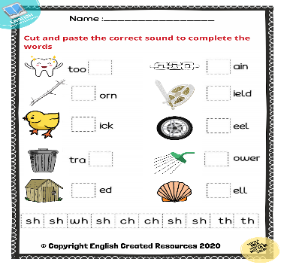  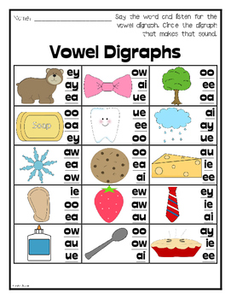 | Written | Memo  [Worksheet/Classwork book] | K/A | M | SA | 6
2. | Phonics:  Written | Spelling Test:  Word list of 10 words and 1 Dictation sentence | Word list and 1 Dictation Sentence | Written | Memo | K/A | M | SA | 6
3. | Reading:  Oral | Group Guided Reading Sessions  Word Recognition: Assess each learner individually: on at least 60-70 sight words [Big Book, Theme, Reader] | Assess Word Recognition of 60-70 sight words | Oral | Rubric | K/A | M | SA | 5
3. | Reading:  Oral | Oral Reading: Asses each learner on oral reading text [Graded Reader] which has at least 60-70 words and ask questions about the text.  [Include the following on the Memo: Reader title, page number/s and possible questions and answers] | Assess Reading for meaning – Text at least 60-70 words | Oral | Rubric/Memo | K/A | M | SA/OEQ | 5
3. | Reading Comprehension:  Written | Written Comprehension: Reading passage, reader, DBE workbook  [Include the following on the Memo: Questions and answers] | Blooms Taxonomy question approach | Written | Memo | K/A | M | SA/OEQ/  MCQ | 5
4. | Writing | Writes at least 1-2 sentences of own news or on a topic [Theme/Story etc.] using capital letters and full stops. | Sentence construction using punctuation | Written | Rubric [Exercise book] | K/C/A | M | SA | 15
5. | Handwriting | Forms at least 20 lower case letters correctly according to size and position  Writes two and three letter words with correct spacing | Correct lower case letter formation. Writes 2 & 3 letter words with correct spacing | Written | Rubric | K/C/A | M | SA | 6
TOTAL TASK MARK |  |  |  |  |  |  |  |  | 60

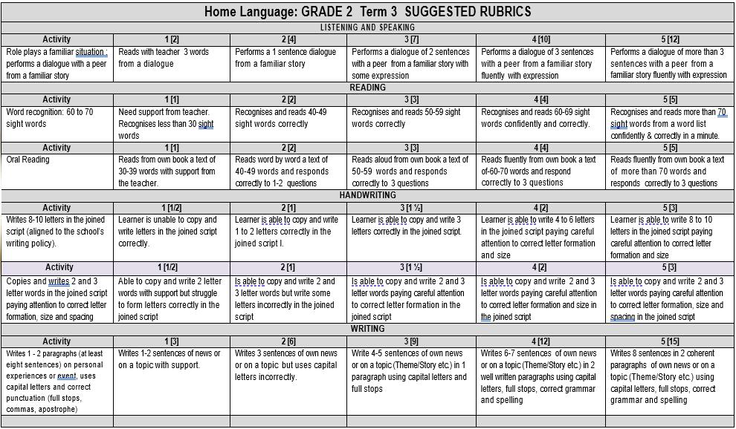
NB! Mark allocation in brackets e.g. 1. [2 marks] next to the criteria on the Rubrics
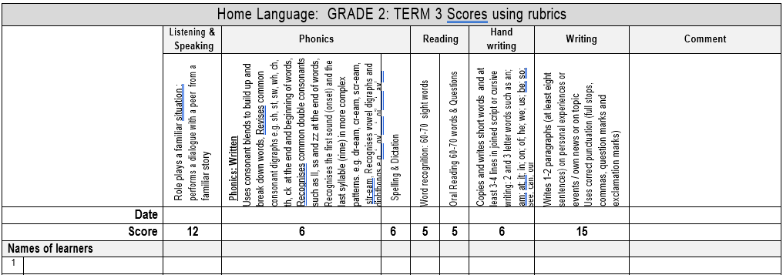

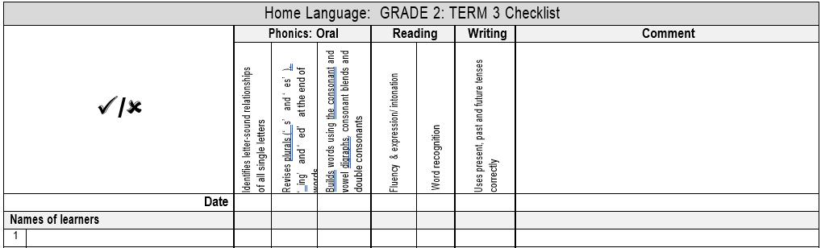

JOHANNESBURG NORTH - DISTRICT 10
FOUNDATION PHASE: GRADES 1-3
__________________________________________________________________________________________________________
ASSESSMENT FRAMEWORK HOME LANGUAGE GRADE 3 – TERM 3
Number | Component | What skills will be assessed | Weighting | Score
1. | Listening & Speaking:  Oral | - Tells a story with a simple plot with a beginning, middle and end and different characters [using props such as masks, puppets etc. integrate with Reading, Life Skills] | 15% | 10
1. | Phonics:  Written | Word level and Sentence level  - Recognises all vowel and consonant blends learnt so far  - Recognises silent letters in words, that is, ‘k’ as in know, ‘l’ as in half, ‘b’ as in comb, ‘w’ as in write, ‘h’ as in hour  - Homonyms: Uses words that are pronounced and spelt the same but have different meanings such as fly : to fly in an aeroplane or a fly that is an insect  - Homophones: Uses words that sound the same but are spelt differently such as ‘pair’ and ‘pear’, ‘hair’ and ‘hare’ | 20% | 4
1. | Phonics:  Written | Spelling & Dictation:  - Word list of at least 15 words from phonic lessons and 2 sentences of dictation | 20% | 10
 |  |  |  | 14
3. | Reading Comprehension:  Oral | Group Guided Reading Sessions  - Word Recognition: Assess each learner individually: on at least 100 sight words | 25% | 8
3. | Reading:  Written | Written Comprehension:  - Choose 2 graphical texts [bar graph, pictorial map, advertisement, weekly class roster etc] | 25% | 10
 |  |  |  | 18
4. | Writing | - Writes and illustrates a familiar story with a title [beginning, middle and end] in at least 10 sentences and uses punctuation correctly: capital letters, full stops, commas, question marks, exclamation marks and inverted commas  - Writes a personal text [40-50 words] e.g. a birthday invitation or a letter to a friend | 30% | 11
 |  |  |  | 10
 |  |  |  | 21
4. | Writing | - Use different sentence types when writing such as statements, questions, commands, etc.  - Identifies and uses nouns, pronouns, adjectives, verbs, adverbs and prepositions correctly  - Joins sentences using conjunctions such as ‘and’, ‘but’ | 30%
5. | Handwriting | - Copies and write short words and short sentences in the joined script with correct letter formation and spacing [integrate with Reading, Life Skills] | 10% | 7
5. | Handwriting | - Writes with increasing speed | 10%
TOTAL |  |  | 100% | 70

TASK SPECIFICATION: GRADE 3 – TERM 3
Component |  | What skills will be assessed | Possible questions | Forms of Assessment | Assessment Tool | Cognitive Level | Level of difficulty | Types of question | Score
1. | Listening & Speaking:  Oral | Story telling – Beginning, Middle, End | Listens to the instruction and respond orally | Observation & Oral | Rubric | K/C/A | M | OEQ | 10
2. | Phonics:  Written | Word Level and Sentence Level:  Recognises all vowel and consonant blends learnt so far  Recognises silent letters in words, that is, ‘k’ as in know, ‘l’ as in half, ‘b’ as in comb, ‘w’ as in write, ‘h’ as in hour  Homonyms: Uses words that are pronounced and spelt the same but have different meanings such as fly : to fly in an aeroplane or a fly that is an insect  Homophones: Uses words that sound the same but are spelt differently such as ‘pair’ and ‘pear’, ‘hair’ and ‘hare’  Write Sentences using phonic words | Recognises:  Vowel and consonant blends  Silent Letters  Uses Homonyms &  Homophones  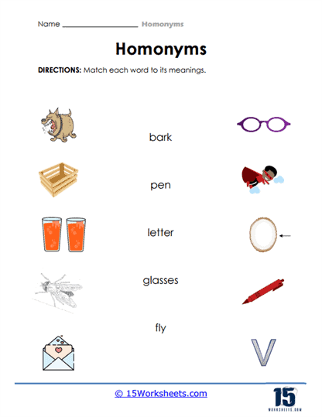  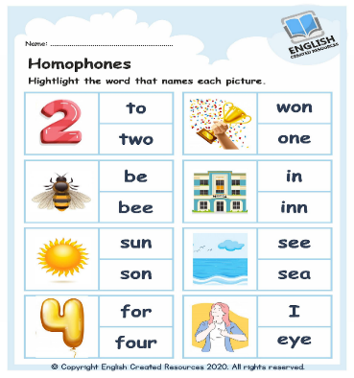 | Written | Memo  [Worksheet/Classwork book] | K/C/A | M | SA | 4
2. | Phonics:  Written | Spelling & Dictation:  Word list of at least 15 words from phonic lessons and 2 sentences of dictation | Assess Spelling & Dictation Skills | Written | Memo | K/A | M | SA | 10
3. | Reading:  Oral | Group Guided Reading Sessions  Word Recognition: Assess each learner individually: on at least 100 sight words | Recognition of 100 sight words | Oral | Rubric | K/A | M | SA | 8
3. | Reading Comprehension:  Written | Written Comprehension:  Choose 2 graphical texts [bar graph, pictorial map, advertisement, weekly class roster etc] | Read for meaning to be able to answer the questions | Written | Rubric/Memo | K/A | M | SA/OEQ | 10
4. | Writing | Writes and illustrates a familiar story with a title [beginning, middle and end] in at least 10 sentences and uses punctuation correctly: capital letters, full stops, commas, question marks, exclamation marks and inverted commas | Writes and illustrate a familiar story | Written | Rubric [Exercise book] | K/C/A | M | SA | 11
4. | Writing | Writes a personal text [40-50 words] e.g. a birthday invitation or a letter to a friend | Creative writing: Writes a personal text | Written | Rubric | K/C/A | M | SA | 10
5. | Handwriting | Copies and write short words and short sentences in the joined script with correct letter formation and spacing [integrate with Reading, Life Skills] | Letter formation in the joined script | Written | Rubric | K/C/A | M | SA | 7
TOTAL TASK MARK |  |  |  |  |  |  |  |  | 70

Cognitive Levels: | Types of question | Level of Difficulty:
K – Knowledge and facts  C – Conceptual knowledge  A – Application | MCQ – Multiple Choice Question OEQ - Open ended question SA – Short answer | E – Easy  M – Moderate  D - Difficult

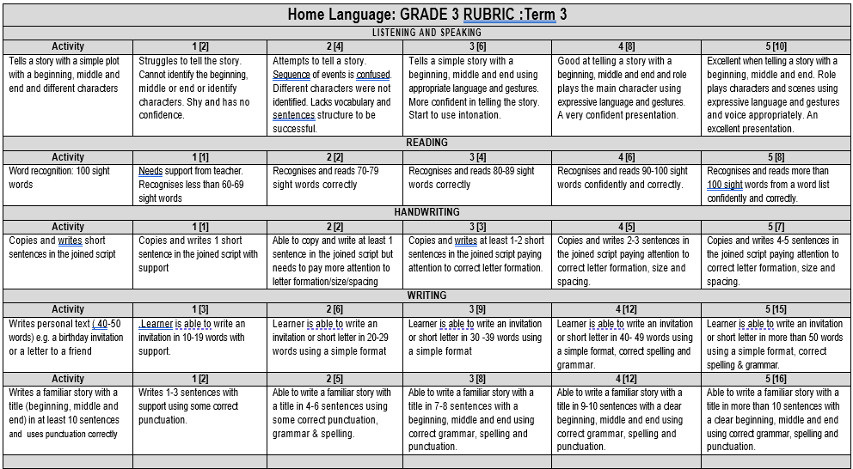
NB! Mark allocation in brackets e.g. 1. [2 mark] next to the criteria on the Rubrics



