AMANANI, IIOPARESHINI NOLWALAMANO
Igama:__________________________________Umhla:________________
Ibanga: 2 A,B,C
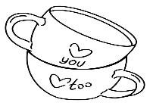
  - Zingaphi iikomityi?

Iikomityi zi______________ [1]

  - Bhala igama lenani; ______________________________ [1]
ngaphambi | inani | emva
 | 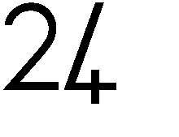
[1]
  - Biyela unobumba onempendulo echanekileyo ukuqala kumbuzo 1.3
Ukuya 1.7
Leliphi igama lenani u 25?
- Amashumi amabini anesihlanu
- Amashumi amathandathu anesibini
- Amashumi amathandathu anesibhozo
- Amashumi amabi nesithandathu. [1]
1.

  - Mangaphi amashumi kwishumi elinesixhenxe-17
- 10
- 17
- 07
- 01 [1]
  - Biyela unobumba onegama lenali amashumi amabini anesithathu.
- 25
- 15
- 23
- 17 [1]
  - Mangaphi amashumi kuma-71
- 10
- 17
- 07
- 01 [1]
  - Lithini ixabiso lenani elirhwelelwe umgca ngaphantsi? 23
- 30
- 3
- 13
- 20 [1]
  - Leliphi inani elingaphezulu nge-2 kuma 21? ______ [1]
  - Leliphi inani elincinane ngesi-3 kuma-19? ______ [1]

2.

  - Hlela la manani ukusuka kwelona lincinane ukuya kwelona likhulu.
9 25 7 6 13

[1]

  - Hlela la manani ukusuka kwelona likhulu ukuya kwelona lincinane.
11 15 10 23 18

[1]

  - Bala ngokucazulula amanani omabini
16+13 =____ [3] | 19 - 11 = ____ [3]

3.
1.13 Sombulula ingxaki
- Kukho abantwana abali-11. Abantwana aba-4 banga mantombazana ,mangaphi amakhwenkwe?
Bonisa ngemizobo apha: [1]

Bhala isivakalisi manani__________________ [1]

- UMbali uneelekese. Utata wakhe wampha iilekese ezili-9 ngaphezulu.
Ngoku uneelekese ezili-14.Zingaphi iilekese ebenazo ekuqaleni uMbali?
Balela kule bhokisi:

[1]

Bhala isivakalisi manani__________________ [1]

4.
1.14 Imali
Jonga imali engezantsi, wandule ufake umbala kwimali ehamelana nomzobo.




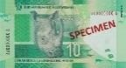
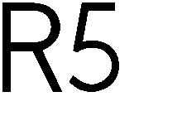
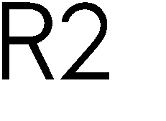


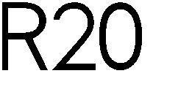
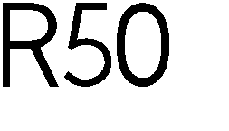

=

=

[1]

[1]
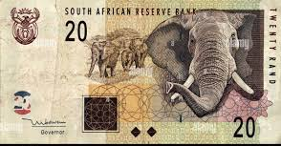
= R5 R10 R20 [1]
1,15 Umgca manani





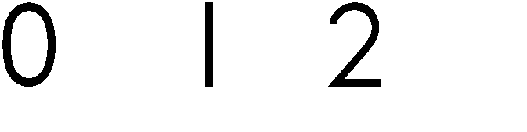
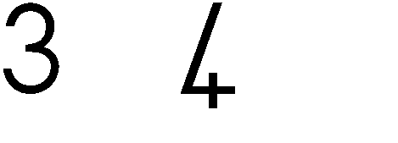
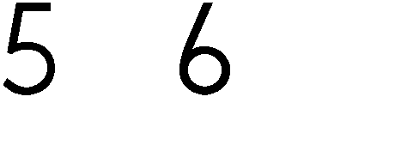
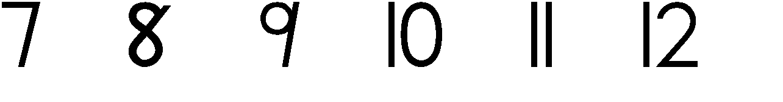

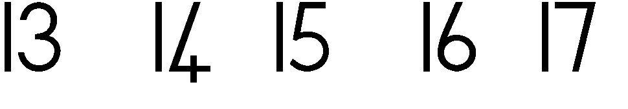
Bhala isivakalisi manani kunye nempendulo [1]


1.16Fakela umbala ubonise isiqingatha salemilo [1]

1.17Bala kumgca manani [1]
- 10 – 5

b. 8+12 [1]

555
Amanqaku =30

IPHATHENI, IFRANKSHINI NEALJIBRA: [ 5 ]
2.1 Iphatheni yejiyometri
Ngeyiphi iphatheni elandelayo?





[1]

[1]

2.2. Iphatheni yamanani
Gqibezela iphatheni
- 4;8;12; ____; ____; ____. [1]
- 24;22;20; _____; ____; _____. [1]
- 15;18; 21; ____; _____; _____. [1]

Amanqaku ewonke= 5

7,
3.ISITHUBA NEEMILO [7]
3.1 Jonga , uchaze igama lemilo uphinde ubale amacala
Imilo | Igama lemilo | Aamacala

[1]
[1]
[1]

3.2 Rhangqela impendulo echanekileyo
a. Ibhola -iyatyibilika /iyaqengqeleka [1[
b. Ibhokisi -iyatyibilika/iyaqengeleka. [1]
3.2. Rhangqela izinto zibe mbini eziqengqelekayo kwezi milo ze 3D
zingezantsi. [2]

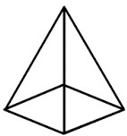
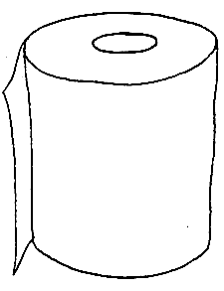
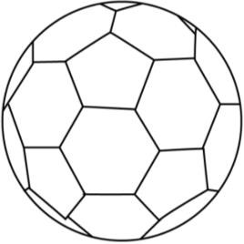
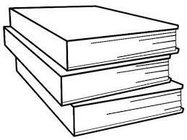
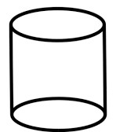

Amannqaku ewonke= 7

8.
4.UMLINGANISELO [6]
4.1. Bala ibhloko uxele ubude bepensile nganye kwibhokisi oyinikiweyo. [2]


4.3 I wotshi ibonisa eliphi ixesha. Faka uphawu( ) kwixesha elichanekileyo.[4]
a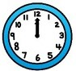 |  |  | b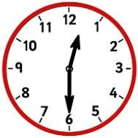
Intsimbi yokuqala  Nkqo entloko | intsimbi yeshumi elinesibini kqo entloko |  | Licala emva  kwentsimbi yokuqala |  | Icala emva  kwentsimbi yeshumi elinesibini
c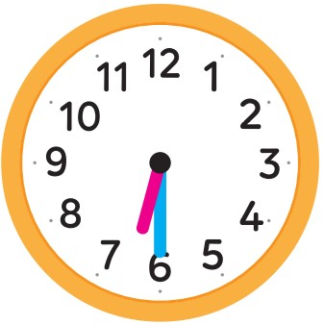 |  |  | d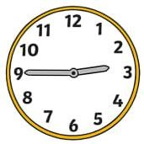
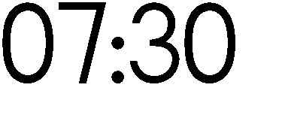 |  | 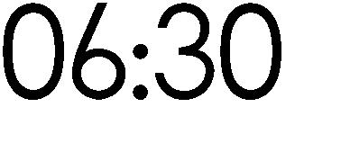 | 3:00 | Imizuzu elishumi eli-15 phambi kwentsimbi yesithathu 2:45

Amanqaku ewonke= 6

9.

5.UKUQOKELELA ULWAZI
5.1 Jonga iimilo ezisebhokisini engezantsi uphendule imibuzo elandelayo.

Phendula imibuzo elandelayo
- Ngeyiphi imilo enenani elinzi? ________________________ [1]

- Ngeyiphi imilo embalwa? _____________________________ [1]

Amanqaku ewonke= 2

10.

