Home Language Weekly Plan
Term: _______ Week: _______ Theme: __________ Grade: _________

Concept |  | Monday | Tuesday |  | Wednesday |  | Thursday | Friday |  | Resources |  |  | Informal Assessment
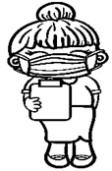 | Listening and Speaking (including Read Aloud)  15 min X 4 days | School and classroom rules: Teacher recaps/reinforce school and classroom rules.  Oral news: talk about personal experiences, e.g., weekend news or holiday news expressing feelings and opinions.  Instructions: Listens to a sequence of instructions and responds appropriately.  Weather chart: Discuss the weather chart, calendar chart, months of the year, birthdays of the week etc. (today, tomorrow, yesterday).  Read Aloud: Teacher chooses story book for the day (3 times per week)
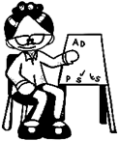 | Phonics- ‘Warm up’  Phonemic Awareness (PHAST)  X 5 days (3 min) |  |  |  |  |  |  |  |  | - PHAST  - Scope and Sequence  - Flashcards- Teacher and learner set  - Big Book  - White Boards  - Koki  - Blank books  - Pencil
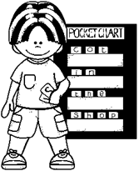 | Jolly Phonics  Grade 1  - Story  - Action  - Flashcard  - Letter Formation  - Blending  - Sounding/ Segmenting  8. Dictation  (20 min x 5 days) | New Sound | Revision |  | New Sound |  | Revision | Revision and Informal Assessment
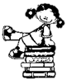 | Group Guided Reading:  Skills | Teaching Point: Choose one  Word – Attacking Strategies: stretch it out, sound out new words, blend as you read, look for parts you know, break into syllables  Comprehension: literal, inferential, evaluative or appreciative questions  Fluency: intonation, speed, accuracy
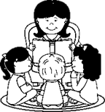 | Group Guided Reading  X 3 groups per day (Mon-Thurs)  60 min per day  Friday (30 min)  X 2 groups  Keys  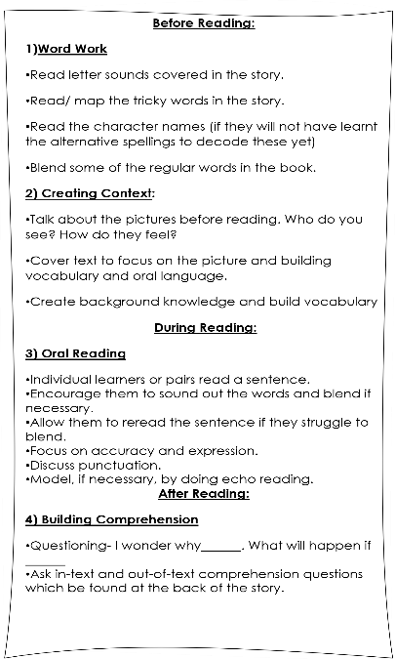 | Group 1 |  | Group 1 |  | Group 1 |  |  | Group 1 |  |  | Group 1
 |  | Word work |  | Word work |  | Word work |  |  | Word work |  |  | Word work
 |  | Context |  | Context |  | Context |  |  | Context |  |  | Context
 |  | Oral Reading |  | Oral Reading |  | Oral Reading |  |  | Oral Reading |  |  | Oral Reading
 |  | Comprehension |  | Comprehension |  | Comprehension |  |  | Comprehension |  |  | Comprehension
 |  | Group 2 |  | Group 2 |  | Group 2 |  |  | Group 2 |  |  | Group 2
 |  | Word work |  | Word work |  | Word work |  |  | Word work |  |  | Word work
 |  | Context |  | Context |  | Context |  |  | Context |  |  | Context
 |  | Oral Reading |  | Oral Reading |  | Oral Reading |  |  | Oral Reading |  |  | Oral Reading
 |  | Comprehension |  | Comprehension |  | Comprehension |  |  | Comprehension |  |  | Comprehension
 |  | Group 3 |  | Group 3 |  | Group 3 |  |  | Group 3 |  |  | Group 3
 |  | Word work |  | Word work |  | Word work |  |  | Word work |  |  | Word work
 |  | Context |  | Context |  | Context |  |  | Context |  |  | Context
 |  | Oral Reading |  | Oral Reading |  | Oral Reading |  |  | Oral Reading |  |  | Oral Reading
 |  | Comprehension |  | Comprehension |  | Comprehension |  |  | Comprehension |  |  | Comprehension
 | 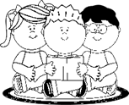  Shared Reading/ Shared writing  (15min X 5 days)  First Read:  Prediction skills  Discuss features of text  Introduce new vocabulary  Comprehension questions  Model fluency  Second Read:  Re-read text, learners join  Model fluency  Revise vocabulary  Model target strategy  Third Read:  Re-read text with learners  Model fluency  Revise vocabulary  Language focus  Model target strategy | Shared Reading  Title:  Picture Walk  Predict, make connections  Introduce new vocabulary before you read the story  Flashcards of vocabulary words  Teacher reads story with expression and intonation. |  | Shared Reading  Read Text:  Discuss  Main characters,  setting,  problem and solution  Ask questions: who, where, what happened, how did they feel and why?  Discuss  vocabulary |  | Shared Reading  Read Text:  Sequence of story  What happened first, next, then and the end of story |  |  | Shared writing Comprehension questions  What is your favourite part of the story?  What did you like or dislike?  Summarize the story.  Give your opinion |  | Shared writing  Draw the sequence of the story  Writing frames  What happened first…next…  then….and at the end…….
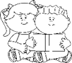 | Paired/ Independent Reading
 | Post Reading Activities
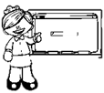 | List of new Vocabulary words on flashcards | Introduce new  Vocabulary words |  | Meaning of vocab words |  | Revise meaning of words |  |  | Revise meaning of words- games |  | Informal Assessment
 | Language structure | Revise  Punctuation |  | Revise  Parts of Speech |  | Revise  Antonyms and synonyms
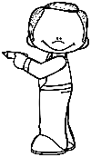 | Creative Writing  Refer to CAPS docs/ATPS for English HL  (20 min x3 )
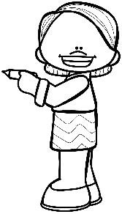 | Handwriting  X4 days  Rhyme” Twinkle, twinkle”  Finger exercises/ songs  Correct pencil grip, posture, spacing  Correct letter formation  Neatness | Pattern:  New:  Sound:  Words:  Sentence/phrase  Number symbol:  Pattern: |  | Pattern:  New:  Sound:  Words  Sentence/phrase  Number symbol  Pattern: |  | Pattern:  New:  Sound:  Words  Sentence/phrase  Number symbol:  Pattern: |  |  | Pattern:  New:  Sound:  Words  Sentence/phrase  Number symbol:  Pattern:
Intervention:

Reflection:

