GRADE 10

TOURISM

NOVEMBER 2022

MARKS: 100
TIME: 1 Hour 30 minutes

This question paper consists of 13 pages

INSTRUCTIONS AND INFORMATION

Read the instructions carefully before answering the questions.

1. | This question paper consists of FIVE sections.
2. | Answer ALL questions.
3. | Start EACH question on a NEW page.
4. | You may use a non-programmable calculator.
5. | Use the mark allocation of each question as a guide to the length of your answer.
6. | Write neatly and legibly.
7. | The table below is a guide to help you to allocate your time according to each section
SECTION |  | TOPIC | MARKS | TIME (minutes)
A |  | Short Questions | 25 | 15
B |  | Map work and Tour Planning; Foreign Exchange | 15 | 15
C |  | Tourism Attractions; Culture and Heritage Tourism; Marketing | 15 | 15
D |  | Tourism Sectors; Suistainable and Responsible Tourism | 20 | 20
E |  | Domestic, Regional and International Tourism; Communication and Customer Care | 25 | 25
 |  | TOTAL | 100 | 90

SECTION A: SHORT QUESTIONS

QUESTION 1

1.1 | Four options are provided as possible answers to the following questions. Choose the correct answer and write only the letter (A-D) next to the question number (1.1.1.-1.1.20)
 | 1.1.1 |  | Something that reminds you about a place you visited:
 |  |  | A | Gift
 |  |  | B | Tour guide
 |  |  | C | Reminder
 |  |  | D | Souvenir
 | 1.1.2 |  | The number of time zones in the world is:
 |  |  | A | 24
 |  |  | B | 18
 |  |  | C | 12
 |  |  | D | 06
 | 1.1.3 |  | Identify the country that is surrounded by South Africa.
 |  |  | A | Zambia
 |  |  | B | Lesotho
 |  |  | C | Zimbabwe
 |  |  | D | Malawi
 | 1.1.4 |  | An example of a natural attraction is:
 |  |  | A | Orlando towers in Soweto
 |  |  | B | Pretoria zoo
 |  |  | C | Blyde river canyon
 |  |  | D | Kango caves at Oudshoorn
 | 1.1.5 |  | This organization is responsible for the grading of accommodation establishments in South Africa.
 |  |  | A | TGCSA
 |  |  | B | TBCSA
 |  |  | C | FTT
 |  |  | D | SATSA
 | 1.1.6 |  | The National road linking Pretoria and Mbombela is …
 |  |  | A | N3
 |  |  | B | N2
 |  |  | C | N1
 |  |  | D | N4
 | 1.1.7 |  | This campaign is used to promote domestic tourism in South Africa.  A  B          C  D
 |  |  | A | regional
 |  |  | B | niche
 |  |  | C | domestic
 |  |  | D | cultural
 | 1.1.8 |  | Time of the year when many tourists travel:
 |  |  | A | Tourism season
 |  |  | B | Peak season
 |  |  | C | Christmas season
 |  |  | D | Travel season
 | 1.1.9 |  | This type of map indicates the location and borders of the different provinces and countries, …
 |  |  | A | road map.
 |  |  | B | political map.
 |  |  | C | general map.
 |  |  | D | specialized map.
 | 1.1.10 |  | Kruger National Park falls under the following attraction subsector:
 |  |  | A | Events and conferences
 |  |  | B | Gambling and lotteries
 |  |  | C | Conservation
 |  |  | D | Sport and recreation
 |  |  |  | (10x1) | (10)
1.2 | Choose a term/s from the list below that best describe the statement provided. Write only the term/s next to the question number (1.2.1 – 1.2.5) in the ANSWER BOOK.
 | Carbon footprint, Global warming, Responsible tourism, Conservation, Sustainability, Environment,
 |  | 1.2.1 | The process of keeping and protecting.
 |  | 1.2.2 | Diverse activities and cultures of country’s inhabitants
 |  | 1.2.3 | Looking after the environment and local community.
 |  | 1.2.4 | The amount of dangerous gases emitted by a person or organization
 |  | 1.2.5 | The process of keeping something the same or in a better position. (5x1) |  | (5)
1.3 |  | Choose the correct word(s) from those given in brackets. Write only the word(s) next to the question number (1.3.1 – 1.3.5) in your ANSWER BOOK.
 |  | 1.3.1 | The Panorama route includes places such as (Gods window/The Kimberly Bighole).
 |  | 1.3.2 | Pilgrim’s Rest is located in (Mpumalanga/Limpopo).
 |  | 1.3.3 | (Extinct/Culling) is when an animal or plant species dies out does not exist anymore.
 |  | 1.3.4 | Face-to-face telephone conversation is called (Verbal/Non-Verbal) communications.
 |  | 1.3.5 | (Reduce/Re-use) is to use grey water to wash a car, water the garden and flash a toilet. (5x1) |  | (5)
1.4 |  | Choose the term that matches with the pictures of tourist information below, write only the term next to the question number. For an example 1.6.1. Attraction.  Hotel, Information, National Park, National monument, Police, Bed and Breakfast, Restaurant, Campsite,





1.4.1

1.4.3

1.4.2

1.4.4 1.4.5
 |  |  | (5x1) |  | (5)
 |  | TOTAL SECTION A: |  |  | 25

SECTION B: MAP WORK AND TOUR PLANNING

QUESTION 2

2.1 | Study the map below and answer the questions that follow.
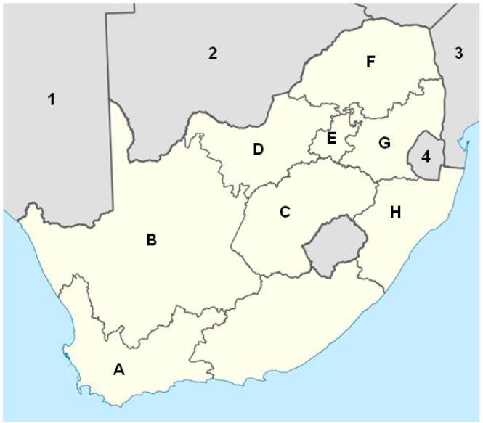
 | 2.1.1 | In each of the following statements below a province of South Africa is described. Give the name of the province that fits with each description.
 |  | (a) | The largest province in the South Africa. | (1)
 |  | (b) | The capital of this province is Mbombela. | (1)
 |  | (c) | Name the International Airport which is named after a political activist in province at E | (1)
 |  | (d) | The province where the legislative capital of the country is housed. | (1)
 |  | (e) | Name the province B and C. | (2)
 | 2.1.2 | Give ONE example of an electronic map that a touist can use. |  | (1)
 | 2.1.3 | Explain to a tourist the use of maps with tourist information on it. |  | (1)
2.2 | Study the world map below and answer the questions that follow.
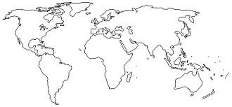
D
G
H
F
E
C
B
I
A
 | 2.2.1 | Identify the continents numberd A to D. Write only the answer next  to the numbers. |  | (4)
2.3 | Use the distanc table below and answer the questions that follow.
 | 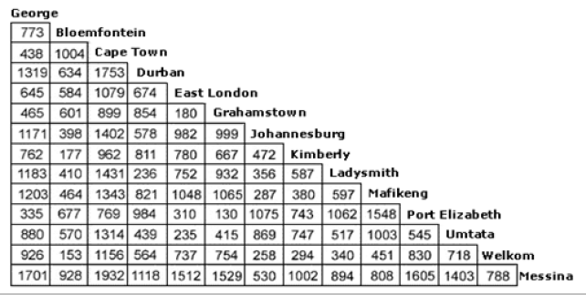
 | 2.3.1 | Tourists travels from Johannesburg to ushaka Marine World in  Durban. The average speed that they travel is 100km/h.  Calculate the travel time. Show all calculations. |  | (3)
 |  |  |  | [15]
 |  | TOTAL SECTION B: |  | 15

SECTION C: TOURISM ATTRACTIONS; CULTUE AND HERITAGE; MARKETING

QUESTION 3

3.1 | Study the pictures below and answer questions that follow:
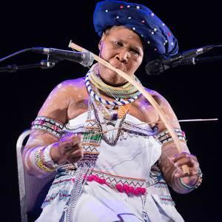
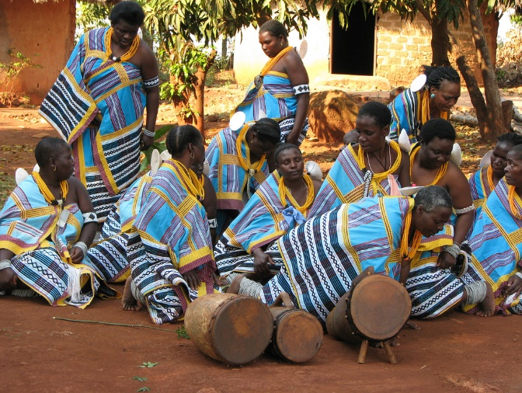
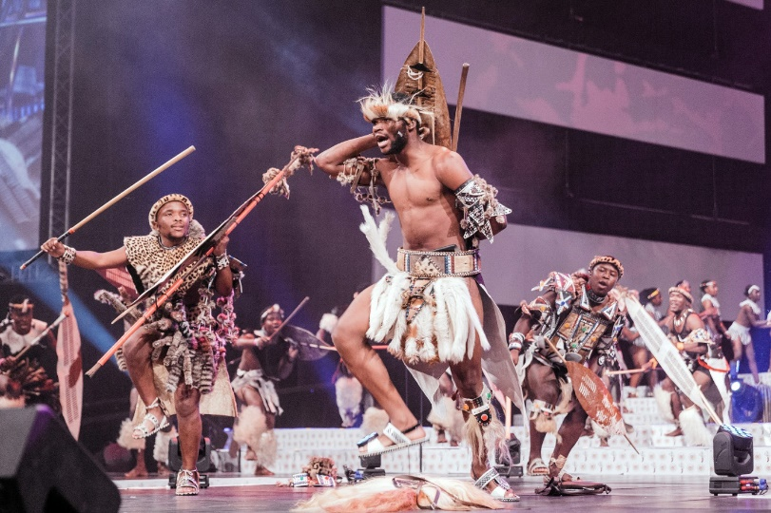
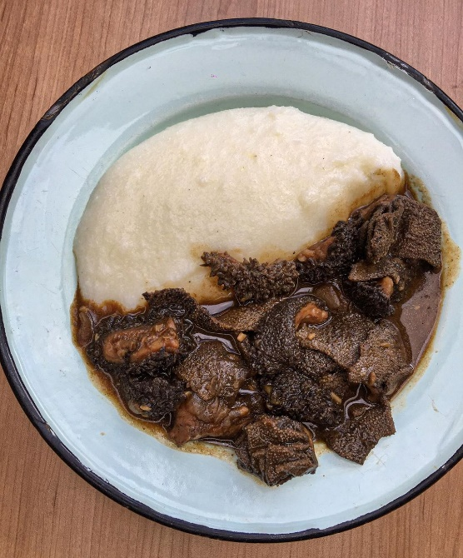
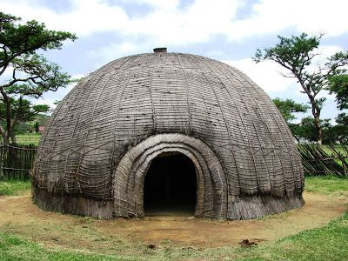
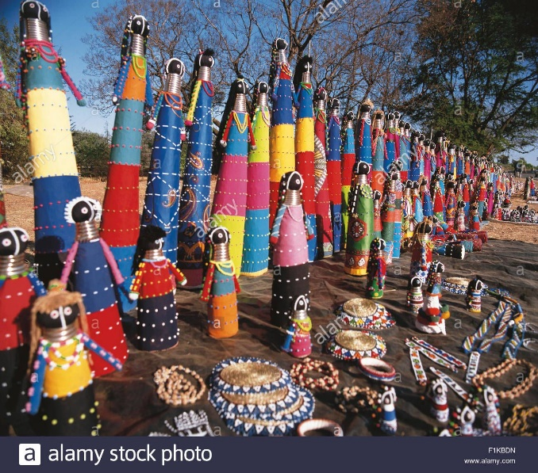
F
E
D
C
B
A
 | 3.1.1 | Differentiate between culture and heritage. | (4)
 | 3.1.2 | Identify FIVE elements of culture from the picture above. | (5)
 | 3.1.3 | Identify cultural group that favours the dish in picture A | (1)
3.2 |  | Study the heritage sites below and answer the questions that follow.
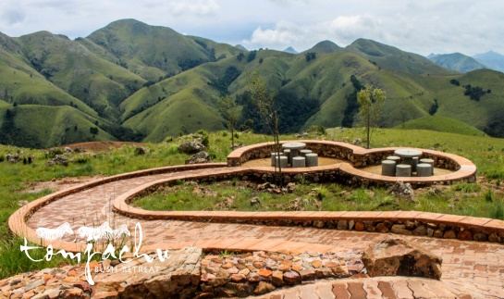
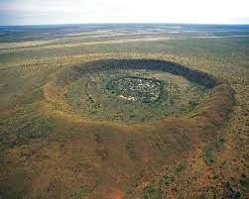
A
B

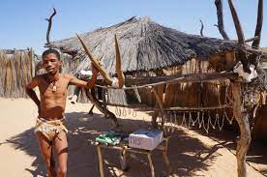
C

 | 3.2.1 | Identify the World Heritage Sites labelled, A,B and C. | (3)
 | 3.2.2 | Name the Organisation that is responsible for protecting the heritage sites above, Write the name in full. | (2)
 |  |  | [15]
 |  | TOTAL SECTION C: | 15

SECTION D: TOURISM SECTORS; SUSTAINABLE AND RESPONSIBLE TOURISM.
QUESTION 4:
4.1 | Study the picture below and answer the questions that follow.
 | 
 | 4.1.1 | Explain what you understand by the “Triple Bottom Line” approach in sustainable tourism. | (2)
 | 4.1.2 | List THREE pillars of sustainable and responsible tourism. | (3)
 | 4.1.3 | Name THREE rules for tourist behaviour around the natural environment. | (3)
4.2 | Look at the pictures below and answer the questions that follows
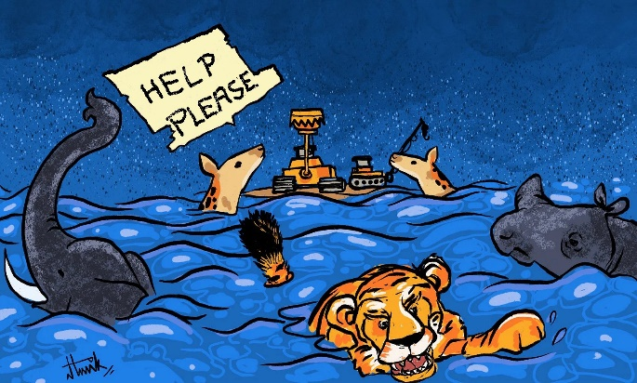
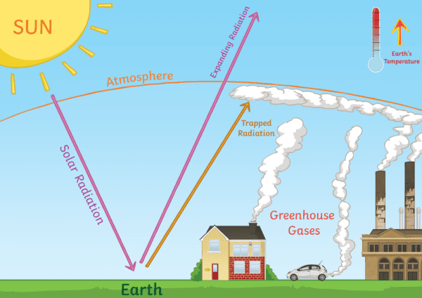
 | 4.2.1 | Distinguish between Global warming and Climate change. (2x2) | (4)
 | 4.2.2 | List THREE causes of Global warming. (1x3) | (3)
 | 4.2.3 | Identify the natural disaster in picture A and explain TWO reasons how it can negatively affect the tourism industry. | (5)
 |  |  | [20]
 |  | TOTAL SECTION D: | 20

SECTION E: DOMESTIC, REGIONAL AND INTERNATIONAL TOURISM;
COMMUNICATION AND CUSTOMER CARE

5.2 | Study the statistics below and answer the questions that follow.
 | 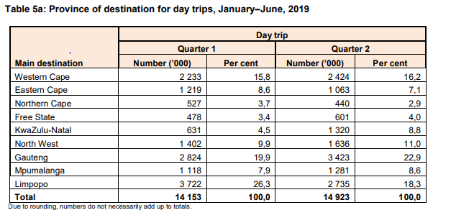
 | 5.1.1 | Determine the most visited province in Quarter 2 |  | (2)
 | 5.1.2 | Rearrange the 6 provinces with the highest trips in quarter 2 from the higher to the lowest. |  | (6)
 | 5.1.3 | Identify the least visited province in quarter 1 |  | (2)
 |  |  |  | [10]

QUESTION 6:

6.1 | The pictures below demonstrate customer service in tourism business.


B
A

 | 6.1.1 | Identify the type of service shown in picture B | (1)
 | 6.1.2 | Explain five ways in which the service in picture A will negatively affect the business. (1x5) | (5)
 | 6.1.3 | Recommend TWO reasons why the management and staff at the restaurant should pay attention to their guests’ complaints. (2x2) | (4)
6.2 | Write the names of the following equipment and technology used to communicate in the tourism industry. A-C |  | (3)
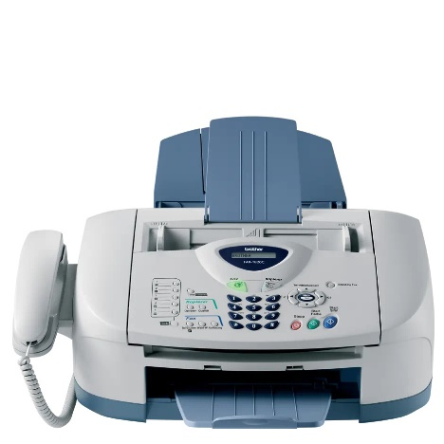

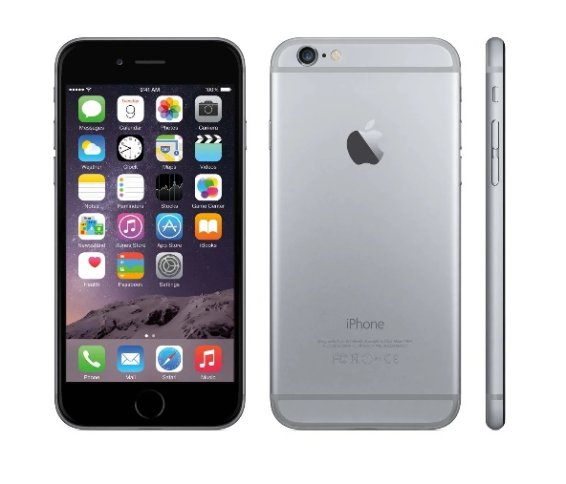
A

C
B
6.3 |  | Name one advantage and disadvantage of technology in picture A. | (2)
 |  |  | [15]
 |  | TOTAL SECTION E: | 25
 |  | GRAND TOTAL: | 100

