- A. AMANANI ,IIOPARESHINI NOLWALAMANO
Igama:_____________________________________________
Umhla:________________ Ibanga 3 A, B, C Iphepha: 1
- Khetha unobumba onamanani ukuqala kwelikhulu ukuya kwelincinci
Khetha unobumba
- 99; 73; 37; 65
- 65; 37; 99; 73
- 99;73;65;37
- 99 ; 73 ; 37 ; 65 [1]
- Leliphi inani elikhulu kulamanani?
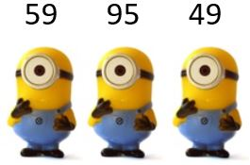
______ [1]

- Leilphi inani elincinci kula manani?

___________ [1]
1

- Khetha unobumba ochanekileyo wegama lenani ama-53
- Amashumi amathathu
- Amashumi amahlanu anesithathu
- Amakhulu amahlanu anesithathu
- Amakhulu amathathu anesihlanu [1]
- Khetha unobumba ochanekileyo wegama lenani ama-200
- Amakhulu amabini
- Mbini
- Isibini nesihlanu
- Amashumi amabini [1]
- Khetha unobumba ochanekileyo ochaza impendulo yenani- amashumi amabini anesihlanu
- 25
- 20
- 205
- 52 [1]

2
- Bala
Zingaphi iibhloko?
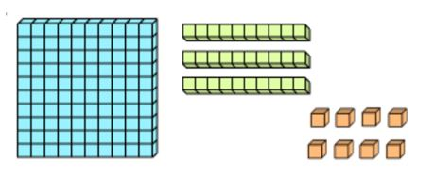
Bhala inani leebhloko zizonke_________ [1]
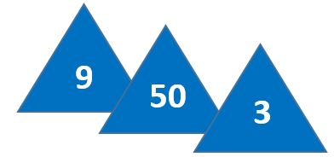
- Gqibezela ngokufaka isivakalisi manani senani elishiyiweyo.

- + impendulo______________+ 3 = 62 [1]
- uJimi uneelekese ezingama-24. UPele uneelekese ezi-5 ngaphezu kwezikaJimi. Zingaphi iilekese uPele anazo?___ [1]

Bala apha: [1]

3
10. UThulani unamapeka ali-10. NgoMvulo uthenga ali-10 ukongeza kulawo ebenawo,aphinde ngoLwesibini athenge ali-10.Mangaphi ngoku amapeka ka Thulani xa ewonke ?
Bhala isivakalisi manani [1]
______ + ______+ ________= _______
Okanye
______ x ________ = _______ [1]
11.Thabatha
- − 9 = ________ [1]

12. Dibanisa
3 + 3 + 3 + 3 + 3 =________ [1]
Amanaqaku ewonke=
Amanqaku ewonke | 14 | Amanqaku  omfundi

4

1B.AMANANI ,IIOPARESHINI NOLWALAMANO
Igama:_____________________________________________
Umhla:________________ Ibanga 3 A, B, C Iphepha: 2
- Bala

Mna nomhlobo singamanani.Igama lam ngu Lithoba igama lomhlobo wam ngumashumi amabini.Xa sidibene senza eliphi inani? [1]

Impendulo:______

- Cazulula ubale nangeyiphina indlela yocazululo
Dibanisa [2] | Thabatha [2]
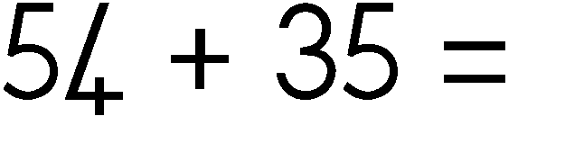 | 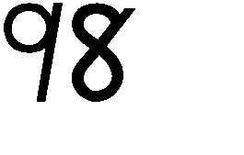    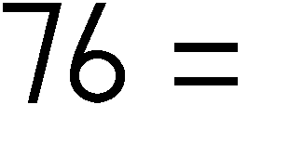

5
- Chaza ixabiso lenani elikrwelwe umgca ngaphantsi
- 86 = __________ [1]
- 155= ____________ [1]
- 137= ___________ [1]
Amaqhezu
- Chaza ukuba (yinyani/ayonyani)
Lemilo ingezantsi inamacala amabini alinganayo.
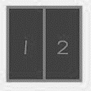

Khetha impendulo
- Yinyani
- Ayonyani [1]
- Le payi yahlulwe yangamacala amangaphi?
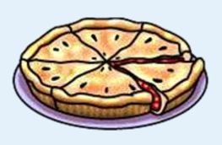

Bhala inani ____ [1]

6
Imali
- Dibanisa ezinkozo zemali ubhale impendulo ngokwe Randi: [1]
R
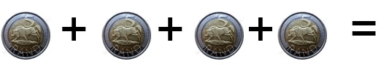
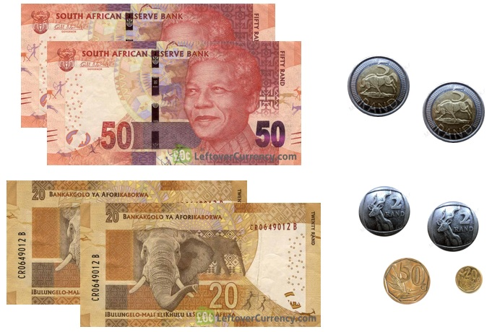
- Bala imali. Yimalini xa iyonke?
- Khetha unobumba wempendulo echanekileyo
- R 44,70
- R 154,70
- R 154,00
- R 110,00 [1]

7

- Khetha ufakele uphawu oluchanekileyo (<,=,>)

25 _____ 52 [1]
- ULona uneminyaka eli- 13. Umdala ngeminyaka emi-5 kuneka dade wabo Mingaphi iminyaka kadade wabo omncinci?
Bala apha: [1]
Bhala isivakalisi manani
-------- ------- = ------- [1]
Amanqaku ewonke=
Amanqaku  ewonke | 15 | Amanqaku  omfundi

8

2. IPHATHENI, IFRANKSHINI NEALJIBRA: [ 5 ]
Igama: ______________________ Umhla: _____________
Ibanga 3 A, B, C
2.1. Fakela amanani ashiyiweyo kule phateni
- 138, 139, _______, _______ , _______
Bala ubuya umva [1]
- 100 ______, ____, ____, _______ 75, 70 [1]
2.2. Bala usiya phambili
- 52, _________,________,_______, 60 [ 1]
2.3. Gqibezela iphatheni
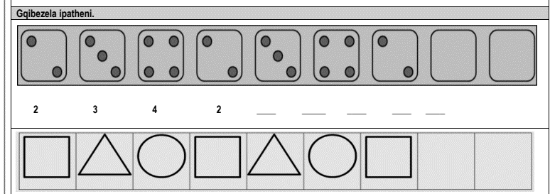
a. [1]
b. Yandisa iphatheni [1]

Amanqaku  ewonke | 5 | Amanqaku  omfundi
1
3. ISITHUBA NEEMILO: [ 6 ]
Igama: ______________________ Umhla:____________
Ibanga 3 A, B, C
Indawo
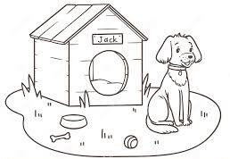  a |  | 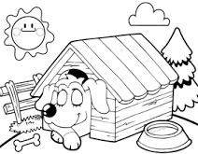  b.
Ecaleni | ngaphambili | ngaphakathi | ngasemva
3.1 Jonga umfanekiso urhangqele impendulo echanekileyo.Indawoni inja? [2]

Igama lemilo | Zoba imilo | Iyatyibilika /iyaqengqeleka
unxantathu | a | b
c |  | d
3.2. Bhala igama,zoba,uchaze iyatyibilika okanye iyaqengqeleka

Amanqaku ewonke | 6 | Amanqaku omfundi
1 [4]

4. UMLINGANISELO [7]
Igama: _________________________ Umhla: ____________
Janyuwari 2025
Cawa | Mvulo | Lwesibini | Lwesithathu | Lwesine | Lwesihlanu | Mgq
 |  |  | 1 | 2 | 3 | 4
5 | 6 | 7 | 8 | 9 | 10 | 11
12 | 13 | 14 | 15 | 16 | 17 | 18
19 | 20 | 12 | 22 | 23 | 24 | 25
26 | 27 | 28 | 29 | 30 | 31
Febhruwari 2025
Cawa | Mvulo | Lwesibini | Lwesithathu | Lwesine | Lwesihlanu | Mgqibelo
 |  |  |  |  |  | 1
2 | 3 | 4 | 5 | 6 | 7 | 8
9 | 10 | 11 | 12 | 13 | 14 | 15
16 | 17 | 18 | 19 | 20 | 21 | 22
23 | 24 | 25 | 26 | 27 | 28
Jonga ikhalenda uphendule imibuzo
  - Izikolo zivulwe nini? Usuku_______________________ umhla_______________ [2]
  - ULinda ubhafa ngomhla wesi-3 kuFebhruwari.UBonile ubhafa emva kwentsuku ezi-6 ebhafile uLinda.Unini umhla wokubhafa ka Bonile? _____________ [1]
  - Ixesha
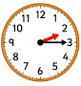 | 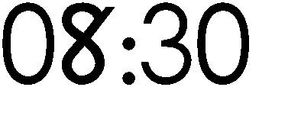
Jonga iiwotshi ubhale amaxesha ngamagama
1
  - Faka ( X ) kwibhokisi enomfanekiso omfutshane [1]
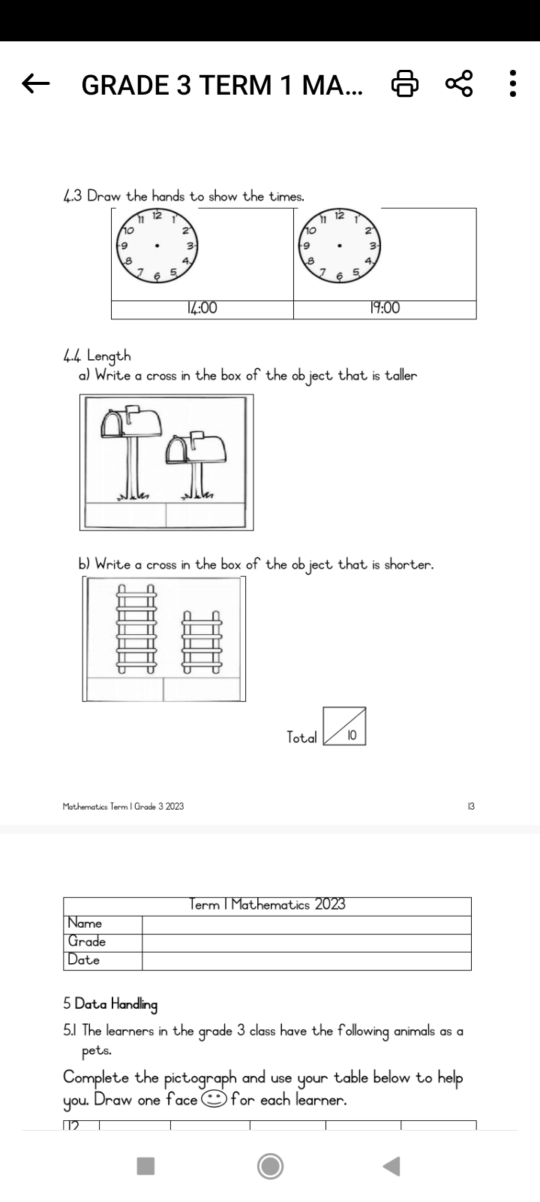

  - Jonga iipensile. Yeyiphi ende ?

Rhangqela unobumba onepensile ende [1]


C.

Amanqaku  ewonke | 7 | Amanqaku  omfundi

2
- UKUQOKELELA ULWAZI [3]
- Igama: _______________________ Umhla: ____________
Inani lamantombazana kwibanga-3
Ibanga 3 A | 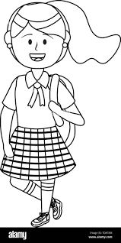
Ibanga 3 B
Ibanga 3 C
Umfundi ubala ka-5
Jonga umfanekiso uphendule kwi grafu

  - Ngeyiphi iklasi enamantombazana amaninzi? ________ [1]
  - Yeyiphi iklasi enamantombazana ambalwa? _________
  - Ibanga 3B lilodlula kangakanani ibanga 3C? Bhala isivakalisi manani
______ - ________ = _______ [1]
Amanqaku  ewonke | 3 | Amanqaku omfundi

1
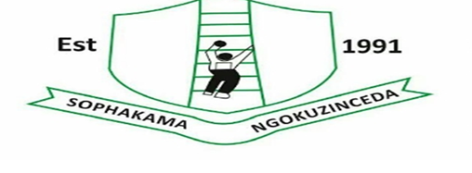
Nomsa Mapongwana Primary School

Igama lomfundi: ______________________________ Umhla : _______________
Mathematiki Uvavanyo: Ikota 1 2025 Ibanga: 3 A, B, C
Ootitshalakazi: Ms Mlotya, Ms Mdliva and Mrs Sono
Moderator: G.Head: Ms Mlotya DH: Ms Mbuqe Phase Deputy: Ms Sakati
Sign: _________ ___________ _________
Itopiki | Amanqaku  ewonke |  | Ipesenteji |  | Amanqaku  omfundi |  | Amanqaku  ahloliweyo
Amanani,iiopareshini nolwalamano | 29 |  | 58%
Iphatheni | 5 |  | 10%
Isithuba nemilo | 6 |  | 13%
Umlunganiselo | 7 |  | 14%
Ukuqokelela Ulwazi | 3 |  | 5%
Amanqaku ewonke | 50 |  | 100%
Tyikitya titshala : _____________________ Umhla: ___________________
Yamkelekile |  | Ayamkelekanga
Ikhowudi | Ipesenteji | Inkcazelo
7 | 80-100% | UPHUMELEL EMAGQABINI
6 | 70-79% | UPHUMELELE NGOKUQAQAMBILEYO
5 | 60-69% | UPHUMELELE KAKHULU
4 | 50-59% | UPHUMELELE NGOMNDILILI
3 | 40-49% | USAFUNA UKUNCEDISWA
2 | 30-39% | KUSENZIMA KAKHULU
1 | 0-29% | AKAPHUMELELANGA

MEMORANDUM

Igama lomfundi: ______________________________ Umhla : _______________
Mathematiki Uvavanyo: Ikota 1 2025 Ibanga: 3 A, B, C
Ootitshalakazi: Ms Mlotya, Ms Mdliva and Mrs Sono
Moderator: G.Head: Ms Mlotya DH: Ms Mbuqe Phase Deputy: Ms Sakati
Sign: _________ ___________ _________
Itopiki | Amanqaku  ewonke | Ipesenteji | Amanqaku  omfundi | Amanqaku  ahloliweyo
Amanani,iiopareshini nolwalamano | 29 | 58%
Iphatheni | 5 | 10%
Isithuba nemilo | 6 | 13%
Umlunganiselo | 7 | 14%
Ukuqokelela Ulwazi | 3 | 5%
Amanqaku ewonke | 50 | 100%
Tyikitya titshala : _____________________ Umhla: ___________________
Yamkelekile |  | Ayamkelekanga
Ikhowudi | Ipesenteji | Inkcazelo
7 | 80-100% | UPHUMELEL EMAGQABINI
6 | 70-79% | UPHUMELELE NGOKUQAQAMBILEYO
5 | 60-69% | UPHUMELELE KAKHULU
4 | 50-59% | UPHUMELELE NGOMNDILILI
3 | 40-49% | USAFUNA UKUNCEDISWA
2 | 30-39% | KUSENZIMA KAKHULU
1 | 0-29% | AKAPHUMELELANGA

