GRADE 7

Natural Sciences
November Examination

MARKS: 70

TIME: 1_{1/2} hours

Marks Obtained:

Name: ____________________________________________ Grade: __________

School: _____________________________________________________________

INSTRUCTIONS AND INFORMATION

- Answer ALL the questions in the question paper.
- Number the answers correctly according to the numbering system used in this question paper.
- Write neatly and legibly.

QUESTION 1: MULTIPLE-CHOICE QUESTIONS

Various options are provided as possible answers to the following questions. Choose the correct answer and write only the letter (A–D) on the space provided in each question e.g., 1.11 G

  - Potential energy is__________

- stored energy
- movement energy
- wasted energy
- chemical energy (1)

1.2 Heat always travel from __________

- north to south
- cold to hot
- hot to cold
- south to north (1)

  - Plastic can be used as __________

- an insulator
- a conductor
- a fire proof vest
- a chain saw (1)

  - A low tide is __________
- when water is muddy
- when water is at its lowest level
- when water is at its highest level
- when water is pulling towards the shore (1)

  - Coal, crude oil and natural gas are known as__________
- renewable energy
- nonrenewable energy
- kinetic energy
- solar energy (1)

QUESTION 2: SOURCES OF ENERGY, POTENTIAL AND KINETIC ENERGY
Use the diagram to answer some of the questions that follow.
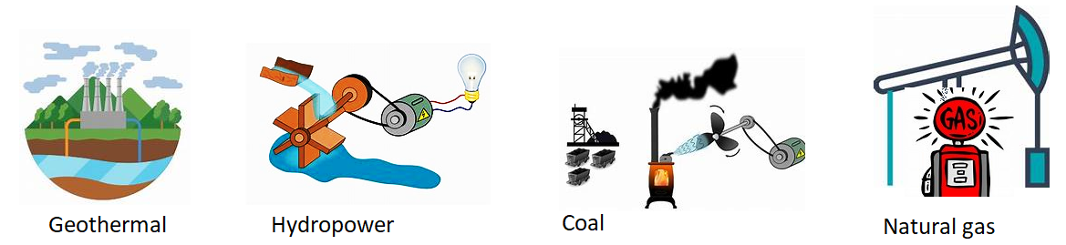
2.1 Label each of the images as renewable or nonrenewable. (4)
________________________________________________________________
2.2 What is the disadvantage of using solar as a source of energy? (2)
________________________________________________________________
________________________________________________________________
2.3 What is a renewable energy? (2)
_________________________________________________________________

2.4 Use the diagram to answer some of the questions that follow:
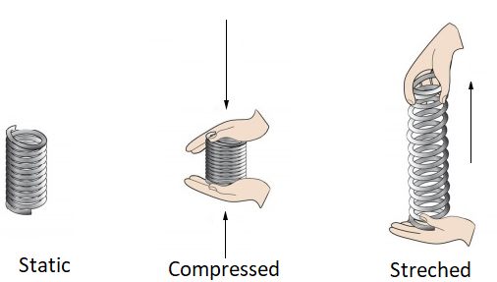
2.4.1 Which of the three springs has no elastic potential energy? _____________ (1)
2.4.2 Discuss why B and C both have elastic potential energy. (2) _________________________________________________________________
2.4.3 When does a spring have elastic potential energy? (2) _________________________________________________________________
2.4.4 Discuss what will happen if the compressed spring is released. (2) ___________________________________________________________________
[15]

QUESTION 3: HEAT TRANSFER AND ELECTRICAL CIRCUITS

Use the diagram to answer some of the questions that follow:
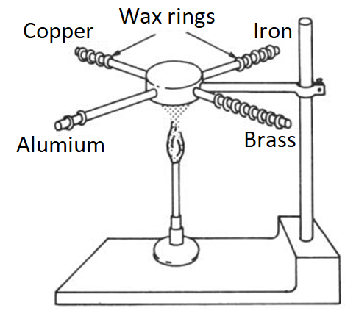

3.1 What do you think is the aim of the investigation? (2) _______________________________________________________________

3.2 Why is wax used in the investigation? (2)
_______________________________________________________________

3.3 The copper wax started melting before the other metals, what conclusion can be drawn from the observation? (2)
_________________________________________________________________

3.4. Why is aluminium used instead of copper for making cooking utensils?
________________________________________________________________ (2)

3.5 Study the diagram shown:
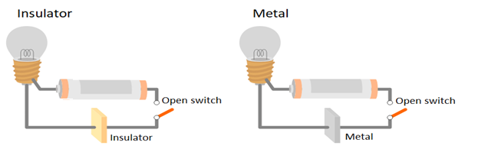
3.5.1 Discuss which electric circuit will not allow electric current to pass through? (2) _________________________________________________________________
3.5.2 By referring to the diagram shown, explain the difference between a
conductor and an insulator. (2)
______________________________________________________________________________________________________________________________________
[12]

QUESTION 4: INSULATION AND ENERGY SAVING

Use the diagram to answer the questions that follow.
The water in the bottles was heated to a temperature of 85 °C.
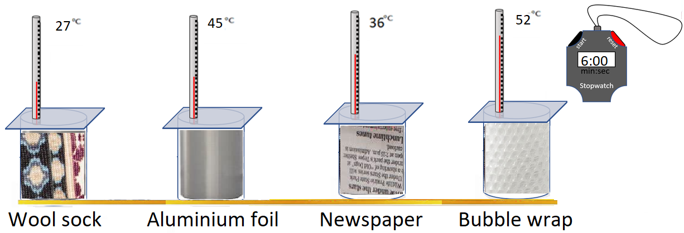

4.1 What do you think is the aim of this investigation? (2)
________________________________________________________________
4.2 What was the temperature of the water before it was put in the bottles? ____ (1)
4.3 In which beaker was the lowest reading recorded? _____________________ (1)
4.4 Discuss which material can be used as a warm water bottle? (2)
________________________________________________________________
4.5 What is the highest temperature recorded? __________________________ (1)
4.6 Why do we use insulators? (2)
________________________________________________________________
4.7 What conclusion can you make out of this investigation? (2)
_________________________________________________________________
4.8 Use the diagram to answer some of the questions that follow:
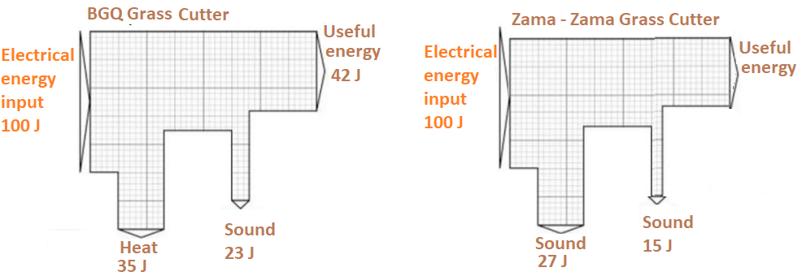
4.8.1 Which of the two grass cutters makes a lot of noise? _________________ (1)
4.8.2 How much energy is wasted by the BGQ Cutter? ____________________ (2)
4.8.3 What is the useful energy in the Zama – Zama Grass Cutter? __________ (2)
4.8.4 Which of the two grass cutters does not waste a lot of energy? _________ (2)
[18]

QUESTION 5: RELATIONSHIP OF THE SUN TO THE EARTH
Use the diagram to answer some of the questions that follow:
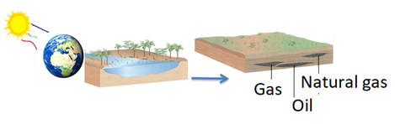
5.1 Give three energy sources that formed from dead organisms over millions
of years. (6)
___________________________________________________________________
5.2 How does heat energy travel from the Sun? (2)
___________________________________________________________________
5.3 Discuss how coal is formed. (4)
______________________________________________________________________________________________________________________________________
5.4 What puts the consumption of natural energy resources at risk? (2)
__________________________________________________________________ [14]

QUESTION 7: RELATIONSHIP OF THE EARTH TO THE MOON
Use the diagram to answer some of the questions that follow:

6.1 What is a Moon? (2)
____________________________________________________________

6.2 What is the relationship between the mass of an object and the force of
attraction? (2)
____________________________________________________________
6.3 Use the diagram to answer some of the questions that follow:

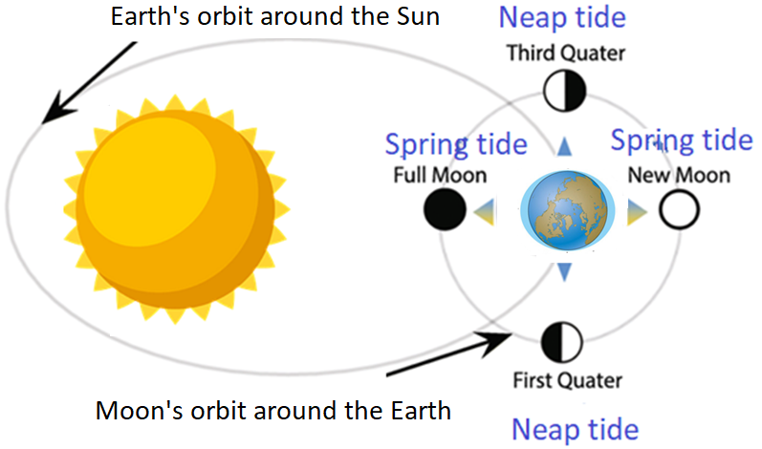
6.3.1 What is a tide? (2)
___________________________________________________________________

6.3.2 Which force keeps planets in their orbits? (1)
___________________________________________________________________
6.3.3 What are the two types of tides? (2)
___________________________________________________________________
6.3.4 Why is a high tide also known as a spring tide? (2)
___________________________________________________________________
6.3.5 When do spring tides occur? (2)
___________________________________________________________________
[14]

