SCHOOL NAME AND EMBLEM
TECHNOLOGY GRADE 7

2024 June Exemplar Test
GRADE 7

MARKS : 30
TIME : 40 MINUTES

NAME OF LEARNER: ____________________________________________

SPECIFIC AIMS | % | Marks | Marks Obtained
THE DESIGN PROCESS SKILLS | 50% | 15
TECHNOLOGICAL KNOWLEDGE AND UNDERSTANDING | 30% | 9
TECHNOLOGY, SOCIETY AND THE ENVIRONMENT | 20% | 6
TOTAL | 100 | 30
 |  |  | %

This question paper consists of 8 pages.

Instructions:
- This question paper consists of 4 questions
- You are required to answer ALL questions on this question paper
- Write your name on the space provided on the cover page
- Read ALL the questions carefully before you write the answers

QUESTION 1: TECHNOLOGICAL PROCESSES/ DESIGN PROCESS

SCENARIO
A school is situated next to an industrial area called Progress Industrial Park. The cell phone users in Progress Industrial Park have complained to their different service providers that they constantly lose signal and have poor reception. They especially battle to conduct video conference calls and their emails take tremendously long to download to their smartphones.

The cell phone provider, Cells-R-Us, has approached your principal to erect a cell phone tower at the bottom of the school property. This will be a wonderful way to make money for the school. The principal agreed, on three conditions:

- The tower must be far enough away from the classrooms to be safe for the children.
- The tower must not make the school look unsightly.
- The Grade 7's of the school should be given the opportunity to design the tower to reinforce what they have been learning in Technology.
The Grade 7’s will be required to design and make their own models
- Each model should be more than 30 cm tall.
- It should have a flat platform near the top of the tower. In a real tower, technicians will stand on this platform when they install or fix the transmitters and receivers at the top of the tower. The platform on your model should not be larger than a 10 cm by 10 cm square.
- The model should fit in with the surroundings. It must be camouflaged in some way.
- The model should be made from strong materials so that it will be stable.
- It should also be rigid and hold its shape.
- Your model should be reinforced using triangulation.
- You can use any suitable building materials for your structure, such as materials that can be found around your home. Examples are stiff reeds; thin, straight sticks; or hand-rolled paper dowels.

Question 1
Read the scenario above and answer the following questions
The cellphone company sends one of their employees to Progress Industrial Park. He talks to the people in the industrial area to find out what the designer should keep in mind when he makes plans for the tower. So, he asks you:

  - Below you are given the description of stages of the design process. Write the correct design stage in each case. (5)

Description | Design stage
Find, use and acknowledge information.
Design brief, specifications, constraints; initial idea sketches; choosing the best design; selecting materials.
Learners evaluate both their design stages and their final product.
Learners present their solutions; learners compile all notes and drawings into a project report in their workbooks.
Draw plans; develop the manufacturing sequence; make the item/model.

  - Formulate the Design brief. (2)
_________________________________________________________________________________________________________________________________________________________________________________________________________

1.3 Give three (3) Specifications from the scenario. (3)
_________________________________________________________________________________________________________________________________________________________________________________________________________
  - Draw a design idea of a Cellphone tower in 3D (OBLIQUE) using the grid provided below. (5)
Criteria | Mark allocated | Mark obtained
Correct Drawing (TOWER) | 2
Correct 3D (OBLIQUE showing 3 dimensions) | 2
Line types | 1
TOTAL | 5



[15]
SECTION B: KNOWLEDGE AND UNDERSTANDING
QUESTION 2: MECHANICAL SYSTEMS AND CONTROL
  - Study the pictures below. Name the class of lever, briefly explain how it is identified in terms of the effort, load and fulcrum. (6)
CLASS  ----------- | Explanation:  -------------------------------------------------------------------------------------------------------------------------------------------------------------------------------------------- | 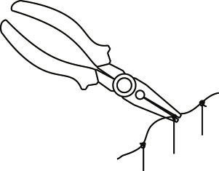
CLASS  ------------- | Explanation:  ---------------------------------------------------------------------------------------------------------------------------------------------
CLASS  -------------- | Explanation:  --------------------------------------------------------------------------------------------------------------------------------------------- | 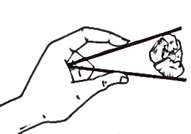

QUESTION 3: STRUCTURES
  - Some cell phone towers are built from solid concrete or fibre glass. Other towers are metal structures. Why do you think the metal towers have triangles in them?
Give two reasons. (2)
______________________________________________________________________________________________________________________________________
  - Name at least one strengthening technique you have learnt other than triangulation. (1)
___________________________________________________________________
[9]

SECTION C: ATTITUDES AND VALUES
QUESTION 4:
Study the pictures below and answer the questions that follow.
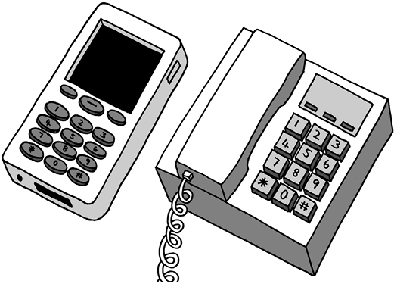
4.1 State one (1) advantage and one (1) disadvantage of using landline phones, and of using cell phones. (4)
Cell phones
Advantages | Disadvantages
Landline phones
Advantages | Disadvantages

4.2 Describe how Cell phones can be used in schools to make teaching and learning more exciting and interesting. (1)
_________________________________________________________________________________________________________________________________________________________________________________________________________
4.3 In term 1 you learnt about JAWS OF LIFE. How do car accidents affect people’s lives? (1)
_________________________________________________________________________________________________________________________________________________________________________________________________________
[6]
TOTAL: 30 MARKS

