TECHNOLOGY GRADE 7
2024 June Exemplar Test Marking Guidelines

MARKS: 30
TIME : 40 MINUTES

This marking guide consists of 3 pages, including the cover page.

SECTION A
QUESTION 1: TECHNOLOGICAL PROCESSES/ DESIGN PROCESS
  - Describe each of the design process stages (5)
Description | Design stage
Find, use and acknowledge information. | Investigate
Design brief, specifications, constraints; initial idea sketches; choosing the best  design; selecting materials. | Design
Learners evaluate both their design stages and their final product. | Evaluate
Learners present their solutions; learners compile all notes and drawings into a project report in their workbooks. | Communicate
Draw plans; develop the manufacturing sequence; make the item/model. | Make

  - Design brief. (2)
I am going to design and make a cellphone tower that will assist people with good network coverage.
1.3 Specifications (3)
30 cm tall ; platform 10cm x 10cm , it must have camouflaged OR any other relevant answer.
1.4 Draw a design idea of a Cellphone tower. Your idea must be in 3D and use the Oblique technique correct line types and dimensions according to the conventions and apply the knowledge and skills that you have learnt so far. (5)

IDEA 2
Criteria | Mark allocated | Mark obtained
Correct Drawing (TOWER) | 2
Correct 3D OBLIQUE | 2
Correct Line types | 1
TOTAL | 5

[15]
SECTION B: KNOWLEDGE AND UNDERSTANDING
QUESTION 2: MECHANICAL SYSTEMS AND CONTROL
  - Name the class of lever, briefly explain how it is identified and indicating where the effort, load and fulcrum is on the picture. (6)

Name:  CLASS 1 | Explanation: The fulcrum is placed between the load and the effort. | 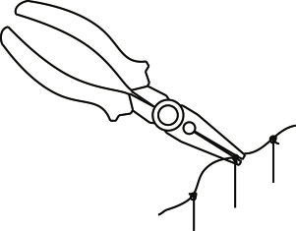
Name:  CLASS 2 | Explanation: The load is between the effort and the fulcrum.
Name:  CLASS 3 | Explanation: The effort is between the fulcrum and the load. | 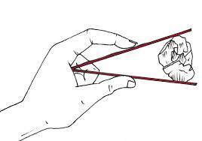

QUESTION 3: STRUCTURES
3.1 Give two reasons. (2)
It should be rigid and hold/keep its shape.
Triangulation prevents a structure from bending while giving stability

3.2 Name at least one strengthening technique you have learnt other than triangulation. (1)
Tubing or folding [9]
SECTION C: ATTITUDES AND VALUES
QUESTION 4:
Study the picture below and answer the questions that follow.
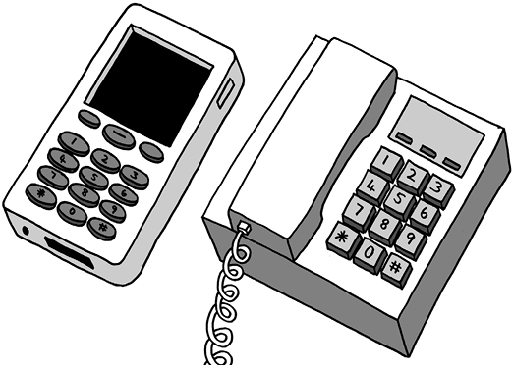
4.1 Name one (1) advantage and one (1) disadvantage of using landline phones, and of using cell phones. (4)

NB: 2 marks for cell phones and 2 marks for landline phones.

Cell phones
advantages | Disadvantages
1. cell phones can send text messages | 1.Expensive for local calls
2.Can be used anywhere | 2. Sometimes poor connection in bad weather
Landline phones
advantages | Disadvantages
1.Cheaper for local calls | 1.Fixed to a point, cannot be used anywhere
2.Good connection even in bad weather | 2.No radio or camera, no text messages

4.2 Describe how Cell phones can be used in schools to make teaching and learning more exciting and interesting. NAME ONE. (1)
To search information
e-learning

4.3 In term 1 you learnt about JAWS OF LIFE. How do car accidents affect people’s lives? (1)
People can lose their lives or loose loved ones.
People can be disabled. /
People can lose their possessions in case the car is written off. /
It has financial implications. / Any one relevant answer. [6]
TOTAL: 30 MARKS

