TECHNOLOGY GRADE 7:
BASELINE / DIAGNOSTIC ACTIVITY
TERM 2 - APRIL 2024

MARKS: 20

DURATION: 20 MINUTES
QUESTION 1
- A natural structure …
- refers to a structure that is not made by man.
- refers to a structure that is made by man.
- refers to a structure that is partially made by man. (1)

- Man- made structures …
- refers to structures that are found naturally in the environment.
- refers to structures that are manufactured and naturally found.
- refers to structures are made by human beings. (1)

- Frame structure…
- refers to a structure that has a skeleton of strong materials which is filled and covered with other materials and supporting the overall structure.
- refers to a structure made without a frame or solid mass material inside.
- refers to a structure that is made strong and rigid. (1)

QUESTION 2
Complete the table below. Study the pictures and choose the correct answer and write it in the applicable space. (10)

Picture | Natural / Human-made | Frame / shell

ball
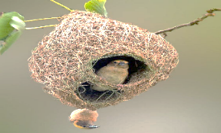
Bird’s nest
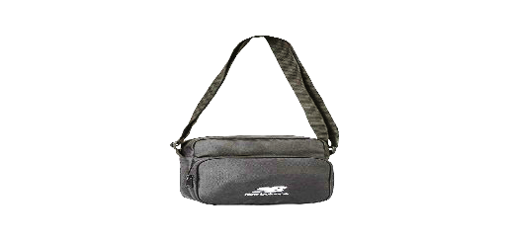
sling bag
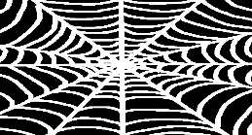
spider web
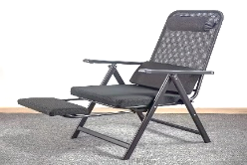
camp chair

QUESTION 3

3.1 Draw a brace or braces onto the square frame below to make it a much stronger structure. (1)

3.2 Name the method of strengthening the paper that are demonstrated below:

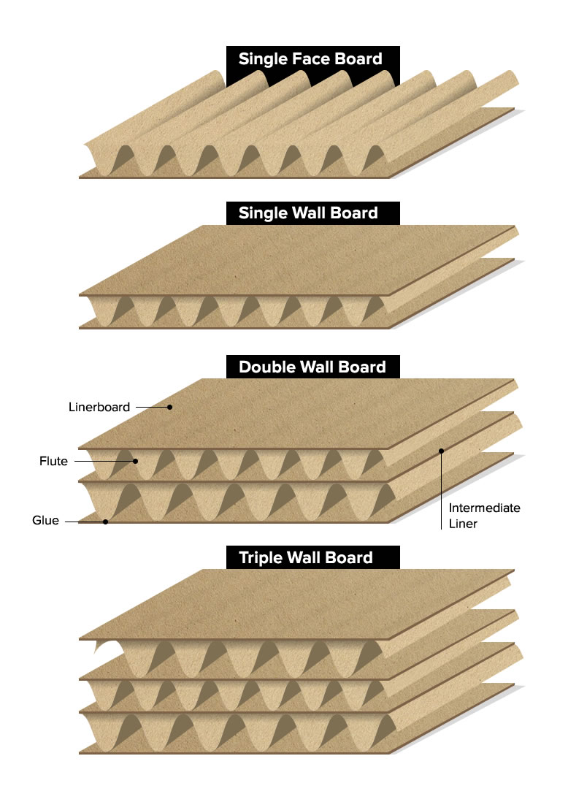
3.2.1 ______________ (1)

3.2.2 _______________ (1)

3.3 Study the pictures from the table below and complete empty spaces by stating whether the structure is stable or unstable and explain why do you say so. (4)

Structure | Stable or Unstable | Why?
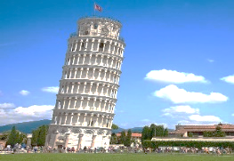
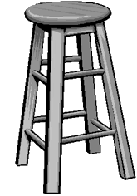

TOTAL MARKS: 20

