DRAMA TERM 3 GRADE 7

TEACHER’S MANUAL
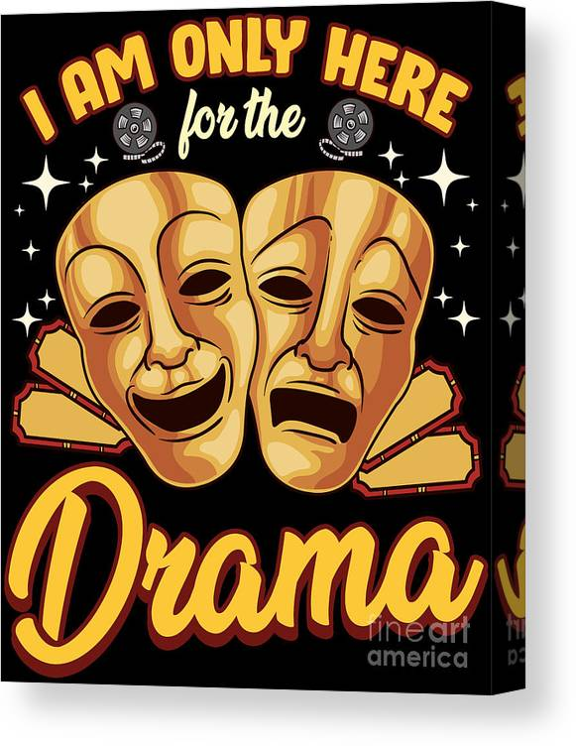

2024

WEEK | TOPIC | CAPS CONTENT | ACTIVITY | DATE COMPLETED
1 | Dramatic skills development Playmaking (improvised drama) | Voice: Relaxation, breathing, posture exercises Physical: Physical loosening up and energising of the body. Improvised drama Create a drama using a cultural or social event as stimulus Drama elements in cultural and social events, compared to their use in theatre | WORKSHEET NO 1  PRACTICAL NO 1
2 | Dramatic skills development Playmaking (improvised drama) | Voice: Relaxation, breathing, resonance exercises (cont.) Physical: Physical loosening up and energising of the body Improvised drama (cont.) • Actors • Audience • Space | WORKSHEET NO 2  PRACTICAL NO 1 CONT.
3 | Dramatic skills development Playmaking (improvised drama) | Voice: Relaxation, breathing, resonance exercises (cont.) Physical: Trust exercises in partners and small groups Improvised drama (cont.) • Time • Costumes | WORKSHEET NO 3  PRACTICAL NO 1 TO COMPLETE IN WEEK 3
4 | Dramatic skills development Playmaking (improvised drama) | Voice: Relaxation, breathing, articulation exercises (cont.) Physical: Mirror work (using slow, controlled mirroring of narrative mime sequences) Improvised drama (cont.) • Props • Special effects | WORKSHEET NO 4  PRACTICAL NO 2
5 | Dramatic skills development Playmaking (improvised drama) | Voice: Relaxation, breathing, articulation exercises (cont.) Physical: Imagery to warm up the body and explore movement dynamics Improvised drama (cont.) • Music or accompaniment • Movement or choreography • Chants or use of call and response, dialogue | WORKSHEET NO 5  PRACTICAL NO 3
6 | Dramatic skills development Playmaking (improvised drama) | Voice: Relaxation, breathing, articulation exercises (cont.) Physical: Lead and follow movements in pairs, small groups and as a class Practise the drama, refining it for performance, prepare for formal practical assessment in week 9- 11 | WORKSHEET NO 6  LEARNERS START WITH PREPARATIONS FOR THE PAT.
7 | Careers | Research careers of support team, including the stage manager, stagehands, make-up artists, costume mistress, props mistress, lighting and sound technicians and front-of-house staff Practise the drama to prepare for formal practical assessment in week 9 -11 | WORKSHEET NO 7  PREPARATIONS FOR THE PAT.
8 | Careers | Present/ submit (video/ written/ audio/ electronic – website/ PowerPoint) research careers of support team, including the stage manager, stagehands, make-up artists, costume mistress, props mistress, lighting and sound technicians and front-ofhouse staff. Practise the drama to prepare for formal practical assessment in weeks 9-11 | WORKSHEET NO 8  PREPARATIONS FOR THE PAT.
9-11 | Formal Practical Assessment | Classroom improvised drama

WARM-UP ACTIVITIES TO USE IN TERM 3 BEFORE DOING PRACTICAL WORK

WARM-UP & BREATHING (Practical)
Suggested activities for voice warm-ups, breathing, relaxation & posture.
a. Stand up straight, but relaxed. Find you center of balance on both feet.
b. Feel that your body is properly aligned-your back is strait, your shoulders, hipbones, and knees are in a straight line, and your weight is evenly balanced.
c. Stand still and look straight ahead at one spot. Keep your head up, your face forward, your chin level and your shoulders relaxed.
d. Breath in and out gently and smoothly.
e. Place your hand on your stomach, just above your belly button.
g. Breath in deeply through your nose. Gently push out your tummy as if it is a ball being filled with air. Your hand should move upwards
g. Breath out slowly through your mouth. Gently push your hand downwards to push out all the air. It should feel like you are squeezing the air out of a ball.
h. Project your voice across the room. Breathe in and mention animal names while breathing out, then imitate animal sounds using different pitch. Repeat few times.
Physical loosening up and energizing the body.
Activity 2 Physical: release tension, loosen and energies the body. (Practical)
a. Start by shaking your hands
b. Shake hands and arms, the shoulders, upper body, and your legs.
c. Your whole body should be shaking in a crazy dance.
Activity 3 Vocal Relaxation (Practical)
- Breath in through your nose, feel your lungs fill up and your rib cage expand.
- Hold for four counts then exhale through your mouth.
- Repeat the above to music if you prefer.
- Breathe in and hold and pant like a dog, then top up your breath through your nose and repeat. Relax.
- Now take a big breath in through your nose, keeping your shoulders down, and hum on a comfortable note. Feel the sound resonating through the resonating chambers.
- Repeat but this time open your mouth and relax the jaw to the sound of MAHH, then gently close the mouth and return to the humming sound.
Now repeat each exercise three times:
Me May Mah. Me May Mah Me May Mah
Roo Rah Ray Roo Rah Ray Roo Rah Ray
Bbbbbbbb ccccccccc

ACTIVITY 4: IMPROVISATION (Practical)
Work in pairs. Choose to play one character in every scenario. You will not have only a few minutes to prepare. Do your drama improvisation in front of the class.
4.1 Thabo comes late for school every day. The principal calls Thabo to his office to hear what the problem for the late coming is. (One learner is the principal and the other is Thabo)
4.2 Veronica did not clean her room the past few days. Her mother calls her to ask why she is not cleaning the room. (One learner is the mother and the other is Veronica)

WEEK 1 WORKSHEET 1
ACTIVITY 1
Complete the following table by writing the correct term next to the desription. Use the terminoligies in the table to assist you.
Voice warm-up | Energising the body | Cultural event | Theatre
Articulation | Improvisation | Social event | Facial expressions

Description | Term
Preparing the voice for performance | Voice warm-up
Showing emotions on the face | Facial expressions
Speaking with clarity | Articulation
Preparing the body for a performance by doing some warm-up exercises. | Energising the body
Spontaneous making up of a play | Improvisation
An activity that is done by different cultural groups to celebrate or to mourn. Examples include weddings /funerals. | Social event
The building designed for performances. It has a stage and seats for the people who are attending. (The audience) | Theatre

ACTIVITY 2
Answer the following questions.
6.1 Name any three cultural or social events.
Weddings/Funerals/Birthday parties/ engagements/ annerversaries etc.
6.2 Why is it so important to warm up the voice before a performance?
It prevent damaging your vocal cords while helping you articulate your words

WEEK 1-3 PRACTICAL NO 1
Notes to the teacher:
- In groups, learners prepare the following song.
- Learners are allowed to do dance movements and use body percussion while performing the song.
- Explain the words (terminologies) in bolded font to the learners.
- Learners will have one period to prepare, and in Week 2 the different groups will perform their song to the rest of the class.
- This is an informal activity. No assessment.

drama | Drama is a play that can be performed for theatre, radio, or even television.
acting | Acting is the art of performance. Actors portray characters and tell stories using dialogue, body language, and facial expressions.
Warm-up | Warmup routines, physical warm-ups, and warmup games are full-body physical, facial, and vocal exercises that help actors get ready to perform.
actors | One who acts in a play, movie, television show, etc.
character | People or creatures in a play.
audience | The people watching the play.
improvise | Acting that is created spontaneously in response to stimuli.

Performing a song about Drama. (Melody – Bana ba sekolo)
We love drama!
We love acting!
Warm-up your voice
The actors have no choice
It’s fun to play a character
The audience enjoys this!
Let’s im-pro-vise!
Drama is so nice!

WEEK 2 CONTENT TO BE TAUGHT
Notes to the Teacher:
- Learners will do a Drama Performance at the end of the term about a Social OR Cultural event.
- Explain and teach learners what Social and Cultural events are.
- Use the information on this page to assist you.
Social Events | Cultural Events
An occasion on which people can assemble for social interaction and entertainment. These events can be big like a festival, but it can also be smaller like a wedding of a birthday celebration. | Cultural events bring people together to network, celebrate, make friends, and learn something new about another ethnic group. They are also occasions to put aside all differences and focus on learning about each other and doing things together

Social Events
South Africa is an exciting host of hundreds of events every year – ranging from international sports events and music concerts to urban markets. Many of these events and festivals are perfect for the whole family,
Our country is the ideal destination for such a range of events because the climate is mild, the cities and towns are unique and full of character, and the infrastructure is equipped to handle the arrival of visitors that love supporting the festivities.
South Africa is also a country of massive cultural diversity and, to celebrate this, there are many fun and inspiring events. Examples of such events are The National Arts Festival in Grahamstown, the Design Indaba in Cape Town and the Cape Town International Jazz Festival.
Cultural Events
South Africa has been famously referred to as the rainbow nation because it is made up of so many diverse cultures and religions. Contained within South Africa's borders are Zulu, Xhosa, Pedi, Tswana, Ndebele, Khoisan, Hindu, Muslim, and Afrikaner people to name but a few. All these cultural groups have their own unique way of celebrating their perspective cultures.

WEEK 2 WORKSHEET NO 2
- Complete the following sentences:
Social event | Rainbow nation | Cultural events | Cultural | wedding

- An occasion on which people can assemble for social interaction and entertainment is called a social event.
- A wedding is an example of a social event.
- South Africans are referred to as the Rainbow nation.
- The different cultures in South Africa have their own cultural events.
- South Africa is also a country of massive cultural diversity
- The Zulu Wedding – A Social Event.
The Zulus are the largest and most well-known South African ethnic tribe. Like any other African wedding, a Zulu traditional wedding is lively with music, colours, dancing, and feasting. While other South African wedding traditions and customs exist, a Zulu wedding takes the lead in popularity, magnificence, and self-importance. The traditional Zulu wedding is always held at the groom's family home.
As with most cultures, the Zulu marriage process has now become modernised in urban societies, starting off with an engagement, followed by the payment of lobola. Once lobola has been paid Izibizo will follow, this is where gifts are given to the brides’ family followed by Umbondo where the bride will in turn give gifts to the grooms family. Finally the actual Zulu Traditional Wedding will take place, Umabo.
  - Who is the largest South African ethnic tribe? The Zulus
  - Where is the traditional Zulu wedding held? At the groom’s family home.
2.3 Describe what each of the following words refer to:
Izibizo | This is where gifts are given to the brides’ family.
Umbondo | Where the bride will in turn give gifts to the grooms family
Umabo | The actual Zulu Traditional Wedding.

2.4 Underline the correct answers:
2.4.1 The Zulu wedding starts with an (engagement / a party).
2.4.2 The Zulu wedding takes the lead in (popularity / unpopularity)
2.4.3 Dancing is (Part of the wedding / not part of the wedding

EXPLORE SOCIAL AND CULTURAL EVENTS
Notes to the teacher:
- Your learners have explored the Drama elements in term 1 when they created short improvisations. During this term’s lessons you will explore the Drama elements. The focus of the lesson activities will be on a comparison between drama elements used in the theatre to drama elements observed in social and cultural events. In this lesson you will:
- 1. Guide your learners to name various social and cultural events and identify one of these that they will focus on for the remainder of the term. (See the provided info on this page)
- 2. Recap the drama elements in playmaking and their use in the theatre and compare them to drama elements in the selected social or cultural event.
Religious Events | Festivals | Rites of Passage | Special Days | Sports Events | Personal Days | National Days
Christmas, Easter, Diwali, Ramadan, etc. | Arts / Music/ Craft/ Food Festival, Social Campaign, Basaar, etc. | Birth, Initiation, Marriage, Death/  Funerals, etc. | New Year, Valentine’s Day, Mother’s/  Father’s Day, etc. | World Cup,  Olympic Games,  Inter Schools,  Wimbledon, etc. | Birthdays, Gr 7 Farewell, Graduation, Anniversaries, etc. | Heritage Day, Youth Day, Freedom Day, etc.

WEEK 3 WORKSHEET NO 3
Social & Cultural Events.
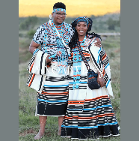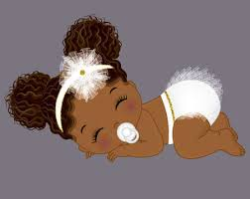
Complete the following activity by giving 3 examples of each type of Social and Cultural event. Use the words provided to you.

Soccer World Cup | Marriage | Mother’s Day | Springbok Rugby Match | Valentines’ Day | Dance Festival | Initiation
Ramadan | Gr 12 Farewell | Youth Day | Christmas | Birthday | Women’s’ Day | Graduation
Heritage Day | Jazz Festival | New Year | Funeral | Comrades Marathon | Easter | Choir Festival

Religious Events | Festivals | Rites of Passage | Special Days | Sports Events | Personal Days | National Days
Easter | Jazz Festival | Funeral | Mother’s Day | Springbok Match | Graduation | Heritage Day
Ramadan | Choir Festival | Initiation | Valentine’s Day | Soccer World Cup | Gr 12 Farewell | Woman’s Day
Christmas | Dance Festival | Marriage | New Year | Comrades | Birthday | Youth Day

WEEK 3 CONTENT TO BE TAUGHT
- Notes to the Teacher:
Explain the following terminologies to the learners. Use the information provided.
actor | audience | stage | costumes | character

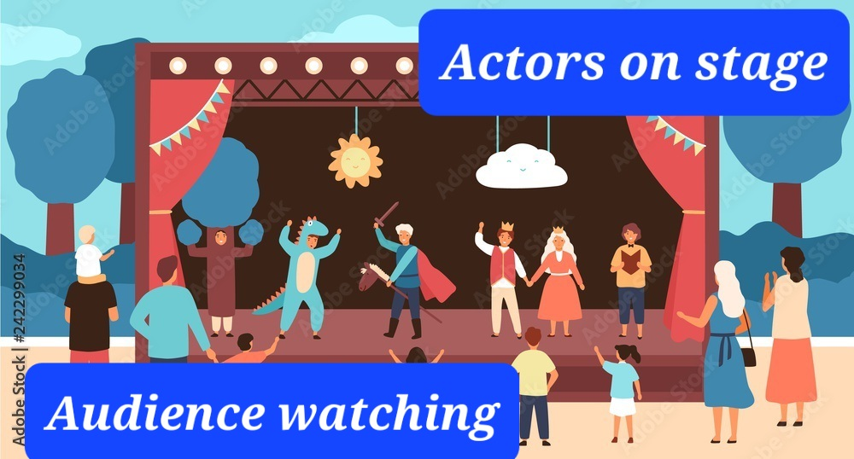
A person whose profession is acting on the stage, in films, or on television, called an actor. Many people study Drama after school to become an actor. Actors play on stage, in TV-shows and movies. They wear certain costumes to make the act look real. (For example an actor will wear a military-like uniform when playing the character of a soldier)The people who are watching the show, concert or drama are called the audience.
The characters that form a part of the story are interwoven with the plot of the drama. Each character in a play has a personality of its own and a set of principles and beliefs. Actors in the play have the responsibility of bringing the characters to life.
- Let us recap the Drama elements in a theatre performance.
Actors | Audience | Space | Time | Costumes | Props | Special Effects | Movement | Dialogues | Music
The people involved in the activity, who have specific roles to fulfil | The people watching the performance. | Arrangement of the  space to  accommodate all the  participants/  audience | The duration of the event. | The clothes worn on stage by actors to make the performance look real. | Objects used by participants in the event, given significance | Use of technology to create impressive visual or aural displays. | Choreography Including processions, or use of simultaneous gesture | What is being said, how is it said and who speaks? | Accompaniment  Including instruments, song

WEEK 4 DRAMA ELEMENTS WORKSHEET NO 4
Use the words provided to complete the following activity.
Audience | Space | Actors | Time | Costumes | Props | Special Effects | Movement | Dialogues
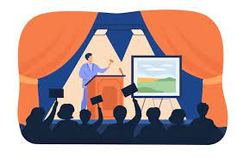 |  |  |  | 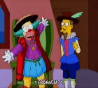 | 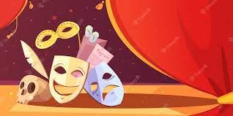 |  | 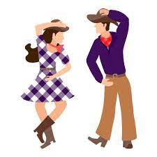 | 

The duration of the event. | Time
Use of technology to create impressive visual or aural displays. | Special effects
The people involved in the activity, who have specific roles to fulfil on stage. | Actors
Objects used by participants in the event, given significance | Props
The people watching the show. | Audience
What is being said, how is it said and who speaks | Dialogues
Arrangement of the space to accommodate all the  Participants/audience. | Space
The clothes actors wear on stage to make the performance look real | Costumes
Choreography, Including processions, or use of simultaneous gesture. | movement

Identify the following social and cultural events.
National Days | Rites of Passage | Personal days

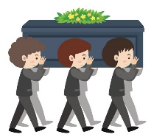 |  | 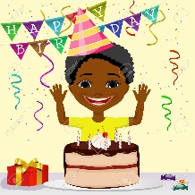
Rites of passage | National Days | Personal Days

WEEK 4 PRACTICAL NO 2
IMPROVISATION
Notes to the teacher: Explain to the learners what improvisation is.
In pairs, learners will do an improvisation on any of the following scenarios:

4.1 Thabo & Peter had to do an assignment for Technology. Peter forgot to do his part and now Thabo is very angry…
What happens next?
4.2 Samm did not do her maths homework for more than a week. The teacher wants an explanation…
What happens next?
4.3 You have been stopped at a road block and your licence is not with you. The traffic officer wants to know the reason for not having your licence…
What happens next?

4.4 You are late for school. The teacher wants to know your reason for being late…
What happens next?

Learners must focus on the following when doing the improvisation:
- Facial expressions
- Tone of Voice
- Body Language
- There must be a proper ending.

WEEK 5 PREPARATIONS FOR THE PRACTICAL ASSESSMENT TASK
Notes to the teacher:
- In the previous weeks, we focused on drama elements in cultural and social events and compared their use in theatre. Now learners will create a short drama using a cultural or social event as stimulus.
- Learners will start preparing for the PAT in Week 5. Assessment to be completed in the last two weeks of the Term. (Week 9-11)

- Divide learners into groups of 5 – 8 depending of the number of learners in your class.
- Each group selects ONE social/cultural event for their Drama Performance.
- The learners will, as a group, work on the dialogue & storyline of the Drama.
- Learners should look at the drama elements and the short description and consider how these elements are present in their selected social or cultural event
- Time allocated: 4-6 Minutes per group.

Drama Elements:

Social or Cultural Event : Drama
Learner need to consider the following when planning the Drama:

- The dialogue
- Use of Space
- Use of Props
- Use of Costumes
- Movement (Dancing etc.)
- Music (Singing, the use of musical instruments like percussion – even body percussion)

WHAT: What happens in your story? Which aspect of the theme/issue will you focus on? WHO: Who are the characters? What is their relationship to one another? What is their function in the play? WHERE: Where does the story take place? WHEN: When does the story take place? In the past, the future? TO WHOM: Who is the audience? Is it friends, parents or the community?
WEEK 5 Preparations for the PAT: Written activity WORKSHEET NO 5
Names of learners participating in the group:

What social or Cultural event did the group choose?
Where does the story take place?
(For example : In a church)
How many characters are in your story?
Name the characters in your story.
(For example:
A Pastor / A groom / A Bride / A Father / A Mother / A policeman / etc.)
Are you going to use any props? What kind of props? | …………………………………………….  …………………………………………….  …………………………………………….
Are you going to use music and movements? | ……………………………………………..  ……………………………………………..  ……………………………………………..

WEEK 5 PRACTICAL NO 3
Dialogue
In pairs, learners will act out the following dialogue.
Remind learners to focus on the following when doing the dialogue:

- Facial expressions
- Tone of voice
- Body language

Teacher | “I see you and your friend did not attend my class yesterday. Why not?”
Learner | “I am sorry Sir, but my schoolbag got lost”
Teacher | “Really? And your friend Mpho? She also did not attend…”
Learner | “I think she lost her bag too, Sir.”
Teacher | “I find that hard to believe Thabo! Please tell me the truth boy, or you will both be in big trouble!”
Learner | “Sir, we both forgot to do our homework and we were afraid to come to class. I am very sorry Sir. Please forgive us. It will not happen again.”
Teacher | “I am very disappointed in you Thabo. Please never lie again to me.”

WEEK 6 – 9 : Learners prepare for the PAT PRACTICAL

Notes to the teacher:
This activity is to be completed by the groups as part of their preparation for the PAT.
Explain to the learners that any Drama has a Beginning, a middle and an End.
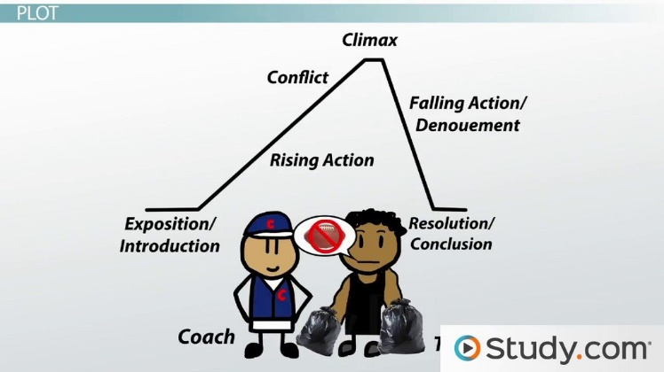

START PLANNING YOUR DRAMA! (Week 6 – 9)
TIPS
1.Your Drama is about a social OR cultural event
2.Your drama must have a Beginning, middle and end.
3. Everybody taking part must play a character.
4. You should all use appropriate facial expressions, body language and tone of voice
5. You may use props
6. You may include dance movements in your performance
7. Use your space effectively

PLAN AND CREATE A DRAMA (Written work in groups)

- The Beginning:
Questions to help you plan the beginning:
- What social OR cultural event are you going to create your Drama on?
- Who will be in this drama? Identify the characters who will be playing. (6-8)
- Where is this event taking place? For example, in the church.
- What is the “problem/challenge” in this drama?
- The Middle:
Questions to help you plan the middle:
- What happens after the opening?
- Is there a fight/conversation/ actions that need to be addressed?
- What is the climax during this drama?
- The End
- Could the problem be solved?
- Is it a happy/sad/exciting ending?
- Are you happy that there is a solution or outcome for this drama?
EXAMPLE OF PLANNING A DRAMA
The Beginning | The Middle | The Ending
It is a wedding.  Characters:  - The Bride  - The Groom  - The Pastor  - The Father of the bride  - The Grandmother of the bride  - The uncle of the groom.  Problem:  The bride and groom are in church ready to get married. The uncle of the groom is indicating that he does not want the groom to marry the bride… | The pastor starts a conversation with the uncle.  Other family members are also taking part in this conversation.  There is a fight between the two families.  Climax: The uncle hits the groom with his fists. | The Pastor com to the rescue of the situation.  He negotiates with the uncle until the uncle is satisfied that the wedding can continue.  Happy Ending: They are celebrating the wedding.
WEEK 6 WORKSHEET NO 6
PLANNING OF DRAMA ON A SOCIAL OR CULTURAL EVENT (Written activity)
In groups of 6-8 learners, do the planning of your drama. Use the example above to guide you.
- The Beginning
What social/cultural event are you going to perform | Who are the characters playing in this drama? | What is the problem/challenge? | Where is it taking place?

- The Middle
What is happening? Just write a short description.
---------------------------------------------------------------------------------------------------------------------------------------------------------------------------------------------------------------------------------------------------------------------------------------------------------------------------------------------------------------------------------------------------------------------------------------------------------------------------------------------------------------------------------------------------- ----------------------------
What is the climax?
------------------------------------------------------------------------------------------------------------------------------------------------------------------------------------------------------------------------------------------------------------------------------------------------------------------------------------------------
- The Ending. How will this drama end?
----------------------------------------------------------------------------------------------------------------------------------------------------------------------------------------------------------------------------------------------------------------------------------------------------------------------------------------------------------------------------------------------------------------------------------------------------------------
- What props will you need?
-----------------------------------------------------------------------------------------------------
WEEK 7 CAREERS WORKSHEET NO 7
Read the paragraph and answer the questions that follow:
Watching a concert or any other production on stage in a theatre is a lovely experience. The audience always sees the actors on the stage, but there are many people working behind the scenes to make sure the concert is a success. They are called the “support-team”
A Stage Manager supports and organises all the different teams involved in the day-to-day running of a theatre production from rehearsals right through to performances and then post-show. He is in charge of all the teams working on stage: The lightning technicians, the props, the sound, the music, and the make-up.
The Make-up artists are responsible for the make-up of the actors. They will do the make-up before the show starts. The prop mistresses will ensure that all the props are on stage for the performance. (The chairs, tables etc) The lightning technicians are responsible for the lightning on stage. Sometimes the stage needs to be bright, and sometimes it needs to be dark. The sound technicians make sure that the music and other sounds are perfect. The audience must always be able to hear what is going on at the stage.
Together this whole team work together to make the concert or production a wonderful experience.
Answer the following questions.
- Who is in charge of the whole production? The stage manager
- Name 3 groups of people forming part of the support team on stage.
The lightning technicians / The make-up artists / The prop mistresses / The sound technicians

- Who is responsible for the furniture used on the stage?
The prop mistresses
- Why do you think is it important to have a sound technician as part of the team?
The sound technicians make sure that the music and other sounds are perfect.
- Do you think the support-team has an important job to do? Or can the actors work on their own?
It is important. Together this whole team work together to make the concert or production a wonderful experience.

WEEK 8 WORKSHEET NO 8
Read more about careers in the Performing Arts and decide which one of them looks interesting for you.

An Actor:
Primary duties: An Actor is a professional who plays a character in a film and memorizes dialogues written by the screenwriter. Actors research and develop the character. They take part in promotional events and audition for their next job.
A Sound Mixer
Primary duties: Sound mixers manage the sound recorded during the movie. It can be dialogues, sound effects or atmosphere.
Camera Operators
Primary duties: Camera operators are responsible for capturing images for motion pictures or television. They achieve visual effects by using different lights, staging and principles like filtering and focusing. They collaborate with other film professionals to capture the ideas and vision of the project's director.
Make-up artist
Primary duties: Make-up artists apply make-up to the actor. They make sure the actors' looks correspond to the movie's requirements.

8.1 Which one of the above careers would you choose to do? Give a reason for your answer.
----------------------------------------------------------------------------------------------------------------
----------------------------------------------------------------------------------------------------------------
8.2 Describe the duties of a sound mixer.
Sound mixers manage the sound recorded during the movie. It can be dialogues, sound effects or atmosphere

8.3 Describe the duties of a make-up artist.
Make-up artists apply make-up to the actor. They make sure the actors' looks correspond to the movie's requirements

WEEK 9-11: LEARNERS PREPARE FOR THE FORMAL ASSESSMENT TASK

PRACTICAL ASSESSMENT: Drama about a social or cultural event.
INSTRUCTIONS
- In groups, create a Drama about a cultural or social event. (4-6 min) Stick to the THEME.
- The Drama must have a beginning, a middle and an end.
- Make use of appropriate facial expressions and body language.
- Make use of props in your performance.
- Use the space effectively.
RUBRIC
CRITERIA | 4-5 MARKS | 3 MARKS | 2 MARKS | 1 MARK
Learners created a Drama about a cultural or social event. The Theme is clear. | Excellent performance about the event. The theme is clear right through the drama. | A good performance about the event. Theme is clear throughout the performance. | Learners could create a drama but theme not always clear. | Learners could not create a drama and the theme is not clear at all.
The Drama has a clear beginning, middle and an end. | Opening sets the scene with excellent and creative development of the story. Ending is very good and indicate the outcome of the event. | Learners succeeded to set the scene and the story developed in a logical way. Good ending. | Satisfactory beginning and development. Ending not quite clear. Needs to improve. | Opening scene not clear. Slow development. Ending not clear.
Learners made use of appropriate facial expressions and body language. | Excellent use of facial expressions and body language. Learners stayed in the characters. | Learners used appropriate facial expressions and body language. | Little use of facial expressions and body language. | No facial expressions. No body language.
Learners used props effectively in the performance. | Very good use of props in the performance. | Learners effectively made use of props in performance. | Little use of props. | Learners did not use any props in the performance.
Space was used effectively. | Space was use very effectively. Learners made optimal use of space. | Learners managed to use the space provided. | Little use of space. Learners only made use of little space. | Poor use of space.

TOTAL MARKS: 25 (25 x 2 = 50)

