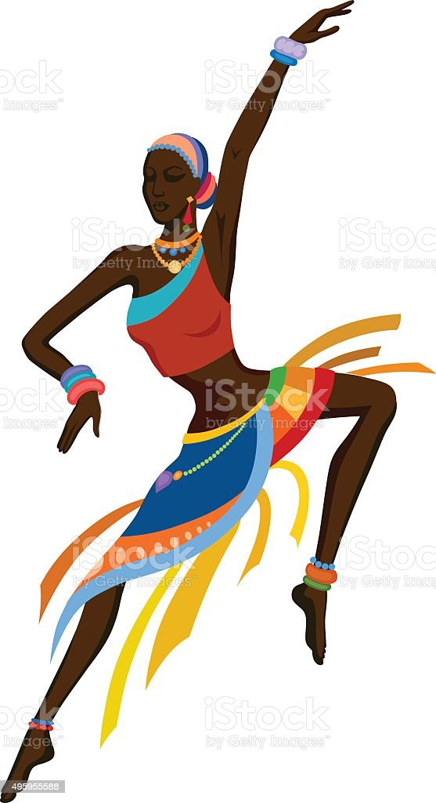
Dance
Term 3
TEACHER’S MANUAL
2024

DANCE TERM 3 ACTIVITIES & ASSESSMENT
WEEK | Topic | CONTENT TO BE COVERED | ACTIVITIES | DATE COMPLETED | DH MONTORING
1& 2 | Dance Performance Dance Theory and Literacy | Dance Performance Consolidation of term 1 and 2 work Dance Conventions should be established. 1.Warm up: Reflect on term 2, focus on using locomotor movements to explore space, direction and levels 2.Floor work: Focus on core stability, flexibility and articulation of the feet 3.Turns: Revise turning movement while spotting 4.Small jumps: Off two feet with focus on safe landing 5.Combination of locomotor movements with coordinating arms 6.Cooling down as in term 2, focus on breathing and stretching while sitting Dance Theory and Literacy Dance terminology Discussion on how movements convey meaning | PRACTICAL NO 1  WORKSHEET NO 1  WORKSHEET NO 2
3 & 4 | Dance Performance Dance Theory and Literacy | Dance Performance Warm up: Add knee bends and rises on two feet 1. Floor work: Continue and increase the mobility of the ankles, knee and hip joint, as well as strengthening of the feet and legs 2. Turns: Half turns while spotting, exploring the importance of eye focus and eye contact 3. Small jumps: Off two feet landing safely on one foot 4. Cooling down through breathing techniques for relaxation and stretches Dance Theory and Literacy Dance terminology – new words Study two different dance styles, e.g. hip hop/ ballroom/ African/ ballet and discuss the differences and similarities | PRACTICAL NO 2  WORKSHEET NO 3  WORKSHEET NO 4
5 & 6 | Dance Performance  Dance Improvisation and Composition  Dance Theory and Literacy | Dance Performance 1. Warm up: Add arm coordination 2. Floor work: Continues by adding strengthening exercises for the feet and legs 3. Turns: Add full turns while spotting 4. Small jumps: Jumping off one foot, landing on one foot Learning a short South African dance, e.g. gumboot, nama stap, amapiano, pantsula, etc. 5. Cooling down with focus on breathing and leg stretches while lying down Dance Improvisation and Composition Learners respond to different stimuli: Themes, ideas, stories, pictures, etc. using eye contact/focus Dance Theory and Literacy Dance terminology Self-reflection on response to stimuli | PRACTICAL NO 3  WORKSHEET NO 5  WORKSHEET NO 6
7 & 8 | Dance Performance  Dance Improvisation and Composition  Dance Theory and Literacy | Dance Performance 1. Warm up: Add good use of posture and alignment 2. Floor work: Strengthening of abdominal and spinal muscles 3. Turns: Half and full turns while spotting, using eye contact and focus 4. Jumps: With focus on safe landing 5. Learning a short South African dance, e.g. gumboot dance, nama stap, amapiano, pantsula, etc. 6. Cooling down with focus on breathing and relaxing while stretching Dance Improvisation and Composition Use pictures – explore moods/ emotions Learners improvise in groups using stimuli: Themes, ideas, stories, pictures, etc. using eye contact/focus | LEARNERS START WITH PREPARATIONS FOR PAT.  WORKSHEET NO 7  WORKSHEET NO 8
9 | Dance Performance Dance Improvisation and Composition | Dance Performance Preparation towards the FAT (Formal Assessment Task). Dance Improvisation and Composition. Composition of movement sequence based on stimulus | PREPARATONS FOR PAT
10 &  11 | Dance Performance Dance Improvisation and Composition | Formal Practical Assessment Task (FAT) Dance Performance Dance Improvisation and Composition Composition of movement sequence based on stimulus 25 marks assessed with a rubric | PRACTICAL ASSESSMENT

Notes to the teacher:
These warm-Ups may be used through the term
WARM UP ACTIVITIES
WARM UP ACTIVITIES: PRACTICAL WORK
FLOORWORK
Core Stability
The ability to control the spine dynamically throughout movement
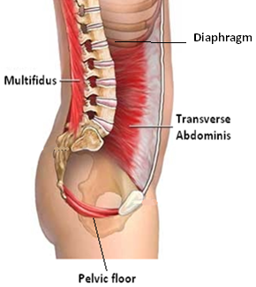
The True Core Muscles
  - Strength & Flexibility
Stretching may not be the most exciting part of working out, but doing flexibility work is just as important for a well-rounded fitness routine as strength and cardio work. Incorporating some stretching exercises into your workout schedule will help you improve flexibility, reduce tightness, and ultimately, make your workouts more efficient and safer.
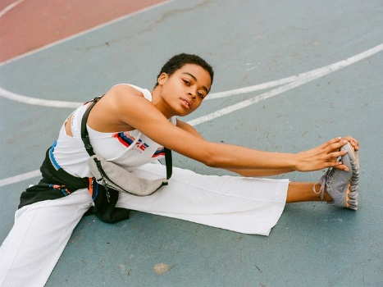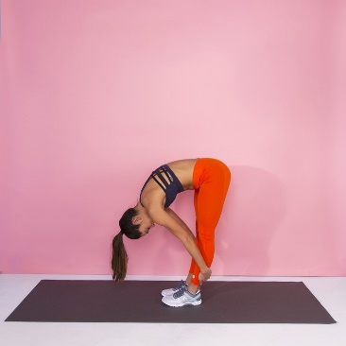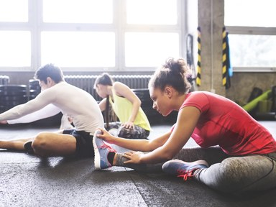

  - Arm Movements: Practical Activity
Do arm swings forward & backwards.
Can you think of any other movements with your arms?

  - Body Part Isolation
At the beginning of class, dancers use isolations to warm up specific body parts, including the neck, shoulders, rib cage and hips.
When individual body parts are warm and supple, dancers can achieve greater fluidity as they progress to more complex movement combinations. Isolations also help a dancer tune into how every body part move, which ultimately leads to greater coordination and versatility.
Once a dancer can successfully isolate one body part, such as a shoulder or hip, she can combine movement of that body part with a traveling step, such as a grapevine or forward walk. If you're a beginning dancer who struggles with rhythm, isolations can help you “feel” the music, which improves movement quality and musicality. Hatchett also claims isolations can help a dancer develop greater precision and master challenging rhythms without losing control.

PRACTICAL ACTIVITIES TO DO

    - Explore body part with Imagery
Fingers: Play an imaginary piano, walk through the yellow pages, climb the stairs, click, tap, point circle, scratch, and make “stars”
Hands: Clap a tune; rub, smack, press a sticky toffee and then try to pull your hands apart ; wash your hands, open and close.
    - Explore body part without Imagery
Sit on the floor in a comfortable position. Close your eyes.
Begin to move your head. Any way at all. See how many ways you can move it.
Repeat with your shoulders, wrists, the whole hand, the whole arm & the trunk.

  - Transfer Weight
A lot of dance movements need you to move your body weight from ons foot to another quickly and efficiently.
HOW DO WE DO IT? : Practical Activity
Place your pelvis over the leg you are standing on so there is no weight on your working leg.
Movements
Move forward & backwards. (In pairs, alone or as a group. When in a group formation you can make a pattern.
Move to the sides (Left & then Right)
  - Small Jumps : Practical Activity
In any jumping movement, you must use your feet and knees correctly.
Your posture & alignment is important when doing this.
Land through the foot, toes-ball-heel. Keep your knees over your toes in all jumps.
Practice different jumps
Let us learn how to make a ¼ ½ & Full Turn. Practice this several times

    - ¼ Means changing direction to face each side of the performance space : side, back, side, front.
    - ½ Means changing direction to face the back or front of the performance space
    - “Full Turns” means turning around completely to face your starting position.
- TIP: All jumps must leave the floor with your feet going heel – ball-point in ht air and land toes – ball-heel. (Safety landings)

  - Spotting & Turning Movements
Spotting is a term that describes the action of a dancer’s head while turning. Learning how to spot correctly is a very important part of technique in all forms of dance. When spotting correctly, a dancer becomes much less dizzy (if at all) while turning, allowing for many turns in sequence.
When spotting, dancers will try to hold their head in place and fix their eyes on a “view” or picture (whether that is a wall of a classroom or the dark audience on a stage) as their body turns.

  - Movement Sequences:” Add on” - Game
Sequence dancing is a form of dance in which a pre-set pattern of movements is followed, usually to music which is also predetermined. Sequence dancing may include dances of many different styles
You will combine locomotor-movements into a short sequence.
Examples of locomotor movements:
Walk | leap | Skip | Gallop
Run | Slide | jump | Hop

Practical Activity:
    - Walking Explorations
Walk anywhere in the room in time to beat.
Walk tall / walk low to the ground / walk in a zigzag / use your arms in an unusual way / walk as if you are exhausted / excited / miserable petrified….
Walk fast / walk slow / walk with your grandmother’s slippers / walk like a soldier / through mud / through long grass. Think of more

    - Walking Dance
Choose 4 walks you like and string them together to make a movement sentence (sequence)
Turn to the person closest to you and teach one another your walking dances. Arrange whether you are going to do them simultaneously, facing one another, back-to-back, side by side of in opposite directions. Make sure you have a starting & ending position.
    - Running Exploration
Run anywhere in the space as fast as you can. Whenever you meet another person, wall or object, make a sharp turn and keep running.
Run backwards, side-wards, add sudden stops and freezes in a statue. For example: Run Low, freeze in a low statue. Run as if on hot coals, freeze in a high position.
Other Running ideas:
- Run as if being chased
- Run as if on a fragile frozen lake
- Run in slow motion
- Play the “add on- Game”. One learner makes a dance movement. The next learner adds a different movement. Then the next learner and the next. Then put all the movements together.

. Locomotor & Freeze
Run fast and then suddenly, freeze.
Run backwards with no bumping – freeze.
Run side-wards and touch all 4 walls.
Run with knees high and freeze low.
Skip backwards while shaking hands, freeze in a twisted shape.
Run with a partner and freeze to form a picture.

  - Cool Down & Stretching
A cool-down provides the body with a smooth transition from exercise back to a steady state of rest.
The overarching goal of a cool-down is to reduce heart and breathing rates, gradually cool body temperature, return muscles to their optimal length-tension relationships, prevent venous pooling of blood in the lower extremities, which may cause dizziness or possible fainting, and restore physiologic systems close to baseline.
The proposed benefits of a cool-down:
• Reduce heart and breathing rates
• Gradually cool body temperature
• Return muscles to their optimal length-tension relationship

WEEK 1 & 2
- Notes to the teacher:
The new terminologies are very important. Please make sure learners understand the meaning of the new words.
NEW TERMINOLOGIES & CONSEPTS
- Non-locomotor or axial movement: Any movement that occurs in one spot including a bend, stretch, swing, rise, fall, shake, turn, rock, tip, suspend, and twist.
- Locomotor movement: Any movement that travels through space including a run, jump, walk, slide, hop, skip, somersault, leap, crawl, gallop, and roll.

TERMINOLOGY | DEFINITION
Warm up | A Routine done to prepare the body for dance. It prevents injuries & improves focus and concentration.
Posture | - Correct Posture involves making your spine longer to form a straight line from the top of your head to the tip of your tailbone  - To maintain a good posture, you have to keep your ears, shoulders and hips in a straight line
Alignment | Alignment is coordinating the head, eyes, arms legs and torso to form lines and movements that all work together
Core Stability | Core stability serves as the centre of our structural support as ALL MOVEMENTS are initiated from here  The ability to control the spine dynamically throughout movement
Strength | Muscular power
Flexibility | The range of movement in the joints (involving muscles, tendons and ligaments)
Body Part Isolation | The separate body parts moving alone at a specific time.
Spotting | The goal of spotting is to attain a constant orientation of the dancer's head and eyes, to the extent possible, in order to enhance the dancer's control and prevent dizziness.
Cool Down / stretch | The purpose of a cool-down is to gradually return the body to its normal functioning.
Safe Landings in Dance | Landing should happen through the foot – toes, ball of the foot, lower the heel and ending in a knee bend. This will add quality to the movement and jumps and prevent joint injury. • To land safely from a jump you need to have a good posture and you need strong muscles to support the weight of the body when landing on the feet

WEEK 1 WORKSHEET NO 1
- Rules is the dance class are important. Name any 3 rules that will apply in the dance class. (Any correct answer)
1.1 Be on time
1.2 Listen to the teacher /
1.3 Respect others / Dress comfortably

- Give two reasons why warm-up is important.
2.1 To prevent injuries / To increase the heartbeat
2.2 Help the focus

- Choose the correct terminology from the provided column that fits the definition.
Warm-up | Cool-down | Spotting | Dance conventions | Force

 | Terminology
A Routine done to prepare the body for dance. It prevents injuries & improves focus and concentration | Warm-up
The rules in a dance class. | Dance conventions
The energy we use when we dance. | Force
Enhance the dancer's control and prevent dizziness. | Spotting
The purpose of this activity is to gradually return the body to its normal functioning. | Cool-down

Underline the correct answer:
- (Alignment / Sitting) is coordinating the head, eyes, arms legs and torso.
- Body part isolation refers to the separate body parts moving (alone/together) at a specific time.
- To maintain a good (posture/body), you have to keep your ears, shoulders and hips in a straight line.
- High, medium and low in dance refer to (directions / levels)

WEEK 1 & 2 PRACTICAL NO 1

WARM-UP ROUTINE
Notes to the teacher:
Guide the learners to do the following warm-Up activities. You may add or choose any other activity. Explain to the learners why warming up and cooling down are important.
The warm-up activities will focus on using locomotor movements to explore space, direction and levels. Learners will also do turning & spotting.
Activity 1
Face forward and keep your legs wide apart. Step 2: Bend your hips and upper body forward. Step 3: Place your hands on your knees, sway your body from your hips, towards the right. Bend and stretch your right knee while you stretch your left leg backwards and point your toes towards the floor. Step 4: Repeat step 3 towards the left and once more towards the right. Step 5: Place your feet together and bend your knees. Now do the Lasso movement. Step 6: Repeat steps 1-5 (4x) in a square formation, each time facing a different wall/side in the space. (side / back / side / front)
Activity 2
JUMPING / ¼ TURNS / SPOTTING Step 1: Start with your feet together. Bounce with your knees twice. Step 2: Rise onto your toes and lift your heels off from the floor. Now jump forward with your feet together (2x). Step 3: Place your left leg to the side. Cross your left leg with your right leg and click your heels together in the air. Step 4: Repeat step 3 starting with the right leg. Step 5: Run for 7 counts in a circle. While you are running, point your toes towards the back, with the bottom part of your feet almost touching your buttocks. On the 8th count, jump with both feet together and face the front. Step 6: Spot, move your head swiftly towards the right and jump towards the right. Spot and jump towards the back. Spot and jump to the right. Spot and jump to the front. Step 7: Repeat step 6, starting towards the left. Remember that when you jump, you have to land softly onto the ball of your feet and keep your knees bent.
Activity 3: Follow the Leader. Use music with the activity to make it more fun!
3.1 One learner will lead the group to warm up the separate body parts.
3.2 The leader may use any locomotor movements in different directions. (Forward/backwards/to the sides)
3.3 The leader must include different levels. (High/medium/low)
3.4 The other learners will follow the leader.

Cooling Down:
Do some stretches to cool down the body before the end of the period.

WEEK 2 WORKSHEET NO 2
- Complete the following sentences by using the words provided:
directions | stretching | Discipline | locomotor movements

1.1 Moving from one point to another in dance refers to locomotor movements
1.2 Dancers can move in different directions like forward and backwards.
1.3 Stretching is an example of a cooling down exercise.
1.4 Learners should always be disciplined in a dance class.
2.1 Give 3 examples of locomotor movements in dance. (For example: “walk”)
Walking / running / skipping / leap / gallop
2.2 Warming up the different body parts: Look at the picture below. Name the different body parts that need to be warmed up.
ankles | legs | Head | hips | shoulders | arms | Wrists & hands
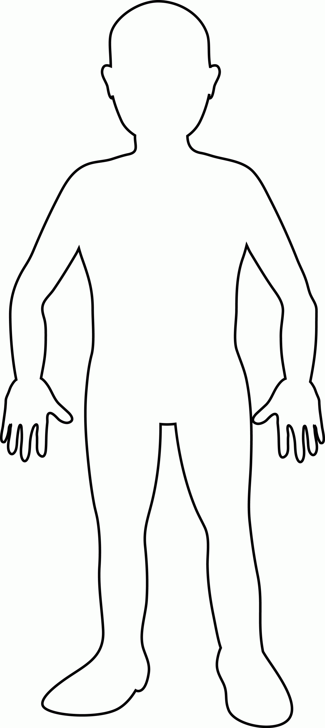
WEEK 2 CONTENT TO BE TAUGHT

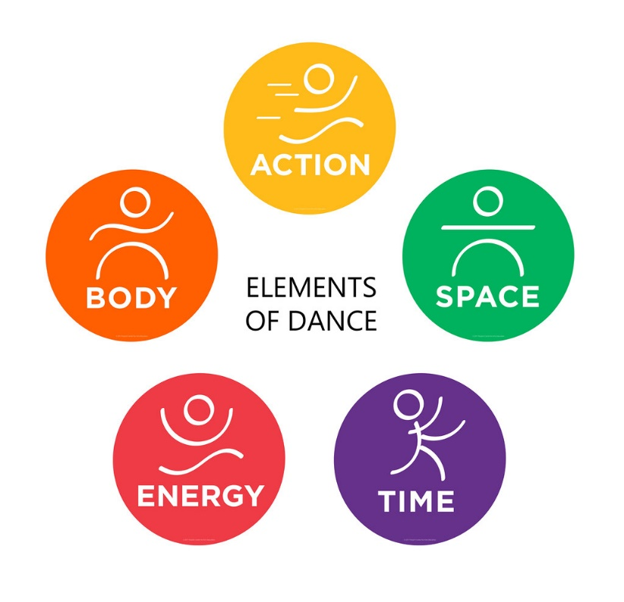
Body &Action | Energy | Space | Time
The body is the dancer’s instrument of expression. When an audience looks at dance, they see the dancer’s body and what is moving. The dance could be made up of a variety of actions and still poses.  Body Shapes  They choose shapes for the dancers to make with their bodies. These can be curved, straight, angular, twisted, wide, narrow, symmetrical, or asymmetrical.  Body Moves/Actions  Locomotor and Non-Locomotor movements  Body Parts  Each part of the body (head, shoulders, elbows, hips, knees, feet, eyes, etc.) can move alone (isolated) or in combination | - Sustained (slow, smooth, continuous)  - Percussive (sharp, choppy, jagged)  Energy is what brings the dancer’s intent or emotion to the audience. | - Personal Space: The space around the dancer’s body.  - General Space: The defined space where the dancer can move can be a small room, a large stage, or even an outdoor setting.  - Levels: Dancers use a variety of levels: high, middle, or low.  - Directions:  Forward/Backwards/To the sides.  - Pathways or Floor Patterns: Where the dancer goes through space is often an important design element. They can travel in a circle, figure eight, spiral, zig-zag, straight lines, and combinations of lines. | Speed (tempo): Fast, moderate, slow

WEEK 3 WORKSHEET NO 3
- Complete the following sentences by using the words provided.
Personal space | General space | pathways | combination

  - Where the dancer goes through space refers to pathways
  - The space around the dancer’s body: personal space
  - The defined space where the dancer can move can be a small room, a large stage, or even an outdoor setting: General space
  - Each part of the body (head, shoulders, elbows, hips, knees, feet, eyes, etc.) can move alone (isolated) or in combination
- State whether the following statements are true or false:
Statement | True / False
Dancers can move in different directions. | T
Dancers can move on different levels. | T
Energy is what brings the dancer’s intent or emotion to the audience. | T

- Circle only the non-locomotor movements.
running | bend | walk
shake | turn | twist
- Energy is what brings the dancer’s emotion to the audience. Which emotions can you identify in the following two dances?
kindness | determined |  | love | excited
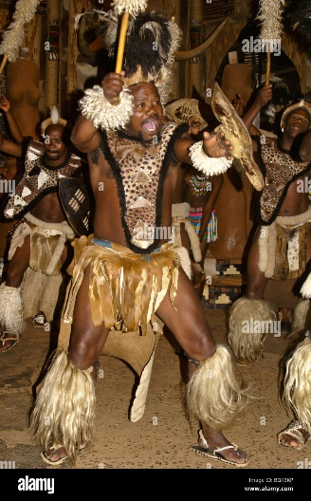  Picture 1 |  | 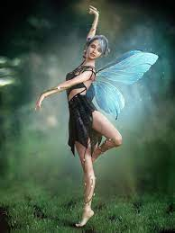  Picture 2

Picture 1  Excited / determined | Picture 2  Love / kindness
WEEK 3 & 4 PRACTICAL NO 2

Notes to the teacher:
- First start the class with a warm-up routine
- Guide the learners to do the following: African Clock Dance
- Use the link below to see a practical demonstration of the dance.

- Warm up routine:
Step 1: Start by walking on the spot, lifting your knees and swinging your arms freely. (8x)
Step 2: Stand with your feet together and your knees bent.
Step 3: Take a step to the right with your right leg and follow with your left leg. Step again to your right with your right leg, this time touch your right leg with your left leg. (2x)
Step 4: Repeat step 3, this time starting with your left leg to the left, following with your right leg. (2x)
Step 5: Stretch your arms shoulder-height each time you step to the sides. (2x)
Step 6: Repeat steps 3-5. (12x)
- Turns: Explain the importance of eye focus and eye contact.
Explain Turning movements to the learners. Must do a ¾ turn, ½ and ¼ turn. Spotting while turning to keep the weight transferred on both legs evenly. Jump off both feet when you turn. Turn clockwise then anticlockwise. Following your shoulder keeping your head in line with head and shoulders while keeping your eyes on the spot while turning.
- Small Jumps: Direct learners to do the following:
- Off two feet landing safely on one foot.
- Repeat several times with the right and the left foot.
Cooling down: Instruct the learners to do the following stretches.
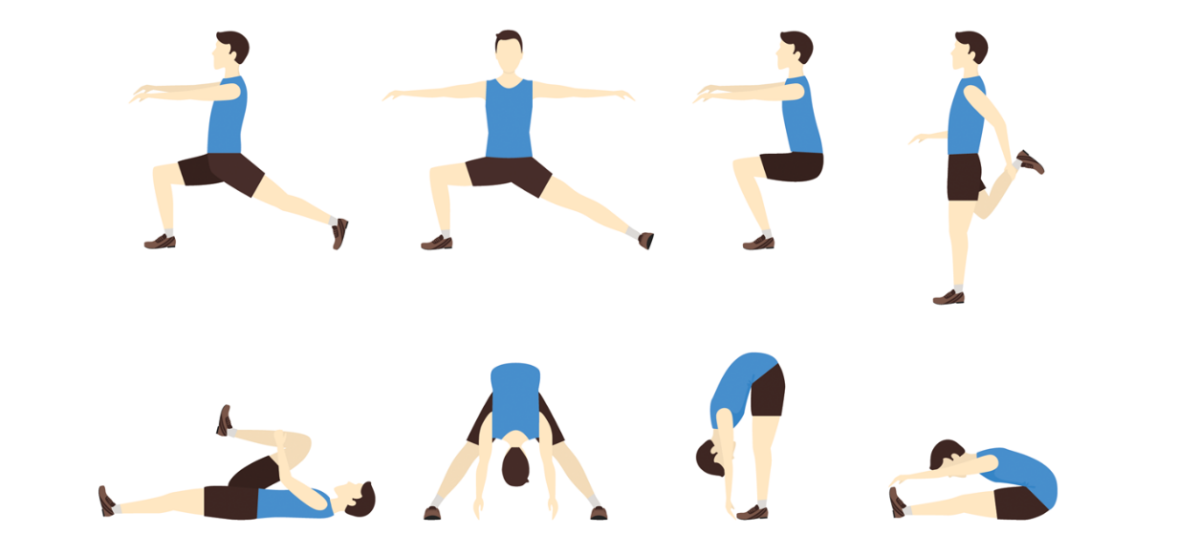

WEEK 4 WORKSHEET NO 4
Different Dance Styles: Read the two paragraphs and answer the questions.
Gumboot Dancing | Gwara Gwara
The dance is usually performed by a large group of people wearing gumboots. The dance involves stamping, clapping, tapping and slapping the gumboots to produce different rhythmic percussion sounds.  Gumboot dancing has developed into a working class, South African art form with a universal appeal. The dancers expand upon traditional steps, with the addition of contemporary movement, music and song. Extremely physical, the dancing serves as a liberating release, celebrating the body as an instrument, and the richness and complexities of South African culture. | Gwara gwara was made famous by South African musician Babes Wodumo. The dance move created by disc jockey and producer DJ Bongz, was heavily imitated by South Africans and other African people mainly during 2016.  Gwara gwara is performed by rolling and swinging the arm and the elbow in terms of making a circle, and one of the leg moves in connection with the arm's rhythm. It has some similarities to the Stanky Leg.

- Who made the Gwara Gwara dance famous? Babes Wodumo
- Who created the Gwara Gwara dance? Jockey and producer DJ Bongz
- Identify each dance style inn the following pictures:
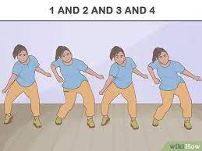 | 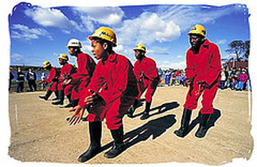
Dance Style: Gwara Gwara  Reason for your answer:  Gwara gwara is performed by rolling and swinging the arm and the elbow in terms of making a circle | Dance Style: Gumboots  Reason for your answer:  The dance is usually performed by a large group of people wearing gumboots. The dance involves stamping, clapping, tapping and slapping the gumboots

- Describe the Gwara Gwara dance in one or two sentences.
Gwara gwara is performed by rolling and swinging the arm and the elbow in terms of making a circle, and one of the leg moves in connection with the arm's rhythm

- Describe the Gumboot dance in one or two sentences.
The dance involves stamping, clapping, tapping and slapping the gumboots to produce different rhythmic percussion sounds.
- Which one of the two dances is you favourite? Give a reason for your answer.

WEEK 5 & 6 PRACTICAL NO 3
Notes to the teacher: (Informal – No assessment)
- Use the link below to show learners an African Dance.
- Once learners know the steps, they can add their own movements.
- You may add music to make it more fun!
- Start the period with a short warm-up routine.

https://drive.google.com/file/d/1oaMApqUCPdNJtbf05tukaKZzCIQB8pbI/view?usp=sharing
AFRICAN DANCE ROUTINE:
1. Step with your right foot to 6, then to 12 and back to the middle. Keep your knees bent. (4x) 2. Repeat step 1, starting with the left foot. (4x) 3. Each time you step backwards, open up your arms with your palms facing to the front, and place your hands on your bent knees when placing your feet together again. (4x) 4. Repeat steps 1-3 in double time. (12x)

Cooling Down
- Doople: Neutral African stance: See the image by clicking on the link.
https://tinyurl.com/y4jy3ejk

Step 1: Start in doople (neutral African stance) with your hands on your hips. Step 2: Move your right hip to the right and your left hip to the left on the counts of 1 and 2. Step 3: Repeat step 2 a little bit faster. Step 4: Now repeat step 2 in double time. Step 5: Move slightly onto the ball of your feet, whilst tilting your hips and pushing your chest forward. Step 6: On the spot, do fast running movements on the ball of your feet, shake the lower part of your body and add free arm movements as you shake and loosen all your body parts. Step 7: Take a deep breath in through your nose as you lift your arms, reaching towards the sky. Step 8: Release a deep breath out through your mouth, as you relax your arms gently down next to your sides. Step 9: Repeat steps 7-8. (4x)

WEEK 5
Assessment in Term 3: Composition of movement sequence based on stimulus.
Notes to the teacher:
- Choreographers must begin with something that inspires an idea for a dance piece, and this "something" is called the stimulus.
- Show the learners pictures with different moods. (Happy/sad/exciting etc.)
- Learners will choose ONE of the pictures that will inspire an idea for a dance sequence.
- In groups, learners will brainstorm their idea for the dance sequence. They need to consider the following:
- What is the mood of the picture?
- What kind of locomotor movements will be used?
- What kind of Non-locomotor movements will be used?
- Different levels & directions.
- Force: Strong OR gentle movements?
- The use of props.
- The use of space.
- Pathways (They can travel in a circle, figure eight, spiral, zig-zag, straight lines, and combinations of lines.)

WEEK 5 WORKSHEET NO 5

Look at the different pictures and describe the mood and message in each of them.
Also indicate what type of movements you will use in a dance based on the pictures.
You may use word from the word bank provided.
sad | happy | exciting | free | life | determined | nature
commitment | friendship | peace | brave | scared | thankful | war

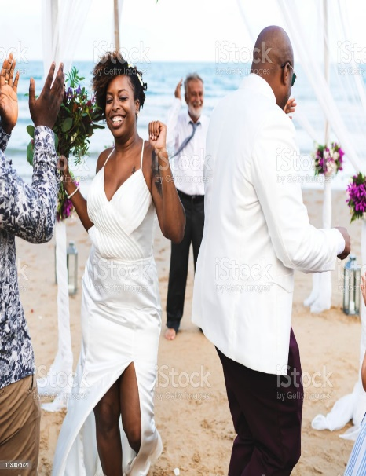 | 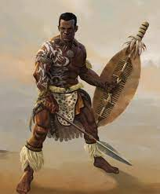 | 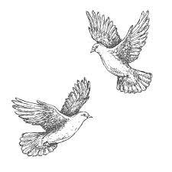
Mood:  ………………………………..  ………………………………..  ………………………………..  ………………………………..  Message  ………………………………..  ………………………………..  ………………………………..  ………………………………..  ………………………………..  Movements for dance:  Strong  Gentle  Fast  Slow | Mood:  ……………………………….  ……………………………….  ……………………………….  ……………………………….  Message  ……………………………….  ……………………………….  ……………………………….  ……………………………….  ……………………………….  Movements for dance:  Strong  Gentle  Fast  Slow | Mood:  …………………………………  …………………………………  …………………………………  …………………………………  Message  …………………………………..  …………………………………..  …………………………………...  ……………………………………  ……………………………………  Movements for dance:  Strong  Gentle  Fast  Slow
WEEK 6
Notes to the teacher:

- In dance, focus refers to the concentration and attention given to the movement and performance. It can also refer to the direction or point in space that a dancer is facing or moving towards.
- Eye contact, and sense of touch in any type of social dancing is very important because it is a tool that helps you connect and communicate with your partners without speaking.
- Cooling down after a performance is essential. The main purpose of a cool down is to encourage the muscles that have been active to return to their resting length to avoid tightness. It also helps to get the heart back to its resting rate and cool your body temperature down.

HOW DOES MOVEMENT CONVEY MEANING?
Ask learners questions like:
How can soft gentle movements create meaning? What emotions might be communicated?
Possible answers: love/shyness/vulnerable/tenderness.
How can definite, strong movements create meaning? What emotions might be communicated?
Possible answers: anger/aggression/power/bullying/confidence
How can moving fast with lots of energy movements create meaning? What emotions might be communicated?
Possible answers: excitements/joy/fear/enthusiasm/freedom.
How can moving slow with little energy movements create meaning? What emotions might be communicated?
Possible answers: tiredness/fear/sadness/rejection/unloved.

WEEK 6 WORKSHEET NO 6
Read the paragraph and answer the questions.
Focus & eye contact in dance.
Eye contact, and sense of touch in dancing is very important because it is a tool that helps you connect and communicate with your partners without speaking. Dancers also need to make eye contact with the audience.
Focus is necessary in dance movements because it enables dancers to refocus their concentration. Second, by getting more oxygen into their body, dancers will relax and perform better.
People performing in a group need to be much disciplined. It is important that they keep eye contact with each other and focus. The warm up routine before a performance helps the dancer to focus.
- Why is eye contact important in dance?
It is a tool that helps you connect and communicate with your partners without speaking.

- Focus is necessary in dance. Explain why.
Focus is necessary in dance movements because it enables dancers to refocus their concentration

- What happens when dancers get more oxygen in their bodies?
Dancers will relax and perform better.

HOW DOES MOVEMENT CONVEY MEANING? (Answers may be different. Use professional judgement)
shyness | winning | love | power | Sadness
joy | anger | fear | excitement | unloved

How can soft, gentle movements create meaning in movement? What emotions might be communicated? Name 2.
Love | Shyness

How can definite, strong movement create meaning in movement? What emotions could be attached to it?
Power | Excitement
How could moving very fast with lots of energy create a meaning in movement? What could the emotion be?
winning | joy
How can moving very slowly, with little energy create meaning? Hat emotion could be conveyed?
unloved | fear

WEEK 7 GROUP WORK: PLANNING FOR PAT. WORKSHEET NO 7
Composition of movement sequence based on stimulus.
- In Groups, choose only ONE picture that will inspire your idea for a dance performance. (The pictures focus on South Africa, but you can use any other picture)
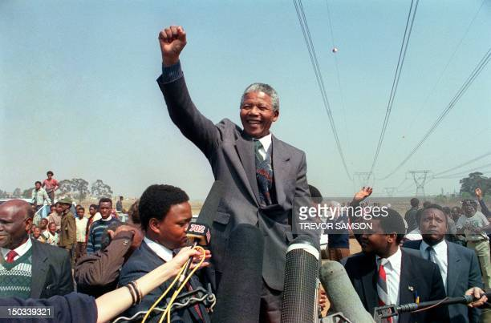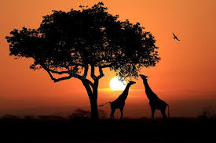
- As a group, write down the words that come to into your mind when you see the picture.

- What emotions do you feel when looking at the picture?

- What kind of movements will you be using in your performance? Explain why you will use those type op movements. (Strong/Gentle/Fast/Slow)

- Which of the following locomotor movements will you be using? Circle those you might use.
walking | galloping | running | jump | hop | leap | slide | skip

- Which of the following non-locomotor movements will you include in your dance performance?
stretch | twist | rise | swing | turn | shake

WEEK 8 (Or to be completed after PAT) WORKSHEET NO 8
REFLECTION ON TEAM WORK FOR DANCE PERFORMANCE

- You worked in a group to prepare for your Practical Assessment Task. Did you enjoy the experience? Give a reason for your answer.

- Did all the members of the group participate in the activity? Did you work well together?

- Which movements worked very well?
- Did you use any props in your dance performance? Was it effective?

- Do you think your group was successful in your performance?

- Did you use music in your performance? Did it contribute to the success of your dance?

- Is there anything you will do different next time?

PRACTICAL ASSESSMENT TASK 25x2 = 50 MARKS

- Learners create a short dance sequence inspired by a picture.
- Learners need to use different locomotor and non-locomotor movements in different directions and on different levels. (High/medium/low)
- The movements must express emotions and tell a story based on the picture.
- Make use of strong/gentle/fast slow movements.
- Eye contact and team work are important.
- Learners may use any music OR singing
ASSESSMENT: PRACTICAL
CRITERIA | 4-5 | 3 | 2 | 1
Learners performed a dance sequence inspired by a picture. | Excellent performance. Focused, well-rehearsed | Good Performance Focused | Most of the performance was good but it can improve | No confidence – Could not do the performance
Performance included Locomotor and non-locomotor movements | A variety of locomotor and non-locomotor movements on different levels and in different directions | Some locomotor and non-locomotor movements on different levels and in different directions | Very few movements in the performance | Learners could not perform a sequence with locomotor and non-locomotor movements
Focus | Excellent | Good | Need to improve | Learners had no focus
Force | Learners managed to make use of appropriate strong, gentle, fast or slow movements. | Strong, gentle, fast and slow movements used in the dance. | Learners did not really understand which movements to use. | No evidence of force in the performance.
Eye contact and Team work | Excellent eye contact and team work. Learners managed to communicate without speaking. | Good eye contact and team work. Continuous communication throughout the dance. | Learners made eye contact but it can improve. Team work satisfactory. | Almost no eye contact. No teamwork.
TOTAL : 25 x 2 = 50

