TECHNOLOGY GRADE 7:

BASELINE / DIAGNOSTIC ACTIVITY –
JANUARY 2024

NAME _________________________________

CLASS: _____

Name of School: __________________

Date: ________________________

Marks: 24

TIME ALLOCATION: 45 MINUTES

- The table below shows different structures. Indicate by using a cross (X) the class in which the structure belongs by putting a tick on the correct box. (8)
Picture | Natural | Manmade
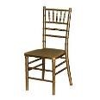
chair
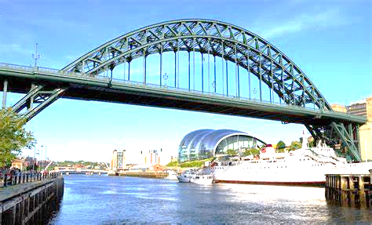
bridge

bird nest

Air balloon
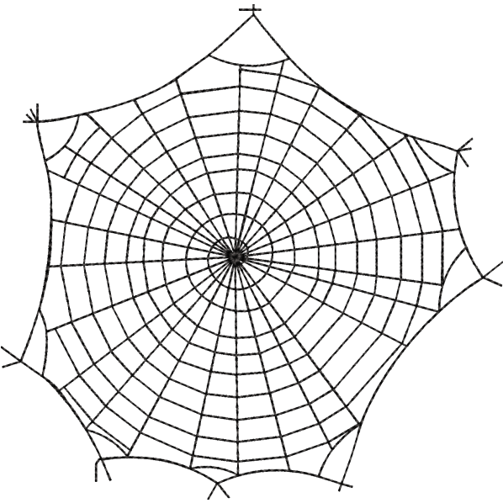 spider web


snail
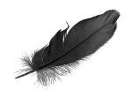

Feather
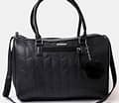
Bag

- Classify the below items as frame structures or shell structures (4)

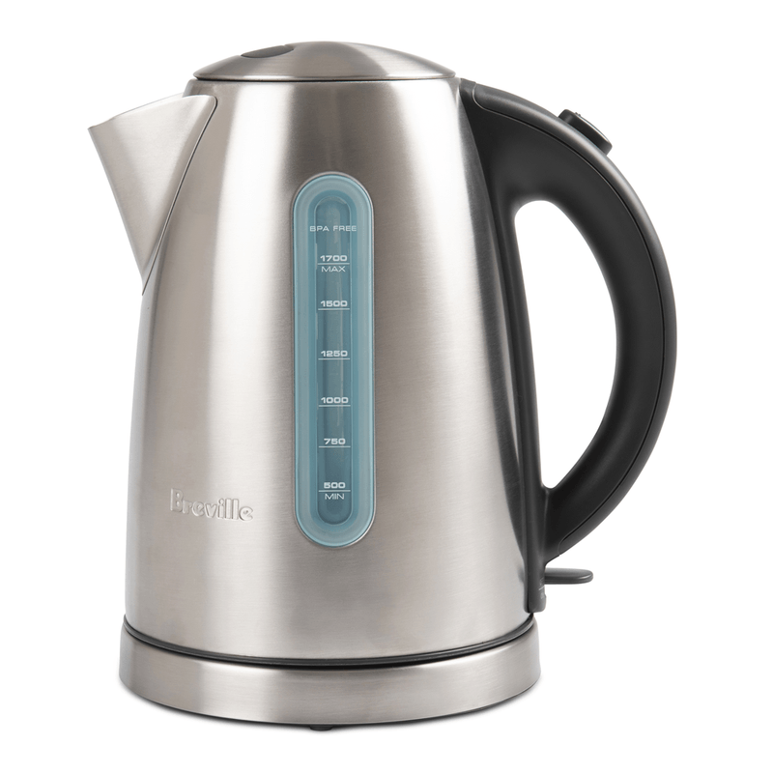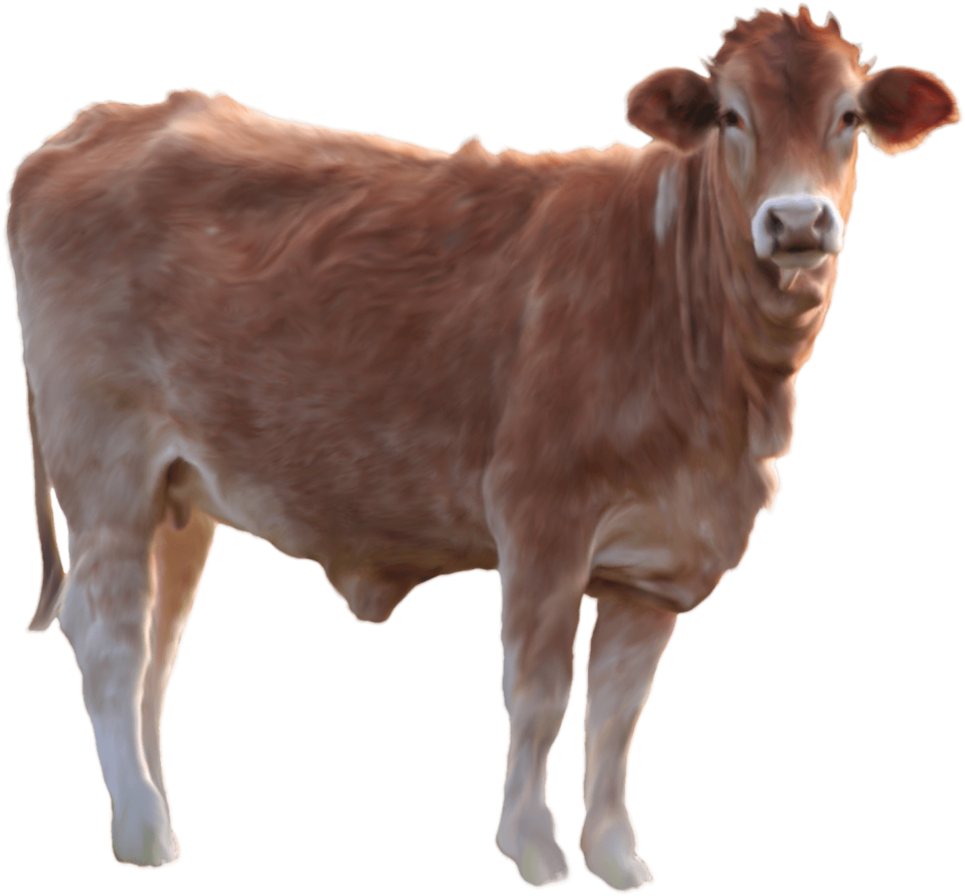
A kettle is a ____________ structure A cow is a ______________ structure

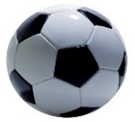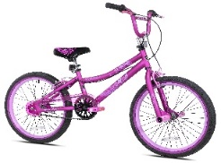

A ball is a ______________structure A bicycle is a ______________structure

- The common mechanism that is used by these objects to move from one position to another is called the levers / wheels and axels. Circle the correct answer. (1)

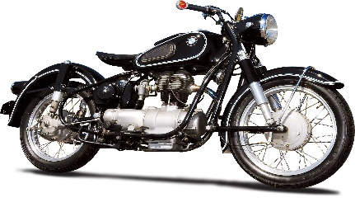

- Below are the two ways of strengthening the paper. Indicate under each picture whether it demonstrate folding or tubing (2)

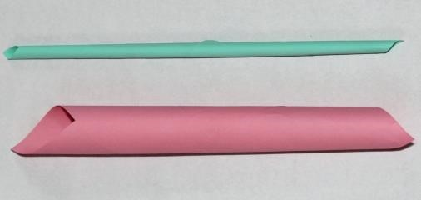
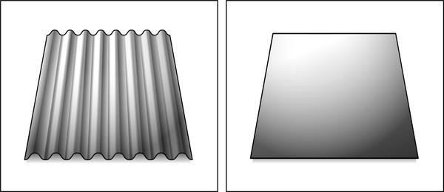 ___________________ _____________________

- Read the statements given in the table below. Indicate by writing an X to tell whether the statement is True or False in the appropriate column

STATEMENT | TRUE | FALSE
All the metal objects are attracted to the
magnet.

Some of the metal objects are attracted to the
magnet.
Some of the metal objects are not attracted to the
magnet.

Some of the non-metal objects are attracted to
the magnet.

None of the non-metal objects are attracted to
the magnet.

6 Look at the circuits below and indicate whether the light bulb will light up or not light up by writing Yes or No.
Circuit | Will the bulb light up? (Yes or no)
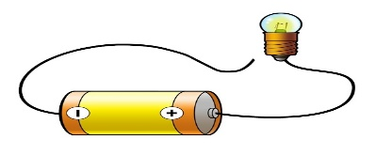
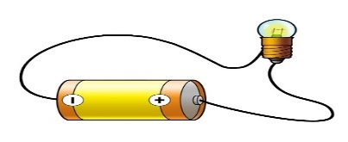
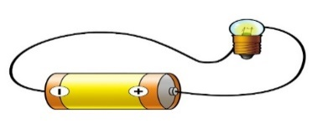
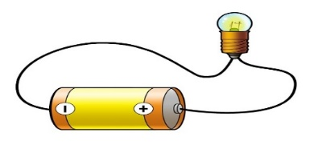
Total : 24
Marking guidelines
Technology Baseline assessment
Grade: 7
Marks: 24
- The table below shows different structures. Indicate by using a cross (X) the class in which the structure belongs by putting a tick on the correct box. (8)
Picture | Natural | Manmade
Chair |  | X
bridge |  | X
bird nest | X
Air ballon |  | X
spider web | X
snail | X
Feather | X
Bag |  | X

- Classify the below items as frame structures or shell structures (4)

A kettle is a __shell_____ structure A cow is a ___frame_____ structure

A ball is a ___shell____structure A bicycle is a __frame__structure

- The common mechanism that is used by these objects to move from one position to another is called the levers / Circle the correct answer. (1)
Wheels and axels

- Below are the two ways of strengthening the paper. Indicate under each picture whether it demonstrate folding or tubing (2)

___tubing___________ ___folding_____________

- Read the statements given in the table below. Indicate by writing an X to tell whether the statement is True or False in the appropriate column

STATEMENT | TRUE | FALSE
All the metal objects are attracted to the  magnet. |  | X
Some of the metal objects are attracted to the  magnet. | X
Some of the metal objects are not attracted to the  magnet. | X
Some of the non-metal objects are attracted to  the magnet. |  | X
None of the non-metal objects are attracted to  the magnet. | X

6 Look at the circuits below and indicate whether the light bulb will light up or not light up by writing Yes or No.
Circuit | Will the bulb light up? (Yes or No)
 | No
 | Yes
 | No
 | No

