
education
Department. of
Education
FREE STATE PROVINCE
PREPARATORY EXAMINATION
GRADE 12

TOURISM
SEPTEMBER 2025
MARKS: 200
TOURISM

 TIME: 3 HOURS

N2870B
This question paper consists of 22 pages.
X05

N3

INSTRUCTIONS AND INFORMATION
Read the instructions carefully before answering the questions.
- This question paper consists of FIVE sections.
- Answer ALL the questions.
- Start EACH question on a NEW page.
- In QUESTION 3.1, round off your answer to TWO decimal places.
- Show ALL calculations.
- You may use a non-programmable calculator.
- Use the mark allocation at each question as a guide to the length of your answer.
- Write neatly and legibly.
- The table below is a guide to help you allocate your time according to each section.
SECTION | TOPIC | MARKS | TIME minutes
 | Short Questions | 40 | 20
 | Map Work and Tour Planning; Foreign Exchange | 50 | 50
c | Tourism Attractions; Culture and Heritage Tourism; Marketing | 50 | 50
 | Tourism Sectors; Sustainable and Responsible Tourism | 30 | 30
 | Domestic, Regional and International Tourism; Communication and Customer Care | 30 | 30
 | TOTAL | 200 | 180
reserved
SECTION A: SHORT QUESTIONS

QUESTION 1
1.1 Various options are provided as possible answers to the following questions. Choose the answer and write only the letter (A—D) next to question numbers (1.1.1 to 1.1.20) in the ANSWER BOOK, for example, 1.1.21 D.

1 .1 .1 A Niche market .
- is seen as negative.
- has the potentiat to grow.
- is small and specialised. D is very stable.
1 .1 .2 The total value of goods and services produced yearly is called a country's .
- VAT.
- GDP.
- BBR. D BSR.
1 1 .3 Identify the country that uses the Euro as currency.
A Scotland B Poland
- Hungary
- Switzerland
 Mandatory vaccinations for international tourists can be obtained from:
- AA
- Travelling clinics
- Pharmacies across the country
- Airport kiosks
1 . 1 .5 This passport is issued to a government employee travelling internationally on government business.
- Presidents' passport
- Temporary passport
- Diplomatic passport
- Student passport
1 .1 .6 The organisation is responsible for collecting levies on all tourism products in South Africa.
A TOMSA

B NDT
C SATourism D SARHA
1 .1 .7 A feature of the Dutch landscape and a symbol of the country's fight against water.
- Harbours
- Cuckoo clocks ²
- Sailboats
- Windmills
1 .1 .8 A parasite usually found in water causes this disease.
A Malaria

B COVID
- Yellow fever
- Bilharzia
1 .1 .9 A travel agent explains to a tourist (from a place practising DST) how to set his watch if daylight saving time is applicable in the country the tourist travels to.
A Set the watch back 1 hour B Set the watch forward 1 hour
- Don't set the watch
- Set the watch to UTK time
1 .1 10 Identify the contribution to the economic pillar (profit) in the triple bottom line.
- Waste management and litter control
- Skills development of the local community
- Buy goods and services from the local community D Use environmentally friendly energy
1 .1 .1 1 An example of a fringe benefit for crew members on a passenger ship is .

- monthly salary.
- uniform allowance.
- reduced taxes.
- annual sick leave.
resetved
1.1.12 This government department issues this document indicating citizenship and permission to leave the country.
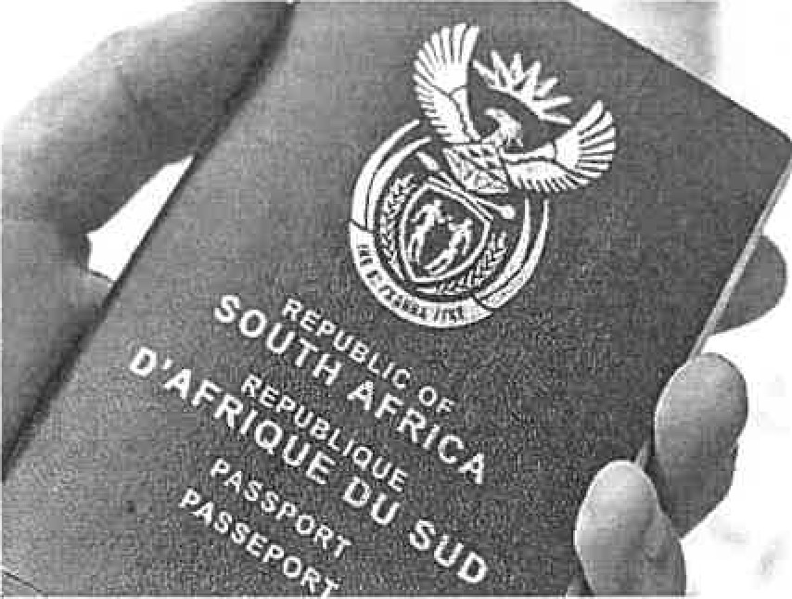
A Department of Foreign Affairs B National Department of Tourism
    - Department of Home Affairs
    - National Department of Immigration
1.1.13 Travel insurance must .
    - pay hospitalisation and related medical costs in the country to be visited.
    - pay the cost of a visa application.
    - pay the cost of plane tickets. D be valid for one month before the traveller departs from his/her country of residence.
1.1.14 The importance of the *Khomani Cultural Landscape World Heritage Site:
    - It has some of the most beautiful scenery in South Africa.
    - It is the only place where the Nama live and practice their traditional nomadic lifestyle.
    - 20% of Africa's plants grow here.
    - It provides crucial information about the Earth's geological history.
1.1.15 During the month of Ramadan, thousands of religious tourists flock to .
    - the Wailing Wall.
    - Mecca.
    - the Blue Mosque.
    - the Mahal.

1 .1 .16 The order of check-in places in an airport building when a traveller on an international flight arrives in South Africa.
A Baggage claim area, immigration, customs B Baggage claim area, customs, immigration
- Customs, immigration, baggage claim area
- Immigration, baggage claim area, customs
1 .1 .17 The time difference between Los Angeles (-8) and Tokyo (+9) is
- 1 hour.
- 11 hours.
- 16 hours.
- 17 hours.
1 .1 .1 8 An electronic system for transferring money from one country to another.
A SWIFT

B EURO

C IBAN D TRAVEL CASH
1 .1 .1 9 This figure relates to the ... province.
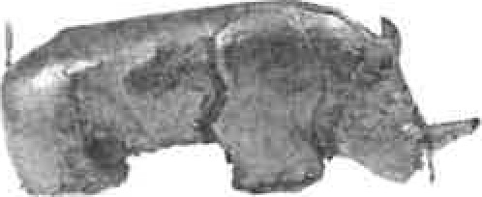
A Free State B Limpopo
C Mpumalanga D Northwest
- .1 .20 A strategy that managers can follow to ensure the success of a tourist attraction:
      - Continuous reinvention of the product by offering new services and diverse activities.
      - Continually offer the same services and activities.
      - Set strategies for high prices.
      - To be conservative in marketing the product.
(20 x 1) (20)
  - Give ONE word/term for EACH of the following descriptions by choosing a word/term from the list below. Write only the word/term next to the question numbers (1.2.1 to 1.2.5) in the ANSWER BOOK, for example, 1.2.6 Illnesses.
Tourism; Rio Carnaval; linear; Comrades marathon; ETYA; AFCON cup; unforeseen event; circle; Lilizela; political; Labour; Health
    - An example of a classic event is the
    - In 2023, a plane crashed in Nepal.
    - A travel route with different start and end points is called a ... route.
    - The award encourages businesses in the hospitality industry to strive for excellent service, facilities and products, thereby marketing South Africa as a preferred destination.
    - The Department of regulates employment contracts.
 (5)
  - Choose the correct word(s) from those given in brackets. Write only the word(s) next to the question numbers (1.3.1 to 1.3.5) in the ANSWER BOOK, for example, 1.3.6 passport.
    - An international driving license is obtained from (AA/Home Affairs).
    - (Yellow Fever/Ebota) is a mandatory vaccination in Brazil.
    - (SAHRA/UNESCO) preserves and manages local heritage sites.
    - (TOMSA/SATourism) is responsible for marketing South Africa abroad.
    - Travel Wallet is an example of a (credit card/preloaded foreign currency card).
 (5)
1 .4 Complete the following table. Write only the question numbers (1.4.1 to 1.4.5) in the ANSWER BOOK and the answer, e.g., 1.4.6 Europe.
ICON | CONTINENT | COUNTRY
Eiffel Tower | 1 .4.1 | France | 1 .4.2
Mount Fifi
Weilin Wall | Asia | Israel | 1 .4.4
1 .4.5 | Euro e | Switzerland | 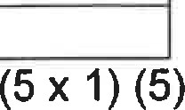
1 .5 Select the host (country/province/city) from COLUMN B that matches the world event in COLUMN,A. Write only the letter (A—F) next to the question numbers (1.5.1 to 1.5.5) in the ANSWER BOOK, e.g., 1.5.6 G.
 | COLUMN A |  | COLUMN B
1.5.1  1 .5.2  1 .5.3  1 .5.4  1 .5.5 | Wimbledon tennis tournament  2026 Commonwealth Games  G20 Summit 2025  Summer Olympics 2024  Tour de France | A  B  C  D  E  F | Rio de Janeiro  Australia  South Africa  London  France  Paris

TOTAL SECTION A: 40

SECTION B: MAP WORK AND TOUR PLANNING; FOREIGN EXCHANGE

QUESTION 2
Study the World Time Zone map and answer the questions that follow.
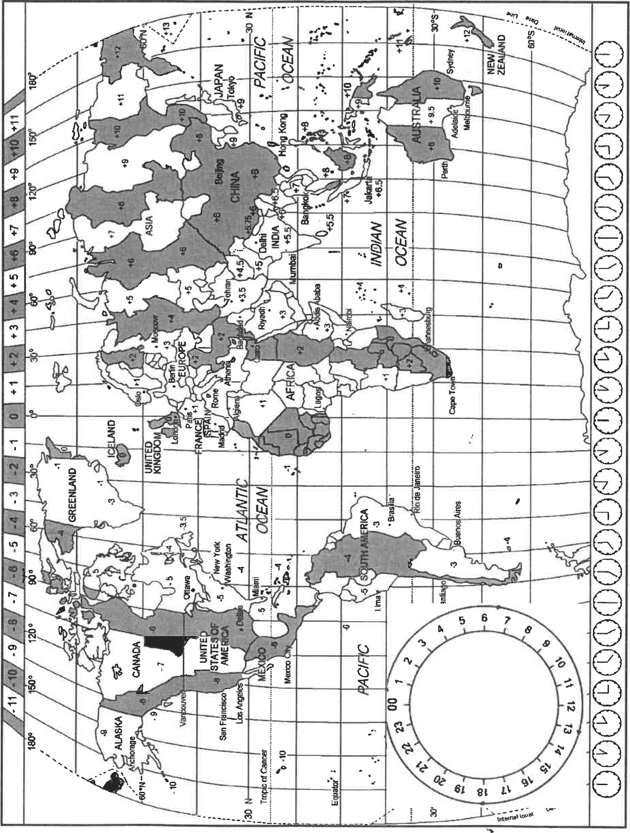
2.1 Read the extract and answer the questions.

ROLAND GARROS
The French Open tennis tournament in Paris, France took place on the Roland Garros tennis courts from June 30 to July 13, 2025. Some of the world's very best tennis players were in action.
Olivia and Noah planned to attend the French Open. Their flight information was a; follows:
 | Delhi (5.5)  Indira Gandhi  International  Airport | Flight time  9 hours 40 min |  | Paris, France (1)  Charles de  Gaulle  International  Air ort
France | ractised Da Ii | ht Savin | Time at the time of the fli ht.
De arture | 07:15 |  |  | Arrival
Date | 5 Jul 2025 |  |  | Date
Fli ht number | BA60 |  |  | Fli ht number | BA60
Seat number | 14A
2.1 .1 Olivia's seat number is indicated as 14A. State whether this seat number is an aisle seat or a window seat.
2.1 .2 Olivia and Noah are likely to suffer from a travel-related condition.
Tabulate the difference between TWO travel-related conditions that travelers may suffer from. 
2.1 .3 Mention TWO benefits for a country that practices Daylight Saving Time. 
2.1 .4 Calculate the time and date of arrival for Olivia and Noah in Paris.
Show ALL calculations. (7)
2.2 Bokang lives in Bloemfontein and plans a holiday to Durban from 1 1 November to 17 November. Bokang will not return to Bloemfontein until 17:30. Use the information below and create a tour budget for him.
Draw the table below in your answer book and complete the budget in full.
DESCRIPTION | CALCULATION | TOTAL
- Overnight in The Oyster Box hotel at R7 600 pppn
- One-way plane ticket: RI 910
- Transport: R750 per'day
- Pocket money: RI 500 per day
- Souvenirs: R2 500
- Tips: R300 (10)
  - As the owner of Veilige Reis tour agency, you must compile an information sheet to be handed to incoming tourists as soon as they arrive in South Africa. Give a summary of your information sheet by referring to the following:
Write TWO safety precautions for tourists on each aspect below: in the car
, in public areas
, after sunset (6)
  - All incoming international passengers must report to customs.
    - Describe the purpose of customs in your own words. (2)
    - Explain the difference between the green and red channels at the international airport. (4)
2 wine; nuts; 50 cigarettes; hunting rifle; 250 ml eau de toilette;
500 g biltong; 3 months of prescription medication; 100 g marijuana

2.5 List TWO limited items from the list above. (2)
[401

QUESTION 3
3.1 Study the foreign exchange table below and answer the questions that follow.
Currency | Code | Bank Selling Rate | Bank Buying Rate
British ound | GBP | 23.29 | 22.59
US dollar | USD | 18.33 | 18.03
Euro | EUR | 19.75 | 19.57
France hosted the Summer Olympics in Paris, France, in 2024.
A South African athletics team member exchanges RI 5 000 for the French currency before leaving for Paris. Calculate how much he will receive in French currency when making this transaction.
NOTE: Round your answer to TWO decimal places.
Show ALL calculations. (4)
3.2 Certain factors contribute to the weakening of the rand against other world currencies. Mention TWO possible factors that could contribute to the weaker rand. (2)
3.3 Analyse the impact of a weak rand on tourism. 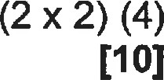
TOTAL SECTION B: 50
SECTION C: TOURISM ATTRACTIONS; CULTURE AND HERITAGE TOURISM; MARKETING

QUESTION 4
4.1 Study the information and answer the questions that follow.
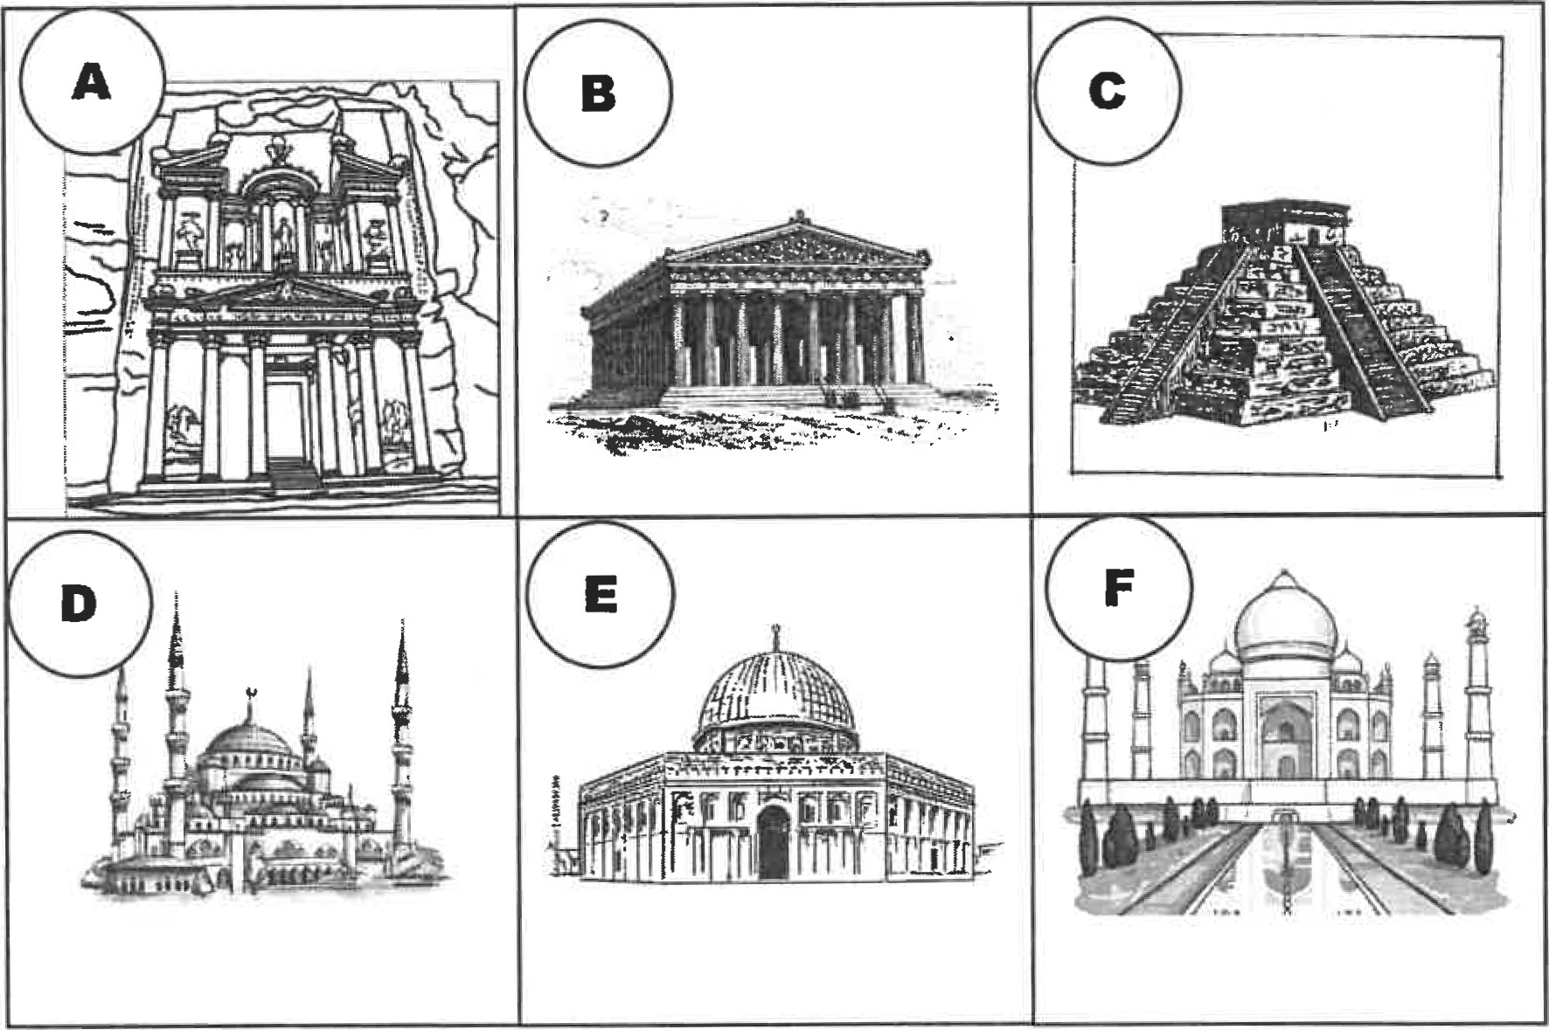
4.1 .1 | Label the icons A—C. | (3)
4.1 .2 | Name the country where icons D—F are located. | (3)
4.1 .3 | Name ONE characteristic that makes icon F world famous. | (2)
4.1 .4 | Name the hill on which icon B stands.
4.1 .5 | Besides icon F, give the names of two more icons in QUESTION 4.1
 | that represent World Heritage Sites. | (2)
4.1 .6 | Identify the religious groups associated with icons D and E. | (2)
4.1 .7 | Write a short sentence to describe the historical importance of icon A. | (2)
4.2 Read the case study and answer the questions.
NEPAL COURT PLACES LIMIT ON EVEREST'S MOUNTAIN
CLIMBING PERMITS
'We are putting too much pressure on the mountain,' a Nepalese court has ruled, limiting the number of Everest climbing permits that can be issued.
The verdict was issued in late April 2024. 'It called for a limitation on the number of climbers ... and requested measures to manage waste dumping, and to protect the mountain's environment.'
[Adapted from Netwerk24, 4 May 20241
42.1 Mount Everest is an icon. Explain the difference between an icon and an attraction. (4)
4.2.2 Give an example of the type of tourist who would visit Mount Everest.
4.2.3 Mount Everest is a prosperous tourist attraction with more than 7 000 climbers yearly.
Evaluate this statement and indicate the economic impact of the reduction of mountaineers on the local community of Mount Everest. 
42.4 The Nepal government applies a sustainable and responsible management plan to contribute to the success of the tourist attraction. This statement applies to the factors that contribute to the success of an icon.
Write a short paragraph to indicate THREE more factors contributing to the success of Mount Everest. 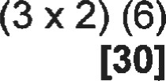

QUESTION 5
5.1 Read the descriptions below and provide the name AND province of the World Heritage Sites in South Africa.
5.1.1 South Africa's first World Heritage Site and one of the largest estuarine systems in Africa, with a diverse ecosystem and different habitats. (2)
5.1.2 It represents less than 0.5% ofthe land area of Africa, but almost
20% of the continent's flower species are spotted here. (2)
5.2 Read the article below and knswer the questions that follow.
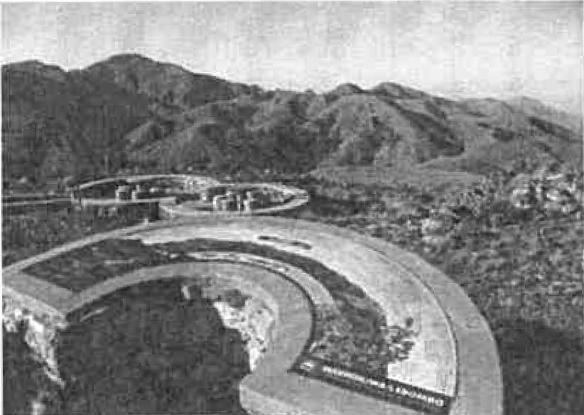 | BABERTON MAKHONJWA MOUNTAINS  Located in the northeast of South Africa, the Barberton Makhonjwa Mountains cover 40% of the Barberton Greenstone Belt, one of the oldest geological structures in the world. The best preserved volcanic and sedimentary rocks are 3.6 billion years old and occur in the area. It provides a predominant repository of information regarding surface conditions, meteoritic impacts, volcanoes, continental drift and environments of early life.  Ada ted from htt s.%vhc.unesco.o
5.2.1 Give the acronym of the World Organisation that declares an area a World Heritage Site.
5.2.2 Identify the TYPE of terrain under which the Barberton Makhonjwa Mountains are classified.
5.2.3 Describe the influence a World Heritage Site can have on the standard of living of the locals. (2)

QUESTION 6
6.1 |  | Name TWO events where South Africa is marketed internationally. |  |  | (2)
6.2 |  | SAToursim uses this logo and slogan to market South Africa. In agreement with this statement, give TWO reasons why it is essential to
 |  | market South Africa internationally. |  |  | (4)

Inspiring new ways
 |  | [Source: https://www.southafrica.net/ql/en/corporatel
 | 6.3 | Write a short paragraph on THREE core functions of SATourism. |  |  | (6)
 |  | TOTAL SECTION C: |  |  | 50

SECTION D: TOURISM SECTORS; SUSTAINABLE AND RESPONSIBLE TOURISM

QUESTION 7
Read the information below and answer the questions that follow.
PROFESSIONAL BEHAVIOUR OF RESTAURANT STAFF
Respect in the workplace: Employees will treat their colleagues with respect. Professionalism: Employees must demonstrate integrity and professionalism.
Personal appearance: The dress code needs to be abided by: Employees must dress appropriately and neatly.
Job duties and authority: Employees must fulfil their duties and perform with integrity and respect towards customers, community and management.
Absence and tardiness: Schedules must be adhered to. Exceptions may occur when employees work outside scheduled hours and perform shift work. However, employees must be punctual during working hours.
Communication: Employees must be open to communication from colleagues, management or employer.
NAME OF EMPLOYER 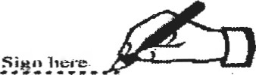
DATE
[Adapted from https://resources.workable.com/employee-code-of-conduct-company-policyl
7.1 Name the law that requires an employment contract between an employer and an employee. (1)
7.2 Using an example, indicate what you understand by 'shift work'.
7.3 Provide TWO skills that a waiter should possess. (2)
7.4 Suggest ONE reason why the phrase 'The dress code needs to be abided by. Employees must dress appropriately and neatly,' is included in this code of conduct. (2)
7.5 Discuss the value of having a code of conduct for a restaurant, such as the one in the example. 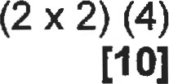

QUESTION 8
8.1 Read the information below and answer the questions that follow.
CARUIÉN
GO GREEN: Rooibos tea
All teabags have been replaced with Bioweb, a plastic-free compostable material, and our pyramid teabags consist of PLA compostable material. Our packaging material is recyclable and FSC-certified. This means for every tree used for paper, a new tree will be planted. Printing inks also comply with environmental conservation requirements and are renewable materials.
COMMUNITY DEVELOPMENT PROJECTS:
All farms with shares in Carmien Tea are Fair Trade accredited and do community projects that support the communities working on the farms.
Funds are managed by a democratically elected committee, and project suggestions come from the communities. The local schools, through donations, facility renovations, and transport of school children, are provided. A full-time nurse and mobile clinic are also available.
TRAINING:
Training is provided in life skills, capacity building and shareholding.

[Adapted from
8.1.1 State the three pillars of sustainability, and under each pillar heading, provide an example from the extract. 
8.1.2 Explain ONE strategy of how Carmien Tea improved its waste management. (2)
8.2 Carmien Tea is involved in CSI
8.2.1 Explain the CSI principle. | (2)
8.2.2 Give TWO examples of CSI provided by Carmien Tea.  8.3 'All farms with shares in Carmien Tea are Fair Trade accredited  8.3.1 Evaluate this statement and indicate TWO principles (from the extract) of Fair Trade Tourism applied by Carmien Tea.  8.3.2 Discuss the value of sustainable tourism for visitors to a sustainable tourism enterprise. | (2)    
[201

TOTAL SECTION D: 30
SECTION E: DOMESTIC, REGIONAL AND INTERNATIONAL TOURISM; COMMUNICATION AND CUSTOMER CARE
QUESTION 9
9.1 Study the information and answer the questions that follow.

SICILY CLOSES AIRPORT WHILE THE VOLCANOES
STROMBOLI AND ETNA ERUPT.


Mount Etna and Stromboli, volcanoes in Italy, spewed hot ash and lava into the air. Alert levels were raised, and the island of Sicily was forced to close Catania airport.
[Source: https://www.aliazeera.com/news/2024/7/5/sicily-closes-airport-as-etna-and-strombolivolcanoes-erupt]
9.1.1 This eruption is an example of a ... global event. (2)
9.1.2 Due to the closure of the airport, this will have an impact on incoming international tourists. Discuss TWO consequences of this on inbound international tourists' travel plans.
9.1.3 Closing the airport will have an economic impact on the island. Evaluate this statement and discuss the negative economic impact.
9.2 Study the statistics for incoming tourists provided by the National Department of Tourism and answer the questions that follow.
Top 5 Land markets |  | Arrivals  Jan-Se t 2022 | Arrivals  Jan-Se t 2021
Zimbabwe |  | 815616 | 281909
Mozambi | ue | 668356 | 363659
Lesotho |  | 593979 | 243530
Eswatini |  | 295642 | 119157
Botswana |  | 172753 | 64495
Top 5 Air markets |  | Arrivals  Jan-Se t 2022 | Arrivals  Jan-Se t 2021
UK |  | 185949 | 16093
USA |  | 184330 | 51630
German |  | 99986 | 15900
Netherlands |  | 59314 | 8320
France |  | 49879 | 9915
[Source: Stats SA Tourism and Migration Report, September 2022 and tourist arrivals data cuts]
9.2.1 Explain the difference between a land market and an air market. (2)
9.2.2 Indicate the air market that grew the most in percentage from
2021 to 2022. (2)
9.2.3 Indicate the land market that increased the least in percentage from 2021 to 2022. (2)
9.2.4 Referring to the arrivals between 2022 and 2021 for both land markets and air markets, indicate the general trend and provide a possible reason for your inference. (4) [201

QUESTION 10
 | business like the one depicted in the cartoon can get
 | customer feedback to evaluate their level of service delivery. | (2)
10.2.2 | Recommend TWO solutions the management could apply to
 | resolve the above complaint. | (4)
 | TOTAL SECTION E: | 30
 | GRAND TOTAL: | 200
10.1 Study the cartoon below and answer the questions that follow.
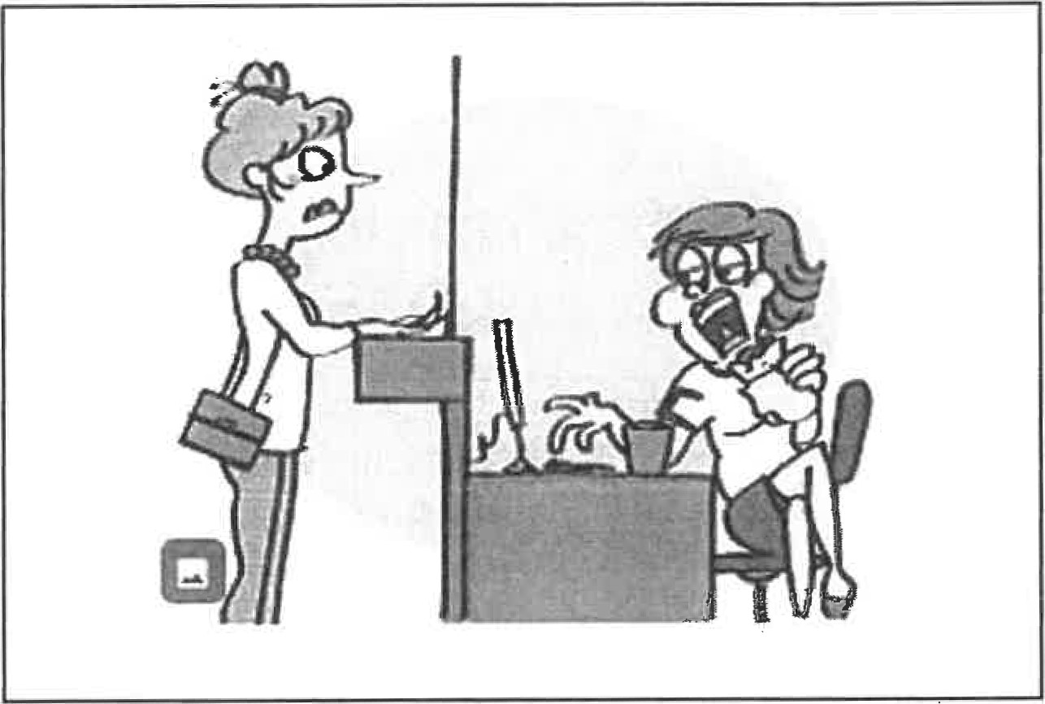
[Source: https://www.istockphoto.coml
10.1.1 Evaluate whether the receptionist provides good or bad service. Motivate your answer. (2)
10.1 .2 Mention TWO disadvantages of poor customer service for a business. (2)
10.2 The customer in the cartoon reported the following complaint to management.
hellopetercom  GOOD OR BAD.  WE'RE LISTENING, | 'When the receptionist finally finished eating, she couldn't help me.'

10.2.1 Name TWO ways (apart from web-based responses) that a

