 | 2024 GRADE 7 TERM 4 WORKSHEETS
ACTIVITY 1: Arrival of the British and the expanding frontiers of Europe
 | Use SOURCE 1A and your own knowledge to answer the following question.
SOURCE 1A
The Dutch were the first European settlers in the Cape, but lost the Cape Colony to the British during the Battle of Muizenberg in 1795. The British took control of the refreshment station which supplied trade ships on their way to the East with fresh food and water. This led to an increase in beneficial trade between Britain and India.
From 1803 to 1806, the Dutch regained control of the Cape once more, only to lose it to the British, following the Battle of Blaauwberg defeated of the Boers, due the British’s superior weapons and a well-trained army.
In 1807, Britain abolishes slave trading in the British empire. Full emancipation of slaves came 26 years later in 1834. The Boers were not happy about slave emancipation. They opposed it because farming would become too expensive as farmers were forced to pay for workers.

1.1 | Draw a time line showing all the important dates mentioned in source A above.  Write a short, brief description for each date  _______________________________________________________________  _______________________________________________________________  ______________________________________________________________  _______________________________________________________________  _______________________________________________________________  -_______________________________________________________________  ________________________________________________________________ | (8)
 | Why was it easy for the British to finally defeat the Dutch at the Cape after a number of battles?  ________________________________________________________________  ________________________________________________________________ | (2)
1.3 | Name FIVE groups of people who were living in the Cape during the arrival of the British  ________________________________________________________________  ________________________________________________________________  ________________________________________________________________  ________________________________________________________________  ________________________________________________________________ | (2)
1.4 | According to the source, give TWO results of the arrival of the British at the Cape  _______________________________________________________________  ___________________________________________________________________________________________________________________________________________________________________________________________________________________________________________________________ | (4)
1.5 | What did the emancipation/ freeing of the slaves mean for the Boer farmers? | (2)
 | TOTAL: 21

Activity 1 Marking guidelines
1.1 | Time line
1795√ | Dutch lost the Cape to the British√
1803-1806 √ | Dutch regained control of the Cape and loose it at the Battle of Blaauwberg√
1807√ | British abolish slave trading in British Empire√
1834√ | Full emancipation of slaves took place. √
 | (8)

1.2 | Britain had a superior weapon and a well-trained army. √√
1.3 | The Griqua√, Khoi√, San√, Xhosa√ and the Dutch√
1.4 | The British took over the refreshment station at the Cape√√ and they emancipated the slaves√√
1.5 | It meant that farming would become expensive as people working on the farms would now have to be paid. √√
 | TOTAL: 21

Activity 2: Arrival of the British and the expanding frontiers of Europe
 | Use SOURCE 2A and your own knowledge to answer the following question
SOURCE 2A
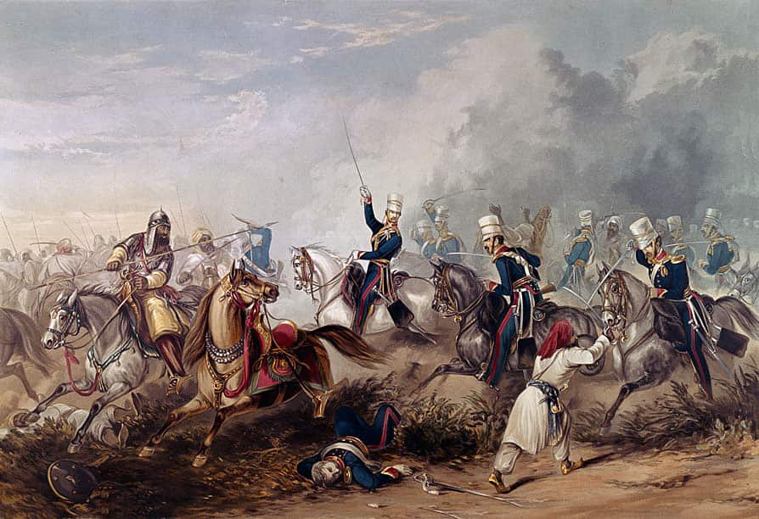
Artist’s impression of a battle being fought during the frontiers

2.1 | Define the following concepts
2.1.1 | Frontiers  ____________________________________________________________________________________________________________________________________________ | (2)
2.1.2 | Dispossession  ____________________________________________________________________________________________________________________________________________ | (2)
2.1.3 | Empire  ____________________________________________________________________________________________________________________________________________ | (2)
2.2 | What was Britain’s intention of occupying the Cape?  ____________________________________________________________________________________________________________________________________________ | (2)
2.3 | What were the results of British settlers arriving at the Cape for people already living there?  ____________________________________________________________________________________________________________________________________________ | (2)
2.4 | Why was it important for Britain to make sure she controlled the Cape?  ____________________________________________________________________________________________________________________________________________ | (2)
2.5 | Write a paragraph summarizing the events and outcome of the nine wars: focus on how these nine wars slowly deprived the Xhosa of their own independence.  ____________________________________________________________________________________________________________________________________________  ____________________________________________________________________________________________________________________________________________  ____________________________________________________________________________________________________________________________________________  ____________________________________________________________________________________________________________________________________________ | (5)
 | TOTAL : 17

Activity 2 marking guidelines.
2.1
2.1.1 | Frontiers: an area of land where two different groups meet, and fight for control of the land √√
2.1.2 | Dispossession: To lose ownership of your own land √√
2.1.3 | Controlled by the government of another country.√√
2.2 | The British wanted to expand their empire through the occupation of the Cape that is why they brought a lot of British people to live at the Cape. √√
2.3 | This resulted in conflict between the British, the Trekboers and the indigenous people living at the Cape.√√
2.4 | The Cape was an important stopping point on the profitable trade route from Europe to the East.√√
2.5 | The events and outcome of the nine wars:  - There were more than 8 000 Xhosa-speaking farmers living in the Zuurveld and few families of white settlers.  - Britain wanted to force the Xhosa to leave the fertile land of the Zuurveld.  - They realised the Xhosa were too powerful and they would need to use a large army if they wanted to force them out.  - In the 100 years from 1779-1879, there were nine frontier wars between the Cape Colony and Xhosa.  - The Xhosa, under a series of chiefs, fought fiercely to defend their land, but in the end they were dispossessed of their land by the superior weapons of the British. (Any relevant answer) √√√√

Activity 3 The Eastern frontier of European settlement
 | Use SOURCE 3C and your own knowledge to answer the following questions
SOURCE 3 C
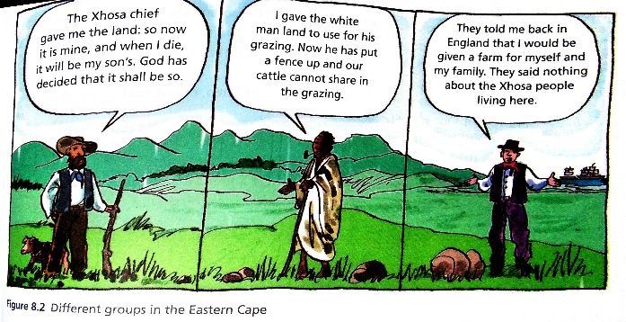
Figure 8.2 Different groups in the Eastern Cape
3.1 | Study figure 8.2 and write down who each person is_______________________ __________________________ _______________________________ | (3x1)
3.2 | Why do you think cattle were so important to the Xhosa?  ____________________________________________________________________________________________________________________________________________ | (2)
3.3 | In a paragraph discuss the conflict between the Dutch and Xhosa farmers on the Eastern Frontier. Include the following facts: -what caused the conflict, the specific area where the conflict took place and what the outcome of this conflict was.  ______________________________________________________________________________________________________________________________________________________________________________________________________________________________________________________________________________________________________________________________________________________________________________________________________________________________________________________________________________________________________________________________________________________________________________________________________________________________________________________ | (5)
 | TOTAL: 10
Activity 3 Marking guidelines
3.1 | The Dutch √, the Xhosa √ and the British √
3.2 | Wealth, meat, milk, transport, lobola, ancestral obligations. (ANY 2)√√
3.3 | Paragraph to cover:  Conflict over Land and cattle  Area where conflict took place Suurveld/ Zuurveld  Through these wars 100-year war / 9 wars (1779 to 1878);  Results of conflict Xhosa driven out of the area; British took control

Activity 4 : Frontier wars on the Eastern frontier of European Settlement- Case study -Chief Maqoma
 | Carefully study SOURCE 4A below, use it and your own knowledge to answer the questions that follow
SOURCE 4A
Commentary about chief Maqoma
Dominic Duval commenting on the life and times of Chief Maqoma
When accommodating and diplomacy failed, resulting in the war of Mlanjeni (1850-53), Maqoma used his skills to lead a guerrilla campaign in the Forest Mountains and valleys of the Waterkloof that frustrated the most skilled British officers.
[Maqoma’s] name lives on. Oral traditions and colonial and missionary documents reveal a man who was well spoken and intelligent, striving to maintain traditional social structures and the power of Xhosa in the face of colonial advancement and dispossession. Maqoma is remembered for his extraordinary tenacity, flexibility and political skills, who tragically became the victim of an advancing colony.
Source: www.sahistory.org.za/ people/chief-maqoma

4.1 | Is this source a Primary or Secondary source? Support your answer.  ____________________________________________________________________________________________________________________________________________ | (2)
4.2 | Who was Chief Maqoma?  ______________________________________________________________________  ______________________________________________________________________ | (2)
4.3 | How long did the War of Mlanjeni last?  ______________________________________________________________________ | (1)
4.4 | What is a guerrilla war?  ______________________________________________________________________  ______________________________________________________________________ | (2)
4.5 | How were historians able to obtain information about Chief Maqoma and his tactics?  ______________________________________________________________________  ______________________________________________________________________ | (2)
4.6 | What is Chief Maqoma remembered for?  ______________________________________________________________________  ______________________________________________________________________ | (2)
4.7 | Where was Maqoma imprisoned?  ______________________________________________________________________ | (1)
4.8 | In an essay discuss the causes OR the results of the eighth frontier war 1850-53.  ______________________________________________________________________  ______________________________________________________________________  ______________________________________________________________________  ______________________________________________________________________  ______________________________________________________________________  ______________________________________________________________________  ______________________________________________________________________  ______________________________________________________________________  ______________________________________________________________________  ______________________________________________________________________  ______________________________________________________________________  ______________________________________________________________________  ______________________________________________________________________  ______________________________________________________________________  ______________________________________________________________________  ______________________________________________________________________  ______________________________________________________________________  ______________________________________________________________________  ______________________________________________________________________  ______________________________________________________________________  ______________________________________________________________________  ______________________________________________________________________  ______________________________________________________________________  ______________________________________________________________________  ______________________________________________________________________  ______________________________________________________________________  ______________________________________________________________________  ______________________________________________________________________  ______________________________________________________________________  ______________________________________________________________________  ______________________________________________________________________  ______________________________________________________________________  ______________________________________________________________________  ______________________________________________________________________  ______________________________________________________________________  ______________________________________________________________________  ______________________________________________________________________  ______________________________________________________________________  ______________________________________________________________________  ______________________________________________________________________  ______________________________________________________________________  ______________________________________________________________________  ______________________________________________________________________  ______________________________________________________________________  ______________________________________________________________________  ______________________________________________________________________  ______________________________________________________________________  ______________________________________________________________________  ______________________________________________________________________  ______________________________________________________________________ | (15)

Activity 4 Marking Guidelines
4.1 | Secondary source √ Because it is not the original source√(any relevant answer)
4.2 | Chief Maqoma was the leader of the Xhosa speaking people √√
4.3 | 1850 – 1853; 2/ 3 year (either one) √
4.4 | A guerrilla war is fighting by making sudden attacks in small groups. √√
4.5 | They obtained information from oral traditions and colonial and missionary documents (any 2)√√
4.6 | Maqoma is remembered for his extraordinary tenacity, flexibility and political skills. (any 2) √√
4.7 | Robben Island√
4.8 | Causes of the Eighth Frontier War  - Land Dispossession and Colonial Expansion: One of the primary causes of the Eighth Frontier War was the ongoing dispossession of Xhosa lands by British colonists. The British had been steadily expanding their control over the Eastern Cape, pushing the Xhosa people further eastward and reducing their access to fertile land. This expansion not only threatened the Xhosa's traditional way of life but also their very survival, as their economic livelihood was heavily dependent on farming and cattle herding.  - Cultural and Religious Tensions: The war was also fueled by deep cultural and religious tensions between the Xhosa people and the British. The British sought to impose their ways, including Christianity and European laws, on the Xhosa, which were often at odds with traditional Xhosa beliefs and practices. This cultural imposition created resentment and resistance among the Xhosa, who viewed the British as a threat to their identity and sovereignty.  - Economic Pressures: Economic factors also played a crucial role in the build-up to the war. The Xhosa economy, which was primarily based on cattle herding, was severely impacted by the spread of lung sickness (bovine pleuropneumonia), which devastated their cattle populations. This loss was catastrophic, as cattle were not only a source of food but also a symbol of wealth and social status. The resulting economic distress contributed to widespread dissatisfaction and unrest among the Xhosa people.  - The Role of Mlanjeni: The war is named after Mlanjeni, a Xhosa prophet who emerged during this period and whose visions and teachings became a rallying point for the Xhosa resistance. Mlanjeni prophesied that the ancestors would return to drive the British out of Xhosa land, and he encouraged his followers to rise against the colonial forces. His influence galvanized many Xhosa people to take up arms in defense of their land and way of life.  Results of the Eighth Frontier War  - Xhosa Defeat and Further Land Loss: The war ended in a decisive defeat for the Xhosa. Despite their fierce resistance, the British military, equipped with superior weapons and resources, was eventually able to crush the Xhosa forces. As a result, the Xhosa lost even more of their land to the British, further diminishing their territorial base and pushing them into more marginal areas.  - Increased British Control: The war significantly strengthened British control over the Eastern Cape. After the war, the British established several new forts and military posts in the region to maintain order and prevent future uprisings. They also implemented policies aimed at assimilating the Xhosa into colonial society, including the introduction of European farming practices and legal systems.  - Social and Economic Disruption: The war caused widespread social and economic disruption among the Xhosa people. Many Xhosa communities were displaced from their lands, and the loss of cattle and other resources led to widespread poverty and famine. The traditional social structure of the Xhosa was also undermined, as the British sought to impose their authority on Xhosa leaders and institutions.  - The Cattle-Killing Movement: The defeat in the Eighth Frontier War set the stage for the tragic events of 1856-1857, when the Xhosa prophetess Nongqawuse claimed that the ancestors had instructed her people to kill their cattle and destroy their crops in order to bring about the resurrection of the dead and the expulsion of the British. This event, known as the Cattle-Killing Movement, led to a massive famine and the further weakening of the Xhosa, making them even more vulnerable to British control.

ACTIVITY 5 :ABOLITION OF SLAVERY
 | Use SOURCE 5A and your own knowledge to answer the following questions
SOURCE 6A
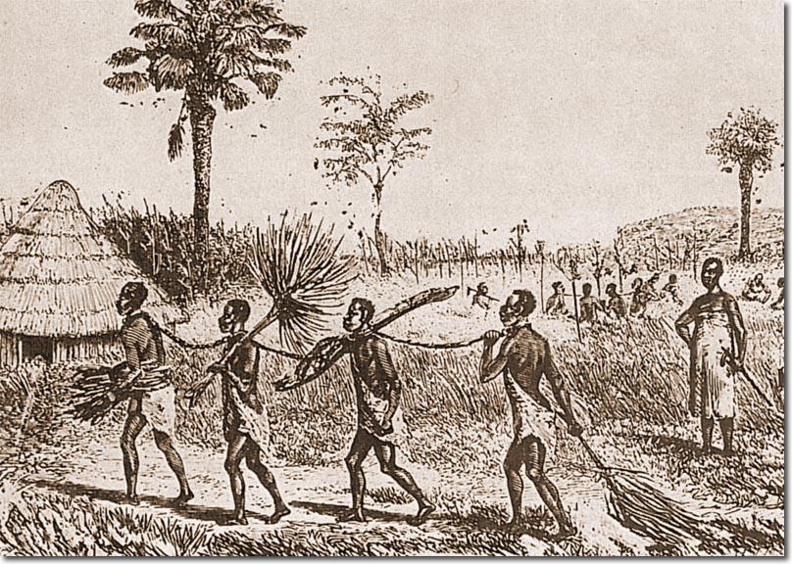
Slave trade in the 19th century(http:google/QRGMKF)

5.1 | Explain your understanding of the following:
5.1.1 | Emancipation of slaves  ____________________________________________________________________________________________________________________________________________ | (2)
5.2 | What led to the abolition of slavery in the Cape?  ____________________________________________________________________________________________________________________________________________ | (2)
5.3 | In which year were slaves freed in the British colonies?  ______________________________________________________________________ | (1)
5.4. | How do you think the Dutch trekboers felt about the abolition of slavery? Give ONE reason for your answer.  ___________________________________________________________________________________________________________________________________________________________________________________________________________________________________________________________________________________ | (3)
5.5 | Write a paragraph in your own words: Where you are a slave owner who is about to lose all his/her slaves because of the abolition of slavery.  Explain your worries of what may happen as well as how you which to be paid back by the British government.  ____________________________________________________________________________________________________________________________________________________________________________________________________________________________________________________________________________________________________________________________________________________________________________________________________________________________________________________________________________________________________________________________________________________________________________________________________________________________________________________________________________________________________________________________ | (5)
5.6 | You are slave who has been freed from slavery. Write a paragraph in which you explain about your joy of being freed, about the four years of apprenticeship and your plans for the future  ____________________________________________________________________________________________________________________________________________________________________________________________________________________________________________________________________________________________________________________________________________________________________________________________________________________________________________________________________________________________________________________________________________________________________________________________________________________________________________________________________________________________________________________________
 | TOTAL:18

Activity 5 Marking guidelines

5.1.1 | Emancipation of slaves refers to the process of abolishing slavery √√
5.2 | Because it was regarded as inhumane and many people in Britain were calling for its abolition√√
5.3 | 5.3. 1843 √
5.4. | angry/ not happy √ because they thought it could cost them a lot to farm successfully as they had always depended on slaves for labour. √√ (Any relevant answer)
5.5 | You are a slave owner  - My most worry is my monthly income of my wine farm.  - The wine that we imported to Britain will be far less than before.  - Even if one considers the compensation from the British government, economy will still be affected because as slave owners we normally not used in paying our slaves they worked for free.  - Giving them rights will make them to have a “say” to their boss. √√√√√
You are a slave who has been freed from slavery.
- Four years of being a slave was like 20years, of hardship and hard labour.
- Remembering those working conditions which were not conducive in most cases.
- We were purchase like cattle and
- Associated in the mind of the owner with his/her value in money.
- Thou I have mixed feelings but the skill I have obtained can take me somewhere in life.
- I can be able to plant grapes and manufacture wine; it is what I will be doing in the next four years and grows my business also creating job opportunities for young people in my community. √√√√√

Activity 6: Northern Frontier of European Expansion settlement
 | Use SOURCE 6A and your own knowledge to answer the following question
SOURCE 6A
Very little expansion occurred to the north of the Cape Colony because of the dry and infertile environment of that region. Farmers battled to farm and could only farm close to rivers or natural springs, because of the low rainfall and arid conditions.
The Indigenous people of the area did not practice permanent settlements but rather moved according to the season. They therefore were pastoralists, living off the milk and meat of their livestock, hunting wild animals and gather wild berries and fruits.
Due to the barren conditions of the northern frontier, very few Europeans settlers settle in the area. It became a place of refuge for runaway slaves and soldiers, and escaped convicts. It was considered a wild and lawless place.
A group of runaway slaves and Europeans settled in this region. There were many mixed relationships resulting in a group of mixed-race people.
e-classroom.

6 | Define the following terms
6.1 | Expansion  ____________________________________________________________________________________________________________________________________________ | (2)
6.2 | Infertile  ____________________________________________________________________________________________________________________________________________ | (2)
6.3 | Pastoral  ____________________________________________________________________________________________________________________________________________ | (2)
6.4 | Mixed relationship  ____________________________________________________________________________________________________________________________________________ | (2)
6.5 | Why did people not settle in the North of Cape town?  ____________________________________________________________________________________________________________________________________________ | (2)
6.6 | What led to the emergence of mixed relationships in this area?  ____________________________________________________________________________________________________________________________________________ | (2)
6.7 | What type of people lived here?  ____________________________________________________________________________________________________________________________________________ | (2)
 | TOTAL :14

 | Activity 6 Marking guidelines
6.1 | Expansion : The action of larger or more extensive √√
6.2 | Infertile: Infertile area or soil is of poor quality so that plants cannot grow in it. √√
6.3 | Pastoral: A famer who breeds and takes care of animals.√√
6.4 | Mixed relationship: Interracial marriage is a form of marriage outside a specific social group. √√
6.5 | Because of the barren conditions of the Northern Cape √√
6.6 | It was because people of different backgrounds or descent lived in this area √√
6.7 | Run-away convicts, runaway slaves and soldiers lived in this area. √√

ACTIVITY 7 Northern Frontier of European Expansion settlement – The Kora
7 | Use SOURCE 7A and your own knowledge to answer the questions that follow
SOURCE 7A
The Kora originated from small group of Khoikhoi who had lost their land to the Dutch in the south-western Cape. The groups included runaway slaves and people of mixed European and Khoikhoi descent. Most of the first Kora used guns and rode horses. They lived in groups along the Gariep River in the central parts of southern Africa.
Platinum p 198

7.1 | Explain the following concepts
7.1.1 | Mixed descent  ____________________________________________________________________________________________________________________________________________ | (2)
7.1.2 | Pack of oxen  ____________________________________________________________________________________________________________________________________________ | (2)
7.2 | Where did the Kora originate?  ______________________________________________________________________ | (2)
7.3 | What advantage did the Kora have in travelling and in defence?  ____________________________________________________________________________________________________________________________________________ | (2)
7.4 | Where did they live?  ______________________________________________________________________ | (2)
7.5 | How did they make their living? Name THREE.  ____________________________________________________________________________________________________________________________________________ | (3)
 | TOTAL : 12
 | Activity 7 Marking guidelines
7.1.1 | Mixed descent: children of Boers, slaves and Khoikhoi. √√
7.1.2 | Pack oxen: oxen trained to carry loads and pull wagons with goods. √√
7.2 | The Kora originated from small groups of Khoikhoi who had lost their land to the Dutch in the south-western Cape. √√
7.3 | The advantage they had in travelling they knew to ride horses and in defense they also knew how to use the gun. √√
7.4 | Along the Gariep River in the central parts of southern Africa. √√
7.5 | Traded in manufactured good√, tobacco√ and pack oxen√.

ACTIVITY 8 :Northern Frontier of European Expansion settlement- The Tswana
 | Use SOURCE 8A below and your own knowledge to answer the following questions
SOURCE 8 A
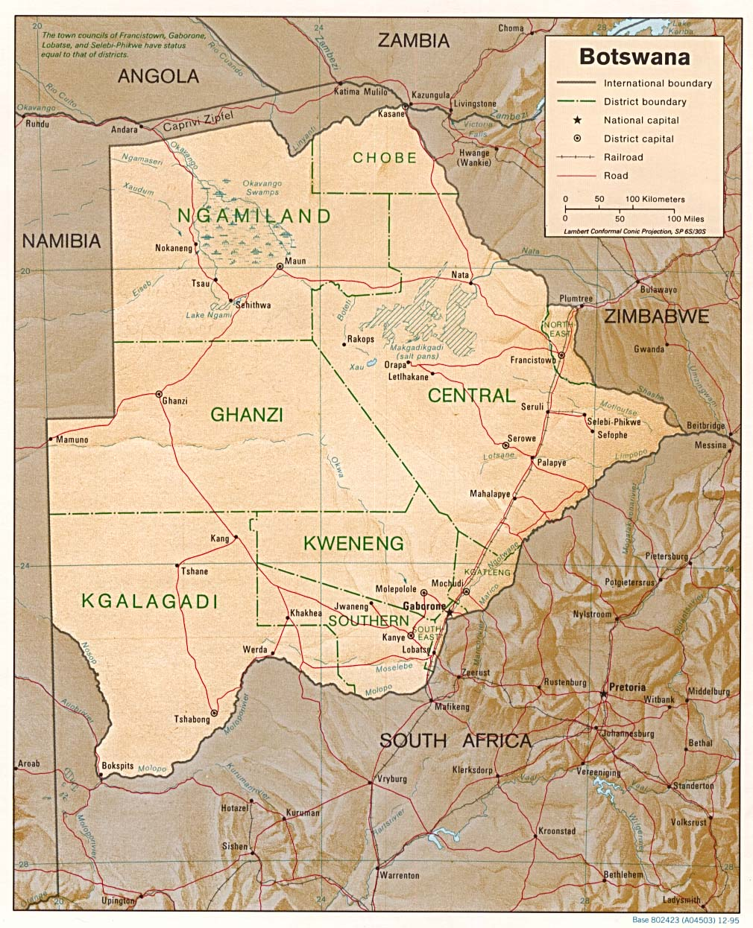
Tswana towns of the early 19th century: (http://www.google.map.co.za)
8.1 | Define the following concept:
8.1.1 | Trade  ___________________________________________________________________________________________________________________________________________ | (2)
8.2 | In which TWO parts of the country do we find the Tswana People?  ___________________________________________________________________________________________________________________________________________ | (2)
8.3 | Name the THREE main Tswana groups?  ___________________________________________________________________________________________________________________________________________ | (3)
8.4 | What things did the Tswana have that the colonists at the Cape wanted? Name SEVEN  ___________________________________________________________________________________________________________________________________________ | (7)
8.5 | Why do you think the Tswana wanted guns?  ___________________________________________________________________________________________________________________________________________ | (2)
 | TOTAL : 16

 | Activity 8 Marking guidelines
8.1.1 | Trade involves the transfer of goods or services from one person or entity to another, often in exchange for money. √√
8.2 | North West and Northern Cape Provinces √√
8.3 | BaTlhaping, √ the BaTlhare√ and the BaRolong √
8.4 | iron, copper, ivory, hides, skins, and furs for beads and cloth from the east coast of southern Africa. √√√√√√√
8.5 | They wanted the guns to protect themselves and their valuable asserts. √√

ACTIVITY 9 Northern Frontier of European Expansion settlement- Missionaries and trader- Case Study Robert Moffat
 | Use SOURCE 9A and your own knowledge to answer the following questions
SOURCE 9
Case study Robert Moffat (1795-1883) at Kuruman
Robert Moffat, born in Scotland, was a Methodist who wanted to convert other people to Christianity. He came to south Africa in 1817 when he was 21 years old. His wife Mary worked with him.
Moffat work among the Griqua and Tswana people. He and Mary settled in Kuruman and built up a mission station there. Moffat translated the Bible into Setswana. The mission station become important. Other missionaries started their work there. Important people from the Cape Colony also stayed there when they were in the area.
The mission station had a church, houses, a school and other buildings. Moffat wrote down the language rules of Setswana. In 1831, he brought a printing press to Kuruman that he could print religious works in Setswana.
Moffat was skilled at carpentry, gardening, farming, printing and working with metals. He was a good negotiator and helped the Tswana people with some of their conflicts in the area. Moffat and his wife went back to Britain in 1870.
e-classroom
9.1 | Who was Robert Moffat?  ______________________________________________________________________  ______________________________________________________________________ | (2)
9.2 | In which town did he build his mission station?  ____________________________________________________________________ | (1)
9.3 | Why was it important that Moffat learnt to speak Setswana?  ______________________________________________________________________  ______________________________________________________________________ | (2)
9.4 | Give TWO reasons why the Kuruman Mission station became important  ______________________________________________________________________  ______________________________________________________________________  ______________________________________________________________________  ______________________________________________________________________ | (4)
9.5 | What was Moffat’s Tswana name?  ______________________________________________________________________ | (1)
9.6 | List any THREE skills that Moffat possessed.  ______________________________________________________________________  ______________________________________________________________________  _____________________________________________________________________ | (3)
9.7 | In an essay describe the role played by Moffat in the Tswana community  ______________________________________________________________________  ______________________________________________________________________  ______________________________________________________________________  ______________________________________________________________________  ______________________________________________________________________  ______________________________________________________________________  ______________________________________________________________________  ______________________________________________________________________  ______________________________________________________________________  ______________________________________________________________________  ______________________________________________________________________  ______________________________________________________________________  ______________________________________________________________________  ______________________________________________________________________  ______________________________________________________________________  ______________________________________________________________________  ______________________________________________________________________  ______________________________________________________________________  ______________________________________________________________________  ______________________________________________________________________  ______________________________________________________________________  ______________________________________________________________________  ______________________________________________________________________  ______________________________________________________________________  ______________________________________________________________________  ______________________________________________________________________  ______________________________________________________________________  ______________________________________________________________________  ______________________________________________________________________  ______________________________________________________________________  ______________________________________________________________________  ______________________________________________________________________  ______________________________________________________________________  ______________________________________________________________________  ______________________________________________________________________  ______________________________________________________________________  ______________________________________________________________________  ______________________________________________________________________  ______________________________________________________________________  ______________________________________________________________________  ______________________________________________________________________  ______________________________________________________________________  ______________________________________________________________________  ______________________________________________________________________  ______________________________________________________________________  ______________________________________________________________________  ______________________________________________________________________  ______________________________________________________________________  ______________________________________________________________________  ______________________________________________________________________  ______________________________________________________________________  ______________________________________________________________________  ______________________________________________________________________  ______________________________________________________________________  ______________________________________________________________________  ______________________________________________________________________  ______________________________________________________________________  ______________________________________________________________________ | (15)

ACTIVITY 9 Marking guideline
9.1 | He was regarded as the father of missionary work in South Africa  It was important for him to learn Setswana so that it can be easy for him to communicate with them well. √√
9.2 | Kuruman√
9.3 | Their main aim was to be able to translate the bible in Tswana so he could convert Tswana people into Christianity. √√
9.4 | Other missionaries started their work there. √√ Important people from the Cape Colony also stayed there when they were in the area√√
9.5 | Moshete of the Bechuanas √
9.6 | Carpentry, gardening, farming, printing and working with metals and a good negotiator (Any THREE) √√√
9.7 | Essay to focus on the following  - Introduced them to Christianity  - Translated bible into Tswana  - Helped Tswana people to become farmers and grow their own food  - Helped the BaTlhapeng in a battle against a rival Tswana group  - (Any other relevant response) (15)

Essay on the abolishing of slavery in the cape
The abolition of slavery in the Cape Colony was a significant event in South African history, marking a turning point in the social and economic fabric of the region. Slavery had been a fundamental part of the Cape's economy and society since the establishment of the Dutch East India Company (VOC) settlement in 1652. The process of abolition, culminating in 1834, was complex and had profound implications for both enslaved people and the wider colonial society.
The Context of Slavery in the Cape Colony
Slavery was introduced to the Cape Colony shortly after its establishment by the VOC. Enslaved people were brought from various regions, including West and East Africa, Madagascar, India, and Southeast Asia, to serve the needs of the European settlers. Slavery became deeply entrenched in the colony’s economy, particularly in agriculture, where enslaved labor was essential for farming and viticulture.
The system of slavery in the Cape was characterized by harsh conditions, with enslaved people facing severe restrictions on their freedoms and enduring brutal treatment. They were considered the property of their owners, with little legal protection, and were subjected to physical punishment, forced labor, and family separation.
The Road to Abolition
The movement to abolish slavery in the Cape Colony was influenced by broader global trends, particularly the abolitionist movement in Britain. By the late 18th and early 19th centuries, public opinion in Britain was increasingly turning against slavery, driven by humanitarian concerns and the efforts of abolitionists like William Wilberforce. The British government, which took control of the Cape Colony from the Dutch in 1806, began to introduce legislation aimed at improving the conditions of enslaved people.
One significant milestone was the 1807 Abolition of the Slave Trade Act, which prohibited the transatlantic slave trade in the British Empire. While this did not end slavery in the Cape, it was a crucial step towards its eventual abolition. Subsequent legislation, such as the 1823 Amelioration Laws, sought to improve the living and working conditions of enslaved people, although these laws were often poorly enforced in the Cape.
The final push for abolition came with the Slavery Abolition Act of 1833, which was passed by the British Parliament and came into effect on 1 August 1834. This Act emancipated all enslaved people in the British Empire, including the Cape Colony. However, the process was not immediate; a system of "apprenticeship" was introduced, requiring former enslaved people to continue working for their former owners for a period of four years, ostensibly to ease the transition to freedom. This system was widely criticized and eventually abolished in 1838, leading to the full emancipation of the enslaved population.
The Impact of Abolition
The abolition of slavery in the Cape had far-reaching consequences for both the enslaved people and the broader society. For the approximately 35,000 enslaved individuals in the colony, emancipation was a momentous event, granting them legal freedom and the right to live and work independently. However, the reality of freedom was often harsh. Former enslaved people faced significant challenges, including poverty, lack of land, and continued discrimination. Many found it difficult to secure employment or to earn a living, as they were now competing in a labor market that still favored white settlers.
For the slave-owning settlers, the abolition of slavery was met with resentment and economic hardship. Compensation was provided to slave owners by the British government, but the payments were often insufficient to cover the loss of their labor force. Many farmers, particularly those in the rural areas of the colony, struggled to adapt to the new economic realities. The loss of enslaved labor led to a decline in agricultural productivity, and some settlers were forced to sell their land or abandon farming altogether.
The abolition of slavery also had broader social and political implications. It marked the beginning of a slow and uneven process of social change in the Cape Colony. While legal slavery was abolished, racial inequalities and discrimination persisted, laying the groundwork for future conflicts and struggles for equality. The legacy of slavery continued to shape the social hierarchies and power dynamics in the colony, influencing the development of South African society for decades to come.
Conclusion
The abolition of slavery in the Cape Colony was a pivotal event that brought about significant social, economic, and political changes. While it marked the end of a brutal and inhumane system, the transition to freedom was fraught with challenges for the formerly enslaved people, who continued to face hardships and discrimination. The abolition also disrupted the economic foundations of the Cape, leading to long-term adjustments in the colony's agricultural sector. Despite the difficulties, the end of slavery was a crucial step towards greater human rights and laid the foundation for future struggles against racial oppression in South Africa.

Essay on role played by missionaries and trader in the cape colony
The role of missionaries and traders in the Cape Colony was significant, particularly in the 19th century as both groups were influential in shaping the social, economic, and political landscape of the region. Their activities were intertwined with the colonial objectives of the British Empire and had a profound impact on the indigenous populations, the spread of Christianity, and the establishment of trade networks.
The Role of Missionaries
Missionaries in the Cape Colony played a central role in the spread of Christianity among the indigenous populations. The arrival of missionaries was part of a broader wave of European missionary activity in Africa, driven by the belief that it was their duty to "civilize" and convert non-Christian populations. Missionaries such as Dr. John Philip of the London Missionary Society (LMS) were instrumental in advocating for the rights of indigenous people. They often acted as intermediaries between colonial authorities and local communities, sometimes challenging colonial policies that they viewed as unjust.
The influence of missionaries extended beyond religious conversion. They established schools, hospitals, and other institutions, promoting literacy and Western education among the indigenous populations. This education was often aimed at assimilating local people into European ways of life, which had both positive and negative effects. On one hand, it provided some individuals with opportunities for social mobility. On the other hand, it contributed to the erosion of indigenous cultures and traditions.
Moreover, missionaries played a role in land disputes. They were often granted land by the colonial authorities, and their missions became centers of European settlement. In some cases, this led to the dispossession of land from local communities, exacerbating tensions between settlers and indigenous populations. Despite their humanitarian intentions, missionaries were also part of the broader colonial project, and their actions sometimes aligned with the interests of the colonial government.
The Role of Traders
Traders were another key group in the Cape Colony, driving the economic development of the region. The Cape Colony, initially established by the Dutch East India Company (VOC) in the 17th century, was a strategic supply station for ships traveling between Europe and Asia. This strategic position made it a hub for trade.
With the arrival of the British in the early 19th century, trade in the Cape Colony expanded significantly. British traders established extensive networks that connected the colony to global markets. They traded in goods such as wool, wine, and agricultural products, which became important exports from the Cape.
Traders also played a role in the expansion of colonial frontiers. They established trading posts in the interior, which often led to the establishment of new settlements and the further encroachment on indigenous lands. The demand for land for agriculture and grazing increased, leading to further conflicts with local populations, such as the Xhosa in the Eastern Cape.
Additionally, traders were involved in the slave trade, which was a significant part of the economy of the Cape Colony until the abolition of slavery in 1834. The demand for labor to work on farms and in households meant that slaves were an integral part of the Cape’s economy. The abolition of slavery had far-reaching economic and social consequences, leading to labor shortages and changes in the economic structure of the colony.
Conclusion
In conclusion, missionaries and traders played crucial roles in the development of the Cape Colony. Missionaries were key in spreading Christianity, advocating for indigenous rights, and introducing Western education, but their work also contributed to the colonization process. Traders were instrumental in establishing the Cape Colony as a key trading hub, driving economic development, and expanding colonial frontiers, but their activities also led to the exploitation and displacement of indigenous populations. Both groups, while acting in their own interests and those of the colonial authorities, had a lasting impact on the history and development of the Cape Colony.

