
1/1/2023
NATURAL SCIENCES
GRADE 7 TMED TERM 3 BOOKLETS:01
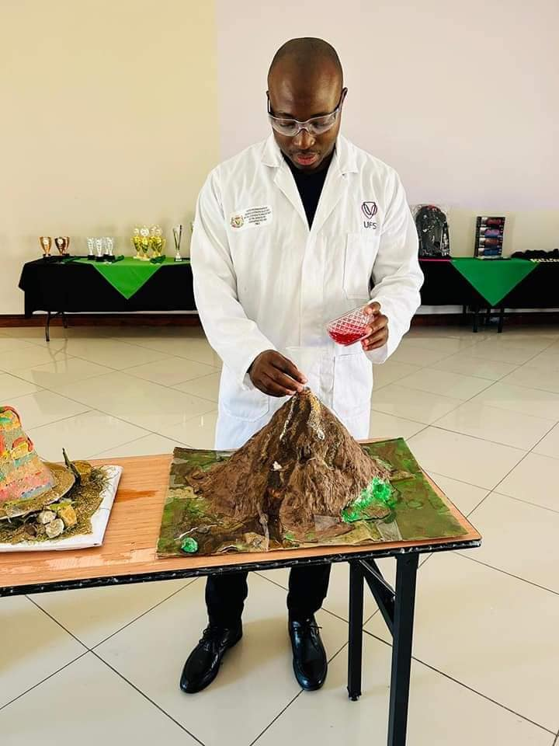

TMED
FSDOE




REVISION ACTIVITY:

SECTION A: Sources of Energy and Potential & Kinetic energy

Question 1
Four options are provided as possible answers to the following questions. Each question only has ONE correct answer. Write only the letter (A-D) next to each question number

1.1 Which of these sources of energy is not mentioned as relying on the Sun?
A. Nuclear energy. B. Fossil fuels.
- Food.
- Wind power. (1)
1.2 An energy source is useful and is stored until we need it.
Fossil fuels are considered to be sources of ...
A. industrial energy. B. biological energy.
- geothermal energy.
- chemical energy. (1)
1.3 Fossil fuels are considered nonrenewable because they …
- produce pollution
- are no longer used by humans C. often contain microscopic animals
D. take millions of years to form (1)
1.4 Sivuyile helped his mother to install a solar generator on the roof of their home. Which statement best explains the advantage of using a solar generator?
A. Solar power is easy to store. B. Solar power is readily available.
- Solar generators can produce energy at all times.
- Solar generators can produce very large amounts of energy. (1)
1.5 The fuel for nuclear energy is ……
A. coal. B. wood. C. water.
D. uranium. (1)
1.6 Most of the chemical energy of petrol burned in a car is not used to move the car. It is changed into —
- electricity.
- heat.
- magnetism.
- sound. (1)
1.7 Which of the following forms of energy is released or absorbed in most chemical
reactions?
- light energy.
- electrical energy. C. sound energy.
D. heat energy. (1)
1.8 Thermal energy from inside the Earth's crust can be harnessed as a useful thermal energy source. Volcanoes, hot springs and geysers are example of this type of thermal energy source. This type of thermal energy is ...
A. called volcanic energy. B. an environmental pollutant.
- a clean alternative to using fossil fuels.
- used to generate fossil fuel resources. (1)
1.9 Energy is the measure of something's ability to do work. Which of the following has the most thermal energy?
A. a dead battery. B. a slushie.
- a cup of hot chocolate.
- a swimming pool. (1)

(9)
Question 2 Study the diagram below showing Elmarie’s house and answer the questions that follow. She uses three methods to generate electricity.

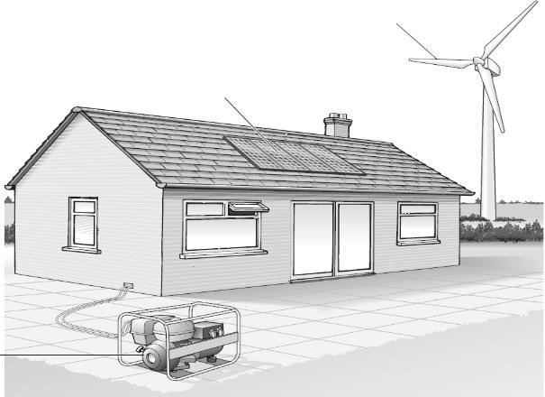

Solar cells

Wind turbine


Petrol
generator
Three methods to generate electricity

2.1 Identify the main energy resource used to generate electricity for each of the methods
indicated in the diagram. (3)
2.2 Give ONE reason why the solar cells cannot not work at night. (2)
2.3 Explain an alternative technology that can be used for solar panels to provide power
overnight. (3)
2.4 What makes the blades of the turbine in the picture above turn? (2)
2.5 Give ONE reason why the wind turbine cannot generate electricity all the time. (2)
2.6 Provide TWO advantages (other than cost) of using wind turbines and solar panel system rather than burning fossil fuels to produce electricity. (2)

(14)
Question 3 The table below gives information about three fuels that can be used in cars.
✓ - shows a substance is produced when the fuel burns.
X - shows a substance is not produced when the fuel burns.

Three fuels that can be used in cars and substances produced when the fuels burns
 |  |  | Some of the substances produced when the fuel burns
Fuel | Physical | Energy released, in kJ/kg | Carbon | Sulfur dioxide | water
Petrol | liquid | 48 000 | ✓ | ✓ | ✓
Hydrogen | gas | 121 000 | X | X | ✓
Ethanol  (alcohol) | liquid | 30 000 | ✓ | X | ✓

3.1 Which fuel, in the table, releases the least energy per kilogram (kg)? (2)
3.2 Some scientists say that if hydrogen is burned as a fuel there will be less pollution.
From the information in the table, give ONE reason why there will be less pollution. (2)
3.3 Which one of the three fuels in the table can be compressed into a small container? (2)
3.4 Which gas in the air is needed for fuels to burn? (1) 3.5 Petrol and ethanol are both fuels. Petrol is made from oil.
Scientists say that oil could run out in 100 years.
In some countries people plant sugar cane and use it to make ethanol.
Sugar cane will NOT run out. Explain why. (2)
(9)

Question 4
Study the diagram below that shows the ride.
The letters A, B, C, D, E and F show different points along the track.
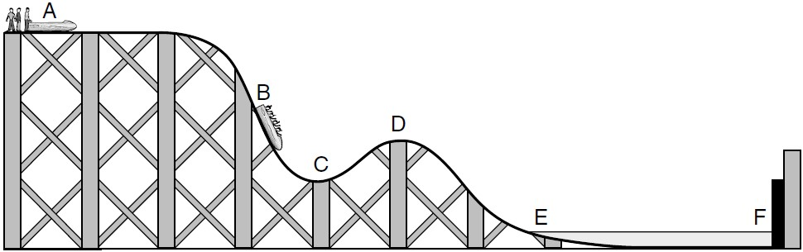

Start

Car

Bumper

Finish

Water

A car ride along the
track

4.1 The car starts from A and travels to F, where it stops by hitting a bumper.
At E the car enters a trench filled with water.
4.1.1 At which TWO points does the car have no kinetic energy? (2)
Give the TWO correct letters.
4.1.2 At which point does the car have the most gravitational potential energy?
Give the correct letter. (1)
4.1.3 At which point does the car have some kinetic energy and the least gravitational potential energy?
Give the correct letter. (1)
4.1.4 The cars are not powered by a motor.
What force causes the cars to move along the track from B to C? (1) 4.1.5 When a car splashes through the water at E, it slows down. What force acts on the car to slow it down? (2)

4.2 Complete the sentences below
When the car hits the bumper at F, its___________ energy is transferred into _____________ energy and _________________ energy. (3)

4.3 Luyanda listens to music on his headphones.
The useful energy change in the headphones is from ____________________
energy into ____________________ energy. (2)
4.4 A rocket exploded making a loud sound and a bright flash.
The learners could see the rocket explode because it gave out ____________ (1) energy.

4.5 Busisiwe replaces the battery of her bicycle light with a generator called a dynamo. When she pedals her bicycle, the back wheel turns the generator.
4.5.1 As Busisiwe pedals, _________energy in her muscles is changed to _____ energy. (2)
4.5.2 When the generator turns, _________energy is changed to useful ______________
energy in the wires. This energy in the wires is changed to useful ___________
energy in the bulb. (3)
4.6 The diagram below shows the battery of a mobile phone being charged.
  Mobile phone containing a battery | 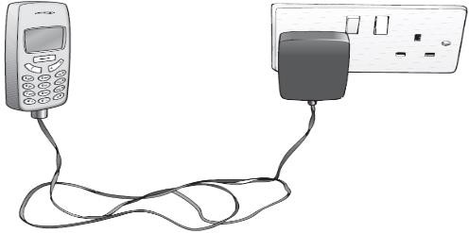  Battery charger

4.6.1 Which energy transfer takes place in the battery as it is being charged? (2)
4.6.2 When the battery is fully charged, a mobile phone is unplugged. Which energy
transfers will take place when the mobile phone rings? (3)
4.7 State the Law of Conservation of Energy. (2)
(25)

Question 5
Study Masego’s investigation. The investigation was conducted with a spring that was compressed a distance (cm) and then released. The height the spring reached (cm) was measured. Answer the questions that follow based on the investigation.
Masego put a spring over a wooden rod | She compresses the spring down 2 cm. | She let go of the spring and  measured the  height it reached.
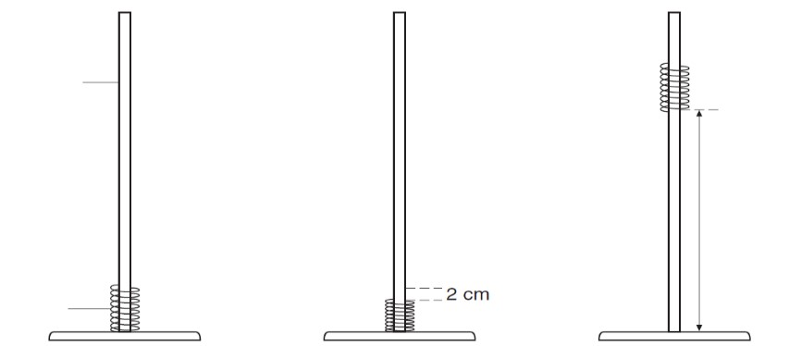
Height
reached

Wooden
rod

Spring

Masego repeated her experiment. She compresses the spring further down each time. Her results are shown in the graph below.
Use Masego ’s graph to complete the table below.



0
10
20
30
40
50
60
70
80
90
0
1
2
3
4
5
Height the spring reached (cm
)
Distance the spring was compressed down (cm)
An investigation with a spring on distance
compressed down (cm) and the height
reached when released(cm)

5.1
Distance the spring was compressed down (cm) | Height the spring reached (cm)
2
3
4

(3)

5.2 Masego said, ‘If I double the distance, I compress the spring down, the height it reaches when released will also double’.
How do the results show she was wrong? (6)
This diagram shows the moving spring in three different positions.

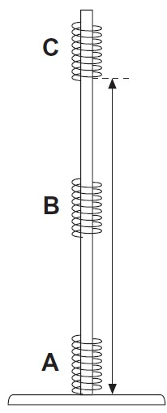
Height
reached

5.3 Complete the sentences below by choosing words from the box.
You can use each word more than once.
most | some | least

5.3.1 When the spring is moving at B it has _________ kinetic energy and ___________ gravitational potential energy. (2)
5.3.2 When the spring reaches C it has _______ gravitational potential energy and
______________ kinetic energy. (2)
5.3.3 When the spring stops at A it has _______________ kinetic energy and
________________gravitational potential energy. (2)

(15)
Question 6 Michael investigated the heating of water. He predicted that the rise in temperature would depend on the volume of water.
The diagram below shows the apparatus he used.

 Thermometer
Stirring
rod

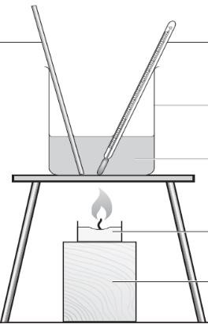  Apparatus to investigate heating of water | 100 cm³ beaker
Water

Candle

Block

Michael recorded his results in a table as shown below.

Beaker | Volume of water, in cm³ | Temperature at start, in °C | Temperature after  2 minutes, in °C
A | 25 | 18 | 30
B | 50 | 18 | 24
C | 75 | 18 | 22

6.1 Identify the independent variable for this investigation. (1)
6.2 Identify the dependent variable for this investigation? (1)
6.3 What equipment was used to determine the dependent variable? (1)
6.4 Why did Michael need to know the temperature of the water at the beginning and at
the end of the experiment? (2)
6.5 6.51 Did Michael’s results support his prediction? (1)
6.5.2 Explain your answer for the question above. (2)
6.6 Michael stirred the water during the experiment.
How did this make his results more reliable? (2)
6.7 Which of the following statements about the energy transferred to the beakers is correct?
- Much more energy went into beaker ‘A’ because its temperature increased the most.
- The same amount of energy went into all three beakers.
- Beaker ‘C’ received the most energy because there was more water to heat. (1)
6.8 After a time, all three beakers cooled down to room temperature. What happened to
the thermal energy in the beakers as they cooled down? (2)
(13)

TOTAL (85)

Memorandum
Question 1
1.1 A. Nuclear energy. (1)
1.2 D. chemical energy. (1)
1.3 D. take millions of years to form (1)
1.4 B. Solar power is readily available. (1)
1.5 D. uranium. (1)
1.6 B. heat. (1)
1.7 D. heat energy. (1)
1.8 C. a clean alternative to using fossil fuels. (1)
1.9 C. a cup of hot chocolate. (1)
(9)
Question 2 2.1 For solar cells it is sunlight For wind turbines it is wind.
For petrol generator it is chemicals (3)
2.2 No light / no rays from the Sun (2)
2.3 Solar-plus-storage technology allow one’s solar panel system to access electricity overnight when solar panel production is dormant, either through connection to the
electric grid or to a battery (3)
2.4 The wind's energy (2)
2.5 They need air movement or 'wind' / the wind might not be strong enough (2)
2.6 • They won't run out
- They cause less air pollution
- No carbon emissions ANY TWO (2)
(14)
Question 3
  - Ethanol or alcohol (2)
  - • burning hydrogen does not produce carbon monoxide
- burning hydrogen does not produce Sulfur dioxide (2)
- burning hydrogen only produces water
- burning petrol causes acid rain ANY ONE
  - Hydrogen (2)
  - Oxygen (1)
  - • It can be grown / it can be replanted / it can be reproduced
- It is renewable (2)
(9)
Question 4
4.1 4.1.1 A and F (2)
4.1.2 A (1) 4.1.3 E (1)
    - Gravity or gravitational force (1)
    - Friction (2) Complete the sentences below
  - When the car hits the bumper at F, its kinetic energy is transferred into sound
energy and thermal / heat energy. (3)
  - From electrical energy to sound energy (2)
  - Light energy (1)
  - 4.5.1 Chemical energy in her muscles is changed to kinetic energy (2)
4.5.2 When the generator turns, kinetic energy is changed to useful electrical
energy in the wires. This energy in the wires is changed to useful light energy in
the bulb. (3)
4.6 4.6.1 Electrical to chemical (2)
4.6.2 Chemical to electrical to sound (3)
4.7 Energy cannot be created or destroyed. It is transferred from one part of a system to
another. (2)
(25)
Question 5
Distance the spring was compressed down (cm) | Height the spring reached (cm)
2 | 20
3 | 45 or 46
4 | 80
5.1

(3)

5.2 the height for 4 cm is 4 times the height for 2 cm the graph is a curve
- the height for 2 cm is not twice the height for 1 cm
- the height should have been 40 cm when he pressed it down 4 cm ANY THREE (6)
5.3 5.3.1 When the spring is moving at B it has some kinetic energy and some
gravitational potential energy. (2)
    - When the spring reaches C it has most gravitational potential energy and least
kinetic energy. (2)
    - When the spring stops at A it has least kinetic energy and least gravitational
potential energy. (2)
(15)
Question 6
  - Independent variable - Volume of water (1)
  - Dependent variable - Temperature (1)
  - Thermometer (1)
  - To see how much the temperature went up / to work out the temperature rise (2)
  - 6.5.1 Yes (1)
6.5.2 Because the smaller the volume the greater the rise in temperature / because the greater the volume the smaller the rise in temperature (2) 6.6 It distributed the hot water throughout the beaker / it made sure the water was heated evenly / to make sure the temperature of the water was the same throughout
(2)
  - (b) The same amount of energy went into all three beakers. (1)
  - It decreased / it was transferred from the water to the surrounding air. (2)
(13)
TOTAL (85)

SECTION B: Heat transfer

Question 1
1.1 How is energy being transferred in the following photos showing different heating processes? Write down conduction, convection or radiation. Some illustrations may show more than one form.

ENERGY TRANSFER PROCESS
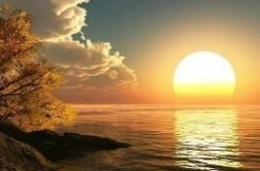
The heat from the Sun travels to the Earth.
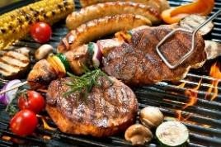
Cooking food on a braai or fire.
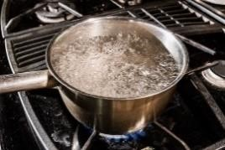
Boiling water in a metal pot.
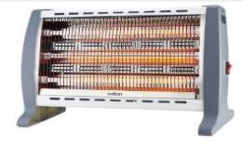

A heater in a room.

1.2 In each of the following situations, identify the method of energy transfer taking place (conduction, convection, radiation).
1.2.1 A fireplace has a glass screen in front of it. The person sitting in a chair next to the fireplace chair feels hot due to ____________________.
1.2.2 When you stir your tea with a metal spoon the handle gets hot because of _____. 1.2.3 When you are lying on the beach your skin feels hot because of ______________.
1.3 Draw an energy transfer Flow Map for the following:
You buy a cup of hot chocolate and hold it in your hands on a cold winter day.
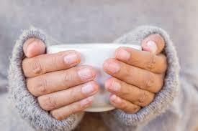

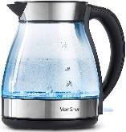
1.4 Explain why the heating element for a kettle is at the bottom and not at the top.
1.5 Explain why you think the water boils throughout the kettle pot and not just at the bottom?
1.6 Why should you place an air conditioner at the top of a room, near the ceiling, rather than at the bottom near the floor?

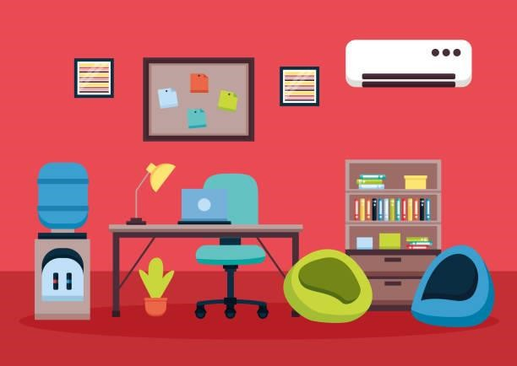

1.7 Imagine you want to build a small enclosure for some chickens on your property. You have an outside area for them that is made from barbed wire, and you have made a small inside, covered enclosure for them out of bricks and cement which you would like to paint. You know that it can get quite cold in winter in your area, so you want the house to be as warm as possible for the chickens. What colour paint are you going to choose to paint the outside of chicken house? Will it be a dark-coloured paint, such as brown or black, or a light-coloured paint, such as white or yellow? Explain your choice.

Memorandum
1.1 Radiation
Convection and some radiation
Conduction (through the metal) and convection (in the water) Radiation and convection
1.2 1.2.1 radiation
1.2.2 conduction
1.2.3 radiation
1.3
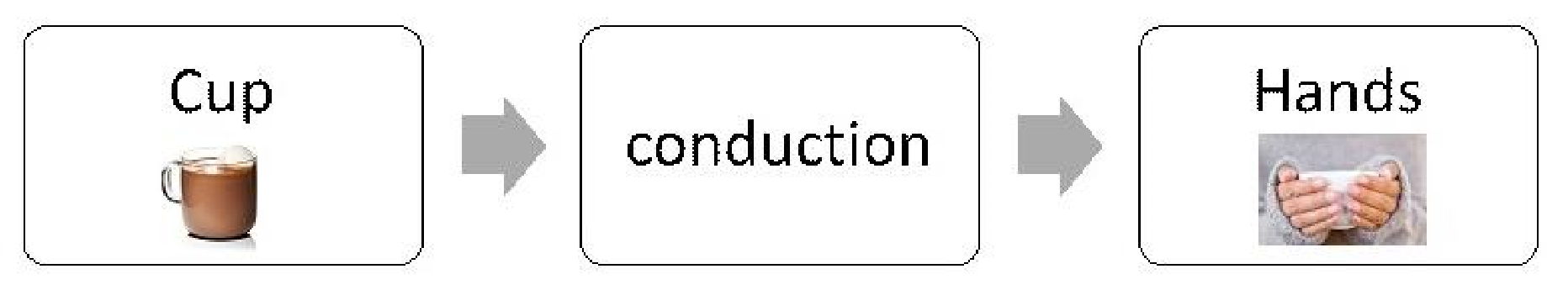

The energy is transferred from the cup to the hands by conduction.
NOTE:
One of the marks is for choosing the correct direction of the energy transfer. The second mark is for drawing it in the form of a flow chart.

1.4 The heating element is at the bottom because as the element transfers energy to the water, the water expands and moves upwards and the colder water (slower moving particles) will sink to the bottom, forming a convection current. This cycle will ensure that all the water is heated as quickly as possible. If the element was at the top, the water at the bottom would take much longer to boil.
NOTE:
Learners must mention the term convection current.
1.5 The water at the bottom of the pot gets hot and then moves to the top of the pot because of convection. This allows the cold water to sink to the bottom and heat up. This constant circulation allows all the water to heat up and boil
1.6 This is because cold air will move downwards, therefore cooling the room, and the hot air will rise and can therefore be removed by the air conditioner at the top of the room, near the ceiling.
1.7 The best choice to keep the house as warm as possible on the inside is a dark-coloured paint. This is because the dark colours absorb more radiant heat from the Sun during the day than the light colours, which reflect heat. The dark paint will absorb the heat and it will be transferred to the air inside of the house, making it warmer, especially during winter.

SECTION C: Electric circuits

Question 1
1.1 Explain in your own words what an electric circuit is.

1.2 In a table below, FOUR electrical components have been listed. For each component:
1.2.1 Draw a symbol used.
1.2.2 Give a function of each electrical component

 | COMPONENT | SYMBOL (1.2.1) | FUNCTION (1.2.2)
1. | Electric wire
2. | Battery
3. | Switch
4. | Bulb

1.3 When you hook up a battery to a complete circuit, what flows from one pole of the battery to the other through the wires?
A. Heat B. Light
- Electricity
- Sound

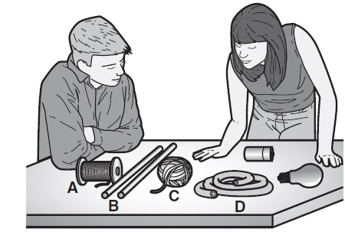
1.4 Learners are gathering materials to build an electrical
circuit. Which material from those that they gathered will allow electricity to flow between the battery and the light bulb?
A. Copper wire B. Wooden dowels C. Cotton string
D. Rubber tube

1.5 Certain substances allow electricity to flow through them. These substances are called conductors. Study the following results from an experiment carefully.

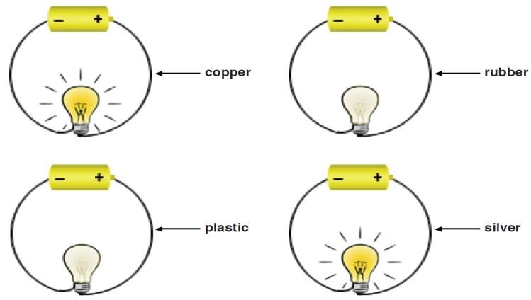

What conclusion can be made based on the findings of the above experiment?
- plastic and rubber are conductors of electricity.
- Silver and copper are conductors of electricity.
- All these substances are conductors of electricity.
- None of these substances are conductors of electricity.

  - Study the circuits below. In which circuit are both bulbs lit?
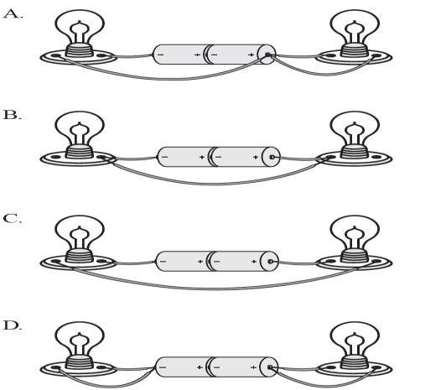

  - Draw a circuit diagram of the circuit shown below.

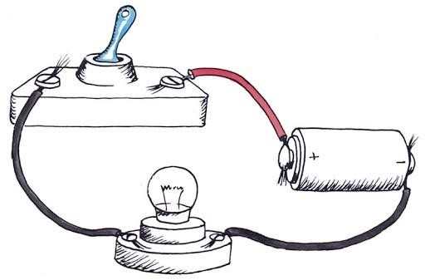

SECTION D: Electrical conductors and insulators

Question 2
2.1 Many electrical wires are wrapped with a plastic coating because plastic is …
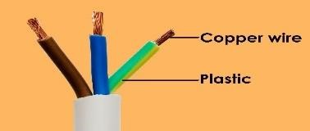
A. less expensive than steel. B. able to keep its shape. C. more dense than copper. D. a good insulator.

2.2 The diagram below shows a three-pin plug and electrical cable.

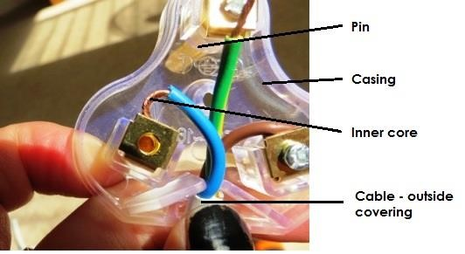

Name a suitable material to make the:
- plug casing, and
- inner core of the cable.
  - Give a reason for each of the choices in material that you have made.
  - Why are insulators important?
  - List four insulating materials.
  - The diagram below shows an incomplete circuit due to a break in the wire between points A and B.

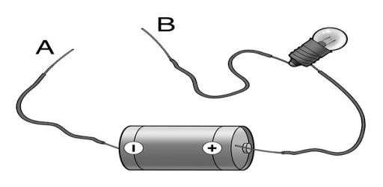

A learner is testing materials to see if they conduct electricity.
The learner places each item in the table below between points A and B, making sure the objects are in contact with the loose end of each wire.

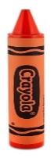 | 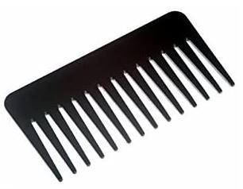 | 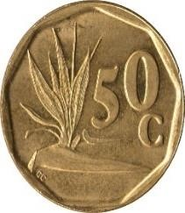 | 
A. Crayon | B. Plastic comb | C. Coin | D. Notepad paper

2.6.1 Which item will allow electricity to flow through it and cause the light bulb to light up?
2.7 The grade 6 learners are testing objects to see if they conduct electricity. The learners use the circuit in the drawing below to test the objects.

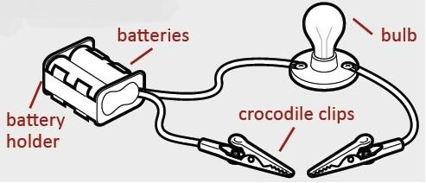

The learners place the following objects between the crocodile clips:
    - paper clip
    - wooden ruler
    - scissors
    - rubber
    - sheet of paper
    - plastic spoon
2.7.1 Explain how you could use these objects to test an item for conductivity? 2.7.2 How will the learners know if an object conducts electricity?
2.7.3 Draw up a table with the following criteria:
      - Object
      - Conductivity
Write yes or no to show if an object can conduct electricity.

2.8 Look at the owl sitting on the pole below.
2.8.1 Why does it not get an electric shock from the power lines?

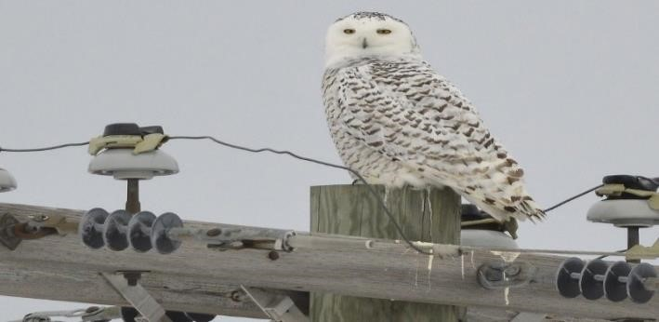

2.9 If you are asked to design gloves that must protect an electrician from getting an electrical shock:
2.9.1 What material(s) would you choose? (Choose from the list below).
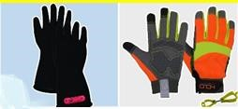
        - Leather • Plastic
        - Vinyl
        - Rubber
        - Cotton cloth • Wood

2.9.2 Why would that material make the gloves safe? 2.9.3 What problems might be experienced with the materials the gloves are made from when making the gloves or when wearing the gloves?

Memorandum

SECTION C: Electric circuits

Question 1
1.1 An electric circuit is a system for transferring electrical energy. It is a complete, unbroken path for electricity.

1.2
 | COMPONENT | SYMBOL (1.2.1) | FUNCTION (1.2.2)
1. | Electric wire |  | Conducting material
2. | Battery | 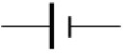 | The source of energy.
3. | Switch | 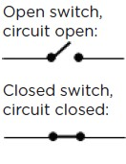 | It is used to turn an electrical device on or off. It controls the flow of energy.
4. | Bulb | 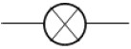 | A device that transfers the electrical energy into another form of energy such as light and heat.

1.3 C Electricity 1.4 A Copper wire
1.5 B Silver and copper are conductors of electricity.
1.6 C
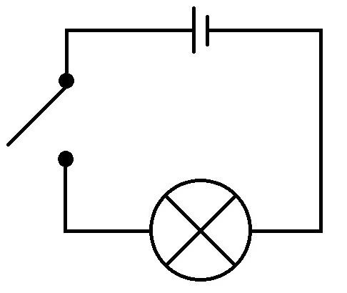
1.7 Circuit diagram

SECTION D: Electrical conductors and insulators

Question 2

2.1 D A good insulator.
2.2 a. Plug casing – Plastic b. inner core of the cable – Copper
2.3 Plastic is a good electrical insulator and copper is a good electrical conductor
2.4 It protects people from an electric shock and in some cases from possible death.
It also protects appliances from damage.
2.5 Any 4 possible answers: glass, plastic, wood, ceramics, rubber, chalk, paper, cardboard, etc.
2.6.1 C Coin 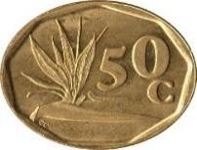
2.7.1 They will clamp each object individually between the crocodile clips to test if they can conduct electricity.
2.7.2 If the object can conduct electricity the bulb will light up.
2.7.3
Object | Conductivity
Paper clip | Yes
Wooden ruler | No
Scissors | Yes
Rubber | No
Sheet of paper | No
Plastic spoon | No

2.8.1 The pole is made from wood which does not conduct electricity. There are also ceramic caps between the power lines and the pole that act as further insulation.
2.9.1 Rubber, cloth and leather
2.9.2 The materials are all poor conductors of electricity.
2.9.3 Rubber – does not absorb moisture. Hands can be very sweaty inside the glove. It would be best to line the rubber with a soft natural fibre like cotton to absorb the moisture. The rubber can also get punctured easily and allows for injuries.

Leather: A leather outer will protect the hands from other injuries. Although the cloth and leather can be sewn the rubber must be moulded. (Any answer where the learner can justify his/her answer).

SECTION E: Heat insulation and energy saving

Problem solving
1.1 You have designed a new material for insulating coffee cups. You're hoping to make money from this new material, but you have to test that it works better than other materials. You arrange a blind test to convince a group of people who might invest in your new company so you can develop it.

The scientist who is performing the test is given 4 different materials, labelled A, B, C and D. One of the 4 materials is your new material you have developed, but she does not know which one it is. This is called a blind test. She takes 4 beakers and wraps each one in a different material. She pours hot water into each beaker. She measures the temperature of the water at the start of the experiment and again 30 minutes later.

The following table shows the results of her experiment:

Timed (minutes) | Material A (ºC) | Material B (ºC) | Material C (ºC) | Material D (ºC)
0 | 70 | 70 | 70 | 70
30 | 34 | 30 | 50 | 48

1.1.1 What is the independent variable for this experiment?
1.1.2 What is the dependent variable for the experiment? 1.1.3 Draw a bar graph of the information collected. Show the starting temperature and end temperature for each material as separate bars.
1.1.4 After the experiment, the results show that your material is the best insulator. Based on the results, which material (A, B, C or D) is yours?
1.1.5 How do you know?
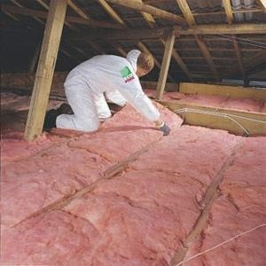
1.2 Look at the following photo showing the inside of a
ceiling in a house being constructed. Do you see the material the person is laying down on the ceiling?

1.2.1 What do you think this is for?
1.2.2 How will it work? 1.2.3 What type of climate do you think this house is
being built in? Why?

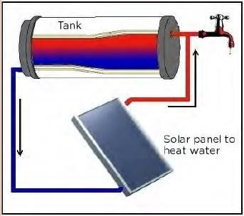
1.3 Study the following diagram showing the parts that make
up a solar water heating system. This is a different type to the one we looked at in the beginning of the chapter. In this solar water heater, instead of evacuated tubes, there is a flat solar panel, called a collector.
1.3.1 What are the parts that make up this system?
1.3.2 Why does it make sense to have the outlet pipe
for the tank to go to the solar panel at the bottom of the tank?
1.3.3 Why do you think the tap is at the top of the tank?
1.3.4 What sort of covering do you think this tank should have to make it the most efficient system?

Memorandum

1.1.1 The type of material is the independent variable. 1.1.2 The temperature of the water is the dependent variable.
1.1.3 Here is an example of the graph.

0
10
20
30
40
50
60
70
80
Material A
Material B
Material C
Materiaal D
Temperature (
o
C)
Type of material
Bar graph showing the starting and end temperatures of coffee
with the cups insulated in different materials
0
minutes
30
minutes

1.1.4 Material C is your material
1.1.5 Material C shows the smallest drop in temperature which means that the material prevented the most energy from transferring to the surroundings
1.2 1.2.1 The pink material is an insulator to prevent heat loss
1.2.2 The material is a poor conductor of heat and so it minimizes heat from being transferred from the air in the house, through the roof and to the outside. The material also traps air in it, and the air is also a poor conductor of heat, increasing the insulation
1.2.3 It is probably being built in a cold climate as extra measures are being taken to reduce heat loss from the house
1.3 1.3.1 The tank, the connecting pipes and the solar panel heater
1.3.2 This is because as the water in the tank cools, it moves to the bottom (convection current) so the pipe at the bottom funnels the cooler water to the heater to be warmed again
1.3.3 Similarly to the previous question, the warm water is pumped from the solar panel heater and into the top of the tank. The warm water collects at the top of the tank as warm water rises (convection current). So, it makes sense to have the tap at the top of the tank to collect the water while it is warm. If the tap was at the bottom, the water would be cooler
1.3.4 It should be covered in an insulating material to conserve heat inside the water and reduce heat loss to the surroundings by conduction

SECTION F: Energy transfer to surroundings

REMEMBER:
- Energy is the capacity of an object/body for doing work.
- Energy is measured in Joule (J).
- When a device transfers energy, only part of the energy is usefully transferred to where it is wanted and in the form that’s wanted.
- The rest of the energy is transformed in a non-useful way, mainly as heat and sound energy. This non-useful energy is called wasted energy.
- The wasted energy and the useful energy eventually end up warming the air around us. In this way the energy becomes more and more spread out into the surroundings and it is then more difficult to use for further energy transfers.
- The efficiency of a device refers to the amount of the input energy which the device transforms into useful output energy.
- The greater the efficiency, the greater is the amount of the input energy which is transformed into useful energy.
- Some energy is always ‘wasted’ so no device is 100% efficient.

DID YOU KNOW:
Energy cannot be created or destroyed but it can be converted from one form into another.
This is called “The principle of conservation of energy”

SANKEY DIAGRAMS
We can clearly represent energy transfers and transformations using Sankey diagrams. The flow
of energy is shown as a large arrow pointing from left to right. If some of the energy is transformed into other types, then the main arrow splits into a number of different arrows.
There are two main rules:
- The thickness of each arrow indicates the amount of energy of that type.
- Because the total amount of energy is always conserved, the combined thickness of the "output" arrows must be equal to the combined thickness of the "input" arrows.

A Sankey diagram represents the energy transfer through a device.  Knowing that energy cannot be created or destroyed, energy input must equal the total energy output:  Total energy + Useful Energy + Wasted Energy | 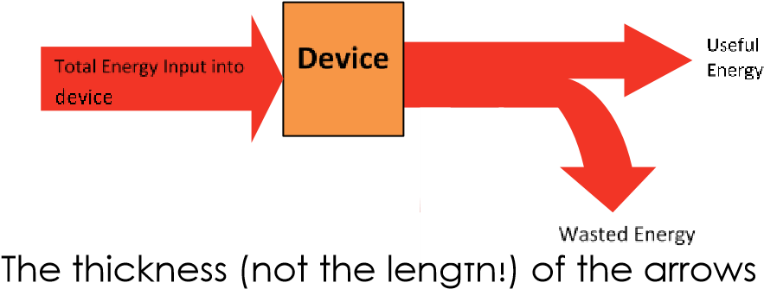  shows how much energy is transferred usefully or wasted.
On the right is a Sankey diagram for the transfer of energy from the spring to the coyote. Before the transfer, all of the energy we're interested in is elastic potential energy in the spring.  - Most of this is converted into kinetic energy in the coyote and the spring as they start to move  - Some of the potential energy in the spring is transformed into heat energy – heat is usually produced whenever things move through air or rub against each other.  - A very small amount of the input energy is transformed into sound energy as the spring goes "TWANG-NG-NG". | 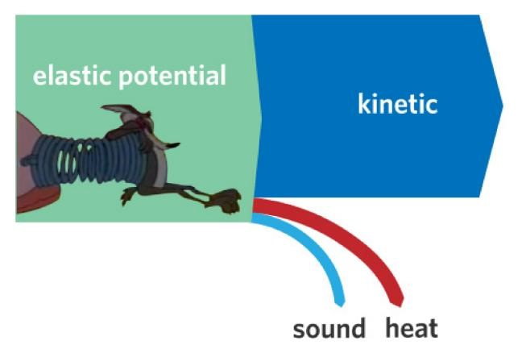

QUESTION 1- ENERGY AND EFFICIENCY

1.1 For the following systems state what type of Energy is used from this list:

Chemical | Kinetic | Heat (thermal) | Sound | Electrical | Light

1.2 Complete the table below: The first one has been done for you.

System |  | Input Energy | Useful Energy | Waste Energy
Car engine | 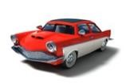 | Chemical Energy | Kinetic | - Heat (Thermal)  - Sound
Light bulb | 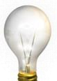
Electric drill | 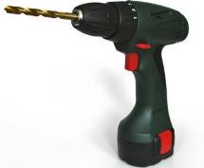 |  |  | 1.  2.
Television | 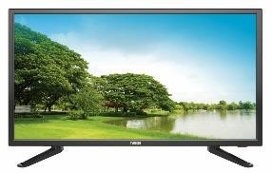 |  | 1.  2.

QUESTION 2 - ENERGY INPUT AND OUTPUT

Complete the table by filling in the missing values. The first one has been done for you.

APPLIANCE | ENERGY INPUT | ENERGY OUTPUT
APPLIANCE | ENERGY INPUT | USEFUL ENERGY | WASTED ENERGY
Television | 500 J electrical energy | 400 J energy [light] | 50 J energy [heat]
Electric drill | ______ J electrical energy | 300 J energy [kinetic] | 70 J energy [heat]
Hairdryer | 350 J electrical energy | ______ J energy [kinetic] | 50 J energy sound]

QUESTION 3 - READING A SANKEY DIAGRAM

3.1 The Sankey Diagram represents energy input and output for a pool pump motor How much thermal energy does the motor produce?

A. 62 joules B. 18 joules
- 60 joules
- 42 joules 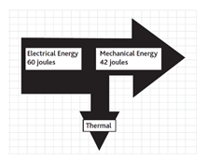

QUESTION 4 - READING A SANKEY DIAGRAM

4.1 Which of the three lights, A, B or C is the most efficient? Give a reason for your answer

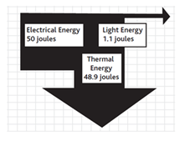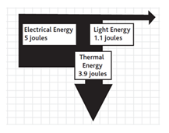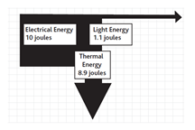

A: Filament Lamp B: LED Lamp C: CFL Lamp

4.2 How much heat energy is emitted by each of the light bulbs in question 4.1?
ANSWER:

Filament  Lamp | ________ joules |  | LED Lamp | ________ joules |  | CFL Lamp | ________ joules

4.3 What is a filament bulb?

4.4 Explain what the letters CFL represent.

Memorandum

QUESTION 1- ENERGY AND EFFICIENCY

System |  | Input Energy | Useful Energy | Waste Energy
Car engine |  | Chemical Energy | Kinetic | - Heat (Thermal)  - Sound
Light bulb |  | Electrical | Light | Heat (thermal)
Electric drill | 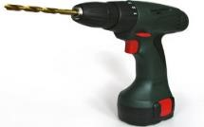 | Electrical | Kinetic | - Sound  - Heat (thermal)
Television | 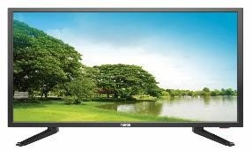 | Electrical | - Sound  - Light | Heat (thermal)

QUESTION 2- ENERGY INPUT AND OUTPUT

APPLIANCE | ENERGY INPUT | ENERGY OUTPUT
APPLIANCE | ENERGY INPUT | USEFUL ENERGY | WASTED ENERGY
Television | 500 J electrical energy | 400 J energy [light]  50 J energy [sound] | 50 J energy [heat]
Electric drill | 400 J electrical energy | 300 J energy [kinetic] | 70 J energy [heat]  30 J energy [sound]
Hairdryer | 350 J electrical energy | 150 J energy [kinetic]  150 J energy [heat] | 50 J energy sound]

QUESTION 3 - READING A SANKEY DIAGRAM

3.1 18 joules

QUESTION 4 - READING A SANKEY DIAGRAM

4.1 The LED lamp is the most efficient as it requires the least amount of Input Energy and also has the least amount of wasted energy in relation to the Filament and CFL lamps.

4.2

Filament  Lamp | 48.9 joules |  | LED Lamp | 3.9 joules |  | CFL Lamp | 8.9 joules

4.3 A filament bulb or also known as incandescent light bulb, is an electric light with a wire filament heated until it glows. The filament is enclosed in a bulb to protect the filament from oxidation. The word Filament itself refers to the wire or thread inside the bulb which lights up when you turn it on.

4.4 CFL stands for compact fluorescent lamp. These light bulbs are the most common type of energy-saving bulb, although LED lights are becoming more popular as they are more energy efficient.

ACKNOWLEDGEMENTS
Pearson Marang (Pty) LTD
Platinum Natural Sciences (Grade 7), Extension and Remediation worksheet Book
Oxford Natural Sciences (Grade 7) textbook.
Google
Kheswa Nkosana Shadrack
Nkosana2225@gmail.com
0738052225
Thabo Mofutsanyana Education District
Western Cape Department of Education
Free State Department of Education.



