

EKURHULENI NORTH DISTRICT

SUBJECT | TECHNOLOLGY
GRADE | 9
YEAR | 2023
TASK | NOVEMBER EXAM
TIME ALLOCATION | 1HOUR 30 MINUTES
MARKS | 80

This paper consist of 11 pages.
INSTRUCTIONS TO LEARNERS:
- This paper consists of THREE sections: Sections A, B and C.
- Read all instructions carefully.
- Answer all Questions - sections A to C.
- Write neatly and answer all the questions in the spaces provided in this question paper.
- Use a pencil for all drawings.
- Where required to calculate show all working out.
- Write your name in the space provided above.
- Use scale 1:1 if the scale is not stated.
- For drawings all construction lines and projections must be shown.

SPECIFIC AIMS:
TECHNOLOGICAL PROCESS SKILLS : SECTION TECHNOLOGICAL KNOWLEDGE AND UNDERSTANDING : SECTION TECHNOLOGY, SOCIETY AND THE ENVIRONMENT : SECTION C
SECTION | ALLOCATED MARKS | MARKS OBTAINED | MODERATED MARK
A | 40
B | 24
C | 16
TOTAL | 80

SECTION A: TECHNOLOGICAL PROCESS SKILLS AND GRAPHIC COMMUNICATION
QUESTION 1
Read the scenario below and answer questions that follow:
Grade 8 learners at your school are struggling finding the right pen or pencil and selecting it from a pencil case straightaway . Often this wastes time at the beginning of lessons.
As a Technology class your teachers has asked you to design a pens, pencils and other stationery holder that will store pencils/ pens in an organised manner manner.
Your solution must:
- Have three compartments to hold pencils, pens and other stationery.
- Have a combination of 2 types of plastics.
- Be stable and durable.

1.1 Identify the problem in the given scenario. (2)

___________________________________________________________________
___________________________________________________________________
1.2 Write a design brief for the given scenario. (2)

___________________________________________________________________
___________________________________________________________________

1.3 List TWO specifications for your design. (2)
1.3.1_______________________________________________________________
1.3.2_______________________________________________________________
1.4 List TWO constraints for your design. (2)
1.4.1_______________________________________________________________
1.4.2_______________________________________________________________
1.5. List THREE tools and THREE materials you would use to make the solution to the given scenario. (6)
Tools | Materials
5.1 | 5.4
5.2 | 5.5
5.3 | 5.6

1.6. Draw a freehand sketch of the solution to the given problem in the scenario. Your solution(idea) must be innovative and you must use labels and notes to explain your design. Use the space provided below. (8)

Assessment criteria for freehand sketch
Criteria | Maximum marks | Marks obtained
Solution addresses the problem (Design brief), specifications and constraints | 2
Solution is free hand( ruler and other instruments not used) | 2
Innovation and creativity | 2
Labels and notes are used | 2
TOTAL | 8

Freehand sketch

QUESTION 2: GRAPHIC COMMUNICATION
2.1 The given figure below is an isometric view of a model. Use your instruments and draw it in a first-angle orthographic projection. Also, draw a projection symbol. Use the assessment criteria as a guide.
Criteria | Maximum marks | Marks obtained
Views are placed correctly | 3
Views are correctly drawn (Front, top and side view) | 3
Linework | 2
Projection symbol | 1
Neatness | 1
TOTAL | 10
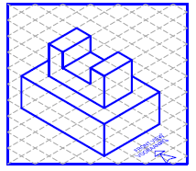

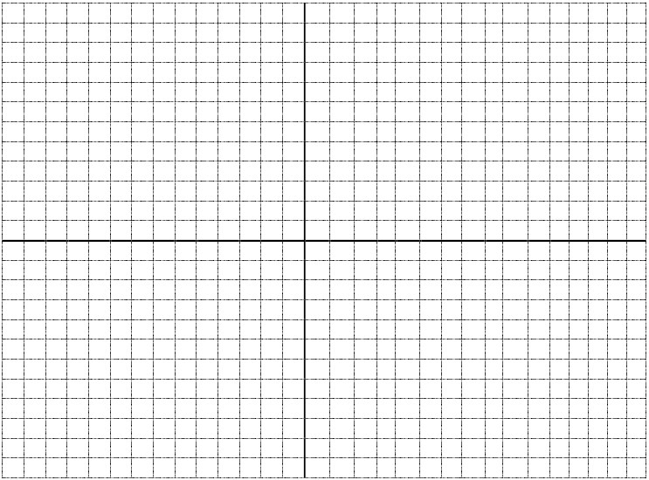

2.2 Use the given information to draw a neat 3D Assembly drawing in exploded view. Use the assessment criteria as your guide. (8)
Criteria | Maximum marks | Marks obtained
Correct technique/ interpretation | 3
Line work ( Outlines, Construction lines, Hidden Details) | 3
Neatness | 2
Total | 8

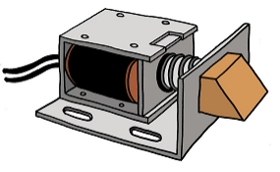


SECTION A: 40 MARKS

SECTION B: TECHNOLOGICAL KNOWLEDGE AND UNDERSTANDING
QUESTION 3
MULTIPLE CHOICE QUESTIONS (4/2 = 2)
3. Read the following statements carefully and CIRCLE the correct answer.
3.1 A metal that can be used to coat an object during electroplating.
A. Copper
B. Gold
C. Zinc
D. All of the above

3.2 Which one of the following is not a method used to preserve food?
A. Pickling
B. Freezing
C. Galvanising
D. Salting

3.3 A good storage container should not:
A. Keep grain cool.
B. protect grain from insects
C. Allow rats and mice to eat the grain
D Keep grain free from moisture

3.4 The type of a switch below is a ____________.

A. Single pole single throw
B. Single pole, double throw
C. Double pole, double throw
D. None of the above

QUESTION 4
Complete the following table by writing the name and drawing the symbol for each component. (8/2=4)
COMPONENT | NAME OF COMPONENT | SYMBOL
4.1 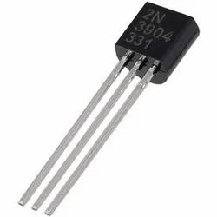
4.2 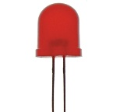
4.3
4.4 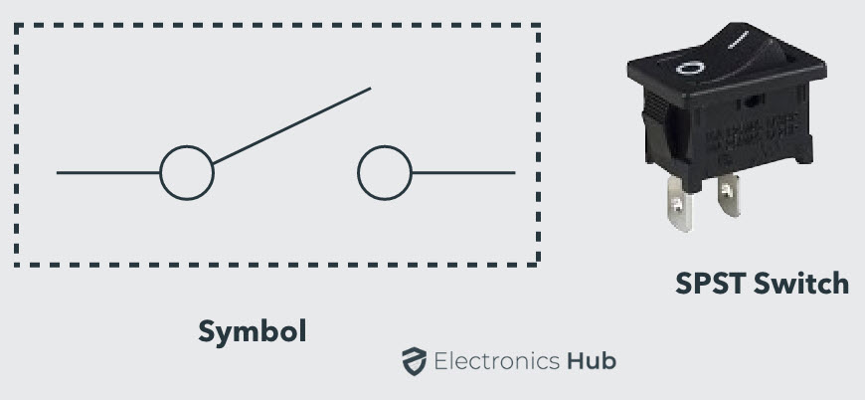

QUESTION 5
Match the description in Column A to the correct answer in Column B. Write only the letter of the correct answer in the space provided. (4)

Column A | Column B
5.1. Process waste materials to make new products | A. corrosion
5.2. Structure used to store grain | B. painting
5.3. Rust formation due to air, humidity and water | C. diodes
5.4. Electronic devices that allow current to flow in one direction only | D. recycle
 | E. silo

5.1. ____________
5.2. ____________
5.3. ____________
5.4. ____________

QUESTION 6
6.1. Complete the truth table for the circuit shown below (4/2=2)
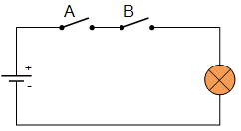
INPUT A | INPUT B | OUTPUT
0
0
1
1

6.2. A practical investigation was conducted on a relationship between potential difference(voltage) and the current in an electrical circuit. The readings below were recorded.

 | With one cell | With two cells | With three cells
Voltage | 1,5 V | 3 V | 4,5 V
Current | 3 mA | 6 mA | 9 mA

6.2.1 Plot these readings below. (3)

6.2.2. What important conclusion can we reach from these readings and the graph? (2)
_______________________________________________________________
_______________________________________________________________
6.3. Calculate the value of the voltage supply in the circuit below if the resistor has a value of 4 Ω and the current through the resistor is 2,5 A. (3)
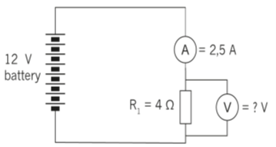

6.4 Refer to the resistor colour code table below and determine the colours of the resistor with a value of 470Ω ±5% . (4)

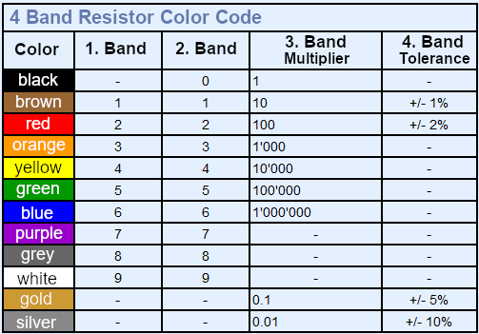

Colours:
Band 1 = ____________________________________
Band 2 = ___________________________________
Band 3 = ___________________________________
Band 4 = ___________________________________

SECTION B: 24 MARKS
SECTION C: TECHNOLOGY, SOCIETY AND THE ENVIRONMENT
QUESTION 7
Read the text below and answer the questions that follow:
Most food products deteriorate as a result of the presence of micro-organisms, such as bacteria, yeast or mould. Remember that not all bacteria is harmful. We need good bacteria to perform certain functions in our bodies and to make certain food products, such as yoghurt and cheese.
In the past, people had to store fresh food so that it was safe to eat long after it was harvested. There were no fridges or freezers to stop food from going off. Fruit and vegetables were dried, salted, pickled or made into jam so that they could be eaten long after they were picked. Dried, pickled, salted foods and jams meant that people had a bigger variety of food and nutrients in their diet for a longer time.

South Africa has a few favourite pickles. Achaar is a traditional pickle that was brought to our country by the Malay people more than a century ago. It can be eaten as a side dish or with curry, and is widely enjoyed, especially in the Western Cape. Achaar is made from vegetables such as cauliflower, carrots, cabbage and beans, that have been finely cut and are mixed together with mustard, turmeric, coriander, vinegar and sugar. Chutney is another favourite South African pickled product, normally made with fruit. For pickling, we can use salt and water or salt, water and an acid, usually vinegar. Vegetables and fish are the two most common food types that are pickled. Pickling preserves the food because the brine creates an environment where oxygen is not present. Thus the micro-organisms contained in and around the food cannot grow and multiply and, in turn, cause the food to go bad. The food to be pickled is placed in a clean glass jar. A hot brine mix is poured over the food and covers it completely. The brine is poured until the jar is full. A clean, tight-fitting lid seals the jar. Pickles last for many months, depending on the type of food. Pickles have become very popular. There are many pickling recipes available, and people often experiment with different combinations of vegetables, herbs and spices.

7.1 Critically discuss THREE advantages of pickling as a method of food preservation.
7.1.1___________________________________________________________ (2)
7.1.2___________________________________________________________ (2)
7.1.3____________________________________________________________ (2)
7.2 Critically discuss THREE disadvantages of pickling as a method of food preservation.
7.2.1___________________________________________________________ (2)
7.2.2___________________________________________________________ (2)
7.2.3___________________________________________________________ (2)
7.3 Load shedding is affecting South Africans in many ways. How does food preservation solve food spoilage problem?
___________________________________________________________ (2)
7.4 How does the increase of wastage of food due to spoilage negatively affect the environment. Provide TWO
7.4.1 ___________________________________________________________ (1)
7.4.2 ____________________________________________________________(1)

SECTION C :16 MARKS

