TECHNOLOGY
CONTENT WORKSHOP
GRADE 7
TERM 2

STRUCTURES

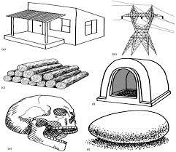
APRIL TO JUNE 2025

STRUCTURES

- DEFINITION OF STRUCTURES
- PURPOSE AND CLASSIFICATION
- STIFFENING OF MATERIALS
- STRENGTHENING OF STRUCTURES
- INVESTIGATE CELLPHONE TOWERS
- LAND LINE VERSUS CELLPHONE TOWERS

WEEK 1

1. Structures
A structure is something that is built, made or put together in a particular way. It can be a strong material; it can be stable and strong and can support loads. Structures serve the following purposes

2. Purpose of structures

Structures are designed for four basic functions:

2.1 To support something – it supports the weight
Examples: chair, table, bed
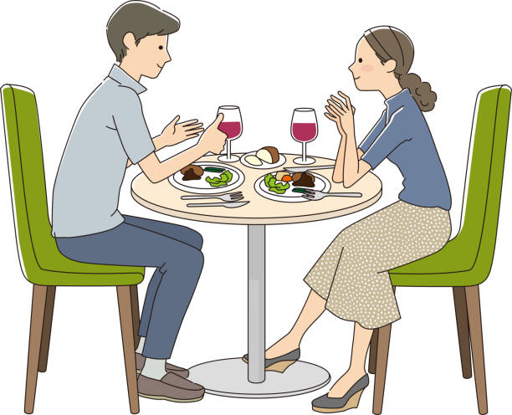

2.2 To contain things – Examples: egg shell, cup, bag

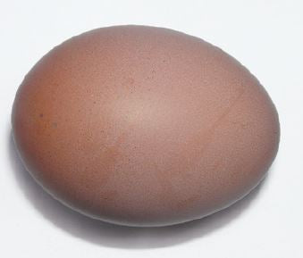

2.3 To span a gap or enclose a distance - a distance between two objects or places to connect them
Examples: a bridge, crane, ladder


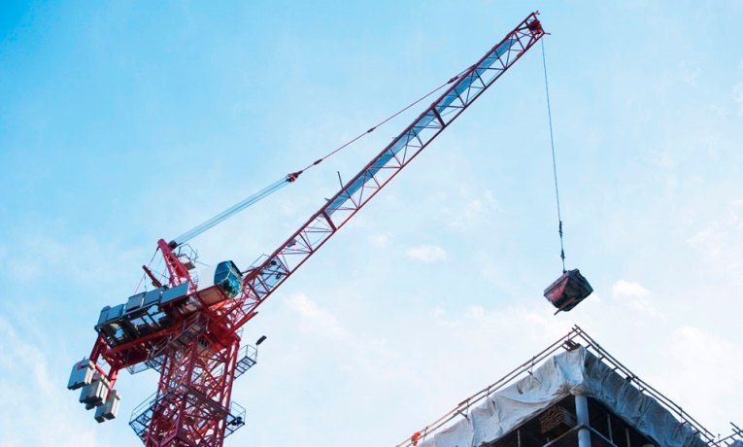

2.3 To protect something - Examples: the helmet, egg container, egg shell




3 .Classification of structures
Structures can be classified into Man-made and Natural structures.

3.1 Natural Structures are structures that are not made by people, e.g. trees, plants and rock formations, e.g. caves, skeletons, skull and bones

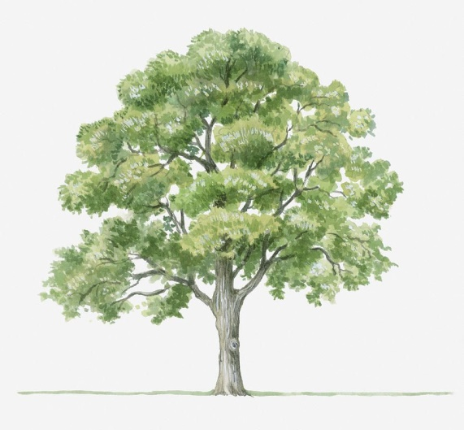
Skeleton Cave Tree

3.2 Man-made structures are structures that are made in workshops and factories which include everything people make, any object, even the packaging, e.g. a tent, towers etc.


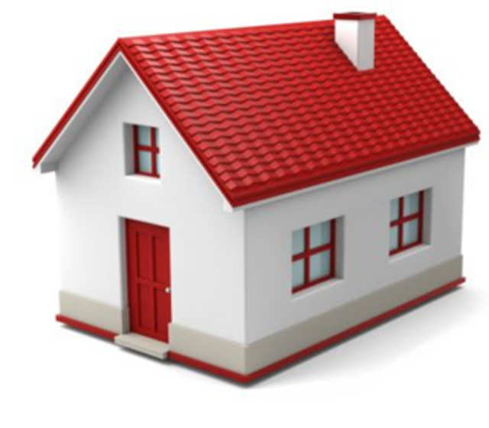 Towers Tent House

WEEK 2

4. Investigation: A cell phone tower as a frame structure

4.1 A cell phone tower is an example of a frame structure. Why do we call this type of tower a frame structure?
4.2 Analyse the definition by looking at the many different pieces used to build the tower. Designers and engineers use triangulation to stiffen and support frames. What is triangulation?
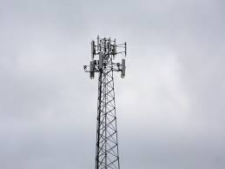

Case study – Examine existing towers strengthened by triangulation

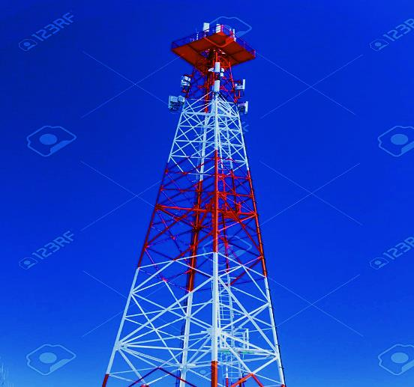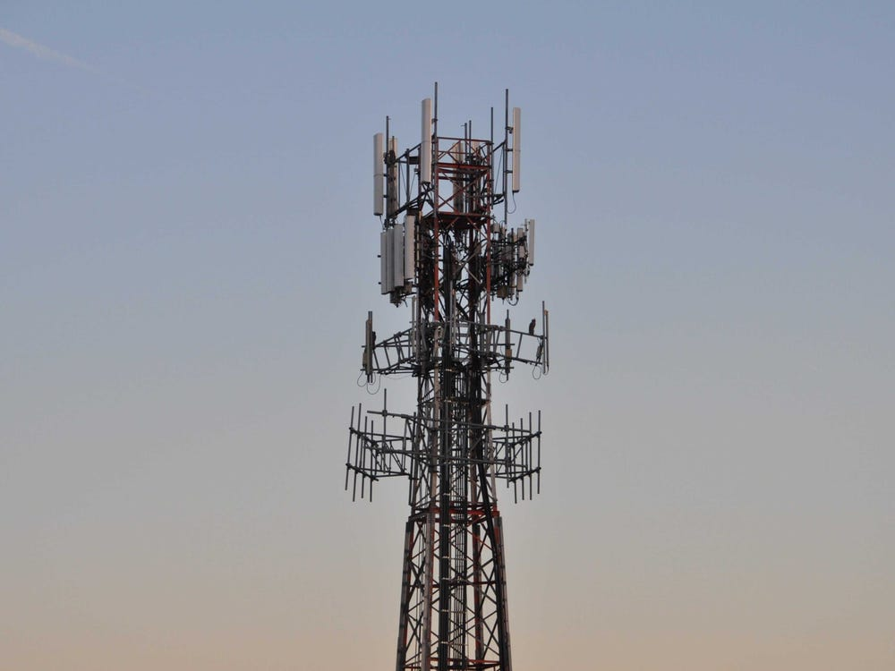
- 2.
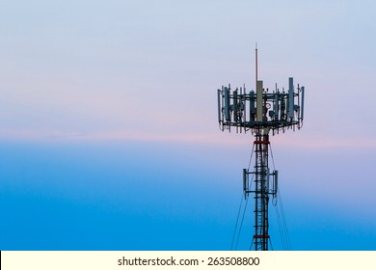
3

WEEK 3
Case study 1 – Existing designs: Examine the features of a school desk; write the design brief with specifications for a school desk.

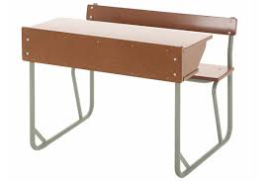
School desk
When you examine existing school desks, you'll find they typically follow a simple, functional design. The surface is usually made from materials like wood, laminate, or plastic, providing a flat area for students to write and place books. The frame is often constructed from metal or sturdy plastic, ensuring stability and long-term use. Many desks have adjustable height features to accommodate students of various sizes. Some designs also include built-in storage, such as drawers or shelves, for organizing stationery and personal items. The legs are often designed with non-slip feet to prevent wobbling and provide stability. In general, the design of school desks focuses on practicality, durability, and comfort to meet the needs of students during their school day.

Case study 2: Examine the features of a school desk and write a design brief with specifications. Examine the examples of school desks below. Think about how you would design and make a new desk. Write notes and make a few free-hand sketches too to help you develop an idea.

When making a cell phone tower, you should use lightweight materials like "elephant grass" or rolled paper dowels for the struts. The structure should be reinforced with triangular webs, gussets, and internal cross-bracing to ensure stability and strength. These elements will help the tower withstand environmental pressures, like wind. Using these materials and design techniques ensures the tower is durable, functional, and environmentally friendly while being easy to build with available resources.

One design idea should focus on disguising the cell phone tower to blend seamlessly with the environment, reducing visual pollution. This could involve shaping the tower to resemble a tree, using materials like bark or foliage for camouflage, or designing it to mimic natural elements like bamboo or a utility pole. The goal is to make the tower less noticeable, ensuring it doesn't disrupt the aesthetics of the surrounding landscape.

For this task, draw two different 3D design ideas for a cell phone tower to be erected near the school, using oblique projection. The first design should focus on a traditional tower structure, incorporating features like triangular webs and cross-bracing for reinforcement and stability. The second design should explore an alternative approach, with unique structural elements such as slanted beams or curved supports, while still ensuring the tower remains strong and balanced. Both sketches should clearly show the dimensions, shape, and reinforcing features, using oblique projection to represent the towers in a 3D perspective.

5. Evaluate the differences by thinking of the advantages and disadvantages of telephone systems.


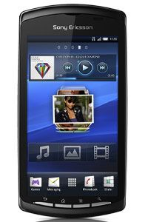
Landline Cellphone

Compare a cell phone (mobile) to a landline phone. First, write a rough copy of the differences in your books. When you write the differences, think of the following: the purpose, safety, cost and the impact on the environment and society

WEEK 4

6. Action research: To stiffen materials/ structures.
Learners must bring newspapers and old paper for this practical activity. We will be rolling paper into tubes and folding paper and using triangular shapes to stiffen materials. We all know that a flat sheet of paper is not strong enough to carry a heavy weight. However, we can change the character of a sheet of paper by changing its shape. For example, we can form it into a tube which will be strong and stable enough to build affordable and sturdy structures. We can use the following processes to change the characteristics of a material
Folding –bending something flexible over on itself so that one part of it covers another part.

Triangulation is the technique of building a structure out of triangular shapes to increase the strength of the structure.

Tubing – a piece of tube or a system of tubes.

7. Research: Find pictures of existing cell phone towers noting structural elements, reinforcing techniques and design issues such as visual pollution, stability, base size and centre of gravity. Remember that the taller the structure, the bigger the base needs to be.

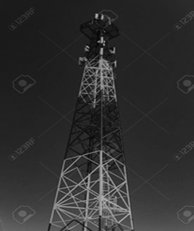

WEEK 5

Design Brief: Write the design brief: Individual learners write the design brief with specifications for a new cell phone tower.

Note: 1. At a minimum, the cell phone tower can consist of struts made of found materials like “Elephant grass” or rolled paper dowels.
It should show reinforcing using triangular webs, gussets and internal cross bracing.

One design idea should focus on disguising the cell phone tower to blend seamlessly with the environment, reducing visual pollution. This could involve shaping the tower to resemble a tree, using materials like bark or foliage for camouflage, or designing it to mimic natural elements like bamboo or a utility pole. The goal is to make the tower less noticeable, ensuring it doesn't disrupt the aesthetics of the surrounding landscape.

For this task, draw two different 3D design ideas for a cell phone tower to be erected near the school, using oblique projection. The first design should focus on a traditional tower structure, incorporating features like triangular webs and cross-bracing for reinforcement and stability. The second design should explore an alternative approach, with unique structural elements such as slanted beams or curved supports, while still ensuring the tower remains strong and balanced. Both sketches should clearly show the dimensions, shape, and reinforcing features, using oblique projection to represent the towers in a 3D perspective.

Draw two free-hand 3D sketches of different cell phone tower designs for a location near the school, using oblique projection. The first design should feature a traditional tower with reinforcing elements like triangular webs and cross-bracing. The second design should explore a different structure with unique supports or angles, still ensuring stability. Both sketches should clearly show the shape, dimensions, and supporting features in a 3D view.

WEEK 6

Form groups to examine and discuss each individual’s cell phone tower design. Evaluate the advantages and disadvantages of each sketch, focusing on stability, practicality, and aesthetics. After the discussion, revise your design based on the group’s feedback, making necessary improvements to enhance its functionality and visual appeal.

Form groups to examine and discuss each individual’s cell phone tower design. Within the group, evaluate the advantages and disadvantages of each sketch, considering factors like stability, practicality, and aesthetics. After the discussion, each learner should adapt their design based on the group’s feedback, making necessary improvements to enhance its functionality and visual appeal.

WEEK 7

In the making stage, each learner will create a working drawing of his or her cell phone tower, showing one face in 2D. This stage involves selecting materials and tools for construction. Learners will list the resources they plan to use, including materials like "elephant grass" or rolled paper dowels and the necessary tools for assembly. Informal assessment will take place throughout this stage as learners develop their working drawings and gather their resources, with feedback given on their design and choices.

WEEK 8

Revise and consolidate term 1 and 2 content in preparation for formal test.

WEEK 9
Revise and consolidate term 1 and 2 content in preparation for formal test
WEEK 10

Administration of Test
WEEK 11

Stiffening of materials Frame structures

ACTIVITIES

ACTIVITY 1

  - Write a simple definition to explain or define a structure
_________________________________________________________________________________________________________________________________________________________________________________________________________

  - What are the functions of structures?
_________________________________________________________________________________________________________________________________________________________________________________________________________

  - Classification of structures:

1.3.1Natural structures- Give three examples
_________________________________________________________________________________________________________________________________________________________________________________________________________

1.3.2 Man-made structures- Give three examples

_________________________________________________________________________________________________________________________________________________________________________________________________________

ACTIVITY 2

Types of structures:

2.1 Give three examples of shell structures
_________________________________________________________________________________________________________________________________________________________________________________________________________

2.2 Give three examples of frame structures
_________________________________________________________________________________________________________________________________________________________________________________________________________

2.3 Give three examples of solid structures
_________________________________________________________________________________________________________________________________________________________________________________________________________
2.4 Landline vs. mobile. Learners complete a table

 | Mobile Phone | Landline Phone
Advantages
Disadvantages

ACTIVITY 3 (Practical activity)

3.1 Stiffening and strengthening structural materials

3.1.1 Making and testing tubes

3.1.2 How to strengthen and stiffen structural material through folding

3.1.3 How to stiffen a frame structure by triangulation

3.2 Explain the following terms

3.2.1 Stability of a structure
________________________________________________________________________________________________________________________________

3.2.2 Cross bracing
________________________________________________________________________________________________________________________________

3.2.3 Visual pollution
________________________________________________________________________________________________________________________________________________________________________________________________

2.2.4 Centre of gravity

3.3 Identify features of a school desk, write design brief with specifications.

________________________________________________________________________________________________________________________________________________________________________________________________________________________________________________________________________________________

ACTIVITY 4

Explain the concept “visual pollution”
____________________________________________________________________________________________________________________________________________________________________________________________________________________________________________________________

