SP: SOCIAL SCIENCE
GRADE 7: TERM 4
HISTORY: LEARNER BOOKLET

Learner Name: __________________________Grade: 7A_________
CO-OPERATION AND CONFLICT ON THE FRONTIERS OF THE CAPE COLONY IN THE EARLY 19TH CENTURY
THE ARRIVAL OF THE BRITISH AND THE EXPANDING FRONTEIRS OF EUROPEAN SETTLEMENT
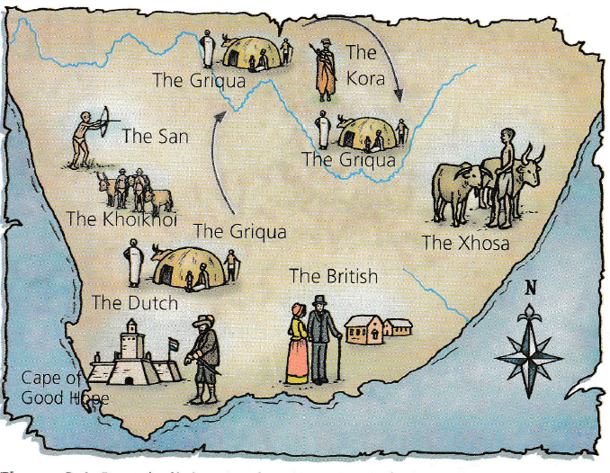

CONCEPT | DEFINITION
Frontier | An area of land where two different groups meet, and fight for control of the land.
Empire | A group of countries controlled by the government of another country.
Indigenous people | People who live in the place where they were born/local people.
Seized | Take hold of suddenly and forcibly
Profitable | Geographical Cape was the trade route from Europe to the East, and that was going to make more money for them, hence they wanted to make sure that they controlled it.
Communal | Shared by all members of a community for common use
Lobola | Payment made by a man to the family of his bride
Trek Boers | Were nomadic pastorals descended from mostly Dutch colonists, French Huguenots and German Protestants in the Cape colony
Guerrilla Warfare | Fighting by making sudden attacks in small groups.
Ceded | To give your land away without a fight
Gallant | of a person or their behaviour of being brave or heroic
Kraals | land or huts with a fence or wall around it
King | Male ruler of an independent state especially the one who inherits the position by right of birth
Fertile | of soil or land producing abundant vegetation or crops
Imprisoned | State of being imprisonment , captivity
Brave | Ready to face and endure danger or pain, showing courage
Loyal | Showing firm and constant support to a person or institution
Fearless | Showing a lack of fear
Hatred | Intense dislike or to hate
Magistrate | A civil officer who administers the law, especially one who conducts a court that deals with manor offences and hold preliminary hearings for more serious ones.
Peace | Freedom from disturbances, tranquillity
Respect | A feeling of deep admiration for someone or something elicited by their abilities, qualities or achievements
Calmed | Not showing nervousness, anger or other strong emotions
Raids | A rapid surprise attack on an enemy by troops or other armed forces
Unfair | Not based on or behaving according to the principles of equality and justice.
Empathy | The ability to understand and share the feelings of another
Abolish | Formally put an end of a system or practice
Conflict | A serious disagreement or argument between people
Great Trek | Migration of Dutch speaking settlers who travelled by wagon trains from the Cape Colony into the interior.
Disrupted | An interrupt process by causing a disturbance or problem
Black ivory | farmers raided local communities and stole their children. They were called “black ivory” because they were vulnerable.
Orphans | A person without living parents to care for.
'inboekselings' | The farmers had to register (or book in) the children they brought back from the raids, with the magistrate of the district.
The Khoisan | They were a mixture of Khoikhoi and San people.
The Boers | They were the descendants of the Dutch people from the Cape Colony.
The Oorlams | Their ancestors were from different groups - some were a mix of Boer and Khoikhoi, or slaves and Khoikhoi, or Boer and slaves. They spoke Dutch (Afrikaans).
The Tswana | They were African people who spoke Setswana and ruled by chiefs.
Mixed descent | children of boers, slaves and Khoisan
Pack oxen | oxen trained to carry loads and pull wagons with goods
The Kora and Griqua. | The Kora and Griqua were groups of people of mixed descent and runaway slaves who had left the Cape Colony.
Adam Kok | Founder of the Griqua was a freed slave.
Missionaries | A person sent on a religious mission, especially one sent to promote Christianity in a foreign country.



