GRADE 7 SOCIAL SCIENCES WORKSHEETS TERM 3
POPULATION CONCEPTS
WORKSHEET 1 A
1.1. Define the following concepts:
a) Population (2)
____________________________________________________________________________________________________________________________________________________________________________________________________________________________________________________________________________
b) Birth rates (2)
_________________________________________________________________________________________________________________________________________________________________________________________________________
c) Death rates (2)
_________________________________________________________________________________________________________________________________________________________________________________________________________
d) Infant mortality rates (2)
____________________________________________________________________________________________________________________________________________________________________________________________________________________________________________________________________________

e) Life expectancy (2)
____________________________________________________________________________________________________________________________________________________________________________________________________________________________________________________________________________
1.2 What do you understand by this term population growth and change in geography? (4)
_______________________________________________________________________________________________________________________________________________________________________________________________________________________________________________________________________________________________________________________________________________

1.3 Indicate four ways which contributes towards the growth of a population (6)
__________________________________________________________________________________________________________________________________________________________________________________________________________________________________________________________________________________________________________________________________________________________________________________________________________________
1.4 Study the chart below of both low and high birth rates and answer the questions that follows:
COUNTRIES | BIRTH RATES
Niger | 6.9
Chad | 6.6
Mali | 6.5
Somalia | 6.4
Angola | 6.3
Japan | 1.4
Italy | 1.2
Spain | 1.1
Germany | 0.8
Hungary | 0.7

1.4.1 Which countries have the highest birth rate (5)
______________________________________________________________________________________________________________________________________
1.4.1.2 Which continent have the least birth rate (2)
______________________________________________________________________________________________________________________________________
1.4.1.3 What are the reasons behind the low birth rates on the chart (3)
_________________________________________________________________________________________________________________________________________________________________________________________________________I

Total: 30

POPULATION CONCEPTS
WORKSHEET 1 A : MEMO
1.1 Population
- It’s a total number of people living in a particular place (2)
b) Birth rates (2)
- The number of babies born per 1000 people in a population
c) Death rates (2)
- The number of people who die per 1000 people in a population.
d) Infant mortality rates (2)
- Is the number of death of infants under one year per 1000 live.
e) Life expectancy (2)
- It is the average number of years that a person is expected to live.
1.2 What do you understand by this term population growth and change in geography? (4)
Population growth
- it is the increase in the number of people living in a place over time
Population change
- It’s an overall change of number of people in a place over time looking whether the change is because of population increasing or decreasing
1.3 Indicate four ways which contributes towards the growth of a population (8)
- Birth rate: The number of babies born per 1000 people in a population
- Death rate: The number of people who die per 1000 people in a population.
- Infant mortality: Is the number of death of infants under one year per 1000 live births. It means many babies are dying affecting population growth
- Life Expectancy: It is the average number of years that a person is expected to live. If people live longer the population will grow if they don’t live the population will decrease

1.4 Study the chart below of both low and high birth rates and answer the questions that follows:
COUNTRIES | BIRTH RATES
Niger | 6.9
Chad | 6.6
Mali | 6.5
Somalia | 6.4
Angola | 6.3
Japan | 1.4
Italy | 1.2
Spain | 1.1
Germany | 0.8
Hungary | 0.7

1.4.1 Which countries have the highest birth rate (5)
Niger, Chad, Mali, Somali, Angola
1.4.1.2 Which continent have the least birth rate (2)
Europe
1.4.1.3 What are the reasons behind the low birth rates on the chart (3)
It can be that the people in Europeans countries have access to quality health care
Their economic status, they regard they can only afford to have small family and their believes is in small family.

Total: 30

POPULATION CONCEPTS
WORKSHEET 1 B
- Study the map showing infant mortality in 2012 to answer the questions below.
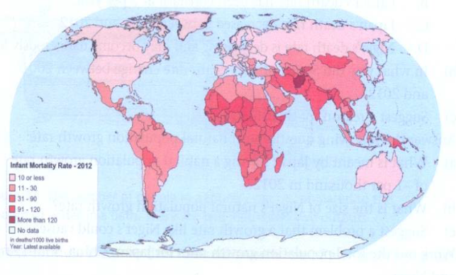
Infant mortality in 2012 – every country is affected in some way

  - Which continent had the lowest infant mortality rate? (1)
_______________________________________________________
  - Which continent generally had the highest death rates for infants? (1)
_______________________________________________________
  - Name two countries on that continent where more than 90 infants out of every 1 000 die. (2)
______________________________________________________________________________________________________________________

High infant mortality rates:
  - Suggest two causes for some countries having so many babies dying. (2)
______________________________________________________________________________________________________________________
  - What can be done to improve the chances of babies living to reach their first birthday? (2)
______________________________________________________________________________________________________________________

Total: 08

POPULATION CONCEPTS
WORKSHEET 1 B: MEMO
- Study the map showing infant mortality in 2012 to answer the questions below.

  - Which continent had the lowest infant mortality rate? (1)
- Australia
  - Which continent generally had the highest death rates for infants? (1)
- Africa
  - Name two countries on that continent where more than 90 infants out of every 1 000 die. (2)
- Chad
- Niger
- Mali
Any country shaded with colour of more than 120

High infant mortality rates:
  - Suggest two causes for some countries having so many babies dying. (2)
- Because of wars
- Countries are poor
- Poor health care systems
Any other relevant correct answer
  - What can be done to improve the chances of babies living to reach their first birthday? (2)
Discourage wars
Improve health care system
Improve economic status of countries
Any other relevant correct answer

Total: 08

World population growth (Pattern of world population growth from 1 AD to present day (interpreting a line graph)

WORKSHEET 2
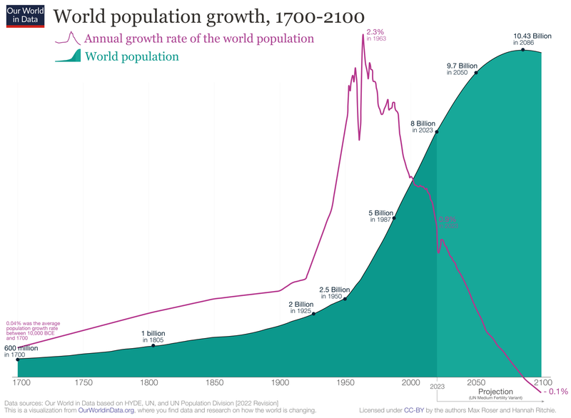
STUDY THE GRAPH ABOVE AND ANSWER THE QUESTIONS THAT FOLLOWS
2.1. What was the world population in 1 AD? (1)
2.2. How many years did it take the world population to reach 1 billion? (2)
2.3. How many years did it take the world population to reach 2 billion? (2)
2.4. What is the projected population of the world in 2050? (1)
2.5. What are some of the factors that have contributed to the growth of the world population? (4)

Total: 10
World population growth (Pattern of world population growth from 1 AD to present day (interpreting a line graph)

WORKSHEET 2: MEMO
2.1. 600 Million (1)
2.2. 100 years (2)
2.3. 225 years (2)
2.4. 9.7 Billion (1)
2.5. Improved health care, improved understanding of diseases and infections and sanitation (4)

Total: 10

WORKSHEET 3
Developments that have affected population growth [Widespread illnesses such as HIV and AIDS, tuberculosis, malaria, diarrhoea]
Use the map below and answer questions that follow:
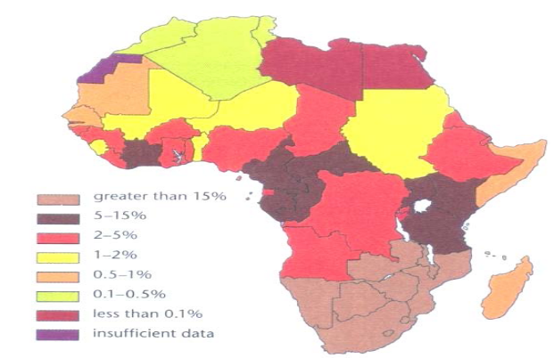

PERCENTAGE OF THE POPULATION INFECTED WITH HIV

- Name 4 countries which have the highest percentage of people with HIV and AIDS (4)
________________________________________________________
________________________________________________________
________________________________________________________
________________________________________________________
2. Explain how the following diseases are spread: (3)
a) Malaria
____________________________________________________________________________________________________________________________
b) Diarrhoea
____________________________________________________________________________________________________________________________
c) HIV and AIDS
________________________________________________________________________________________________________________________

3. Name one way to prevent the spread of malaria. (1)
___________________________________________________________________
4. What is the simplest way to treat a person with diarrhoea? (1)
______________________________________________________________________________________________________________________________________
5. Which of the diseases has no cure? (1)
___________________________________________________________________
6. In which part of Africa is there a risk of being affected with malaria? (1)
___________________________________________________________________
7. Which is the only Southern African country that is not a malaria area? (1)
___________________________________________________________________
8. Why do people with HIV often get TB? (1)
___________________________________________________________________
9. Study the pictures below and write a paragraph about impact of HIV on population. (5)
Your paragraph should include the following points:
- What is HIV?
- Impact of HIV on population.
- What measures are in place for the prevention of HIV?
.
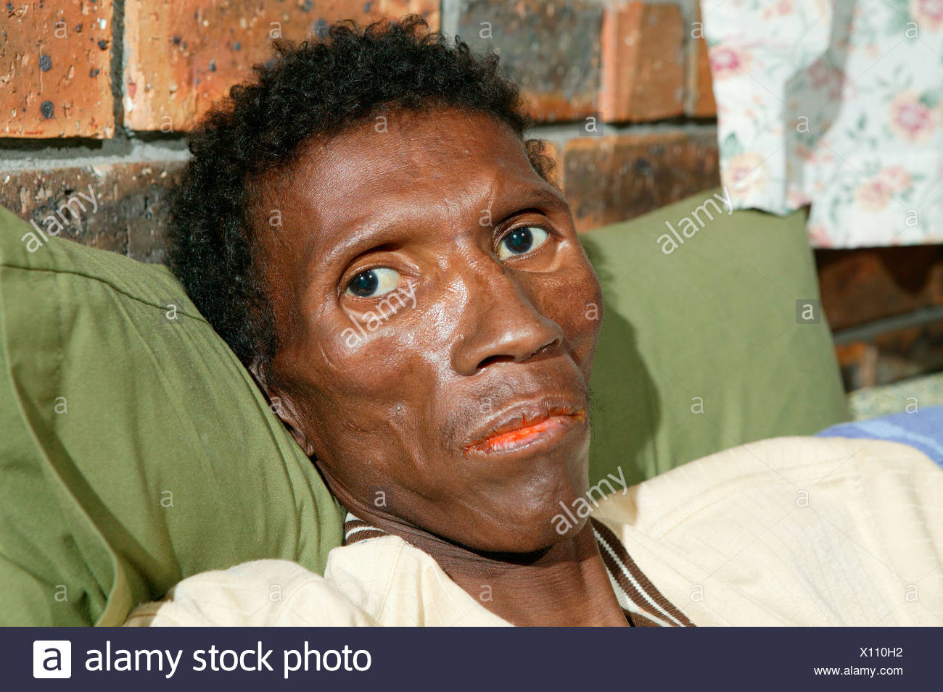 | 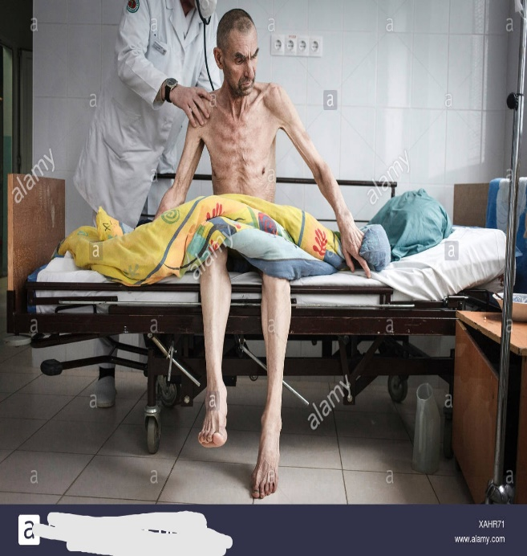

___________________________________________________________________________________________________________________________________________________________________________________________________________________________________________________________________________________________________________________________________________________________________________________________________________________________________________________________________________________________________________________________________________________________________________________________________________________________________________________________________________________________________________________________________________________________________________________________________________________________________

Total: 18

WORKSHEET 3: MEMO
- Southern African countries [South Africa, Botswana, Lesotho, Swaziland, Mozambique, Namibia]

- Malaria spread when an infected person is bitten by mosquito and transports it to another person who is not infected.
- Diarrhoea spread when flies feed on faeces of an infected person and contaminate food.
- HIV & AIDS spread when unprotected sex is practised with an infected person, blood contact with an infected person.
- Using of:
- Mosquito nets
- Insect repellent
- Short-term drugs
- It can be treated by giving the sick person a drink made from 1 litre of water, 6 level teaspoons of sugar and ½ level teaspoon of salt.
- HIV & AIDS
- Central Africa / Tropical region.
- Lesotho
- Their immune system is weak
- Impact of HIV on population [ USE A RUBRIC TO MARK]
HIV is human immunodeficiency virus, it is the most destructive health crises of modern times, ravaging families and communities throughout the world. More people are infected every day. Communities and countries hit by the pandemic are experiencing mortality surge/ high death rates and life expectancy drop as such population can decline. This is because people living with HIV and AIDS are prone to developing illnesses and infections due to their suppressed immune system. Population growth can decline or stop due to the pandemic. Preventive measures in place are to get tested, choosing less risky behaviours, usage of condoms during sex, limitation of sexual partners and usage of Prep( pre-exposure prophylaxis). Despite all preventive measures or efforts in place the pandemic continues to spread worldwide
• Any acceptable answer from the learner

Total: 18

DEVELOPMENT THAT HAVE AFFECTED POPULATION GROWTH (Spanish flu and COVID-19 pandemic)
WORKSHEET 4
The Spanish Flu: The Global Impact of the Largest Influenza Pandemic in History: https://ourworldindata.org/spanish-flu-largest-influenza-pandemic-in-history by Our World in Data
The Spanish flu pandemic of 1918-19 killed an estimated 50 million people worldwide, or 2.7% of the global population. The pandemic had a significant impact on population growth, both in the short term and the long term.
In the short term, the pandemic caused a decline in the birth rate in many countries. This was due to a number of factors, including fear of the virus, economic disruption, and the death of many young adults who would have otherwise become parents. As a result, the global population growth rate declined from 1.3% in 1918 to 0.9% in 1919.
In the long term, the pandemic also had an impact on the age structure of the population. The pandemic disproportionately killed young adults, which left a larger proportion of older people in the population. This had a number of implications, including an increase in the demand for healthcare services and a decline in the labor force.
The COVID-19 pandemic is still ongoing, so it is too early to say what its long-term impact on population growth will be. However, it is likely that the pandemic will have a similar impact to the Spanish flu pandemic, with a decline in the birth rate and a change in the age structure of the population.
Here are some specific examples of how the Spanish flu and COVID influenced population growth:
- In the United States, the birth rate declined by 10% in 1919. This was the largest decline in the birth rate in American history.
- In India, the death rate from the Spanish flu was estimated to be 5% of the population. This led to a decline in the population growth rate from 1.5% in 1918 to 0.7% in 1919.
- In China, the COVID-19 pandemic has led to a decline in the birth rate. The birth rate in China fell by 15% in the first half of 2020.
The impact of the Spanish flu and COVID on population growth is a complex issue that is influenced by a number of factors. However, it is clear that these pandemics can have a significant impact on the size and structure of a population.
Sources
info
www.happycampus.com/report-doc/26455492/

4.1. Use the above source to write a paragraph on how Spanish flue affected population growth from 1918-1919 (5)
NB your paragraph should consists of 7-8 lines
The structure of the paragraph should be as follows:
- Should have a controlling/ opening sentence which states the main idea of what is to be discussed.
- Supporting sentences which support the main idea.
- Concluding sentence which concludes the paragraph by referring to the main idea.

Total: 5

DEVELOPMENT THAT HAVE AFFECTED POPULATION GROWTH (Spanish flu and COVID-19 pandemic)
WORKSHEET 4 : MEMO
RUBRIC:
Level 1 | - Uses evidence in an elementary manner e.g. shows little or no understanding.  - Uses evidence partially to report on topic or cannot report on topic. | MARKS: 0-1
Level 2 | - Evidence is mostly relevant and relates to a great extent to the topic. Uses evidence in a very basic manner. | MARKS: 2-3
Level 3 | - Uses relevant evidence e.g. demonstrates a thorough understanding of the topic.  - Uses evidence very effectively in an organised paragraph that shows an understanding of the topic. | MARKS: 4-5

Total: 5

WORKSHEET 5
Developments that have affected population growth [Economic status, Conflicts and wars Government policy (as in China)]

Read the information below and answer questions that follow:
CONFLICT AND WARS
Between 1900 and 2000, approximately 160 million people died as a result of wars and conflicts across the world. Conflict and war have existed for as long as there have been people on Earth. Conflict refers to fighting between groups of people, while war refers to organised fighting between countries.
WARS
Wars affect a country's birth and death rate in the following ways:
- Wars keep birth rates low. People have fewer children during times of war.
- Wars prevent people from farming and living a normal life.
- Many people die from hunger and disease during wars.
- In time of war, the land is not properly farmed as farmers may have to leave the land and become soldiers. Some wars take place on the land where people usually farm. This means food is often in short supply during a war.
CONFLICTS
In many places in the world, huge groups of people have been murdered because of their race, religion or tribe. This kind of large-scale murder is called genocide, which means the deliberate killing of a particular group of people by another group of people because they are of a different race, religion or tribe. For example, in the Amazon forest of Brazil, an average of one tribe a year has been wiped out since 1900

- What is war?
________________________________________________________________________________________________________________________ (2)
- What are the effects of wars into birth rates and death rates?
_______________________________________________________________________________________________________________________________________________________________________________________ (6)
- Define
- Overpopulation
_____________________________________________________________________________________________________________ (2)
- How do the Chinese avoid high birth rates?
___________________________________________________________________________________________________________________ (2)

- ECONOMIC STATUS
Economic status tells you a person's income. In population studies, economic status is an indicator that can help you to work out how well that person lives. All people are somewhere in a wide range of economic status. At one end of the range is a poor, underfed person in a poor country. At the other end, is a rich, well-fed person in a developed country. How rich or poor people are, affects their birth rates and death rates. Let's compare a poor and a rich country.

  - Study the pictures below and write a paragraph about Economic status and how this affects the birth and death rate of a country. (5)
Your paragraph should include the following points:
- What is Economic status?
- How does the Economic status of a country affect the birth and death rate?
- How developing and developed countries affect the birth and death rate.
- The difference between high and low economic status

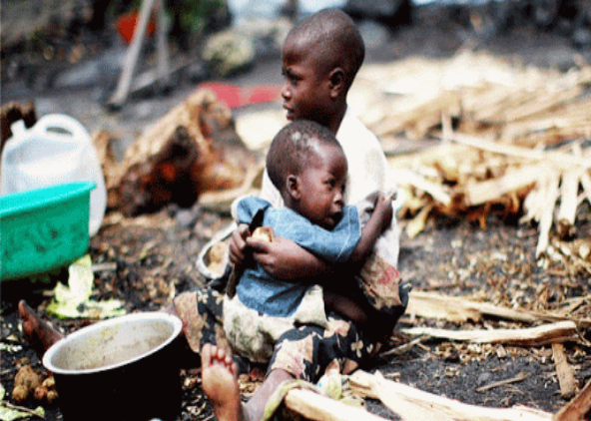 | 

_______________________________________________________________________________________________________________________________________________________________________________________________________________________________________________________________________________________________________________________________________________________________________________________________________________________________________________________________________________________________________________________________________________________________________________________________________________________________________________________________________________________________________________________________________________________________________________________________

Total: 17

WORKSHEET 5: MEMO
Developments that have affected population growth [Economic status, Conflicts and wars Government policy (as in China)]

- War is a battle, fight between nations
- - Wars keep birth rates low.
- People have fewer children during times of war.
- Many people die from hunger and disease during wars.

- Overpopulation – means too many people for the land to feed properly.
- Chinese use one child per family policy.
- Economic status and how this affects the birth and death rate of a country (5 )
- Economic status is the wealth of the country/ how well a person lives √
- Developed countries have a high economic status as a result they have a high standard of living such as high quality health care services, clean water supplies, well-constructed houses/ good food/ good education √
- This makes a low birth rate and high life expectancy. √
- Developing countries have a low economic status so these countries don’t have proper government services/ poor, underfed people√
- They have low employment opportunities, poor living conditions, not enough healthy opportunities, very little education etc. √
- Developing countries have high birth rate, high death rate and low life expectancy. √
Any acceptable answer from the learner

WORKSHEET 6
Developments that have affected population growth

- Read the following case study and answer the questions that follows:
Scientific developments

People have better a chance of living longer because of scientific development. Medicine has been developed and health care is improved by scientific developments. These are new ways that scientists have developed to make our lives better, like health services, living conditions, and general things we need in our everyday life. There has been a decrease in death rate and infant mortality all over the world due to scientific developments. Discoveries have led to technological advances that helped to improve lives.
Here are some scientific developments:
For a long time people thought diseases were spread by bad smells. Science has helped us to understand diseases and this has made it easy to treat and control diseases. Vaccinations and medicinal drugs helped to control diseases. Immunization has also been used in many countries to prevent their babies from dying.
In 1860 a French scientist named Louis Pasteur proved that diseases are spread through air and in water by germs. Pasteurization has been named after him- i.e. a process that kills germs in fresh milk. In the past many patients died during and after operations; but after a process of washing hands and changing clothes before assisting the next patient was introduced the death rate dropped in Vienna hospital (Austria). John Lister, a surgeon, began to clean and sterilize everything used during operations- patient’s skin, surgeon’s hands, instruments, sewing threads and cotton wool. That was done with the use of antiseptics such as carbolic soap. Today antiseptics such as Dettol, Lysol and Savlon are used`
Death rate in Lister’s surgery fell from 50% to 5% in two years. Later surgeons wore special sterile gowns and masks instead of their ordinary clothes. Rubber gloves were invented in 1890

  - Explain the term “Scientific Developments” in your own words. (2)
__________________________________________________________________________________________________________________________________________________________________________________________
  - Mention THREE scientific developments that are mentioned in the article (3)
__________________________________________________________________________________________________________________________________________________________________________________________
  - How have these developments affected the world population? (1)
______________________________________________________________
  - What is Pasteurization? (1)
____________________________________________________________________________________________________________________________
  - What caused the death rate in Vienna in Austria to drop? (1)
____________________________________________________________________________________________________________________________
  - What caused the infant mortality rate to decrease? (1)
______________________________________________________________
  - Mention one disease you were immunized against when you were a baby. (1)
______________________________________________________________

Total: 10

Worksheet 6: Memo
Developments that have affected population growth

  - Scientific developments are a new ways that scientists have developed to make our lives better, like health, living conditions, and general things we use in our everyday life. √√
  - Scientific developments (3)
- Vaccinations. √
- Immunisation√
- Pasteurisation√
- Washing of hands before and after the operation- hand hygiene
- The use of antiseptics
- Sterile gowns and masks ANY THREE
  - These developments have made the world population grow/ increase √ (1)
  - Pasteurisation a process that kills germs in fresh milk. √ (1)
  - When the process of washing hands and changing clothes before assisting the next patient was introduced the death rate dropped in Vienna hospital (Austria). √ (1)
  - Vaccination/ Immunisation √ (1)
  - Any acceptable answer from the learner i.e. smallpox, polio,

Total: 10

WORKSHEET: 7
Developments that have affected population growth (Improved healthcare)

7. Look at the source below on improved health care and use your knowledge to answer the questions that follows:
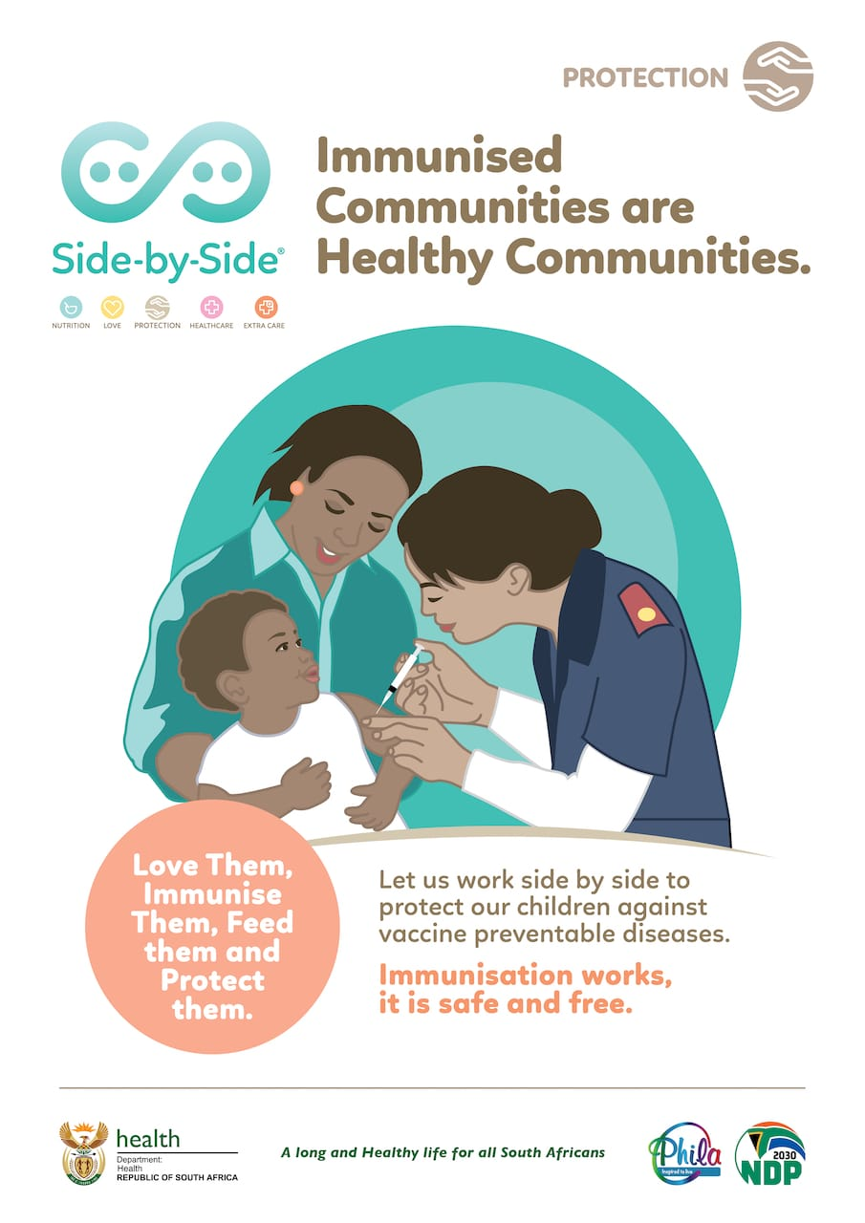

7.1. What do you understand by improved healthcare? (2)
______________________________________________________________________________________________________________________________________
7.2. Give four ways of improving healthcare in our communities. (4)
____________________________________________________________________________________________________________________________________________________________________________________________________________________________________________________________________________
7.3. Give two reasons for the importance of having improved health care. (4)
____________________________________________________________________________________________________________________________________________________________________________________________________________________________________________________________________________
Total: 10
WORKSHEET 7: MEMO
Developments that have affected population growth (Improved healthcare)

7.1. What do you understand by improved healthcare? (2)
- Organised provision of medical care to individuals or a community
7.2. Give four ways of improving healthcare in our communities. (4)
- Immunization
- Cleanliness
- Surgery
- Blood transfusion
7.3. Give two reasons for the importance of having improved health care. (4)
- To decrease high mortality rate
- To improve life expectancy

Total: 10

