GRADE 7 : GEOGRAPHY TERM 2
STRUCTURE OF THE EATH
WORKSHEET 1 : CORE, MANTLE, CRUST-HOW THE CRUST MOVES

Use SOURCE 1A and your own knowledge to answer the question that follows
.
SOURCE 1A is the structure of the earth
SOURCE 1A
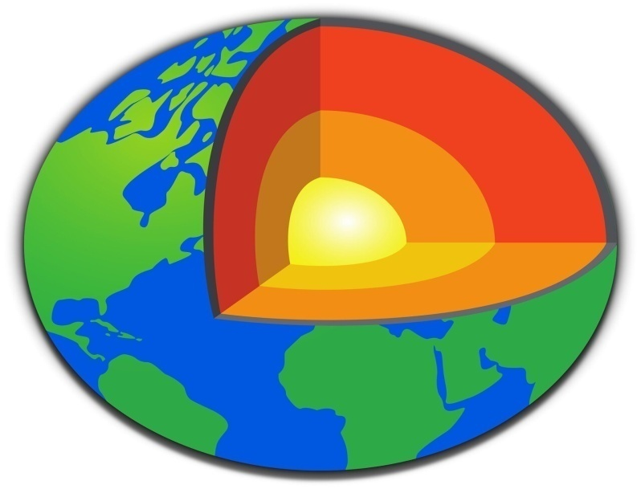

1.1 Identify the main three layers of the earth (3)
___________________________________________________________________________________________________________________________________________________________________________________________________________________________

1.2 Which part of the earth is extremely hot and solid (2)
__________________________________________________________________________________________________________________________________________________

1.3 Why is magma formed in the following part of the earth crust and the mantle? (2)
__________________________________________________________________________________________________________________________________________________

1.4 Give a brief description of tectonic plates (3)
___________________________________________________________________________________________________________________________________________________________________________________________________________________________

1.5 Give a brief explanation on how tectonic plates moves (6)
____________________________________________________________________________________________________________________________________________________________________________________________________________________________________________________________________________________________________
[16]

GRADE 7: GEOGRAPHY TERM 2
STRUCTURE OF THE EARTH
WORKSHEET 1: MEMO : CORE, MANTLE, CRUST-HOW THE CRUST MOVES
Use SOURCE 1A and your own knowledge to answer the question that follows
SOURCE 1A is the structure of the earth
SOURCE 1A

1.1 Identify the main three layers of the earth (3)
The Crust
Mantle
Core
2 Which part of the earth is extremely hot and solid (2)
The Core
1.3 Why is magma formed in the following part of the earth crust and the mantle? (2)
Extreme Heat from the core melt the rock in this two area to form magma
1.4 Give a brief description of tectonic plates (3)
Earth crust is made of pieces of huge rocks called tectonic plates there are thin spaces between these huge rocks and they fit each other like puzzles, some tectonic plates are smaller and thinner than the other tectonic plates
1.5 Give a brief explanation on how tectonic plates moves (6)
Tectonic plates can move toward each other and this movement is called convergent the second movement is when tectonic plates move apart from each it is called divergent movement ,the third movement is tectonic plates move and grinding past each other and it's called transform boundaries
[16]
GRADE 7: GEOGRAPHY TERM 2
STRUCTURE OF THE EARTH
WORKSHEET 2: CORE, MANTLE, CRUST-HOW THE CRUST MOVES
COMPLETE THE FOLLOWING WORKSHEET

- Tick the correct option

 | CRUST | MANTLE | CORE
Earth’s outer layer.
Highest temperatures found here.
Thickest layer.
Thinnest layer.
Has an inner and outer section.
Convection currents cause rocks to move here.
Moho separates these two layers (two ticks)
2 900 km thick.
(8X1=8)
Answer the multiple-choice questions. Underline the correct option for each question.
1. Temperatures of approximately 1 200˚C are found in the _______.
A. crust C. outer core
B. mantle D. inner core (1X1=1)

2. The crust is thickest ________.
A. Under deep oceans. C. Under valleys
B. Under large deserts. D. Under high mountains (1X1=1)

3. Rocks in the mantle can move because they are _______.
A. solid C. semi-molten
B. cool D. at temperatures less than 1 000˚C (1X1=1)

4. The inner core is solid because _________.
A. it forms the surface of Earth
B. very high pressure is found there
C. it is 1 400 km thick
D. molten rocks are found there (1X1=1)

Total: 12

GRADE 7: GEOGRAPHY TERM 2
STRUCTURE OF THE EARTH
WORKSHEET 2: MEMO CORE, MANTLE, CRUST-HOW THE CRUST MOVES

- Tick the correct option

 | CRUST | MANTLE | CORE
Earth’s outer layer. | √
Highest temperatures found here. |  |  | √
Thickest layer. |  | √
Thinnest layer. | √
Has an inner and outer section. |  |  | √
Convection currents cause rocks to move here. |  | √
Moho separates these two layers (two ticks) | √ | √
2 900 km thick. |  | √
(8X1=8)
Answer the multiple-choice questions. Underline the correct option for each question.
1. Temperatures of approximately 1 200˚C are found in the D.
A. crust C. outer core
B. mantle D. inner core (1X1=1)

2. The crust is thickest A.
A. Under deep oceans. C. Under valleys
B. Under large deserts. D. Under high mountains (1X1=1)

3. Rocks in the mantle can move because they are C.
A. solid C. semi-molten
B. cool D. at temperatures less than 1 000˚C (1X1=1)

4. The inner core is solid because B.
A. it forms the surface of Earth
B. very high pressure is found there
C. it is 1 400 km thick
D. molten rocks are found there (1X1=1)

Total: 12

GRADE 7: GEOGRAPHY TERM 2
STRUCTURE OF THE EATH
WORKSHEET : CORE, MANTLE, CRUST-HOW THE CRUST MOVES
Use SOURCE 3A and your own knowledge to answer the question that follows
SOURCE 3A is the structure of the earth
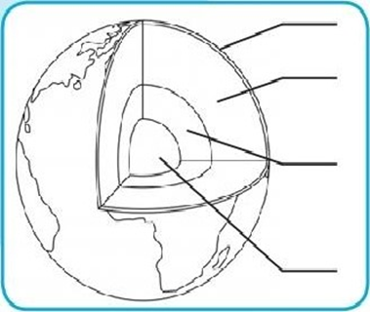
D
C
B
A

- Provide the correct title of the above diagram. (1)
………………………………………………………………………………………….
- The above structure has got FOUR layers. Label them from A- D (4) ……………………………………………………………………………………………………………………………………………………………………………………
- Briefly explain the characteristics of each layer. (8)
……………………………………………………………………………………………………………………………………………………………………………………………………………………………………………………………………………………………………………………………………………………………………………………………………………………………………………………………………
- In which part of the earth’s structure do we find tectonic movement? (1)
…………………………………………………………………………………………

- Refer to the map on Tectonic plate movement below.

TECTONIC PLATES OF THE EARTH (MAP)
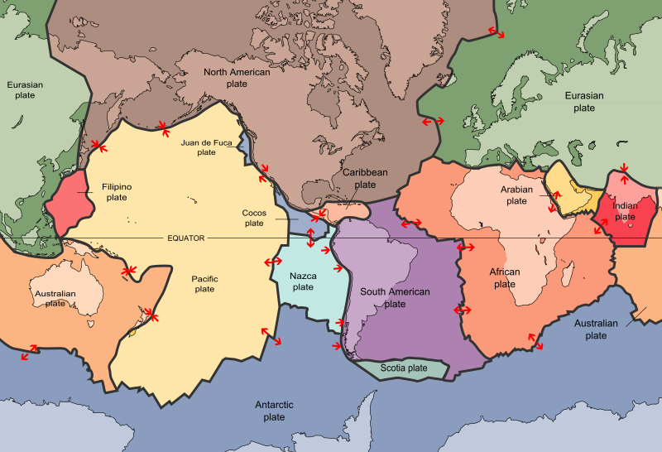
  - Explain why some of the plates are moving towards each other while others are moving further apart. Use a paragraph of 5-6 lines. (8)
………………………………………………………………………………………………………………………………………………………………………………………………………………………………………………………………………………………………………………………………………………………………………………………………………………………………………………………………………………………………………………………………………………………………
TOTAL: 22
___________________________________________________________________

GRADE 7 : GEOGRAPHY TERM 2
STRUCTURE OF THE EATH
WORKSHEET 3: MEMO - CORE, MANTLE, CRUST-HOW THE CRUST MOVES

- Earth’s structure (1)
- A. Crust
B. Mantle
C. Outer core
C. Inner core. (4)
- The crust: is the thinnest layer of rock around the earth. It covers the surface completely and it is thinner under the sea.
Mantle: is a thick layer of very hot rock between the crust and the outer core. This rock is so hot that it is molten and moves slowly.
Outer core: surrounds the core. Like the core, it is made of nickel and iron. These metals are so hot that they are like a thick liquid.
Inner core: is at the centre of the earth It is a red-hot ball of nickel and iron. It is solid because of the pressure from the other layers. (8)
4. In the crust (1)
5.1. The phenomenon [the earth crust ] where some tectonic plates move towards each other and others move apart are caused by natural processes which take place below earth’s crust. The earth consists of four layers that is the earth crust, the mantle and the outer and inner core. In the earth crust that’s where movement takes place. In the core that’s where the currents of the molten magma occur. Movements occur. Tectonic plates move at different speed and in different direction and their speed and direction depend on the currents in the magma. (8)
USE THE RUBRIC TO MARK
Total: 22
___________________________________________________________________

GRADE 7: GEOGRAPHY TERM 2
STRUCTURE OF THE EATH
WORKSHEET 4: CORE, MANTLE, CRUST-HOW THE CRUST MOVES
Use SOURCE 4A and your own knowledge to answer the question that follows
SOURCE 4A is the earth’ plates
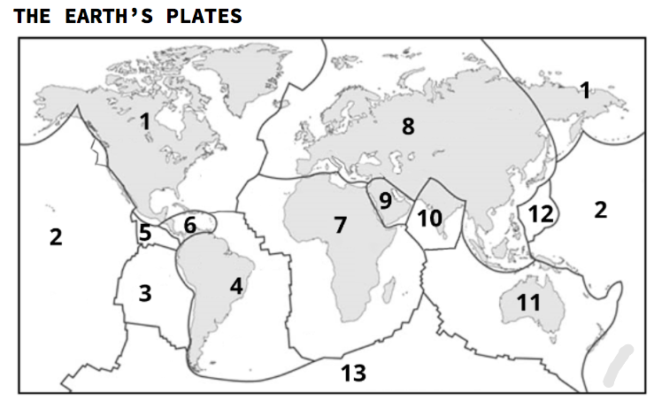
- Describe what a tectonic plate is. (2)
__________________________________________________________________________________________________________________________________________________________________________________________________________________
- Define a plate boundary. (1)
____________________________________________________________________________________________________________________________________________
- How do the tectonic plates move? (1)
____________________________________________________________________________________________________________________________________________
- Look at the picture and name and describe three areas where tectonic plates meet. (6)

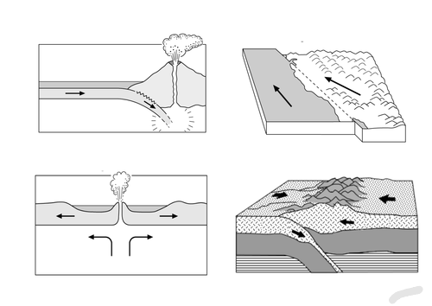
________________________________________________________________________________________________________________________________________________________________________________________________________________________________________________________________________________________________________________________________________________________________________________________________________________________________________________________________________________________________________________________________________________________________________________

- List the names of three tectonic plates. (3)
______________________________________________________________
______________________________________________________________
______________________________________________________________

- Describe the difference between continental and oceanic tectonic plates. (2)
____________________________________________________________________________________________________________________________________________
- Explain why the Great Rift Valley in Africa is a good example of divergent convergence.(3)
________________________________________________________________________________________________________________________________________________________________________________________________________________________________________________________________________________________

Total: 18

GRADE 7: GEOGRAPHY TERM 2
STRUCTURE OF THE EATH
WORKSHEET 4: MEMO - CORE, MANTLE, CRUST-HOW THE CRUST MOVES

- Describe what a tectonic plate is. (2)
A tectonic plate is a smaller piece of the crust, which can be thousands of kilometres in size.
The tectonic plates float on the underlying layer of magma and exert pressure as they move.
- Define a plate boundary. (1)
The edges of the tectonic plates are called ‘plate boundaries
- How do the tectonic plates move? (1)
The tectonic plates move on the layer of hot slow-moving magma that lies underneath the crust.
- Name and describe three areas where tectonic plates meet. (6)
Convergent boundaries: These occur when two tectonic plates push against each other and one plate is forced upwards. The other plate sinks back into the core and melts.
Divergent boundaries: These occur when the tectonic plates pull away from each other. The crust breaks apart. The space that remains is called a rift. Magma seeps up to fill the rift and so new crust is made.
Transform boundaries: This type of boundary is where two plates meet and move against each other horizontally, in different directions. As they move, neither plate is displaced up or down. This movement causes a build-up of energy, which may be released in a sudden movement which can cause an earthquake.
- List the names of three tectonic plates. (3)
Any three of the following:
Arabian plate, Eurasian Plate, South American Plate, Indo-Austrailian Plate,
North American Plate, Antartic Plate, African Plate, Nazca Plate, Pacific Plate,
Cocos Plate.
- Describe the difference between continental and oceanic tectonic plates. (2)
The plates that lie beneath the continents are called continental plates and the plates that lie beneath the oceans are called oceanic plates.
- Explain why the Great Rift Valley in Africa is a good example of divergent convergence.(3)
The Great Rift Valley is a good example of divergent convergence as a divergent boundary happens when two plates pull apart and the crust breaks apart. Magma seeps into the rift and new crust is formed. This rift can clearly be seen on photograph of that area of Africa.
Total: 18
_________________________________________________________________________

GRADE 7: GEOGRAPHY TERM 2
VOLCANOES

WORKSHEET 5: LOCATION OF VOLCANOES AROUND THE WORLD (MAP) WHY VOLCANOES OCCUR
Use SOURCE 5A and 5B, your own knowledge to answer the question that follows
SOURCE 5A and 5B are picture depicting Volcanoes
SOURCE 5A | SOURCE 5B

- Name THREE different types of volcanoes on Earth. (3)
_____________________________________________
_____________________________________________
_____________________________________________
- Where do volcanoes occur? (3)
_______________________________________________________________________________________________________________________________
- Describe a volcano. (3)
___________________________________________________________________________________________________________________________
- Explain the difference between magma and lava. (1)
______________________________________________________________
- Why do volcanoes occur? (2)
______________________________________________________________________________________________________________________________________
- Describe the Ring of Fire. (2)
__________________________________________________________________________________________________________________________________________________________________________________________
[14]
GRADE 7: GEOGRAPHY TERM 2
VOLCANOES

WORKSHEET 5: MEMO- LOCATION OF VOLCANOES AROUND THE WORLD (MAP) WHY VOLCANOES OCCUR

- Name three different types of volcanoes on Earth. (3)
Active volcanoes
Extinct volcanoes
Dormant volcanoes
- Where do volcanoes occur? (3)
Volcanoes are often found near the edges of the tectonic plates that cover the surface of the earth, both on land and underwater.
- Describe a volcano. (3)
A volcano allows molten rock form the mantle to flow out on to the earth’s surface through the earth’s crust, in the form of lava.
- Explain the difference between magma and lava. (1)
When the magma reaches the earth’s surface, it is called lava.
- Why do volcanoes occur? (2)
The pressure caused by the movement of magma beneath the earth’s crust forces magma up through faults in the earth’s surface. This movement of magma causes a volcano.
- Describe the Ring of Fire. (2)
The Ring of Fire is a ring of volcanoes that is found in Pacific Ocean. There are approximately 450 volcanoes in this area. There are frequent earthquakes and volcanic eruptions in this area.
[14]

GRADE 7: GEOGRAPHY TERM 2
VOLCANOES

WORKSHEET 6: LOCATION OF VOLCANOES AROUND THE WORLD (MAP) WHY VOLCANOES OCCUR

Use SOURCE 6A your own knowledge to answer the question that follows
SOURCE 6A is a picture depicting Volcanoes
SOURCE 6A
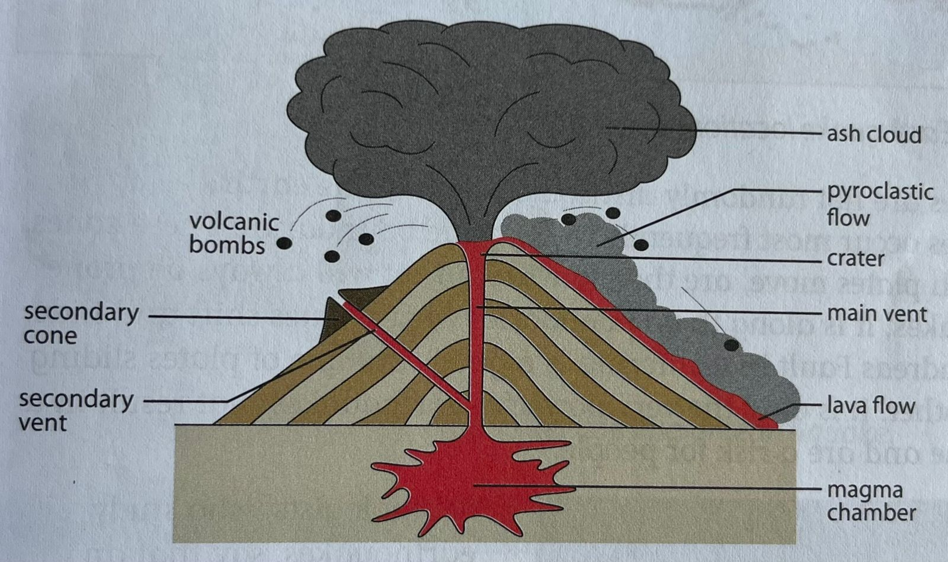

1.1. Describe the following part of the volcano (6× 2)
Term | Description
Magma Chamber
Vent
Crater
Ash
Volcanic bombs
Volcano cone

Total : 12

GRADE 7: GEOGRAPHY TERM 2
VOLCANOES

WORKSHEET 6: MEMO- LOCATION OF VOLCANOES AROUND THE WORLD (MAP) WHY VOLCANOES OCCUR
Use SOURCE 6A your own knowledge to answer the question that follows
SOURCE 6A is a picture depicting Volcanoes
SOURCE 6A

  - Describe the following part of the volcano (6×2)
Term | Description
Magma Chamber | It is an area beneath the vent of a volcano where magma is stored before it erupts
Vent | It is opening at the earth surface through which magma erupts
Crater | It a hole at the top of the vent where the lava blast into the air
Ash | These are small rocks ,minerals and glasses blasted from the volcano
Lava | It’s a magma which has flowed onto the Earth surface
Volcano cone | It is a triangular hill formed by eruption debris (lava and ashes)

Total: 12
GRADE 7: GEOGRAPHY TERM 2
EARTHQUAKES
WORKSHEET 7: LOCATION OF EARTHQUAKES AROUND THE WORLD (MAP); CAUSES OF EARTHQUAKES: LINK BACK TO PLATE MOVEMENTS
Use SOURCE 7A your own knowledge to answer the question that follows
SOURCE 7A is world map earthquake zone
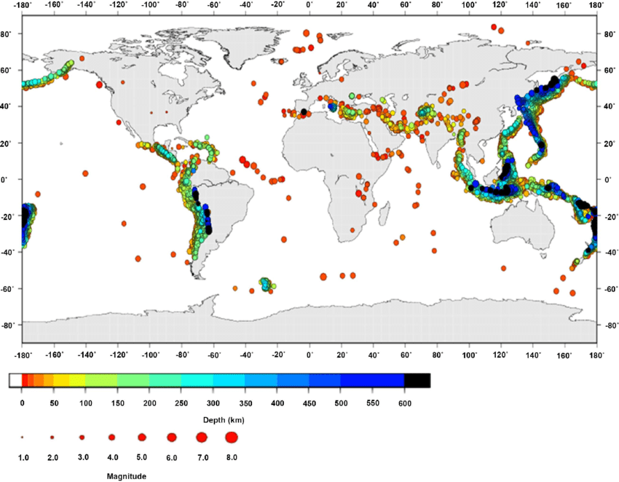

1.1What is an Earthquake? (2)
______________________________________________________________________________________________________________________________________
1.2 Explain what causes Earthquakes (3)
_________________________________________________________________________________________________________________________________________________________________________________________________________
1.3. Identify the area which experiences high volume of Earthquakes (1)
________________________________________________________________
  - Can earthquakes be predicted? (1)
________________________________________________________________
  - Why is it more destructive when an earthquake hits a densely populated area, than when an earthquake hits a less populated area? (2)
______________________________________________________________________________________________________________________________________
  - What do we use to measure the impact of earthquake? (1)
__________________________________________________________
  - Which earthquake is more destructive between 4.0 and 7.0 magnitude?
________________________________________________________ (1)
  - Which continent is mostly affected by earth quake on the map? (2)
___________________________________________________________
  - Based on the map, did SA ever experience destructive earthquake? Support your answer.
____________________________________________________________(3)
[16]

GRADE 7: GEOGRAPHY TERM 2
EARTHQUAKES

WORKSHEET 7: MEMO- LOCATION OF EARTHQUAKES AROUND THE WORLD (MAP) ; CAUSES OF EARTHQUAKES: LINK BACK TO PLATE MOVEMENTS
___________________________________________________________________
1.1 What is an Earthquake? (2)
It is the shaking and vibration of the Earth crust
1.2 Explain what causes Earthquakes (3)
When tectonic move can cause Earthquake especially when they diverge or pull away from each other and when they slide and grind each other and sometimes when they converge against each other
  - Identify the area which experiences high volume of Earthquakes (1) Area is called "Ring of fire"
  - Can earthquakes be predicted? (1)
No
  - Why is it more catastrophic when an earthquake hits a densely populated area, than when an earthquake hits a less populated area? (2)
  - Why is it more destructive when an earthquake hits a densely populated area, than when an earthquake hits a less populated area? (2)
As there are more people in the area, more people are hurt. There are more buildings that are damaged.

  - What do we use to measure the impact of earthquake? (1)
Richer scale
  - Which earthquake is more destructive between 4.0 and 7.0 magnitude?
7.0 (1)
  - Which continent is mostly affected by earth quake on the map? (2)
Asia
  - Based on the map, did SA ever experience destructive earthquake? Support your answer.
No. The earthquake magnitude was at 4,0, which is not severe (3)
[16]

GRADE 7: GEOGRAPHY TERM 2
EARTHQUAKES

WORKSHEET 8: LOCATION OF EARTHQUAKES AROUND THE WORLD (MAP); CAUSES OF EARTHQUAKES: LINK BACK TO PLATE MOVEMENTS

1.1 Use SOURCE 8A your own knowledge to answer the question that follows
SOURCE 8A is an earthquake zone
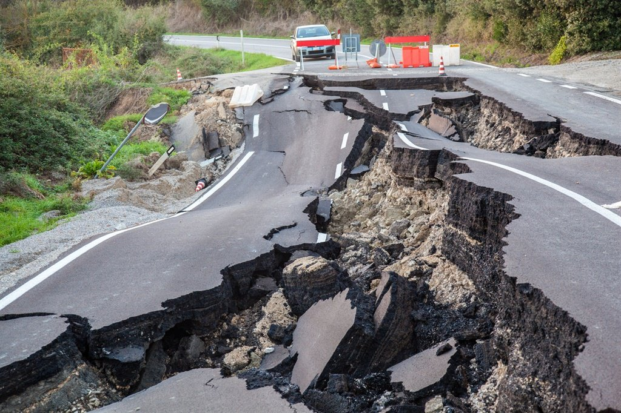
    - Identify the type of the natural hazard shown on the picture.
…………………………………………………………………………………………… (1)
    - Define the term of the feature named above.
…………………………………………………………………………………… (2)
    - Briefly explain how earthquakes are formed. (3)
…………………………………………………………………………………………………………………………………………………………………………………………………………………………………………………………………………………………………………………………………………………………………………

2. Study the below table and answer the questions that follow:
Country | Haiti | Japan
Date of the earthquake | January 2010 | March 2011
Strength of the earthquake | Strong(7.0 Richer scale) | Very strong(9.0 Richter scale)
Deaths | 316 000 | 17 000
Distance from earthquake | Close (60)km | Close (45km)
Countries’ wealth | 19th poorest country in the world. | 19th richest country in the world.

  - Which country experienced more deaths? Provide a reason for your answer. (2)
………………………………………………………………………………………
  - .Which country experienced a stronger earthquake? (1)
………………………………………………………………………………………
  - Which country is poorer? (1)
……………………………………………………………………………………
  - Why do you think that more people died in the poorer country even though the earthquake was less powerful in that country? (2)
……………………………………………………………………………………………………………………………………………………………………………………………………………………………………………………..
Total: 12
___________________________________________________________

GRADE 7: GEOGRAPHY TERM 2
EARTHQUAKES

WORKSHEET 8: MEMO- LOCATION OF EARTHQUAKES AROUND THE WORLD (MAP); CAUSES OF EARTHQUAKES: LINK BACK TO PLATE MOVEMENTS

    - Earthquake. (1)
    - An earthquake is the sudden and rapid shaking of the surface of the earth. (2)
    - The pressure builds up in the crust at the plate boundaries as the tectonic plates are either pushed together or pulled apart. When the pressure becomes too great, the plates give way suddenly in a violent, jerking movement, causing an earthquake. (3)
  - Haiti, 316 000 people died, while in Japan 17 000 people died. (2)
  - Japan (1)
  - Haiti. (1)
2.4 Haiti is not as developed as Japan and many of these buildings were not built to cope with the earthquake. (2)

(12)

GRADE 7: GEOGRAPHY TERM 2
EARTHQUAKES

WORKSHEET 9: EFFECTS OF EARTHQUAKES, INCLUDING INJURY AND LOSS OF LIFE, DISEASE, DISPLACEMENT OF PEOPLE, DAMAGE TO INFRASTRUCTURE, FIRES AND TSUNAMIS

1.1. Use SOURCE 9A your own knowledge to answer the question that follows
SOURCE 9A is depicts effects of earthquake
SOURCE 9A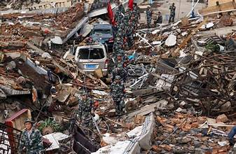

- Where does an earthquake start? _______________________________________________________________________________________________________________________________________________________________________________________(1)
- Mention THREE (3) effects of the earthquake from the Source. (3)
- ______________________________________________________________
- ______________________________________________________________
- ______________________________________________________________
- What help do you think the affected people should receive from the International community. (2)
____________________________________________________________________________________________________________________________
- Name ONE disease that affected the survivors of this earthquake? (2)
__________________________________________________________________
[8]
Tsunami
  - Study the pictures below and answer questions that follow:
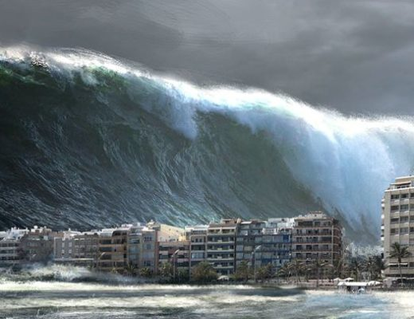 | 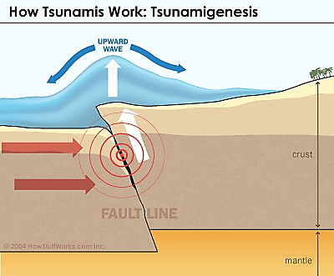

    - What is a tsunami?
_______________________________________________________________________________________________________________________________________________________________________________________ (1)
    - Describe how tsunamis occur.
______________________________________________________________________________________________________________________________________________________________________________________________________________________________________________________(2)

    - Justify why some coastal communities are at higher risks of tsunami than others.
_______________________________________________________________________________________________________________________________________________________________________________________________________________________________________________________________________________________________________________(1x2)(2)
[15]

GRADE 7: GEOGRAPHY TERM 2
EARTHQUAKES

WORKSHEET 9: MEMO- EFFECTS OF EARTHQUAKES, INCLUDING INJURY AND LOSS OF LIFE, DISEASE, DISPLACEMENT OF PEOPLE, DAMAGE TO INFRASTRUCTURE, FIRES AND TSUNAMIS

- Where does an earthquake start? (1)
The epicentre
- Mention THREE (3) effects of the earthquake from the Source. (3)
- Loss of life
- Destruction of infrastructure( roads,buildings,cars)
3. What help do you think the affected people should receive from the International community.
They need medical services , food, water, rescue experts, earth –moving machinery ANY other relevant correct answer (2)
4.Name ONE disease that affected the survivors of this earthquake? (2)
Cholera, water borne disease

    - A big wave caused by an earthquake under the sea√
    - When the ocean floor at a plate boundary rises or falls suddenly, it displaces the water above it and launches the rolling waves that will become a tsunami √√ ( allocate marks for any reasonable answer)
    - Developed countries have warning systems √
- Developed countries have evacuation procedures while developing countries don’t. √
- Rescue and medical care are better in wealthy countries √ Any relevant answer

GRADE 7: GEOGRAPHY TERM 2
EARTHQUAKES
WORKSHEET 10: EFFECTS OF EARTHQUAKES, INCLUDING INJURY AND LOSS OF LIFE, DISEASE, DISPLACEMENT OF PEOPLE, DAMAGE TO INFRASTRUCTURE, FIRES AND TSUNAMIS
- Read the articles below and answer the questions that follow.
Earthquake in Japan

Japan’s most powerful earthquake since records began has struck the northeast coast, triggering a massive tsunami. The quake was the fifth largest in the world since 1900. On March 11 2011, measuring at 8.9 by the US Geological Survey, the tsunami struck at 05:46 GMT at a depth of about 24km. A 10m-wave struck Sendai, burying farmland and sweeping cars across the airport’s runway. Fires broke out in the centre of the city. Cars, ships and buildings were swept away by a wall of water after the 8.9 magnitude tremor, which struck about 400km (250 miles) northeast of Tokyo. Japan’s NHK television showed a massive surge of debris-filled water reaching far inland, consuming houses, cars and ships. Motorists could be seen trying to speed away from the wall of water. The tsunami rolled across the Pacific Ocean at 800km/h before hitting Hawaii and the US West Coast, but there were no reports of major damage from those regions.

Thousands of people evacuated coastal areas in the states of California, Oregon and
Washington. The biggest waves of more than 2m were recorded near California’s Crescent City. A tsunami warning extended across the Pacific to North and South America, where many other coastal regions were evacuated, but the alert was later lifted in most parts, including the Philippines, Australia and China.

The terrifying wall of water that smashed into northeast Japan was unstoppable. It wasn’t the Earthquake but the following tsunami that caused most devastation in Japan. The tsunami was triggered by an 8.9-magnitude earthquake. This earthquake took place around 400 kilometres from Tokyo, off the coastal city of Sendai. The tremor itself was a result of the Pacific tectonic plate submerging beneath the North American and Eurasian tectonic plate. The tectonic plate, could not withstand the pressure of submerging. When it cracked, the upper part of the Pacific plate rebounded, causing the sea level to rise by up to 4 meters along a 100 to 150 kilometre fracture zone. This resulted in a wave that travelled at high speed through the ocean towards the shore. The tsunami reached a wave height of approximately 10 meters. It is not only the height of the wave that is so dangerous, it is the wavelength of 200 meters that unfolds the deadly impact as a huge volume of water filled with debris, cars, ships and even parts of houses crashes onto shore. The chances of surviving this are highly unlikely.
http://www.nhm.ac.uk/nature-online/Earth/volcanoesearthquakes/
tsunami/how-an-earthquake-causes-a-tsunami/index.html

  - Why was the earthquake in Japan recorded as the most powerful one? (1)
____________________________________________________________________________________________________________________________
Because it was measured at 8.9 on the richer scale
  - Which plates were responsible in causing this earthquake in Japan? (3)

______________________________________________________________________________________________________________________________________
Pacific tectonic plate, North American and Eurasian tectonic plate.
  - Was the earthquake caused by submerging or converging plates? (1)
________________________________________________________
  - In a paragraph discuss the effects of the earthquakes. (5)
___________________________________________________________________________________________________________________________________________________________________________________________________________________________________________________________________________________________________________________________________________________________________________________________________________________________________________________________________________________________________________________________________________________________________________________________________________________________
LEARNER MUST INCLUDE THE FOLLOWING IN ANSWERING: Injury and Loss of life, fire broke out, car, ships and buildings were swept away, diseases, shortage of food, pressure on rescue teams, fire

  - Look at the picture below and answer questions that follow:

  - How do you know that this tsunami wave was powerful and forceful? (2)
____________________________________________________________________________________________________________________________________
  - What type of debris can be seen in the tsunami wave? (2)
__________________________________________________________________

1.6. What is a tsunami? (2)
______________________________________________________________

[16]

GRADE 7: GEOGRAPHY TERM 2
EARTHQUAKES

WORKSHEET 10: MEMO- EFFECTS OF EARTHQUAKES, INCLUDING INJURY AND LOSS OF LIFE, DISEASE, DISPLACEMENT OF PEOPLE, DAMAGE TO INFRASTRUCTURE, FIRES AND TSUNAMIS

  - Why was the earthquake in Japan recorded as the most powerful one? (1)
Because it was measured at 8.9 on the richer scale
  - Which plates were responsible in causing this earthquake in Japan? (3)
Pacific tectonic plate, North American and Eurasian tectonic plate.
  - Was the earthquake caused by submerging or converging plates? (1)
Submerging
  - In a paragraph discuss the effects of the earthquakes. (5)
USE A RUBRIC TO MARK
LEARNER MUST INCLUDE THE FOLLOWING IN ANSWERING:
- Disease- clean water supplies were destroyed and dirt and sewerage can lie around. These problems can lead to diseases like cholera, which can lead to more deaths.
- Displacement of people. People have nowhere to live as their homes are destroyed. These displaced people look for shelter in tent camps and sometimes have nowhere to sleep.
- Damage to infrastructure – roads, railway lines, pipelines and services such as electricity, water, gas, sewerage and telephone lines can be damaged and destroyed. Flooding is caused by broken dams and burst water pipes.
- Fires - Broken electrical wires and gas and fuel tank leaks can cause fires.
- Tsunamis - Tsunamis can kill many people and can cause major damage to settlements and the environment.
- Economic - Earthquakes damage a country’ economy. A country’s trade with other countries can be affected too.
- Medical- Earthquakes put pressure on hospitals and medical and rescue services Organizations like the Red Cross and United Nations help with medical services, food, shelter and rescue workers.

  - Look at the picture below:
  - How do you know that this tsunami wave was powerful and forceful? (2)
The wave crashed into buildings and over roads. Cars had been overturned and swept away
  - What type of debris can be seen in the tsunami wave? (2)
Vehicles, trees, boats
1.6. What is a tsunami? (2)
- It is a large ocean wave caused by a sudden motion on the ocean floor
- It is a large wave of water caused by an earthquake in the oceans crust.

[16]

GRADE 7: GEOGRAPHY TERM 2
EARTHQUAKES
WORKSHEET 11: REDUCING THE IMPACT: PREPARING FOR AND RESPONDING TO EARTHQUAKES
    - Read the articles below and answer the questions that follow.
Earthquake Rocks China!
An earthquake of 7.8 magnitude hit China’s Sichuan province on Monday, May
12, 2008. Within one week of the massive quake, at least 32,000 people were reported dead and more than 200,000 injured. Hundreds of aftershocks rippled through the region after the quake, causing landslides and other damage. Unlike hurricanes, no one can predict when an earthquake will hit. There is no warning and no evacuation time. The U.S.Geological Survey (USGS) says that at least one earthquake happens somewhere on the globe every day, usually small and in remote regions where few people live. But when big earthquakes hit in heavily populated areas, it can easily become a catastrophe.

When earthquake happened aftershocks and heavy rain put recovery crews on heightened alert, fearful further strong tremors could bring down already weakened buildings. The state media on this earthquake reported that more than 200 recovery workers had been buried by landslides over the past two days in the disaster zone.
But while recovery efforts are switching to focus on clearing up the tonnes of debris, a few survivors are still being pulled out alive from collapsed buildings. The authorities will also battle to prevent the outbreak of diseases, with the risks heightened by the rotting carcasses of million livestock and poultry. “Combating epidemics will be the most urgent and the biggest task facing the country. Based on this epidemic the World Health Organisation said that the lack of safe drinking water or proper waste disposal along with cramped conditions in temporary shelters was “conducive” to outbreaks. “Preventing communicable disease outbreaks is the key public health issue now facing the People’s Republic of China,” the UN body said in a statement.
http://www.dallasnews.com/sharedcontent/dws

- In which country and on which continent is Sichuan located? (1)
______________________________________________________
- What was the size of this earthquake? (1)
__________________________________________________
- There were many aftershocks reported after the earthquake. What further damage did these aftershocks cause? (1)
______________________________________________________________________________________________________________________________________
- What should have been done to reduce number of death caused by the earthquake?(2)
______________________________________________________________________________________________________________________________________
- Provide the abbreviation for the World Health Organisation. (1)
________________________________________________________
- What role did the WHO play in the aftermath of the Earthquake in Sichuan? (1)
______________________________________________________________________________________________________________________________________
- In a paragraph explain how we can reduce the impact of earthquakes. (5)
_________________________________________________________________________________________________________________________________________________________________________________________________________________________________________________________________________________________________________________________________________________________________________________________________________________________________________________________________________________________________________________________________________________________________________________________________________________________________________________________________________________________________________________
________________________________________________________________________________________________________________________________________________________________________________________________________________________________________________________________________________________________________________________________________________________
[12]

GRADE 7: GEOGRAPHY TERM 2
EARTHQUAKES
WORKSHEET 11: MEMO- REDUCING THE IMPACT: PREPARING FOR AND RESPONDING TO EARTHQUAKES
- In which country and on which continent is Sichuan located? (1)
China, Asia
- What was the size of this earthquake? (1)
7.8 in magnitude
- There were many aftershocks reported after the earthquake. What further damage did these aftershocks cause? (1)
Landslides occurred
- What should have been done to reduce number of death caused by the earthquake? (2)
Early warning signs so that people could be evacuated
- Provide the abbreviation for the World Health Organisation. (1)
WHO
- What role did the WHO play in the aftermath of the earthquake? in Sichuan? (1)
The WHO assisted in containing epidemics that might have occurred after the earthquake.
- In a paragraph explain how we can reduce the impact of earthquakes. (5)
The impact of earthquakes can be reduced by putting some safety measures in place. These can include ways such as:
- Making stronger buildings. Building structures should be designed in such a way that they can withstand tremors from the ground. Buildings in areas where there is a high risk of an earthquake are required to follow strict rules or regulations. These buildings have to have special foundations that allow the earth to move without the building collapsing.
- Some of the building regulations include:
- Restricting their height.
- Building wide roads between buildings helps to prevent the spread of fire during an earthquake and also allows buildings to sway without crashing into each other.
- Gas and water pipes as well as electricity cables are well protected.
- Developing earthquake and tsunami warning systems
- Having emergency plans that shut down dangerous industries such as power stations and gas supplies.
- Training rescue workers to help survivors. [12]
GRADE 7: GEOGRAPHY TERM 2
FLOODS
WORKSHEET 12: CAUSES OF FLOODS AND EFFECTS
Read the SOURCES below to help you answer the questions that follow:

SOURCE 12A
Flooding in South Africa has killed more than 100 people, forced at least 8,400 from their homes and prompted the government to declare 33 disaster areas.
The government said that 88 deaths in the rising toll were in the eastern KwaZulu-Natal province. The Johannesburg area, Limpopo and Mpumalanga provinces have experienced some of their greatest rainfall in 20 years. Flimsy houses in townships, where drainage systems are sometimes poor, are particularly vulnerable to the floods. Bathabile Dlamini, the Social Development minister, warned that 20,000 people, or about 5,000 families, have been affected in provinces that are running out of money for flood relief.
Adapted from: www.theguardian.com/
SOURCE 12B
FLOODING IN KLIPTOWN, SOWETO.
Johannesburg, 27 January 2011 Adapted from www.timeslive.co.za

- Define the concept flood. (1X2) (2)
________________________________________________________________________________________________________________________________

- What was the main cause of floods according to SOURCE 12A? (1)
_________________________________________________________________
- Give TWO WAYS in which people contribute to the cause of floods. (2)
__________________________________________________________________
__________________________________________________________________
- Use the information in the SOURCES 12A AND 12B to write a paragraph of 5 – 6 sentences that describe the consequences a flood has on the lives of the people. (8)
________________________________________________________________________________________________________________________________________________________________________________________________________________________________________________________________________________________________________________________________________________________________________________________________________________________________________________________________________________________________________________________________________________________
GRADE 7: GEOGRAPHY TERM 2
FLOODS

WORKSHEET 12: MEMO- CAUSES OF FLOODS AND EFFECTS

- More water in rivers or on land√√/ Water covering land that is normally dry. √√
- What was the main cause of floods according to SOURCE 12A? (1)
Floods were caused by heavy rainfall.√
- Give TWO WAYS in which people contribute to the cause of floods. (2)
Poor ploughing methods, overgrazing, settling next to rivers, deforestation, destroying wetlands. ANY TWO RELEVANT ANSWERS
- Use the information in the SOURCES 12A AND 12B to write a paragraph of 5 – 6 sentences that describe the consequences a flood has on the lives of the people. (8)
In the paragraph the following facts must be included.

- injury and loss of life
- no safe drinking water
- famine
- diseases, for example cholera
- displacement of people, homes washed away, homelessness
- damage to fields
- damage to buildings
- damage to infrastructure (e.g. roads, bridges, power lines, and railway
- lines washed away)
- loss of property
The rubric underneath will be used to assess the paragraph.

LEVELS | ASSESSMENT CRITERIA | MARKS
Level 1 | - Uses evidence in an elementary manner e.g. shows little or no understanding.  - Uses evidence partially to report on topic or cannot report on topic. | Marks: 0-1
Level 2 | - Evidence is mostly relevant and relates to a great extent to the topic. Uses evidence in a very basic manner. | Marks: 2-3
Level 3 | - Uses relevant evidence e.g. demonstrates a thorough understanding of the topic.  - Uses evidence very effectively in an organised paragraph that shows an understanding of the topic. | Marks: 4-5

GRADE 7: GEOGRAPHY TERM 2
FLOODS
WORKSHEET 13: CAUSES OF FLOODS AND EFFECTS
Use SOURCE 13A, 13B and your own knowledge to answer the question that follows
SOURCE 9A is depicts flooding
SOURCE 13A | SOURCE 13B

- Explain two causes of floods? (2X2) (4)
____________________________________________________________________________________________________________________________________________
- Mention any two negative effects/dangers of flooding. (2X2) (4)
______________________________________________________________________________________________________________________________________________________________________________________________
- Write a short paragraph about the effect of floods on people and the land. (5)
Remember your paragraph should be structured as follows:
• Topic sentence
• The main point/s
• The concluding sentence
__________________________________________________________________________________________________________________________________________________________________________________________________________________________________________________________________________________________________________________________________________________________________________________________________________________________________________________________________________________________________________

[15]
GRADE 7: GEOGRAPHY TERM 2
FLOOD
WORKSHEET 13: MEMO-(WEEK 7 & 8) CAUSES OF FLOODS AND EFFECTS
- Building dams which fill up and flood the land√√
- Farming the land wherein the remove vegetation and cause water to flow quickly√√,
- Building cities and cover the soil with tarmac and cement and make water to run fast√√ Any relevant answer
- Causes injuries √√
Causes loss of life √√ Any relevant answer
4. Write a short paragraph about the effect of floods on people and the land.
Expected paragraph
- People drown and are injured in floods.
- Floods can destroy crops and animals resulting in food shortages.
- Floods can wash away soil making the land infertile and bad for farming.
- Floods can destroy buildings, property and transport systems.
- Floods can wash sewage out of sewage work, polluting food and water supplies.
- Diseases can spread easily after a flood.
NB: USE THE RUBRIC TO MARK
Level 1 | - Uses evidence in an elementary manner e.g. shows little or no understanding.  - Uses evidence partially to report on topic or cannot report on topic. | MARKS: 0-1
Level 2 | - Evidence is mostly relevant and relates to a great extent to the topic.  - Uses evidence in a very basic manner. | MARKS: 2-3
Level 3 | - Uses relevant evidence e.g. demonstrates a thorough understanding of the topic.  - Uses evidence very effectively in an organised paragraph that shows an understanding of the topic. | MARKS: 4-5

[15]

GRADE 7: GEOGRAPHY TERM 2
FLOODS
WORKSHEET 14: REDUCING THE IMPACT: FLOODS
Use SOURCE 14A (case study) and your own knowledge to answer the question that follows.
SOURCE 14A is a case study on cyclone Idai

SOURCE 14A

Cyclone Idai

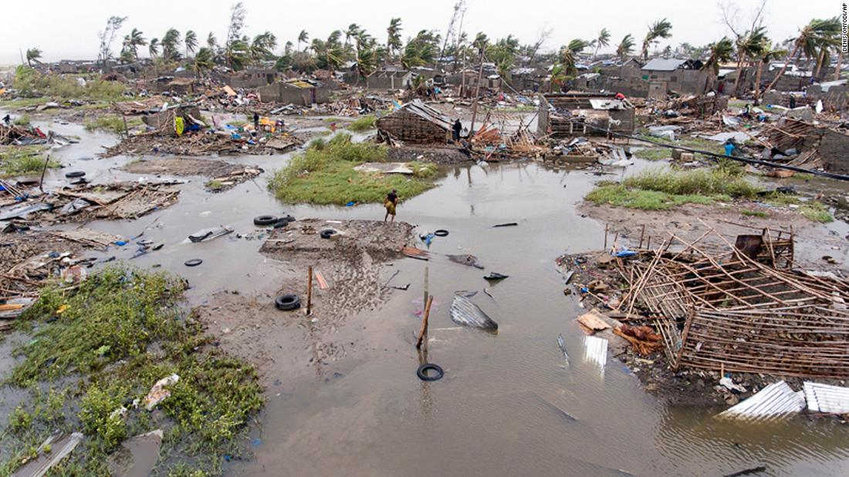

Intense Tropical Cyclone Idai was one of the worst tropical cyclones on record to affect Africa and the Southern Hemisphere.^{[4]}.The long-lived storm caused damage in Mozambique, Zimbabwe, and Malawi, leaving more than 1,000 people dead and thousands more missing. Idai is the second-deadliest tropical cyclone recorded in the South-West Indian Ocean basin.
Idai brought strong winds and caused severe flooding in Madagascar, Mozambique, Malawi, and Zimbabwe, which killed at least 1,007 people – 602 in Mozambique, 344 in Zimbabwe, 60 in Malawi, and one in Madagascar – and affected more than 3 million others. Damage occurred in and around Beira in central Mozambique. The President of Mozambique stated that more than 1,000 people may have died in the storm. A major humanitarian crisis unfolded in the wake of the cyclone, with hundreds of thousands of people in urgent need of assistance across Mozambique and Zimbabwe. In the former nation, rescuers were forced to let some people die in order to save others. A cholera outbreak ensued in the storm's wake, with more than 4,000 confirmed cases and seven fatalities by 10 April. Infrastructural damage from Idai across Mozambique, Zimbabwe, Madagascar and Malawi were estimated to be at least US$1 billion, making Idai the costliest tropical cyclone in the South-West Indian Ocean basin.

- Name the cyclone that caused the area to be flooded. (1)
_______________________________________________________________

- From which ocean did the cyclone came from? (1)
________________________________________________________________
- Name TWO other countries affected by the storm. (2)
________________________________________________________________________________________________________________________________
- Mention TWO humanitarian crisis faced by people of Mozambique after the storm. (2)
_______________________________________________________________________________________________________________________________
- Based on the Source 14A, give THREE reasons why they are exposed/ subjected to flooding? (6)
________________________________________________________________
________________________________________________________________________________________________________________________________________________________________________________________________
- Write a paragraph explaining how the people of Mozambique can reduce the impact of the floods. (5)
Remember your paragraph should be structured as follows:
• Topic sentence
• The main point/s
• The concluding sentence

Include the following points when answering:
- Which areas to avoid for settlement.
- Early Warning systems
- Laws that the government can implement.
- Types of house to be built.
- Disaster management and practice drills.
___________________________________________________________________________________________________________________________________________________________________________________________________________________________________________________________________________________________________________________________________________________________________________________________________________________________________________________________________________________________________________________________________________________________________________________________________________________________
[17]

GRADE 7: GEOGRAPHY TERM 2
FLOODS
WORKSHEET 14: MEMO- REDUCING THE IMPACT: FLOODS
- Name the cyclone that caused the area to be flooded. (1)
Idai
- From which ocean did the cyclone came from? (1)
Indian Ocean
- Name TWO other countries affected by the storm. (2)
Zimbabwe and Malawi
- Mention TWO humanitarian crisis faced by people of Mozambique after the storm. (2)
Cholera; Shelter/homeless, shortage of food
- Based on the Source 14A, give THREE reasons why they are exposed/ subjected to flooding? (6)
The area is flat
No drainage system
Informal settle/ no proper infrastructure
- Write a paragraph explaining how the people of Mozambique can reduce the impact of the floods. (5)
The paragraph must include the following:
- Areas to avoid for settlement- low lying coastal areas, catchment areas, floodplains, high –water Tables, slopes of hills.√
- Early warning systems – special equipment to detect seismic activity set up by the government. √
- Laws that the government can implement when people settle in areas that are not suitable for living. Or danger of natural disasters. √
- Types of buildings to be built on areas that could be affected by floods√
- Disaster management and practice drills- drop, cover and hold on to a safe object, family plans that are in place for when there’s an emergency, evacuation and rescue plans by the government. √
NB: USE THE RUBRIC TO MARK
Level 1 | - Uses evidence in an elementary manner e.g. shows little or no understanding.  - Uses evidence partially to report on topic or cannot report on topic. | MARKS: 0-1
Level 2 | - Evidence is mostly relevant and relates to a great extent to the topic.  - Uses evidence in a very basic manner. | MARKS: 2-3
Level 3 | - Uses relevant evidence e.g. demonstrates a thorough understanding of the topic.  - Uses evidence very effectively in an organised paragraph that shows an understanding of the topic. | MARKS: 4-5

