2024 GEOGRAPHY GRADE: 7 T4: WORKSHEETS
WORKSHEET: 1A
SUB TOPIC: Natural resources
1.1 | Make use of your knowledge to explain the following terms
 | - Natural resources  ______________________________________________________________________  ______________________________________________________________________  - Renewable resources  ______________________________________________________________________  ______________________________________________________________________  - non- renewable resources  ______________________________________________________________________  ______________________________________________________________________  - depletion of resources  ______________________________________________________________________  ______________________________________________________________________  - Deforestation  ______________________________________________________________________  ______________________________________________________________________  - Pollution  ______________________________________________________________________  ______________________________________________________________________  - over fishing and conservation  ______________________________________________________________________  ______________________________________________________________________ | (16)
1.2 | Give examples of four Renewable and non-renewable resources and their usage | (8)
______________________________________________________________________
______________________________________________________________________
______________________________________________________________________
______________________________________________________________________
1.3 | List ways in which people abuse resources | (6)
______________________________________________________________________
______________________________________________________________________
______________________________________________________________________
______________________________________________________________________
1.4 | Use the table below and show how the given natural resources they can be protected | (12)
Natural resources | Protection of Resources
Air
Soil
Water
Forest
Marine
Coal, oil and gas

 | WORKSHEET: 1A MEMO
 | SUB TOPIC: natural resources
1.1 | - Natural resources are material or substances on the environment that are used by people  - Renewable resources are, materials used by people which can be renewed or regenerated over a period of time  - Non- renewable resources are materials which cannot be renewed or regenerated if is finished or depleted. Coal, oil and natural energy.  - Depletion of resources is when natural resources are used too much (excessively) to an extent they are scarce, water, coal, fishes, oil and natural energy.  - Deforestation is the cutting down of trees in a large area.  - Pollution is when harmful substances or products in the environment.  - Over fishing is when fishing occurs at a higher rate than they can regenerate themselves  - Conservation it is the protection and management of natural resources ensure the last for long period of time. | (16)
1.2 | Give examples of four Renewable e.g. forest, they are used for fuel and as building materials,
The sun used to make energy
Wind used to make energy,
Water used for drinking and irrigation,
Examples of Non-renewable resources and their usage
Coal is used as energy, gold is used to make jewelry and furniture
crude oil makes petrol
silver makes jewelry
ANY OTHER CORRECT RELEVANT ANSWER
1.3 | List ways in which people abuse resources | (6)
Pollutes, over fish, causes land degradation, causes deforestation, mismanage water, Over-consumption of energy, Use pesticides
ANY OTHER CORRECT RELEVANT ANSWER
1.4 | Use the table below and show how the given natural resources they can be protected | (12)
Natural resources | Protection of Resources
air | Use green energy to avoid pollution
Soil | Plant vegetation to cover the soil
Water | Use minimally in house hold, fix leaking taps
Forest | Plant trees
Marine | Implement fish quotas
Coal, oil and gas | Switch to renewable sources, sun and wind

WORKSHEET: 1B
SUB TOPIC : Natural resources on earth, including water, air and soil ; Use and abuse of selected examples
1 | The picture below depicts the use of natural resources. Analyse and answer the questions that follow
  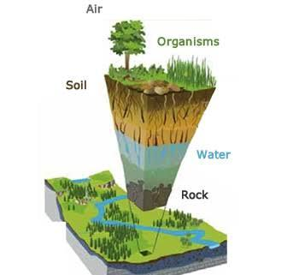
1.1 | What is meant by natural resource? | (2)
 | _____________________________________________________________________
1.2 | List any THREE Natural resources that you regard as being important.  ___________________________________________  __________________________________________  __________________________________________ | (3)
1.3 | Write a paragraph of 7-8 lines about natural sources on earth and how people abuse it (choose ONE between water,air,animals and marine life) what do you think we can do to reduce abusing natural resources. | (5)
______________________________________________________________________
______________________________________________________________________
______________________________________________________________________
______________________________________________________________________
______________________________________________________________________
______________________________________________________________________
______________________________________________________________________
______________________________________________________________________
______________________________________________________________________
______________________________________________________________________
______________________________________________________________________
______________________________________________________________________
______________________________________________________________________
______________________________________________________________________
______________________________________________________________________
______________________________________________________________________
 | TOTAL : 10

WORKSHEET: 1B MEMO
SUB TOPIC : Natural resources on earth, including water, air and soil ; Use and abuse of selected examples
1.1 | What is meant by natural resource? | (2)
 | Everything humans use in order to live. Man did not create any natural resources
1.2 | List any THREE Natural resources that you regard as being important. | (3)
 | Water, soil, coal, natural gas, oil, forest .Any other relevant correct answer
1.3 | Write a paragraph of 7-8 lines about natural sources on earth and how people abuse it (think about water,air,animals and marine life) what do you think we can do to reduce abusing natural sources. | (5)
PARAGRAPH CAN INCLUDE THE FOLLOWING.
- Litter, especially plastic, contaminates the water, making it dangerous to drink.
- Plastic is not biodegradable, thus it will remain there for many years
- We can stop using plastic bags and use paper bags
- Land that is not fertile, cannot be used to cultivate crops.
- Give land time to rest be not planting crops for a season.
- Cattle may be hurt from falling into large dongas.
- Air pollution destroys the atmospheric layers, such as the ozone layer, which protects Earth.
- Ride bicycles instead of cars
- Too much carbon dioxide in atmosphere results in global warming.
- Pollution can also cause acid rain.
- Deforestation on a large scale can contribute to global warming.
- Animals and people are forced to move (displace).
- Soil erosion can occur once the land is exposed.
- Oil spills cause large scale destruction to marine life and ecosystems can be destroyed or altered for many years to come.
Any other relevant answers
RUBRIC:
Level 1 | - Uses evidence in an elementary manner e.g. shows little or no understanding.  - Uses evidence partially to report on topic or cannot report on topic. | MARKS: 0-1
Level 2 | - Evidence is mostly relevant and relates to a great extent to the topic. Uses evidence in a very basic manner. | MARKS: 2-3
Level 3 | - Uses relevant evidence e.g. demonstrates a thorough understanding of the topic.  - Uses evidence very effectively in an organised paragraph that shows an understanding of the topic. | MARKS: 4-5

 | TOTAL : 10

WORKSHEET: 2 A
SUB TOPIC : Concept of conservation, including reasons for conservation
 | Use the SOURCE below and your own knowdledge to answer question that follow
 | 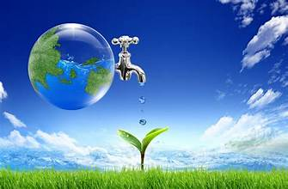
1 | Define the concept Conservation  _____________________________________________________________________  _____________________________________________________________________ | (2)
2 | State 4 reasons for conserving the environment (natural resources).  _____________________________________________________________________  _____________________________________________________________________  _____________________________________________________________________  _____________________________________________________________________  _____________________________________________________________________ | (4)
 | TOTAL : 6

WORKSHEET: 2 A MEMO
SUB TOPIC :Concept of conservation, including reasons for conservation
1 | Conservation 🡪 is the protection and the management of the natural environment | (2)
2 | State 4 reasons for conserving the environment (natural resources). | (4)
- Life depends on natural resources.
- Protect a balance between in the ecosystem (between living organisms and non-living organisms).
- Economy depends on natural resources. (Industries like forestry; fishing; agriculture; mining depend on natural resources).
- Protect the beauty of the environment
- Promote eco-tourism. (ANY OTHER RELEVANT)
 | TOTAL : 6

WORKSHEET: 2 B
SUB TOPIC: Conservation /management of resources
1 | What is meant by conservation | (2)
____________________________________________________________________
_____________________________________________________________________
2 | Why is it important to conserve resources? Give FOUR reasons | (8)
 | ___________________________________________________________________________________________________________________________________________________________________________________________________________________________________________________________________________________
3 | Make use of the table below showing different natural resources and indicate how each resource can be conserved | (12)
Natural Resource | Conserve resource
water
Fishes
Energy
Forest
Soil
animals

4. | List Conservation areas in South Africa and what is being conserved in those areas | (6)
 | ___________________________________________________________________________________________________________________________________________________________________________________________________________________________________________________________________________________
 |  | [28]

WORKSHEET: 2 B MEMO
SUB TOPIC: Conservation /management of resources
1 | What is meant by conservation | 2
 | Prevention of wasteful use of resources- Any other correct relevant answer
2 | Why it is important to conserve resources | (8)
- To ensure that non-renewable are not depleted
- To protect the well- being of the environment and human being
- To save money
- To ensure that everyone has access to these resources and also coming generation need can be met
- To reduce toxic gas emission
3
  Natural Resource | Conserve resource
  water | Reduce and recycle
  Marine | Avoid overfishing
  Energy | Reduce consumption of energy
  Forest | Plant trees, establish nature reserves and national parks
  Soil | Plant ground covers to protect
  animals | Establish game reserves, National parks
4 | List Conservation areas in South Africa and what is being conserved in those areas | (8)
- Kruger National park home to biodiversity
- Table Mountain National Park for mountains and beaches
- Blyde River Canyon Nature Reserves home to wild life
- Isimangaliso Wetland Park home to Wetland beaches and forest
ANY OTHER CORRECT RELEVNT ANSWER

 |  | [28]

WORKSHEET: 3
SUB TOPIC: Conservation areas ;Case study of a selected area
3 | Make use of the case study below and your own knowledge to answer the following questions:
Marine parks
The ocean is very important for humans and animals to breath. It provides food to people and animals and recycles waste. It is thus of utmost importance to protect the ocean. Because of this reason, are marine parks established. The ocean is an important FIGURE for food, salt, fresh water, oil, tidal energy, and minerals. Oil is the most valuable resource obtained from the ocean.
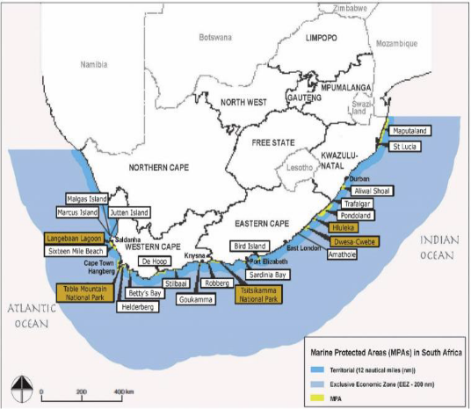

3.1 | Name the TWO oceans that surround South Africa?  _________________________________________________________________  ___________________________________________________________________ | (2)
3.2 | List any 4 natural sources that we get from the ocean and shoreline.  _____________________________________________________  _____________________________________________________  _____________________________________________________  _____________________________________________________ | (4)
3.3 | What does MPA stand for?  ___________________________________________________________________ | (2)
3.4 | Name the MPA’s you see on the map:  ___________________________________________________  ___________________________________________________ | (2)
 | Read the SOURCE below and use your own knowledge and information to answer questions that follow.
Purpose and place
The purposes on conservations areas are to protect the flora and fauna of South Africa.
Poaching is a serious problem. Hundreds of rhinos are being poached for their horns, because some believe it has medicinal properties. Perlemoen is an edible sea snail that sucks onto rocks. Poachers know they can make money if they sell it to illegal traders.
Geneem uit Kollig op Sosiale Wetenskappe bl 73

3.5 | What does “flora” means?  ____________________________________________________________________ | (2)
3.6 | What does “fauna” means?  ____________________________________________________________________ | (2)
3.7 | Explain the purpose of marine conservation areas.  ___________________________________________________________ | (2)
3.8 | Why would it be more difficult to protect marine conservation parks than a game reserve?  _____________________________________________________________________  _____________________________________________________________________  ____________________________________________________________________ | (2)
 | TOTAL: 18

WORKSHEET: 3 MEMO
SUB TOPIC: Conservation areas ;Case study of a selected area
3 | Make use of the case study below and your own knowledge to answer the following questions:
3.1 | Name the TWO oceans that surround South Africa? | (2)
Western side: Atlantic Ocean
Eastern side: Indian Ocean.
3.2 | List any 4 natural sources that we get from the ocean and shoreline. | (4)
 | Food, salt, fresh water, oil, tidal energy, and minerals
3.3 | What does MPA stand for? | (2)
 | Marine Protected Area
3.4 | Name the MPA’s you see on the map: | (2)
 | Langebaan Lagoon, Table Mountain National Park
3.5 | What does “flora” means? | (2)
 | Plants in an area
3.6 | What does “fauna” means? | (2)
 | Animal life in an area
3.7 | Explain the purpose of marine conservation areas. | (2)
 | To protect our marine life.
3.8 | Why would it be more difficult to protect marine conservation parks than a game reserve? | (2)
 | To protect our marine life. It is not possible to protect these areas because there are no fences unlike at the game reserves.
 | TOTAL: 18

WORKSHEET: 4
SUB TOPIC: Community Conservation Projects Case Study
4 | Study the case study below and your own knowledge to answer the following questions:
The Maluleke community
In 1969 the Maluleke community were forced to move out of their ancestors’ homes that were situated in the Kruger National Park. In 1996 their land was given back to them and until today they manage is as part of the conservation project.
The Imbewu Project.
Imbewu is a Zulu or Xhosa word that means “seed”. Imbewu is a project in conjunction with the South African National Parks (SANPark) and the Wilderness foundation.
Youth leaders, especially those that come from historical disadvantaged communities, were taken on a four day wilderness trip. Imbewu is also working together with local HIV organizations. Various HIV positive males and females have been admitted.
Imbewu is aiming for:
• To improve overall conservation in South Africa.
• To give a quality experience that will restore every identity and natural heritage ties.
• To improve environmental awareness.
• To empower black role models.
• To give an advantage to rural and local neighbourhood within a radius of 300km from national parks.

Wise words from elderly people are shared as well as their stories, experiences and enthusiasm with South African youth leaders to plant the seed of passion for the African nature and culture. Through the use of their narrative traditions and indigenous knowledge, the elders lead trails and interpret their natural environment. The elders are chosen carefully. They are retired, qualified conservationists. Many of these wise elders are women. Imbewu includes historical disadvantaged youth from all the big urban centres.
The Imbewu Project is currently presented in the following areas:
Addo Elephant National Park Kgalagardi National Park Namakwa National Park Umfolozi Wild Reserve. Golden Gate Highlands National Park Marakele National Park
National Kruger Park Tsitsikamma National Park.

4.1 | What are the aims of Imbewu project? Give TWO  __________________________________________________________________  __________________________________________________________________ | (2)
4.2 | What role does the Malulele community and Imbewu project play in preserving traditions and indigenous knowledge? ____________________________________________________________________  ____________________________________________________________________ | (2)
4.3 | Why is it so important that elder people share their stories with the youth of today? What does it means?  _____________________________________________________________________  _____________________________________________________________________  _____________________________________________________________________  ____________________________________________________________________ | (4)
 | TOTAL: 8

WORKSHEET: 4 MEMO
SUB TOPIC: Community Conservation Projects Case Study
4 | Study the case study below and your own knowledge to answer the following questions:
4.1 | What are the aims of Imbewu project? Give TWO | (2)
• To improve overall conservation in South Africa.
• To give a quality experience that will restore every identity and natural heritage ties.
• To improve environmental awareness.
• To empower black role models.
• To give an advantage to rural and local neighbourhood within a radius of 300km from national parks
4.2 | What role does the Malulele community and Imbewu project play in preserving traditions and indigenous knowledge? | (2)
 | Stories are shared by elders, planting a seed of passion for African and nature and culture
4.3 | Why is it so important that elder people share their stories with the youth of today? What does it means? | (4)
 | To transfer knowledge on African culture and nature to the youth so that it is lost. It means that the stories must also let young people understand the importance of our culture and nature and learn to love it.
 | TOTAL: 8

WORKSHEET: 5
SUB TOPIC : Eco tourism – examples
 | Study SOURCE below and use your own knowledge to answer the following questions:
According to the international eco-tourism association is eco-tourism the “responsible travel to natural areas that conserve the environment and to improve the wellbeing of the local people.”
Eco tourism target is to attract people to areas that are conserved in their natural form and to make the people aware of their environment. The money that is made out of eco-tourism is used for conservation and to empower the local community. The local community can for example sell handmade goods to the tourist. In this way more jobs are being created. The tour organizers have the responsibility to ensure that the environment don’t get harm in the process.
South Africa has a lot of beautiful destinations. Examples of eco-tourism are the visit to many of our wild reserves or the Drakensberg. For the people that like to travel by foot the “Ottervoetslaanpad” is one of the best routes. The route is from Stormrivermond in the Tsitsikamma National Park to Nature’s Valley besides the Eastern Cape’s shoreline. The route is 42.5km and it will take you just a bit more than 4 days to complete. Because of the rocky shoreline and the climb to a height of more than 150m the right walking shoes is a necessity. The scenery is breath-taking.
(Geneem uit Kollig op Sosiale Wetenskappe bl 7)

5.1 | What is the difference between a normal tourist and an eco-tourist?  _____________________________________________________________________  _____________________________________________________________________  _____________________________________________________________________ | (4)
5.2 | How does the information “Just take photos, only leave footprints behind” link with eco-tourism?  _____________________________________________________________________  _____________________________________________________________________ | (2)
5.3 | How does eco-tourism benefit the local community?  _____________________________________________________________________  _____________________________________________________________________ | (2)
5.4 | Mention TWO activities that can be done by tourists in the areas mentioned in the source.  _____________________________________________________________________  _____________________________________________________________________ | (4)
 | TOTAL: 12

WORKSHEET: 5 MEMO
SUB TOPIC : Eco tourism – examples
 | Study SOURCE below and use your own knowledge to answer the following questions:
5.1 | What is the difference between a normal tourist and an eco-tourist? | (4)
Tourists travel through the country by car and visit places for the pleasure.
Eco Tourists visit natural areas that conserve the environment for the future.
5.2 | How does the information “Just take photos, only leave footprints behind” link with eco-tourism? | (2)
 | You may not harm the environment and therefor only photos may be taken.
5.3 | How does eco-tourism benefit the local community? | (2)
The local community can for example sell handmade goods to the tourist.
In this way more jobs are being created.
5.4 | Mention TWO activities that can be done by tourists in the areas mentioned in the source. | (4)
 | Hiking , walking, zip lining, bungee jumping Any other correct relevant answer
 | TOTAL: 12

WORKSHEET 6
SUB TOPIC :Who uses South Africa’s water (pie chart of water users)
6 | Refer to the pie graph below to answer the questions that follow
 | 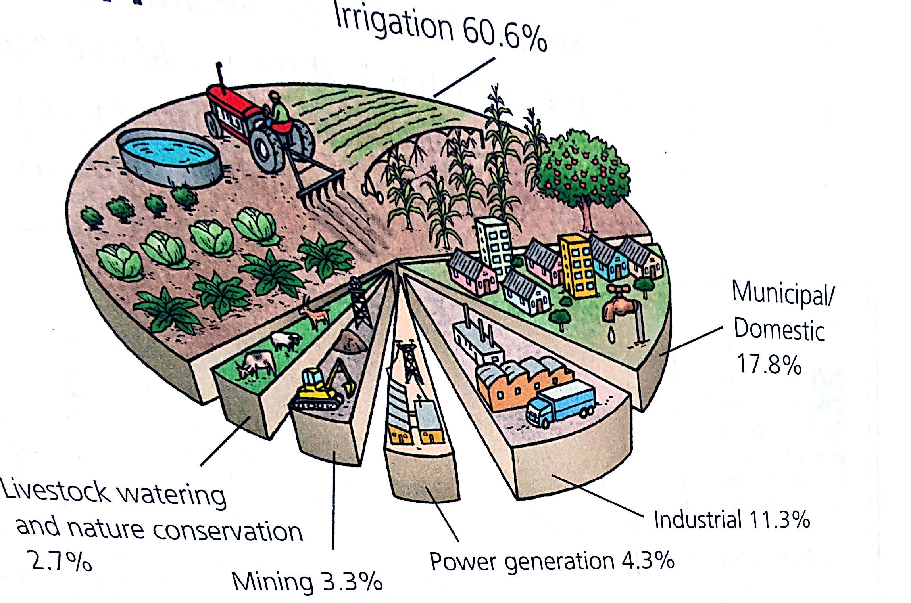
6.1 | Which sector uses the most water and for what purpose?  ____________________________________________________________________ | (2)
6.2 | Which sector uses less water and for what purpose?  ___________________________________________________________________ | (2)
6.3 | Complete the table below to show 4 sectors from the pie graph using water and the amount of water that they are using. List them in order from the highest to the lowest users. An example has been done for you. | (12)
  Sector | Activity | % of water
 | TOTAL :14

WORKSHEET 6
SUB TOPIC :Who uses South Africa’s water (pie chart of water users)
6
6.1 | Which sector uses the most water and for what purpose? | (2)
 | Agriculture, for irrigation
6.2 | Which sector uses less water and for what purpose? | (2)
 | Nature conservation, for livestock
6.3 | Complete the table below to show 4 sectors from the pie graph using water and the amount of water that they are using. List them in order from the highest to the lowest users. An example has been done for you. | (12)
Sector | Activity | % of water
Agriculture√ | Watering crops√ | 60,6%√
Municipal/ √domestic | Sanitation, drinking, cooking, laundering and other household funtion√ | 17,8%√
Industrial √ | Fabricating, processing, washing, transporting product√ | 11.3√
Energy √ | Generating power, fuel production, operation, power plant construction | 4,3%√
Mining | Mineral conveyance, mineral processing and separation, mineral extraction, cooling, tailings dams, cleaning machinery and dust suppression | 3.3%

 | TOTAL :14

WORKSHEET: 7
SUB TOPIC : Water in South Africa : Availability of water and requirements in South Africa
7 | Refer to the SOURCE below to answer the questions that follow
Availability of water and requirements in South Africa
- South Africa is ‘n dry country.
- The rainfall decreases from the South Coast to the West Coast. The eastern part also gets more rain than the western part of South Africa.
- South Africa often experiences drought and the country does not have enough water.
- Pollution by industries, mines and sewage and litter makes this water shortage worse.
Responsible use of water sources
- All South Africans must use water responsibly. This means that we should not waste it or pollute it.
E classroom

7.1 | Mention THREE ways for which water can be used.  ___________________________________________________________________  __________________________________________________________________  __________________________________________________________________  __________________________________________________________________ | (3)
7.2 | Study the SOURCE below to answer the questions that follow
Water use in South Africa during 2013
Activity | % Water use
Livestock drinking water and nature conservation | 2.7%
Mining | 3.3%
Irrigation/Farming | 60.6%
Industrial /Factories | 11.3%
Municipal/Household | 17.85%
Power generation | 4.3%

7.2.1 | What percentage of water did the following industries use during 2013? | (4)
- Mining_______________________
- Household___________________
- Power generation_________________
- Farming _______________________
7.2.2 | What is the percentage of water used by households and factories together?  ___________________________________________________________________ | (2)
7.2.3 | Why do you think the farming sector uses so much water?  _____________________________________________________________________  ____________________________________________________________________ | (2)
7.2.4 | Use the picture below and write a paragraph of 7-8 lines on how you as an individual can save and use water responsibly. | (5)
 | 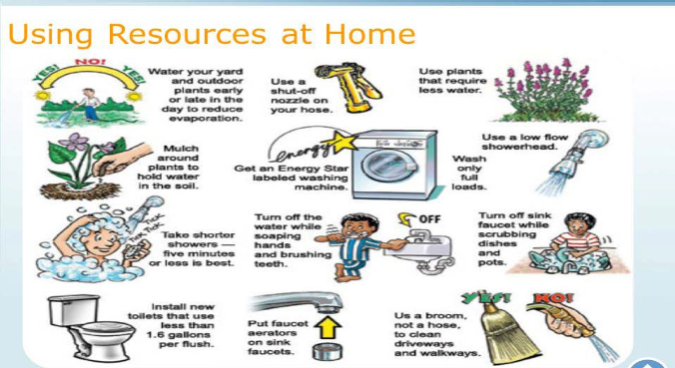
____________________________________________________________________________________________
____________________________________________________________________________________________
____________________________________________________________________________________________
____________________________________________________________________________________________
____________________________________________________________________________________________
____________________________________________________________________________________________
____________________________________________________________________________________________
____________________________________________________________________________________________
____________________________________________________________________________________________
____________________________________________________________________________________________
____________________________________________________________________________________________
 | TOTAL : 16

WORKSHEET: 7 MEMO
SUB TOPIC : Water in South Africa : Availability of water and requirements in South Africa
7 | Refer to the SOURCE below to answer the questions that follow
7.1 | Mention THREE ways for which water can be used. | (3)
- Household use: Washing of clothes , Washing your body, Garden and swimming pool (Any relevant answer)
- Relaxing: To swim in the ocean, swimming pool, Catching fish in the river, dam, sea riding with your boat on the water (Any relevant answer)
- Industrial use: The manufacturing of goods, The generation of electricity, The cleaning of machinery (Any relevant answer)
7.2 | Study the SOURCE below to answer the questions that follow
7.2.1 | What percentage of water did the following industries use during 2013? | (4)
 | Mining: 3,3 % Household: 17.85% Power generation: 4,3% Farming : 60,6%
7.2.2 | What is the percentage of water used by households and factories together? | (2)
 | 17,85 + 11,3 = 29,15%
7.2.3 | Why do you think the farming sector uses so much water? | (2)
 | All the animals need water as well as all the crops. Processes like dairy etc. also need water
7.2.4 | Use the picture below and write a paragraph of 7-8 lines on how you as an individual can save and use water responsibly. | (5)
Use a broom not a hose to clean driveways and walkways✔ Take a shorter showers ✔ Turn off the water while soaping hands and brushing teeth ✔ Turn off the tap when scrubbing pots or washing dishes✔ Wash only full loads✔
Buy energy saving machines✔ Plant flowers and plants that require less water✔ Water the garden in the late afternoon to avoid evaporation✔
ANY FIVE
RUBRIC:
Level 1 | - Uses evidence in an elementary manner e.g. shows little or no understanding.  - Uses evidence partially to report on topic or cannot report on topic. | MARKS: 0-1
Level 2 | - Evidence is mostly relevant and relates to a great extent to the topic. Uses evidence in a very basic manner. | MARKS: 2-3
Level 3 | - Uses relevant evidence e.g. demonstrates a thorough understanding of the topic.  - Uses evidence very effectively in an organised paragraph that shows an understanding of the topic. | MARKS: 4-5

 | TOTAL : 16

WORKSHEET : 8
SUB TOPIC :River health and the care of catchment areas
8 | Use the information on the source below and your own knowledge to answer the questions that follow
The River Health Programme is an organisation that works towards repairing damage to catchment areas. It encourages farmers to use natural fertilisers and pesticides that won’t poison the water, and to keep natural vegetation on river banks that prevent soil being washed away. The programme also tries to stop sewage, waste water and other pollutants flowing into rivers.
Platinum

8.1 | Explain the following words
 | - River catchment  _____________________________________________________________________  _____________________________________________________________________ | (2)
 | - Soil erosion  _____________________________________________________________________  _____________________________________________________________________ | (2)
8.2 | What is the aim of River Health programme?  _____________________________________________________________________  _____________________________________________________________________ | (2)
8.3 | Look at the picture below of activities in a catchment area: List 6 activities that have harmful impact on the catchment area and on the river’s health? | (6)
  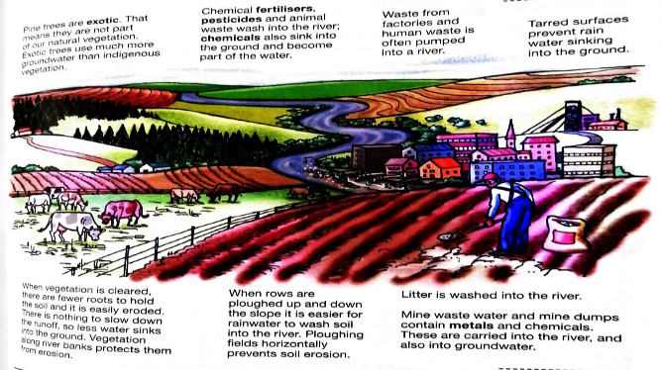
- ___________________________________________________________________________
- __________________________________________________________________________
- __________________________________________________________________________
- __________________________________________________________________________
- __________________________________________________________________________
- __________________________________________________________________________
8.4 | Refer to the picture below in order to answer questions that follow:
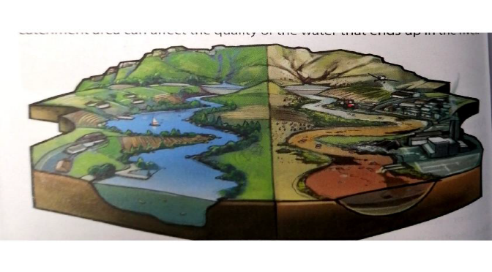

The left side of the diagram shows a river catchment that is not damaged by the action of people. The right side of the diagram shows the many ways people can abuse and damage a river catchment.

8.4.1 | Choose ONE of the ways people damaged the health of the river?  _________________________________________________________________ | (2)
8.4.2 | Look at the left side of the diagram. How have people prevented the river getting damaged in the way identified in 8.4.1? Name 2 ways.  ___________________________________________________________________  ___________________________________________________________________ | (2)
 | TOTAL:16

WORKSHEET : 8 MEMO
SUB TOPIC :River health and the care of catchment areas
8 | Use the information on the source below and your own knowledge to answer the questions that follow
8.1 | Explain the following words
 | River catchment-the area drained by one main river and all the rivers that flow into it | (2)
 | Soil erosion-the process in which soil is picked up and carried away by water or wind | (2)
8.2 | What is the aim of River Health programme? | (2)
 | The river health programme is an organisation that works towards finding out where and how river catchments have been damaged
8.3 | Look at the picture below of activities in a catchment area: List 6 activities that have harmful impact on the catchment area and on the river’s health? | (6)
 | Littering; mine waste ;mine dumps; rows ploughed up and down slopes; chemicals; fertiliser; pesticides; animal waste; factory waste; human waste;
8.4 | Refer to the picture below in order to answer questions that follow:
8.4.1 | Choose ONE of the ways people damaged the health of the river? | (2)
 | Dumping, domestic animals, littering, damming (obstructing flow of the river) , channelizing ( modifying a stream),recreation (i.e. river recreation like riding horses, walking with dogs) ANY other relevant answer
8.4.2 | Look at the left side of the diagram. How have people prevented the river getting damaged in the same way? Name 2 ways. | (2)
 | Stop littering; practice water conservation; avoid water polluting recreational activities; avoid pesticides ANY other relevant answer
 | TOTAL:16

