

GENERAL EDUCATION AND TRAINING

GRADE 4
IBANGA LESI-4

NATURAL SCIENCES AND TECHNOLOGY
ISAYENSI YEMVELO NETHEKHNOLOJI
JUNE PLC PRE-TEST
UKUHLOLWA KUKA-JUNE KWANGAPHAMBILI KWE-PLC
2025 TERM 2
2025 ITHEMU YESI-2

Time: 80 Minutes/ Isikhathi: imizuzu engama-80
Marks: 40/ Amamaki:40

Instructions and Information/ Imiyalelo Nolwazi
- You must answer all the questions./ Phendula yonke imibuzo.
- Read the instructions carefully and answer questions as instructed./ Fundisisa imiyalelo bese uphendula imibuzo ngokwemiyalelo.
- Number your answers exactly as the questions are numbered./ Izinombolo zezimpendulo zakho azifane nse nezemibuzo.
- For Question 3.5. a graph sheet is provided. Submit the graph sheet together with your answer sheet./ Okombuzo 3.5 iphepha lokudweba i-graph linikeziwe. Letha iphepha lokudweba i-graph kanye nephepha lezimpendulo zakho.
- Write neatly and legibly./ Bhala ngobunono futhi okufundekayo
NB. This question paper consists of 8 pages and contains 6 questions.
Qaphela lokhu: Leli phepha lemibuzo linamakhasi ayi-8 futhi liqukethe imibuzo eyi-6

Section A: Multiple Choice/ Isigaba A: Ukukhetha Okuningi

Question 1/ Umbuzo 1
Various options are provided as possible answers to the following questions. Choose the most correct answer and write down only the letter next to the question number e.g. 1.1. D
Izinketho ezihlukahlukene zinikezwa njengezimpendulo ezingenzeka zemibuzo elandelayo. Khetha impendulo efanele kakhulu bese ubhala phansi kuphela uhlamvu oluseduze nenombolo yombuzo isib. 1.1. D

  - What is matter? Yini imetha?
- Something we cannot see and touch./ Okuthile esingakwazi ukukubona nesingakwazi ukukuthinta.
- Takes up space and has a mass. /Ithatha indawo futhi inesisindo
- Solid only. / Okuqinile kuphela
- Vapour pressure only./ Umfutho we-vapor kuphela. (1)

  - Which one of the following substances is an example of a gas?/ Iyiphi kulezizinto ezilandelayo eyisibonelo segesi?
- Glass of water./ Ingilazi yamanzi
- Steam from tea./ Iphunga elivela etiyeni
- Ice blocks./ Amabhulokhi eqhwa.
- Rock. / Idwala (1)

  - What do we call the process where a gas changes into a liquid?/ Siyibiza ngokuthini inqubo lapho igesi ishintsha ibe uketshezi?
- Melting./ Ukuncibilika
- Evaporation./ Ukuhwamuka
- Condensation./ Ukujiya kokusamoya
- Freezing./ ukwenzaqhwa (1)

  - Which one of the following is the best property of a gas?/ Yikuphi kokulandelayo okuyindawo engcono kakhulu yegesi?
- It has no definite shape and fills./ Ayinasimo esiqondile futhi igcwele.
- Does not take up all the space available./ Ayithathi sonke isikhala esikhona.
- It has a fixed shape which cannot be easily changed./ Inesimo esinqunyiwe esingenakushintshwa kalula
- Does not flow./ Ayigelezi (1)
  - What happens when water boils? Kwenzekani lapho amanzi ebila?
- Changes colour from colourless to red./ Ishintsha umbala usuke ekubeni bomvu uye ongenambala.
- Becomes heavier./ Iba nzima
- Stops bubbling./ Iyeka ukubhavumula
- Changes the state from liquid to water vapour./ Ishintsha isimo sisuke esiwuketshezi sibe ngumhwamuko wamanzi (1)

[5]
Section B/ Isigaba B
Question 2/ Umbuzo 2
Study the following diagrams and answer the following questions. / Funda imidwebo elandelayo bese uphendula imibuzo elandelayo.

A. | 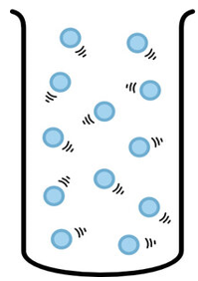 | B. | 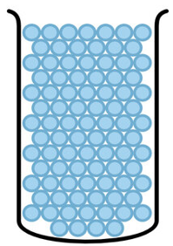 | C. | 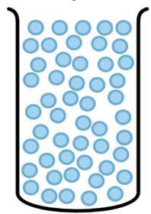

  - Which one of the following phases of matter (solid, liquid or gas) is represented by the arrangement of particles in diagram B? Give a reason for your answer. (2)
Isiphi kulezi zigaba ezilandelayo zento (okuqinile, uketshezi noma igesi) esimelelwa ukuhlelwa kwezinhlayiya kumdwebo B? Nikeza isizathu sempendulo yakho.

  - Classify each of the following as a solid, liquid or a gas./ Hlukanisa lokhu okulandelayo njengokuqinile, uketshezi noma igesi.
    - Paraffin./ Upharafini (1)
    - Steam from kettle./ I-Steam kusuka kwiketela. (1)
    - Eraser./ Isisuli (1) [5]
Question 3/ Umbuzo 3
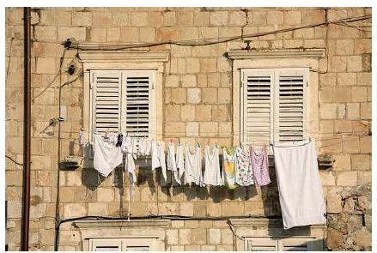
Christina hangs clothes of three different materials in the sun to dry as shown in the picture below. Clothes of material A, B and C. She predicted that clothes with material B would dry the fastest.
UChristina uneka izingubo zezinto ezintathu ezahlukene elangeni ukuze zome njengoba kuboniswe esithombeni esingezansi. Izingubo zezinto eziwu-A, B no-C. Wabikezela ukuthi izingubo ezinempahla engu-B zizokoma ngokushesha kakhulu.
Study the actual data table below and answer the following questions./ Funda ithebula ledatha langempela elingezansi bese uphendula imibuzo elandelayo.
Clothes Material  Impahla Yezingubo | Drying time (minutes)  Isikhathi sokomisa (amaminithi) | Temperature(°C)  Izingakushisa(°C)
A | 30 | 30
B | 35 | 30
C | 42 | 30

  - Was Christina’s prediction, correct? Support your answer. (2)
Ngabe ukuhlawumbisela kukaChristina kulungile? Sekela impendulo yakho
  - Give one controlled variable indicated in the table above. (1)
Nikeza okuguquguqukayo okukodwa okulawulwayo kokukhonjiswe kuthebula elingenhla
  - What is the dependent variable?/ Kuyini okuguquguqukayo okuncikile? (1)
  - What is the independent variable? Kuyini okuguquguqukayo okuzimele? (1)
  - Use the information in the above table to draw a bar graph in the graph paper
provided to show time taken to dry clothes of different materials A, B, and C. (5)
Sebenzisa ulwazi olusethebula elingenhla ukudweba igrafu yebha ephepheni legrafu enikeziwe ukuze kuboniswe isikhathi esithathwa ukomiswa izingubo zezinto ezihlukahlukene A, B, no-C.
[10]
Question 4
  - Study the pictures of wood and paper below to answer the questions which follow.
Fundisisa izithombe zokhuni nephepha ngezansi ukuze uphendule imibuzo elandelayo.
Wood/ Izinkuni | Paper/ Iphepha

    - Is wood and paper a raw or manufactured material? (2)
Ingabe izinkuni nephepha kuyimpahla eluhlaza noma eyenziwe?
    - Give a reason for your answer in 4.1.1. above. (2)
Nikeza isizathu sempendulo yakho ku-4.1.1. ngenhla.

  - Study the pictures of cow and sheep below to answer the questions which follow.
Fundisisa izithombe zenkomo nezimvu ngezansi ukuze uphendule imibuzo elandelayo.
Cow/ Inkomo | Sheep/ Imvu
    - Give two examples of the things that are made from the skin of a cow (hide). (2)
Nikeza izibonelo ezimbili zezinto ezenziwe ngesikhumba senkomo (isikhumba).
    - What do we make with wool from the sheep? (1)
Senzani ngoboya bezimvu?

  - Study the image of a diamond below and answer the question that follow.
Fundisisa isithombe sedayimane ngezansi bese uphendula umbuzo olandelayo.
Diamond/ Idayimane
    - Is diamond a hard or soft material? Give a reason for your answer. (2)
Ingabe idayimane liqinile noma lithambile? Nikeza isizathu sempendulo yakho.
[9]

Question 5/ Umbuzo 5
Study the diagrams A and B below to answer the questions that follow.
Funda imidwebo A no B engezansi ukuze uphendule imibuzo elandelayo.
  A |   B
  - Name 3 strong structures that make use of triangulation for their strengthening. (3)
Yisho izakhiwo ezi-3 eziqinile ezisebenzisa unxantathu ukuze ziqinise.
  - Which one of the shapes above is stable and more rigid? (1)
Imuphi umumo kwezingenhla ozinzile futhi oqinile?
- Explain why the joints in the structures need to be strengthened? (1)
Chaza ukuthi kungani amalunga ezinhlakeni edinga ukuqiniswa?
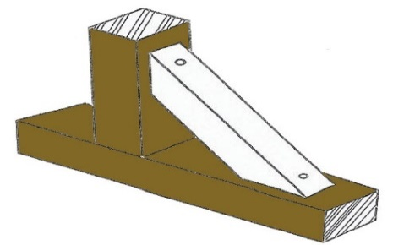
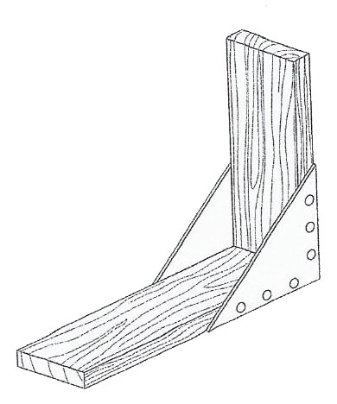
  - Study the diagrams A and B below to answer the following question.
Fundisisa imidwebo A no B ngezansi ukuze uphendule umbuzo olandelayo
A
B

    - Describe the method of strengthening corners that has been used in each of the following diagrams of corner joints A and B? (2)
Chaza indlela yokuqinisa amakhona esetshenziswe kumdwebo ngamunye kwelandelayo wamalunga ekhoneni A no-B?

  - Materials of building structures need to be strong, not to break or collapse easy. People add something like braces and struts to make a material stronger (reinforce). Using a table or a chair as an example, describe how struts strengthen the structure.
Izinto zezakhiwo zokwakha zidinga ukuqina, zingaphuki noma ziwe kalula. Abantu bengeza okuthile okufana nezinsimbi nama-struts ukuze benze into ibe namandla (qinisa). Usebenzisa itafula noma isitulo njengesibonelo, chaza ukuthi ama-struts aqinisa kanjani isakhiwo. (2)
[9]

Question 6/ Umbuzo 6
The Nama people make the matjieshuise from thin branches, which they bend into a beehive shape and tie together. The Nama people cover the structure with mats, which they weave from reeds as shown in the picture below. Matjieshuise are waterproof, cool in summer and warm in winter.

Abantu baseNama benza i-matjieshuise ngamagatsha amancane, abawagoba abe isidleke sezinyosi bese bebopha ndawonye. Abantu baseNama bavala isakhiwo ngamacansi, abaweluka emhlangeni njengoba kukhonjisiwe esithombeni esingezansi. I-Matjieshuise ayinamanzi, iyaphola ehlobo futhi ifudumele ebusika.
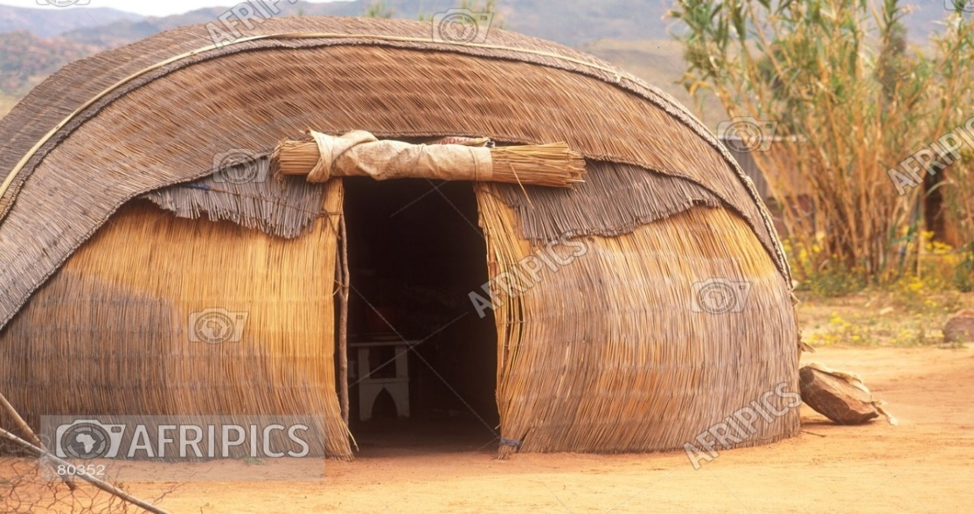

  - Name the materials that the Nama people use to make their Matjieshuise. (1)
Yisho izinto ezisetshenziswa abantu baseNama ukwenza iMatjieshuise yabo.
  - Where do you think they got the materials that they used to make their houses? (1)
Ucabanga ukuthi bazithathaphi izinto abazisebenzisa ukwakha izindlu zabo?
[2]
Total Marks: 40/ Amaphuzu Aphelele:40

Name/ Igama: _______________________________________

Question 3.5./ Umbuzo 3.5

