

EXAMINER: MOJAPELO MODERATER: MR SHAIKH

TERM: 4 GRADE: 6___

DURATION: 1 HOUR MARKS: 40

DISTRICT: D 11 SUBJECT: SOCIAL SCEINCES (HISTORY)

Name and Surname: _____________________________________________

Date: _________________________________________________________

Section | Section A |  |  |  | Section B
Question | Q 1 | Q 2 |  |  | Q 3 | Q 4 | Q5 | Q 9
Mark | 10 | 05 |  |  | 09 | 04 | 07 | 05
Mark
obtained

Term 3 content: 15 marks: Source-based questions and paragraph writing
Term 4 content: 25 marks: Source based questions and essay writing

INSTRUCTIONS:
Answer all the questions. Write neatly and legibly.
Answer on the QUESTION PAPER provided.

SECTION A: DEMOCRACY AND CITIZENSHIP [15]
QUESTION 1 [10]
SOURCE A: NATIONAL ANTHEM
Read the source below and answer questions that follow.
The national anthem is the official song of the country. South Africa’s national anthem is Nkosi Sikelel’ iAfrika. Our national anthem is in five languages. The first two verses were written by Enoch Sontonga in 1897. The last two verses are from the old national anthem Die Stem van Suid Afrika, which was written in 1918 by C. J. Langenhoven.

Nkosi sikelel’ iAfrika Maluphakanyisw’ uphpndo lwayo, Yizwa imithandazo yethu,
Nkosi sikelela, thina lusapho lwayo.

Morena boloka setjhaba sa heso, O fedise dintwa le matshwenyeho,
O se boloke , o se boloke setjhaba sa heso, Setjhaba
sa South Afrika – South Afrika.
Uit die blou van onse hemel, Uit diepte van ons see,
Oor ons ewige gebergtes , Waar die kranse antwoord gee.

Sounds the call to come together, And united we shall stand,
Let us live and strive for freedom In South Africa our land.
(Source taken from: Clever Social Sciences Grade 6)

  - Who wrote the original Nkosi sikelel ‘iAfrika? (1)

  - In which year was the song composed? (1)

  - When do we sing the national anthem? (1)

  - List any TWO languages in which the national anthem is sung. (2)

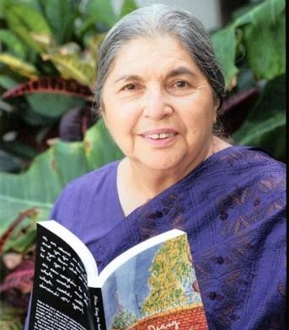
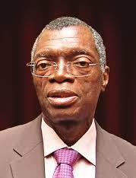
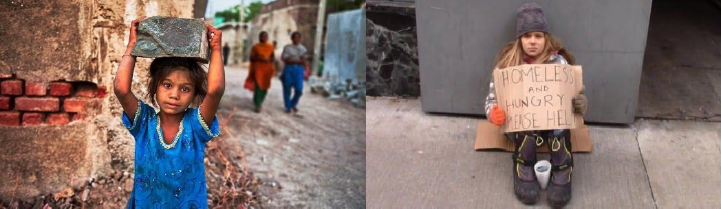
SOURCE B: The Children’s Charter
A child is any person under the age of 18. Children have special rights in South Africa. The Children’s Charter states that children have the right to go to school and learn in a safe environment.
(Source: Solutions for Social Sciences Grade 6)
  - Name TWO children’s rights you have learned about. (2)

  - Refer to the pictures below. List 3 children’s rights that are not being upheld. (3)

QUESTION 2 [5]
We have learned about Fatima Meer and Pius Langa and how they have helped shape democracy in South Africa.
Choose one from the two leaders below. Write the name of the leader of your choice as heading
then choose the relevant information from the jumbled text below to create a paragraph.

He / she was the head of the Constitutional Court from 2005. After acting as a Deputy Chief Justice of South Africa from 2001. She / he was a human rights activist, a writer and a political leader. She /he was born in Bushbuckridge in 1939, the second of seven children. He/she completed his high school education through private study and obtained a B. Luris and LL.B. degrees through the University of South Africa. He/ she was born in Durban, in 1928. His /Her father was widely respected for his
/her religious knowledge and he passed on his beliefs of religious tolerance. He / she started working for the family owned newspaper, The Indian View, on a part-time basis, when she/he was still in school. She / he was lucky to receive an excellent education and attended university. In 1977 was employed as an advocate and also worked in the Supreme Court and Appeal Court. He
/she represented the underprivileged, civic bodies, trade unions and people charged with political offences. As an advocate in the 1970’s and 1980’s he/she helped many people who were suffering under apartheid laws.
She /he was active with groups who wanted Nelson Mandela to be released from prison. He/she went on to become very involved in the fight against racial and gender discrimination during the time of the apartheid government.
After the democratic elections of 1994, he/ she helped to set up a democratic government, justice system and also helped other countries to develop their own constitutions. …… has received numerous awards. She /he became involved in the Passive Resistance campaign while she/ she was still in high school. He /She participated in the Defiance Campaign in 1952. She / he was banned by the government for three years. She / he was the founding member of the Federation of South African Women, in 1955. This organisation marched to the Union Buildings in Pretoria on the 9 August, 1956 in the famous anti-pass march. This march is still remembered today as it is a public holiday, Women’s Day.
The highest honour given to him/ her by President Thabo Mbeki was the Order of the Supreme Counsellor of the Baobab: Gold award in 2008. His /Her house was petrol bombed in 1976 when someone tried to kill him / her.
…….. opened high schools for black students and sent black students to India to study as she focused mainly on education in the 1980s.
He/she retired in October 2009. He died in 2013, aged 74, following a long illness. She / he
continued to work for women’s rights and justice for all, right up to he/she died in 2010.

Heading: (Name of the leader)

Rubric for Paragraph
LEVEL 1 | - Cannot extract evidence or extract evidence from the sources in a very exemplary manner.  - Use evidence partially to report on topic or cannot report on topic. | Marks: 0-1
LEVEL 2 | - Extracts evidence from the sources that is mostly relevant and relates to a great extent to the topic.  - Use evidence from sources in a very basic manner. | Marks: 2-3
LEVEL 3 | - Extract relevant evidence from the sources.  - Extracted evidence - relates well to the topic.  - Use evidence from the sources very effectively in an organized paragraph that shows an understanding of the topic. | Marks: 4-5

SECTION B: MEDICINE THROUGH TIME [25]

QUESTION 3 [9]
- Read the sources below and answer the questions that follow.

SOURCE D: How people are identified and trained as healers.
Traditional healers are born with a gift for healing. Their ancestors call them to use their healing gift. A person who has a certain kind of illness, or who has certain kinds of dreams, will know that he or she is called to be a healer.
The person called may suffer from strange visions and mental disturbance, even
madness. To become a healer, the person must first be cured of this “illness”. A practising indigenous healer will take the person through a series of ceremonies. The person may also be given various plant medicines to cure them.
The person called is then trained to be a practising indigenous healer. The healer will train the trainee in the techniques of healing or divining, and of curing illnesses using plant medicines. The training may take months. A traditional healer, a trainee, wears certain clothes and beads.
(Source: Oxford Successful Social Sciences Grade 6)
  - What symptoms do people experience when they are being called to be a traditional healer? (Give 2) (2)

  - Define the word “ancestor”. (1)

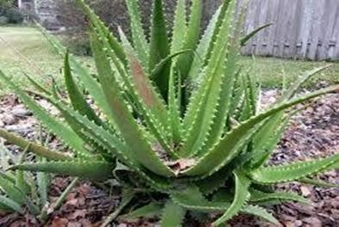
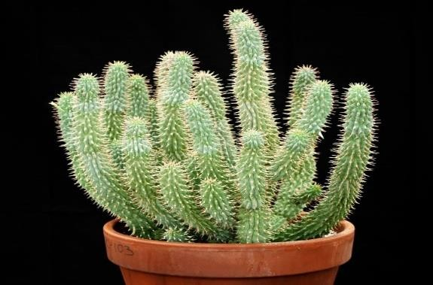
  - Discuss how indigenous healers cure the sick people. (2)

  - Rewrite the following sentences to make them TRUE.
    - Indigenous healers give patients drugs to treat an illness. (1)

    - The complete training of a sangoma is called graduation. (1)

  - Select the correct word to complete the sentences below.
Western doctor; Patient; Inyanga, isangoma
    - A traditional healer who uses plants to make medicines is an … (1)

    - A person who uses scientific medicine to heal people is a … (1)

QUESTION 4 [4]
  - Identify the medicinal plant blow: (1)
  - Mention any TWO illnesses that it has been traditionally used to cure. (2)

  - Why do we say hoodia is an indigenous traditional medicine? (1)

QUESTION 5 [7]
  - Put the name of the relevant person under each picture. (5)
Wilhelm Rontgen
Robert Koch
Louis Pasteur
Edward Jenner
Christiaan Barnard

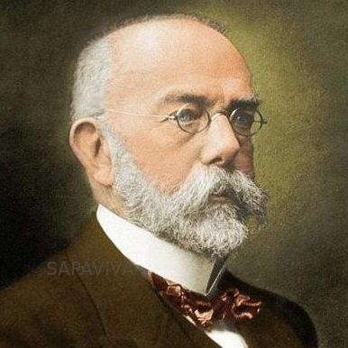 | 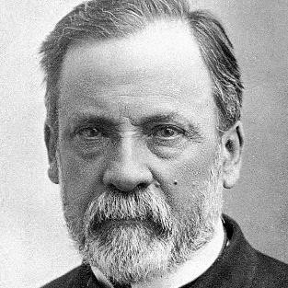 | 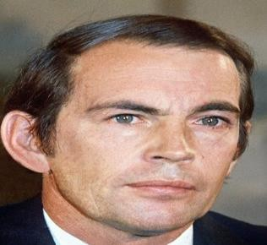 | 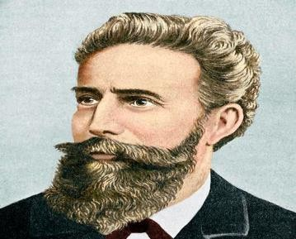 | 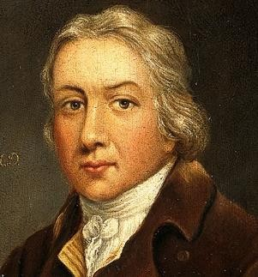
1882, he announced that he had found the germ that caused TB | He invented a process where bacteria could be removed by boiling and then cooling liquid in 1862. | He performed the first heart transplant in December 1967 | He discovered x-ray in 1895. | He developed a safe vaccination against smallpox in 1796
Give ONE word for each of the following statements.
  - The signs of an illness. (1)

  - Find out what kind of illness someone has by examining them. (1)

QUESTION 5 [5]
- Write a paragraph to explain how each invention helps in the operation process. (5)
  - X-rays
  - Cleanliness in the operating theatre
  - Blood transfusions
  - Anaesthetics

Rubric for Paragraph
LEVEL 1 | - Cannot extract evidence or extract evidence from the sources in a very exemplary manner.  - Use evidence partially to report on topic or cannot report on topic. | Marks: 0-1
LEVEL 2 | - Extracts evidence from the sources that is mostly relevant and relates to a great extent to the topic.  - Use evidence from sources in a very basic manner. | Marks: 2-3
LEVEL 3 | - Extract relevant evidence from the sources.  - Extracted evidence - relates well to the topic.  - Use evidence from the sources very effectively in an organized paragraph that shows an understanding of the topic. | Marks: 4-5

