

INTERMEDIATE PHASE – SOCIAL SCIENCES

GRADE FIVE

TERM 2 WORKBOOK – GEOGRAPHY

TEACHER’S GUIDE

Week # 1

1.1 | Introduction to the topic:  Physical features of South Africa
 | State whether the following statements are True or False: |  | L1
 | - A physical feature may be a border between two countries. True√ | 1x1(1) | L1
 | 1.1.2 Six provinces of South Africa are landlocked. False√ | 1X1(1) | L1
 | 1.1.3 All rivers in South Africa flow into the Indian Ocean False√ | 1X1(1) | L1
 | 1.1.4 A dam is a natural feature. False√ | 1X1(1) | L1
 | 1.1.5 South Africa is a country with a coastline. True√ | 1X1(1) | L1
 | 1.1.6 A cliff may separate land from the ocean. True√ | 1X1(1) | L1
 | 1.1.7 The source of the Limpopo River is in Limpopo Province. False√ | 1X1(1) | L1
 | 1.1.8 South Africa shares borders with six different countries True√ | 1X1(1) | L1
 | 1.1.9 All continents have coastlines. True √ | 1X1(1) | L1
 | 1.1.10 A mountain range is a series of mountains arranged in a line and connected by high ground. True √ | 1X1(1) | L1
1.2 | 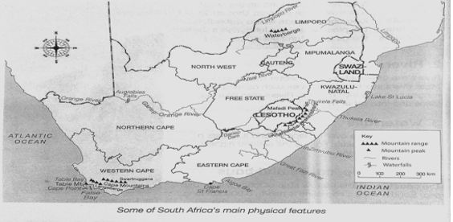  Study the physical map of South Africa below and answer the questions below it.  Source A : Macmillan Solutions for all: Social Sciences Grade
 | 1.2.1 What is the name of the Ocean that is in the West of South Africa? Atlantic Ocean√ | 1x1(1) | L1
 | 1.2.2 Give the river in KwaZulu-Natal that flows into the Indian Ocean on the map. Tukela river √ | 1x1(1) | L2
 | 1.2.3 What is the name of the river that flows to the west coast of South Africa? Orange river(orange -Gariep River )√ | 1x1(1) | L1
 | 1.2.4 What is the direction of Swaziland (Kingdom of Eswatini) from Table Bay? North East√ | 1x1(1) | L2
 | 1.2.5 Identify three provinces sharing borders with Lesotho.  Free state; √KwaZulu -Natal √and the Eastern Cape.√ | 1x3(3) | L1
 | 1.2.6 List the four provinces that have coastlines in South Africa.  Eastern Cape;√ Northern Cape; √Western cape √and KwaZulu-natal√ | 1x4(4) | L1
 | 1.2.7 Name two natural features that form borders between Lesotho and South Africa.  Mountain range√ and a river √ | 1x2(2) | L2
 | 1.2.8 What is the name of the river that separates Gauteng from the Free State Province? (1) Vaal River√ | 1x1(1) | L1
 | 1.2.9. What is the name of the lake found in KwaZulu-Natal (1) Lake St Lucia √ | 1x2(2) | L1
1.3 | 1.3.1 Differentiate between a political map and a physical map? (2)  Political maps show Continents, countries, provinces, cities and towns and national boundaries √but a physical map shows physical features of an area such as mountains, rivers, lakes, and other natural features√ | 1x2(2) | L2
 | 1.3.2 Explain the following terms:  a) A waterfall is a point in a river or stream where water flows over a vertical drop√√  b) The coastline: is the place where land and the sea/ocean meet√√ | 2x2(4) | L2
Week # 2
South Africa from above (physical map):
High places and low places (review ‘sea level and height above sea level)
The coastal plain, escarpment, and plateau (concepts and location of features in South Africa)

2.1 | Read the statements below and say whether they are True or false. |  | L1
 | 2.1.1 The coast is the line where the coast meets the land True √ | 1x1(1) | L1
 | 2.1.2 A flat or gently sloping low-lying area along the coast is called the plateau False√ | 1x1(1) | L1
 | 2.1.3 The height of the sea level is 0 meters. True√ | 1x1(1) | L1
2.2 | Study the diagram below that shows the physical features of South Africa from the west coast to the east coast. Answer each question by choosing the correct option from the list provided.
 | The drawing adapted from e-classroom resources
 | 2.2.1.1 In which part of South Africa do we find the highest relief( height)?  - the north-west  - the north-east  - the south  - the east√ | 1x1(1) | L1
 | - The biggest part of South Africa lies in/on the  - Drakensberg  - Little Karroo  - plateau√  - Lowveld | 1X1(1) | L1
 | - The area marked A is the  - coastal plain√  - escarpment  - plateau  - Great Karroo | 1X1(1) | L1
 | - The area marked B is the  - coastal plain  - escarpment√  - plateau  - Kalahari | 1X1(1) | L1
 | - The area marked C is the  - coastal plain  - escarpment  - plateau√  - Lowveld | 1X1(1) | L1

Week # 3

3. | Topic: South Africa from above (physical map):  Location of the Highveld, Lowveld, Great Karoo, Little Karoo, Kalahari, and Namaqualand  Physical features of South Africa  Mountains, mountain ranges, valleys and hills, rivers, waterfall, coastlines: capes and bays
Study the sources below and answer the questions that follow.
(a) Great Karoo:
Karoo (also spelled Karroo, Afrikaans Groot Karoo, also called Central Karoo, plateau basin in Western Cape province, South Africa), lies between the Great Escarpment (north) and the Swartberg (south).
(b) The Little Karoo
The Little Karoo is separated from the Great Karoo by the Swartberg Mountain range. It is a 290km long valley, only 40–60 km wide, formed by two parallel Cape Fold Mountain ranges, the Swartberg to the north, and the continuous Langeberg-Outeniqua range to the south.
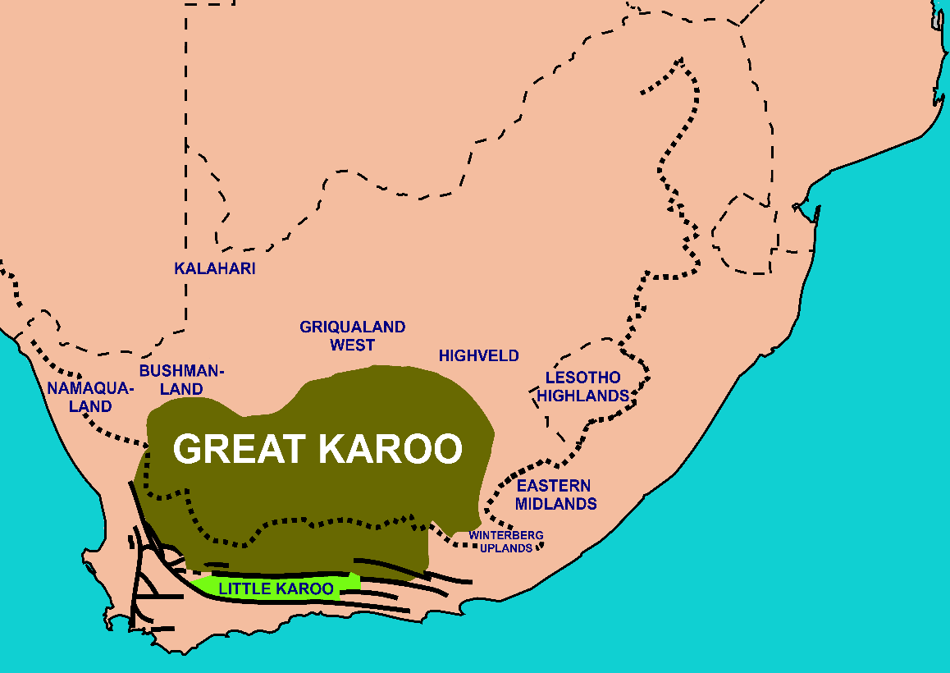
Source:https: https://en.wikipedia.org/wiki/Karoo
(c)The Highveld
The Highveld constitutes almost the whole of the Free State, and Gauteng Provinces, and portions of the surrounding areas: the western rim of Lesotho, and portions of the Eastern Cape, Northern Cape, North West, Limpopo, and Mpumalanga Provinces of South Africa
(d) Lowveld
The Lowveld is a lower lying area only approximately 800m above sea level high. It is found mostly in Mpumalanga and the Limpopo Province on the eastern and northern side of the Highveld.

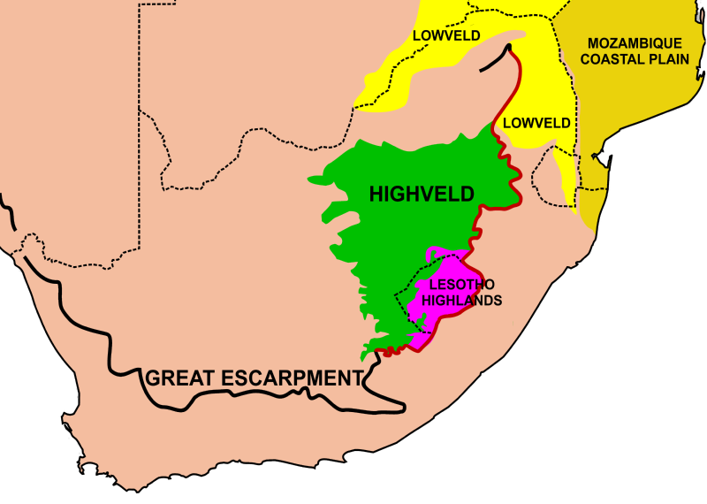
Source: https://en.wikipedia.org

(e) The Kalahari
Kalahari Desert, large basinlike plain of the interior plateau of Southern Africa. It occupies almost all of Botswana, the eastern third of Namibia, and the northernmost part of Northern Cape province in South Africa. In the southwest it merges with the Namib, the coastal desert of Namibia.
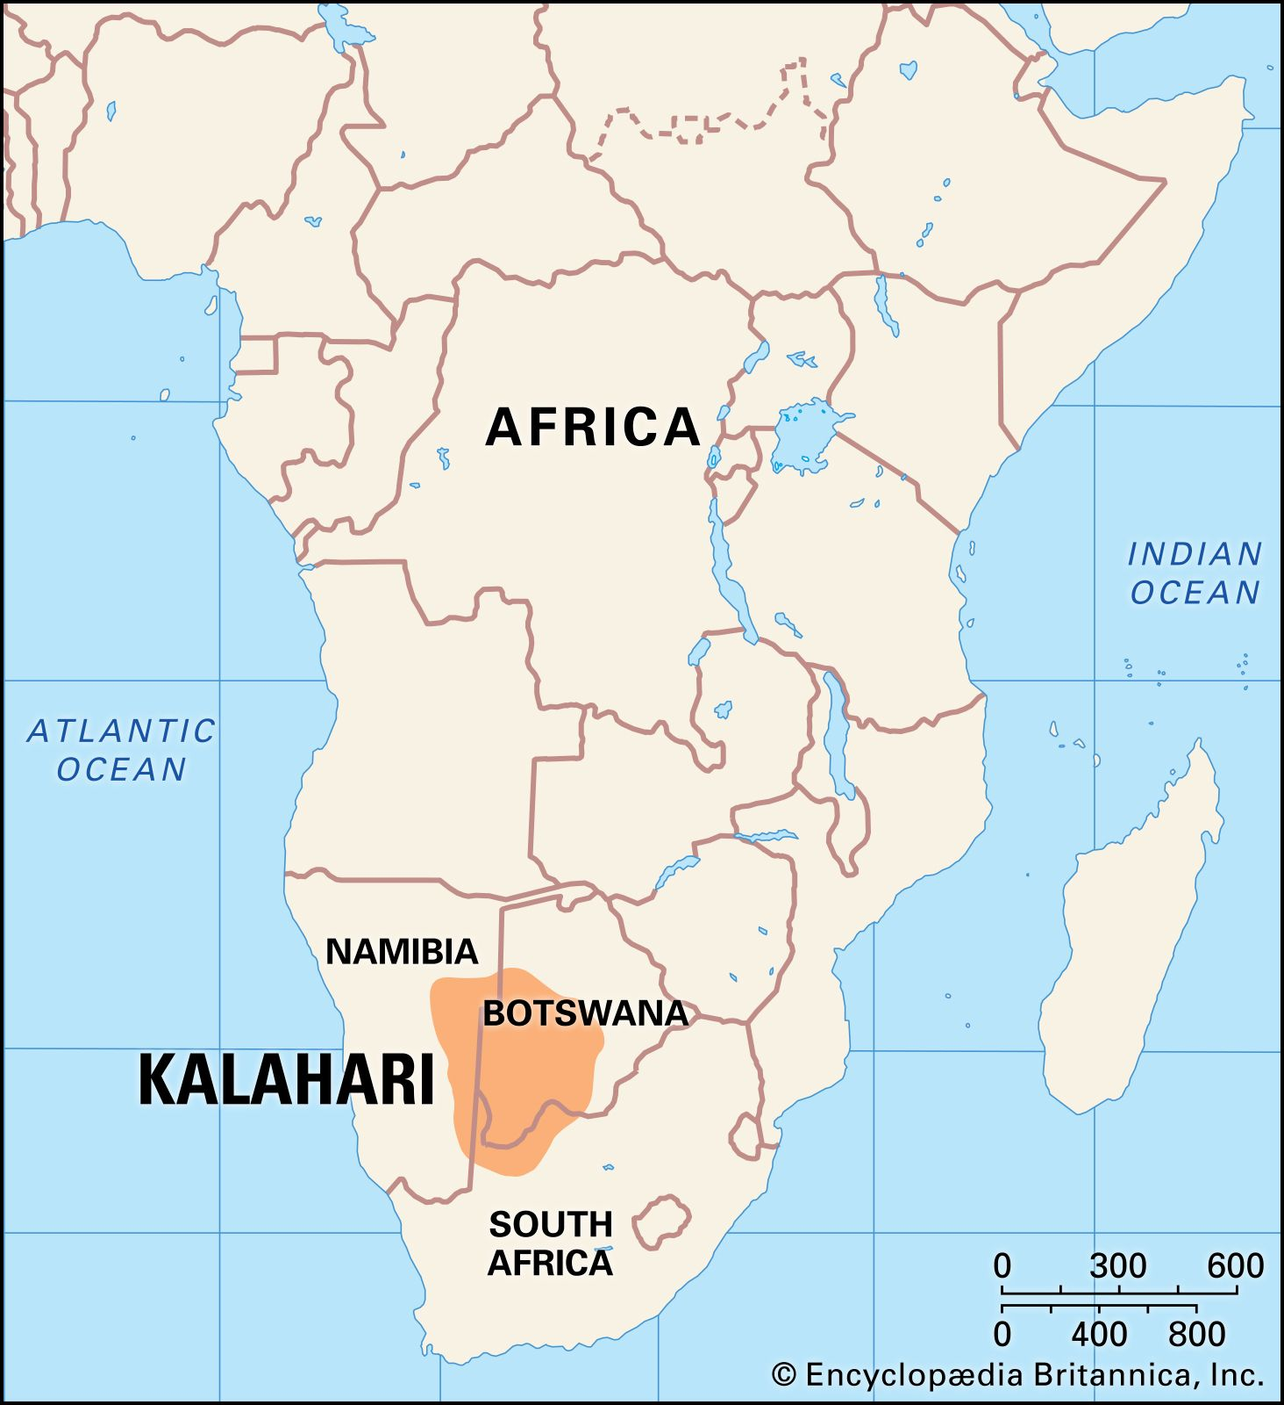
Source: https://www.britannica.com

(f) Namaqualand (The Namaqualand Region, Northern Cape).
Regarded as a portion of the Succulent Karoo, Namakwa (Namaqualand) forms part of the only arid hotspot in the world; is regarded as a biodiversity hotspot, and as such boasts the richest succulent flora on Earth.

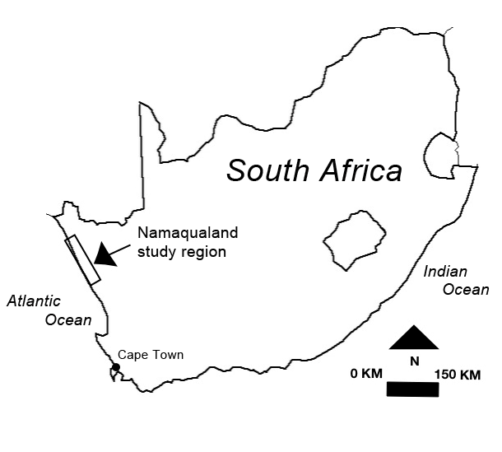
Source:https://www.researchgate.net

3.1 | Complete the table by matching the correct location to each physical feature. Write Only the letter of alphabet on the spaces provided below.
  Physical feature | Location of physical feature
  3.1.1. Highveld | A. The smaller of two valleys in the Western Cape that are found  between mountain ranges.
  3.1 2. Namaqualand | B. High lying plateau in the centre of South Africa
  3.1.3. Little Karoo | C. Found on the eastern part of South Africa, about 800m above  sea level
  3.1.4. Lowveld | D. The name of a desert.
  3.1.5. Kalahari | E. A large valley found between the Swartberg and Nuweveldberg  mountains
  3.1.6. Great Karoo | F. Found along the west coast next to the cold Atlantic Ocean
Complete the table: 1X6(6) L1
Column A | 1 | 2 | 3 | 4 | 5 | 6
Column B | B√ | F√ | A√ | C√ | D√ | E√

3.2 | As part of your homework/assignment, use the table below to identify some of the physical features found in each province in South Africa. Use any resource available to complete the activity. | 1x36 (36) | L1
 | The location of some physical features in South Africa.
Province | Mountains | Valleys and hills | Rivers | Waterfalls | Capes and bays
Northern Cape | Richtersveldt Range | Orange/ Gariep Valley | Orange/ Gariep | Augrabies | West Coast Cape
Eastern Cape | Escarpment  Sneeuberge  Amatola | Gamtoos valley  Langkloof valley | Sundays  Fish  Kei | Riviersonderend | Algoa Bay  Cape Recife
Western Cape | Cedarberg Mountains  Table Mountain | Breede River  Valley  Berg River Valley | Breede Berg  Olifants | Magwa | Table Bay  Saldanha Bay  Cape Agulhas
Kwazulu - Natal | Drakensberg  Sneeuberge  Escarpment | Valley of a thousand hills | Tugela  Duzi  Mzimkulu | Oribi  Tugela | Richards Bay  Umzinto  Bay
Free State | Escarpment  Drakensberg  Maluti | Clarence valley | Caledon  Vaal  Ash |  | None
Mpumulanga | Escarpment  Drakensberg  Lebombo | Loskop valley | Crocodile  Olifants | Berlin  Lisbon | None
North west | Pilanesberg  Magaliesberg | Pilanesberg | Crocodile  Hartz |  | None
Gauteng | Witwatersrand  Magaliesberg | Lonehill  Koppie | Vaal  Apies |  | None
Limpopo | Soutpansberge  Waterberge | Limpopo  valley | Limpopo  Lephalala |  | None

Week # 4

4.1 | Activity 1  4.1.1.Look at the picture below and answer the questions that follow.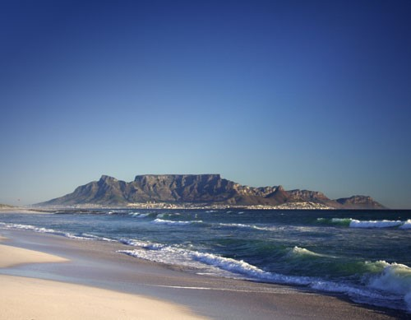  Table Mountain
 | 4.1.1 In which province is this mountain? Western Cape | 1x1(1) | L2
 | 4. 1.2. Name the city where the mountain is situated. Cape Town | 1x1(1) | L1
 | 4. 1.3. How many metres above sea level is this mountain? 1087 meters | 1x1(1) | L2
 | 4. 1.4. Which economic activity does this mountain support? Tourism | 1x1(1) | L2
 | 4. 1.5. Why is this mountain called Table Mountain? It is flat on top like a table | 1x1(1) | L2
4.2 | 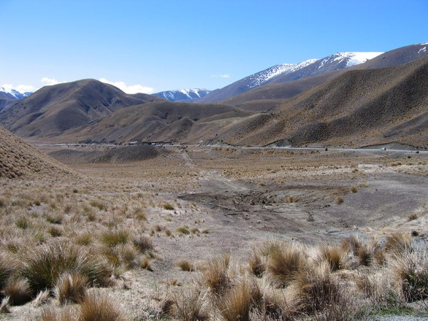  A Plateau
 | 4.2.1 . Which Mountain range is found between the free state and KwaZulu Natal? uKhahlamba/ Drakensberg Mt. | 1x1(1) | L1
 | 4.2. 2. Why are coastal plains not found in the Gauteng province? It is landlocked or Gauteng is not situated near the coastline/ the coast √ | 1X2(2) | L2
 | 4. 2.3. Are escarpments good areas for farming? Give a reason for your answer. No. there is a lot of soil erosion√√ ( a mark can be awarded for any relevant answer) | 1X2(2) | L2
 | 4. 2.4. Will coastal plains be good areas for farming? Give a reason for your answer. No. There is too much water √√ ( a mark can be awarded for any relevant answer) | 1X2(2) | L2
4.3 | Study the picture below and answer the question  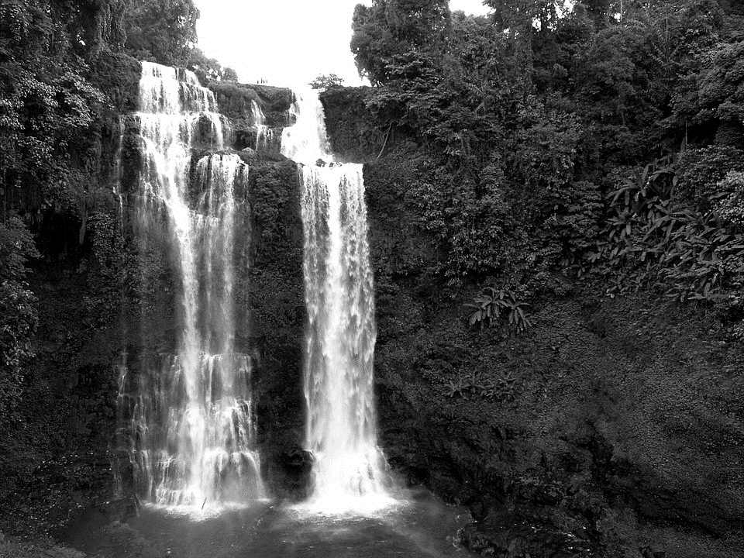  Source: showing a waterfall taken
 | 4. 3.1. The place where a river starts is called a?....... Source √ | 1x1(1)
 | 4. 3.2. The last end of the river is called………………. The mouth of the river √ | 1x1(1)
 | 4. 3.3. The Augrabies Falls are found in which river………. Orange River√ | 1x1(1)
 | 4. 3.4. Augrabies Falls has a height of ……. metres. 56 meters √ | 1x1(1)
4.4 | State whether the following statements are TRUE or FALSE |  | L1
 | 4.4.1. St Lucia is found north of Durban True√ | 1x1(1)
 | 4. 4.2. There is an abundance of iguanas in St Lucia True √ | 1x1(1)
 | 4. 4.3. St Lucia was proclaimed a World Heritage Day in 1999 True √ | 1x1(1)
 | 4. 4.5. The word Augrabies is a Zulu word False√ | 1x1(1)
 | 4. 4.5. uKhahlamba means barrier of spears True√ | 1x1(1)
4.5 | Explain the following Terms |  | L2
 | 4. 5.1. Plateau Large flat area above sea level√√ | 1X2(2)
 | 4. 5.2. Escarpment Steep Mountain between low-lying land and high-lying land √√ | 1X2(2)
 | 4. 5.3. Coastal Plain Flat or sloping area of land between the sea on the other side and a mountain on the other side√√ | 1X2(2)
 | 4. 5.4. Bay Large area of land where the sea indents inland√√ | 1X2(2)

Week # 5

5.1 | Topic- Rivers -  Where rivers begin and end: Directions of flow from high areas to the sea  Concept of river systems: tributaries and catchment areas
 | Where rivers begin and end: Directions of flow from high areas to the sea
 | 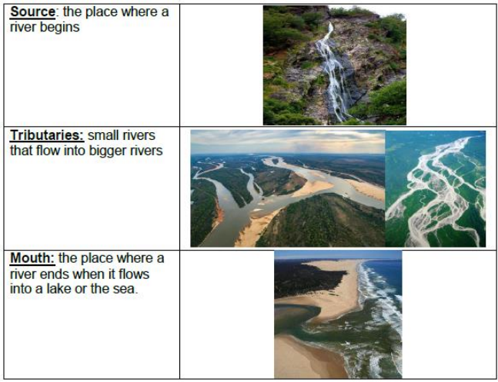
 | 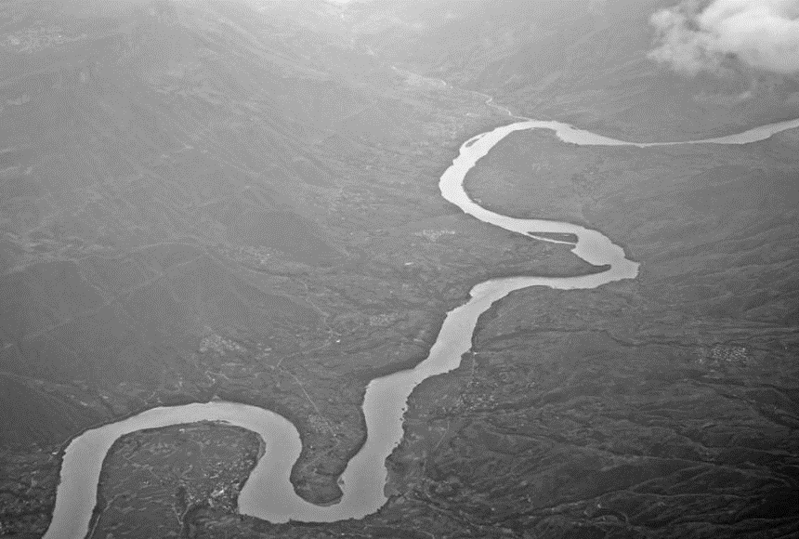
 | 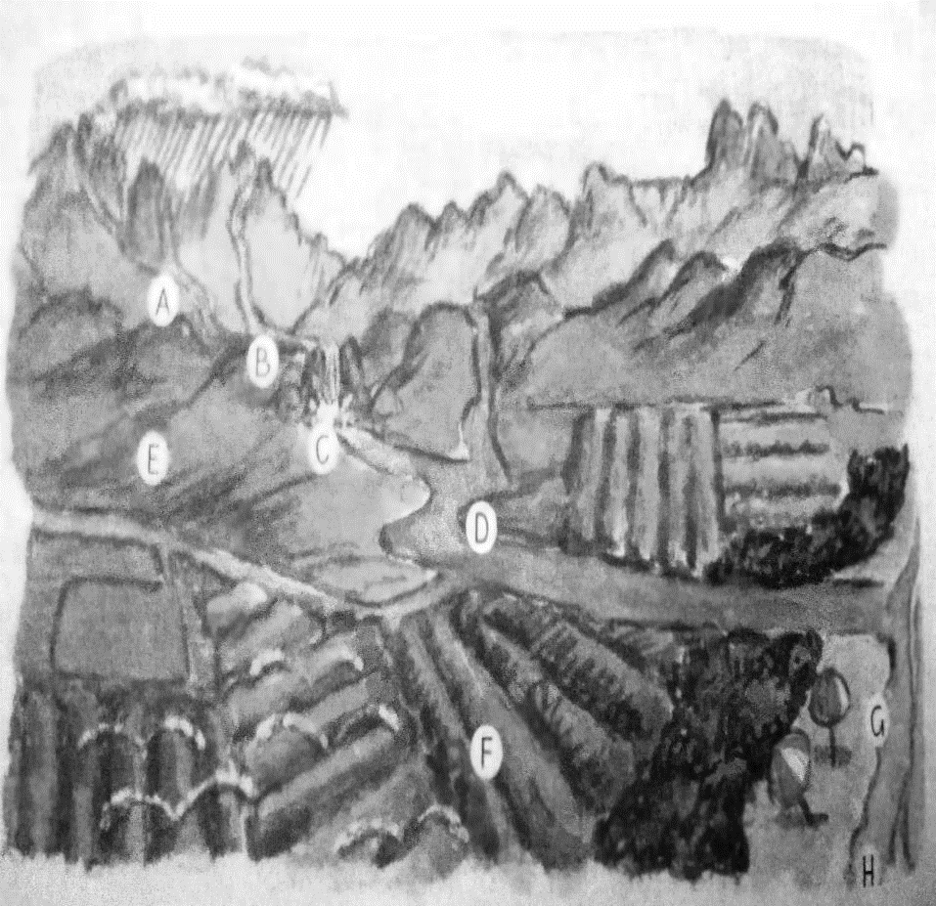
5.1 | A diagram of a river system in a catchment area
Use the word bank to fill in the missing words
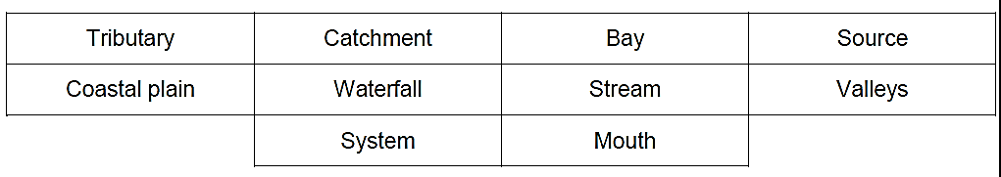
 | 5.1.1. The (A)Source of this river is in the mountains. √ | 1x1(1) |  | L1
 | 5.1.2. A (B)Stream is a small river. √ | 1x1(1) |  | L1
 | 5.1.3. Here the river flows over a (C) Waterfall. √ | 1x1(1) |  | L1
 | 5.1.4. This is a (D)tributary of the bigger river that it flows into. √ | 1x1(1) |  | L1
 | 5.1.5. The streams and rivers flow down (E)Valley between the hills. √ | 1x1(1) |  | L1
 | 5.1.6. The river flows across the flat (F)Coastal plain. √ | 1x1(1) |  | L1
 | 5.1.7. This point where the river flows into the sea is the river(G)Mouth. √ | 1x1(1) |  | L1
 | 5.1.8. This dent in the coastline is called an (H)Bay. √ | 1x1(1) |  | L1
 | 5.1.9. All these rivers are in the same Catchment area. √ | 1x1(1) |  | L1
 | 5.1.10. All the rivers in a catchment area make up one river System. √ | 1x1(1) |  | L1
5.2 | 5.2.1. Create (build or draw) a river system.  - Use recyclable materials and build a river system. A teacher may show various models shown below to learners.  - Label your river system.  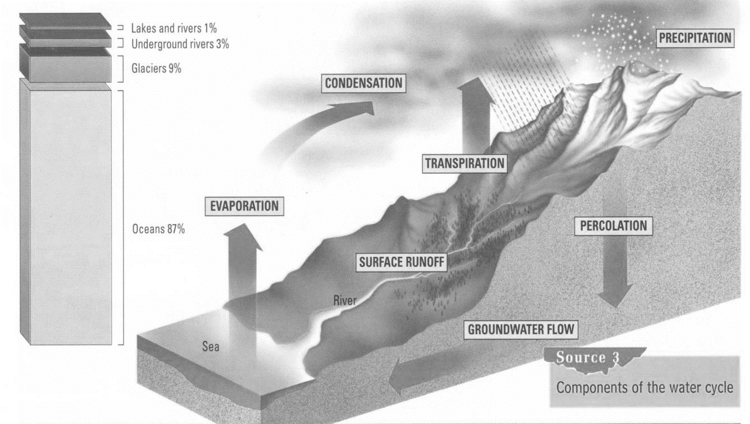  River System  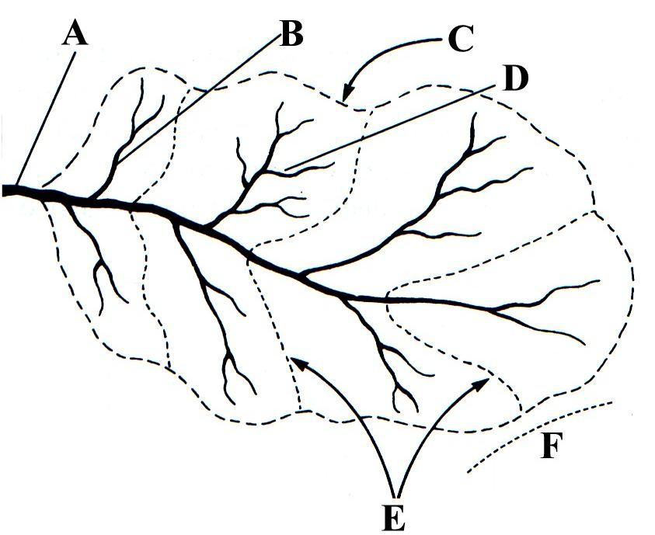  A: Mainstream / Mouth  B: Tributary  C: Watershed  D: Origin of stream  E: Interfluves  F: Main watershed
Below are examples of river systems created to guide you.
E.g., of
models

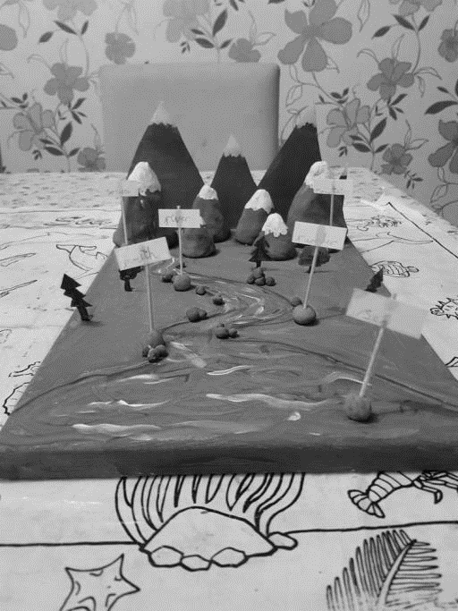
 | 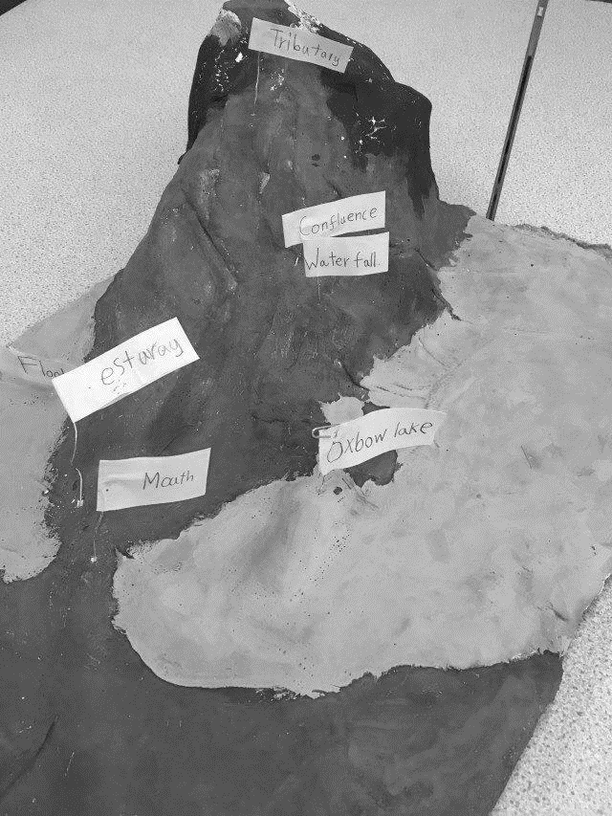
E.g. of a poster

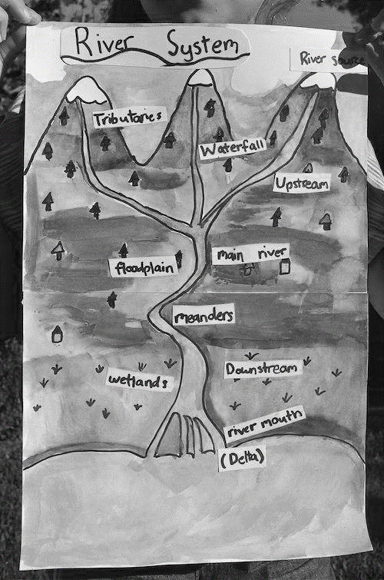

 | Week # 6
6.1 | Topic: Rivers -  Main rivers of South Africa: Identifying the sources, major tributaries, and directions of flow (map)
 | 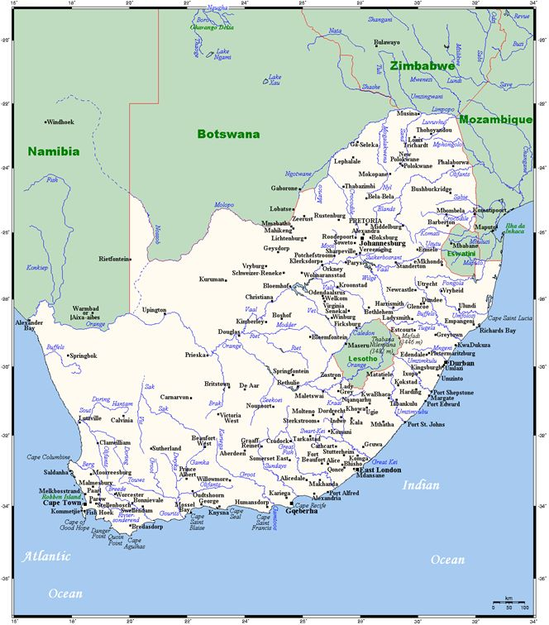
https://en.wikipedia.org/wiki/List_of_rivers_of_South_Africa#/media/File:South_Africa_Topography.png
Use the map above to complete the activity below
 | 6.1.1. Find the Gariep-Orange River on the map
 | a) In which country is its source? Lesotho√ | 1x1(1) | L2
 | b) Give the names of two of its tributaries?Caledon/ Vaal/ Harts/ Riet/Kraai /(any other two tributaries they may locate on the map they are using) √ | 1x2(2) | L1
 | c) Which province in South Africa has the mouth of the Gariep-Orange on its border? Northern Cape√ | 1x1(1) | L2
 | 6.1.2. Follow the course of the Limpopo River on the map. Underline the correct word to complete the sentences.
 | The source of the Limpopo River is in a) Limpopo/North West Province. It flows towards the b) south – west/north – east. It then flows c) east/west along South Africa’s border with Zimbabwe. Finally it drops down into d)Swaziland/Mozambique.At this point, another big river called the e) Olifants/Zambezi joins the limpopo River. This river is a f) mouth/tributary of the limpopo River
 | 6.1.3 Refer to the map above to answer the questions below about the rivers in KwaZulu-Natal.
 | a) Write down the names of any two of these rivers.  Any two rivers in KwaZulu-Natal that are on the map. For example: Tugela, Umfolozi. Umkomazi. Mzimkhulu√√ | 1x1(1) | L1
 | b) Which mountain range is the source of these rivers?  uKhahlamba-Drakensberg mountains√ | 1x1(1) | L2
 | c) Explain why there are many waterfalls on these rivers?  Any answer that demonstrates an understanding of the link between steep slopes or rocky terrain and waterfalls. For example, the river flows down steep slopes from the high mountains to the sea./These rivers flow down steep mountainsides./there are many rocky slopes for the water to flow over√ | 1x1(1) | L2
 | 6.1.4. State whether the statements are True or False |  | L1
 | a) The Tugela and Mzimkulu Rivers are in the same catchment area. False√ | 1x1(1)
 | b) The Gariep-Orange is the longest river in South Africa. True√ | 1x1(1)
 | c) The Gariep-Orange flows from the west towards the east. False√ | 1x1(1)
 | d) The mouth of the Sunday River is in Algoa Bay. True√ | 1x1(1)

Week # 7

7.1 | Physical features and human activities  Links between physical features, where people live, and what they do (human activities)
Study the paragraph below and answer the question that follows.

South Africa is a diverse country spanning from 22°S to 35°S latitude and 17°E to 33°E longitude. It covers 1,219,602 km2 and has a wide range of physical features such as bushveld, grasslands, forests, deserts, mountains, and coastal areas. It shares borders with Namibia, Botswana, Zimbabwe, Mozambique, and Swaziland, while Lesotho is completely surrounded by South Africa. The country experiences different climates and vegetation due to the warm Mozambique-Agulhas Current on the east and south coasts and the cold Benguela Current on the west coast. The west coast is particularly rich in marine resources, supporting the fishing industry. South Africa lacks navigable rivers and natural lakes, relying on artificial lakes for irrigation purposes. The Orange River is the largest river, flowing through the Drakensberg Mountains and forming the border with Namibia. The country's geography can be divided into the interior plateau and the coastal region.
Source: https://www.gov.za/about-sa/geography-and-climate#land

 | 7.1.1 In a paragraph of 5 to 6 lines, explain how the physical features of the Mountains of South Africa influence where people live and what they do, give an example of a mountain.  Example response.  Mountains: The presence of mountains, influences settlement patterns and economic activities. People tend to settle on the leeward side of mountains, which receive more rainfall and have a milder climate suitable for agriculture. These areas provide fertile soil for farming and support activities such as crop cultivation and livestock rearing. Additionally, mountains offer opportunities for tourism and recreational activities like hiking, mountaineering, and wildlife exploration.  Example: Drakensberg Mountains, which act as a natural barrier and provide protection from harsh weather conditions. As a result, people tend to settle on the eastern side of the mountains where the climate is more favorable for agriculture. | 1x5(5) | L3
  Level 1 | Uses evidence in an elementary manner e.g. shows little or no understanding of how physical features of South Africa influence where people live and what they do. | MARKS:  0-1
  Level 2 | Evidence is mostly relevant to how the physical features of South Africa influence where people live and what they do. | MARKS:  2-3
  Level 3 | Uses relevant evidence e.g. demonstrates a thorough understanding of how physical features of South Africa influence where people live and what they do. | MARKS:  4-5
 | 7.1.2 Name two physical features of South Africa that can influence where people live.  Possible correct answers include, but are not limited to:  - Drakensberg Mountains  - Karoo Basin  - Great Escarpment  - Cape Fold Mountains  - Orange River  - Limpopo River  - Vaal River  - Zambezi River  - Table Mountain  - The Kalahari Desert | 1x2(2) | L1
 | 7.1.3 Why do people settle along major rivers in South Africa?  Marking guideline: Award 1 mark per valid reason for settling along major rivers.  Example response:  People settle along major rivers in South Africa for an abundant water supply.  Major rivers provide a consistent source of fresh water, which is essential for various human activities such as drinking, irrigation, and sanitation.  The availability of water from rivers supports agriculture, allowing communities to grow crops and raise livestock.  Other possible answers:  It also facilitates transportation and trade, as rivers provide natural channels for the movement of goods and people.  Additionally, settling along major rivers offers opportunities for fishing, which can provide a source of food and livelihood for the local population.  Overall, the presence of major rivers ensures access to vital resources and economic opportunities, making them attractive locations for human settlement in South Africa. | 1x3(3) | L2
 | 7.1.4 Give two reasons why people would want to settle in coastal areas.  There are several reasons why people are often attracted to settle in coastal areas:  Access to Natural Resources: Coastal areas often provide easy access to abundant natural resources such as fisheries, seafood, and minerals. Fishing communities and industries thrive in coastal regions due to the proximity to the ocean, which supports livelihoods and economic activities. Additionally, coastal areas may offer opportunities for tourism, as beaches, water sports, and coastal landscapes attract visitors, leading to potential economic benefits.  2. Recreational and Aesthetic Value: Coastal areas are often associated with beautiful beaches, scenic views, and a pleasant climate. Many people are drawn to the recreational opportunities provided by the coast, such as swimming, surfing, boating, and sunbathing. The coastal environment also offers a sense of tranquility and natural beauty, making it an attractive place for relaxation, leisure, and vacation. This aesthetic appeal contributes to the desirability of coastal living for many individuals. | 1x2(2) | L2
 | 7.1.5 In short explain why fishing found in the coastal regions of South Africa is important to the coastal communities.  Marking guideline: Award 1 mark per valid explanation.  Possible explanations:  - Due to the country's extensive coastline along the Indian Ocean and the Atlantic Ocean, fishing plays a significant role in the livelihoods of many coastal communities.  - Fishermen and fishing communities engage in various fishing practices, including commercial fishing, subsistence fishing, and recreational fishing.  - They rely on the rich marine resources of the oceans to catch fish and other seafood, to be consumed locally.  - Fishing supports the local economy, provides employment opportunities, and contributes to the cultural heritage of coastal communities in South Africa. | 1x2(2) | L2

Week # 8

8.1 | Ways in which human activities change the physical landscape.
New word:
Mountainous – an area with lots of mountains and hills.
Pipeline – a line of pipes that carry water, oil, or gas for a long way.
Medicinal plants – plants used for medicine.
Thatching grass – grass used for roofs of buildings.
Ecosystem – a biological community of interacting organisms and their physical environment.
Sediments – a matter that settles to the bottom of a liquid.
Hydroelectric – the generation of electricity using flowing water.
Irrigation – the supply of water to land or crops to help growth, typically by use of channels.
Wildlife – wild animals collectively.
8.1 | Case study – Dams and roads open up the Lesotho Highlands  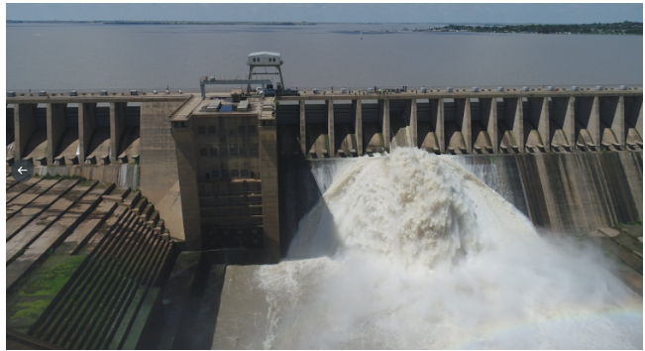  Lesotho is a very mountainous country and some regions are hard to reach. People had to walk very far to get water. In the dry season, there was no water. The Lesotho Highlands Water Scheme was started 30 years ago and is still taking place. This scheme has built many dams, such as the Katse dam, to supply water to the people of Lesotho and South Africa. The water from the dams gets to South Africa by pipeline.  Thousands of people had to move because the land where their villages stood was flooded when the dams were built. These people use to fish in the rivers and grow vegetables and collect medicinal plants and thatching grass. They cannot do these activities now. All the plants have been flooded and have died. Before the dams were built there was only one sand road. This road often got washed away by the rain or closed in winter because of snow.  Now tarred roads have been built to transport people and goods to and from the area. People can get goods from shops in nearby towns. Many people got jobs building roads and dams. A new tourist centre was built high in the mountains near Katse which created jobs.  Oxford Successful Social Sciences Learner’s book pg. 50
8.1 | Read the case study above and answer the following questions.
 | 8.1.1 Name one of the dams that were built to supply water to the people of Lesotho and South Africa? Katse dam√ | 1x1(1) | L1
 | 8.1.2 Give 3 activities that people used to do in their villages before the dam was built.  Fishing√  Grow vegetables√  Collect medicanal plants√  Cut grass for thatching grass√ (any 3) | 1x3(3) | L2
 | 8.1.3 How have the people of Lesotho benefited from the Lesotho Highlands scheme? List 3 benefits.  Jobs were created√  The dam supply the people with water. √  Tarred roads were built√ | 1x3(3) | L1
 | 8.1.4 How has the Lesotho Highlands project changed the physical landscape?  The natural vegetation was destroyed. √  The land was flooded. √  Tar road was built where it used to be the sand road. √ | 1x2(2) | L1
Case study – the impact of dams on the physical environment.
Dams are important structures that are built to control water flow, generate hydroelectric power, and provide water for irrigation and other purposes. However, the construction and operation of dams can have significant impacts on the natural environment.
The environmental impacts of dams can include changes in water flow, sediment transport, and water quality. Dams can also affect fish and wildlife populations, alter river ecosystems, and disrupt the natural processes of rivers.
8.2 | Read the case study above and answer the following questions.
 | 8.2.1 What is the purpose of dams?  To control the flow of water. √  To generate hydroelectric power. √  To provide water for irrigation. √ | 1x2(2) | L1
 | 8.2.2 Name two environmental impacts of dams.  Changes in water flow√√  Sediment transport√√  Affects the quality of water. √√ | 2x2(4) | L1
 | 8.2.3 How can dams affect aquatic animals and wildlife populations?  The building of dams destroys the trees and other natural vegetation that animals eat. √√  The natural flow of the river is disturbed and therefore affects the aquatic animals. √√ | 2x2(4) | L2

Week # 9

9.1 | Read the following statements and select the correct answer.
 | - Which physical feature can serve as a border between two countries?  a) Coastline  b) Mountain range  c) Waterfall  d) Sea level | 1x1(1) | L1
 | - Which country has a coastline?  a) South Africa  b) Lesotho  c) Swaziland  d) Botswana | 1x1(1) | L1
 | - How are mountains in a mountain range connected?  a) By rivers  b) By high ground  c) By deserts  d) By forests | 1x1(1) | L1
 | - How many countries does South Africa share borders with?  a) Four  b) Five  c) Six  d) Seven | 1x1(1) | L1
 | - Which ocean is located to the west of South Africa?  a) Indian Ocean  b) Pacific Ocean  c) Atlantic Ocean  d) Arctic Ocean | 1x1(1) | L1
 | - Which river in KwaZulu Natal flows into the Indian Ocean?  a) Orange River  b) Tugela River  c) Limpopo River  d) Zambezi River | 1x1(1) | L1
 | - What does a physical map primarily show?  a) Continents and countries  b) Provinces and towns  c) National Boundaries  d) Mountains and rivers | 1x1(1) | L1
 | - What is a waterfall?  a) A coastal feature  b) A mountain range  c) When a river or stream pours over a cliff  d) A political boundary | 1x1(1) | L1
 | 9.1.9 Which human activity is most closely associated with the coastal regions of South Africa?  a) Mining  b) Farming  c) Fishing  d) Hunting | 1x1(1) | L1
 | 9.1.10 The primary causes of settling along main rivers in South Africa DO NOT include one of the reasons listed below:  a) Easy access to transportation  b) Scarcity of water supply  c) Natural barriers for protection  d) Fertile soil for agriculture | 1x1(1) | L1
 | - Which river separates South Africa from its neighbouring country, Namibia?  a) Orange River  b) Limpopo River  c) Zambezi River  d) Vaal River | 1x1(1) | L1
 | - Which physical feature of South Africa is known for its large, flat grasslands?  a) Drakensberg Mountains  b) Great Escarpment  c) Karoo Basin  d) Cape Fold Mountains | 1x1(1) | L1
9.2 | Write down the differences between the Highveld and Lowveld areas in South Africa. | 1x8(8) | L2
   | Highveld Areas | Lowveld Areas
  Altitude | high-altitude grassy plain√ | The low-lying region√
  Temperature | cool temperatures √ | warmer climates √
  Rainfall | moderate rainfall√ | higher rainfall√
  Location | It is located in the central part of South Africa.√ | It is situated in the northeastern part of South Africa, closer to Kruger National Park√
9.3 | Match the location of the selected physical features in South Africa. Use the table below: NOTE some of the locations might be used more than once. Write down only the letter next to the number in COLUMN C | 1X7(7) | L1
COLUMN A- Names of Physical Features | COLUMN B- Province (Where it is located) | COLUMN C- ANSWERS
9.3.1. Table Mountain | A. KwaZulu Natal | 9.3.1. C √
9.3.2. uKhahlamba- Drakensberg | B. Northern Cape | 9.3.2. A √
9.3.3. Waterberg | C. Western Cape | 9.3.3. E √
9.3.4. Lake St Lucia | D. Eastern Cape | 9.3.4. A √
9.3.5. Augrabies Falls | E. Limpopo | 9.3.5. B √
9.3.6. Cape Point | F. Free State | 9.3.6. C √
9.3.7. Algoa Bay |  | 9.3.7. D √

9.4 | Label the diagram below and complete the table by giving definitions of each terminology
 | 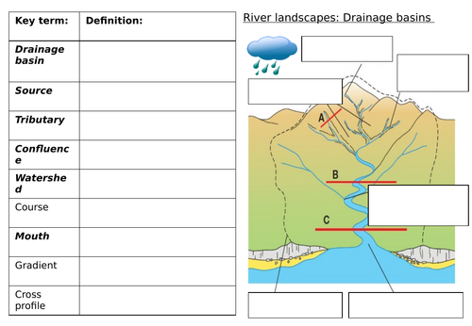  D | 1X3(3)
A. Source√
B. Tributaries√
C. Catchment
Key Terminology | Definition
Source
Mouth
Tributaries

Study the map below and answer the questions that follow
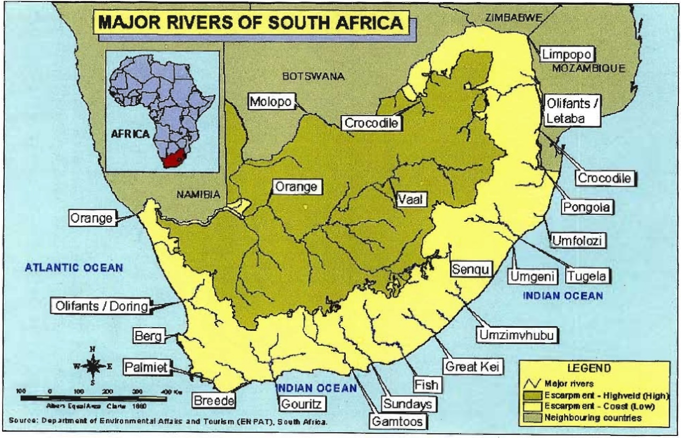
Source: Map showing South Africa’s Major Rivers

 | 9.5.1 Which is the longest river in South Africa  (a) Orange River√  (b) Limpopo River  (c) Vaal River  (d) Tugela River | 1X1(1) | L1
 | 9.5.2 The Limpopo√ River flows towards the northeastern part of South Africa and shares its name with the province where it is found. | 1x1(1) | L2
 | 9.5.3 The Crocodile River√ flows through Kruger National Park and forms the border between South Africa and Mozambique. | 1x1(1) | L2

