Grade 6 Geography Term 4 Worksheets

Population Distribution Date: ____________________________
Population distribution means the pattern of where people live. It is the way in which people are spread across an area.
Geographers study population distribution patterns at different scales: local (your town or city), regions (your provinces), national (your country), and global (the world).
World population distribution is uneven. Places which are sparsely populated contain few people as they tend to be difficult places in which to live e.g., Antarctica or the Sahara Desert. Places which are densely populated contain many people as they are environments that are suitable to live in e.g., Europe

Activity 1
List some of the factors that you think would make an environment habitable (i.e., suitable to live in)
- _________________________________________________________________________
- _________________________________________________________________________
- _________________________________________________________________________
- _________________________________________________________________________
- _________________________________________________________________________
- _________________________________________________________________________

Population Density

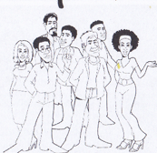
Population density is a measurement of the number of people in an area.
Population density is the average number of people per square kilometre.

Population density is calculated using the following formula:
Population density= total population ÷ total land area in km²

Activity 2
For each of the following soccer matches, describe the population distribution and density using the words in the box below:
Sparse Dense Even Uneven

Match 1 | Match 2
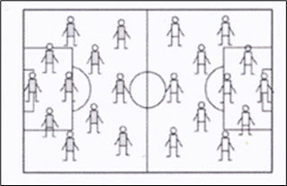 | 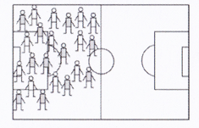
Population Density:  _____________________________________  Population Distribution:  ____________________________________ | Population Density:  _______________________________________  Population Distribution:  _______________________________________

Match 3 | Match 4
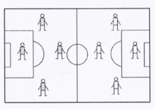 | 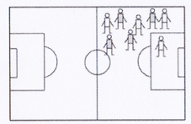
Population Density:  ____________________________________  Population Distribution:  ___________________________________ | Population Density:  _________________________________________  Population Distribution:  ________________________________________

Activity 3 Date: _______________________________
Use dots to show the following population distribution and densities on the imaginary countries:

- Give the country a ________________ population | - Give the country a ________________population
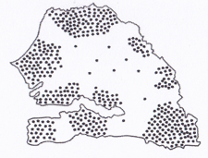 | 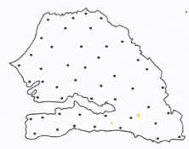

- Give the country an _______________population | - Give the country an _______________population
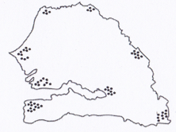 | 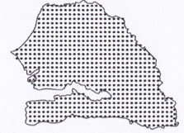

FIGURE A: Population density of South Africa
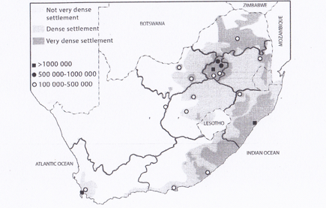
A Limpopo B North West
C Northern Cape
D Western Cape
E Eastern Cape
F Kwa-Zulu Natal G Free State
H Gauteng I Mpumalanga
Activity 4
- Write on FIGURE A the correct letter of the province
- Refer to FIGURE A , the population distribution in South Africa and answer the following questions:
  - Identify and name the three South African province which have a population of more than 1 million people
__________________________ _______________________ __________________________
  - Which South African province has a sparse population density? _______________________________
2.3. Can you think of any three reason why so few people live there? _______________________________________
________________________________________ ___________________________________________________
2.4. Which South African province has a very dense population density? ______________________
2.5. Can you think of any three reasons why so many people live here? ___________________________________
_______________________________________ ___________________________________________________

Activity 5 Date: ____________________________
South Africa’s population by province census 2011.
The current population of South Africa is 54.531 as of Friday, February 12, 2016, based on the latest United Nations estimates. South Africa’s population is equivalent to 0.74% of the total world population. South Africa ranks number 25 on the list of countries by population.

FIGURE B: South Africa’s population
Province | Population | Density  (Number of people per km²)
Gauteng | 12 272 263 | 675
Kwa-Zulu Natal | 10 267 300 | 108
Mpumalanga | 4 309 939 | 53
Western Cape | 5 822 734 | 45
Limpopo | 5 404 868 | 42
Eastern Cape | 6 562 052 | 39
North-West | 3 509 953 | 33
Free State | 2 745 590 | 21
Northern Cape | 1 145 861 | 3
Total | 51 770 560
Activity 5
Use the information in FIGURE B, which shows the population in millions for each province, and then draw a
bar graph below.

Population in Millions
13
12
11
10
9
8
7
6
5
4
3
2
1
 | Gauteng | KwaZulu-Natal | Mpumalanga | Western Cape | Eastern Cape | North West | Free state | Northern Cape

FIGURE C: Pie chart showing population density
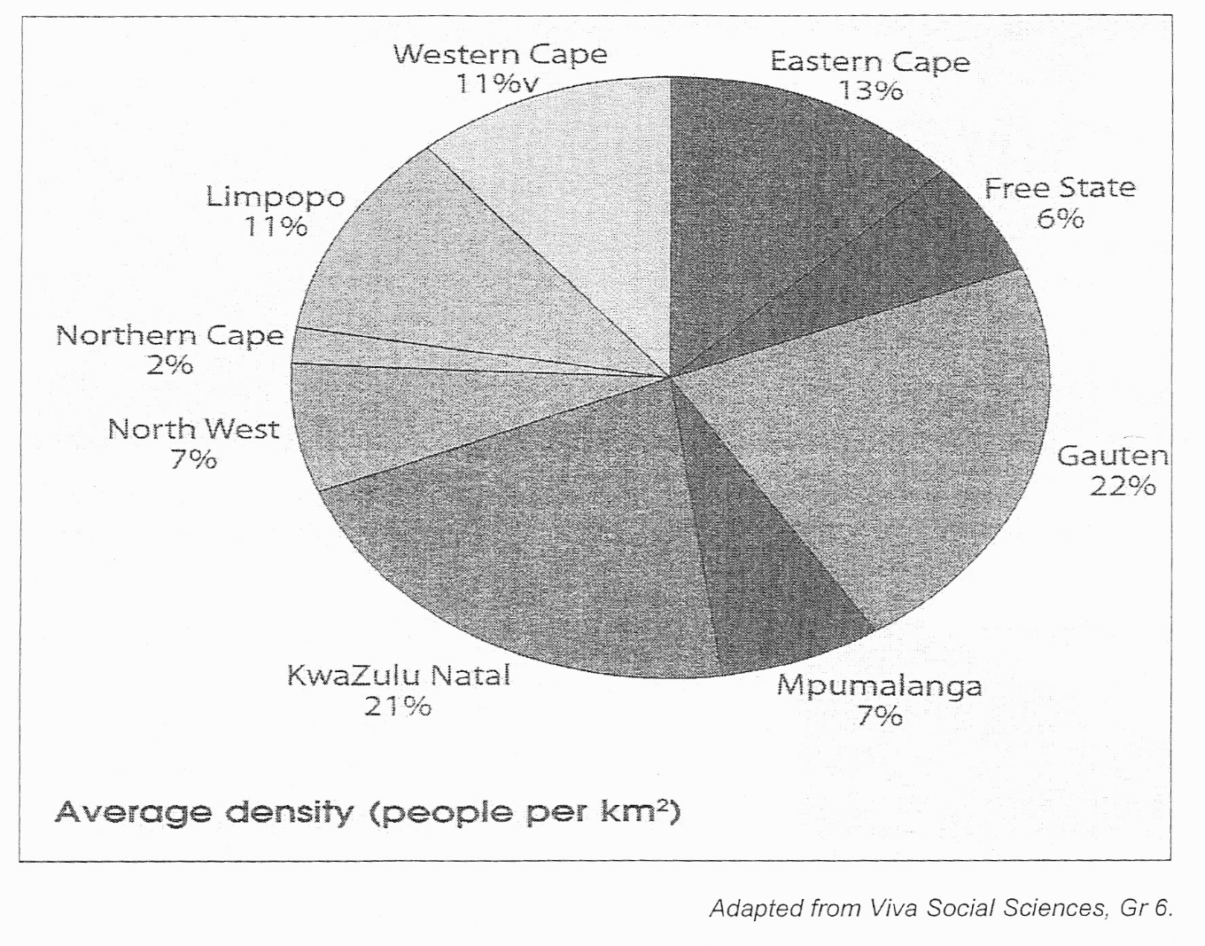

Study FIGURE C and answer the following questions:
- Which province has the lowest average density? ______________________________
- What is the average population density of the Free State? _____________________
- The average population density of North West is lower than that of Gauteng.
Name TWO reasons why you think Gauteng’s density can be higher.
_____________________________________________________________________________________________
- Define the term “population density”.
______________________________________________________________________________________________

Why people live where they do in South Africa Date: ____________________________

The following factors attract settlements in South Africa

- _______________________ – where it is not too hot or too cold and where there is enough rainfall (look at the sparse population density of the Northern Cape, where there is very little rainfall)
- ______________________ – where there is natural vegetation such as forests, as wood from the trees can be used for fuel and for building materials
- _______________________ – such as harbours for trade and transport, rivers for water, mountains for protection (look at the dense population, density of Cape Town and Durban)
- ___________________ -in South Africa the Apartheid laws stipulated that certain race had to live in specific places and therefore some people had no choice of where to live
- ___________________– such as gold in Gauteng, diamonds in the Northern Cape and coal in Mpumalanga.
- ___________________ – people settle where there are opportunities to make a living, such as farming, fishing, mining, trading, or jobs.
Activity 6
Read the following extracts about the growth of three of South African settlements and then answer the questions that follow of Cape Town.

FIGURE D:
Cape Town
Jan van Riebeek and other employees of the Dutch East Company were sent to the Cape to set up a halfway station to provide fresh water, vegetables, and meat for passing ships travelling between Europe and Asia. Water from the Fresh River, which flowed down from Table Mountain, was channelled into canals to provide irrigation to the farms. | 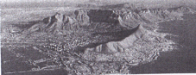
Johannesburg
When the first gold was found on a farm in the area in 1886, the news spread like wildfire and people from all over the world rushed to Johannesburg to find their fortunes. Three years later the place was the biggest town in the country. | 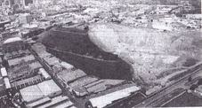
Soweto
Soweto (South-Western Township) was established to house the black South Africans who were homeless from the city under the segregation laws which prevented people of different races living in the same areas. Black South Africans had been drawn to work on the gold mines that were established after 1886. From the start they were accommodated in separate areas on the outskirts of Johannesburg. | 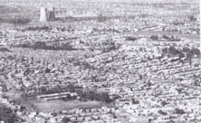

Make use of FIGURE D to answer the following questions:

1. List three factors that were favourable for the settlement of Cape Town.
- __________________________________________
- __________________________________________
- __________________________________________

- . What led to the growth of Johannesburg? ____________________________________

- . Why did so many black South Africans move to Johannesburg. ___________________________________

- . Explain the factor that led to the growth of Soweto_____________________________________________
________________________________________________________________________________________________

Rural and urban settlements Date: ____________________________

A _____________________ is one in which people are involved in primary activities, such as ____________________________________. There are not many buildings or roads in rural areas and there are very few services, such as _____________________________________________________  ___________________________________________________________ | 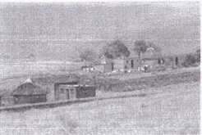
An ________________________________________ is one in which people are involved in secondary and tertiary activities, such as banking, teaching, and business. There are ______________of buildings and transport routes in urban areas and there are many services available, such as electricity, piped water, schools, and hospitals. | 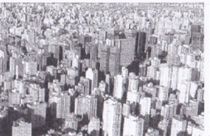

Rural – urban migration

Many people living in the rural areas move to urban areas as they believe that the city can offer them a better quality of life.
Some of the reasons for this movement:
- Job opportunities and more ____________________________money
- More services such as electricity, piped water, schools, and hospitals
- Better ______________________________ and transport options
- Entertainment such as ______________________ _________________ and _________________

FIGURE E:
Life was very tough in the village. We did not have enough land to farm for a living. There were some jobs on the farms nearby, but the wages were very low. We were often without water and if you were sick, you suffered because the hospital was far away. Village life can be very boring. We have one bar and that is all. My cousin got me a job in a factory in Johannesburg. I earn much more money than I could in the rural areas. My wife sells fruit at the school. If they are sick, they get good care at the clinic. When I first came, I stayed with my cousin. Now I have built my own place on some vacant land near the river. The city has its problems, but I feel I have a chance of improving my life here. I can also provide a better future for my children.

List all the factors that caused this man to leave the rural areas (these are called PUSH factors) and all the factors that attracted him to the city (these are called PULL factors)

PUSH Factors | PULL Factors

Write a paragraph of 8 lines about the factors that cause people to move to cities, think about pushing and pulling factors (8x1) (8)
_____________________________________________________________________________________________________________________________________________________________________________________________________________________________________________________________________________________________________________________________________________________________________________________________________________________________________________________________________________________________________________________________________

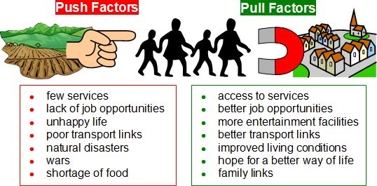

FIGURE F: Pull and push
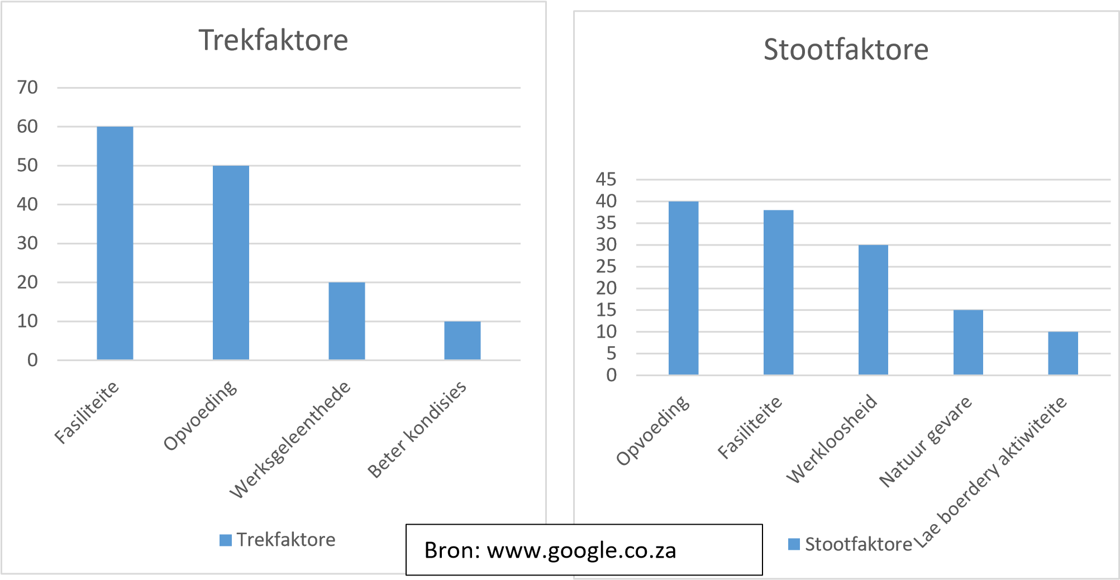
Key:
Fasiliteite: Facilities
Opvoeding:Education
Werksgeleenthede:Job
Beter kondisie: Better conditions
Werkloosheid: Unemployment
Natuurgevare: Natural hazards
Lae boerdery aktiwiteite: Low farming activities
Push factors
Pull factors
Make sure you study FIGURE F carefully before answering the questions that follow.
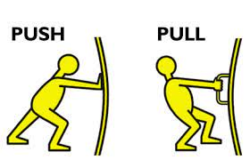

1. Give the definition of:

Pull factors: _______________________________________________________________________________

Push factors: ______________________________________________________________________________

2. Which push factors have the lowest percentage? ____________________________________________

3. Which pull factors have the highest percentage? ____________________________________________

4. What is the difference in percentage between Natural Hazards and Unemployment? _______

5. How can municipalities and governments use this information to their advantage?

__________________________________________________________________________________________________

6. How does education push people away from a place? _____________________________________________________

7. What does better living conditions refer to?

__________________________________________________________________________________________________

Population Distribution around the world Date: ____________________________
Activity 8
FIGURE G: World map indicate high, medium, and low densities
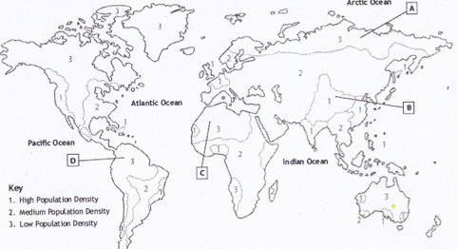
Make use of FIGURE G to answer the following questions:

- What is the density mostly in Africa? __________________________________
- What is the density mostly in North-Africa? ____________________________________
3.Why do you think the places labelled A – D have low population densities

Place | Reason
A
B
C
D
FIGURE H: Major cities if the world Date: ____________________________

Number | City | Country | Population
1 | Tokyo-Yokohama | Japan | 37843000
2 | Jakarta (Jaboticaba) | Indonesia | 30539000
3 | Delhi | India | 24998000
4 | Manila | Philippines | 24123000
5 | Seoul-Gyeonggi-Incheon (Sudogwon) | South Korea | 23480000
6 | Shanghai | China | 23416000
7 | Karachi | Pakistan | 22123000
8 | Beijing | China | 21009000
9 | New York City | United States of America | 20630000
10 | Guangzhou-Foshan (Guano) | China | 20597000

Make use of FIGURE H to answer the following questions:
- In what country do you find Delhi? ______________________
- In what country do you find the least population density? ________________________
- What is the highest population density? _________________________
People around the world. Date: ____________________

FIGURE I: List of the seven continents ranked by current population

 | Continent | Population  (2018) | Area  (Km²) | Density  (P/Km²) | World  Population
1 | Asia | 4,545,133,094 | 31,033,131 | 146 | 59.55%
2 | Africa | 1,287,920,518 | 29,648,481 | 43 | 16.87%
3 | Europe | 742,648,010 | 22,134,900 | 34 | 9.73%
4 | North Amerika | 587,615,976 | 21,329,926 | 28 | 7.70%
5 | South Amerika | 428,240,515 | 17,461,112 | 25 | 5.61%
6 | Australia/Oseania | 41,261,212 | 8,486,460 | 5 | 0.54%
7 | Antarctica | 0 | 13,720,000 | 0 | 0.00%

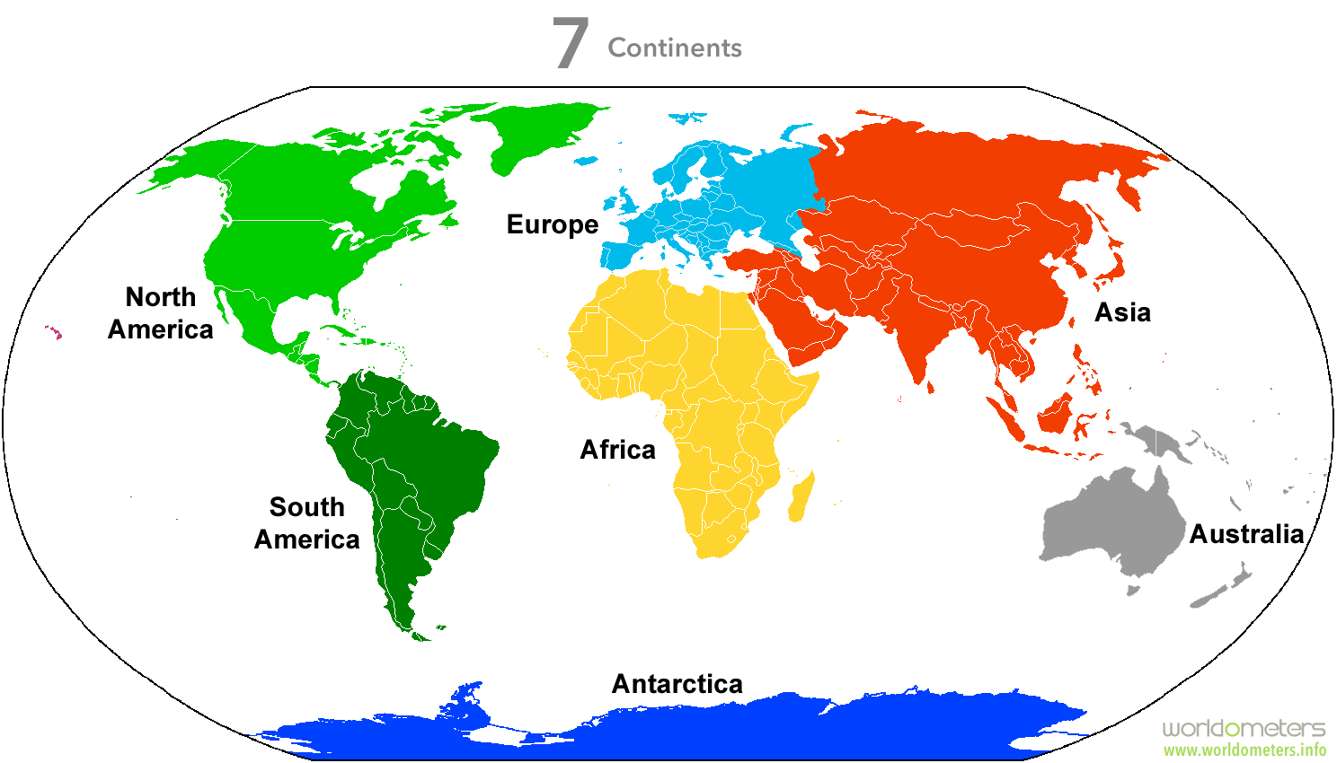

Study FIGURE I and answer the following questions:
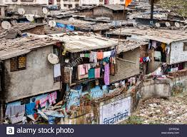
a. Name the continent with the highest population: ___________________
b. Why is there no permanent population in Antarctica? (Name two reasons)
________________________________________________
___________________________________________________________

c. Which area is the largest using FIGURE A's table? __________________________
d. Where do we find the densest population?________________________________
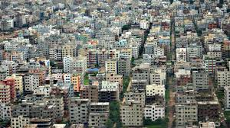
e. Which area has a lot of space for population? ______________________________
d. Describe the influence of minerals, climate and rivers on the population distribution of Africa

- Minerals : ____________________________________________________________
- Climate : _____________________________________________________________
- Rivers : ____________________________________________________________________________________

