Grade 6 Geography Term 4 Planning memorandum
Population – Why people live where they do

- This whole document must be in your planning book, paste in at the left-hand side. All your planning should be done on these papers and on the clean pages of the book. You can also do planning in files or flip file….as long as you do your planning.
- Add more paragraph questions to teach learners how to answer paragraphs.
- You can add more relevant FIGURES and information to make the content easier for the learners to understand. These worksheets are the minimum to be done.
- You MUST ADD work out of your textbook or other resources, that extra work must also be in this planning book.
- You are welcome to add marks for the questions in the activities, it will help learners when answering the questions. Don’t mark in your planning book the answers.
- Please correct any errors on these pages.
- You cannot continue with the following lesson if the learners did not mark the previous work and did corrections.
- You cannot just give the answers to the learners, you must tell the story/explain the work… only then the learners go and do the work and then you mark it together.
- If ALL, the answers are not completed you do it yourself on these papers.
- Planning must be done in pen; you welcome to use color pens but dates must be in pencil.
This is your planning book; you make it easy and pleasant to use for yourself
- Planning must be neat and thoroughly done to use for many years. You are just going to add every year new information. You can also do your extra notes in this book or paste it in.

Thank you for your hard work
Anette

2022 Curriculum coverage – Term 4: SOCIAL SCIENCE(GEOGRAPHY): Grade 6
Term 4:  47 days | Week 1  14/10 | Week 1  14/10 | Week 2  21/10 | Week 3  28/10 | Week 4  4/11 | Week 5  11/11 | Week 6,7  Week 8,9,10
CAPS Topic: Population – Why people live where they do (Focus: South Africa and the world)
Content and skills | - Intervention term 3  - Introduction to the topic: Population – Why people live where they do | People and provinces in South Africa |  | Why people live where they do (South Africa) |  |  | Population around the world  - Population distribution around the world  - Major cities and their population sizes (map).  - Case study  Major city to highlight the reasons for its location  Revision Consolidation  Controlled tests
Content and skills |  | - Population distribution and population density  - Population distribution in South Africa (distribution map) | - Total population figures for each province (reading graphs)  - Average population density for each province (reading graphs) | - Reasons for location of settlements:  - climate  - vegetation,  - natural features, | - Reasons for location of settlements continue:  - laws (past and present),  - resources and  - human activities (such as mining, fishing and trade) | - Concept of rural and urban  - Why people move from rural areas to towns and cities
Curriculum coverage
√
signature
Date completed with ALL classes
Geography formal task: Grade 6 Term 4 2022
Type of formal assessment: Controlled tests with section A and section B

Topics to assessed:
- Section A: Climate and vegetation around the world (15 marks)
- Section B: Population (25 marks)
Total: 40 marks
Types of questions: Source-based and paragraph writing (6 marks – term 4 content) and (2 marks – term 3 content)
- Make use of a source and write a paragraph of about 6-7 lines about the factors that cause people to move to cities, think about pushing and pulling factors) (6x1) (6)

Level 1: 12/40 Level 2: 20/40 Level 3: 8/40

SOCIAL SCIENCES – INTERMEDIATE PHASE

LESSON PLAN : Geography

Lesson group 1

Topic: Population – Why people live where they do Grade 6 Term 4

Content / Concepts: People and provinces in South Africa

1. Population distribution and population density:

Word bank words:

Informal assessment / worksheet pages:

Date completed with last group:
Extra:

2. Population distribution in South Africa (distribution map):

Word bank words:

Informal assessment / worksheet pages:

Date completed with last group:
Extra:

3. Total population figures for each province (reading graphs):

Word bank words:

Informal assessment / worksheet pages:

Date completed with last group:
Extra:

4. Average population density for each province (reading graphs):

Word bank words:

Informal assessment / worksheet pages:

Date completed with last group:
Extra:
What did you do extra to assist progressed and retained learners?

Population – Why people live where they do

Population Distribution Date: ____________________________
Population distribution means the pattern of where people live. It is the way in which people are spread across an area.
Geographers study population distribution patterns at different scales: local (your town or city), regions (your provinces), national (your country), and global (the world).
World population distribution is uneven. Places which are sparsely populated contain few people as they tend to be difficult places in which to live e.g., Antarctica or the Sahara Desert. Places which are densely populated contain many people as they are environments that are suitable to live in e.g., Europe

Activity 1
List some of the factors that you think would make an environment habitable (i.e., suitable to live in)
- Flat land (easier to farm and to construct buildings and transport routes)
- Fertile soil (for farming)
- Fresh water source (for drinking and farming)
- Natural resources (such as forests/fish)
- Moderate climate (not too hot, not too cold, not too dry, not too wet)
- Minerals (such as gold/coal/etc. for mining)

Population Density

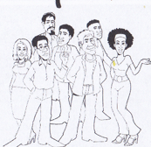
Population density is a measurement of the number of people in an area.
Population density is the average number of people per square kilometre.

Population density is calculated using the following formula:
Population density= total population ÷ total land area in km²

Activity 2
For each of the following soccer matches, describe the population distribution and density using the words in the box below:
Sparse Dense Even Uneven

Match 1 | Match 2
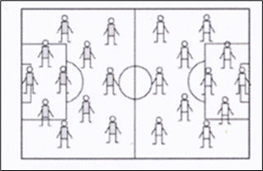 | 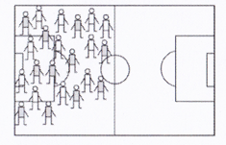
Population Density:  Dense  Population Distribution:  Even | Population Density:  Dense  Population Distribution:  Uneven

Match 3 | Match 4
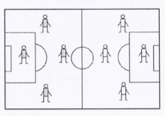 | 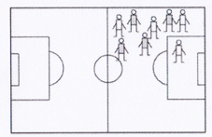
Population Density:  Sparse  Population Distribution:  Even | Population Density:  Dense  Population Distribution:  Uneven
Activity 3 Date: _______________________________
Use dots to show the following population distribution and densities on the imaginary countries:

- Give the country a dense population | - Give the country a sparse population
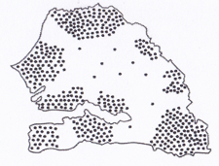 | 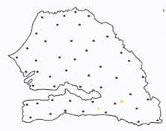

- Give the country an uneven population | - Give the country an even population
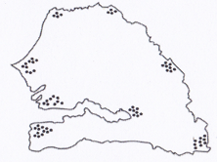 | 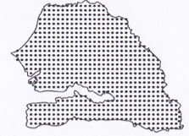
FIGURE A: Population density of South Africa

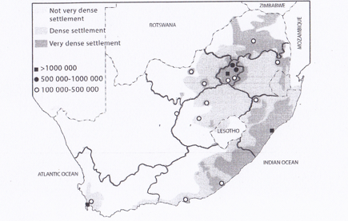
A Limpopo B North West
C Northern Cape
D Western Cape
E Eastern Cape
F Kwa-Zulu Natal G Free State
H Gauteng I Mpumalanga

- Write on FIGURE A the correct letter of the province
- Refer to FIGURE A , the population distribution in South Africa and answer the following
questions:
  - Identify and name the three South African province which have a population of more than 1 million people
Western Cape Kwa Zulu Natal Gauteng
  - Which South African province has a sparse population density? Northern Cape
  - Can you think of any three reason why so few people live there?
Very little rainfall, desert like conditions and limited farming opportunities.
  - Which South African province has a very dense population density? Gauteng
  - Can you think of any three reasons why so many people live here?
Discovery of gold, lots of industries and job opportunities

Activity 5 Date: ____________________________
South Africa’s population by province census 2011.
The current population of South Africa is 54.531 as of Friday, February 12, 2016, based on the latest United Nations estimates. South Africa’s population is equivalent to 0.74% of the total world population. South Africa ranks number 25 on the list of countries by population.

FIGURE B: South Africa’s population
Province | Population | Density  (Number of people per km²)
Gauteng | 12 272 263 | 675
Kwa-Zulu Natal | 10 267 300 | 108
Mpumalanga | 4 309 939 | 53
Western Cape | 5 822 734 | 45
Limpopo | 5 404 868 | 42
Eastern Cape | 6 562 052 | 39
North-West | 3 509 953 | 33
Free State | 2 745 590 | 21
Northern Cape | 1 145 861 | 3
Total | 51 770 560

Activity 5
Use the information in FIGURE B, which shows the population in millions for each province, and then draw a
bar graph below.
Population in Millions
13
12
11
10
9
8
7
6
5
4
3
2
1
 | Gauteng | KwaZulu-Natal | Mpumalanga | Western Cape | Eastern Cape | North West | Free state | Northern Cape

FIGURE C: Pie chart showing population density 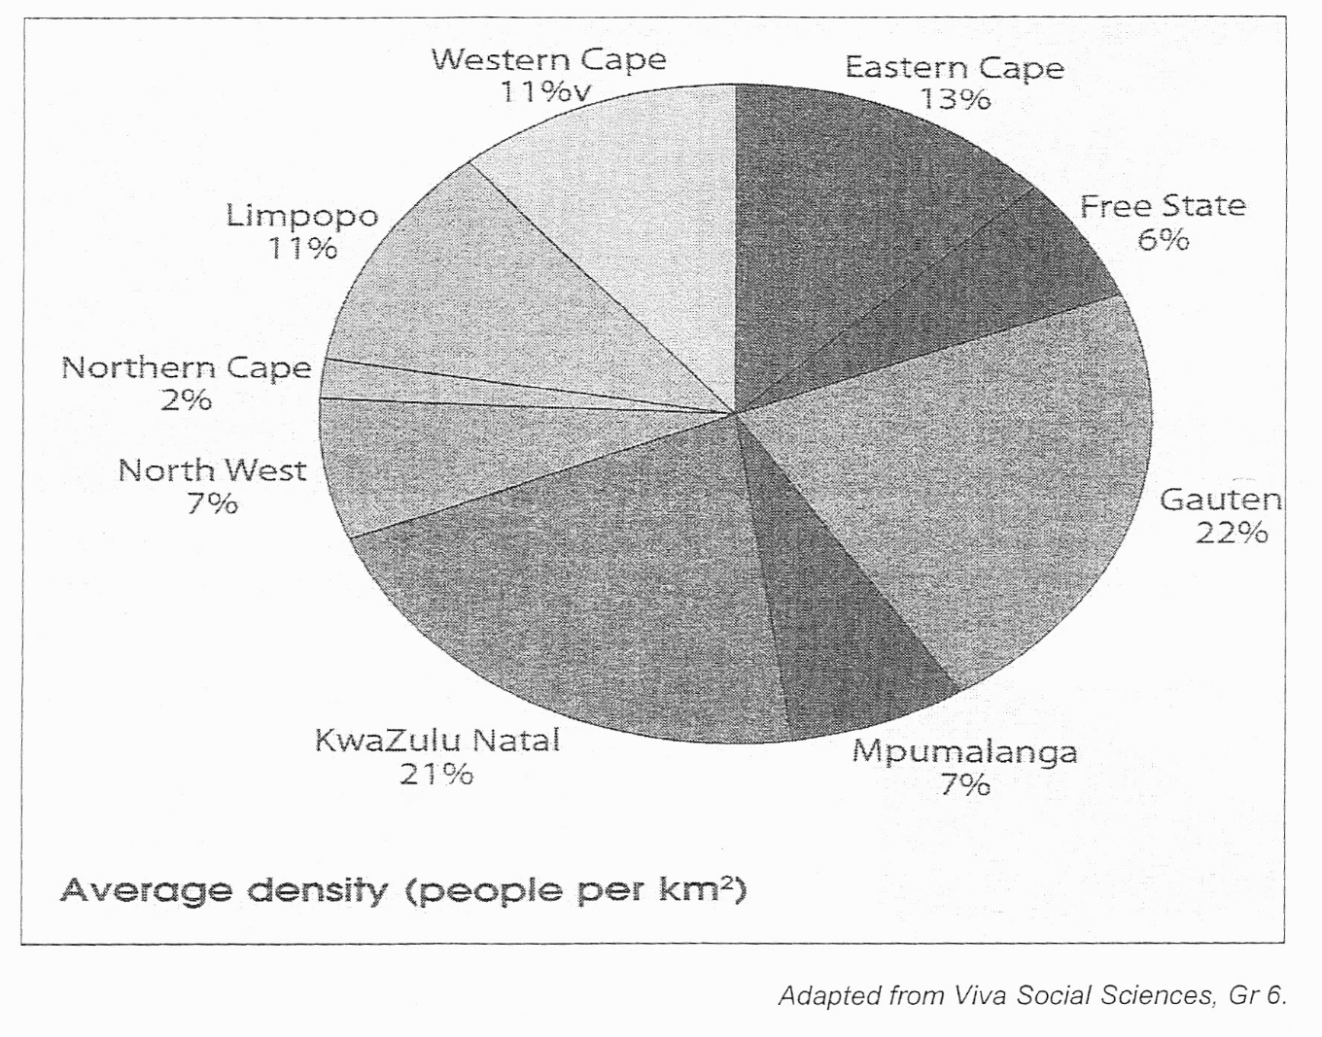
Study FIGURE C and answer the following questions:
- Which province has the lowest average density? Northern Cape
- What is the average population density of the Free State? 6%
- The average population density of North West is lower than that of Gauteng.
Name TWO reasons why you think Gauteng’s density can be higher.
Gauteng province has more people /it has more mines / more job opportunities/ more urban areas
- Define the term “population density”.
The number of people per square kilometre in an area.

SOCIAL SCIENCES – INTERMEDIATE PHASE

LESSON PLAN : Geography

Lesson group 2

Topic: Population – Why people live where they do Grade 6 Term 4

Content / Concepts: Why people live where they do (South Africa)

1.Reasons for location of settlements – such as climate, vegetation, natural features, laws (past and present):

Word bank words:

Informal assessment / worksheet pages:

Date completed with last group:
Extra:

2. Resources and human activities (such as mining, fishing and trade):

Word bank words:

Informal assessment / worksheet pages:

Date completed with last group:
Extra:

3.Concepts of rural and urban:

Word bank words:

Informal assessment / worksheet pages:

Date completed with last group:
Extra:

4.Why people move from rural areas to towns and cities/urban areas:

Word bank words:

Informal assessment / worksheet pages:

Date completed with last group:
Extra:

What did you do extra to assist progressed and retained learners?

Why people live where they do in South Africa Date: ____________________________

The following factors attract settlements in South Africa

- Climate – where it is not too hot or too cold and where there is enough rainfall (look at the sparse population density of the Northern Cape, where there is very little rainfall)
- Vegetation – where there is natural vegetation such as forests, as wood from the trees can be used for fuel and for building materials
- Natural features – such as harbours for trade and transport, rivers for water, mountains for protection (look at the dense population, density of Cape Town and Durban)
- Laws -in South Africa the Apartheid laws stipulated that certain race had to live in specific places and therefore some people had no choice of where to live
- Resources – such as gold in Gauteng, diamonds in the Northern Cape and coal in Mpumalanga.
- Human activities – people settle where there are opportunities to make a living, such as farming, fishing, mining, trading, or jobs.

Activity 6
Read the following extracts about the growth of three of South African settlements and then answer the questions that follow of Cape Town.

FIGURE C

Cape Town
Jan van Riebeek and other employees of the Dutch East Company were sent to the Cape to set up a halfway station to provide fresh water, vegetables, and meat for passing ships travelling between Europe and Asia. Water from the Fresh River, which flowed down from Table Mountain, was channelled into canals to provide irrigation to the farms. | 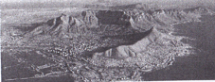
Johannesburg
When the first gold was found on a farm in the area in 1886, the news spread like wildfire and people from all over the world rushed to Johannesburg to find their fortunes. Three years later the place was the biggest town in the country. | 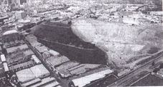
Soweto
Soweto (South-Western Township) was established to house the black South Africans who were homeless from the city under the segregation laws which prevented people of different races living in the same areas. Black South Africans had been drawn to work on the gold mines that were established after 1886. From the start they were accommodated in separate areas on the outskirts of Johannesburg. | 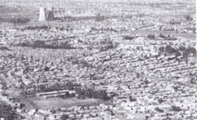
Make use of FIGURE C to answer the following questions:

1. List three factors that were favourable for the settlement of Cape Town.
- Natural harbours (for passing ships)
- Fresh water (for farming)
- Forests (for timber to build houses and ships

- . What led to the growth of Johannesburg? Discovery of gold

- .Why did so many black South Africans move to Johannesburg. To get work on the mines

- .Explain the factor that led to the growth of Soweto?
Apartheid’s segregation law stated that black people had to live in separate areas to white people and so Soweto was built to house the black people who were working on the gold mines.

Rural and urban settlements Date: ____________________________

A rural settlement is one in which people are involved in primary activities, such as farming, fishing, forestry, and mining. There are not many buildings or roads in rural areas and there are very few services, such as electricity, piped waters, schools, and hospitals. | 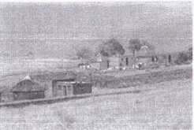
An urban settlement is one in which people are involved in secondary and tertiary activities, such as banking, teaching, and business. There are lots of buildings and transport routes in urban areas and there are many services available, such as electricity, piped water, schools, and hospitals. | 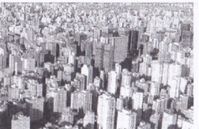

Rural – urban migration
Many people living in the rural areas move to urban areas as they believe that the city can offer them a better quality of life.

Some of the reasons for this movement:
- Job opportunities and more money
- More services such as electricity, piped water, schools, and hospitals
- Better housing and transport options
- Entertainment such as movies, restaurants, and shopping malls

FIGURE D
Life was very tough in the village. We did not have enough land to farm for a living. There were some jobs on the farms nearby, but the wages were very low. We were often without water and if you were sick, you suffered because the hospital was far away. Village life can be very boring. We have one bar and that is all. My cousin got me a job in a factory in Johannesburg. I earn much more money than I could in the rural areas. My wife sells fruit at the school. If they are sick, they get good care at the clinic. When I first came, I stayed with my cousin. Now I have built my own place on some vacant land near the river. The city has its problems, but I feel I have a chance of improving my life here. I can also provide a better future for my children.

List all the factors that caused this man to leave the rural areas (these are called PUSH factors) and all the factors that attracted him to the city (these are called PULL factors)

PUSH Factors | PULL Factors
Not enough land | Higher pay
Low wages | Schools
No piped water | Clinics
No hospitals | More jobs
No entertainment | Better future

Write a paragraph of 8 lines about the factors that cause people to move to cities, think about pushing and pulling factors

Teachers at this space I want to see your own memorandum

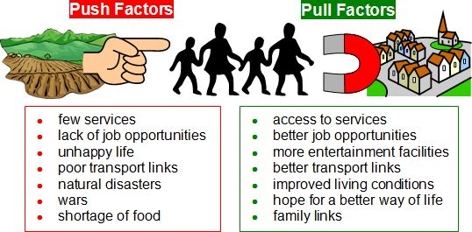

SOURCE E: Pull and push factors
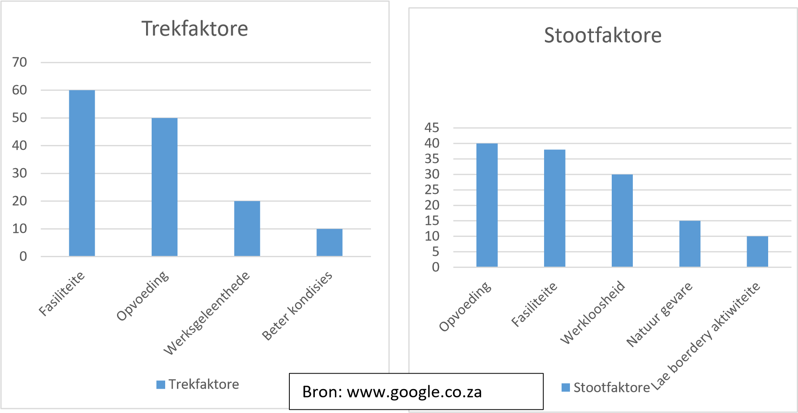
Push factors
Key:
Fasiliteite: Facilities
Opvoeding:Education
Werksgeleenthede:Job
Beter kondisie: Better conditions
Werkloosheid: Unemployment
Natuurgevare: Natural hazards
Lae boerdery aktiwiteite: Low farming activities
Pull factors

Make sure you study FIGURE E carefully before answering the questions that follow.

1. Give the definition of:

Pull factors: Factors that draw (attract) people to a place

Push factors: Factors that push people away from a place.

2. Which push factors have the lowest percentage? Low farming activities

3. Which pull factors have the highest percentage? Better conditions

4. What is the difference in percentage between Natural Hazards and Unemployment? 15%

5. How can municipalities and governments use this information to their advantage?

They can see what people's needs are and try to develop/build them etc. in the relevant areas.

6. How does education push people away from a place? Poor education or no education

7. What does better living conditions refer to? Water and electricity, sanitation and less crime.

SOCIAL SCIENCES – INTERMEDIATE PHASE

LESSON PLAN : Geography

Lesson group 3

Topic: Population – Why people live where they do Grade 6 Term 4

Content / Concepts: People around the world

1. Population distribution around the world (distribution map):

Word bank words:

Informal assessment / worksheet pages:

Date completed with last group:
Extra:

2. The influence of climate, water and mineral resources on global settlement:

Word bank words:

Informal assessment / worksheet pages:

Date completed with last group:
Extra:

3. Major cities and their population sizes (map):

Word bank words:

Informal assessment / worksheet pages:

Date completed with last group:
Extra:

4. Case study of a major city to highlight the reasons for its location:

Word bank words:

Informal assessment / worksheet pages:

Date completed with last group:
Extra:

What did you do extra to assist progressed and retained learners?

Population Distribution around the world Date: ____________________________
Activity 8
FIGURE F: World map indicate high, medium, and low densities
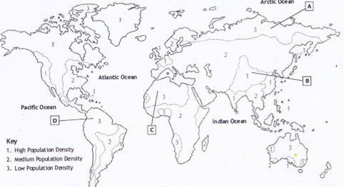

Make use of FIGURE F to answer the following questions:

- What is the density mostly in Africa? Medium population density
- What is the density mostly in North-Africa? Low population density

3.Why do you think the places labelled A – D have low population densities ?
Place | Reason
A | Very cold, mainly covered in snow and difficult to farm
B | Steep mountains, difficult to build homes, transport routes and to farm
C | Desert - no rainfall or fertile soil for farming
D | Jungle - dense vegetation and no place for building or to farm

FIGURE G: Major cities if the world

Number | City | Country | Population
1 | Tokyo-Yokohama | Japan | 37843000
2 | Jakarta (Jaboticaba) | Indonesia | 30539000
3 | Delhi | India | 24998000
4 | Manila | Philippines | 24123000
5 | Seoul-Gyeonggi-Incheon (Sudogwon) | South Korea | 23480000
6 | Shanghai | China | 23416000
7 | Karachi | Pakistan | 22123000
8 | Beijing | China | 21009000
9 | New York City | United States of America | 20630000
10 | Guangzhou-Foshan (Guano) | China | 20597000

Make use of FIGURE G to answer the following questions:

- In what country do you find Delhi? India
- In what country do you find the least population density? China
- What is the highest population density? 37843000
People around the world. Date: ____________________

FIGURE H: List of the seven continents ranked by current population

 | Continent | Population  (2018) | Area  (Km²) | Density  (P/Km²) | World  Population
1 | Asia | 4,545,133,094 | 31,033,131 | 146 | 59.55%
2 | Africa | 1,287,920,518 | 29,648,481 | 43 | 16.87%
3 | Europe | 742,648,010 | 22,134,900 | 34 | 9.73%
4 | North Amerika | 587,615,976 | 21,329,926 | 28 | 7.70%
5 | South Amerika | 428,240,515 | 17,461,112 | 25 | 5.61%
6 | Australia/Oseania | 41,261,212 | 8,486,460 | 5 | 0.54%
7 | Antarctica | 0 | 13,720,000 | 0 | 0.00%

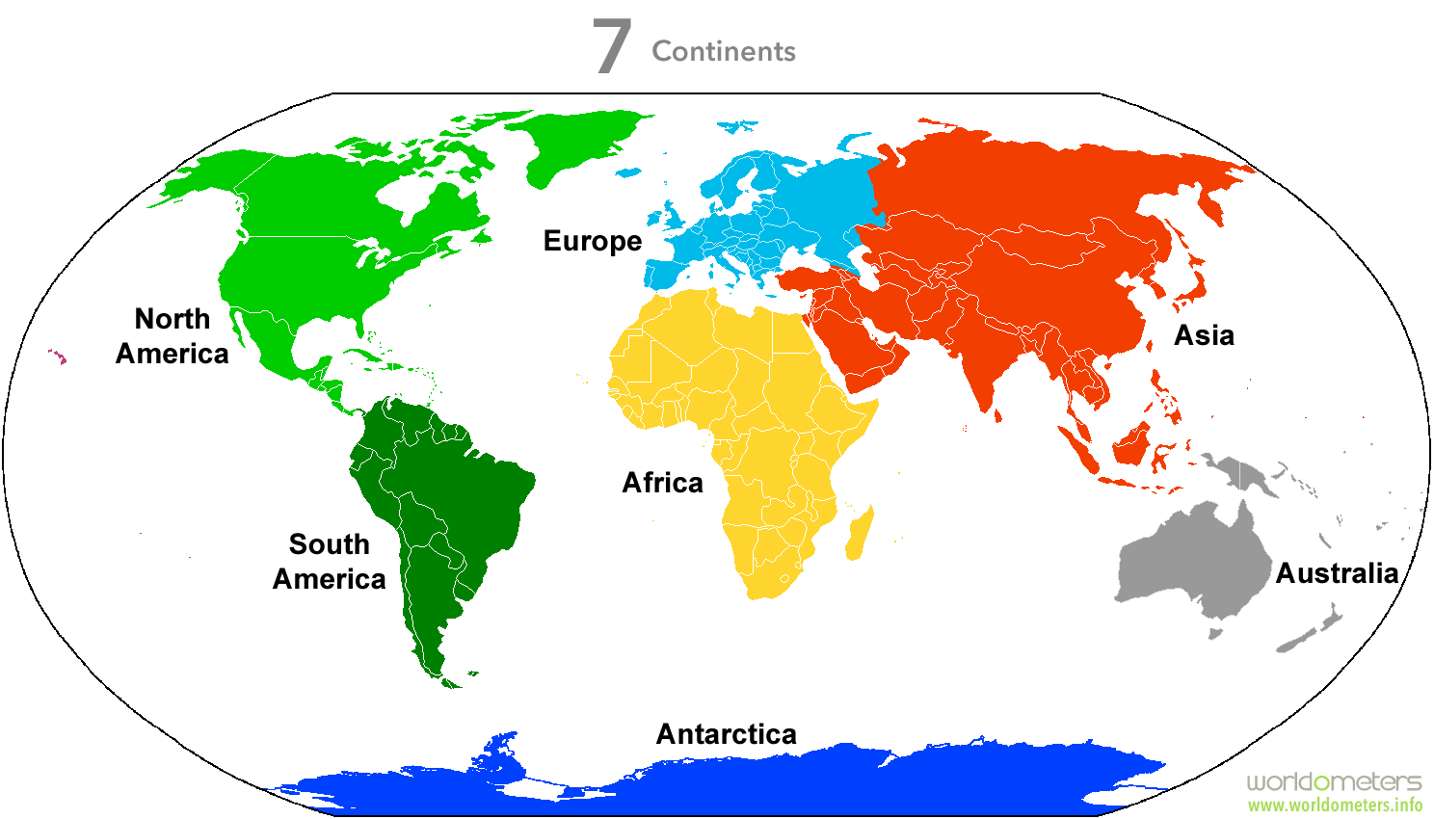

Study source H and answer the following questions:
a. Name the continent with the highest population: Asia
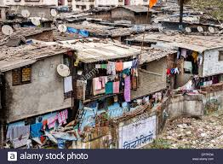
b. Why is there no permanent population in Antarctica? (Name two reasons)
There is a lot of snow
It is very cold
Far from cities
c. Which area is the largest using source A's table? Mississippi
d. Where do we find the densest population? Asia
e. Which area has a lot of space for population? Antarctica
d. Describe the influence of minerals, climate and rivers on the population distribution of Africa
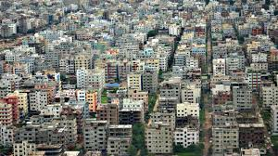
- Minerals : A lot of work for people
- Climate : Good rainfall for farming attracts people
- Rivers : People need water resources

