GRADE 4

PSW

TERM 4

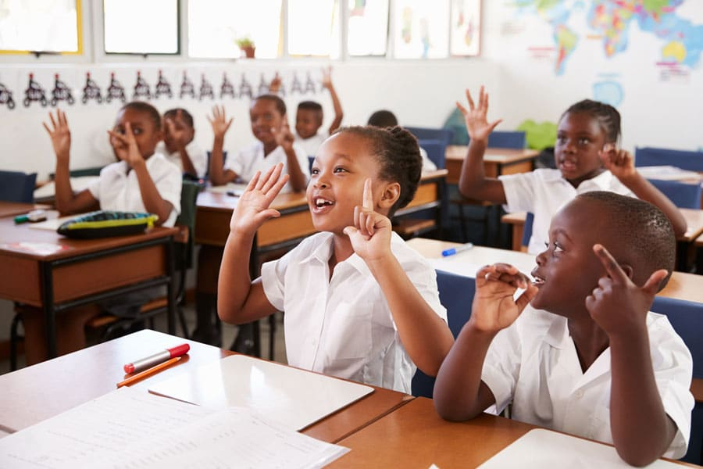

TERM 4

Sub topic: Traffic rules relevant to road users:

There are rules about how to behave when you walk or cycle down the road. There are also rules that drivers and passengers in cars, buses, trains and taxis must obey. These rules help to keep us safe.
Be safe on the road. Know the rules!

Pedestrians
Walk on the left and face the traffic.
Walk on the pavement
Look left, right and left again before you cross a road.
Walk fast but never runs across the road.

Always cross a road at:
A pedestrian crossing
A pedestrian bridge
A traffic light (with a green person).

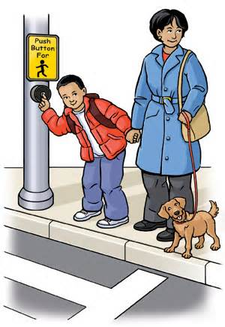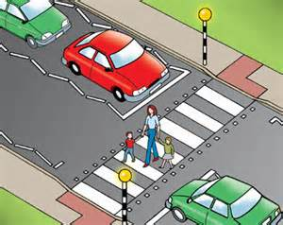
Wear brightly coloured clothes.
When getting off the bus, wait for it to move away before crossing

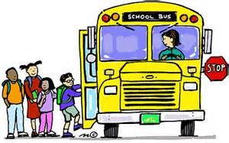
Safety tips (cyclist)
- Always wear a helmet
- Look both ways for traffic
- Wear bright clothes
- Make sure your tires have air in them
- Use a backpack to carry books and other stuff!
- Always lock your bike up
- Always ride with a friend

Safety rules for cyclists
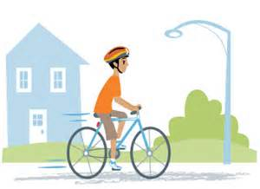
Do know the meaning of hand signals for cyclists and use them when cycling.

Don'ts
Don't ever ride or attempt to ride a bicycle while under the influence of alcohol or drugs.
Don't ever hold on to a moving vehicle.
Don't ever cycle side-by-side with more than one cyclist.
Don't ever cycle against the flow of traffic on one-way streets.
Don't ever cycle through red traffic lights or pedestrian lights.
Don't ever cycle on a motorway.
Don't ever cycle in a contra-flow bus lane.
Don't ever cycle without appropriate lighting during hours of darkness.
Don't ever hold on to or lean against stationary vehicles.
Don't ever weave in and out of moving traffic.
Don't ever carry a passenger unless your bicycle has been built or specially adapted to carry one.
Don't ever use a personal entertainment system when cycling.
Don't ever use a mobile phone while cycling

Do's
Do keep well back when cycling behind a motor vehicle in slow moving traffic.
Do take extra care on wet or icy roads or when it is windy. Do use your bell as a warning device only.
Do take extra care and look well ahead for uneven road surfaces, drains and other obstructions so that you do not have to swerve suddenly in front of another vehicle.
Do use a bus lane, and be extra vigilant when a bus is stopped and about to move off from the stop.

Answer the following questions:
1. List three safety rules to remember when walking along the road.

2. Name 3 safety tips for cyclists

3.Railway safety rules:

What else can you do to be safer around trains?

Always obey the signs, lights and bells when driving near railway crossings
Stand at least 1.5m back from the platform edge to avoid the backdraft of passing trains.

Where to cross a railway.

Only cross railway tracks at proper crossings.
Stop, look and listen for trains
Use the signs, lights and bells to cross safely
So not walk along the railway tracks or corridor
Look both ways – if there are two track there could be two trains.

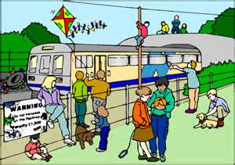
Safety around trains
4.Use the picture and sentences above to answer the questions:

1. Where can you cross a railway?

2. What can you do to be safer around trains?

3. List all the unsafe things that the children are doing in the picture above.

5.Fill in the missing words

Pe
Pedestrian crossing, railway tracts, bus, safety belts, robot, right, left.

1. Cross the road at ______________________ and _____________

2. When getting off the _______________ wait for it to move away before crossing.

3. Sit down in cars and wear ____________________

4. Never walk or play on ________________________

5. Look left __________ and left again before you cross a road.

Sub topic: Personal and household hygiene

Keeping clean and germ-free is called hygiene
Germs are everywhere. We pass germs to other people without even knowing it! We carry germs on our hands and clothing and we spread these germs to everything we touch.
You should not share some personal hygiene items.

Do not share:
- Hairbrushes and combs because they can spread head lice or nits
- Toothbrushes because they can spread germs
- Towels because they can spread germs and skin diseases
- Facecloths because they can spread germs, skin diseases and eye diseases
- Cream that you put on sores, especially on your mouth
- A handkerchief or tissues that you’ve used
- A cloth that you have used to clean a bleeding cut.
- A razor

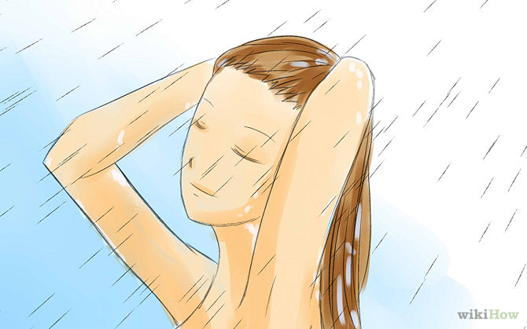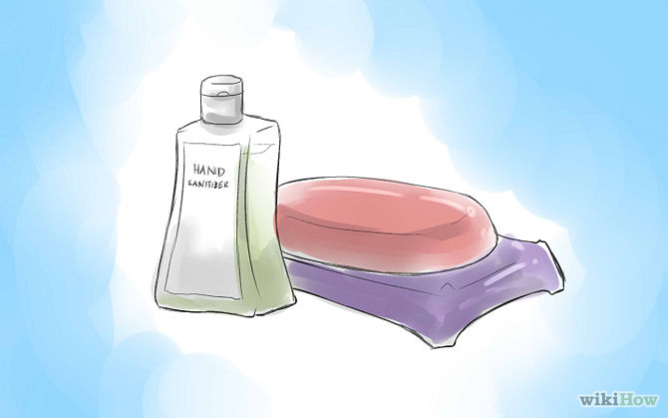

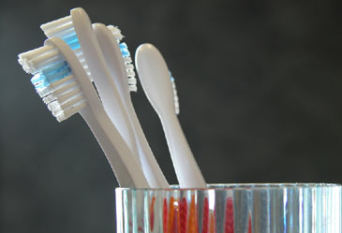

Germ breeding areas in the house

Your home can hide bad germs if you do not keep it clean.

Bathroom and toilets
Germs grow in dirty toilets and bathrooms, so they must be cleaned every day.
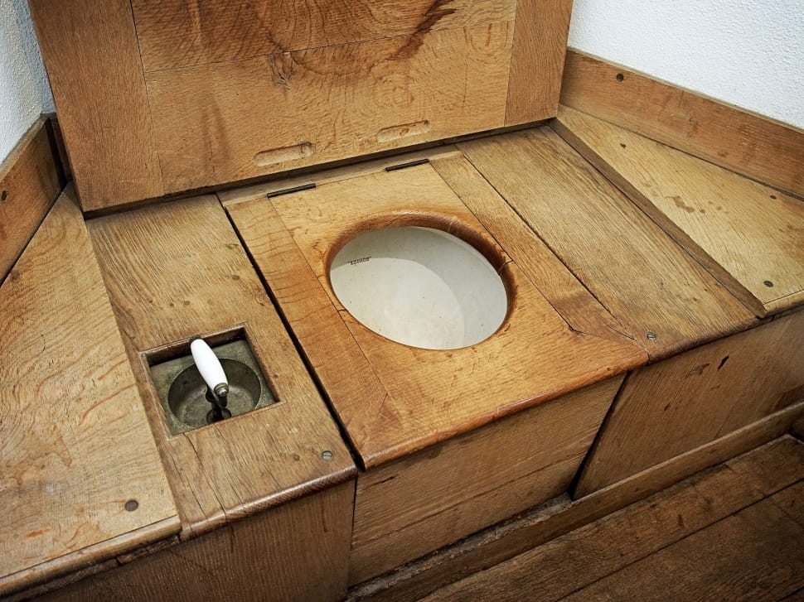

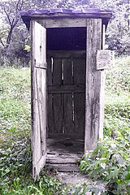
Kitchen sink
The kitchen sink is one of the worst breeding grounds for household germs. Food particles from plates left to soak or rinsed from dishes on their way to the dishwasher can serve as a breeding ground for illness- causing bacteria. They can get onto your hands or spread to food. Most people rinse their sinks only with water and assume they are clean. To sanitise your sink and prevent the spread of bacteria, wash it with a solution of bleach and water once a day.

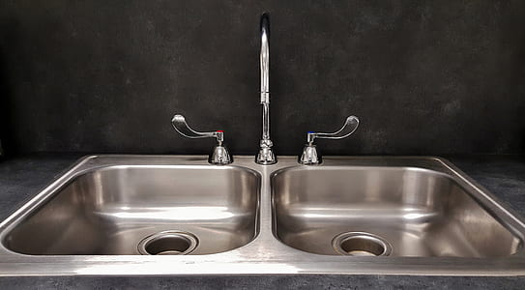

Sponges used in the kitchen
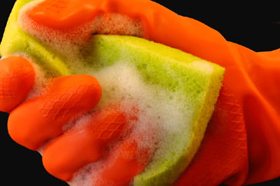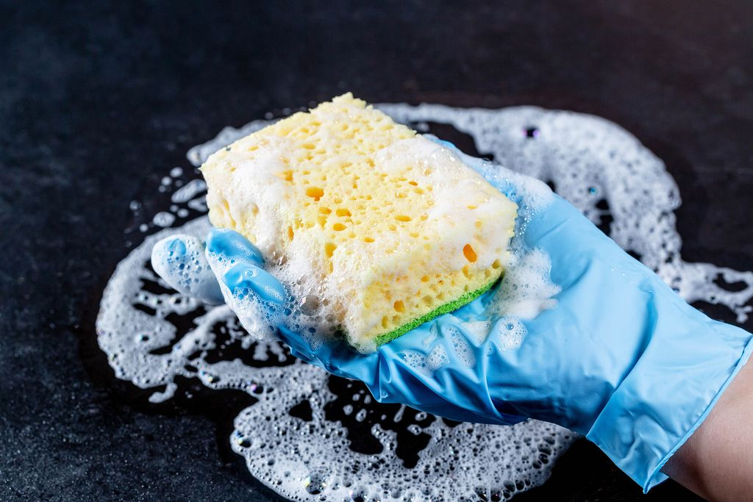
One of the dirtiest items in the house are the sponges used in the kitchen. Sponges and dishrags are exposed to all of the germs and bacteria from the animal products. They are also conducive to breeding germs because of their porous composition and the fact that they are usually wet. Sponges should be regularly disinfected every week and replaced at least one a month.

Carpets
The majority of houses have a massive amount of floor space in the home covered in these germ ridden materials. Although most of the households do vacuum regularly, the carpets are rarely disinfected and are filled with household germs. Try to vacuum at least 2-3 times a week and have your carpets cleaned regularly with a toxin free solution.

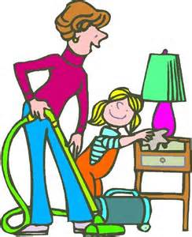

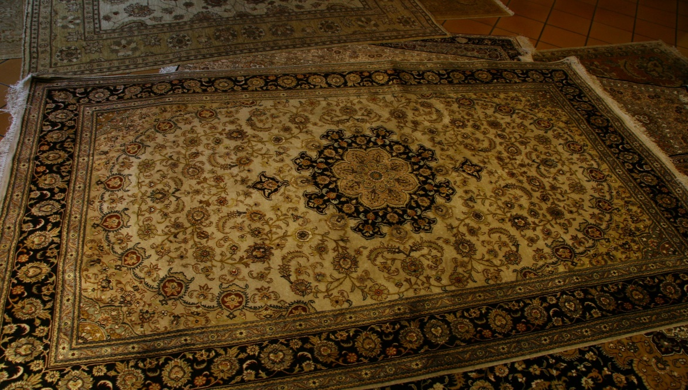

Mobile phone
Mobile phones or cell phones are such fun to have and germs like them as much as we do. These phones are small but can carry 18 times more harmful germs than the flush handle on a toilet.

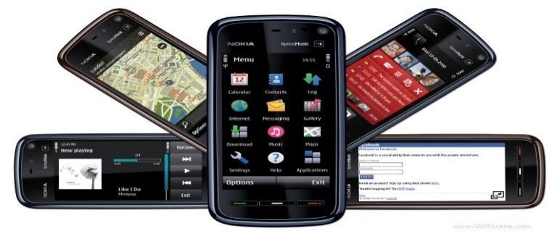

Dustbins
Clean the dustbins regularly to prevent germs breeding.

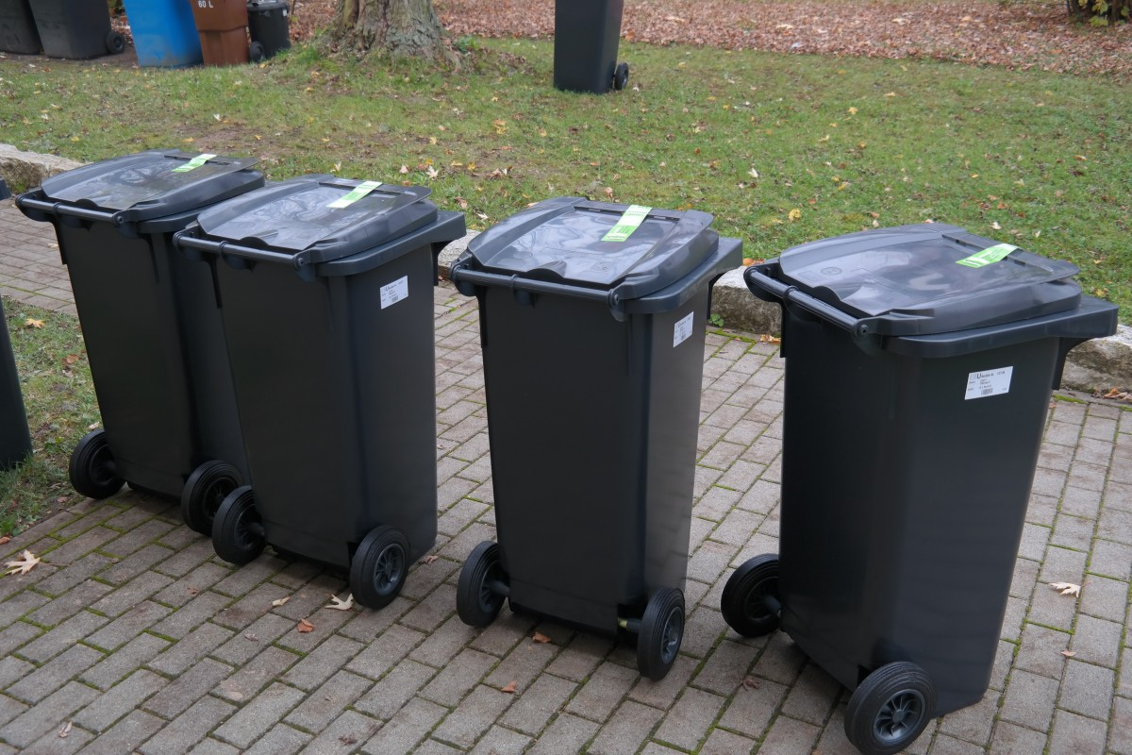

Clean surfaces in the home regularly. You should wipe the kitchen counter, floors, shower and dining tables at least one a week using either soap and water or conventional household cleaning products.

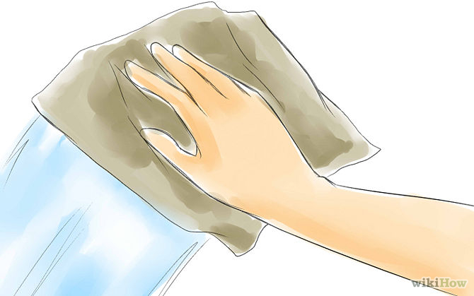

Sub- topic: Dietary habits of children

Healthy eating is important for everyone, especially children. We all need carbohydrates, proteins, dairy products, fresh fruit and vegetables and water in our diet. Children are still growing and need the vitamins and nutrients found in these foods.
Many children like to eat sweets and drink fizzy cool drinks. These have very little goodness in them to keep children healthy. Too many sweets and fizzy drinks are also bad for your teeth. These cool drinks contain acids and sugars that break down and wear away tooth enamel over time. Holes develop. These can lead to toothache and gum infections.

It is important to brush your teeth with toothpaste every morning and every night. This will keep them clean from food and get rid of bacteria. It will also keep your breath from smelling bad.
Teeth brush with a tooth paste

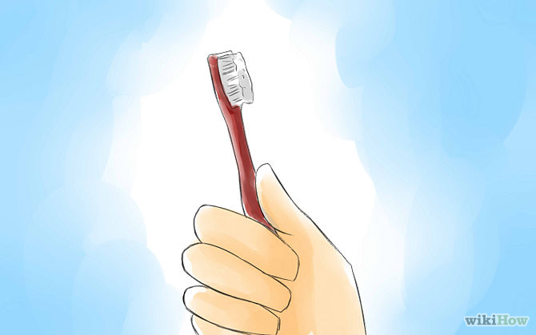
Brush your teeth regularly

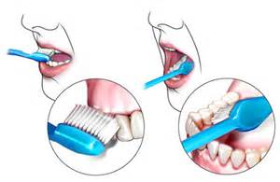
Go to the clinic for check-ups every year (teeth).

ACTIVITY

Fill in true or false:
Use your own face cloth
Use your own brush or comb
Sweets and fizzy drinks are bad for your teeth
Brush your teeth twice a day
Visit a dentist regularly
Wash your hands after using the toilet

Complete the sentences. Use the word box the choose the correct words

Brush, twice, lice, warts, dry, teeth, hands, germs

1. Rubbish bins and sinks often have lots of __________________.

2. Sharing a hairbrush can spread ____.

3. Always wash ________________ before working with food.

4.We should ____________ our teeth ____________ a day.

Sub topic: healthy environment and personal health: home, school and community

You and your family must keep your home clean. The place where you play and learn must also be clean. If you leave rubbish lying around, the people and the world around you will become sick.

Pollution in your environment (community)
The environment is made up of everything around you, including the air, water, the soil and plants and animals. People can make the environment better or worse. People make the environment worse by putting rubbish into it. This is known as pollution. Dumping in our communities cause infections and diseases. Mice’s will multiply and infect people with diseases.

Examples of environment that are unhealthy as a result of pollution

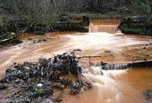
At home
Keep your home and your yard clean. Have a rubbish bin were you put in all the rubbish and keep it closed. The rubbish bin must be cleaned, if not it will accumulate cockroaches and flies that will cause diseases. The house must also be cleaned on daily basis, wash dishes, sweep and scrub the floor, clean the toilet and everything in the house. If you drink or wash in dirty water you can get diarrhoea or cholera. These diseases are dangerous and you can even die from them.
.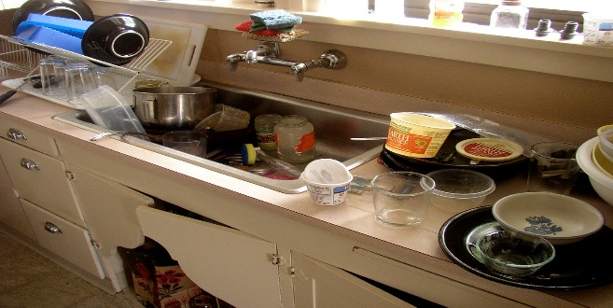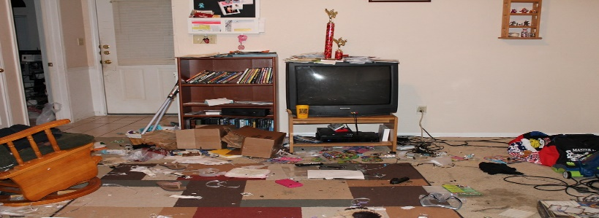
At school: Keep your classroom clean and neat. Put a bin were you through in all papers and all the rubbish. Empty the bin daily. Sweep and scrub the floor and windows. Don’t litter in the school yard. Keep the toilets clean and don’t put unwanted things in the toilets. Use toilet papers and wash your hands every time you come from the toilet.
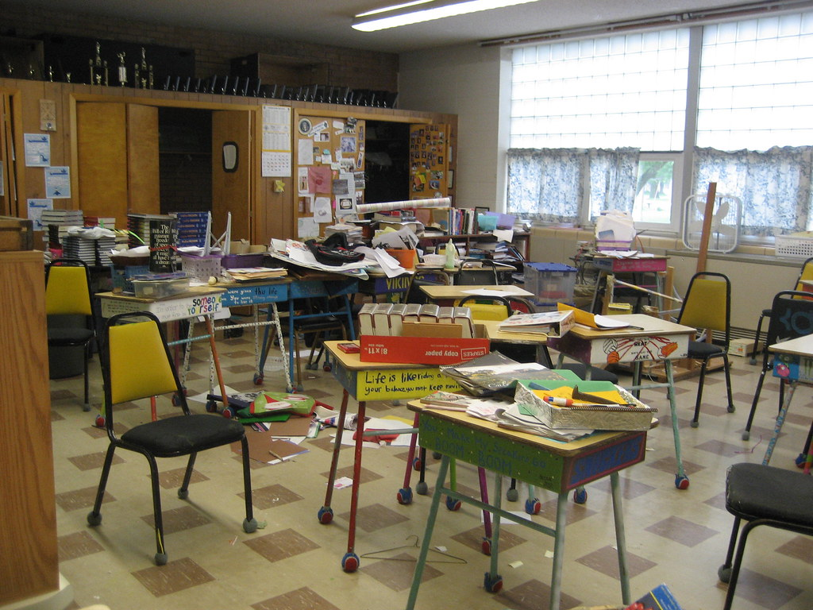
Dirty air: Air pollution can give people a bad cough, a sore chest and make it very hard to breath. It can cause diseases in your lungs.
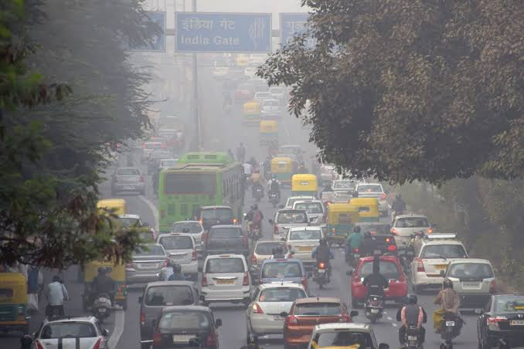
Illegal dumping sites
When people throw rubbish in the streets or in open spaces, it can cause health problems. Poison and germs can spread into the soil and water. This can spread diseases and make people sick.
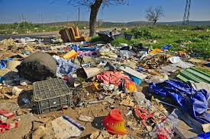
Keeping the environment healthy
Strategies to keep the environment we live in healthy.
- If you see any rubbish on the ground, pick it up and put it in the bin. Wash your hands afterwards.
- Recycle at home and at school. This means re-using glass and plastic containers, making compost form vegetable and fruit peels, or recycling newspapers, tin cans and plastic.
- Plant more flower, plants and trees to help the environment. Plants help keep the air clean.
- Do not throw rubbish into rivers, dams or the sea.
- Do not litter or dump rubbish where it is not allowed
- Do not go to the toilet in a river or near a river.

Activity
Write five things that you can do to keep your environment clean and healthy.
__________________________________________________________________________________________________________________________________________________________________________________________________________________________________________________________________________________________________________________________________________________________________________________________________________________________________________

Pollution in your environment
The environment is made up of everything around you, including the air, water, the soil and plants and animals. People can make the environment better or worse. People make the environment worse by putting rubbish into it. This is known as pollution.

Pollution means dertifying our environment, littering, lots of dirty smoke, throwing dirt into the river and making a lot of noise.

Different types of pollution
*Water pollution
*Land pollution
*Air pollution
*Noise pollution

Effects of pollution on people
Dirty water
If you drink or wash in dirty water you can get diarrhoea or cholera. These diseases are dangerous and you can even die from them.

Dirty air
Air pollution can give people a bad cough, a sore chest and make it very hard to breath. It can cause diseases in your lungs.
Illegal dumping sites
When people throw rubbish in the streets or in open spaces, it can cause health problems. Poison and germs can spread into the soil and water, this can spread diseases and make people sick.

Activity
In groups create a poster of a healthy environment. Collect pictures of illegal dumping, dirty yards, filthy houses. Paste them and write strategies to keep your environment clean.

Sub- Topic: Dangers in and around water: at home and public swimming pools and in rivers and dams.

People enjoy being near water. But water can be very dangerous. In South Africa, every year many people drown in water and also get hurt in accidents. Some of these accidents could have been avoided if they knew how to act and what to do when they were in danger.

Ways to be safe around water at home.
- Always have an adult present when the bath is filling up and when a young child is in the bath.
- A rubber mat on the bath can stop slipping
- Always empty buckets with water or put a lid on them.
- Plastic inflatable pools should be emptied and packed away after each use.
- Keep toilet seats closed – a young child might fall in and drown.
- Mop up puddles of water so no-one slips
- Keep electrical appliances far from water.
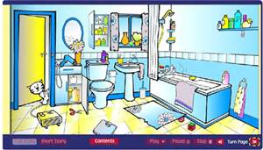

Activity
Danger in and around water.

1. Look at the picture. Identify and write down four (4) dangers that are shown in the picture.

2. Why is it dangerous to leave young children alone near anything that has water in it?

Responsible safety measures in and around water
- Ways to be safe around swimming pools
- Do not swim if an adult is not watching. Do not swim alone
- Never swim straight after meal.
- Don’t run around and jump in the pool.
- Don’t swim under the diving board in case someone lands on you.
- Don’t push other people or jump on other people, you could hurt them or yourself.
- Don’t eat while you are swimming because you could choke.
- Do not dive or jump into shallow water – always find out how deep the water is first
- Do not swim when you are tired, cold or sick.
- Do not swim during a thunderstorm.

Safety in rivers and dams
- Rivers often look gentle and shallow, but they can suddenly become deep. The wat in the deep part can flow very fast.
- Read and obey signs that warn of danger
- There may be strong currents that could wash you away.

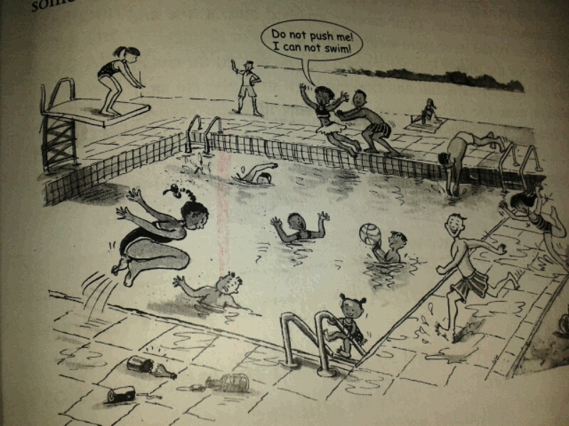

Activity
1. Look at the picture. Identify and write down six dangers that are shown in the picture.

2. Do you think it is important for children to learn to swim? Why?

3. Why must you never walk across a low river when it has been raining heavily?

4. Why must you first see how deep the water is before you dive or jump in?

5. Read the story: Maria’s day at the pool.
It was a hot say. Maria decided to spend the day at the local pool. A couple of boys were chewing gum while they were swimming. Other boys were chasing each other around the edge of the pool. They were trying to push each other into the water. Three teenagers were swimming under the diving board. A young girl was learning to dive at the shallow end of the pool. Other boys were diving wildly and not taking note of where people were swimming. Maria decided to come back another day when it was safe to swim.

5.1 List four reasons why Maria decided it was not safe to go swimming after all.

5.2 Do you think Maria made a good decision? Explain.

Sub- topic: Strategies to keep environment healthy, conversation environment

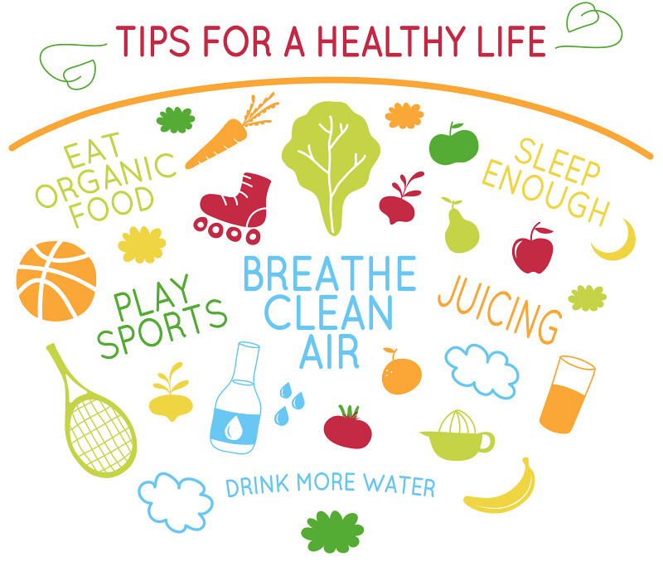

Teacher’s notes
With learners go through the picture and discuss about it. Make learners aware that we have to conserve our environment. Write points that learners give on the board.

Strategies to keep environments healthy: conservation of environment
-Ride your bike, walk or take public transport instead of driving.
-Recycle and make a compost
-Plant and make a garden
-Use natural cleaning products
-Reuse bottles (recycle)

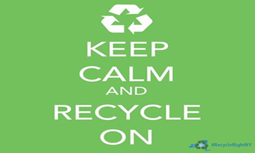

ACTIVITY
- Mention four strategies on how you keep your environment healthy

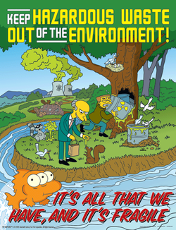

Sub Topic: HIV and AIDS education
HIV is a virus that attacks peoples’ immune systems.
Many years after getting the virus, the immune system becomes so weak that it can’t fight any illnesses. At this stage, we say the person has Aids. So HIV and Aids is not the same thing. HIV is a virus that weakens our bodies. Aids is when people become very sick because their bodies can’t fight illnesses any more. When you have the virus, we say you are HIV-positive.

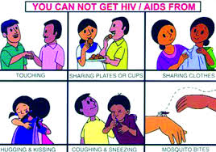

*There are only three ways that people can get HIV:
- By having unprotected sex with someone who has HIV- This means sex without a condom.
- By allowing blood from an infected person to get into their own bloodstream. For an example, if a person with HIV uses a needle to inject drugs, and then shares the needle with someone else, the virus can be passed to them. Or ear and body piercing and tattoos using a dirty needle. If you are in an accident and get infected blood in a cut.
- A mother with HIV can pass it on to her baby during pregnancy, in childbirth, or by breast-feeding.

A. Activity
Write True or False

1. You can be infected by HIV and Aids through blood transmission.
2. If you hug an HIV infected person you will be infected.
3. You can’t share foods with a person infected.
4. HIV and AIDS is curable.
5.HIV and AIDS person must exercise and eat healthy.

B. Activity
Answer and give a reason
1. Can you pick a person infected with HIV and AIDS who takes care of himself in a crowed.
_________________________________________________________________________________________________________________________________________________________________________________________________________________________________________________________________________________________
THE END

