CREATIVE ARTS
GRADE 6

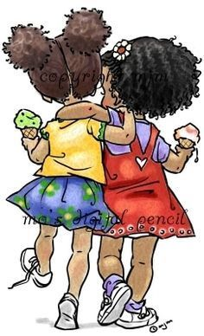

TERM 4

Creativity is contagious, pass it on.” – Albert Einstein

2025

WEEK | TOPIC | CAPS CONTENT (ATP) | ACTIVITY | DATE COMPLETED | DH MONITORING
1 | Create in 2D: Buildings, architecture and the environment Visual literacy | Visual literacy • Observe visual stimuli in photographs and real objects to identify and name relevant art elements found in images of buildings and architecture • Questions to deepen and extend observation of elements and design principles • Apply, identify and personally interpret in own work Create in 2D: Buildings: architecture and the environment Art elements Overview of developed use of all art elements found in own images of buildings, architecture and the environment Design principles Reinforce relevant design principles in own images of buildings, architecture and the environment Drawing and/or colour media Exploring a variety of media and techniques | WORKSHEET 1
2 | Create in 3D or relief: Buildings, architecture and the environment  Visual Literacy | Visual literacy • Observe visual stimuli in photographs and real objects to identify and name examples of design principles found in images of buildings and architecture • Questions to deepen and extend observation of elements and design principles • Apply, identify and personally interpret in own work Create in 2D: Buildings, architecture and the environment Art elements Overview of developed use of all art elements found in own images of buildings, architecture and the environment Design principles Reinforce relevant design principles in own images of buildings, architecture and the environment Drawing and/or colour media Exploring a variety of media and techniques | WORKSHEET 2  PRACTICAL NO 1
3 | Create in 3D or relief: Buildings,  architecture and the environment | Visual literacy Observe visual stimuli in photographs and real objects to identify and name examples of design principles found in images of buildings and architecture Create in 3D or relief: Buildings, architecture and the environment Art elements Reinforce relevant art elements through own construction of buildings and architecture Design principles Reinforce relevant design principles through use in own construction Skills and techniques Pasting, cutting, wrapping, tying and joining various recyclable materials Spatial awareness • Reinforce conscious awareness of working in deep and shallow space, e.g. model to be viewed from front, back and sides, and parts of model can extend into space • Appropriate tidiness and sharing of space • Appropriate use of tools | WORKSHEET 3  PRACTICAL NO 2
4 | Create in 3D or relief: Buildings, architecture and the environment | Visual literacy Observe visual stimuli in photographs and real objects to identify and name examples of design principles found in images of buildings and architecture Create in 3D or relief: Buildings, architecture and the environment Art elements Reinforce relevant art elements through own construction of buildings and architecture Design principles Reinforce relevant design principles through use in own construction Skills and techniques Pasting, cutting, wrapping, tying and joining various recyclable materials Spatial awareness • Reinforce conscious awareness of working in deep and shallow space, e.g. model to be viewed from front, back and sides, and parts of model can extend into space • Appropriate tidiness and sharing of space • Appropriate use of tools | WORKSHEET 4  WORKSHEET 5
5 - 6 | Practical formal assessment | Create in 2D: Buildings, architecture and the environment OR Create in 3D or relief: Buildings, architecture and the environment Assessment rubric: 40 marks | PRACTICAL ASSESSMENT TASK:  CHOOSE TO DO 2D OR 3D  NOT BOTH!
7 - 8 | Warm up and play Improvise and create Read, interpret and perform | Warm up • Vocal warmup, including breathing with chanting • Physical warmup for co-ordination and control • Singing warmups (including songs in unison, canon, in two-part harmony and/or call and response) Improvise and create • Short story inspired by listening to a suitable piece of music and identifying the impact of the different musical elements • Movement sequences to explore aspects of the above story using elements of dance (time, space, weight and energy) and combinations of locomotor and non locomotor movements OR Read, interpret and perform Puppetry A puppet performance: • Dialogue • Puppet movement • Musical accompaniment • Consider characters, relationships and structure (conflict and resolution) | WEEK 7  PRACTICAL NO 3  PRACTICAL NO 4  WEEK 8  WORKSHEET 6  WORKSHEET 7
9-10 | Warm up and play Improvise and create Read, interpret and perform Appreciate and reflect on | Warmup and cool-down • Singing warmups (including songs in unison, canon, in two-part harmony and/or call and response) • Leading and following games • Story development games Improvise and create • Short story inspired by listening to a suitable piece of music and identifying the impact of the different musical elements • Movement sequences to explore aspects of the above story using elements of dance (time, space, weight and energy) and combinations of locomotor and non-locomotor movements OR Read, interpret and perform Puppetry A puppet performance: • Dialogue • Puppet movement • Musical accompaniment • Consider characters, relationships and structure (conflict and resolution) • Musical signature tunes for each of the puppet characters using voice and found or made instruments | PRACTICAL NO 5

VISUAL ARTS 2D , BUILDINGS
Notes to the teacher: Revise the Elements of Art and the Principles of design.
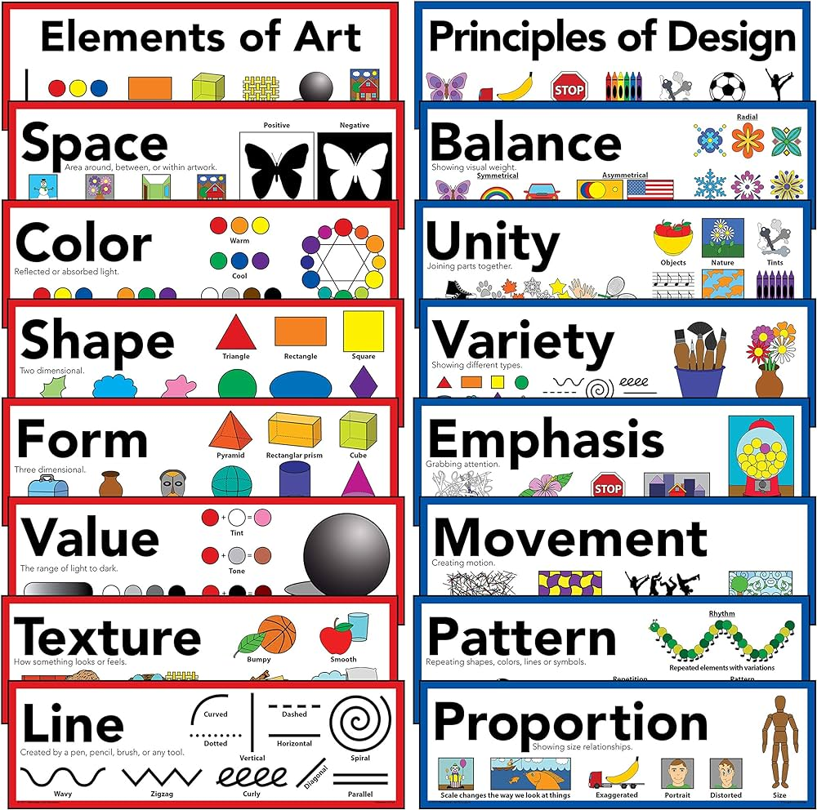
BUILDINGS
Start a class discussion recapping the Elements and Principles of Art used in previous lessons.
Talk about the different types of buildings one finds in the city and residential areas, their shapes, materials, colour, size and forms.
Use reference images when discussing the various Elements and Principles of Arts. Use your school building as an example.

EXAMPLE OF A CITYSCAPE - COLLAGE
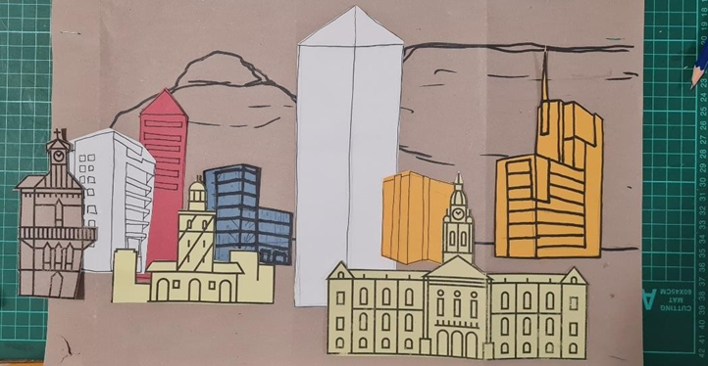

WEEK 1 WORKSHEET NO 1
- DIFFERENT BUILDINGS. Identify the type of building in each picture.
school | hut | House
hospital | church | Fuel station

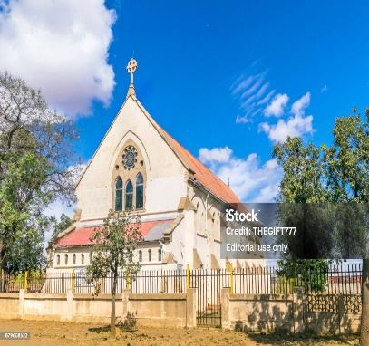  CHURCH | 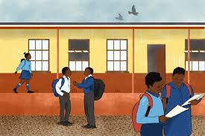  SCHOOL |   HOSPITAL
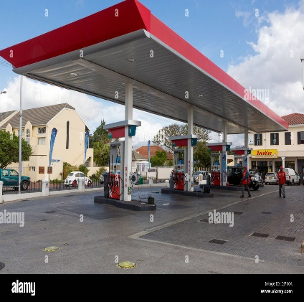  FUEL STATION | 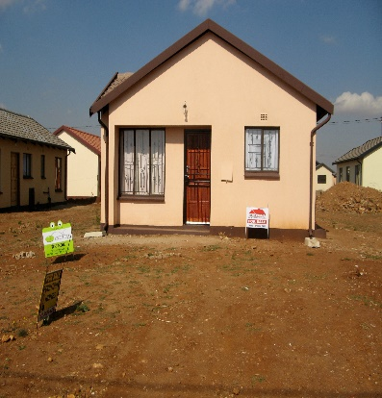  HOUSE | 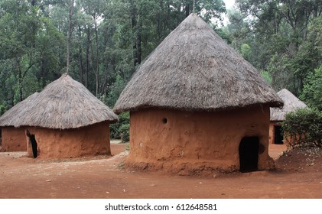  HUT

- Shapes : How many shapes can you identify in this building? Write them down.
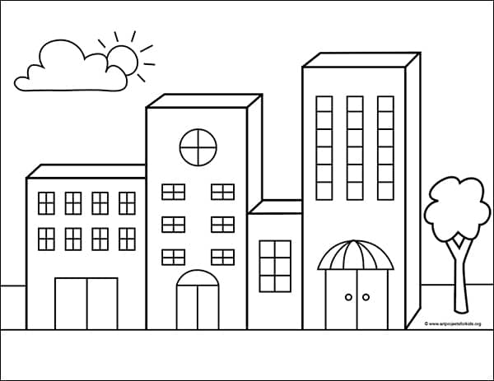 | SQUARE
 | RECTANGLE
 | OVAL
 | TRIANGLE

WEEK 2 PRACTICAL NO 1
Draw your own building(s) using shapes.

WEEK 2 WORKSHEET NO 2
Elements of Art: Look at this art work and answer the questions.
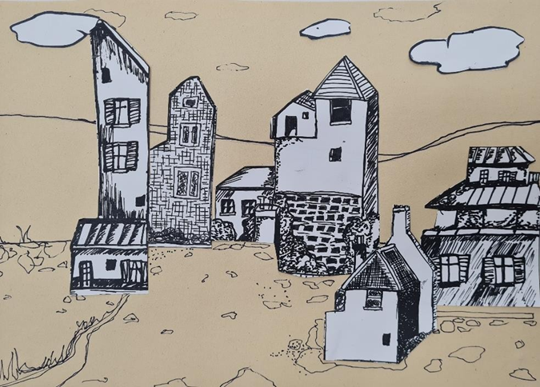
- How many shapes can you identify in this picture? Name them.
Square | Rectangle | Triangle

- Circle the type of lines that you can see.
Thick lines | Thin Lines | Straight lines | Zig-zag lines | Curved lines

- What can you see in this picture except for the buildings? Circle the correct answers.
clouds | trees | grass | birds | Stones | flowers

- How does this picture make you feel? Circle the emotion that you feel when looking at it.
angry | sad | happy | lonely

- In the space provided, create your own pattern. Be creative! 

WEEK 3 PRACTICAL NO 2
Elements of Art: Texture.
Actual texture is the way an object feels to the touch. Drawing or painting texture on a 2–dimensional, flat surface is a challenge for artists. The artist must instead convey the illusion of the actual texture to the viewer on the flat surface. How this is done is by the careful use of value and specific marks / brush strokes which then mimic the actual texture. The learners cn complete this activity to see how texture can be drawn.

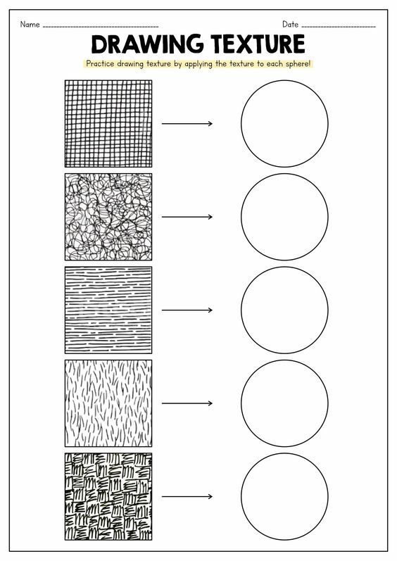
WEEK 3
CREATE A CITYSCAPE
- Study different images of cityscapes and the use of perspective in the images.

Note to the teacher: Explain the following to the learners:
- Rule of thirds: All landscapes and cityscapes consist of a:
foreground (things that appear in front of the artwork always much bolder and more detailed than the rest)
middle ground (all things eye level on the horizon line)
background (sky line, clouds, etc.)

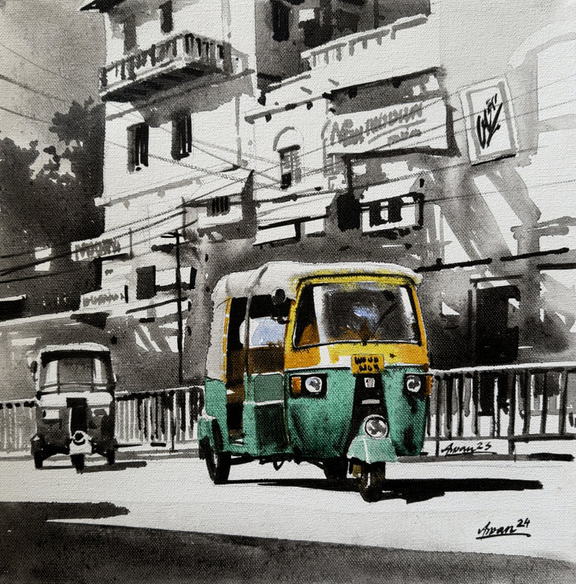
Background
Middle ground
Foreground
WEEK 3 WORKSHEET NO 3
Look at this painting, then answer the questions:
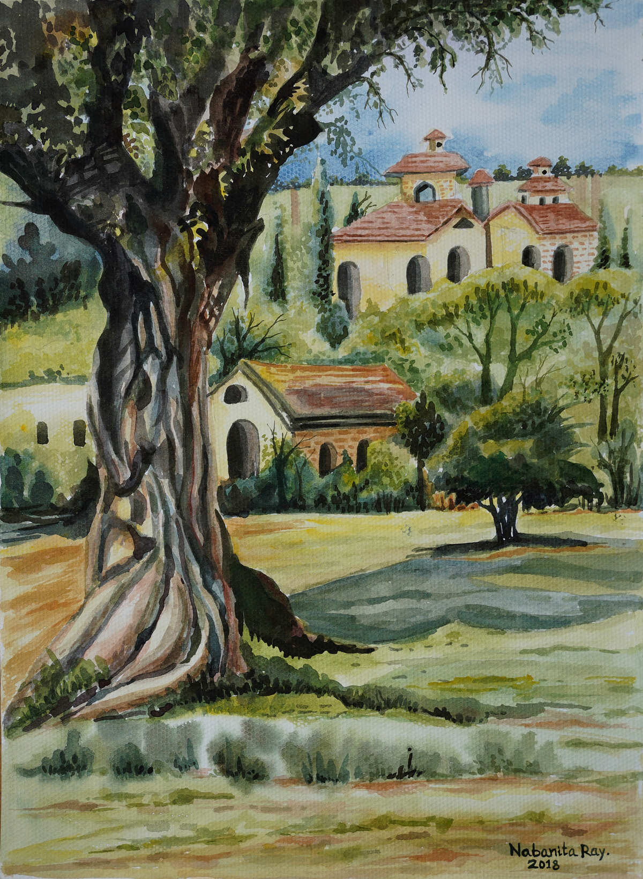

- The (tree / the house) is in the foreground of the picture.
- The ( small house and trees / only the trees) are in the middle ground of the picture.
- The ( big house / small house ) is in the background of the picture.

- Can you identify any contrasts in this picture?

Big trees / Small trees Big Buildings / Small buildings
Darker colours / Lighter colours

WEEK 4 Architects and buildings WORKSHEET NO 4
Read the paragraph and answer the questions.
An architect is a person who designs and plans a building for a specific purpose and who oversees the construction of the building. He has to consider the following:
- The space that is required for a purpose such as, for example, a school, a shopping centre or a private home.
- The materials that are needed
- How the building will fit into the environment.
Every building has a function – In other words the purpose or use for which it is designed.

- An architect is a person who designs and plans a building.
- The façade is the front face of a building.
- An architect has to consider 3 things :
  - The space that is required for a purpose, such as example, a school or a private home.
  - The materials that are needed
  - How the building will fit into the environment.

- What is the purpose of each building? Underline the correct answers.
 | 
This building is used as:  - A Private home.  - A place where people gather to practice their religion. (A church) | This building is used as:  - A place where sick people are treated. ( A Hospital)  - A Place where children are taught. (A school)

- How many buildings can you name that a community needs? Name 5.
Churches / Schools / Shopping Centre / Private home / Flats / Hospitals
Any other relevant answer

WEEK 4 WORKSHEET NO 5
What features do all buildings have in common?
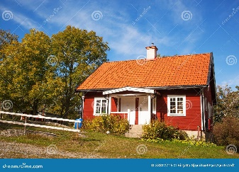 | 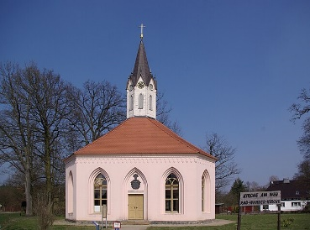 | 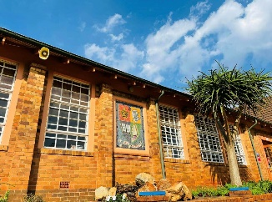
A house | A Church | A School

Look at the three different buildings. Each one of them has its own purpose. They however have some features in common. Circle the correct answers.
windows | roofs | doors | walls | towers

Graffiti is the name we use for lettering or images that are painted, drawn or scratched on the walls of buildings.
Look at this graffiti. What did the artist paint here?

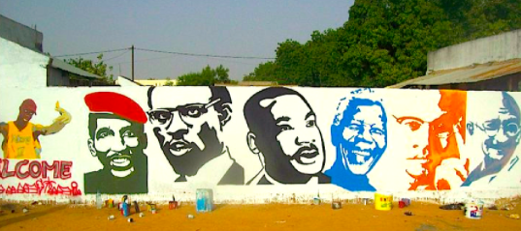
The faces of political leaders.
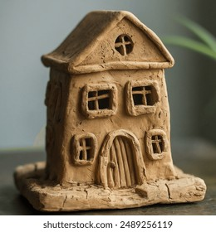
A very small clay modelling house is called a (big / miniature) building.

WEEK 5 – 6 FORMAL PRACTICAL ASSESSMENT
Notes to the teacher: The learners can choose between 2D OR 3D.
Create in 2D: Buildings, architecture and the environment OR Create in 3D or relief: Buildings, architecture and the environment Assessment rubric: 40 marks.

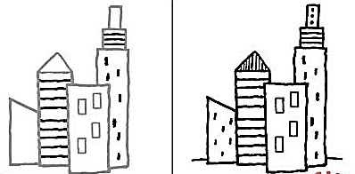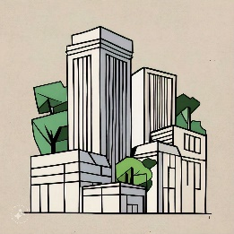
2D: INSTRUCTIONS: CREATE A CITYSCAPE
- Use an A3 OR an A4 paper to create your cityscape.
- First make a rough planning of the background and the buildings.
- Make use of shapes to draw your buildings.
- Use your whole page. (Space)
- Remember about the foreground, the middle ground and the background.

RUBRIC FOR 2D ASSESSMENT (20 MARKS ; 20 X 2 = 40)
CRITERIA | 4-5 | 2-3 | 1
Planning and Composition | Thoughtfully planned layout with clear foreground, middle ground, and background; demonstrates excellent spatial organization. | Good planning evident; includes all three grounds but may lack some clarity in spatial organization. | Little to no planning; unclear layout with no distinct foreground, middle ground, or background.
Use of shapes | Creative and varied use of shapes enhances the composition; shapes are well-integrated into the design. | Good use of shapes; generally enhances the overall design but may lack some variety or integration. | Minimal use of shapes; does not contribute effectively to the composition.
Use of space | Learner used the whole page. Well balanced | Learner used almost the whole page | The drawing is very small and there are many open spaces
Finishing and Presentation | Artwork is meticulously finished; clean lines, consistent colour application, and attention to detail. | Good finishing; mostly clean lines and decent colour application, though some areas may need more attention. | Little to no finishing; artwork appears rushed or unfinished.

3D : FORMAL ASSESSMENT
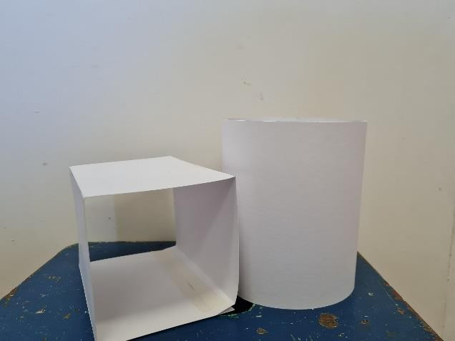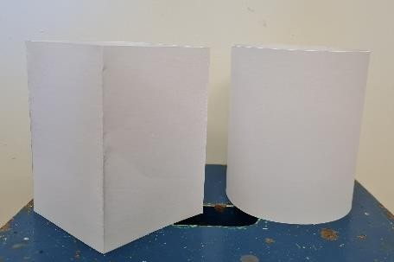

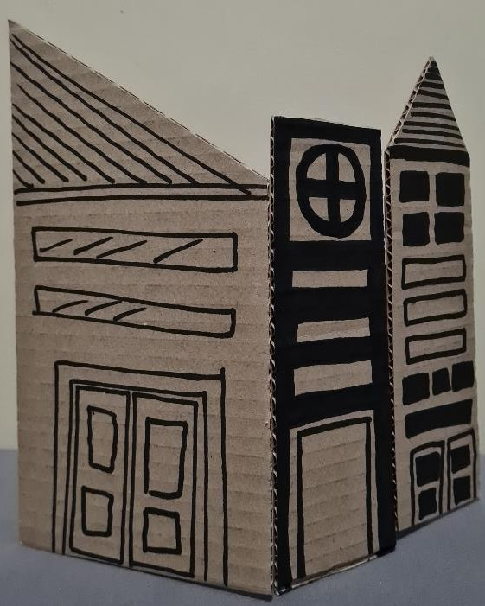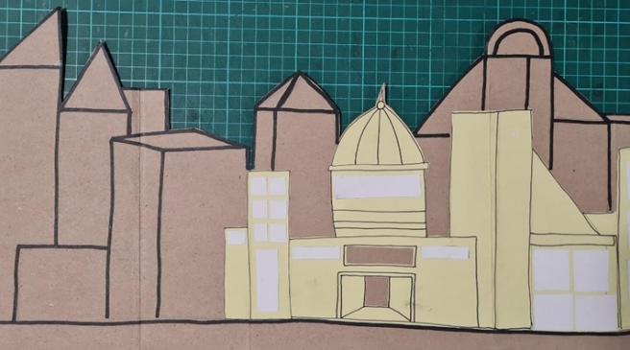
Instructions
- Sketch Your Design:
  - Take a piece of paper and sketch a rough layout of your cityscape. Include different types of buildings (skyscrapers, houses, parks, etc.), streets, and any other features (bridges, water bodies).
  - Think about the overall shape of each building. Will they be tall, short, wide, or narrow?
- Decide on Proportions:
  - Establish a scale for your cityscape. For example, if one building represents 10 feet in real life, decide how tall that will be in your model (e.g., 10 inches).
  - Keep similar proportions for similar types of buildings (e.g., all houses should be shorter than skyscrapers).

Step 2: Gather Materials
- Collect waste materials that can be used for different building types:
  - Cardboard: Great for flat surfaces and can be cut into various shapes.
  - Plastic Bottles: Can represent tall buildings or unique shapes.
  - Tin Cans: Use for cylindrical buildings or towers.
  - Old Newspapers: Can be crumpled or rolled to create textured buildings.
Step 3: Building the Structures
- Cut and Shape the Materials:
  - Use scissors or a craft knife to cut your materials into the shapes needed for your buildings. Be sure to work carefully for clean edges.
  - Create a variety of shapes (rectangles, cubes, pyramids) to add visual interest.
- Assemble the Buildings:
  - Glue the pieces together based on your design. Make sure to allow time for the glue to dry between steps.
  - Ensure stability by reinforcing corners and edges with extra material if needed.
- Create Details:
  - Add windows, doors, and other architectural features using smaller pieces of cardboard, paper, or markers.
  - You can use different textures (e.g., crumpled paper for a roof) to add depth.
Step 4: Layout Your Cityscape
- Plan the Layout:
  - Before gluing everything down, arrange your buildings on a flat base (like cardboard or a wooden board) to find a pleasing layout.
  - Leave space for streets, parks, and other features you want to include.
- Fix in Place:
  - Once satisfied with the layout, glue the buildings onto the base. Ensure they are secure and allow for drying time.
Step 5: Add Color and Details
Step 6: Finishing Touches
- Review your cityscape for neatness. Touch up any rough edges or areas that need additional glue or paint.
- Consider adding figures, cars, or trees made from more waste materials to bring your city to life.

RUBRIC : 3D ASSESSMENT
CRITERIA | 4 -5 | 2 - 3 | 1
Planning | Clear and detailed sketch; thoughtful layout; considers proportions | Good sketch; layout is mostly clear; some consideration of proportions | Basic sketch; layout is unclear; limited consideration of proportions.
Waste materials | Creative use of diverse waste materials; effectively enhances the artwork. | Good use of some waste materials; contributes positively to the artwork | Limited use of waste materials; minimal enhancement to the artwork.
Craftsmanship | High level of craftsmanship; clean edges, secure assembly, attention to detail. | Good craftsmanship; minor imperfections; buildings are mostly secure. | Average craftsmanship; several imperfections; some buildings may be unstable.
End Product | Visually striking; creative and cohesive cityscape; effectively communicates the theme. | Visually appealing; good creativity; mostly cohesive cityscape. | Unappealing; lacks creativity; does not communicate the theme effectively.

20 Marks : 20 x 2 = 40

WEEK 7 SING A SONG (Canon) PRACTICAL NO 3
Notes to the teacher:
- Teach learners the words of the song “Bana ba sekolo”.
- Divide the class into 2 groups and sing it as a canon.
- Learners may add movements and body percussion
Lyrics
Bana ba sekolo (Bana ba sekolo)
Etlang sekolong (Etlang sekolong)
Utlwa tshipi e a lla (Utlwa tshipi e a lla)
Ding dong mbelelele (Ding dong mbelelele)
Bana ba sekolo (Bana ba sekolo)
Etlang sekolong (Etlang sekolong)
Utlwa tshipi e a lla (Utlwa tshipi e a lla)
Ding dong mbelelele (Ding dong mbelelele)

Mama Tembu’s Wedding ( Use the Link to play this video with lyrics. Learners will enjoy singing it!)
https://youtu.be/U5KxYIjkKPU



WEEK 7 PRACTICAL NO 4
Notes to the teacher:
Sound and music have the power to evoke pictures in our imagination which are personal and specific.
Take different songs, and let the learners listen to it.
Ask the following questions and discuss it as a class. You may use the links provided OR choose your own songs. ( At least 3 different songs with different moods)
Discuss each song after listening to it.

National Anthem of South Africa | The rivers of Babilon. Boney M | Ladismith Black Mambazo
https://youtu.be/W83_2Up--7U | https://youtu.be/l3QxT-w3WMo | https://youtu.be/GZgbyvV1hCE

    - What is the MOOD of each song?
    - How does the song make you feel? (Emotions)
    - What is the song about?
    - Can you identify any of the instruments used in the music?
    - Is the music fast or slow?
    - Is the music happy or sad?
    - Do you like the music? Give reasons.
(You can ask more questions – As long as the learners will be able to talk about the music)

N

WEEK 8
Notes to the teacher: Teach learners the following content:
A Ritual is a ceremony that has a series of actions that are repeated on certain special occasions.
The procedure of a ritual is specified and detailed and followed regularly by the people involved. Every culture and society has rituals.
Examples:
Weddings   | Funerals  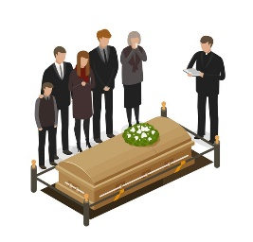
Coronations  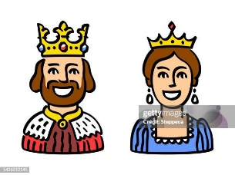 | Church : baptism / Eucharist  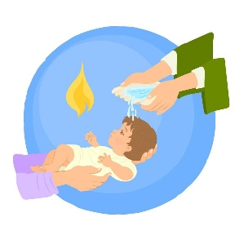

WEEK 8 WORKSHEET NO 6
Complete the following sentences:
ceremony | actions | detailed | society | wedding

- A Ritual is a ceremony that has a series of actions that are repeated on certain special occasions.
- The procedure of a ritual is specified and detailed and followed regularly by the people involved. Every culture and society has rituals.
- A wedding is an example of a ritual.

- Identify the following rituals. Make use of the words provided to help you.

wedding | baptism | birthday | coronation | funeral | graduation

baptism | 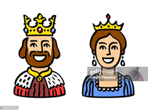  coronation
wedding | funeral

Getting up in the morning and preparing yourself for the day is also a ritual. Write down what your ritual is like in the morning before you go to school. Write 3 sentences. (For example: You get out of bed by six o clock. What happens next?
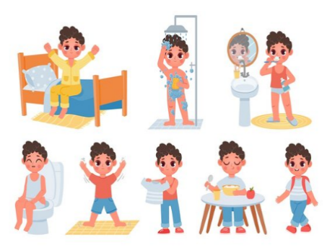 | Wake up at six o’ clock.  Go to the bathroom.  Wash  Dress  Eat  (Any relevant answers)
WEEK 8 RITUALS: A WEDDING WORKSHEET NO 7

A Wedding is also a ritual. Let’s discuss what happens at a wedding.
- Who are the people who are involved at a wedding? Think of as many as you can. (For example: The bride. Look at the words provided and choose the correct ones. Write them down on the lines provided.
Father of bride | Mother of bride | Shop owner | Groom | Bride | Family | Pastor / reverend | painter | Photographer

(Any other relevant answers.)
1.1 | 1.4
1.2 | 1.5
1.3 | 1.6

- Where does this ritual take place?
Any correct answer. Examples : church / garden / a private house / a city hall.

- Is there music used during this ceremony? What type of music is used?
Religious music in the church / party music – Any other relevant answers.

- What is the purpose of this ritual?
To make a relationship formal / legal.

- Have you ever attended a wedding? What was it like? Write 2 – 3 sentences about the wedding.
Any relevant answers

WEEK 9 – 10 CREATE A DRAMA (INFORMAL – NO ASSESSMENT) PRACTICAL NO 5

- In Groups, create a Drama about ANY ritual.
- Remember the patterns. Repetition and sequence of the ritual.
- You may use music and movement.
- Rehearse and perform it to the class.


