CREATIVE ARTS
GRADE 6



TERM 4
LEARNER ACTIVITY BOOK

Creativity is contagious, pass it on.” – Albert Einstein

2025

WEEK 1 WORKSHEET NO 1
- DIFFERENT BUILDINGS. Identify the type of building in each picture.
school | hut | House
hospital | church | Fuel station

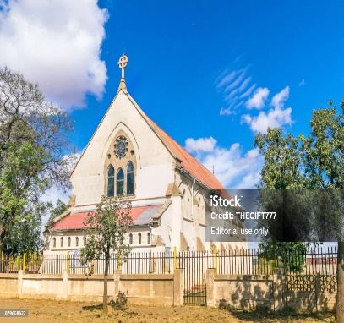  ………………………………………….. | 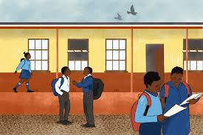  ………………………………………… |   …………………………………………….
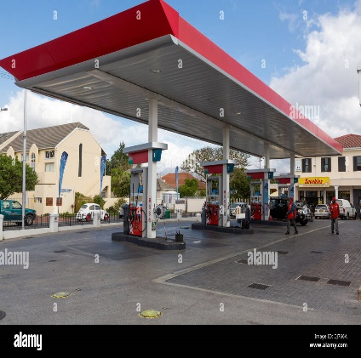  ……………………………………………. | 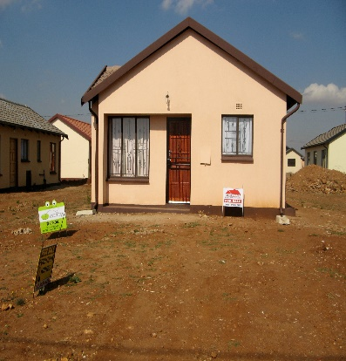  ………………………………………….. | 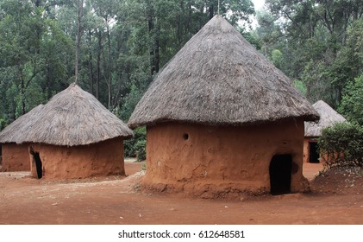  …………………………………………….

- Shapes : How many shapes can you identify in this building? Write them down.
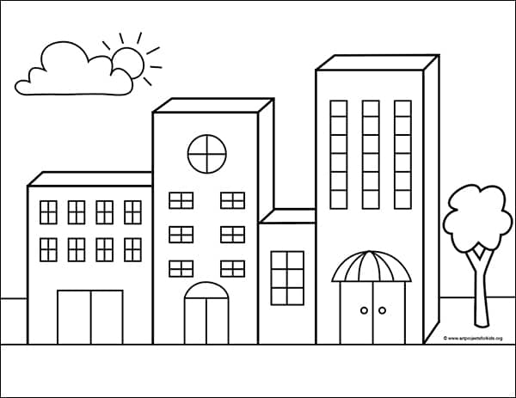

WEEK 2 PRACTICAL NO 1
Draw your own building(s) using shapes.

WEEK 2 WORKSHEET NO 2
Elements of Art: Look at this art work and answer the questions.
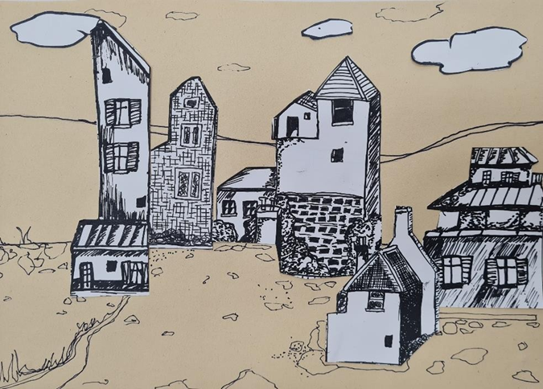
- How many shapes can you identify in this picture? Name them.

- Circle the type of lines that you can see.
Thick lines | Thin Lines | Straight lines | Zig-zag lines | Curved lines

- What can you see in this picture except for the buildings? Circle the correct answers.
clouds | trees | grass | birds | Stones | flowers

- How does this picture make you feel? Circle the emotion that you feel when looking at it.
angry | sad | happy | lonely

- In the space provided, create your own pattern. Be creative! 

WEEK 3 PRACTICAL NO 2
Elements of Art: Texture.
Actual texture is the way an object feels to the touch. Drawing or painting texture on a 2–dimensional, flat surface is a challenge for artists. The artist must instead convey the illusion of the actual texture to the viewer on the flat surface. How this is done is by the careful use of value and specific marks / brush strokes which then mimic the actual texture. The learners cn complete this activity to see how texture can be drawn.

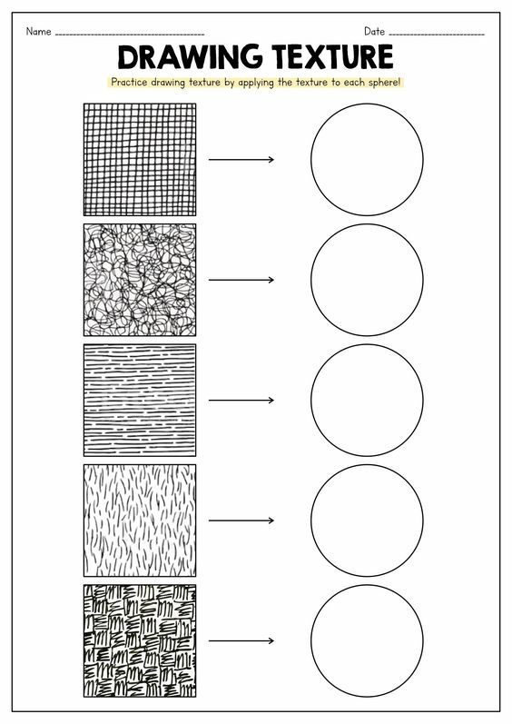
WEEK 3
CREATE A CITYSCAPE

Rule of thirds: All landscapes and cityscapes consist of a:
foreground (things that appear in front of the artwork always much bolder and more detailed than the rest)
middle ground (all things eye level on the horizon line)
background (sky line, clouds, etc.)

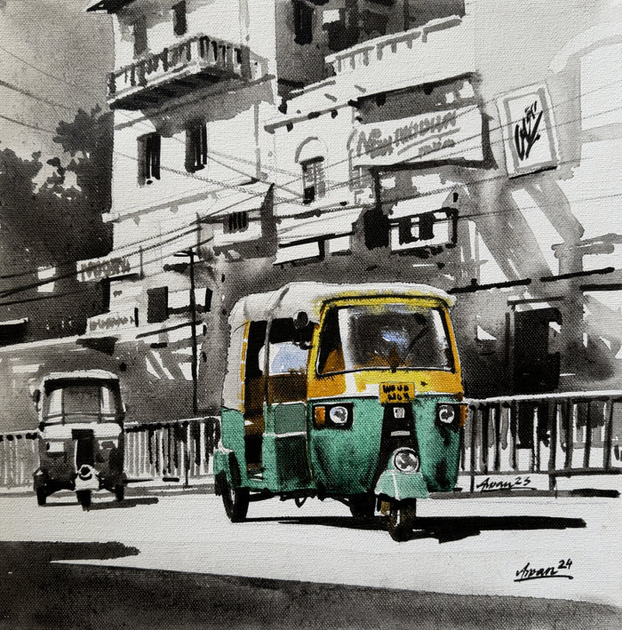
Background
Middle ground
Foreground

WEEK 3 WORKSHEET NO 3
Look at this painting, then answer the questions:
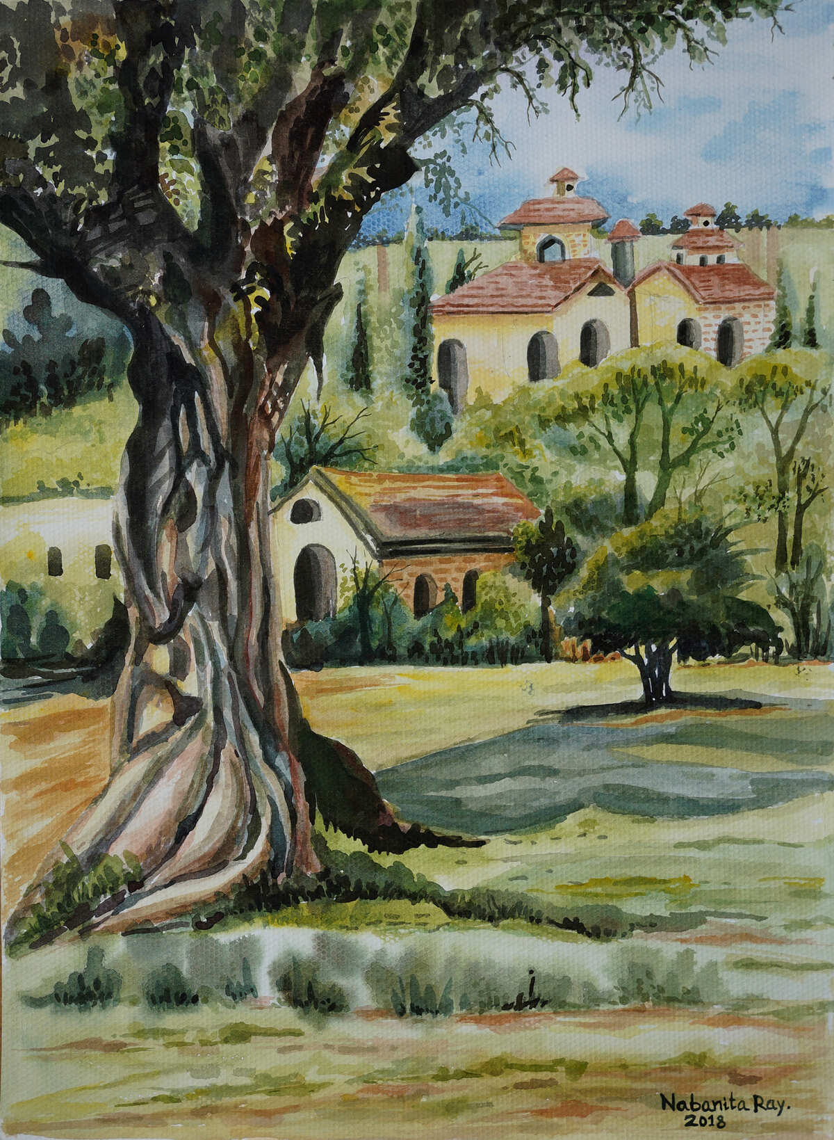

- The (tree / the house) is in the foreground of the picture.
- The ( small house and trees / only the trees) are in the middle ground of the picture.
- The ( big house / small house ) is in the background of the picture.

- Can you identify any contrasts in this picture?

WEEK 4 Architects and buildings WORKSHEET NO 4
Read the paragraph and answer the questions.
An architect is a person who designs and plans a building for a specific purpose and who oversees the construction of the building. He has to consider the following:
- The space that is required for a purpose such as, for example, a school, a shopping centre or a private home.
- The materials that are needed
- How the building will fit into the environment.
Every building has a function – In other words the purpose or use for which it is designed.

- An ……………………. is a person who designs and plans a building.
- The …………………………. the front face of a building.
- An architect has to consider 3 things :
  - The …………………….that is required for a purpose, such as example, a school or a private home.
  - The …………………………. that are needed
  - How the building will fit into the ………………………………….
- What is the purpose of each building? Underline the correct answers.
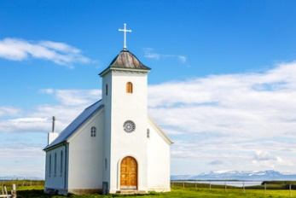 | 
This building is used as:  - A Private home.  - A place where people gather to practice their religion. (A church) | This building is used as:  - A place where sick people are treated. ( A Hospital)  - A Place where children are taught. (A school)

- How many buildings can you name that a community needs? Name 5.
……………………………………………………………………………………………………………………………………………………………………………………………………………………………………………………………………………………………………………………………………………………………………………………………………………………………………………………………………………………………………………

WEEK 4 WORKSHEET NO 5
What features do all buildings have in common?
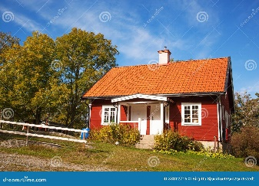 | 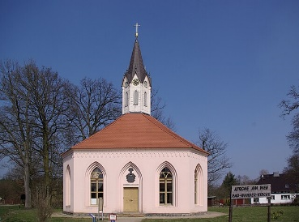 | 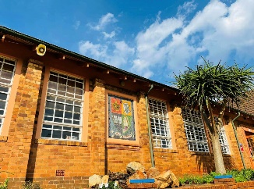
A house | A Church | A School

Look at the three different buildings. Each one of them has its own purpose. They however have some features in common. Circle the correct answers.
windows | roofs | doors | walls | towers

Graffiti is the name we use for lettering or images that are painted, drawn or scratched on the walls of buildings.
Look at this graffiti. What did the artist paint here?

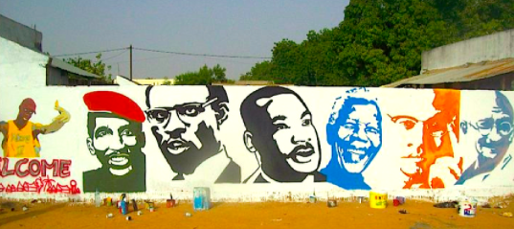
………………………………………………………………………………………………………………………………………………………………………………………………………………………………………………………………………………………………………………
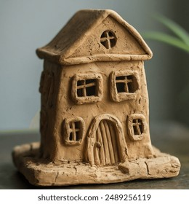
A very small clay modelling house is called a (big / miniature) building.

WEEK 5 – 6 FORMAL PRACTICAL ASSESSMENT

Create in 2D: Buildings, architecture and the environment OR Create in 3D or relief: Buildings, architecture and the environment Assessment rubric: 40 marks.

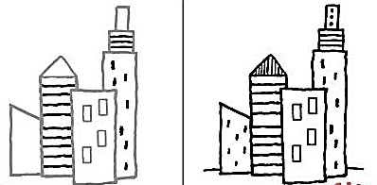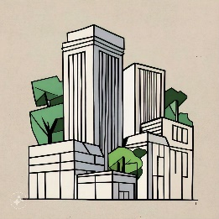
2D: INSTRUCTIONS: CREATE A CITYSCAPE
- Use an A3 OR an A4 paper to create your cityscape.
- First make a rough planning of the background and the buildings.
- Make use of shapes to draw your buildings.
- Use your whole page. (Space)
- Remember about the foreground, the middle ground and the background.

RUBRIC FOR 2D ASSESSMENT (20 MARKS ; 20 X 2 = 40)
CRITERIA | 4-5 | 2-3 | 1
Planning and Composition | Thoughtfully planned layout with clear foreground, middle ground, and background; demonstrates excellent spatial organization. | Good planning evident; includes all three grounds but may lack some clarity in spatial organization. | Little to no planning; unclear layout with no distinct foreground, middle ground, or background.
Use of shapes | Creative and varied use of shapes enhances the composition; shapes are well-integrated into the design. | Good use of shapes; generally enhances the overall design but may lack some variety or integration. | Minimal use of shapes; does not contribute effectively to the composition.
Use of space | Learner used the whole page. Well balanced | Learner used almost the whole page | The drawing is very small and there are many open spaces
Finishing and Presentation | Artwork is meticulously finished; clean lines, consistent colour application, and attention to detail. | Good finishing; mostly clean lines and decent colour application, though some areas may need more attention. | Little to no finishing; artwork appears rushed or unfinished.

3D : FORMAL ASSESSMENT
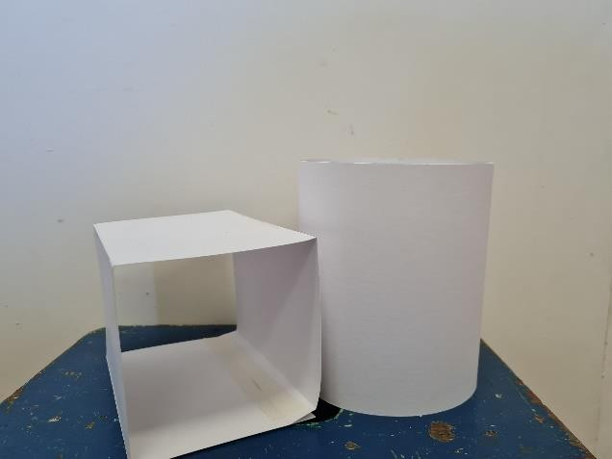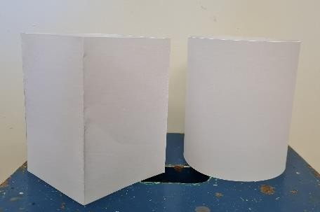

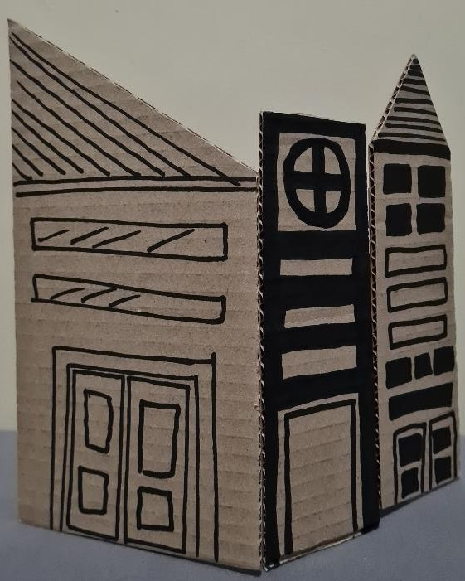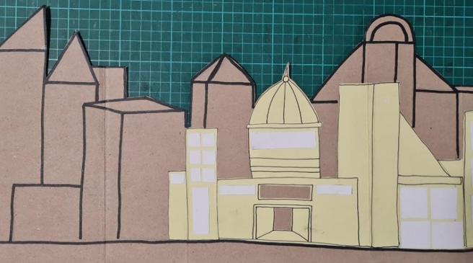
Instructions
- Sketch Your Design:
  - Take a piece of paper and sketch a rough layout of your cityscape. Include different types of buildings (skyscrapers, houses, parks, etc.), streets, and any other features (bridges, water bodies).
  - Think about the overall shape of each building. Will they be tall, short, wide, or narrow?
- Decide on Proportions:
  - Establish a scale for your cityscape. For example, if one building represents 10 feet in real life, decide how tall that will be in your model (e.g., 10 inches).
  - Keep similar proportions for similar types of buildings (e.g., all houses should be shorter than skyscrapers).

Step 2: Gather Materials
- Collect waste materials that can be used for different building types:
  - Cardboard: Great for flat surfaces and can be cut into various shapes.
  - Plastic Bottles: Can represent tall buildings or unique shapes.
  - Tin Cans: Use for cylindrical buildings or towers.
  - Old Newspapers: Can be crumpled or rolled to create textured buildings.
Step 3: Building the Structures
- Cut and Shape the Materials:
  - Use scissors or a craft knife to cut your materials into the shapes needed for your buildings. Be sure to work carefully for clean edges.
  - Create a variety of shapes (rectangles, cubes, pyramids) to add visual interest.
- Assemble the Buildings:
  - Glue the pieces together based on your design. Make sure to allow time for the glue to dry between steps.
  - Ensure stability by reinforcing corners and edges with extra material if needed.
- Create Details:
  - Add windows, doors, and other architectural features using smaller pieces of cardboard, paper, or markers.
  - You can use different textures (e.g., crumpled paper for a roof) to add depth.
Step 4: Layout Your Cityscape
- Plan the Layout:
  - Before gluing everything down, arrange your buildings on a flat base (like cardboard or a wooden board) to find a pleasing layout.
  - Leave space for streets, parks, and other features you want to include.
- Fix in Place:
  - Once satisfied with the layout, glue the buildings onto the base. Ensure they are secure and allow for drying time.
Step 5: Add Color and Details
Step 6: Finishing Touches
- Review your cityscape for neatness. Touch up any rough edges or areas that need additional glue or paint.
- Consider adding figures, cars, or trees made from more waste materials to bring your city to life.

RUBRIC : 3D ASSESSMENT
CRITERIA | 4 -5 | 2 - 3 | 1
Planning | Clear and detailed sketch; thoughtful layout; considers proportions | Good sketch; layout is mostly clear; some consideration of proportions | Basic sketch; layout is unclear; limited consideration of proportions.
Waste materials | Creative use of diverse waste materials; effectively enhances the artwork. | Good use of some waste materials; contributes positively to the artwork | Limited use of waste materials; minimal enhancement to the artwork.
Craftsmanship | High level of craftsmanship; clean edges, secure assembly, attention to detail. | Good craftsmanship; minor imperfections; buildings are mostly secure. | Average craftsmanship; several imperfections; some buildings may be unstable.
End Product | Visually striking; creative and cohesive cityscape; effectively communicates the theme. | Visually appealing; good creativity; mostly cohesive cityscape. | Unappealing; lacks creativity; does not communicate the theme effectively.

20 Marks : 20 x 2 = 40

WEEK 7 SING A SONG (Canon) PRACTICAL NO 3
Lyrics
Bana ba sekolo (Bana ba sekolo)
Etlang sekolong (Etlang sekolong)
Utlwa tshipi e a lla (Utlwa tshipi e a lla)
Ding dong mbelelele (Ding dong mbelelele)
Bana ba sekolo (Bana ba sekolo)
Etlang sekolong (Etlang sekolong)
Utlwa tshipi e a lla (Utlwa tshipi e a lla)
Ding dong mbelelele (Ding dong mbelelele)

Mama Tembu’s Wedding ( Use the Link to play this video with lyrics. Learners will enjoy singing it!)
https://youtu.be/U5KxYIjkKPU

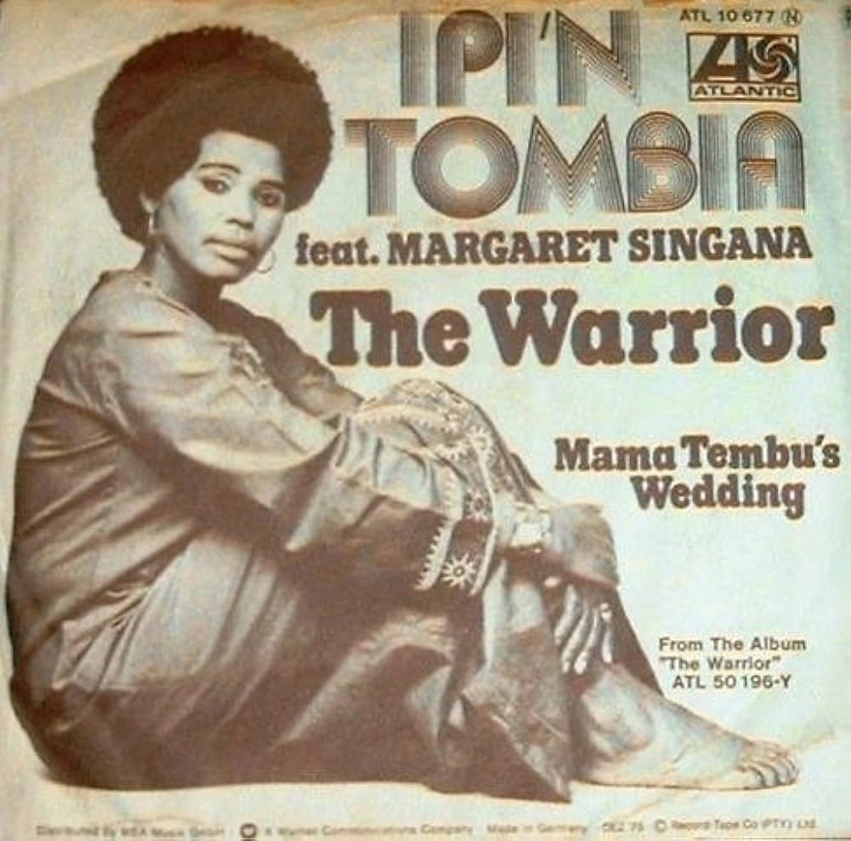

WEEK 7 PRACTICAL NO 4

Sound and music have the power to evoke pictures in our imagination which are personal and specific.
Take different songs, and let the learners listen to it.
Ask the following questions and discuss it as a class. You may use the links provided OR choose your own songs. ( At least 3 different songs with different moods)
Discuss each song after listening to it.

National Anthem of South Africa | The rivers of Babilon. Boney M | Ladismith Black Mambazo
https://youtu.be/W83_2Up--7U | https://youtu.be/l3QxT-w3WMo | https://youtu.be/GZgbyvV1hCE

    - What is the MOOD of each song?
    - How does the song make you feel? (Emotions)
    - What is the song about?
    - Can you identify any of the instruments used in the music?
    - Is the music fast or slow?
    - Is the music happy or sad?
    - Do you like the music? Give reasons.
(You can ask more questions – As long as the learners will be able to talk about the music)

N

WEEK 8 WORKSHEET NO 6
Complete the following sentences:
ceremony | actions | detailed | society | wedding

- A Ritual is a ………………………………….that has a series of ……………………… that are repeated on certain special occasions.
- The procedure of a ritual is specified and……………………………………..followed regularly by the people involved. Every culture and ………………………………… has rituals.
- A………………………………………… is an example of a ritual.
- Identify the following rituals. Make use of the words provided to help you.
wedding | baptism | birthday | coronation | funeral | graduation

  …………………………………………………. | 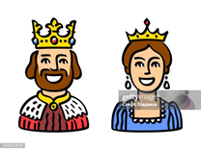  …………………………………………….
  …………………………………………………. | 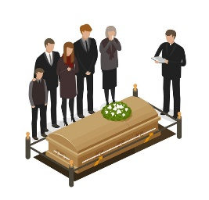  …………………………………………………

Getting up in the morning and preparing yourself for the day is also a ritual. Write down what your ritual is like in the morning before you go to school. Write 3 sentences. (For example: You get out of bed by six o clock. What happens next?
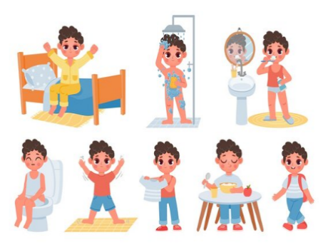 | ………………………………………………………………  ………………………………………………………………  ……………………………………………………………...  ………………………………………………………………  ………………………………………………………………..

WEEK 8 RITUALS: A WEDDING WORKSHEET NO 7
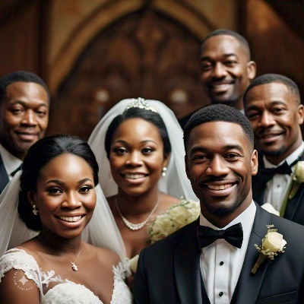
A Wedding is also a ritual. Let’s discuss what happens at a wedding.
- Who are the people who are involved at a wedding? Think of as many as you can. (For example: The bride. Look at the words provided and choose the correct ones. Write them down on the lines provided.
Father of bride | Mother of bride | Shop owner | Groom | Bride | Family | Pastor / reverend | painter | Photographer

1.1 | 1.4
1.2 | 1.5
1.3 | 1.6

- Where does this ritual take place?

- Is there music used during this ceremony? What type of music is used?

- What is the purpose of this ritual?

- Have you ever attended a wedding? What was it like? Write 2 – 3 sentences about the wedding.

WEEK 9 – 10 CREATE A DRAMA (INFORMAL – NO ASSESSMENT) PRACTICAL NO 5

- In Groups, create a Drama about ANY ritual.
- Remember the patterns. Repetition and sequence of the ritual.
- You may use music and movement.
- Rehearse and perform it to the class.


