CREATIVE ARTS
GRADE 5
TERM 4
TEACHER’S MANUAL
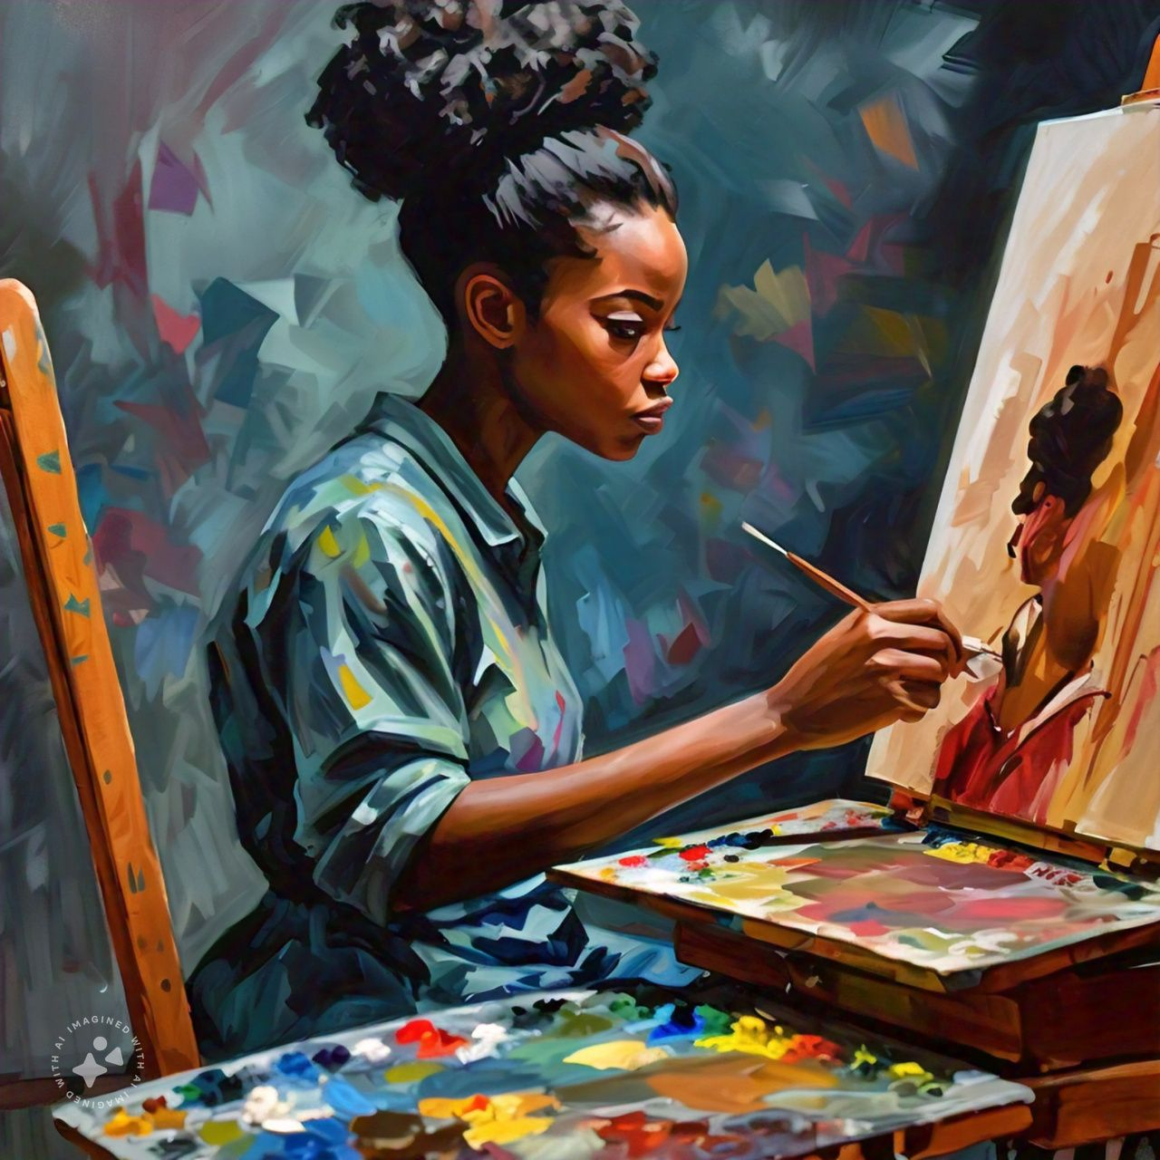

2025

week | topic | Caps (atp) | activity | Date completed | Dh monitoring
1 | Create in 2D things that fly (natural or mechanical)  Visual literacy | Visual literacy  Observe and discuss visual stimuli in photographs and real objects to identify and name art elements found in images of things that fly (natural or mechanical)  Observe and discuss visual stimuli in photographs and real objects to identify and name examples of contrast and proportion found in images of things that fly (natural or mechanical)  Create in 2D things that fly (natural or mechanical)  Art elements  Overview of use of appropriate art elements found in own images of things that fly (natural or mechanical)  Design principles  Reinforce emphasis in own images of things that fly (natural or mechanical)  Drawing and/or colour media  Exploring a variety of media and techniques.  This may include, but is not limited to, any of the following: blind/contour drawings, colour pencil, pastel, painting, wax resist, collage, pencils, ink and stick drawings, etc. | Worksheet 1
2 | Create in 2D things that fly (natural or mechanical)  Visual literacy | Visual literacy  Observe and discuss visual stimuli in photographs and real objects to identify and name art elements found in images of things that fly (natural or mechanical)  Observe and discuss visual stimuli in photographs and real objects to identify and name examples of contrast and proportion found in images of things that fly (natural or mechanical)  Create in 2D things that fly (natural or mechanical)  Art elements  Overview of use of appropriate art elements found in own images of things that fly (natural or mechanical)  Design principles  Reinforce emphasis in own images of things that fly (natural or mechanical)  Drawing and/or colour media  Exploring a variety of media and techniques | Practical no 1
3 | Create in 3D things that fly Visual literacy | Visual literacy  Observe and discuss visual stimuli in photographs, artworks and real objects to identify and name examples of contrast and proportion found in the natural world  Create in 3D things that fly  Art elements  Reinforce texture, shape/form and colour through own construction of things that fly (natural or mechanical)  Design principles  Reinforce contrast and proportion through use in own construction  Skills and techniques  Pasting, cutting, wrapping, tying and joining various recyclable materials  Spatial awareness  Reinforce conscious awareness of working in space, e.g. model to be viewed from front, back and sides, and parts of model can extend into space  Appropriate use of tools | Practical 2  Worksheet no 2
4-5 | Create in 3D things that fly Visual literacy  assessment | Visual literacy  Observe and discuss visual stimuli in photographs, artworks and real objects to identify and name examples of contrast and proportion found in the natural world  Create in 3D things that fly  Art elements  Reinforce texture, shape/form and colour through own construction of things that fly (natural or mechanical)  Design principles  Reinforce contrast and proportion through use in own construction  Skills and techniques  Pasting, cutting, wrapping, tying and joining various recyclable materials  Spatial awareness  Reinforce conscious awareness of working in space, e.g. model to be viewed from front, back and sides, parts of model can extend into space  Appropriate use of tools  Practical formal assessment: Visual Art  Create in 2D things that fly (natural or mechanical) OR  Create in 3D things that fly Assessment rubric: 40 marks | Practical assessment:  40 marks  The rubric is 20 marks – multiply by 2 to get a mark out of 40.
6 | Warm up and play Improvise and create Appreciate and reflect on | Warm up  Physical warmups for strength and flexibility  Vocal warmups  Improvise and create and read, interpret and perform  Short drama/dance improvisations reflecting a social, cultural or environmental issue relevant to the learners using selected tableaux, movement, poetry and speaking/singing in unison or individually  Short composition of poetry and song to draw attention to social, cultural and environmental issues to be used in above presentation  Appreciate and reflect on A live or recorded drama: Key moments in a drama Themes, ideas and moods  Why particular techniques were used  Sensitivity to the social and cultural contexts | Practical no 3
7 | Warm up and play Improvise and create  Read, interpret and perform  Appreciate and reflect on | Warm up  Singing warmups (including South African songs in unison and two-part harmony)  Call and response games  Improvise and create and read, interpret and perform  Short drama/dance improvisations reflecting a social, cultural or environmental issue relevant to the learners  Selected tableaux, movement, poetry and speaking/singing in unison or individually  Short composition of poetry and song to draw attention to social, cultural and environmental issues to be used in above presentation  Appreciate and reflect on A live or recorded drama: Key moments in a drama Themes, ideas and moods  Why particular techniques were used  Sensitivity to the social and cultural contexts | Practical no 4  Worksheet no 3  Worksheet no 4
8 | Warm up and play Improvise and create  Read, interpret and perform | Warm up  Singing warmups  Call and response games  Improvise and create and read, interpret and perform  Short drama/dance improvisations reflecting a social, cultural or environmental issue relevant to the learners (continue)  Short music piece combining a number of instruments (drums, marimba, etc.) reflecting a mood related to the social, cultural or environmental issue | Practical no 5
9-10 | Warm up and play Improvise and create  Read, interpret and perform | Warm up  Singing warmups  Group awareness games (such as creating a machine through complementary movements)  Improvise and create and read, interpret and perform  Short drama/dance improvisations reflecting a social, cultural or environmental issue relevant to the learners (continue)  Short music piece combining a number of instruments (drums, marimba, etc.) reflecting a mood related to the social, cultural or environmental issue | Practical no 5

Formal assessment: term 4 --------------- 3d art work, things that fly
Create in 2D things that fly (natural or mechanical) OR
Create in 3D things that fly Assessment rubric: 40 marks

Notes to the teacher:
- The theme for this term is images of things that fly. (Natural OR mechanical)
- Show learners the different images of things that fly (natural AND mechanical) and discuss the similarities and differences between them.
- Discuss with learners how it must feel to fly?

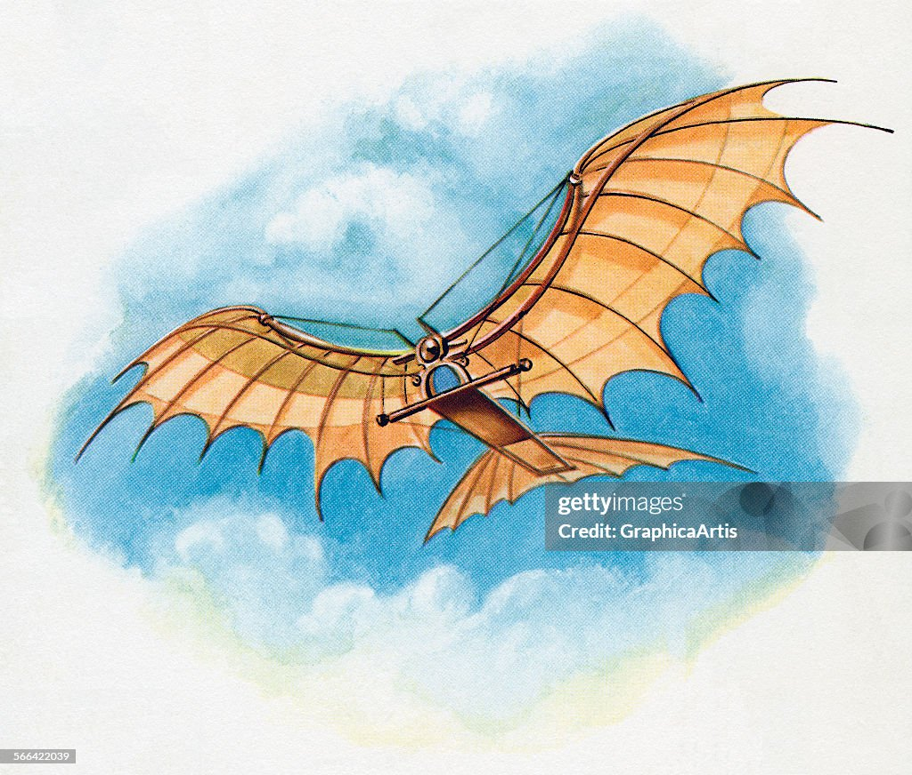
Things that fly : Birds, insects, and flying machines.
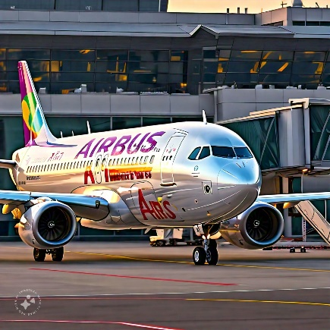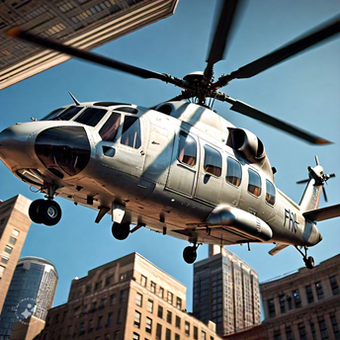
A big aeroplane: An Airbus A helicopter
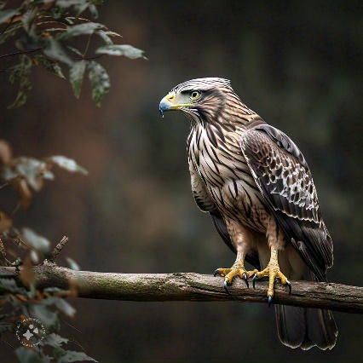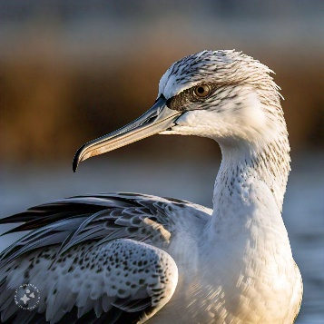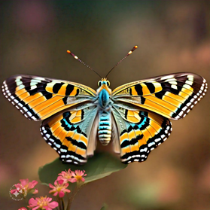
A hawk A waterbird A butterfly

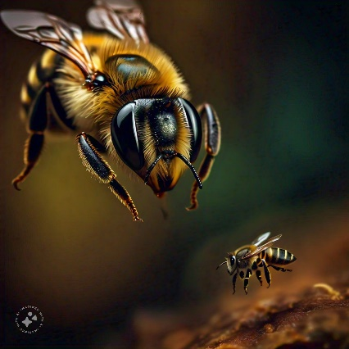
A bee

WEEK 1 Things that fly WORKSHEET NO 1
- Identify what you see in the pictures. Use the words provided to help you.
helicopter | aeroplane | bee | butterfly

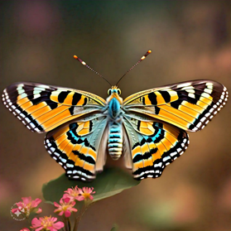 | 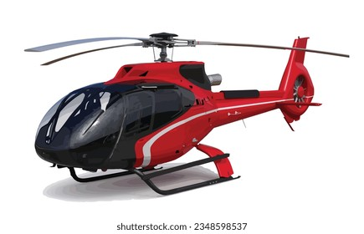 |  | 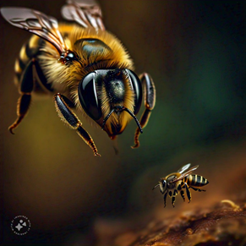
butterfly | helicopter | aeroplane | bee

- Look at this drawing of a bird and answer the questions. (Elements of art/Principles of design)
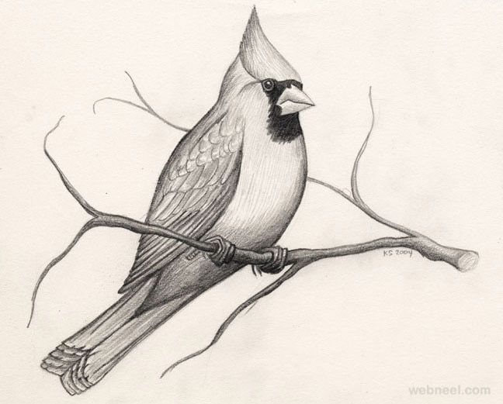
  - Line : What types of line can you identify? Circle the correct answers.

Dotted lines | Straight lines | Curved lines | Zig-zag lines

  - Shapes: Can you identify any shapes in the drawing? Circle the correct answer.
square | oval | triangle | rectangle

  - Contrast: Did the artist use contrast in the drawing?
Yes. Darker part at the chest.

WEEK 2 (Use 2 periods for this activity) PRACTICAL NO 1
Make a drawing of a bird using shapes.
Look at this drawing of a bird. The artist made use of shapes to do the drawing. In the space provided, make your own drawing by doing exactly what was done in this picture.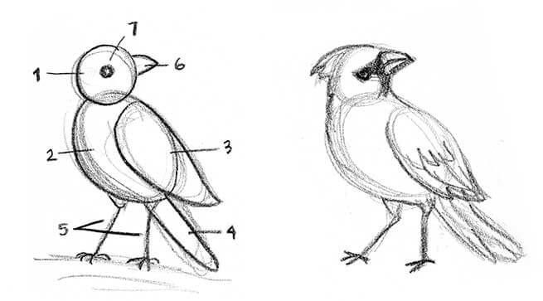

WEEK 3 PRINCIPLES OF DESIGN: PATTERN PRACTICAL NO 2
Pattern is a repeated design or motif. Look at the beautiful patterns on these butterflies, then make your own patterns on the butterfly below. Be creative!
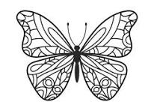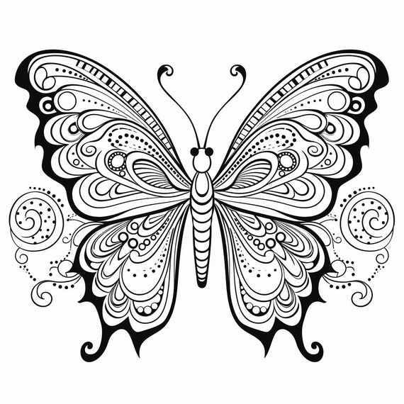

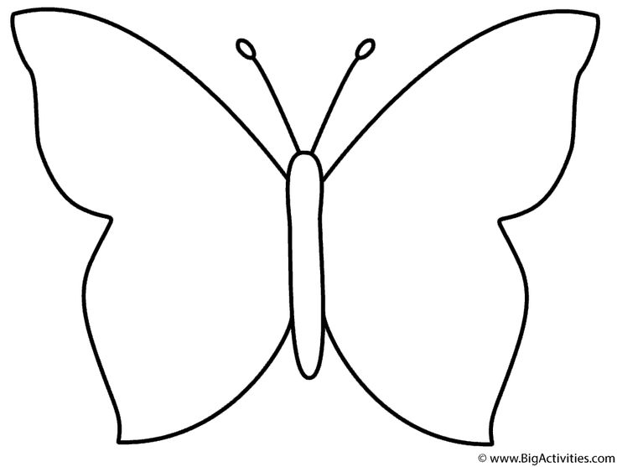
WEEK 3 WORKSHEET NO 2
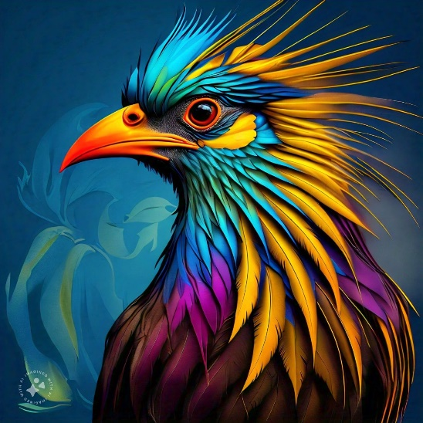

Look at the painting of a bird and answer the questions:
- Can you identify any shapes in this painting?
Circle / Triangle
- Can you identify any lines in this painting?
Straight lines / Curved lines / Thin lines / Thick lines
- Did the artist make use of contrast?
Light versus darker colours
- What will you name this painting? Be creative!
………………………………………………………..
- In the space provided, write your own name in a very creative way! Just your name. Look at the example given.
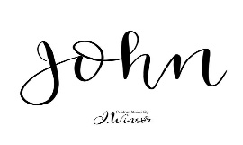

WEEK 4-5 Create in 3D things that fly Visual literacy FORMAL ASSESSMENT
INSTRUCTIONS
Materials Needed: ( You may use any other materials)
- Cardboard or plastic bottle (for the body)
- Plastic or paper straws (for wings)
- Tape or glue
- Scissors
- Markers /paint/pencils (for decoration)
- Old newspapers or magazines (for lightweight parts)
- Rubber bands (optional, for propulsion)
- Lightweight plastic or foam (like from food packaging) (for additional wing support)

Step 1: Create the Body
- Choose a Base: Use a piece of cardboard or an empty plastic bottle as the main body of your artwork. Shape it until you are satisfied.

Step 2: Make the Wings
- Cut the Wings: Use the cardboard or old magazines to cut out two wing shapes.
- Attach the Wings: Use tape or glue to attach the wings to the body. Place them about a third of the way from the front. Make sure they’re level!

Step 3: Add detail and decorate your art work.
- Get Creative: Use markers, paint, or stickers to decorate your art work. Make it colourful and unique!

EXAMPLES

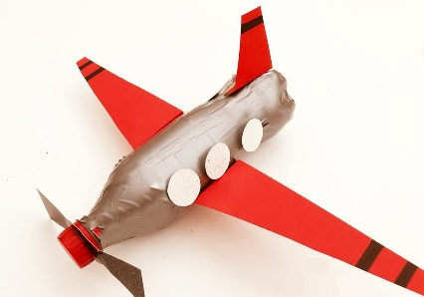

*

RUBRIC: FLYING THING

CRITERIA | 4-5 | 2-3 | 1
Theme Visibility | The theme is very clear and creatively represented; the flying object is immediately recognizable. | The theme is clear and well-represented; the flying object is recognizable. | The theme is vague; the flying object is hard to recognize.
Craftsman ship | Good attention to detail; most parts are securely attached and finished. | Some attention to detail; some parts may not be securely attached | Limited attention to detail; many parts are poorly finished or attached.
Decoration | Good decoration that adds to the artwork. | Basic decoration | Minimal decoration
Final product | The final product is appealing and shows good effort and creativity | The final product is acceptable but lacks strong visual appeal. | The final product is somewhat lacking in presentation and creativity

MARKS : 20 ( 20 X 2 = 40)

WEEK 6 PRACTICAL NO 3
ACTIVITY 1: MUSIC
In today’s lesson we will be singing Three Blind Mice. Canon: Three Blind Mice in a canon
https://youtu.be/YgoCf8k9GAE
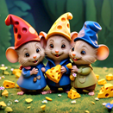

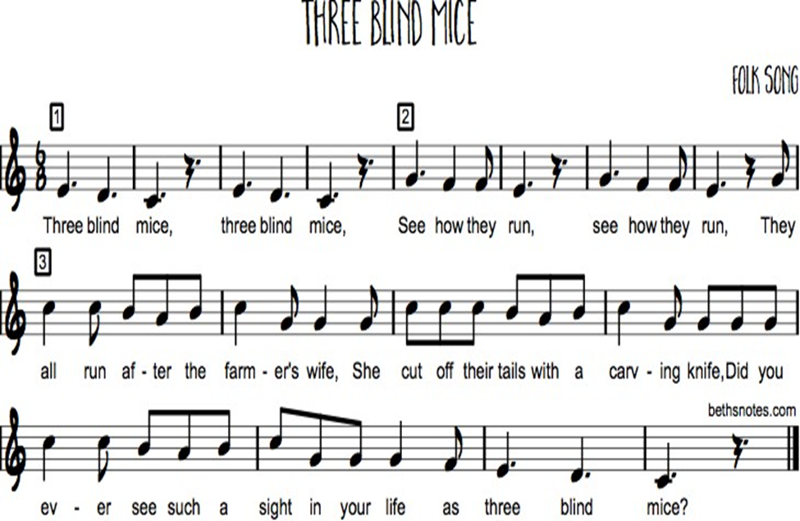
- Step 1 Listen to the song and follow the lyrics (words) on your music score.
- Step 2 Your teacher will play the song again, but this time you will be humming the melody with the song.
- Step 3 Now sing the lyrics and learn the words and music until you can sing it fluently and spontaneously.
- Step 4 Your teacher will now divide the class into three groups (A, B, C) and let each group sing the song on their own while the others listen.
- Step 5 Have a look at the sheet music. Group A will start at the beginning 1 and when they reach 2, Group B will start at 1. When Group B is at 2 , Group C starts at 1. Group A will then be at 3.
- Step 6 When Group A finishes the song, they all start from 1 again until your teacher indicates when to stop singing the song.

WEEK 7 PRACTICAL N0 4
IMPROVISATION TECHNIQUES: MOVEMENT WITH PROPS
(Properties/props are the movable articles or objects used onstage. They may be merely decorative or have a functional use within the drama.)

Let’s improvise:
→ Your group of five members will be allocated a whole bunch of interesting and differently sized objects (e.g. a hat, a broom, a bucket, a suitcase, a ball, a pen, etc.)
→ Each group forms a circle. There are three props in the middle of the circle. Any one group member must walk into the circle and use the prop in the way it was meant to be used.
→ Someone would wear the hat, sweep with the broom etc.
→ Once each item has been used in the way it was meant to be used, the next time it is picked up, it must be transformed by the person using it, into something else. The hat can become a fan, or a flag, or a baby.
→ The broom can become a motorbike, a microphone, a golf club.
→ No one is allowed to use the prop in the same way twice.
→ It should always be possible for the group watching to answer the question “what is this object” clearly.

MIME
Mime is nonverbal, physical communication to tell a story or explore an idea.

WEEK 7 WORKSHEET NO 3

  - What is mime? Underline the correct answer:
1.1 Mime is where an artist uses gestures, facial expressions and body movements to tell a story.
1.2 Mime is where artists speak a lot to tell a story.

  - State whether the following statements are true of false.
Statement | True / False
2.1 It is important to warm up the voice before a performance. | T
2.2 Mime and regular acting is the same thing. | F
2.3 The people watching a show is called the audience. | T
2.4 It is important to speak with clarity when doing a performance. | T

  - Facial expressions in mime is very important. Can you identify the emotions of the following facial expressions? Write the answers in the space provided.
angry | happy | sad | excited | confused

 | 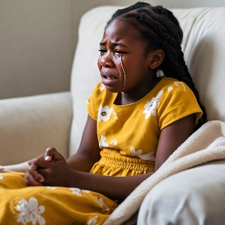 | 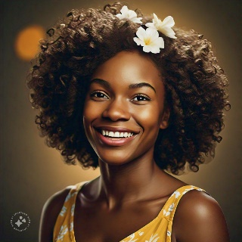 | 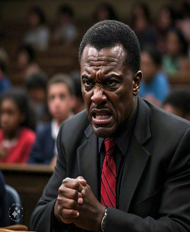
excited | sad | Happy | angry

  - An (actor / teacher) is a person who performs in plays, movies, television shows, or other forms of entertainment, portraying characters to tell stories.

WEEK 7: CONTENT TO BE TAUGHT

Environmental, Cultural and Social issues.

Make sure learners understand what these issues are. They will have to create a Drama on ONE of the issues.

Environmental Issues
These involve the impact of human activity on the natural world. Examples include:
- Climate Change: Global warming and its effects on weather patterns, ecosystems, and sea levels.
- Pollution: Contamination of air, water, and soil, affecting health and wildlife.

Cultural Issues
These pertain to the beliefs, practices, and social norms of different groups. Examples include:
- Cultural Heritage Preservation: Protecting traditions and practices in the face of globalization.
- Cultural Identity: Struggles related to maintaining cultural identity in diverse societies.
- Discrimination: Issues of racism, sexism, and other forms of prejudice that affect marginalized groups.
Social issues are problems that affect individuals and communities within a society, often rooted in social structures and norms. They can impact the quality of life, well-being, and opportunities for individuals and groups. Here are some common social issues:
1. Poverty
Lack of access to basic needs like food, shelter, and healthcare.
2. Inequality
Disparities in wealth, education, and opportunities based on race, gender, or socioeconomic status.
3. Discrimination
Unjust treatment of individuals based on characteristics such as race, gender, sexual orientation, or disability.
4. Education Access
Barriers to quality education for certain populations, leading to a cycle of disadvantage.
5. Health Care Access
Inequalities in access to health services, resulting in poorer health outcomes for marginalized groups.
6. Unemployment
Lack of job opportunities leading to economic instability for individuals and families.
WEEK 7 WORKSHEET NO 4
- Which of the following are environmental issues? Choose the correct answers and write them down in the space provided:
Discrimination  Climate change | ………………………………………………..
- Which of the following are examples of cultural issues?
Racism  Sexism  Pollution | ……………………………  ……………………………
- Social issues are problems that affect individuals and communities within a society. Which of the following are examples of social issues?
Climate change  Poverty  Education access  Health care access | ………………………………………  ………………………………………  ………………………………………  ………………………………………
- Which 3 things are important to take in consideration when performing I a drama? Underline the correct answers.
Sitting | Facial expressions | Body language | Tone of voice | Smiling
- Name any two social issues that you can think of in your environment.

Poverty / Education access / Health care etc
WEEK 8- 10 PRACTICAL NO 5
CREATE A SHORT DRAMA ( INFORMAL – NO ASSESSMENT)

1. Choose a Topic

Brainstorm Issues: Discuss relevant social, cultural, or environmental issues. Examples might include: Climate change, Racial equality, Mental health awareness, Cultural identity and Poverty and homelessness.
Select One: Choose an issue that resonates with the group.

Research the Issue : Gather Information: Look into the chosen topic. What are its causes, effects, and possible solutions?

Create the Narrative
Outline the Story: Decide on the main message or theme. Create a simple narrative structure:
  - Beginning: Introduce the issue and characters.
  - Middle: Show the conflict or challenge related to the issue.
  - End: Present a resolution or a call to action.

4. Add a Song and Movement
- performance.

6. Rehearse the Performance
- Practice Together: Go through the entire piece multiple times. Focus on:
Facial expressions / Tone of Voice / Body language

7. Prepare for Performance
- Set the Stage: Choose a performance space. Consider simple props or costumes that enhance the story.

.

