Creative Arts
Teacher’s Manual
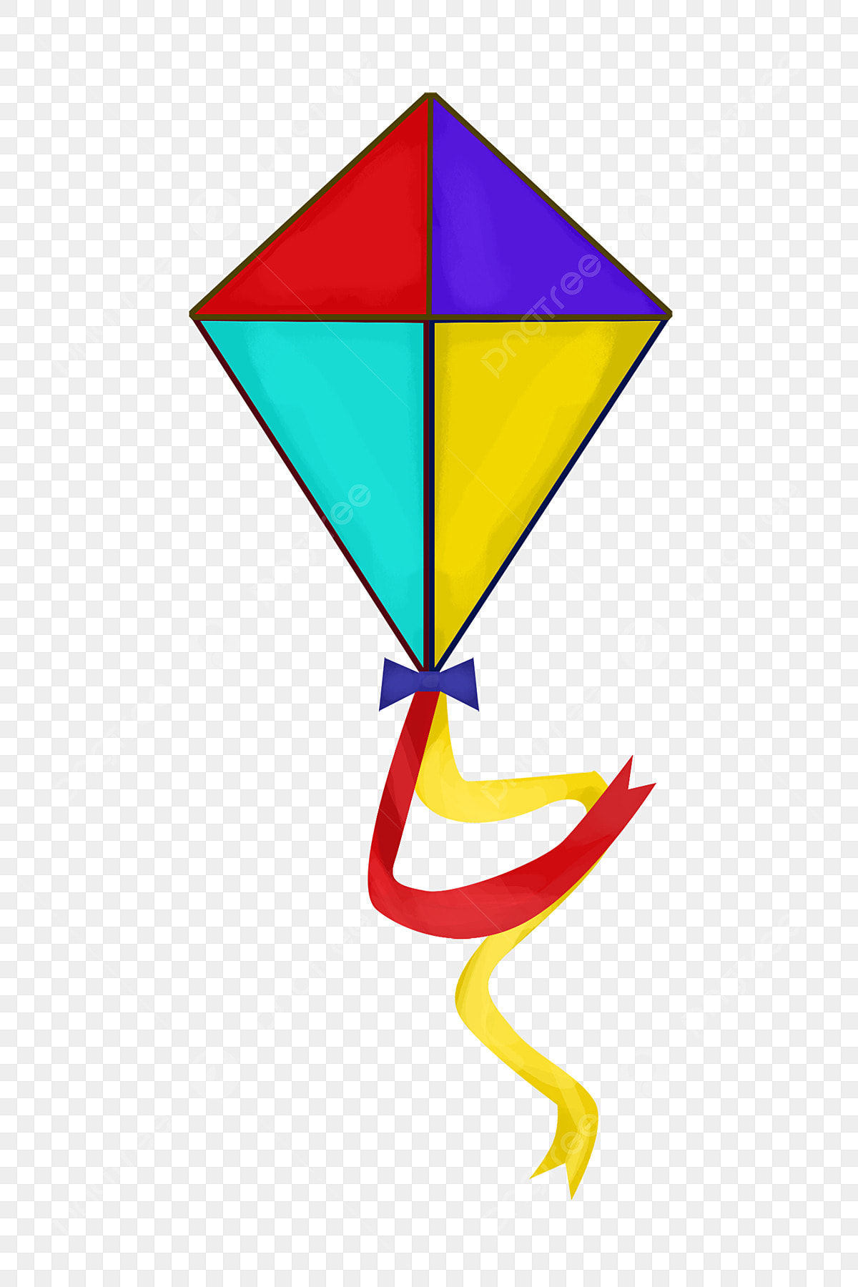
GRADE 4
TERM 4
2025
WEEK | TOPIC | ATP/CAPS CONTENT | ACTIVITY | DATE COMPLETED | DH
1 | Create in 2D  Visual Lit | Visual Literacy Observe and discuss visual stimuli in photographs, artworks and real objects to identify and name art elements found in the natural world Create in 2D: The natural world Art elements Reinforce secondary and related colours, including tints and shades Design principles Reinforce use of contrast and proportion in own images of the natural world Drawing and/or colour media | WORKSHEET 1
2 | Create in 2D. The natural world | Visual literacy • Observe and discuss visual stimuli in photographs, artworks and real objects to identify and name examples of contrast and proportion found in the natural world • Questions to deepen and extend observation of elements and design principle • Apply learning to own work Create in 2D: The natural world Art elements Reinforce secondary and related colours in own images of the natural world, including tints and shades Design principles Reinforce use of contrast and proportion in own images of the natural world Drawing and/or colour media Exploring a variety of media and techniques | WORKSHEET 2  PRACTICAL NO 1
3 | Create in 3D: A Kite / Dream catcher / Bird feeder | Visual literacy Observe and discuss visual stimuli in photographs, artworks and real objects to identify and name examples of contrast and proportion found in the natural world Create in 3D: A kite/dream catcher/bird feeder Art elements Texture, shape/form and colour reinforced through use in own construction Design principles Reinforce conscious use and naming of contrast and proportion in construction Skills and techniques Pasting, cutting, wrapping, tying, and joining various recyclable materials. Spatial awareness • Reinforce conscious awareness of extending parts of models into space • Appropriate use of tools | WORKSHEET 3
4 | Create in 3D: A kite / dream catcher / bird feeder | Create in 3D: A kite/dream catcher/bird feeder Art elements Texture, shape/form and colour Design principles Reinforce conscious use and naming of contrast and proportion in construction Spatial awareness • Extending parts of models into space • Appropriate use of tools | PRACTICAL NO 2  Start with PAT
5 | PRACTICAL FORMAL ASSESSMENT | Create in 2D: The natural world OR Create in 3D: A kite/dream catcher/bird feeder Assessment rubric: 40 marks | PAT  40 Marks
6 | Warm up and play. Improvise and create | Warm up Posture games, exploring neutral posture and character's postures Improvise and create Mime using imaginary objects, expressing feelings and ideas through movement, gesture and facial expression Physical shapes using gesture, posture and balance (balancing on different body parts) | WORKSHEET 4  PRACTICAL 3
7 | Warm up and play  Read, interpret and perform.  Appreciate and reflect on | Warm up . Posture games, exploring neutral posture and character's postures • Body part isolations and stretching Improvise and create Mime using imaginary objects, expressing feelings and ideas through movement, gesture and facial expression Read, interpret and perform Building a drama from a stimulus: Tableaux in response to location or theme: Storyline Character Space Time | WORKSHEET 5  PRACTICAL NO 4
8 | Warm up and play  Read, interpret and perform  Appreciate and reflect on | Warm up • Different kinds of jumps (with soft landings) and other travelling movements • Trust and listening games Building a drama from a stimulus • Tableaux in response to location or theme, add start and end the drama, limited dialogue appropriate to the drama • Sound pictures using instruments (body percussion, self-made, found and traditional) to create an appropriate soundtrack for the drama, including interludes (between actions) and underscoring (during action) • Musical symbols of stave, minims, crotchets, quavers and respective rests in short musical phrases | PRACTICAL NO 5
9 – 10 | Warm up and play  Read, interpret and perform  Appreciate and reflect on | Warm up • Body percussion “songs” in unison and in canon • Musical games focusing on numeracy and literacy Read, interpret and perform • Building a drama from a stimulus: Tableaux in response to location or theme (consolidate previous weeks) • Songs to improve intune singing related to the themes of the drama • Recognising melodies in range of 5th (doh to soh) Appreciate and reflect on Own and other’s performances and processes using simple Creative Arts terminology | PRACTICAL NO 5

The Natural World
Notes to the teacher:
- Explain to learners what the Natural world is and what we will find in it.
The natural worked is filled with:
- Landscapes, mountains, oceans, deserts and more.
- Varied wildlife, animals, insects, birds and fish.
- Plant life : Trees, flowers, crops and vegetables.
- Water sources: rivers, lakes, wetlands and groundwater
- Weather patterns: Rain , sunshine, clouds and wind.
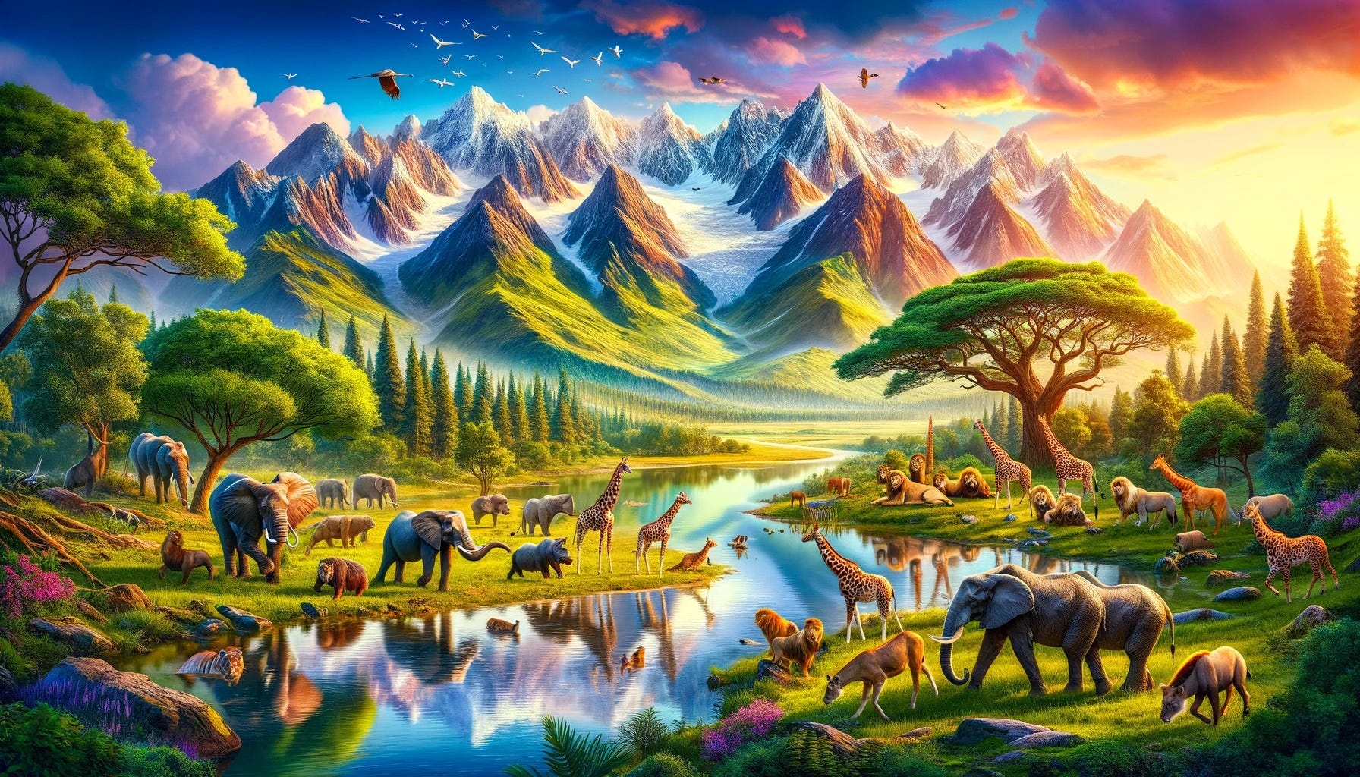

- ELEMENTS OF ART.
Remind the learners about:
Shape
Line
Colour.

WEEK 1 The natural world. WORKSHEET NO 1
Look at the picture of the natural world and answer the questions:
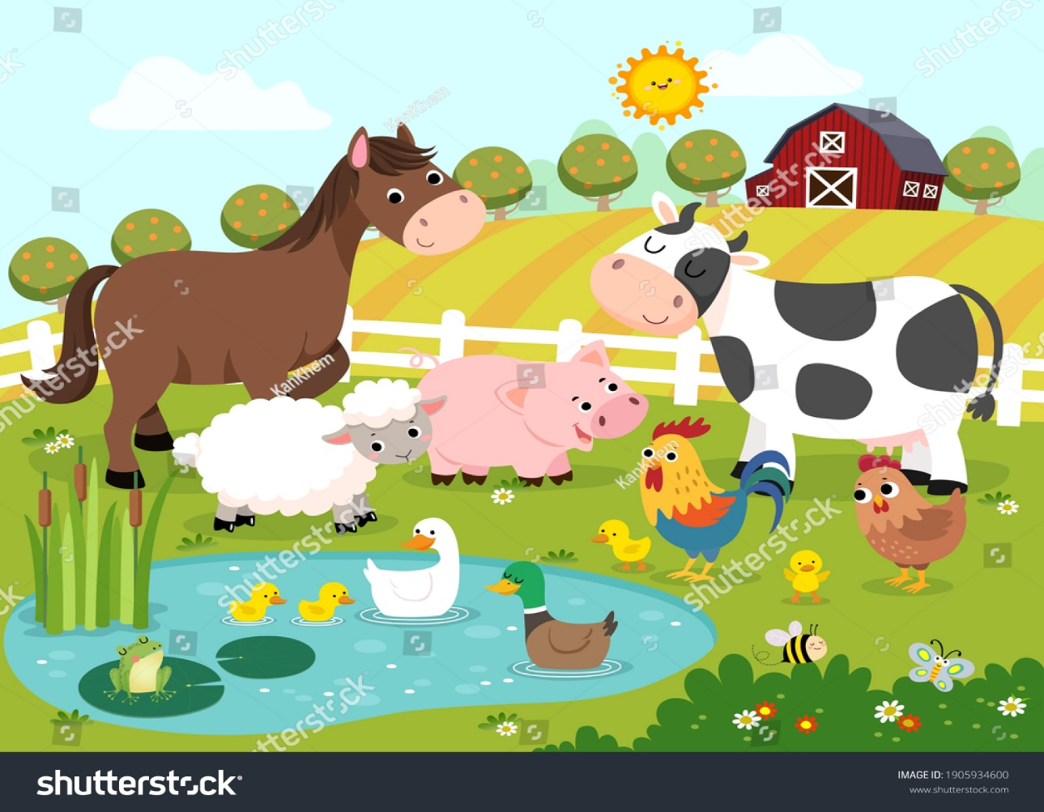

- How many animals can you identify? Circle the correct answers.
A cow | A horse | An elephant | A chicken | A Sheep | A Snake
Can you see any plants in this picture? Circle the correct answers.
Trees | flowers | a snake | A house | A bee

- Can you identify any shapes in this picture? Circle the correct answers.
circles | rectangle | oval | star

WEEK 2 PRACTICAL NO 1
Draw your own natural world in the space provided. Make sure you include the following:
A mountain
Trees
Plants / Flowers
Animals
WEEK 2 WORKSHEET NO 2
Look at the following shapes and identify them:
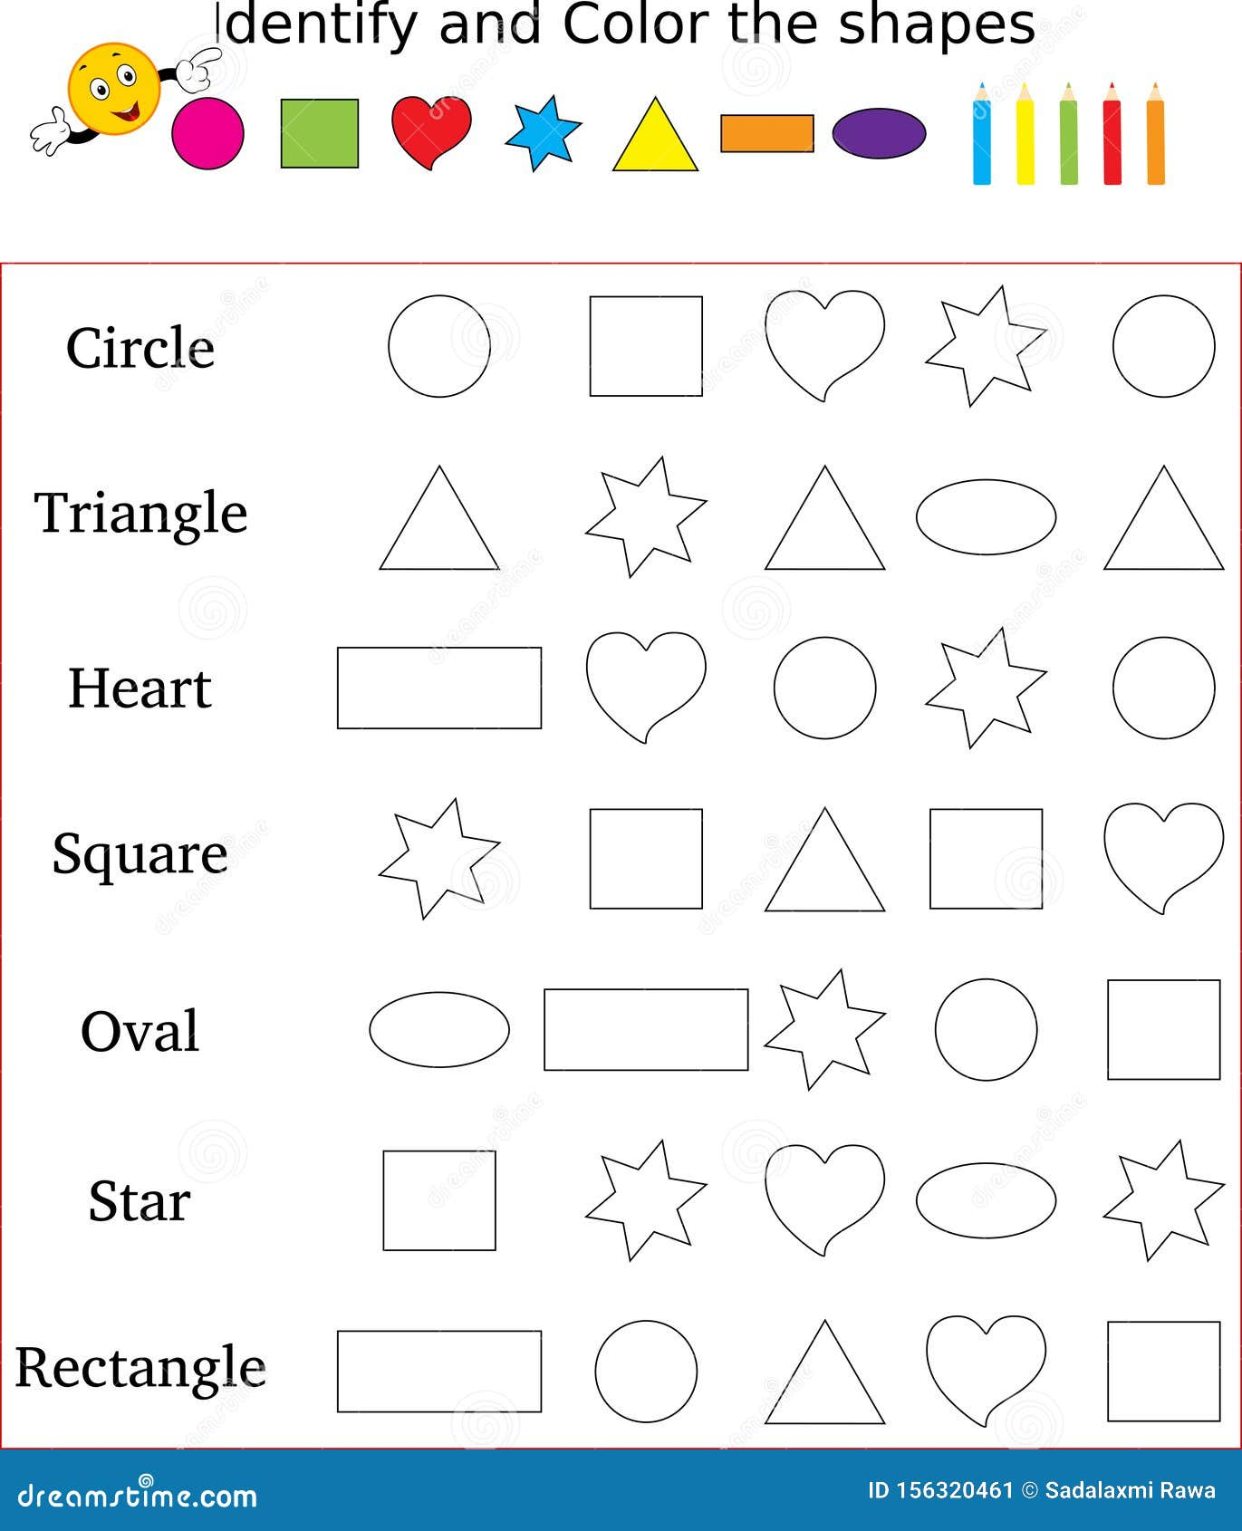

WEEK 3 Elements of Art: Line WORKSHEET NO 3
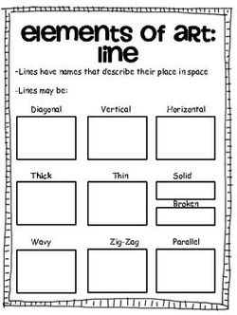
WEEK 4
In this lesson the learners will be creating a 2D repeat/ radiating pattern.
Explain that pattern is when you repeat a line, shape or colour. Explore the different types of patterns such as linear, radial and patterns that occur naturally in nature.
Giving learners A4 card, ask them to create about 4 to 5 different shapes. This could be Geometric shapes (man-made) or Organic shapes (shapes found in nature).
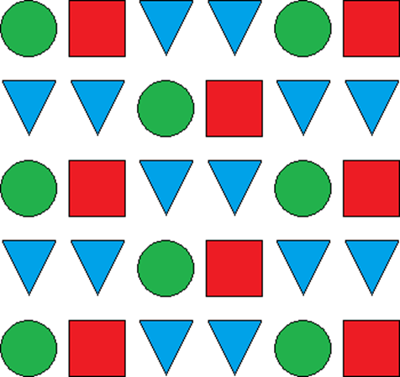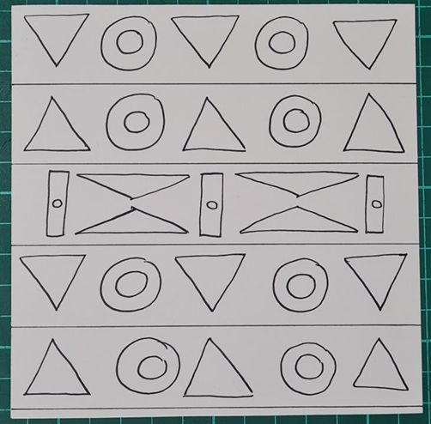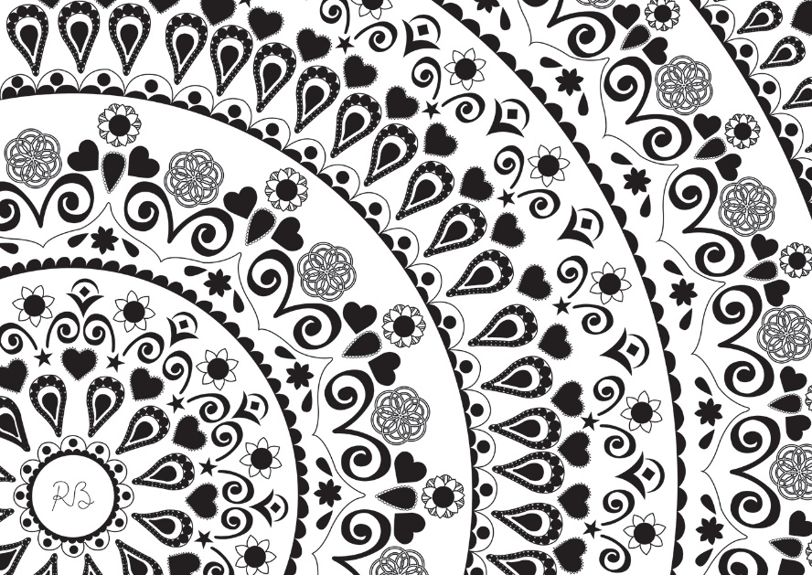

WEEK 4 PRACTICAL NO 2
Create your own pattern by using geometric OR organic shapes. Use the whole page.

WEEK 5 FORMAL PRACTICAL ASSESSMENT
NOTES TO THE TEACHER:
- Learners can make a kite, a bird feeder OR a dream catcher.
- If you do not have materials for a 3D product, then learners van make a drawing of one of the three. (2d)
- PLEASE CHOOSE BETWEEN 2D OR 3D
3D : Simple Instructions for Making a Kite, Bird Feeder, and Dream Catcher

1. How to Make a Kite
Materials Needed:
- 1 large sheet of paper or plastic
- 2 wooden dowels or sturdy sticks
- String
- Tape or glue
- Scissors
Instructions:
- Shape the Kite: Cut the paper into a diamond shape.
- Create the Frame: Use the dowels to make a cross. Tape them together in the centre.
- Attach the Paper: Lay the diamond shape over the frame and tape the edges down.
- Add String: Tie a long piece of string to the bottom of the kite.
- Decorate: Use markers or stickers to decorate your kite.
- Fly Your Kite: Find an open space, hold the string tight, and let it fly!

2. How to Make a Bird Feeder
Materials Needed:
- 1 empty plastic bottle or milk carton
- String or yarn
- Birdseed
- Scissors
Instructions:
- Prepare the Bottle: Cut holes on opposite sides of the bottle, about 1/3 of the way up.
- Fill with Birdseed: Pour birdseed into the bottle.
- Add Perches: If using a carton, you can insert small sticks through the holes for birds to land on.
- Hang It Up: Tie string around the bottle or carton and hang it from a tree branch.
- Watch the Birds: Enjoy watching birds come to eat!

3. How to Make a Dream Catcher
Materials Needed:
- A hoop (can be made from a wire or a sturdy twig)
- Yarn or string
- Beads (optional)
- Feathers (optional)
- Scissors
Instructions:
- Wrap the Hoop: Take yarn and wrap it around the hoop until it’s covered.
- Create the Web: Tie a piece of string across the hoop, making a web pattern. Start from the top and go down to the sides.
- Add Beads: Thread beads onto the string if you like, and tie them into the web.
- Decorate with Feathers: Attach feathers to the bottom by tying them to the hoop.
- Hang It Up: Find a special place to hang your dream catcher!

RUBRIC FOR ASSESSMENT (3D) 20 MARKS. (20 X 2 = 40)
CRITERIA | 4-5 | 2-3 | 1
PLANNING | Detailed plan with sketches and materials listed; clear understanding of project goals. | Basic plan, some materials listed; minimal understanding of project goals. | Incomplete plan; few materials listed; unclear project goals.
PROCESS | Followed most steps; organized; adapted to some challenges | Followed some steps; minimal organization; struggled with challenges | Inconsistently followed steps; disorganized; did not adapt.
CRAFTMAN SHIP | Good attention to detail; mostly clean edges and connections; good finish. | Some attention to detail; uneven edges or connections; acceptable finish. | Minimal attention to detail; rough edges or weak connections; poor finish.
END PRODUCT | Creative and original. | Some creativity; basic understanding; functions but has flaws. | Limited creativity; lacks understanding; does not function as intended.

INSTRUCTIONS FOR A DRAWING OF A KITE. (2D)

Instructions to Draw a Kite on A4 Paper
Materials Needed:
- A4 paper
- Pencil
- Eraser (optional)
- Colored pencils or markers (for decorating)

Step-by-Step Guide:
- Draw the Kite Shape:
  - Start by drawing a large diamond shape in the center of the paper. The top point should be near the top edge of the paper, and the bottom point should be a little above the bottom edge.
- Add the Tail:
  - Draw a wavy line starting from the bottom point of the diamond to create the kite's tail. You can make the tail long and add small bows or loops along the way.
- Divide the Kite:
  - Lightly draw two diagonal lines from the top point to the bottom corners of the diamond to divide the kite into four sections.
- Create Patterns:
  - In each section, draw different patterns. Here are some ideas:
    - Stripes (zigzag or straight)
    - Dots or circles
    - Stars or flowers
    - Waves or spirals
  - Fill the sections with a mix of these patterns.
- Decorate the Tail:
  - Add patterns to the tail as well. You can use triangles, diamonds, or any other shapes.
- Final Touches:
  - Erase any unnecessary pencil lines that are still visible

RUBRIC FOR 2D DRAWING 20 Marks (20 x 2 = 40)
CRITERIA | 4-5 | 2-3 | 1
PLANNING | Well-planned with most aspects outlined | Some planning evident but lacks clarity in execution | Almost no planning done
USE OF SPACE | Good use of space; mostly balanced | Average use of space | Poor use of space
PATTERNS | Interesting patterns that add to the design; some originality. | Basic patterns used | Limited patterns that do not contribute significantly to design
END PRODUCT | Final drawing is neat with minor flaws; shows good skill. | Final drawing is adequate but lacks refinement; some noticeable flaws. | Final drawing is messy or poorly executed; lacks effort.

WEEK 6 MIME PRACTICAL NO 3
Notes to the teacher: Explain the following to the learners:
In drama, MIME refers to a form of performance that uses physical gestures, movements, and facial expressions to convey a story or emotion without spoken words. It relies on non-verbal communication to express ideas and feelings, allowing the audience to interpret the performance through visual cues.
ACTIVITY
Improvise and create Mime using imaginary objects, expressing feelings and ideas through movement, gesture and facial expression.
Learners van act out any of the following situations/routines. They have time to rehearse and the do it for the class. They are only allowed to use :
- Movement
- Body language
- Facial expressions
- Gestures

- Demonstrate your morning routine. (Waking up – washing your face etc)
- Your cell phone is missing. You are searching for it.
- Baking a cake.
- Putting on make-up.
- Cleaning the house
(You may give other ideas to the learners)
WEEK 6 MIME WORKSHEET NO 4
- Facial Expressions
sad | happy | confused | angry | excited

 |  | 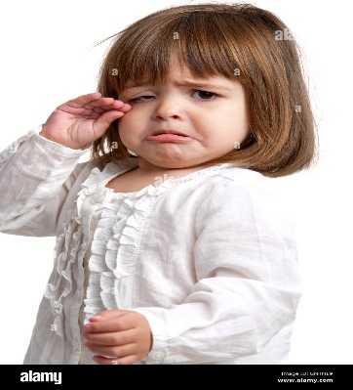
happy | angry | sad

- Underline the correct answers:
  - Mime refers to (dancing / acting without speaking)
  - In mime, (you are allowed to speak / you are not allowed to speak)
- Look at the following pictures, and figure out what is happening in the picture. Choose the correct answer.
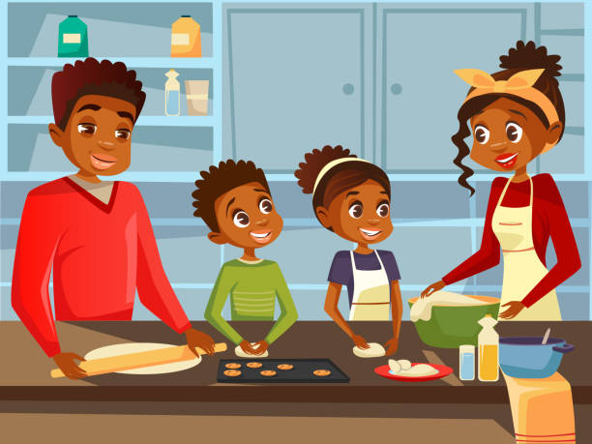 | 
- This family is (walking / cooking)  - The family seems ( happy / sad) | - This is a (nurse / policeman)  - The man seems (happy / angry)
WEEK 7 Mime using objects PRACTICAL NO 4
Examples of objects that can be used to do mime. There are many other objects that can be used – umbrellas, scarves, books, boxes, glasses, a toothbrush, a hairbrush, etc.
ACTIVITY
Learners use an object and improvise a mime. They can use the object, facial expressions and movement. Encourage them to be creative!
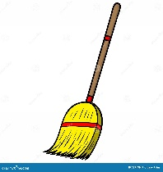  A Broom  Examples :  - Use the broom as a dancing partner  - Use the broom as a microphone when you sing.  - Use it for it’s original purpose | 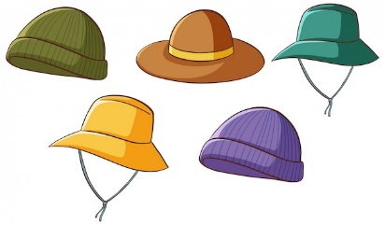  Hats  Use different hats to play different characters.

WEEK 7 Body part isolation WORKSHEET NO 5

WEEK 8 - 9 PRACTICAL NO 5
DRAMA & MUSIC
Elephant | “All animals in my valley. Listen carefully. We have a problem here.”
Fox | “What is the problem, mr. Elephant? How can we help?”
Lion | “Yes. Please tell us. What is the matter?”
Elephant | “We did not get rain. We are almost out of water.”
Rabbit | “I saw the water level in the dam was very low”
Lion | “I think we must search for another water whole.”
Fox | “That seems like a very good plan mr. Lion.”
Elephant | “Thank you my dear friends. Now we must find someone who will go and look for water.”
Rabbit | “I will go my dear friends. I can run very fast.
Fox | “Thank you mr. Rabbit. Then off you go. Come back soon!”

The whole class will sing this song after their performances. The learners can use body percussion. (Clapping hands / clicking fingers etc.)
Melody : The wheels of the bus go round and round.
The animals walk to the waterhole,
Splash, splash, splash, splash, splash splash
With their noses high, searching for a flow,
Splash, splash, splash, splash splash!
(Chorus)
The water’s low, the sun beats down,
Oh, where can we find water now?
The animals roam, looking all around,
Hoping for the rain to please come down!

