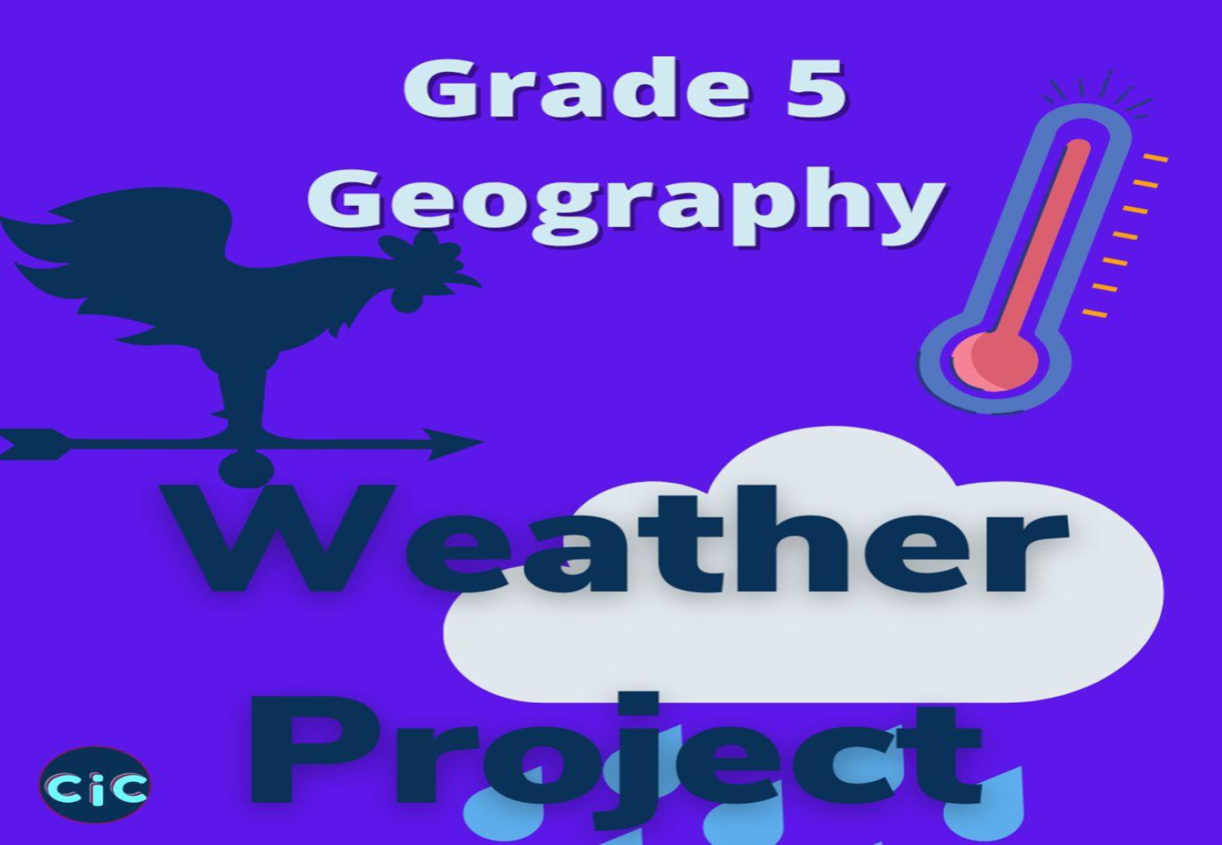
SOCIAL SCIENCES
GEOGRAPHY PROJECT: GRADE 5
OBSERVING AND RECORDING WEATHER – 30 MARKS
STEP 1:
- Use the table provided to observe and record the weather conditions of your area for TWO weeks.
STEP 2:
- Study your table carefully
- Write three sentences that describe the weather patterns for two weeks
- Describe how weather conditions affect the lives of people (two sentences).

STEP 3:
- Hand in your project two days after you have completed it
- Marks will be deducted for projects submitted after the due date.
GEOGRAPHY PROJECT: GRADE 5
OBSERVING AND RECORDING THE WEATHER
NAME_______________________ TOWN: ________________
DATE | TEMPERATURE  Min and Max | CLOUD COVER  Draw | PRECIPITATION | WIND DIRECTION

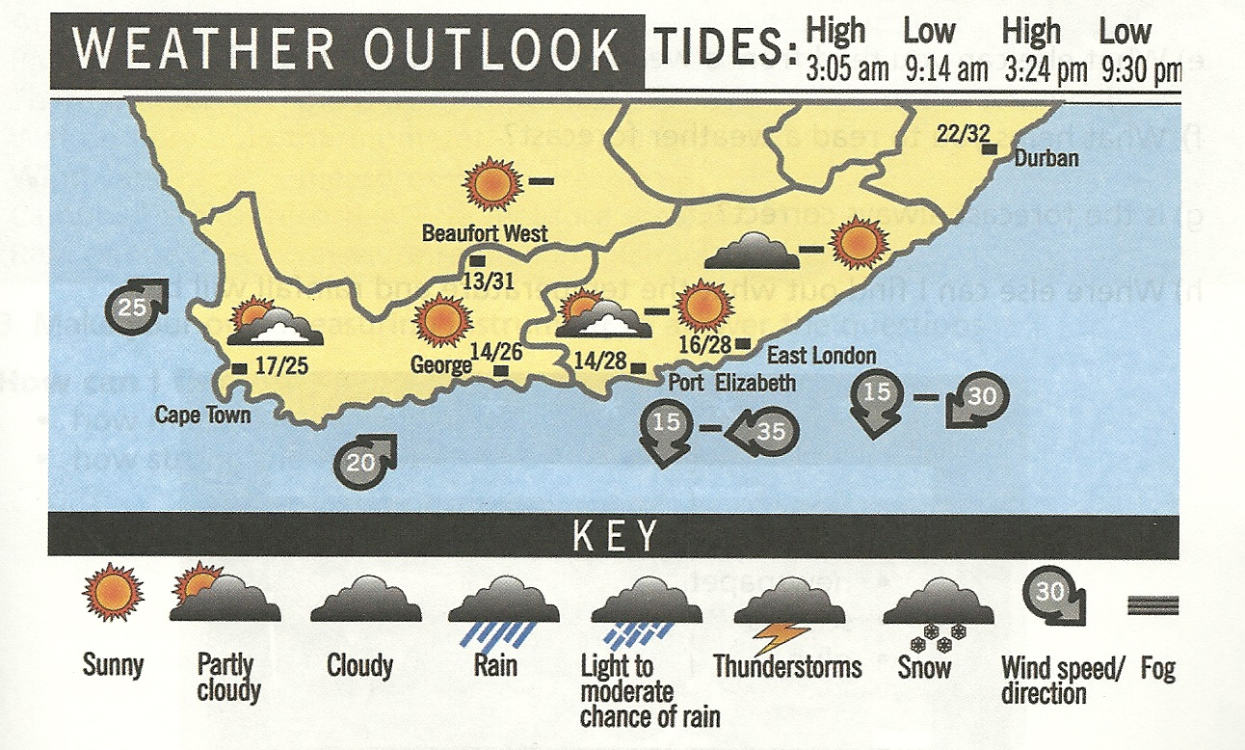

2. Write THREE (3) sentences that describe the weather patterns for two weeks observed. (3)
____________________________________________________________________________________________________________________________________________________________________________________________________________________________________________________________________________________________________________________________________________________________________________________________________________________________________________________________________________________________________________
3. In TWO (2) sentences describe how weather conditions affect the lives of people. (4)
______________________________________________________________________________________________________________________________________________________________________________________________________________________________________________________________________________________________________________________________________________________________________________________________________________________________________________________________________________________________________________________________________________________________________________________________

ASSESSMENT TOOL (RUBRIC) FOR MARKING GEOGRAPHY PROJECT
Assessment criteria | Mark allocation | Learner’s mark
Inserts observations in correct column of table. | 2
Use the correct descriptions of weather elements:
Temperature | 3
Cloud cover | 3
Precipitation | 3
Wind direction | 3
Records observation every day for two weeks. | 7
Description of weather patterns for two weeks. | 3
Description of how the weather conditions affect the lives of people. (2 sentences) | 4
Clear, neat and submitted on time | 2
TOTAL MARK | 30

