2024- GRADE 5 TERM 3 HISTORY WORKSHEETS
AN ANCIENT AFRICAN SOCIETY: EGYPT
ACTIVITY 1 DATE: ________________
(The Nile River and how it influenced settlement)
Study the source below and answer the questions that follow.
The Nile River and how it influenced settlement

Ancient Egypt is a kingdom that thrived for thousands of years (from 8 000 BC to 525 BC). Without the Nile River, Ancient Egypt would never have been as successful as it was. The Nile was its lifeblood. The Nile is the longest river in Africa. It is about 6 600 km long. The Nile was the main transport route for Ancient Egypt. It gave them plenty of water and fertile soil for growing crops.

Every year, after the snow on the mountains of East Africa melted, the water would flow fast down the Nile and the river would flood. The floods brought rich, fresh soil up onto the land. This soil was used for planting barley and other grains. People also caught fish from the river with spears and nets. There was plenty of fresh water for drinking and bathing.

Adapted from Platinum Social Sciences

  - State whether the following statements are TRUE or FALSE.

    - The Nile River is the shortest river in Africa __________________________ (1)
1.1.2 The fertile soil from the Nile was used for mining gold. ___________________ (1)
1.1.3 Ancient Egypt is a kingdom that existed from 525 AD to 8 000 AD.
_________________________ (1)
1.1.4 The Nile was the lifeblood of Ancient Egypt. ________________________ (1)
1.1.5 The Nile is about 6 600 km long. __________________________ (1)
(5)
  - Fill in the correct terms in the provided spaces

    - Egypt is situated in the continent of __________________________ (1)

    - The term ____________________ means long, long ago. (1)
    - The Nile soil was used for planting _____________________and other grains. (1)

    - People caught fish from the river with ___________________ and ________________ (2)

    - Fresh water was used for drinking and ____________________. (1)
(6)
(11)

ACTIVITY 2 DATE: __________________
(The Nile River and how it influenced settlement)
Study the sources below and the one in ACTIVITY 1 and answer the questions that follow.
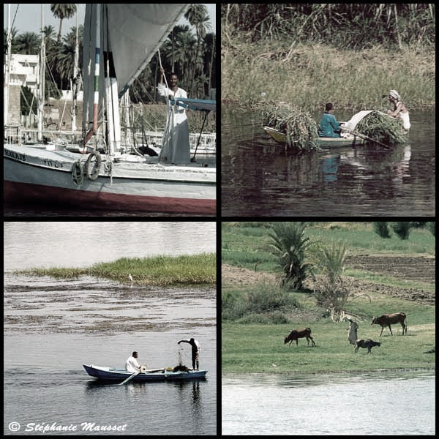
Downloaded from internet

2.1 The Nile River flows into the (Red or Mediterranean) Sea _____________________ (1)
2.2 In ONE (1) sentence, explain what you understand by the following statement: “The Nile River was the lifeblood of Ancient Egypt”. (2)
________________________________________________________________________________________________________________________________________________________________

2.3 Define the term:
Flood (2) ________________________________________________________________________________________________________________________________________________________________

2.4 In a paragraph of FIVE (5) sentences, explain how the Ancient Egyptians used the Nile River to their advantage. Your paragraph should have a topic sentence, supporting sentences and a concluding sentence. (5)
________________________________________________________________________________________________________________________________________________________________________________________________________________________________________________________________________________________________________________________________________________________________________________________________________________________________________________________________________________________________________________________________________________________________________________ Assessment guideline for a paragraph
Level 1 | - Uses evidence in an elementary manner e.g shows little or no understanding. Uses evidence partially to report on topic or cannot report on topic | Marks: 0-1
Level 2 | - Evidence is mostly relevant and relates to a great extent to the topic. Uses evidence in a very basic manner. | Marks: 2-3
Level 3 | - Uses relevant evidence e.g demonstrates a thorough understanding.  - Uses evidence very effectively in an organised paragraph that shows an understanding of the topic | Marks: 4-5
(10)

ACTIVITY 3 DATE: _______________
(Social structure in ancient Egypt)
Study the source below and answer the questions that follow.
Social structure in Ancient Egypt
In Ancient Egypt some people were rich and powerful, but most people were poor and had to work hard. This drawing shows you how people used to fit into Egyptian society. The people near the top were the richest and most powerful, while the people at the bottom were the poorest. The pharaoh, or king, had the most power.

Rich and poor people in Ancient Egypt lived very different lives. Rich people ate well, wore fine clothes and lived in big houses. They had time to play games. Their children went to school. Poor people lived in small houses, which were built close together. The poorest people were slaves, who were usually captured in war by the Egyptian soldiers.
Adapted from Platinum Social Sciences

3.1 According to the pyramid, the person on top was the ___________________ and the people at the bottom were the ___________________________ (2)
3.2 Who were the poorest people in the Egyptian society? __________________________ (1)
3.2 Explain the difference between the rich and poor people in Ancient Egypt in terms of housing. (2)
________________________________________________________________________________________________________________________________________________________________
3.4 Define the following concepts:
3.4.1 Society (2) ________________________________________________________________________________________________________________________________________________________________
3.4.2 Pharaoh (2)
________________________________________________________________________________________________________________________________________________________________
3.4.3 Scribe (2)
________________________________________________________________________________________________________________________________________________________________
(11)

ACTIVITY 4 DATE: ___________________
(Sphinx, pyramids and temples)
Study the sources below and answer the questions that follow.
Pyramids, temples and the Sphinx
Pyramids
The pyramids were the graves of some of the pharaohs. We can still see about 50 pyramids in Egypt today. The pyramid at Giza was the tallest building in the world for 4 500 years. Building a pyramid could take 20 years. The ancient Egyptians painted pictures on the walls of the pyramids. We can learn a lot about their lives from these pictures.
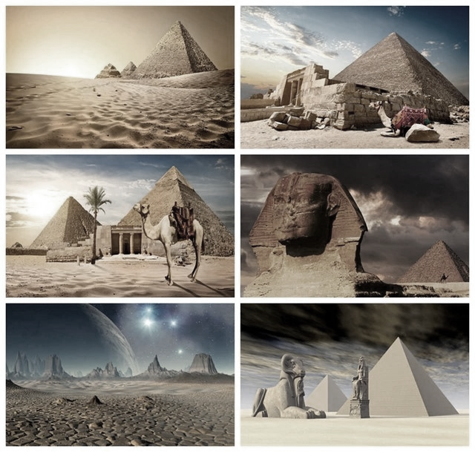

Downloaded from the Internet
Temples
Egyptian temples were large stone buildings full of rooms and corridors. The ancient Egyptians believed that their temples were homes for the gods. Priests looked after the gods in the temples. Ordinary people were not allowed inside the temples.
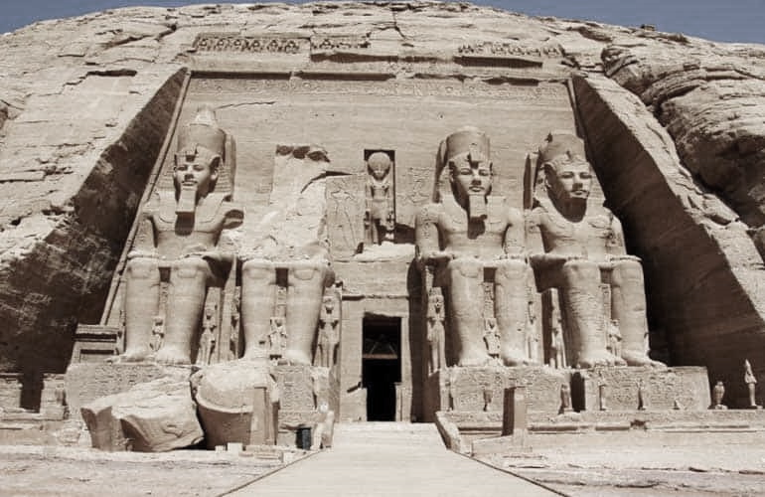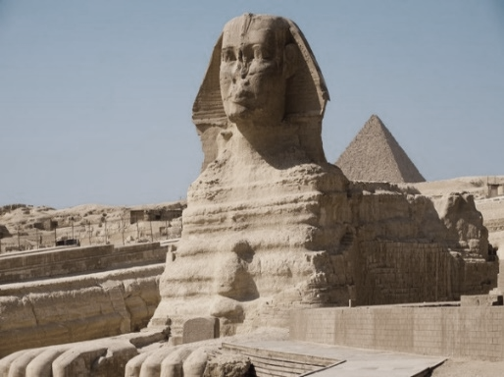
The Great Sphinx
The Great Sphinx is a giant stone statue. The Sphinx has the head of a pharaoh and the body of a lion. It is 20 m high and almost as long as a soccer field. The Great Sphinx was made to guard the tomb of the pharaoh Khafra. The Great Sphinx is 4 500 years old.
Adapted from Solutions for all Social Sciences and Internet

4.1 Match the items in Column A with the corresponding responses in Column B. Write your answer in Column C, e.g.,4.1.7 J.
Column A | Column B | Column C
4.1.1 The tallest building in the world for 4 500 years. | A. The Great Sphinx | 4.1.1
4.1.2 It is a giant stone statue. | B. Priests | 4.1.2
4.1.3 These were the graves of some of the pharaohs. | C. Khafra | 4.1.3
4.1.4 Ordinary people were not allowed inside these buildings. | D. Giza pyramid | 4.1.4
4.1.5 These people looked after the gods in the building. | E. Temples | 4.1.5
 | F. Soldiers
 | G. The pyramids

(5)
4.2 In ONE (1) sentence, explain how pyramids can enable people to learn about the lives of the ancient Egyptians. (2)
________________________________________________________________________________________________________________________________________________________________
4.3 In a paragraph of FIVE (5) sentences, discuss about The Great Sphinx. Your paragraph should have a topic sentence, supporting sentences and a concluding sentence. (5)
________________________________________________________________________________________________________________________________________________________________________________________________________________________________________________________________________________________________________________________________________________________________________________________________________________________________________________________________________________________________________________________________________________________________________________ ________________________________________________________________________________________________________________________________________________________________
Assessment guideline for a paragraph
Level 1 | - Uses evidence in an elementary manner e.g shows little or no understanding. Uses evidence partially to report on topic or cannot report on topic | Marks: 0-1
Level 2 | - Evidence is mostly relevant and relates to a great extent to the topic. Uses evidence in a very basic manner. | Marks: 2-3
Level 3 | - Uses relevant evidence e.g demonstrates a thorough understanding.  - Uses evidence very effectively in an organised paragraph that shows an understanding of the topic | Marks: 4-5
(12)

ACTIVITY 5 DATE: ______________
(Hieroglyphics)
Study the source below and answer the questions that follow.

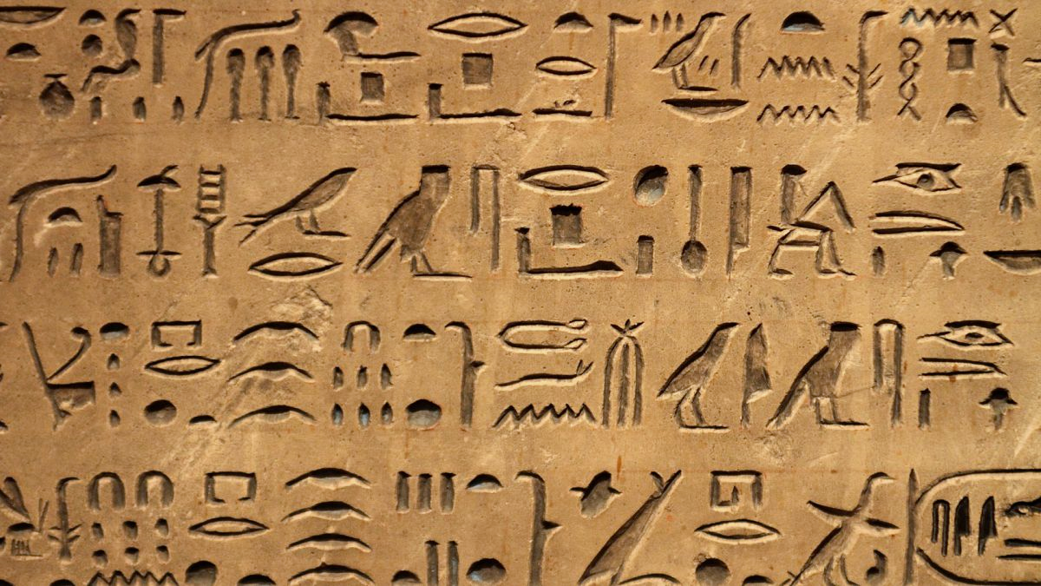
Hieroglyphics
The ancient Egyptians had a kind of writing called hieroglyphics. Hieroglyphics is picture writing. Each picture stands for a sound or an idea. There were over 700 pictures in hieroglyphics. Egyptians wrote on paper made from papyrus reed. They also carved hieroglyphics on stone. They painted hieroglyphics on walls of tombs and temples.
The scribes used pens made from thin sharp reeds. They made ink and paint from plants. The Egyptians wrote about business and trade. The scribes also wrote down how much tax people paid.
Adapted from Solutions for all Social Sciences

5.1 From the social structure of the Egyptians, which people were responsible for writing? (1)
________________________________________________________________________________
5.2 What is hieroglyphics? (2)
________________________________________________________________________________________________________________________________________________________________
5.3 How many pictures were in hieroglyphics? (1)
________________________________________________________________________________
________________________________________________________________________________

5.4 Mention THREE (3) places where hieroglyphics could be written? (3) ________________________________________________________________________________________________________________________________________________________________________________________________________________________________________________
5.5 In TWO (2) sentences, explain what the Egyptians wrote about. (2) _______________________________________________________________________________________________________________________________________________________________________________________________________________________________________________
(9)

ACTIVITY 6 DATE: ______________
(Mathematics and astrology)
Study the source below and answer the questions that follow.
MATHEMATICS
The ancient Egyptians knew a lot about mathematics and had many practical uses for it. They used maths for measuring time, for predicting the yearly flood of the Nile river, for dividing areas of the land, counting money, working out taxes and cooking. Maths was also used for building tombs, pyramids and other monuments.

The Egyptians also created a calendar based on the agricultural seasons and the Nile flood predictions. Their calendar had 365 days a year, 12 months with 30 days each and five feast days at the end of the year. Much of ancient Egypt’s mathematical knowledge is written down in a document called the Rhind Papyrus.
Adapted from Study & Master Social Sciences
ASTRONOMY
Astronomy is the study of the stars and planets. It was very important in Ancient Egypt. The Ancient Egyptians built and positioned their pyramids and temples in relation to the stars. They also worked out their calendar, and when to plough and plant, based on the stars. For all these they needed maths, just like we do today.
Adapted from Platinum Social Sciences

6.1 The Egyptian calendar was based on TWO (2) factors. Name them. (2)
___________________________________, _________________________________________
6.2 How many seasons does our modern day calendar have? ___________________________ (1)
6.3 State the number of days that the Egyptian calendar had. ________________________ (1)
6.4 Define the term astronomy. (2)
________________________________________________________________________________
6.4 Describe TWO (2) ways in which the Ancient Egyptians used the Stars. (2)
________________________________________________________________________________________________________________________________________________________________________________________________________________________________________________
6.5 In a paragraph of FIVE (5) sentences, explain the ways in which the Egyptians used mathematics. Your paragraph should have a topic sentence, supporting sentences and a concluding sentence. (5)
________________________________________________________________________________________________________________________________________________________________________________________________________________________________________________________________________________________________________________________________________________________________________________________________________________________________________________________________________________________________________________________________________________________________________________________________________________________________________________________________
Assessment guideline for a paragraph
Level 1 | - Uses evidence in an elementary manner e.g shows little or no understanding. Uses evidence partially to report on topic or cannot report on topic | Marks: 0-1
Level 2 | - Evidence is mostly relevant and relates to a great extent to the topic. Uses evidence in a very basic manner. | Marks: 2-3
Level 3 | - Uses relevant evidence e.g demonstrates a thorough understanding.  - Uses evidence very effectively in an organised paragraph that shows an understanding of the topic | Marks: 4-5
(13)
ACTIVITY 7 DATE: __________________
(Medicine and physicians)
Study the source below and answer the questions that follow.
MEDICINE

The ancient Egyptians had a great deal of knowledge of healing herbs and repairing physical injuries. The ancient Egyptians made sure that labourers were fed a healthy diet. The diet included rich food that provided natural healing substances to the body. For example, garlic was used to prevent colds and flu. Cumin seeds were used to ease the pain of arthritis. Coriander helped improve digestion. These powerful natural substances helped to prevent outbreaks of disease in the crowded conditions of the work camps.

Evidence shows that ancient Egyptian doctors also performed eye surgery. Ancient Egyptian doctors used physiotherapy and used heat to treat aches and pains. The medicine also included repairing and splinting broken bones. Priest-doctors also practised amputation. Antiseptics were used to reduce the chance of infection and gangrene. Many of the herbs they used are still used by modern herbalists, thousands of years later. The ancient Egyptians also practised dentistry and even extracted teeth and made false teeth.

The Egyptian physicians knew how to stitch a wound. Honey was used to fight infections. Priest-doctors used mouldy bread to kill germs that caused infection thousands of years before the modern world discovered penicillin. Much of the Egyptians knowledge of parts of the body came from their practice of embalming the dead. This allowed them to study the structure of the body. They made some accurate observations about which part of the body was responsible for certain tasks.
Adapted from Viva Social Sciences

7.1 What is the other name for the medical doctors? _____________________________ (1)
7.2 Explain why the labourers were fed a healthy diet. (2)
______________________________________________________________________________
7.3 What did the Egyptian doctors use heat for? (1)
______________________________________________________________________________
7.4 Give ONE (1) example of an antiseptic that we use in our homes. ______________________ (1)
7.5 Explain how the Egyptian doctors got more knowledge about the human body. (2)
________________________________________________________________________________________________________________________________________________________________
7.6 In a paragraph of FIVE (5) sentences, discuss how Egyptians practised medicine. Your paragraph should have a topic sentence, supporting sentences and a concluding sentence. (5) ________________________________________________________________________________________________________________________________________________________________________________________________________________________________________________________________________________________________________________________________________________________________________________________________________________________________________________________________________________________________________________________________________________________________________________________________________________________________________________________________________________________________________________________________________________

Assessment guideline for a paragraph
Level 1 | - Uses evidence in an elementary manner e.g shows little or no understanding. Uses evidence partially to report on topic or cannot report on topic | Marks: 0-1
Level 2 | - Evidence is mostly relevant and relates to a great extent to the topic. Uses evidence in a very basic manner. | Marks: 2-3
Level 3 | - Uses relevant evidence e.g demonstrates a thorough understanding.  - Uses evidence very effectively in an organised paragraph that shows an understanding of the topic | Marks: 4-5
(11)

ACTIVITY 8 Date: ________________
(Discovery of the tomb)
Study the source below and answer the questions that follow.
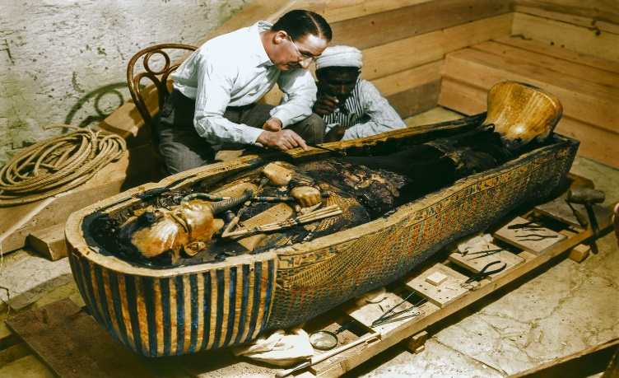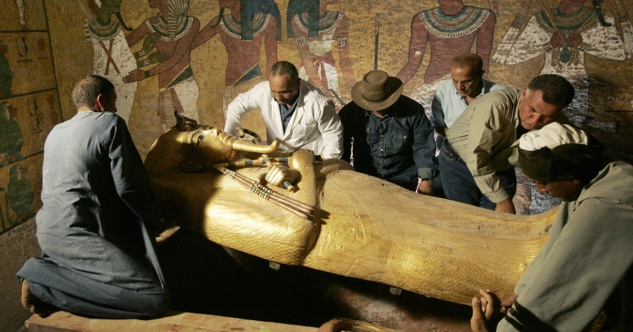
Downloaded from Internet
Discovery of the tomb

The tomb of Tutankhamen was discovered in 1922 by an English archaeologist called Howard Carter. The tomb had been sealed for 3 000 years. Tutankhamen was buried in the Valley of the Kings near the ancient city of Thebes. This was where many pharaohs were buried. Scientists tested the Tutankhamen mummy. They discovered the following: Tutankhamen was only 18 when he died. He had a broken leg. He may have died from an infection from the leg.
Adapted from Solutions for all Social Sciences

Tutankhamen was the most famous pharaoh of ancient Egypt. Many interesting things were found in his tomb. Furniture, jewellery, a war chariot, make-up and even a boat were found in Tutankhamen’s tomb. The mask worn by Tutankhamen was made from two sheets of gold and decorated with precious gems.
Adapted from Viva Social Sciences

8.1 Who discovered the tomb of Tutankhamen? _______________________________________ (1)
8.2 Name TWO (2) items that were found in Tutankhamen’s tomb. (2)
______________________________________________________________________________
8.3 Mention the place where many pharaohs were buried. _______________________________ (1)
8.4 In a paragraph of FIVE (5) sentences, describe the life of Tutankhamen. Your paragraph should have a topic sentence, supporting sentences and a concluding sentence. (5)
________________________________________________________________________________________________________________________________________________________________________________________________________________________________________________________________________________________________________________________________________________________________________________________________________________________________________________________________________________________________________________________________________________________________________________________________________________________________________________________________________________________________________________________________________________
Assessment guideline for a paragraph
Level 1 | - Uses evidence in an elementary manner e.g shows little or no understanding. Uses evidence partially to report on topic or cannot report on topic | Marks: 0-1
Level 2 | - Evidence is mostly relevant and relates to a great extent to the topic. Uses evidence in a very basic manner. | Marks: 2-3
Level 3 | - Uses relevant evidence e.g demonstrates a thorough understanding.  - Uses evidence very effectively in an organised paragraph that shows an understanding of the topic | Marks: 4-5
(9)
ACTIVITY 9 DATE ______________________
(What the discovery revealed about ancient Egyptian society)
Study the source below and answer the questions that follow.
What the discovery of Tutankhamen’s tomb revealed about Ancient Egyptian society

These are some of the things that were found in Tutankhamen’s tomb: a painted wooden casket, a gold-covered statue of Tutankhamen as a warrior god, the mask of Tutankhamen, a panel decorated with a picture of a horse and chariot, and a golden throne with a picture of Tutankhamen and his sister.
The fact that the tomb was still in in its original state, and intact, gave Howard Carter and researchers all over the world an enormous amount of information about Ancient Egypt: its religion, daily life, death, burial, and how pharaohs lived and ruled.
Adapted from Platinum Social Sciences

9.1 Give another name for a warrior ______________________________ (1)
9.2 Mention THREE (3) items that were found in Tutankhamen’s tomb. (3)
________________________________________________________________________________________________________________________________________________________________
9.3 What is a chariot? (2)
________________________________________________________________________________________________________________________________________________________________
9.4 In ONE (1) sentence, explain what Howard Carter and researchers gained from the discovery of Tutankhamen’s tomb. (2)
________________________________________________________________________________________________________________________________________________________________________________________________________________________________________________
(8)

