CLIMATE AND VEGETATION AROUND THE WORLD
2024 TERM 3 GEOGRAPHY GRADE 6 WORKSHEETS
ACTIVITY 1 DATE: _____________________
HOT, MILD AND COLD CLIMATES OF THE WORLD
Study the source and answer the questions below
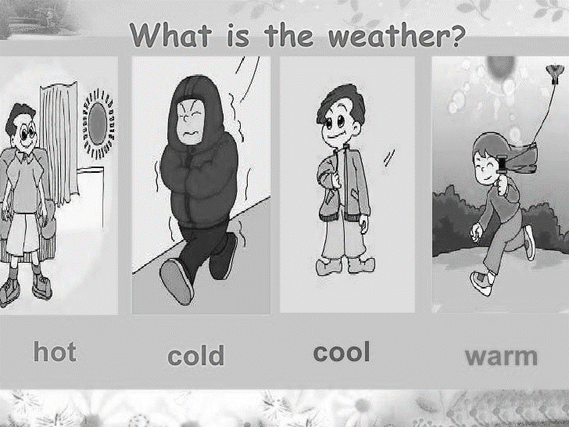
1 text here
2 text here
4 text here
3 text here
Adapted from Internet

  - The coldest parts of the world are at which poles. (2)
______________________ and ____________________
  - Where can we found the hottest places of the world. (1)
__________________________
  - Places near the sea have a ___________________________ climate. (1)
  - What temperatures does South Africa experience in winter? (2)
________________________________________________________________________________________________________________________________
  - If you had to choose one of the places numbered 1 to 4 to live in. Which place would you choose and why. (2)
________________________________________________________________________________________________________________________________
________________________________________________________________
(8)

ACTIVITY 2 DATE: _____________________
HOT, MILD AND COLD CLIMATES OF THE WORLD
Study the source and answer the questions below
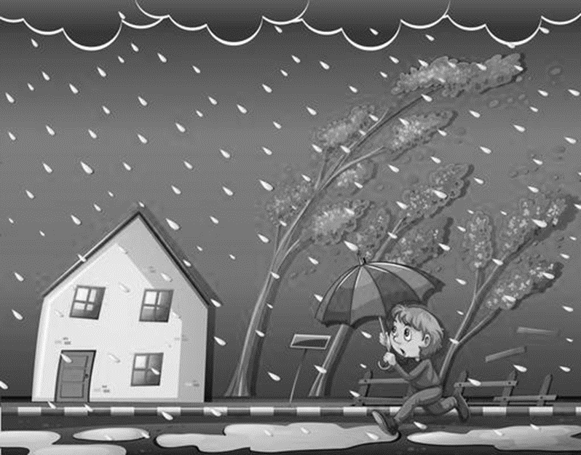
Adapted from Internet
Define the following terms
2.1 Weather (2)
______________________________________________________________________________________________________________________________________
2.2 Climate (2)
______________________________________________________________________________________________________________________________________
2.3 Global warming (2)
______________________________________________________________________________________________________________________________________
2.4 Current condition (2)
______________________________________________________________________________________________________________________________________
2.5 Polar regions (2)
______________________________________________________________________________________________________________________________________
(8)

ACTIVITY 3 DATE: _______________________
HOT, MILD AND COLD CLIMATES OF THE WORLD
Study the source and answer the questions below
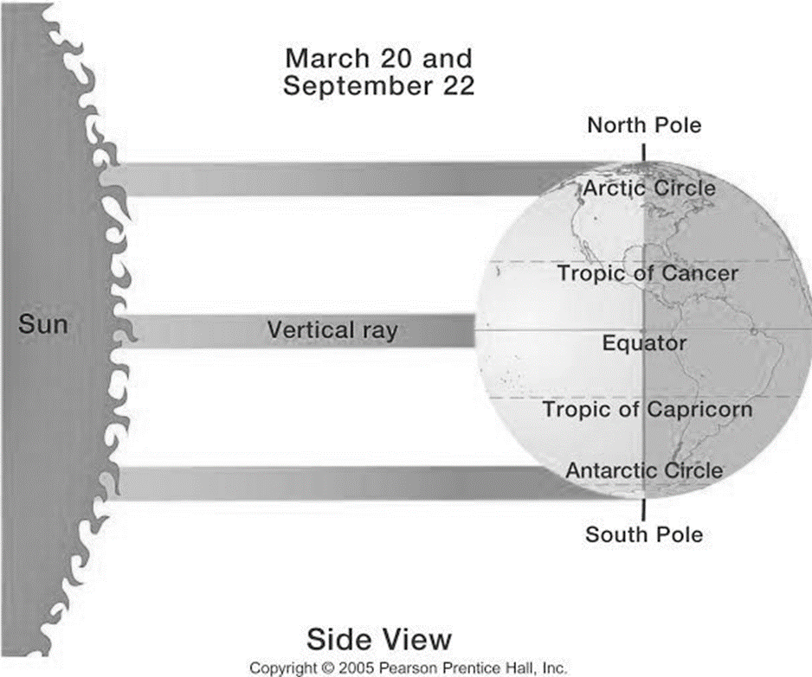
Adapted from Internet

3.1 Which line of latitude is the hottest? (1)
___________________________________________________________________
3.2 Explain why the equator is the hottest. (2)
______________________________________________________________________________________________________________________________________
3.3 Where are the cold climate zones located? (1)
___________________________________________________________________
(4)

ACTIVITY 4 DATE: ___________________
WET AND DRY AREAS OF THE WORLD
Study the source and answer the questions below
Extremely wet areas and dry areas of the world
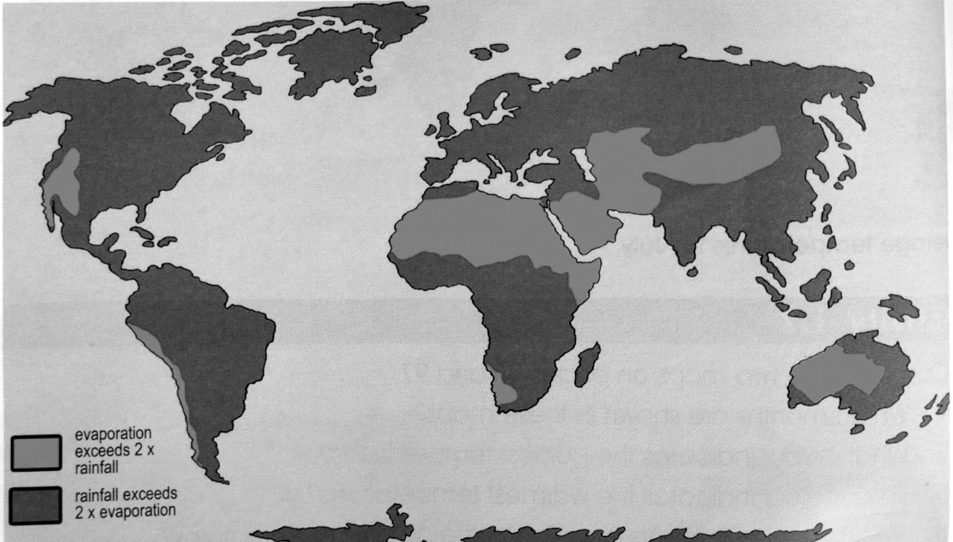
Adapted from Viva Social Sciences

State whether the following sentences are TRUE or FALSE
4.1 The tropical and temperate regions do not get rain at all. _______________ (1)
4.2 Polar regions are usually very dry throughout the year. ________________ (1)
4.3 Thick green forests are found in wet areas. _________________________ (1)
4.4 Wet areas of the world are found far away from the oceans. ____________ (1)
(4)

ACTIVITY 5 DATE: ___________________
CLIMATE (TEMPERATURE AND RAINFALL) OF TROPICAL RAINFORESTS
Study the source and answer the questions below
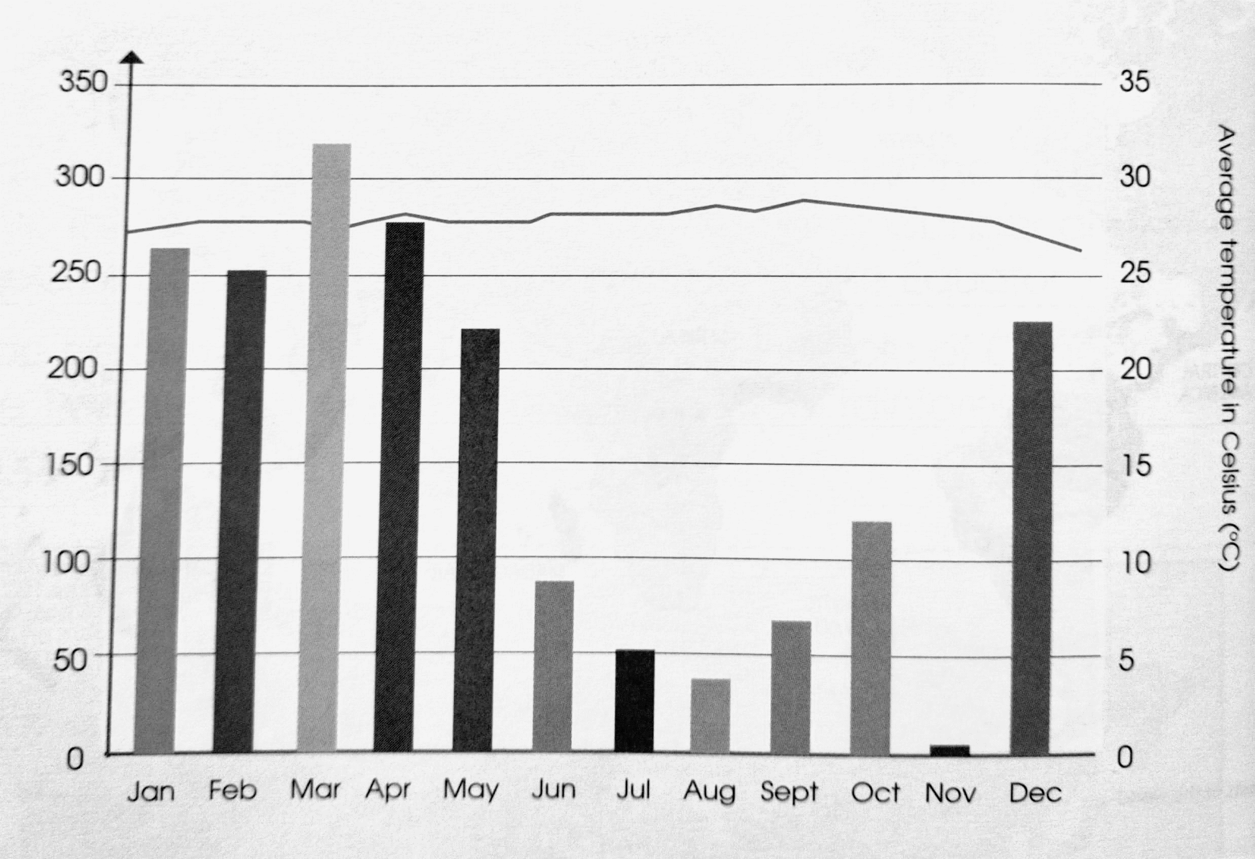
Adapted from Viva Social Sciences

5.1 Where are the tropical rainforests situated? (1)
___________________________________________________________________
5.2 Which month is having the highest rainfall? (1)
___________________________________________________________________
5.3 Which month is having the lowest rainfall? (1)
___________________________________________________________________
5.4 How many months of the year is the rainfall high (over 200mm)? (1)
___________________________________________________________________
5.5 Why tropical rainforests have lot of rain? (2)
______________________________________________________________________________________________________________________________________
(6)

ACTIVITY 6 DATE: _____________________
NATURAL VEGETATION AND WILDLIFE IN A RAINFOREST
Study the source and answer the questions below
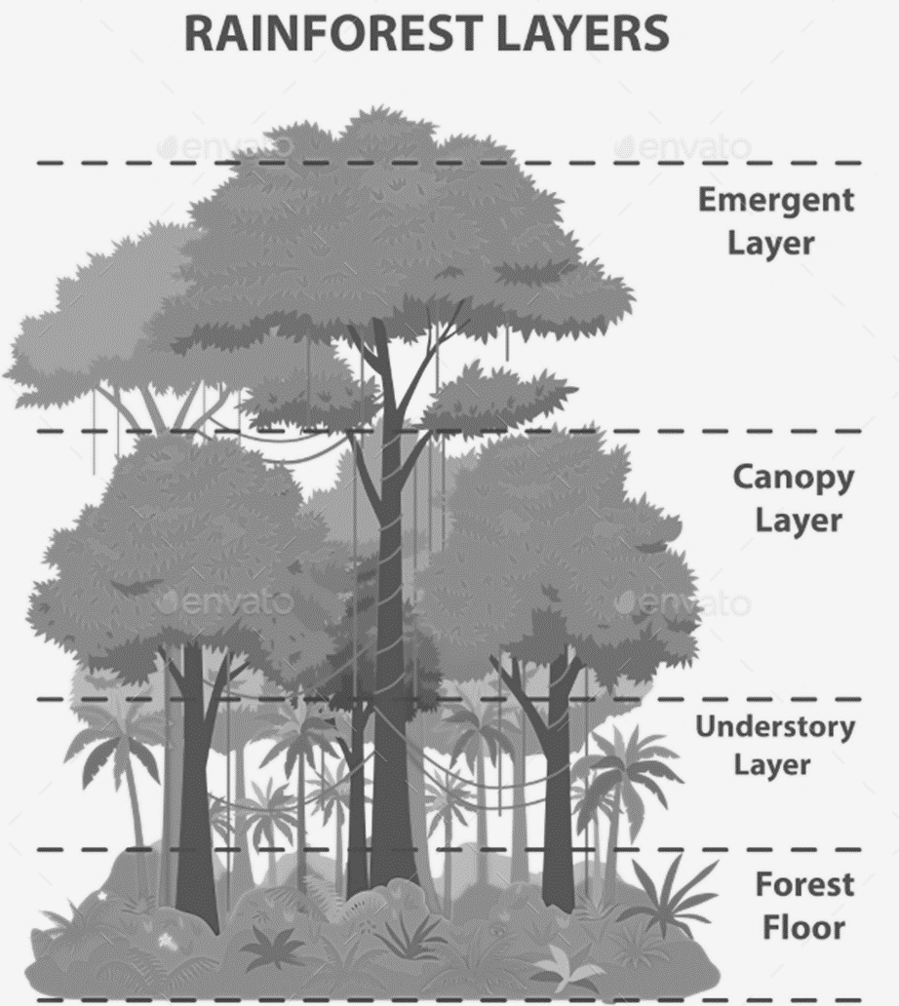
Adapted from Internet

6.1 Which layer receive most of the light? (1)
________________________________________________________________
6.2 Why the understorey layer has a dense shade? (1)
________________________________________________________________
6.3 Why there are very tall trees in the tropical rainforest? (2)
________________________________________________________________
6.4 Give TWO (2) reasons why the canopy is the shelter for many animals. (2)
________________________________________________________________
(6)

ACTIVITY 7 DATE: ____________________
DEFORESTATION - REASONS AND CONSEQUENCES
Read the CASE STUDY and answer the questions below
Ivory Coast used to be covered in tropical rainforests. In only 25 years 12 million hectares of rainforest shrunk to 4 Million hectares. Now there are hardly any trees left. Forestry companies cut down more and more trees but did not replace them. Famers cleared land for crops like coffee and cocoa. Losing their forests has affected the economy, the climate and soil of ivory coast:
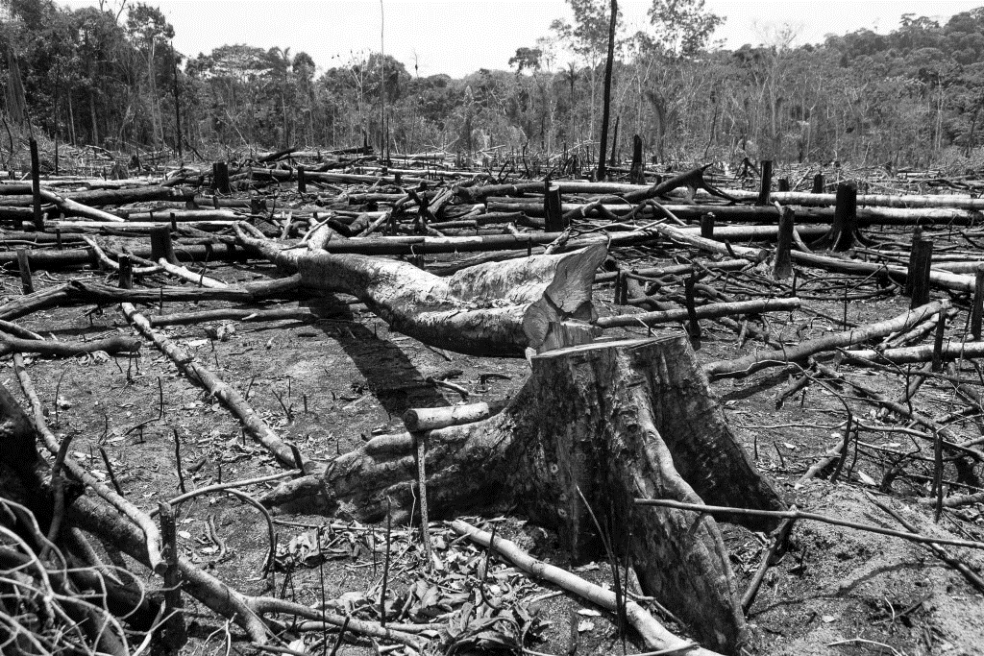
- The fail in timber sales caused the country to get less money from exports
- In the timber industry 30 000 workers have lost their jobs.
- As the forest was cleared, the rainwater either dried up in the hot sun or ran off the land instead of seeping into the soil.
- There was no longer a carpet of leaves rotting to form compost, so the soil became infertile.
- The drier savannah vegetation took over from the forest.
Adapted from Oxford successful and Internet

7.1 What is deforestation? (2)
________________________________________________________________
________________________________________________________________
7.2 Describe reasons of deforestation. (3)
________________________________________________________________
________________________________________________________________
________________________________________________________________
7.3 In a paragraph of FIVE (5) sentences, explain the consequences (results) of
deforestation. Your paragraph should consist of a topic sentence, supporting
sentences and the concluding sentence. (5)
________________________________________________________________
________________________________________________________________
________________________________________________________________
________________________________________________________________
________________________________________________________________
Rubric for marking the paragraph (5 marks)
Level 1 | - Uses evidence in an elementary manner e.g. shows little or no understanding. Uses evidence partially to report on topic or cannot report on topic. | Marks: 0-1
Level 2 | - Evidence is mostly relevant and relates to a great extent to the topic. Uses evidence in a very basic manner. | Marks: 2-3
Level 3 | - Uses relevant evidence e.g. demonstrates a thorough understanding.  - Uses evidence very effectively in an organised paragraph that shows an understanding of the topic. | Marks: 4-5
(10)
ACTIVITY 8 DATE: ________________________
HOT DESERTS
Study the source and answer the questions below
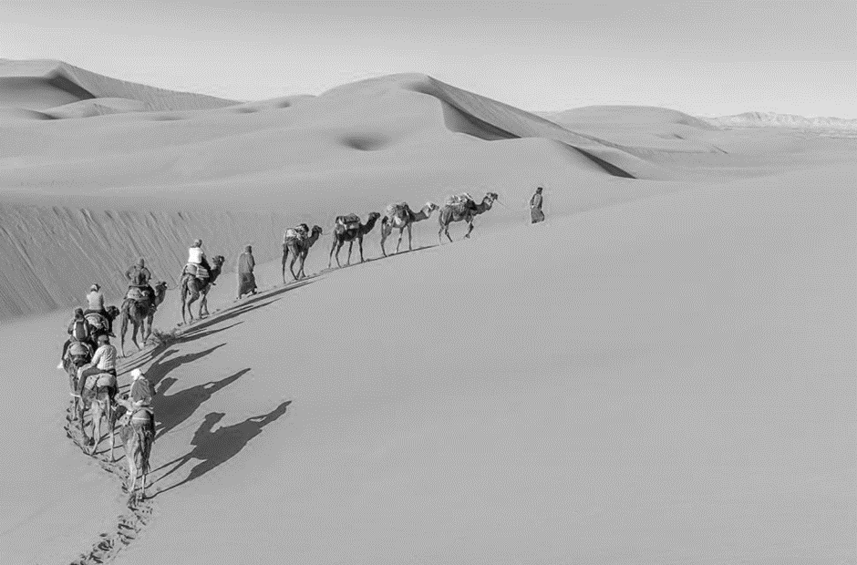
Downloaded from Internet

Match Column A with Column B. Write the correct LETTER in COLUMN C. Eg. 8.1 A
COLUMN A | COLUMN B | COLUMN C
8.1 The area of land where very little rain falls and where temperatures are usually high. | A. Oasis | 8.1
8.2 The largest desert in North Africa. | B. Dromedary camel | 8.2
8.3 The animal that spend most of their time in the trees and is endangered. | C. Nomads | 8.3
8.4The source of water in the desert. | D. Sahara desert | 8.4
8.5 The people who move from one place to another | E. Hot desert | 8.5
 | F. Namib desert
 | G. Orangutans
(5)
ACTIVITY 9 DATE: ______________________
NATURAL VEGETATION AND WILDLIFE IN A DESERT
Study the source and answer the questions below
ANIMALS AND PLANTS IN A HOT DESERT
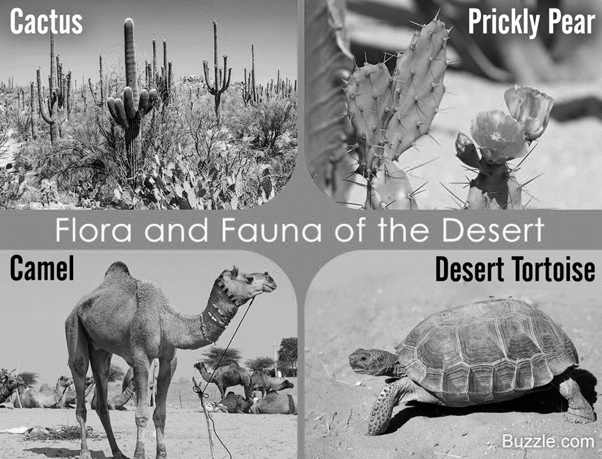
Downloaded from Internet

9.1 Choose the correct answer from the alternatives given below. Write only the
correct letter in the spaces provided. E.g. 9.1.4 A.
9.1.1 The animals in the hot desert hunt _____________ (1)
- In the morning
- In the afternoon
- At night
9.1.2 Plants adapted to the heat and dryness by ________________ (1)
A. short roots.
B. storing water on the leaves and stems.
C. having many leaves.
9.2 How is the condition in the Sahara Desert? (2)
________________________________________________________________
________________________________________________________________
9.3 Explain THREE (3) ways on how plants adapt in the desert. (3)
_________________________________________________________________
_________________________________________________________________
_________________________________________________________________

9.4 In a paragraph of FIVE (5) sentences, explain how animals survive in the
desert. The paragraph must have topic sentence, supporting sentences and a
concluding sentence. (5) _________________________________________________________________
_________________________________________________________________
_________________________________________________________________
_________________________________________________________________
_________________________________________________________________
Rubric for marking the paragraph (5 marks)
Level 1 | - Uses evidence in an elementary manner e.g. shows little or no understanding. Uses evidence partially to report on topic or cannot report on topic. | Marks: 0-1
Level 2 | - Evidence is mostly relevant and relates to a great extent to the topic. Uses evidence in a very basic manner. | Marks: 2-3
Level 3 | - Uses relevant evidence e.g. demonstrates a thorough understanding.  - Uses evidence very effectively in an organised paragraph that shows an understanding of the topic. | Marks: 4-5

(12)
ACTIVITY 10 DATE: _____________________
NATURAL VEGETATION AND WILDLIFE IN A DESERT
Study the source and answer the questions below
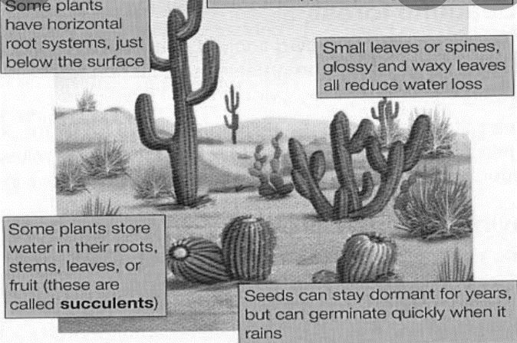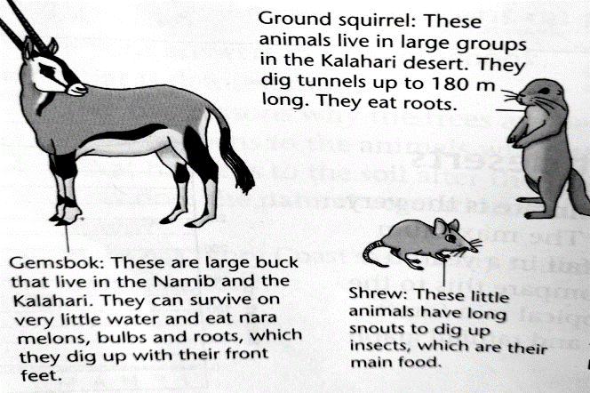

Downloaded from Internet

10.1 Mention TWO (2) plants growing in hot desert. (2)
______________________________________________________________
10.2 Where do most animal live in hot desert during the day? (1)
______________________________________________________________
10.3 How do the plants adapt themselves in hot desert? (2)
______________________________________________________________
(5)

ACTIVITY 11 DATE: ______________________
HOW PEOPLE LIVE IN HOT DESERTS
Study the source and answer the questions below
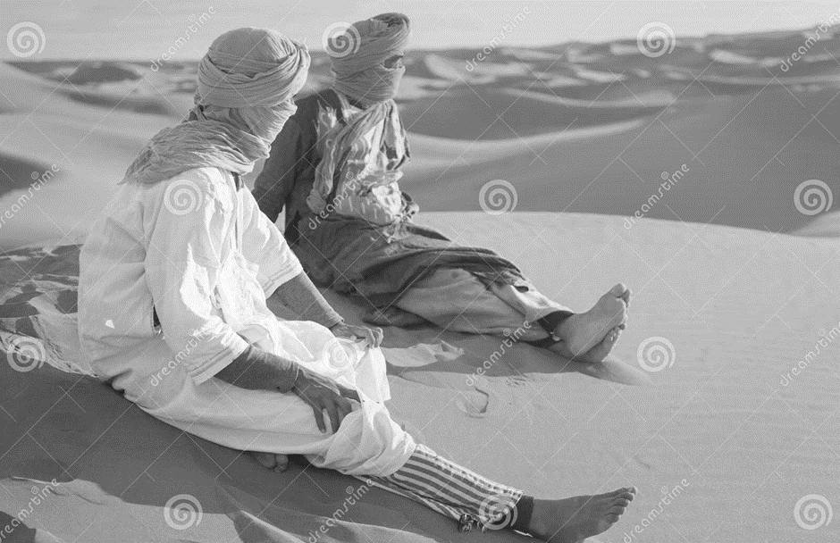
Downloaded from Internet

11.1 What do we call people who move from one place to another? (1)
________________________________________________________________
11.2 What is an oasis? (2)
________________________________________________________________________________________________________________________________
11.3 Name TWO (2) activities that these people are practising. (2)
___________________________ and ________________________________
11.4 Give reasons why they are wearing these types of clothes. (2)
________________________________________________________________________________________________________________________________________________________________________________________________
11.5 Explain in detail why they are using tents as their shelters. (2)
________________________________________________________________________________________________________________________________________________________________________________________________
(9)

ACTIVITY 12 DATE: ______________________
CONIFEROUS FORESTS
Study the source and answer the questions below
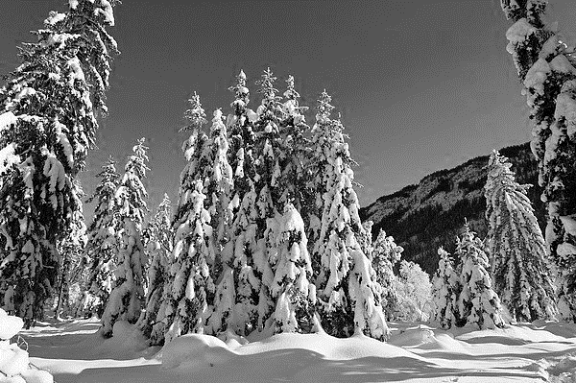
Downloaded from Internet
Choose the correct answer from the alternatives given below. Write only the correct letter in the spaces provided. Eg 12.1 C
  - Temperate coniferous are situated in _____________
A. Along the low-lying areas of the equator
B. Near the equator
C. Close to cool oceans, inland and on high lying areas.
  - Temperate coniferous forests have______________
- Warm summers and cold winters
- Cold summers and cold winters
- None of the above
  - The vegetation of temperate coniferous forests has to cope with_________
- Cold summers and poor soils
- Warm summers and fertile soils
- Cold winters and thin poor soils
  - The most common trees in coniferous trees are _________________
- Fir tree
- Fig tree
- Cactus
(4)

ACTIVITY 13 DATE: ____________________
CLIMATE IN CONIFEROUS FORESTS
Study the temperature and rainfall graph to answer the questions below
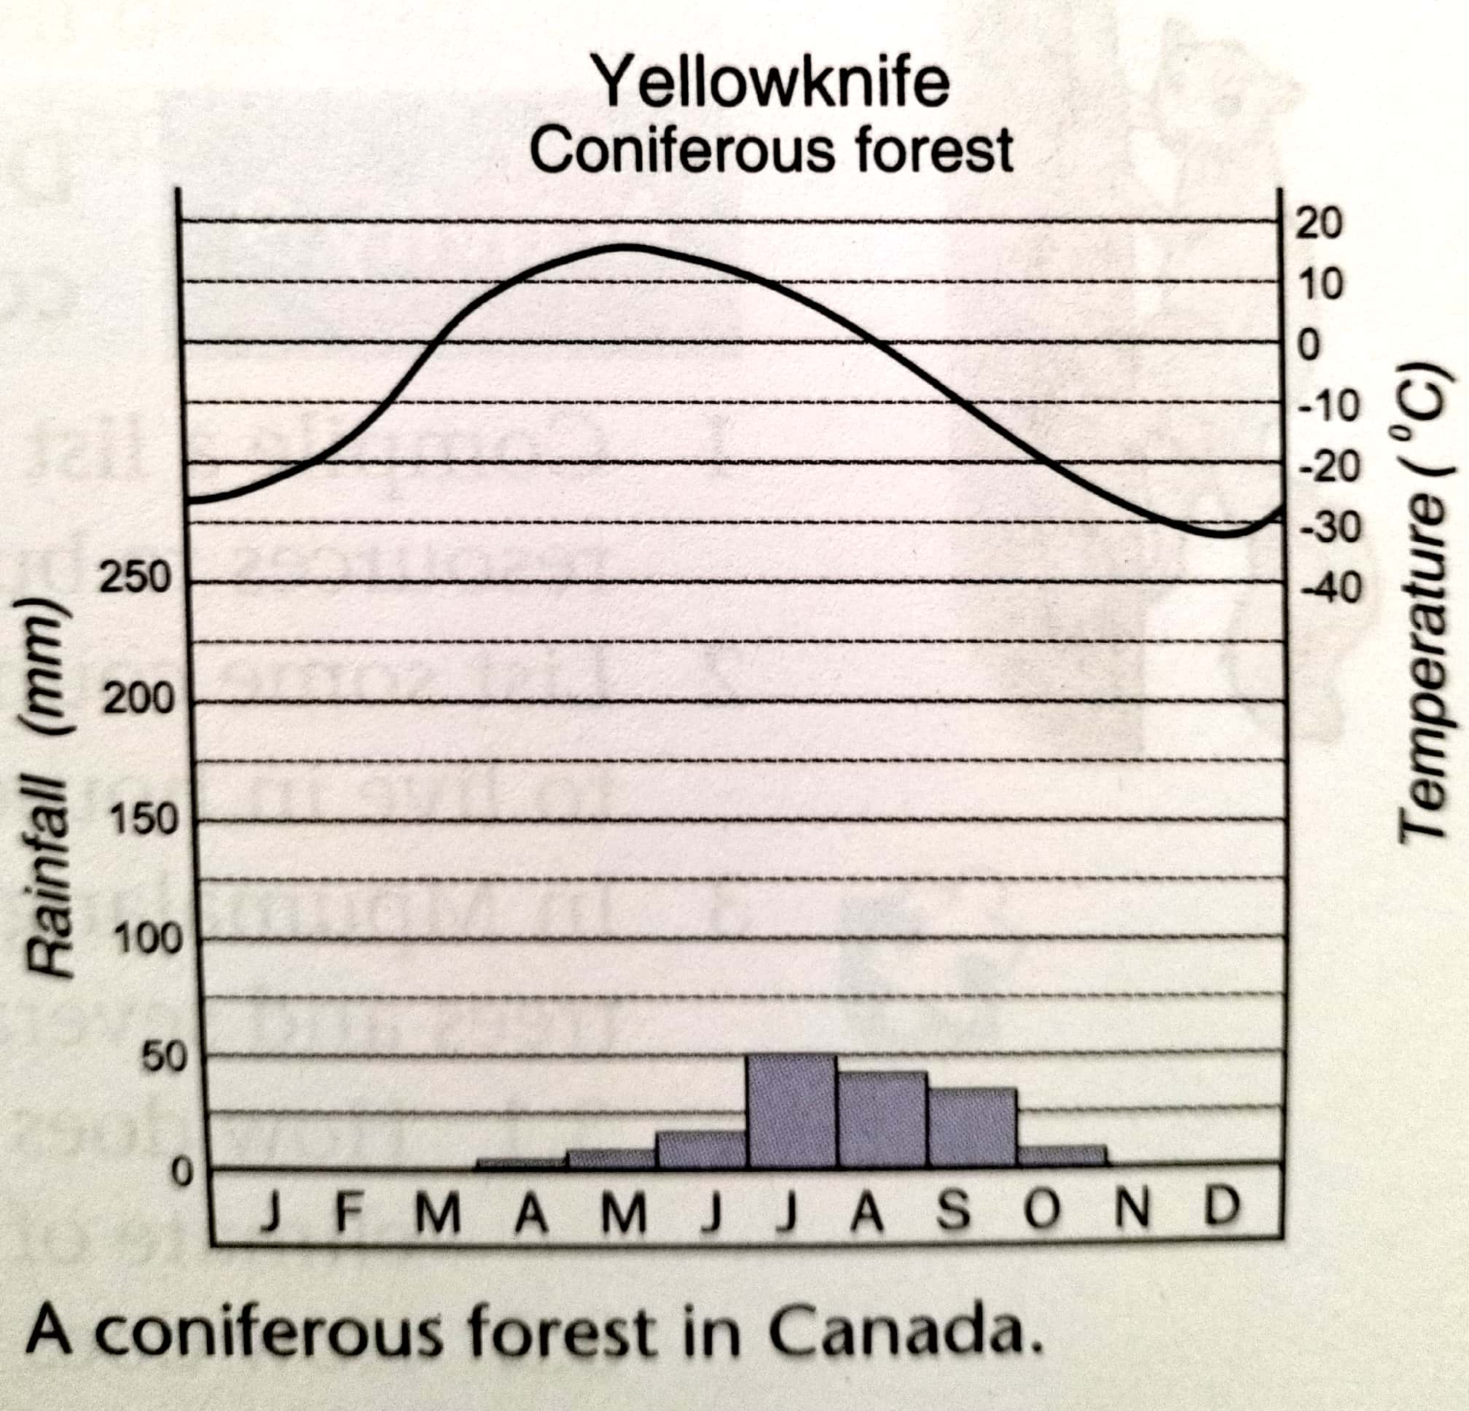
Adapted from Oxford Successful

  - What is the highest temperature in Yellowknife? (1)
______________________________________________________________
  - In which months does this temperature occur? (1)
______________________________________________________________

  - What is the lowest temperature in Yellowknife? (1)
______________________________________________________________
  - In which month does this temperature occur? (1)
______________________________________________________________
  - What is the main type of precipitation that Yellowknife experiences? (1)
______________________________________________________________
(5)

