2024 GRADE 5 HISTORY WORKSHEETS

TERM 2 – THE FIRST FARMERS IN SOUTHERN AFRICA
ACTIVITY 1 Date: ________________
(Attitudes to land)
Study the source below and answer the questions that follow.
In African farming communities, land was used by all the people. You could not buy or sell a piece of land. The chief would decide where the head of a family should plant crops. The head of the family would then divide this land among the members of his family.
Each community also had communal land for grazing cattle and goats. Any family or person who had goats or cattle could use this land. When land became overgrazed, the livestock would be moved to a area.
Adapted from Platinum Social Siences
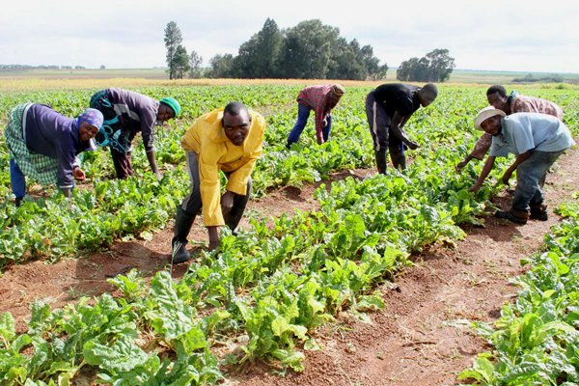
Downloaded from Internet

1.1 State whether the following statements are TRUE or FALSE.
1.1.1 In African farming communities, the land was used only by the chief. (1) _______________________
1.1.2 People were allowed to buy and sell land. (1)
_________________________
1.1.3 Each community had communal land for grazing cattle and goats. (1) _______________________
1.1.4 The land was divided among the family members by the head of the family. (1)
__________________________

1.2 Complete the following statements.
1.2.1 Mention TWO (2) kinds of livestock mentioned in the source. (2) ______________________ and_________________________
1.2.2 In ONE (1) sentence, explain what the farming communities did when the land became overgrazed. (2)
____________________________________________________________________________________________________________________________________________
(8)

ACTIVITY 2 Date: ____________
(Interaction with Khoisan)
Study the source below and answer the questions that follow.
African farmers’ interaction with the Khoisan
The Khoisan and African farmers had different lifestyles, but they shared the same land. As a result, there was a great deal of interaction between them. African chiefs accepted and took strangers into their own societies. People from both groups started marrying one another. Sometimes the Khoisan worked for the farmers on their lands.
There was so much interaction that all the clicks in the Nguni languages come from Khoisan languages.
When the San and the Khoikhoi came into contact with African farmers, they traded with them, and used some of their iron tools. After coming into contact with the iron-smelting, Bantu-speaking farmers, the Khoisan began to use iron points instead of bone for arrows.
Adapted from Platinum Social Science 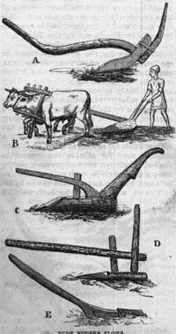 Downloaded from Internet

2.1 Give ONE (1) reason for the Khoisan and African farmers to have had interaction with one another. (2) __________________________________________________________________
2.2 Name the TWO (2) groups of people that the farmers found when they arrived in southern Africa. (2)
_______________________________ and ______________________________
2.3 The African farmers and the Khoisan had same lifestyles. True or False? (1)
_____________________________
2.4 In a paragraph of FIVE (5) sentences, describe how the African farmers had interaction with the Khoisan. (5)
Your paragraph should have a topic sentence, supporting sentences and a concluding sentence.
________________________________________________________________________________________________________________________________________________________________________________________________________________________________________________________________________________________________________________________________________________________________________________________________________________________________________________________________________________________________________________________________________________________________________________
Level 1 | - Uses evidence in an elementary manner e.g shows little or no understanding. Uses evidence partially to report on topic or cannot report on topic | Marks: 0-1
Level 2 | - Evidence is mostly relevant and relates to a great extent to the topic. Uses evidence in a very basic manner. | Marks: 2-3
Level 3 | - Uses relevant evidence e.g demonstrates a thorough understanding.  - Uses evidence very effectively in an organised paragraph that shows an understanding of the topic | Marks: 4-5
(10)
ACTIVITY 3 Date: _______________
(Homesteads and villages)

Study the source below and answer the questions that follow.
Homesteads
A homestead was the place where a family lived. A homestead could be small, with all the people belonging to a single family. This would be a man, his wives, their children and some close relatives. Sometimes the homestead was large and included more than one family and their relatives.
A homestead included a cattle kraal, huts, grain and food stores, kitchens and a meeting area. The head of the homestead lived in the Great Hut. His wives lived in huts close to the Great Hut. Single men lived further away from the Great Hut.
Villages
A village was a group of homesteads. Small villages had only few homesteads. Big villages were in areas that had resources. Important resources such as wood, water, fertile soil, building stones and iron helped villages to grow big.
Adapted from Solutions for all Social Sciences

3.1 Name THREE (3) kinds of people that lived in a homestead. (3)
__________________, ____________________, ________________________
3.2 Mention THREE (3) types of resources that helped villages to grow big. (3)
_______________________, _______________________ and ____________________________________
3.3 Where was the cattle kraal situated in the homestead? (1)
________________________________________________________________

3.4 The head of the homestead lived in the (Kraal/Great Hut). (1)
________________________________

3.5 Define the following terms:
3.5.1 Homestead (2)
____________________________________________________________________________________________________________________________________________
3.5.2 Village (2)
____________________________________________________________________________________________________________________________________________
(12)

ACTIVITY 4 Date: __________________
(Agriculture: crops and livestock)
Study the source and answer the questions that follow.
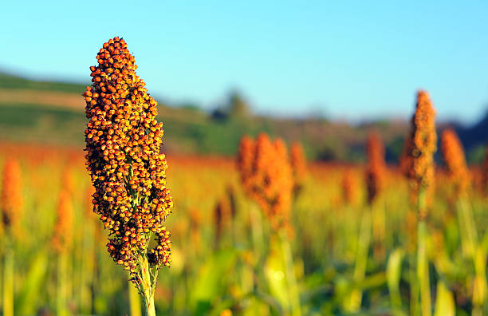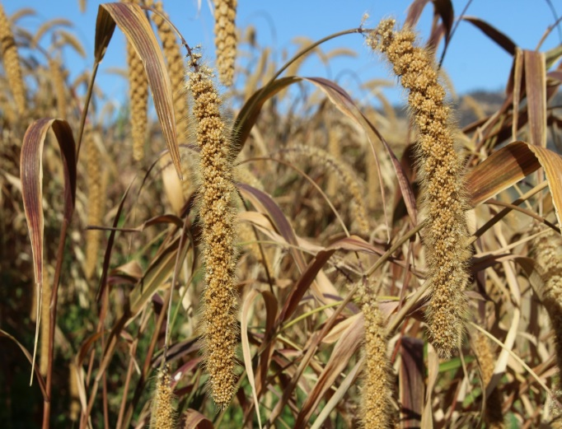

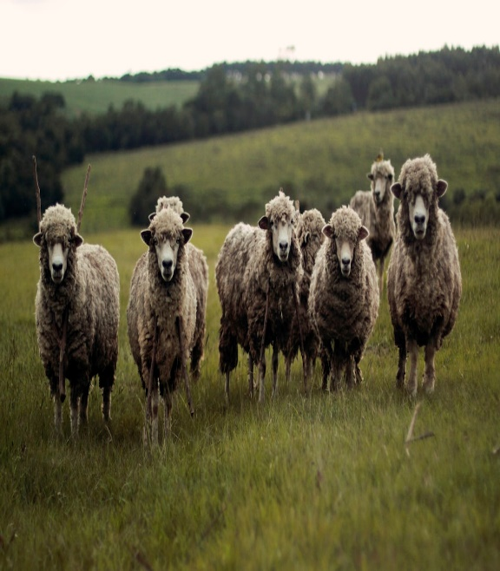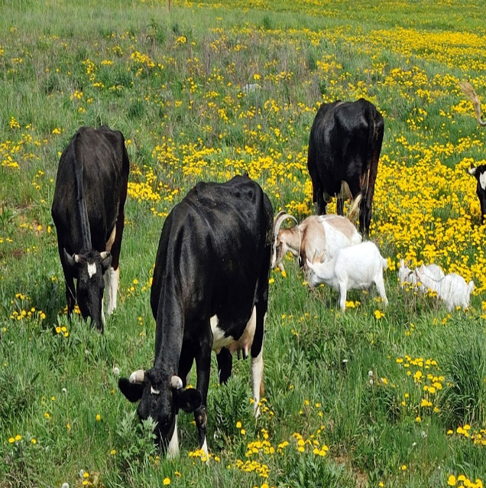

Downloaded from Internet
Early farmers settled in small villages. They planted crops and grazed cattle.
The people and livestock in a farming village had to be fed every day. Looking after the crops was the work of women. Without successful agriculture, no village would have been able to exist. When the soil was no longer fertile and farmers could not grow enough food for themselves and their livestock, they moved and set up another village.
The location of the village was chosen on the basis of the climate and the soil. The temperature and the rainfall had to be just right to grow crops. Sorghum and millet were the main crops of early African farmers. There had to be good rainfall in the summer months to grow sorghum and millet.

Adapted from: Platinum Social Sciences

4.1 Name TWO (2) things that early farmers lived or depended on for food. (2)
_________________________ and _______________________________
4.2 Who looked after crops in a farming village? (1)
__________________________________________________________________
4.3 What is agriculture? (2)
__________________________________________________________________
__________________________________________________________________

4.4 Explain why agriculture was needed in the village. (2)
__________________________________________________________________
__________________________________________________________________

4.5 Mention TWO (2) things the early African farmers chose to settle a village. (2)
___________________________ and __________________________________
4.6 In which season did the early African farmers grow their crops? (1)
____________________________________
(10)

ACTIVITY 5) Date: ___________________
(Social, political and economic structures)
Study the source below and answer the questions that follow.
Social, political and economic structures – how the farmers lived

There were rules and ways of doing things in farming communities. People lived by these rules. Some rules were about leaders and government. Today we call these politics. Other rules were about wealth and jobs. These are economic things. There were rules about who did what jobs. Everybody did work, including children. There was more at certain times of the year.
The roles of
Women and girls
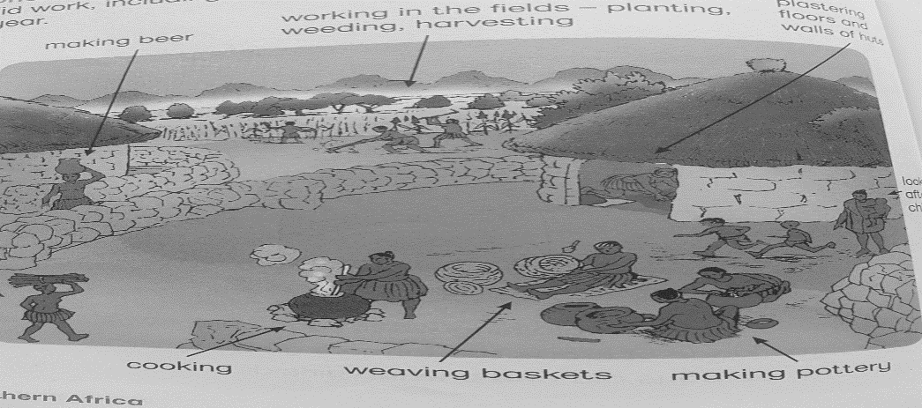

Women and girls did certain kind of work in the village. They were expected to behave in a certain way. Girls learnt about their roles from the older women. The women prepared girls for their initiation ceremonies and marriages.

The roles of boys and men
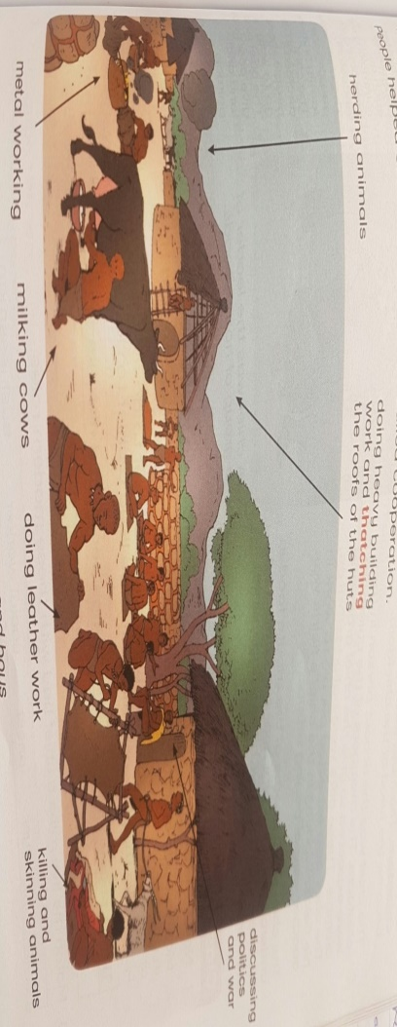

Men and boys looked after the animals. The men decided which animals would be killed for food. They skinned the animals and made leather clothes and shoes. The men did most of the heavy building such as making the huts and stone walls. Men also hunted wild animals. The men were in charge of the boy’s initiation ceremonies. Men were the leaders. They made all the important decisions in the village.

People helped one another. This is called cooperation.

Adapted from Solutions for all Social Sciences

5.1 Match the items in Column A with the corresponding responses in Column B. Write your answer in Column C, e.g.,5.1.7 J.
Column A | Column B | Column C
5.1.1 They decided which animals would be killed for food. | A. Chiefs | 5.1.1
5.1.2 Rules about leaders and government. | B. Economics | 5.1.2
5.1.3 It is the people’s practice of helping one another. | C. Women | 5.1.3
5.1.4 Rules about wealth and jobs. | D. Men | 5.1.4
5.1.5 They made pottery. | E. Help | 5.1.5
 | F. Co-operation
 | G. Politics

(5)

5.2 What do you understand by the term Initiation? (2)
____________________________________________________________________________________________________________________________________________

5.3 In a paragraph of FIVE (5) sentences, discuss the roles of women and girls in a farming community. Your paragraph should have a topic sentence, supporting sentences and a concluding sentence. (5)
____________________________________________________________________
____________________________________________________________________
____________________________________________________________________
____________________________________________________________________
____________________________________________________________________
__________________________________________________________________________________________________________________________________________
Level 1 | - Uses evidence in an elementary manner e.g shows little or no understanding. Uses evidence partially to report on topic or cannot report on topic | Marks: 0-1
Level 2 | - Evidence is mostly relevant and relates to a great extent to the topic. Uses evidence in a very basic manner. | Marks: 2-3
Level 3 | - Uses relevant evidence e.g demonstrates a thorough understanding.  - Uses evidence very effectively in an organised paragraph that shows an understanding of the topic | Marks: 4-5
(12)

ACTIVITY 6 Date: _________________
(THE ROLE OF THE CHIEF)
Read the extract below and then answer the questions that follow.
THE ROLE OF THE CHIEF

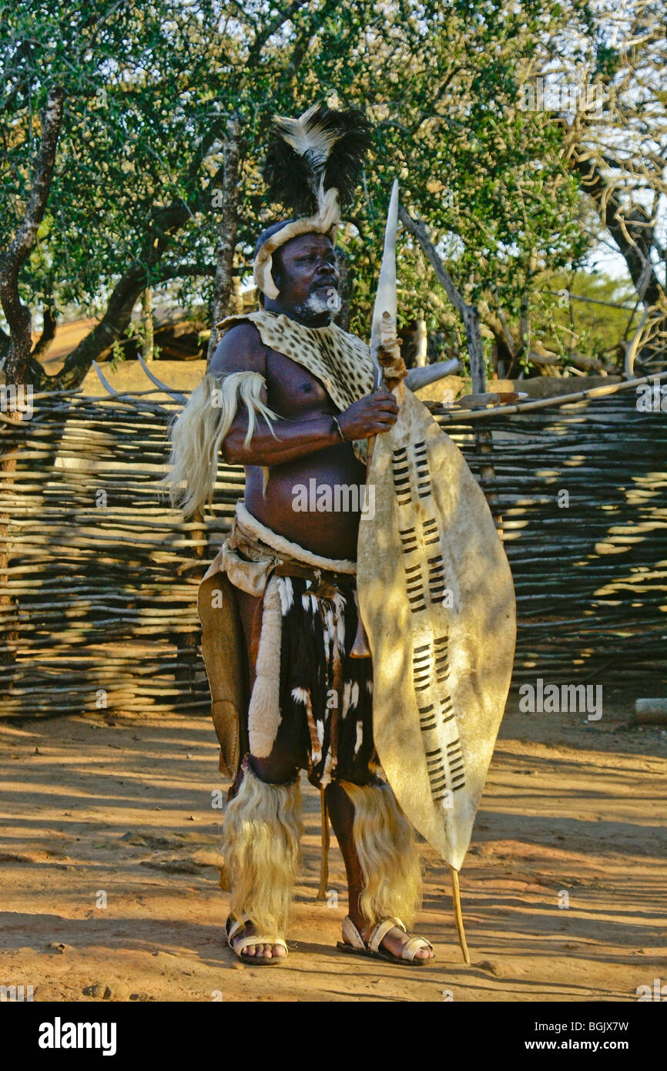
Downloaded from Internet

The chief was the head of the village. He was usually the wealthiest man in the village as he received cattle from his people when he settled their arguments or disagreements. He also fined them for wrong doing. His men also handed him cattle which were taken from any other chiefdoms that they defeated in war. The chiefs used their position of power to accumulate wealth.

The duties of the chief were as follows:
- He had to divide the land among the people, which meant that he could give and take land away. The land was not owned by any particular person and was the property of the entire village.
- He saw to the affairs of the chiefdom such as listening to complaints and settling disagreements.
- The chief was also in charge of social relations such as marriage and decided the lobola.
- The responsibility of the chief was to make sure the village laws were obeyed and if anyone broke the laws or did wrong, the chief could punish them.
- He also had to protect the chiefdom in times of trouble, to provide food during famine and to invoke the spirits of the ancestors.
- A chief who went against the will of his people and did not keep them happy was replaced by someone else.
- The chiefs consulted with the elders when making important decisions.
Adapted from Viva Social Sciences

  - Give TWO (2) ways in which the villagers cooperated to ensure the well-being of the chiefdom. (2)
______________________________________________________________________________________________________________________________________________________________________________________________________

  - Explain THREE (3) ways in which the chief accumulated his wealth (3)
________________________________________________________________________________________________________________________________________________________________________________________________________________________________________________________________________
  - In a paragraph of FIVE (5) sentences, discuss the role of the chief in a farming community. Your paragraph should have: a topic sentence, supporting sentences and a concluding sentence. (5)
____________________________________________________________________________________________________________________________________________________________________________________________________________________________________________________________________________________________________________________________________________________________________________________________________________

Level 1 | - Uses evidence in an elementary manner e.g shows little or no understanding. Uses evidence partially to report on topic or cannot report on topic | Marks: 0-1
Level 2 | - Evidence is mostly relevant and relates to a great extent to the topic. Uses evidence in a very basic manner. | Marks: 2-3
Level 3 | - Uses relevant evidence e.g demonstrates a thorough understanding.  - Uses evidence very effectively in an organised paragraph that shows an understanding of the topic | Marks: 4-5

(10)

ACTIVITY 7 Date: __________________
(THE ROLE OF CATTLE)
Study the source and answer the questions that follow.
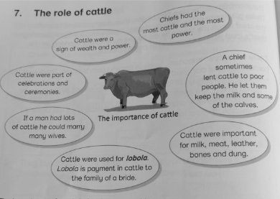 Adapted from Clever Social Sciences

7.1 Rewrite the statement in the bubble that shows that cattle meant wealth and power.
(1)
____________________________________________________________________________________________________________________________________________

7.2 Why do you think cattle, instead of money, were used to pay lobola in the farming community? (2)
_____________________________________________________________________
_____________________________________________________________________
7.3 Nowadays people use money to pay lobola, do you think money is more valuable than cattle? (2)
_____________________________________________________________________
_____________________________________________________________________
7.4 Use the source to complete the following table.
ITEM | WHAT IT WAS USED FOR
 | Making clothes
- Milk
 | For refurbishing the hut floor
(3)

In a paragraph of FIVE (5) sentences, explain why cattle were important in the early farming community. Your paragraph should have a topic sentence, supporting sentences and a concluding sentence. (5)
______________________________________________________________________
______________________________________________________________________
______________________________________________________________________
______________________________________________________________________
______________________________________________________________________
______________________________________________________________________
Level 1 | - Uses evidence in an elementary manner e.g shows little or no understanding. Uses evidence partially to report on topic or cannot report on topic | Marks: 0-1
Level 2 | - Evidence is mostly relevant and relates to a great extent to the topic. Uses evidence in a very basic manner. | Marks: 2-3
Level 3 | - Uses relevant evidence e.g demonstrates a thorough understanding.  - Uses evidence very effectively in an organised paragraph that shows an understanding of the topic | Marks: 4-5

(13)

