ISIZULU – ISIVIVINYO SOKUPHELA KONYAKA WEZI-2024

IBANGA : LESI- 6
ITHEMU : YESI – 4
AMAHORA : AMA-2
AMAMAKI : ANGAMA-50
OHLOLAYO :_________________________________

IGAMA : _______________________________________________________________

USUKU LOKUZALWA: ________________________________________________________

UBULILI : _________________________

IMIYALELO KUBAFUNDI

- FUNDA YONKE IMIYALELO NGOKUCOPHELELA
- PHENDULA YONKE IMIBUZO NGOLIMI LWESIZULU
- BHALA NGOBUNONO

OKUQUKETHWE
- UMBUZO 1 : UMBHALO OFUNDWAYO (20) ______
- UMBUZO 2 : UMBHALO OBHUKWAYO (10) ______
- UMBUZO 3 : UKUFINQGA (05) ______
- UMBUZO 4 : IZAKHIWO NOKUSETSHENZISWA ZOLIMI (15) ______
ISAMBA _____50________

UMBUZO 1: UMBHALO OFUNDWAYO (20)
Isitifiketi Sikamatikuletsheni
Ayikho into ebaluleke njengesitiketi sikamatikuletsheni namuhla. Empeleni nje siyibhuloho lokuwelela ekusaseni eliqhakazile.
Mibalwa kakhulu imikhakha ongaphumelela namuhla kuyona ngaphandle kwesitifiketi sikamatikuletsheni. Kwakungcono kuqala ngoba wawukwazi ukufundela imisebenzi ethile ngaphandle kwesitifiketi sikamatikuletsheni. Phela ngalezo zikhathi wawuba wuqweqwe lukathisha, ube yinkunzimalanga kamabhalane ezikhungweni ezahlukahlukene zikahulumeni, ube ngumhlengikazi njalonjalo. Kepha namuhla ilanga lingawa licoshwe zinkukhu, ayisakhulunywa kwakukhunywa leyo ndaba.
Namuhla ukuze nje uthathe ipeni ufake isicelo sokuyofundela umsebenzi othile ezikhungweni zemfundo ephakeme, kudingeka isitifiketi sikamatikuletsheni kuqala. Sekungakhulunywa kamuva- ke ukuthi simiklomelo emihle kangakanani. Lokhu-ke kukufakazela ngokusobala ukubaluleka kwalesi sitifiketi entsheni ukuze phela iwelele emadlelweni aluhlaza.
Ngeshwa elikhulu-ke kumbalwa kakhulu namhlanje ongaziphilisa ngakho ngaphandle kwemfundo. Engani ngisho ezemidlalo ziyidinga kakhulu imfundo. Kwakukudala lapho umuntu ayethi angaphumelela kwezemidlalo bese ekhohlwa ukufunda. Bonke labo ababenza kanjalo, baphelela ezeni okwesithukuthuku senja. Bheka nje oMnumzane Kaizer Motaung, oMnumzane Jomo Sono kwezebhola lezinyawo, abaculi abahamba phambili oJabu Hlongwane, oMthunzi Namba nabanye abaneziphiwo ezahlukahlukene, bakuleli zinga njengoba bazinika ithuba lokufunda nakuba babenethalente eliyisimanga emikhakheni yezemidlalo nasemculweni. Namuhla iningi labo libuya phesheya kwezilwandle ngenxa yakho ukuthi ithalente labo balendlalela ngemfundo. Ayikho-ke imfundo esezingeni elifanele namuhla ngaphandle kukamatikuletsheni.
Pho thina basha sizithambiselani? Asilisebenzisi ngani ithuba esilinikwe nguMdali? Ingozi enkulu njalo ngaleli thuba liyedlula, ngakho lidinga silibambe ngazo zombili, singalindi amathonsi abanzi. Okuhle namuhla ukuthi uHulumeni uvule amathuba okufunda mahhala. Ngakho-ke akekho ongakhala ngokuthi angisizuzanga isitifiketi sikamatikuletsheni ngoba ngivela emndenini odla imbuya ngothi. Akudingeki ngisho indibilishi ukuze uzitholele lesi sitifiketi esibaluleke kangaka.
Ngaphezu kwalokho ezikoleni kuyadliwa namuhla, abafundi bathola ipuleti eligcwele zonke izinsuku ukuze phela bathibe inkemane. Izikole ziqhibukise okwamakhowe selokhu kwathatha uHulumeni wentando yeningi. Abafundi bakhetha ukuyofunda kwabasithandayo, bayeke abangasithandi. Izincwadi zokufunda zihlinzekwa mahhala ezikoleni. Ngakho-ke akusekho ukuvika ngokuthi ngizoya kanjani esikoleni ngoba ayikho imali yokuthenga izincwadi. uHulumeni uchitha izigidigidi zamarandi ekhokhela izinkampani ezikhiqiza izincwadi ukuze phela wonke umuntu afunde kuleli zwe. (290) (Le ndaba icashunwe encwadini IsiZulu Esicwengekile Esisha ibanga lesi- 7 )

Imibuzo:
  - Ikhuluma ngani le ndaba ngegama elilodwa? (1) __________________________________________________________________________
  - Bala izibonelo ezintathu zemisebenzi umuntu ayekwazi ukuyifundela kuqala ngaphandle kwesitifiketi sikamatikuletsheni ezibalwe kule ndaba. (3)
__________________________________________________________________________________________________________________________________________________________________________________________________________________________________________
  - Yibaphi abantu ababili ababalwe umbhali wale ndaba abanempumelelo emdlalweni webhola lezinyawo? (2)
____________________________________________________________________________________________________________________________________________________________
  - Bala kube kubili okuhle okwenziwe nguHulumeni ngenhloso yokwenza ithuba lemfundo livuleleke kubo bonke abantu okubalwe ngumbhali kule ndaba. (2)
____________________________________________________________________________________________________________________________________________________________
  - Ngokucabango kwakho ngabe la mazwi ayiqiniso noma awumbono. Usho ngani?
Akukho namhlanje ongaziphilisa ngakho ngaphandle kwemfundo. (2)
________________________________________________________________________________________________________________________________________________________________________________________________________________________________________________________________________________________________________________________
  - Nikeza incazelo yalezi zisho ezilandelayo
    - Ukudla imbuya ngothi. (2) ________________________________________________________________________________________________________________________________________________
    - Ukudla izambane likapondo. (2) ________________________________________________________________________________________________________________________________________________
  - Ngokwale ndaba ukuze wamukeleke esikhungweni semfundo ephakeme kudingeka ube nani kuqala. (1) ____________________________________________________________________________________________________________________________________________________________
  - Ngokucabanga kwakho yiziphi izinkinga ezihlangabezana nomuntu ongenawo umatikuletsheni? (2)
________________________________________________________________________________________________________________________________________________________________________________________________________________________________________________________________________________________________________________________
  - Hlobo luni lwesifenqo lolu?
Ziqhibukise okwamakhowe (1) __________________________________________________________________________________________________________________________________________________________________________________________________________________________________________
  - Nikeza igama elimqondofana nelithi inkemane. (1) ______________________________________________________________________________
  - Sebenzisa igama ‘inkemane’ ukwakha umusho oqondile.
________________________________________________________________________________________________________________________________________________________________(1)

[ISAMBA 20]
UMBUZO 2: UMBHALO OBUKWAYO (10)
Buka lesi sithombe bese uphendula imibuzo elandelayo:
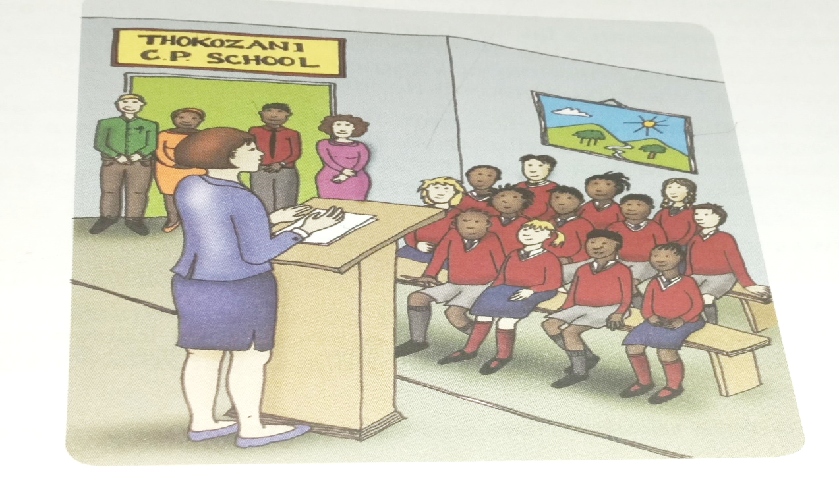
  - Nikeza okukodwa okubona esithombeni. (1)
____________________________________________________________________________________
  - Bakuphi laba bantu uma ubukisisa isithombe? (1)
____________________________________________________________________________________
  - Yini ekhombisa ukuthi kunabafundi kulesi sithombe? (1)
____________________________________________________________________________________
  - Bhala igama lesikole abafundi abafunda kuso. (1)
____________________________________________________________________________________
  - Yisiphi isihloko obungasinika lesi sithombe? Nikeza isizathu sempendulo yakho. (2)
____________________________________________________________________________________
____________________________________________________________________________________
  - Umfundi olalela abazali nothisha uphumelela kahle. Yebo noma Cha? Sekela impendulo yakho. (2)
____________________________________________________________________________________
____________________________________________________________________________________
  - Ngokucabanga kwakho yikuphi okwenza abafundi ukuba bangaphumeleli kahle ezifundweni zabo. (2)
____________________________________________________________________________________________________________________________________________________________________________
[10]

UMBUZO 3: UKUFINGQA (5)
Funda le ndaba elandelayo bese uyayifingqa ngamagama asukela kwamagama-60 kuya kwangama -70
Bavale umgwaqo bekhalaza eJozini
Amalungu omphakathi endaweni yaseMachibini, ngaphansi kukaMasipala waseJozini, kuthiwa avuke indlobane avala umgwaqo ophakathi kwedolobha iJozini noMkhuze izolo, ekhala ngamanzi okuthiwa asephila ngokuwathenga njengoba engabonwa. Umphakathi uthi sekuphele iminyaka uthenjiswa ukufakelwa amanzi, kufika nezikhulu zikahulumeni ezehlukene kodwa kujike kucwebe ekubeni wakhele idamu elikhulu iJozini. Elinye ilungu lomphakathi ebeliyingxenye yalokhu kuphazanyiswa kokuhamba kwezimoto elikhulume neSolezwe, lithe kwevile eminyakeni emihlanu manje belokhu bethenjiswa ukuthi amanzi bazofakelwa wona. “Okubuhlungu wukuthi indawo yakithi ingaphezudlwana kwekhilomitha ukuya edanyini elikhulu esilakhele kangangoba imfuyo iphuza khona. Kube ngangamakhilomitha amahlanu noma ngaphansi ukuya kwisihlanzimanzi sakhona lapha eJozini. Kuyaxaka ukuthi yikuphi okubambile ekutheni sihlinzekwe ngamanzi? Sekuphoqa ukuthi sikhokhe uR800 wethangi ukuthenga amanzi ngoba phela siyawadinga,” usho kanje. Uthe iloli lamanzi sekuphele izinyanga lingabonwa endaweni.
Elinye ilungu lomphakathi elingathandanga ukudalulwa, likhale ngokungabonwa kwekhansela lendawo ukuzama ukuthola isixazululo ngokuphakelwa ngamanzi umphakathi. “Ngesikhathi sivota, wayesithembise ukuthi uzoyisukumela inkinga yamanzi. Ikhansela selokhu saligcina ukulibona ngesikhathi silivotela, asiphindanga sezwa lutho ngalo,” usho kanje. Ikhansela uNksz Ncamisile Zulu, likuphikile ukuthi lalikhankasa ngamanzi nokungabonakali kwalo emphakathini. “lokhu yipolitiki yabathile nje ukuzama ukungcolisa amagama abanye. Amanzi awuhlelo lukaMasipala Umkhanyakude, kodwa nathi kasisongile izandla. Likhona iloli elalinikezwe umasipala ngesikhathi kugasela iCovid-19, elingenelelayo uma kunezimo eziphuthumayo. “Kuyiqiniso ukuthi ngenxa yomnqakiswano okhona phakathi kwe-ANC ne-IFP kuMasipala Umkhanyakude, kube nomthelela ongemuhle ekuhlinzekweni komphakathi ngamanzi. Sizamile kodwa ukungenelela ngixhumana nemeya kuMasipala waseJozini nezinye iziphathimandla, ukugudluza amatshe nokuthi kuxoxwe, iloli lamanzi leli esinalo likwazi ukuphakela umphakathi,” usho kanje.
UNksz Zulu uveze ukuthi yize abantu bebemile ekutheni kabasawafuni amanzi amaloli nokuthi kabawasusi amatshe abebevale ngawo umgwaqo kodwa ngokungenelela kwamaphoyisa isimo sikwazile ukubuyela kwesijwayelekile. Uthe kuphunywe nesinqumo sokuthi imeya kulo masipala nalo ikhansela bazohlanganisa amakhanda namhlanje, ukuzama ukuthola isixazululo njengoba kusalindwe uNgqongqoshe wezaManzi nokuThuthwa kwendle kuleli, uMnuz Senzo Mchunu, owathembisa ukuthi uzovakashela uMasipala waseMkhanyakude, ngodaba lwamanzi. [280]
Isolezwe,umsombuluko, Agasti 8, 2022

IRUBHRIKI YOKUMAKA
- Ukubhala ubeke ngawakho amagama | 1
- Ukuhlala engqikithini | 2
- Ukulandelanisa izigameko | 1
- Ukusebenzisa ulimi oluqondile | 1
ISAMBA | 5

______________________________________________________________________________________________________________________________________________________________________________________________________________________________________________________________________________________________________________________________________________________________________________________________________________________________________________________________________________________________________________________________________________________________________________________________________________________________________________________________________________________________________________________________________________________________________________________________________________________________________________________________________________________________________________________________________________________________________________________________________________________________________________________________________________________________________________________________________________________________________________________________________________________________________________________________________________________________________________________________________________________________________________________________________________________________________________________________________________________________________________________________________________________________________________________________________________________________________________________________________________________________________________________________________________________________________________________________________________________________________________________________________________________________________________________________________________________________________________________________________________________________________________________________________________________________________________________________________________________________________________________________________________________________________
UMBUZO 4: IZAKHIWO NEZIMISO ZOKUSETSHENZISWA KOLIMI ENGQIKITHINI (15)
Funda lesi siqeshana sendaba bese uphendula imibuzo elandelayo.
Ukudlala kuyimpilo
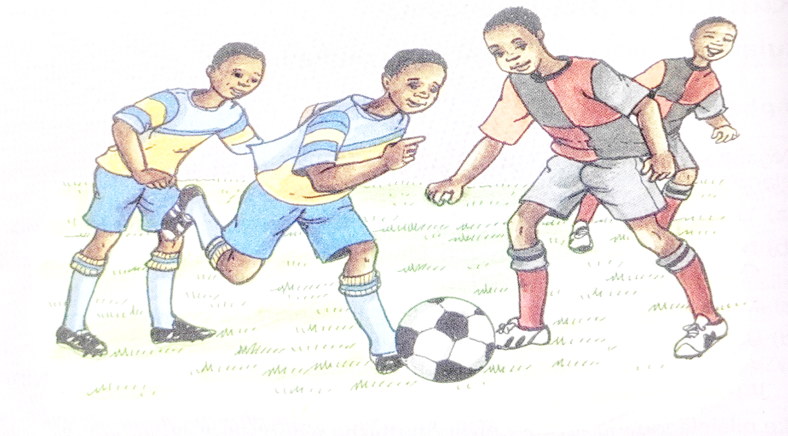
Ezemidlalo zibalulekile kakhulu ekuhlanganiseni abantu bezinhlanga ezehlukene, amasiko nezilimi ezehlukene kanye namazwe ngamazwe.
Umdlalo awukhethi bala, bulili, minyaka, isimo owakhiwe ngaso njalonjalo. Uma uyobukela umdlalo enkundleni noma yimuphi uyofike uthole lonke uhlobo lwabantu lujabule futhi luhleli ngokuzwana.

Nokho eNingizimu-Afrika sisenenkinga yokuhlanganisa abantu kweminye yemidlalo ngenxa yobandlululo olwalusihlukanisile. Ibhola lezinyawo lake laba namaLigi amabili. iLigi yabamhlophe yayibizwa ngokuthi iNational Football League (NFL) kanti eyabamnyama yona yayibizwa ngokuthi iNational Professional Soccer League (NPSL).
Ngonyaka we-1978 lama Ligi omabili ahlangana abizwa nge NPSL. Emva kwezinkinga futhi ezaba khona, kwabe sekwakhiwa iNational Soccer League (NSL) ngonyaka we-1985. Izinkinga zokwakha iLeague eyodwa zaqhubeka kwagcina ngokuvunyelwana kwakhiwa iPremier Soccer League (PSL) kuze kube namuhla. iPSL yona ke ingaphansi kwesigungu esingamele ibhola lezinyawo laseMzansi iSouth Africa Football Association (SAFA). Lesi yisona sigungu-ke esihlanganisa nezinye izigungu zakwamanye amazwe kanye naleso esiphethe ibhola lomhlaba iFIFA.

Imidlalo eminingi isithuthuke yaze yafika ezingeni lomhlaba. Njalo ngonyaka wesibili amazwe ase-Afrika adlalela inkomishi ebizwa ngokuthi yi-Afrika Cup of Nation (AFCON) nokho ngokuzayo sekuzoba iminyaka emine.
Kwaba nomdlalo wombhoxo noma iRagbhi ngeminye imidlalo iNingizimu Africa eyaphumelela kuwo emazingeni amazwe 24 kuNhlangulana ngonyaka we-1995.

Kubalulekile-ke ukuthi imidlalo siyihloniphe futhi sidlale thina bantwana uma ithuba livuma ukuze ngelinye ilanga sibe ngoshampeni. Imidlalo iyosisiza ekwakheni izwe laseNingizimu Afrika ehlangene.

[ISIZULU SOQOBO incwadi yomfundi – ibanga-6]

IMBUZO:

  - Khipha isandiso kule misho elandelayo uphinde uchaze ukuthi siwuhlobo luni.
- Abantu bayazwana enkundleni yezemidlalo (2)
_________________________________________________________________________________
  - Tomula umenzi kanye nomenziwa kulo musho elandelayo.
- Abafana badlala ibhola lezinyawo (2)
_________________________________________________________________________________
_________________________________________________________________________________
- Izinhlanga ezahlukene zihlanganiswa iNingizimu-Afrika. (2)
_________________________________________________________________________________
_________________________________________________________________________________
  - Bhala umusho ophoqayo usebenzise isenzo. Hlonipha (1)
____________________________________________________________________________________
  - Lungisa lo musho olandelayo ufake ikholoni.
- Umphathi wesigungu wathi “dlala ibhola” (1)
____________________________________________________________________________________
  - Khipha umusho oyinhloko kulo musho olandelayo.
- Ziyasekwa lapha eNingizimu-Afrika ezemidlalo. (1)
________________________________________________________________________________
  - Akha imisho embaxa ngale misho ubenzise izihlanganiso ezilandelayo. Ketha kulezi ezilandelayo. Kodwa, ngoba
- Sasheshe safika enkundleni. indlela yayinqamulela. (1)
______________________________________________________________________________________________________________________________________________________________
- I-PSL inhlangano yebhola. I-PSL ayinazinqumo kweyomhlaba. (1)
______________________________________________________________________________________________________________________________________________________________
  - Yisho ukuthi le misho elandelayo iyisifaniso, isingathekiso noma isenzasamuntu.
- Zinyawo zami ngibelethe. (1)
_______________________________________________________________________________
- iSAFA inamandla indlovu uqobo lwayo. (1)
_______________________________________________________________________________
  - Bhala imisho emibili ngebizo elilandelayo ekhombisa izincazelo ezahlukahlukene.
Idumbe (2)
_________________________________________________________________________________________________________________________________________________________________________________________________________________________________________________________
[15]
[ ISAMBA 50]
@@@@@@@@@@@@@@@@@@@@@@@@@@@@@@@@@@@@@@

