TERM 1 TASK 3 RESPONSE TO TEXTS PART A: READING COMPREHENSION
NAME:

Instructions:

- Read the text below twice.
- Answer the questions that follow.

Should English be the only official language in South Africa?

Some people believe that English should be the only official language in South Africa. There are many arguments to back this up. Most people in South Africa already learn English at school, even if English is not their home language.
English is everywhere. There is English in our homes: on our televisions, in film, radio, music and books. Eighty per cent of the information on the Internet is in English, so people who speak English will have a technological advantage.
English is still the most popular language for teaching at university. If you understand English, it will help you to study further. English should be the official language so that the same opportunities are accessible to everyone.

On the other hand, some people are fiercely against making English the only national language. They argue that if English were the only official language, we would lose a lot. Our home languages are the ones we learn first, as babies. We learn to think in those languages, and the way they are set out (their sounds, grammar and idiomatic sayings) shapes the way we think about the world. If we only speak English, we risk of losing those languages. Our home languages need to be supported and developed because languages protect cultures and traditions. We should be making more books, movies, and music in all our many languages. One language is boring! Who wants only one way of doing things?
We need to learn one another’s languages and encourage the growth of all people’s rich heritage.

QUESTIONS:

List three reasons why some people say English should be the only official language in South Africa. [3]
Some people say English should be the only official language in South Africa because

Name two places where we hear English being used and spoken in our homes? [2]

We hear English on the

How much of the information on the Internet is in English? [1]

of the information on the Internet is in English.

The main point in the first paragraph is: (Tick the correct answer.) [1]

  - English is the best language.

  - Everyone who speaks English can go to university.

  - English should be the only official language in South Africa.

Write down the phrase in the second paragraph that shows the writer is now going to give the other side of the argument. [1]

- Why does the writer say we would lose our many cultures and traditions if we only had English as the national language? [2]
If we only had English, we would lose our many cultures and traditions because

_

Does the writer think English should be the only official language? Give a reason for your answer. [2]
The writer thinks

- Quote (write down) an example of a fact from the first paragraph. [1]

- Quote (write down) an example of an opinion in the second paragraph. [1]

- Why do you think the writer wrote this article? [2]

I think the writer wrote this because

Do you think English should be the only official language in South Africa? Why or why not? [2]
I think

because

- Rename this text with your own title. [2]

TOTAL: 20 MARKS

TERM 1 TASK 3 RESPONDS TO TEXTS PART B: VISUAL COMPREHENSION
NAME:

Graph of official languages in South Africa
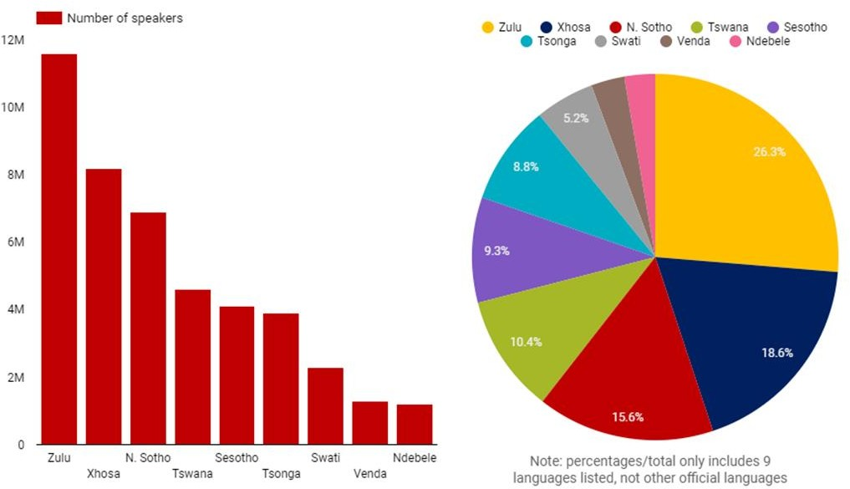

QUESTIONS:

Which language is spoken by the most people in South Africa? How many million people speak this language? [2]
is spoken by the most people. million people speak this language.

What percentage of people speak Northern Sotho in South Africa? [1]

of people speak Northern Sotho.

How many million people speak Xhosa? [1]

speak Xhosa.

Which has more speakers Sesotho or Tsonga? [1]

has more speakers.

How many languages do you speak? Which is your favourite? Why? [2]

I speak languages. My favourite is , because

‘If you talk to a man in a language he understands, that goes to his head. If you talk to him in his language, that goes to his heart.’ - Nelson Mandela
Why do you think Mandela felt it was important to speak to people in their own language? [2]
I think Mandela thought it was important to speak to people in their own language because

Tick the correct word: If you are visiting South Africa, you will probably be invited to someone’s home for a:
  - barbeque

  - braai

  - cook out

  - grill
[1]

TOTAL: 10 MARKS

TERM 1 TASK 3 RESPONDS TO TEXTS PART C: LANGUAGE IN CONTEXT
NAME:

Instructions:

- Read the comprehension text and visual text again.
- Answer the questions that follow.

QUESTIONS:

Change the following sentences into the simple past tense:

  - English is not the only official language. [1]

  - There are many arguments to back this up. [1]

Change the following underlined verbs into the present progressive:

  - Even though she is not fluent, she tries to speak in isiXhosa. [1]

  - He was learning all 11 official languages. [1]

Change the following into the future tense:

  - Maybe someday we have even more official languages. [1]

  - I learn to say hello in new ways. [1]

Change the sentence into the passive voice:

Our home languages protect cultures and traditions. [1]

Change the sentence into the active voice:

Tswana is spoken by 10.4% of the population. [1]

- Look in the first paragraph of the comprehension text (Should English be the only official language in South Africa?) and find a synonym for:
  - reasons

  - well-liked [2]

Underline the correct adjective:

English is (difficult / more difficult / difficulter) to learn than Venda. [1]

(The fewest /Few / More few) people speak Ndebele. [1]

Punctuate the following sentence correctly:

I wish i spoke all the languages in south Africa she exclaimed [6 x ½ =3]

Read the sentence: ‘On the other hand, some people are fiercely against making English the only national language.’ Write down an example of: [2]
  - an adverb

  - a plural noun

Add a prefix to the following words to give them their opposite meaning:

  - advantage

  - popular [2]

Choose the idiom that fits best.

Even though we argued about some things, when it came to solving the problem, we all (agreed).
  - talked a mile a minute

  - spoke the same language

  - spilt the beans.
[1]
PART D: SUMMARY
- Read the following text and summarize it into 50 – 65 words outlining reasons why English should be the only official language in South Africa.

Some people believe that English should be the only official language in South Africa. There are many arguments to back this up. Most people in South Africa already learn English at school, even if English is not their home language.
English is everywhere. There is English in our homes: on our televisions, in film, radio, music and books. Eighty per cent of the information on the Internet is in English, so people who speak English will have a technological advantage.
English is still the most popular language for teaching at university. If you understand English, it will help you to study further. English should be the official language so that the same opportunities are accessible to everyone.
(Word Count: 117)
______________________________________________________________________________________________________________________________________________________________________________________________________________________________________________________________________________________________________________________________________________________________________________________________________________________________________________________________________________________________________________________________________________________________________________________________________________________________________________________________________________________________________________________________________________________________________________

TOTAL: 20 MARKS
TOTAL: 10 MARKS

TERM 1 TASK 3 RESPONDS TO TEXTS MEMORANDA PART A: READING COMPREHENSION MEMORANDUM
- Some people say English should be the only official language in South Africa because so many people already learn it / we hear it on TV, film, music, etc / 80% of the internet is in English / English is the language at most universities. (any 3) [3]
- We hear English on the TV / in films / in music / read it in books. (any 2) [2]
- 80% of the information on the Internet is in English. [1]
- c. English should be the only official language in South Africa. ✓ __ [1]
- ‘On the other hand…’ [1]
- If we only had English, we would lose our many cultures and traditions because our cultures and traditions are carried through our languages. Language influences how we think and see the world, it’s not just words that can be translated. So, if we only had English, all the other cultures and traditions would disappear. [2]
- The writer thinks English should not be the only official language. She thinks we would lose a lot and that one language and way of doing things would be boring. [2]
- Some people believe that English should be the only official language in South Africa.
/There are many arguments to back this up./Most people in South Africa already learn English at school, even if English is not their home language./ Eighty per cent of the information on the Internet is in English. /English is still the most popular language for teaching at university. (any 1 fact) [1]
- Our home languages need to be supported and developed because languages protect cultures and traditions./We should be making more books, movies, and music in all our many languages./One language is boring!/ We need to learn one another’s languages and encourage the growth of all people’s rich heritage. (any 1 opinion) [1]
- I think the writer wrote this because she feels that English should not be the only official language and she wants to convince the reader that her opinion is correct. [2]
- Learner’s own opinion with reason. [2]
- Learner’s own idea for a new title. Must show some understanding of the content of the text. [2]
TOTAL: 20 MARKS

PART B: VISUAL COMPREHENSION MEMORANDUM

- Zulu is spoken by the most people in South Africa. Approx 11.5 million people speak this language. [2]
- 15.6% of people speak Northern Sotho. [1]
- 8 million speak Xhosa. [1]
- Sesotho has more speakers. [1]
- Learner’s own response. Award marks for completing the sentences correctly.

I speak languages. My favourite is , because
- I think Mandela thought it was important to speak to people in their own language because it shows respect and does more than just saying words. It’s about ideas and ways of seeing and understanding the world. (learner’s answer to show some deeper
[2]

understanding of this) [2]

- braai ✓
[1]
TOTAL: 10 MARKS

PART C: LANGUAGE IN CONTEXT MEMORANDUM

- a. English was not the only official language. [1]
b. There were many arguments to back this up. [1]
- a. Even though she is not fluent, she is trying to speak in isiXhosa. [1]
b. He is learning all 11 official languages. [1]
- a. Maybe someday we will have even more official languages. [1]
b. I will learn to say hello in new ways. [1]
- Cultures and traditions are protected by our home languages. [1]
- 10.4% of the population speaks Tswana. [1]
- a. arguments
b. popular [2]
- English is (difficult / more difficult / difficulter) to learn than Venda. [1]
- (The fewest /Few / More few) people speak Ndebele. [1]
- ‘I wish I spoke all the languages in South Africa!’ she exclaimed. [6 x ½ =3]
- fiercely [1]
- people [1]
- disadvantage [1]
- unpopular [1]

- spoke the same language ✓
[1]

TOTAL: 20 MARKS

PART D: SUMMARY MARKING GUIDELINE
Criteria | Marks
6-7 relevant points | 6
4-5 relevant points | 4
2-3 relevant points | 2
Learner has followed correct verbatim | 2
Learner has used his or her own words | 2
TOTAL | 10

