GRADE 7
TERM 3
DANCE

WORKSHEETS

Activity 1
Compare the two columns and match the correct answers
Column A |  | Column B
1.1 Physical area where the body does not occupy C | A. 1.3 | Accent:
1.2 It maintain dance position, shapes, balance, can perform locomotor and or non locomotor, D. | B. 1.5 | Time:
1.3 Strong movements done during dance to send a message A. | C  .1.1 | negative space
1.4 Is a physical area the body moves, a dance can move from point A to B showing levels E. | D. 1.2 | Body
1.5 involves rhythm, tempo accent and duration B. | E. 1.4 | Space:
Activity 2
Choose the correct term inside the box that gives a complete meaning of the explanation
Tempo ,locomotor Pathways Freeze Body base
2.1 A sudden stop during a dance movement freeze …..
2.2 Body base .is part of the body that support the rest of the body
2.3 Pathways is a dance route by dancers when one moves to A the other moves to C and the other to D
2.4 When the body of a dancer moves from one point to another is locomotor movement
2.5 Tempo.is the speed at which a dancer moves ( fast or slowly)

Activity 3
Find the correct explanation of the following words on your own

3.1 Dance studio:_a special place where dancers can train, rehearse and create their dances

3.2 Dress code :the right clothes for the dance style so as to make moves well and stay safe.

3.3 Fluidity: the smooth ,continuous and seamless quality of movement_

3.4 Hamstrings :a group of three muscles located at the back of the thigh, the biceps femoris, semitendinosus and semimembranosus. _______________________________________________________

3.5 Dance teacher a professional who instructs individuals or groups in various styles of dance, helping them develop technique, creativity, rhythm and physical fitness. :_____________________________________________________

Activity
4 explain the following Careers to show that you understand them
4.1 Choreographer: _: a person who creates dances

4.2 Dance therapist”: a person who uses dance and movement to help people feel better in their body and mind.

4.3 Dance writer: __: is someone who writes about dance _

4.4 Dance manager: __ a person who organizes and takes care of the business side of dance

4.5 Rehearsal Director: _ a person who helps dancers practice, improve and prepare for the dance performance

Activity 5
Carefullt study the following pictures in conjunction with the explanations in Column B and match with the relevant dance styles in column A
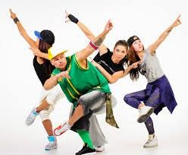 | 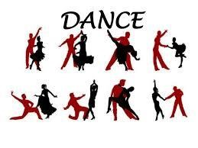
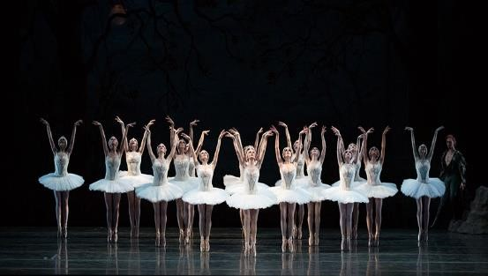 | 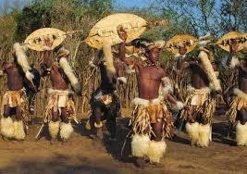

Column A | Column A
5.1 ballroom B | A .A street dance style primary performed to music that evolves in popular culture around the year 1970s
5.2 hip hop .A | B Is a set of partner dances which are enjoyed both socially and competitively around the world on stage or film and television
5.3 African D | C.A classical style of expressive dancing based on precise conventional steps with gestures and movements of grace and fluidity and human emotions
5.4 Eastern dance E | D.Various dance styles of sub-Saharan Africa connected with traditional rhythms using music and bodily movements
5.5 ballet C | E.It is also known as Dance of the Orient is a category of professional forms of the dance including forms of belly dance known as Raqs Baladi, Saídi. Ghawazee and Awalim

Activity 6
Give your own understanding of the following in terms of the dance rules in the dance class
6.1 Dance costume
6.2 Jewellery
6.3 relationship amongst fellow dancers
6.4 Punctuality
6.5 entering and leaving the dance class

Activity 6
Read the passage below about Ballet as one of the dance styles (form) as taken from
From Wikipedia, the free encyclopedia
Ballet
Ballet is a French word which had its origin in Italian balletto,a diminutive of ballo (dance) which comes from Latin ballo, ballare, meaning "to dance", which in turn comes from the Greek "βαλλίζω" (ballizo), "to dance, to jump about". The word came into English usage from the French around 1630.

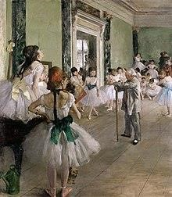
Classical bell tutus in The Ballet Class by Degas, 1874
Ballet (French: [balɛ]) is a type of performance dance that originated during the Italian
Renaissance in the fifteenth century and later developed into a concert dance form in France and Russia. It has since become a widespread and highly technical form of dance with its own vocabulary.
Ballet has been influential globally and has defined the foundational techniques which are used in many other dance genres and cultures. Various schools around the world have incorporated their own cultures. As a result, ballet has evolved in distinct ways.
A ballet as a unified work comprises the choreography and music for a ballet production. Ballets are choreographed and performed by trained ballet dancers. Traditional classical ballets are usually performed with classical music accompaniment and use elaborate costumes and staging, whereas modern ballets are often performed in simple costumes and without elaborate sets or scenery.

4.1 Define ballet as defined in the first paragraph?
4.2 Ballet is one of indigenous dances, do you agree or disagree with this statement? support your choice
4.3 How was Ballet dance perceived in France and Russia?
4.4 Apart from being a dance form Ballet also was considered a technological kind of a language, quote word(s) that talks to this
4.5 Ballet is a local dance true or false, support your statement
4.6 Any person can dance ballet, discuss this
4.7 Summerise your understanding of this dance

Carefully look at the four pictures below and answer question based on them

TERM 3 PRACTICAL ASSESSMENT ASK ART FORM: DANCE
Activity performing a short South African dance, e.g. gumboot, nama stap, amapiano, pantsula based on a theme, an idea, a story, a picture, music, or prop
a dance must clearly be a group or solo dance Performance
Task for: 25 Marks in 3 to 5 minutes, your dance must show the following:
- Unity in performance as a group
- Originality of the dance: (gumboot, nama stap, amapiano, pantsula)
- Creativity in combining music and the dance
- Connectivity with the audience
- Is the stimuli/theme used clear or identifiable
- Performing a short South African dance, e.g. gumboot, nama stap, amapiano, pantsula
•

Date: ________________________ End Date: _________________
Name your Dance __________________________________________
Group members: ______________________ _________________________
______________________ _________________________
________________________ _________________________

 |  | Group dance performance
 | Not achieved 0 | Below standard  1 | Average 2 | Good 3 | Very good  4 | Excellent 5
Unity in performance as a group | No unity | Does not work well with group | Very little participation and group spirit shown | Just enough participation and group spirit shown | Works well with rest of group | Team player
Originality of the dance | Not shown | Shown but confusing | Just shown at average level | Original as  expected | Original and above average | Very original, exceeded  expectations and beyond
Creativity in combining music and the dance | Not combination | Combination to some instances | Some  attempt to combine  music and  dance was made | Combination  Professionally done, but still a little untidy | Professional  Combination of music and dance | Professional  Combination  of music and dance
Connectivity with the audience | No  Connectivity with the audience | Connectivity with the  audience here and there | Connectivity with the  audience was notable | Connectivity with the  audience  was detected in the dance | Connectivity was very good and the  audience  was captured  by it | Excellent Connectivity.  And It kept the audience  on the edge of their seats
Is the stimuli/theme used clear or identifiable | Not clear or identifiable | stimuli/theme is confusing | stimuli/theme  can be improved | stimuli/theme on an  acceptable standard | stimuli/theme  Professionally shown | Excellent and hard  work done to bring out the relevant stimuli/theme

GRADE 7
TERM 4
DANCE
WORKSHEETS

DANCE TERM 4

ACTIVITY 1
Answer the following questions by writing down the correct alphabet
1.1To move one part of your body during warm up or dance moves is known as ……
. A. transition
- spotting
- body part isolation
- aerial movement

1.2 .What do we call an act of changing from one movement to another during a dance?
- floor-work
- elevation
- staccato
- transition

1.3 The … is the main tool for dance moves
A. . Space.
- Body
- Relationship.
- Radio

1.4. What do we call a dance that originated in South African hostels and mines?…
. A.Gumboots dance.
- Ballet dance.
- Yoga.
- Waltz.

1.5.What do we call an act of focussing your eyes into one area during dance ?
B Alignment
- Spotting
- Balance.
- Changing.

ACTIVITY 2
Indicate whether the statement is TRUE or FALSE.
  - Aerial movement are known as locomotor movements … False
  - Flexibility means the stiffness of the body during dance moves… False
  - Warm up exercises are done to prepare the body before an activity … True....
  - Personal hygiene is one of the principles of posture and alignment… False.
  - Toe- ball- heel-bend is a safe landing strategy …. True....

ACTIVITY 3

Match Column A with Column B
Column A | Column B
3.1. Floor-work E. | 3.2 A. the movable objects used in dance
3.2 Props/ Properties A. | 3.5 B. The way the steps follow one another
3.3 Reason for cooling down D | 3.4 C. increase heart rate
3.4 purpose for warming up C. | 3.3 D return the heart to its normal state
3.5 Dance Sequence B. | 3.1 E. Activities that are done on the floor
ACTIVITY 4
Answer the following questions
Define the following dance terms
4.1 Hip Hop Dance A high energy dance style that started in the streets of New York City in the 1970s

4.2 Cultural Dance: A special kind of dance that shows the traditions and stories of a group of people or country

4.3 African dance: A kind of dance from Africa that uses music and body movements to tell stories and celebrate

4.4 Eastern dance:Is a type of dance from Asian and Middle Eastern countries , it tells stories using graceful movements

4.5 Stimulus dance: A dance that begins with an idea or inspiration, the idea helps the dancer create the movements and tell a story through dance _______________________________________________________

ACTIVITY 6
Carefully study the picture below and answer the questions that follow
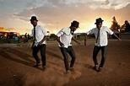
5.1 Name the type of dance represented by the picture above Kwaito or Pantsula_
5.2 Where do you think this dance originated_townships of South Africa
5.3 What makes these dancers identifiable? _It is known for its quick, sharp intricate foot movements performed at a fast pace.
5.4 Discuss 3 dance rules that make any team to be successful: teamwork and cooperation,a successful dance team must work together
-Practice and discipline makes dancers perfect timing, technique and coordination .
-Timing and synchronization all team members must stay in sync with the beat of the music and with each other.

5.5 Name any three dances that originate in South Africa_Gumbooot dance –Indlamu dance _-Venda dance-
______________________________________________________________________
TERM 4 PRACTICAL ASSESSMENT TASK ART FORM: DANCE
Activity: Dance improvisation and Composition:
In groups of 3 to 4 members based on a South African theme using a picture, photograph
Task for:25 Marks in 3 to 5 minutes, your dance must show the following: • Use of the theme following the South African issues as a stimulus
- Creativity and individuality of dancers:
- Use of relevant music
- Connectivity with the audience
- Use of dance element BSTRE

Date: ________________________ End Date: _________________
Name your Dance __________________________________________
Group members: ______________________ _________________________
______________________ _________________________
________________________ _________________________

 | Below  standard 1 | Average 2 | Good 3 | Very good  4 | Excellent  5
Use of the theme and connect with South African issues as a stimulus | theme used does not  connect with the dance | Very little  connection with the dance | Connection between  theme and dance shown | Connection shown well  with the entire dance | Connection shown  excellently
Creativity and individuality of dancers | Creativity and individuality shown but confusing | Creativity and individuality just shown at average level | Original  Creativity and  individuality displayed as expected | Original  Creativity and  individuality shown  above  average | Creativity and individuality, exceeded  expectations and beyond
Use of relevant music | Music used to some instances and not relevant | Attempted use of relevant  music to a minimal extent | Music used  Professionall y but can improve | Professional use of music combined with dance | Excellent use of music  Combination with dance at  professional level
Connectivity with the audience | Connectivity with the  audience minimally | Connectivity with the  audience was notable | Connectivity with the  audience was  detected in the dance | Connectivity was very good and the  audience  was captured  by it | Excellent  Connectivit  y. And It kept the audience on the edge of their seats
Use of dance element  BSTRE | Elements used in a confusing manner | Elements used but can improve | Elements used at an acceptable standard | Elements used  Professionally | All elements used  Excellently and  brings out the best performance

