History worksheet memorandum
Democracy and Citizenship
Definitions
- Democracy
- Classification
- Apartheid
- Protest
- Activist
- Prohibit
- Human Rights
- Elections
- Nationality
- Constitution
- Oppress
- Discrimination
- Symbol
- Legislation
- Equality
- Terminate
The first democratic government
- System of government where everyone can choose the leader of their choice
- By oppressing people and not allowing them to vote
- Nelson Mandela
- In the year 1994
- It meant that South Africa will be a democratic country and people will get their freedom
How people govern themselves in a democracy
- Any four Human rights
• Everyone has equal rights.
• Everyone has the right to freedom and security.
• Everyone has freedom of religion, belief, thought and opinion.
• Everyone has the right to vote for the person of their choice.
• Everyone has the right to be a citizen.
• Everyone has the right to choose what work they want to do.
• Everyone has the right to a clean and healthy environment.
• Everyone has the right to housing, healthcare, food and water.
• Children have special rights.
• Everyone has the right to education.
• Everyone has the right to use the language of their choice.
• No one has the right to interfere with other people’s rights.
- The values of freedom, respect for human rights and the principle of holding genuine elections
- A policy in South Africa that govern relations between white people
The enforced separation of different racial group in a country, community or establishment

- In 1994
- ANC African national congress
- It was the transition to democracy and the end of apartheid
- a. National Party, SACDP, ANC
b. in the apartheid days
c. Nelson Mandela
d.27 April 1994
e. because of the democratic country that we were to become and the equal human rights
f. the president of the country
g. any political party. ANC, DA, EFF,
h. Pius Langa, Fatima Meer, Nelson Mandela
How people govern themselves in a democracy
Match column A and B
- C
- E
- D
- F
- A
- B
Underline the answer.
- Clean drinking water
- Vote for
- Security of the person
- Culture
- Freedom of expression
- Equality
- Bill of rights
- Constitutional court
- Three
- Courts
The constitution and the bill of rights
- Life
- Political rights
- Health care, food, water and security
- Freedom of security
- Environment
- Access to court
- Language and culture
- Education
- Freedom of expression
- Freedom of religion, belief and opinion

The structure of the government
Three tasks of government | Who/what forms the branch | Function of the brand
- Legislative authority | Judges | Makes the laws
- Executive authority | The president with his MPs  The deputy president  The members of cabinet | Carries out the laws
- Judicial authority | Police force and all government organisations | Judges the law when it is broken

Rights and responsibilities in a democracy
Learner can give any of the right
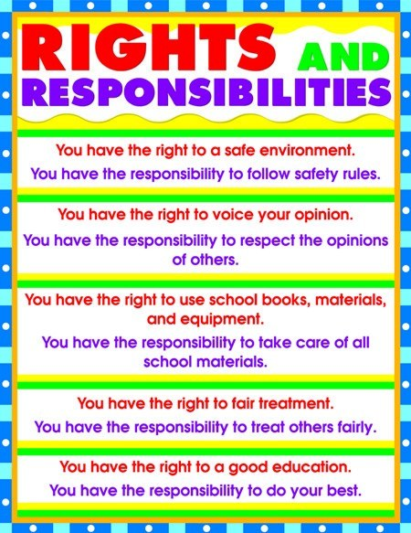

- Pius Langa timeline on page 9
1957 | Got a job at a shirt factory
1970 | Became a magistrate
1994 | Constitutional court was established
2005 | Appointed chief justice
2009 | He retired

- a. True -he passed his examination
b. false -during his studies he worked for the department
c. true -he became a member of the ANC
d. true- he was a chief justice
Children’s charter of rights and responsibilities
charter: a formal document that outlines the right and responsibilities of an organisation or institution
- right to play
right to not to work
right to food and proper nutrition
right to safe and secure environment
- the child has a responsibility to attend school and do their schoolwork
National Symbol page 10
- Symbols include a flag, coat of arms and a national anthem
2.National flag
- Yellow
- Red
- Blue
- Black
- Green
- White
3.Anthem of South Africa
- 5 languages

