INSTRUCTION TO THE LEARNERS
The teacher should read the instructions to the learners.

- Read all the question instructions carefully.

- Answer all the questions in the spaces provided.

- Where there are multiple-choice questions, circle only the letter of the correct answer.
- Where one word is required, write only the word in the space provided.

- Write neatly and legibly.

- This question paper consists of TWELVE questions:

STRANDS
NATURAL SCIENCES | ENERGY AND CHANGE
NATURAL SCIENCES | PLANET EARTH AND BEYOND

SECTION A ENERGY AND CHANGE
Question 1
Multiple choice. Read each question carefully, choose the correct answer from the options provided. Circle only the corresponding alphabet next to each question.

- Which of the following is an example of a renewable source of energy? /1

- Coal
- Hydropower
- Petrol
- Oil

- The energy found in a moving car is known as… /1

- Potential energy
- Kinetic energy
- Heat energy
- Chemical energy

- When wood burns, the _______ potential energy of the wood is released. /1

- Gravitational
- Elastic
- Chemical
- Potential

- The energy of the Sun is transferred to the Earth by… /1

- Radiation
- Conduction
- Absorption
- Convection

- One of the following is an example of fossil fuels. /1

- Natural gas
- Wind
- Hydropower
- Paper

Question 2
Match descriptions in Column A with the correct term in Column B and write answers in Column C. Write only corresponding alphabets next to each number. E.g., 1B /5
Column A | Column B | Column C
1. A material that allows heat to pass through. | a) Joule | 1.
2. All energy is measured in this unit. | b) Coal | 2.
3. Transmission of energy in a form of waves. | c) Conductor | 3.
4. Energy that is stored. | d) Radiation | 4.
5. Mostly used to generate electricity. | e) Potential energy | 5.

Question 3
State whether the following is True or False. Write answers in the spaces provided.

- An insulator is a material that does not transfer heat energy.

____________________

- Convection is the transfer of heat by movement of liquid or gas particles.

____________________

- Radiation is the transfer of heat between objects that are in physical contact.

____________________

- Rubber band is an example of elastic potential energy.

____________________

- Biomass is an energy source that uses moving water to generate energy.

____________________ /5

Question 4
Discuss the difference between renewable energy and non-renewable energy and give examples of each. /6
______________________________________________________________________
______________________________________________________________________
______________________________________________________________________
______________________________________________________________________
______________________________________________________________________
______________________________________________________________________
______________________________________________________________________
______________________________________________________________________

Question 5
Answer the following questions in the spaces provided.
1. Mention three ways in which heat can be transferred. /3
a) _________________________
b) _________________________
c) _________________________
2. Give three examples of heat insulators. /3
a) ________________________
b) ________________________
c)_________________________
3. List three types of potential energy. /3
a) ____________________________________
b) ____________________________________
c) ____________________________________

________/ 30
SECTION B EARTH AND BEYOND
Question 6
Study the diagram below and answer the questions that follow.

Solar energy and the Earth’s seasons
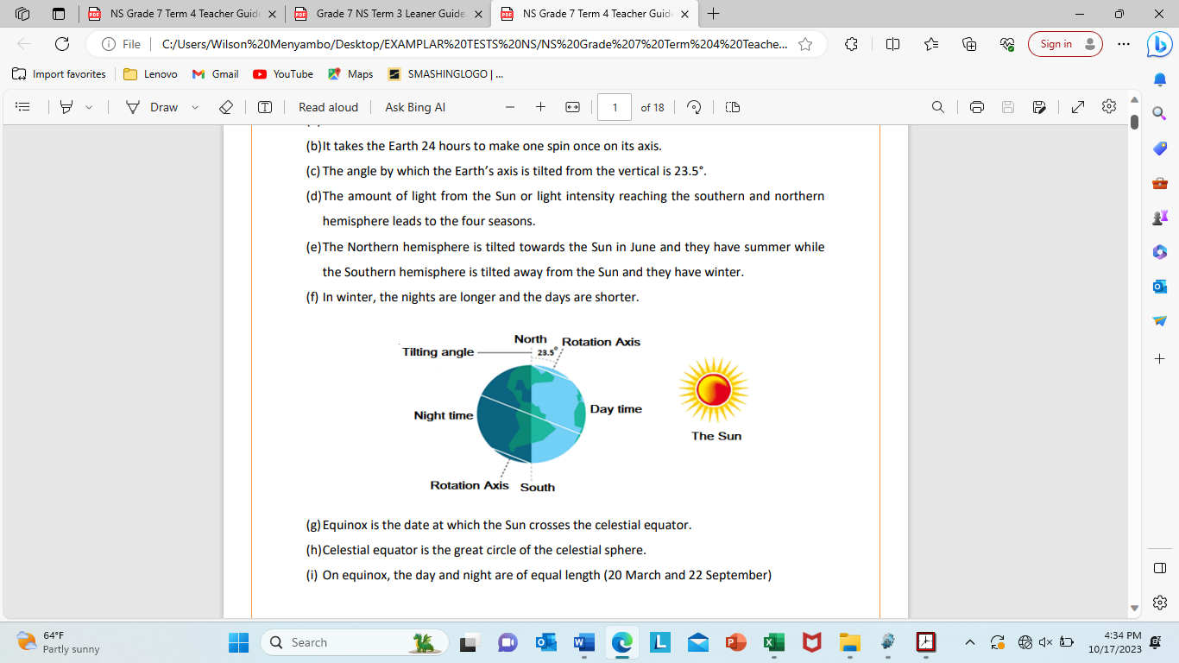
- Specify the direction in which light is radiated. /1

________________________________________________________________

________________________________________________________________

- How long does it take the Earth to spin around once, on its axis? /1

_______________________________

- What is the angle by which the Earth is tilted from the imaginary vertical line? /1

_______________________________

- Complete the following statement.

In winter, the nights are _____________ and the days are _____________. /2

Question 7
The following pictures display Renewable and Non-renewable energy sources. Carefully study the diagram and answer the questions that follow.
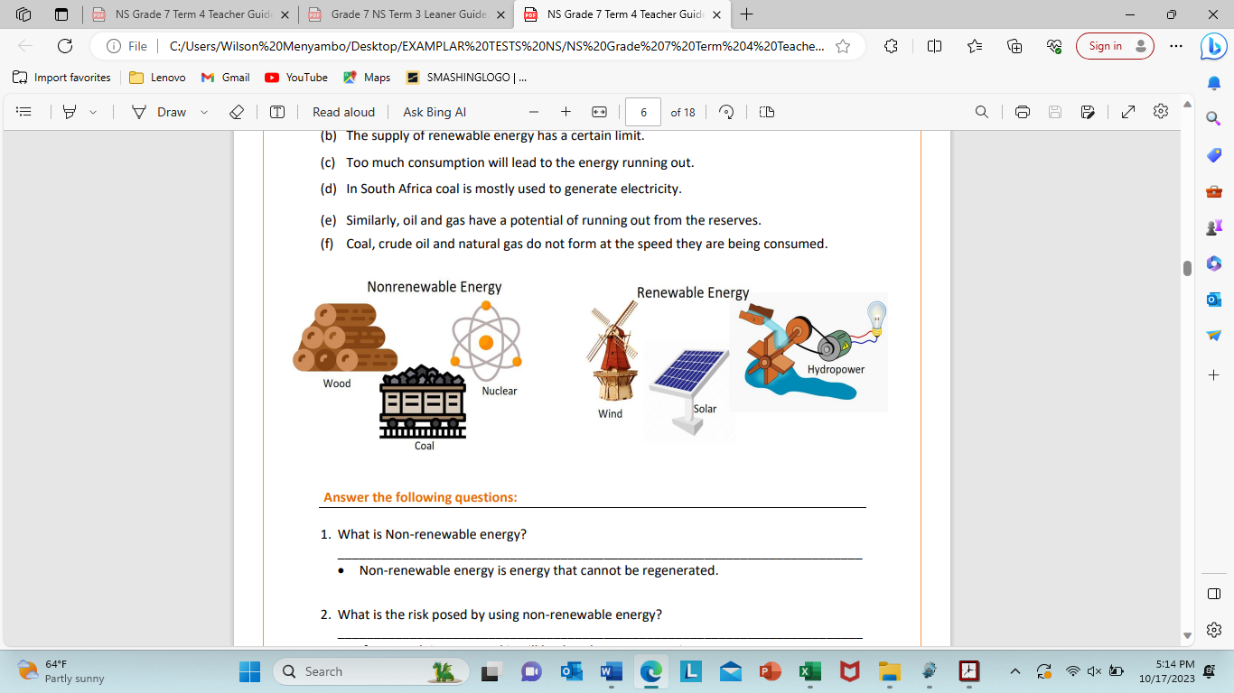
- What is the risk posed by using non-renewable energy? /1

________________________________________________________________

________________________________________________________________

- Discuss what will happen if too much of the non-renewable energy is used. /2

________________________________________________________________

________________________________________________________________

- How is electricity mostly generated in South Africa? /1

________________________________________________________________

________________________________________________________________

- Which energy is mostly generated from falling water? /1

__________________________________________

Question 8
Tides
Tides (waves) are periodic rise and fall of large bodies of water especially in the seas and oceans.
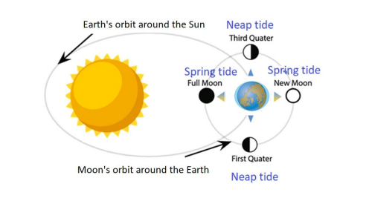
- Tides are caused by the gravitational pull between three objects. Name them. /3

- ________________________

- ________________________

- ________________________

- Mention two types of tides. /2

- ____________________________

- ____________________________

Question 9
- Draw a diagram to show the alignment of the Moon, Earth and Sun at New Moon phase. Label each object clearly. Remember to shade the unlit part of the Earth and the Moon in your diagram. /3

- What is the phase of the moon, after New Moon called? /1

________________________________

- How many phases of the moon are there? /1

________________________________

Question 10
Define the following scientific concepts. /6
- Radiant energy - __________________________________________________

________________________________________________________________

- Axis - ___________________________________________________________

________________________________________________________________

- Circle of illumination - ______________________________________________

________________________________________________________________

Question 11

Discuss the difference between Rotation and Revolution and give relevant examples of each. /6
______________________________________________________________________
______________________________________________________________________
______________________________________________________________________
______________________________________________________________________
______________________________________________________________________
______________________________________________________________________

Question 12

Complete the following Flow Diagram to show the resources required for Photosynthesis and the products of the reaction. /3

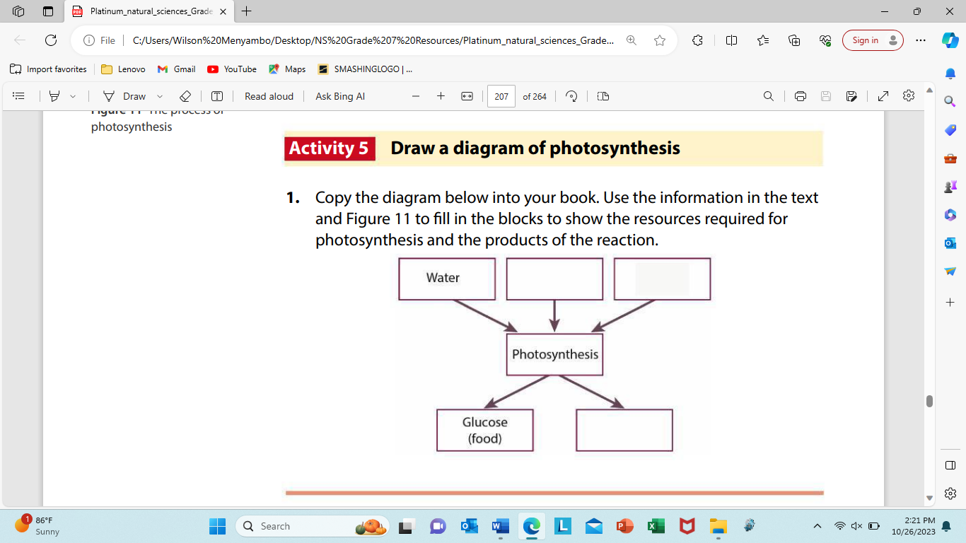
Complete the following paragraph using the words below. /5

herbivores energy carnivores
cycle evaporate food

Life on Earth needs __________________ from the Sun to survive. Plants use light
energy to make ________________. Energy is passed along the food chain when
_________________ eat plants and are in turn eaten by ________________. The
Sun’s energy warms the air, the land, and the water of the Earth. It keeps the
water _________________ going by causing water to evaporate, and
preventing it from freezing.

________/ 40

