SECTION A ENERGY AND CHANGE
Question 1
Multiple choice. Read each question carefully, choose the correct answer from the options provided. Circle only the corresponding alphabet next to each question.

- Which of the following is an example of a renewable source of energy? /1

- Coal
- Hydropower
- Petrol
- Oil

- The energy found in a moving car is known as… /1

- Potential energy
- Kinetic energy
- Heat energy
- Chemical energy

- When wood burns, the _______ potential energy of the wood is released. /1

- Gravitational
- Elastic
- Chemical
- Potential

- The energy of the Sun is transferred to the Earth by… /1

- Radiation
- Conduction
- Absorption
- Convection

- One of the following is an example of fossil fuels. /1

- Natural gas
- Wind
- Hydropower
- Paper

Question 2
Match descriptions in Column A with the correct term in Column B and write answers in Column C. Write only corresponding alphabets next to each number. E.g., 1B /5
Column A | Column B | Column C
1. A material that allows heat to pass through. | a) Joule | 1.C
2. All energy is measured in this unit. | b) Radiation | 2.A
3. Transmission of energy in a form of waves. | c) Conductor | 3.B
4. Energy that is stored. | d) Coal | 4.E
5. Mostly used to generate electricity. | e) Potential energy | 5.D

Question 3
State whether the following is True or False. Write answers in the spaces provided.

- An insulator is a material that does not transfer heat energy.

True

- Convection is the transfer of heat by movement of liquid or gas particles.

True

- Radiation is the transfer of heat between objects that are in physical contact.

False

- Rubber band is an example of elastic potential energy.

True

- Biomass is an energy source that uses moving water to generate energy.

False /5

Question 4
Discuss the difference between renewable energy and non-renewable energy and give examples of each. /6
The difference is that renewable energy is the energy that will not run out while non-renewable energy is the energy that will eventually run out. Examples of renewable energy sources are water, wind, and the sun. Examples of non-renewable energy sources are coal, natural gas, and oil.

Question 5
Answer the following questions in the spaces provided.
1. Mention three ways in which heat can be transferred. /3
a) Conduction
b) Convection
c) Radiation
2. Give three examples of heat insulators. /3
a) Plastic
b) Glass
c) Paper
3. List three types of potential energy. /3
a) Chemical potential energy
b) Gravitational potential energy
c) Elastic potential energy

30 / 30

SECTION B EARTH AND BEYOND
Question 6
Study the diagram below and answer the questions that follow.

Solar energy and the Earth’s seasons
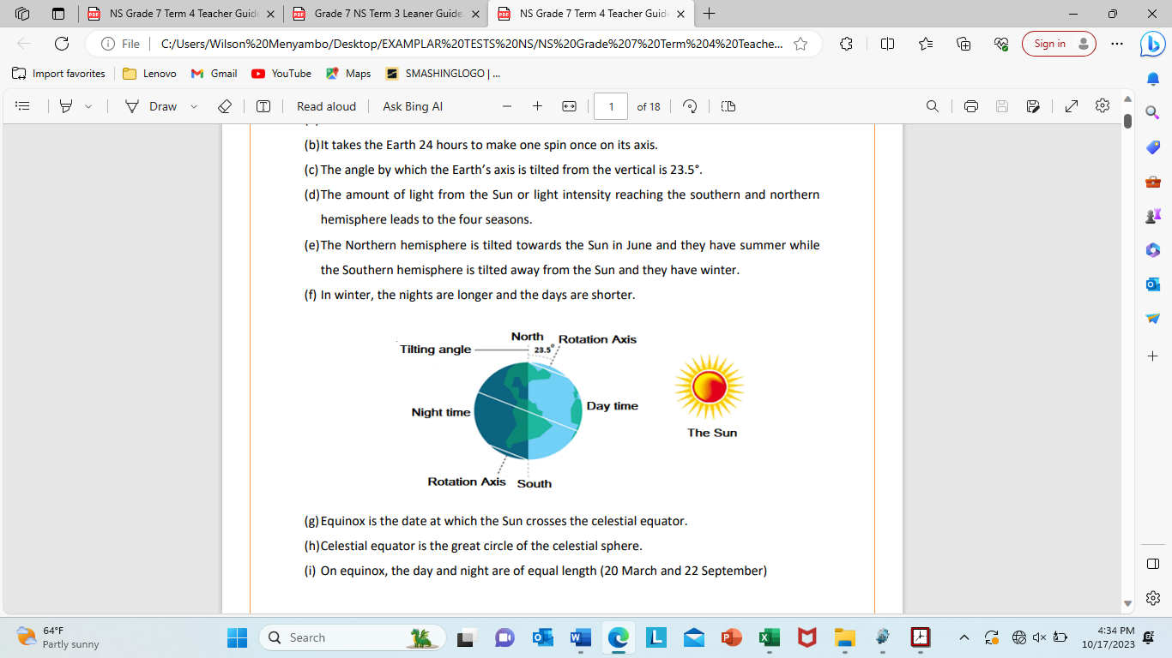
- Specify the direction in which light is radiated. /1

Heat from the Sun is radiated in all directions.

- How long does it take the Earth to spin around once, on its axis? /1

It takes 24 hours.

- What is the angle by which the Earth is tilted from the imaginary vertical line? /1

23.5º

- Complete the following statement.

In winter, the nights are longer and the days are shorter. /2

Question 7
The following pictures display Renewable and Non-renewable energy sources. Carefully study the diagram and answer the questions that follow.
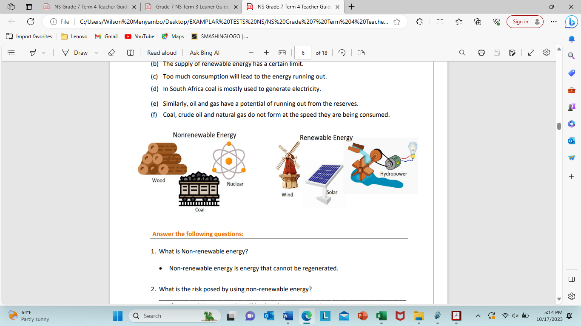
- What is the risk posed by using non-renewable energy? /1

If too much is consumed it will lead to the energy running out.

- Discuss what will happen if too much of the non-renewable energy is used. /2

It will run out and we will have to find alternative means of generating energy.

- How is electricity mostly generated in South Africa? /1

In South Africa coal is mostly used to generate electricity.

- Which energy is mostly generated from falling water? /1

Hydropower

Question 8
Tides
Tides are periodic rise and fall of large bodies of water especially in the seas and
oceans.
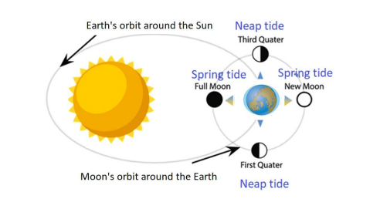
- Tides are caused by the gravitational pull between three objects. Name them. /3

- The Earth

- The Moon

- The Sun

- Mention two types of tides. /2

- Spring tides

- Neap tides

Question 9
- Draw a diagram to show the alignment of the Moon, Earth and Sun at New Moon phase. Label each object clearly. Remember to shade the unlit part of the Earth and the Moon in your diagram. /3

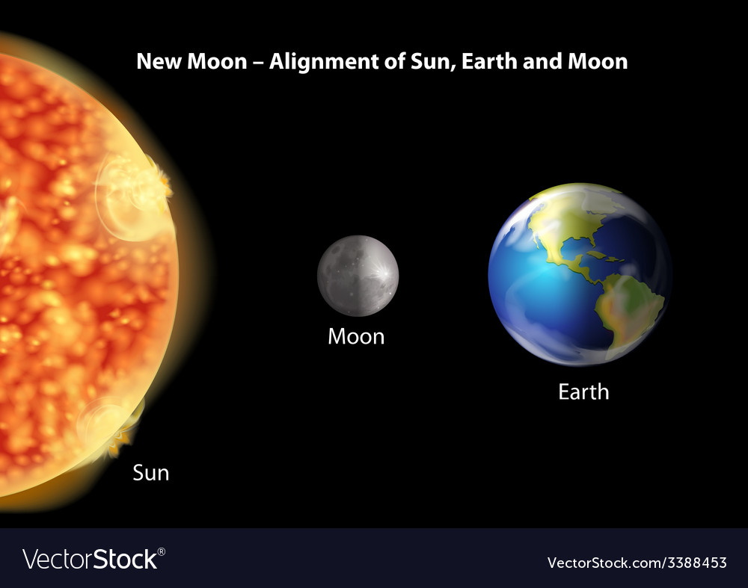

- What is the phase of the moon, after New Moon called? /1

Waxing crescent

- How many phases of the moon are there? /1

Eight (8) phases

Question 10
Define the following scientific concepts. /6
- Radiant energy – is energy from the Sun.

- Axis – an imaginary line going through the center of the Earth.

- Circle of illumination – line dividing the lit from the dark half of the Earth.

Question 11

Discuss the difference between Rotation and Revolution and give relevant examples of each. /6
Rotation refers to an object’s spinning motion about its own axis. Revolution refers to the movement of an object in space around another object. Earth rotates on its own axis, producing the 24-hour day. Earth revolves around the Sun, producing the 365-day year.

Question 12

Complete the following flow diagram to show the resources required for photosynthesis and the products of the reaction. /3

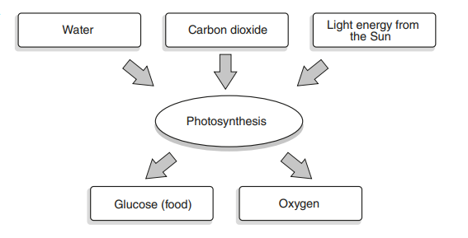

Complete the following paragraph using words below. /5

herbivores energy carnivores
cycle evaporate food

Life on Earth needs energy from the Sun to survive. Plants use light
energy to make food. Energy is passed along the food chain when
herbivores eat plants and are in turn eaten by carnivores. The
Sun’s energy warms the air, the land, and the water of the Earth. It keeps the
water cycle going by causing water to evaporate, and
preventing it from freezing.

40 / 40

