Term 1
Memo book


Task 1
Name of product | What it does | How it meets a need | Type of technology
Photocopier | Make copies | Makes multiple copies quickly | Electrical
Refrigerator | Keeps food cold | Keeps food cool to prevent decay | Electrical
E-mail | Sends messages | Sends messages electronically instantly | Electrical
Pencil | Draw or write | Makes it easy to erase mistakes made. | Mechanical / Non-electrical
School desk | To work on | Makes it easier to work in books. | Mechanical / Non-electrical

Task 2
1) Investigate, design, make, evaluate, communicate
2) Stage 1: Investigate: You gather information about possible problems / needs / wants that exist.
Stage 2: Design: During this stage you are busy planning the solution to the problem.
Stage 3: Make: You make the drawings and the product.
Stage 4: Evaluate: You use the test created in stage 2 to test your product.
Stage 5: Communicate: In this stage you will present your design
3)

Column A | Column B | Column C
Ex. Money | Z) The root of all evil. | Ex) Z
1) People | A) What impact does the product have on the environment; where and under what conditions is it used? | 1) B
2) Purpose | B) Who is the product for: the age/gender of the people, their culture/religion? | 2) D
3) Safety | C) What is the manufacturing/purchase price? Can the product be made more cheaply? | 3) E
4) Environment | D) What need/want/problem is the product addressing? | 4) A
5) Cost | E) Is the product safe to use; what can be done to make it safer? | 5) C
Task 3
1) Set of moving parts that are used to make work easier.
2) The degree to which mechanisms make work easier or harder.
3) Fulcrum, load, effort
4) Cutting, Lifting, Turning and pulling.
5) The difference is what is in between the others, First class: fulcrum in between, second class: load in between, third class: effort in between.

Task 4
1) The longer the effort arm is, the bigger the mechanical advantage.
2) MA > 1
3) MA = 1

Task 5
1. Class: First class 2. Class: First class
Fulcrum B Fulcrum B
Load A Load A
Effort C Effort C

3. Class: First class 4. Class: Third class
Fulcrum B Fulcrum C
Load A Load A
Effort C Effort B
5. Class: Second class 6. Class: First class
Fulcrum C Fulcrum A
Load B Load B
Effort A Effort C

Task 6
1) A mechanism (System) that uses compressed air to make things move.
2) A mechanism (System) that uses compressed liquid to make things move.
3) A pneumatic system uses gas and a hydraulic system uses liquids.
Task 7
Product | Need leading to design | Possible design brief
School bag | Keep school books together | Design and make a bag to keep all your school books together when moving them from one place to another.
Knife | Cut something into smaller pieces | Design and make something sharp to cut a product into pieces.
Lunch box | Carry lunch to school | Design and make a container for a school lunch.
Sun umbrella | Keep sun off when sitting outside | Design and make a large umbrella to make shade when sitting outside.
Egg carton | Protect and contain eggs | Design and make a container to prevent eggs breaking when transporting them.
Gift box | Contains a gift | Design and make an aesthetically pleasing container for gifts.
Pencil case | Store writing utensils safely | Design and make a container for writing utensils that can protect them.

Task 8
1) Check learners
2) Check learners

Task 9
1) In your book draw a rectangle with a height of 50 mm and a width of 60 mm.
2) Dimension your drawing in question one, following the correct dimensioning conventions.
50 mm

60 mm

3a) Ruler
b) Protractor / setsquare
c) Compass
d) Eraser
e) Pencil
4) Small
5) Big
6) New sketch must be 100 mm x 100 mm in learners books.

100 mm

100 mm

Task 10
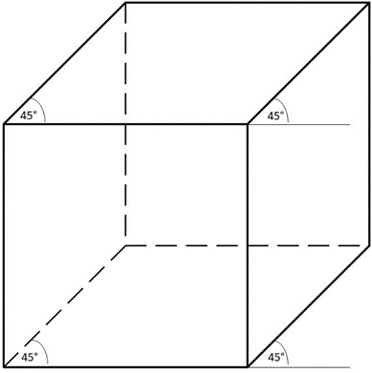
1)
2)

100 mm

100 mm

100 mm

3) A scale must be added, and the drawing should be changed to 2D.

Practical Task 1
Scenario 1: Automatic Pet Feeder
Questions
1. Automatic pet feeder
2. Small pets/ owners of small pets
3. To feed small pets when their owners are away for extended periods.
4. No sharp edges.
No poisonous materials should be used
The pet feeder must be stable.
If electrical no exposed wires
5. It must draw attention. People must buy it.
6. Use materials that can be recycled. Use materials that have already been recycled.

Scenario 2: Jaws of life
Questions
1) C) People get into car accidents and are trapped.
2) B). Rescue services will be able to quickly free trapped people from cars to get the medical attention they need.
3) C) Fire fighters / rescue services.
4) It must be able to cut and spread metal panels in order to free people.
5) Any one of the following
A) Strong, C) Rigid, D) Hard
6) Any 5 of the following
Design and make a mechanism that is powered by a hydraulic system that is capable of cutting or spreading the metal frames and joints of cars in order to free trapped people. The mechanism should be made from strong and durable materials. The product should have bright colours and look like a big scissor.

Practical Task 2
First class levers
Questions example 1
1a) It is about equal to the weight of the load.
1b) No mechanical advantage (Input = output)
1c) MA = 1
Questions example 2
2a) It has become less (easier to move).
2b) Positive mechanical advantage.
2c) MA > 1
Questions example 3
3a) The input force has become greater (more dificult to move).
3b) Negative mechanical advantage.
3c) MA < 1

Practical Task 3
Second class levers
Questions example 1
1a) It is very small (easy to lift)
1b) Positive mechanical advantage.
1c) MA > 1
Questions example 2
2a) It has become greater (very hard to lift)
2b) No mechanical advantage (Input = output)
2c) MA = 1


Term 2

Task 1
1) Copy and complete the following table into your exercise book.
Structure | Function / Job
Cup | Contain
Table | Support
Fence | Protect
Bed | Support
Spider’s web | Span
Bucket | Contain
Bridge | Span
House | Protect
Ladder | Span
Bird’s nest | Protect

Task 2
1) Copy and complete the following table into your exercise book.
Structure | Man-made / Natural
Cup | Man-made
Table | Man-made
Egg | Natural
Bed | Man-made
Spider’s web | Natural
Bucket | Man-made
Shell of a tortoise | Natural
House | Man-made
Ladder | Man-made
Bird’s nest | Natural

Task 3
1) Copy and complete the following table into your exercise book.
Structure | Shell / solid / Frame
Cup | Shell
Table | Frame
Egg | Shell
Bed | Frame
Spider’s web | Frame
Bucket | Shell
Shell of a tortoise | Shell
House | Shell
Ladder | Frame
Bird’s nest | Frame

Task 4
1) Copy the table, then follow the instruction below.
In the following table mark with an X the Classification, type, and function of each structure. (1 X for each category [3X’s total per structure])
Structure | Man-made | Natural | Shell | Frame | Solid | Protect | Contain | Span | Support
Example: Chair | X |  |  | X |  |  |  |  | X
Cup | X |  | X |  |  |  | X
Table | X |  |  | X |  |  |  |  | X
Egg |  | X | X |  |  | X
Bed | X |  |  | X |  |  |  |  | X
Spider’s web |  | X |  | X |  |  |  | X
Bucket | X |  | X |  |  |  | X
Shell of a tortoise |  | X | X |  |  | X
House | X |  | X |  |  | X
Ladder | X |  |  | X |  |  |  | X
Bird’s nest |  | X |  | X |  | X

Task 5
1) For each of the following situations state what telephone system you would use and your reason.
Situation | Telephone system | Reason
1. Your car broke down on the highway. | Mobile | Ease of communication
2. You wish to enter a WhatsApp competition on the radio. | Mobile | Landline doesn’t have WhatsApp
3. You need to contact your father that works on a farm. | Landline | Reliability
4. You wish to phone a relative in America. | Mobile | No long distance charges
5. You wish to inform the school’s office that you will not attend school. | Landline | Emergencies

Task 6
1) Identify the strengthening technique used in the following pictures.
A. Folding
B. Triangulation
C. Tubing

Case study 1: Cellphone tower
1. Foundation, struts, tie beams, columns.
2. Triangulation.
3. Visual pollution: It is painted with a colour that blends with the sky and ocean in the background.
Stability: It has a wide base and a fairly low center of gravity.
Base size: It has a wide base.
Centre of gravity: It has a low center of gravity.

Case study 2 – Existing designs: School desk
1. I am going to design and make a work station for learners to be able to write on while being taught. The workstation will be made from wood and metal. The station must be 1000mm high and 1000mm wide.

Case study 3 – Existing designs: Cell phone
1. Colour black, power button, volume button, touch screen, Dual camera, etc.
2.
Features | Specifications
Rear Camera | 13.0 MP + 2.0 MP Resolution  Auto focus  10X digital zoom  Flash
Front camera | 5.0 MP Resolution  F Number F2.2  Video recording resolution (1920 x 1080) @ 30fps
Memory | 3GB Ram/ 32GB Rom
Display | Size 6.5”  Resolution: 720 x 600 (HD+)  Technology: PLS LCD  Colour depth: 16M
Processor | CPU speed: 2.3GHz, 1.8GHz  CPU type: Octa-core
Sim | Dual Sim
Baterry | 5000 mAh

3. I am going to design and make a communications device, that will allow me to easily communicate with other people. The device must be mobile. The device must have a dark colour.

Revision task 1
Example: 32: Z | 32: School | Z: A place where you go to learn and be prepared for your future.
1: E | 1: Solid Structure | A: A structure that does not fall over easily.
2: H | 2: Frame Structure | B: A structure found in nature or that has been made by animals.
3: C | 3: Shell Structure | C: A single hollow structure.
4: B | 4: Natural Structure | D: A pushing force.
5: G | 5: Man-Made Structure | E: A single structure that has no other members or gaps.
6: A | 6: Rigid | F: A pulling force.
7: F | 7: Tension Force | G: A structure that has been changed or created by a person.
8: D | 8: Compression Force | H: A structure that has many different members (parts).

2) Identify the Kind, type and function of each structure below. Make a X in the 3 correct columns.
Structure | (Natural | Man-made) | (Shell | Solid | Frame) | (Support | Protect | Contain | Span)
1. Chair |  | X |  |  | X | X
2. Shell of tortoise | X |  | X |  |  |  | X
3. Can |  | X | X |  |  |  |  | X
4. Spider’s web | X |  |  |  | X |  |  |  | X
5. Bicycle |  | X |  |  | X | X
6. Bucket |  | X | X |  |  |  |  | X

Revision task 2
1) They have wide bases. The general rule for all things is that the wider their base is, the more stable it is.
They have struts that hold sections of the structure in place with a compressive force.
They have tie beams that hold members in place with tension force.
They have triangulation to strengthen the structure.
2) Ease of communication
No long distance charges
Safety

3) Cable theft
Mobility
Availability
Long-distance charges
4) Columns, Beams, Truss, Strut, Tie, Foundation
5) Any 5 suitable answers.
6) Any 5 suitable answers.

Exam prep 1
1. For each of the following questions, circle the correct answer.
1.1. What happens during stage 1 (Investigate) of the design process
c) We investigate possible problems for us to solve.
1.2. What is stage 2 of the design process?
b) Design
1.3. What is a design constraint?
a) Something that limits your choices.
1.4. During the design consideration “who is it for”, what is one of the things that we have to consider?
a) The age of the person.
1.5. In a lever the load is what?
b) The object that we want to move.
1.6. A scale is a relationship between the size of what you draw and the size in real life.
a) True
1.7. What are the three reinforcing techniques? (Circle the three correct letters)
a) Triangulation
b) Tubing
d) Folding
1.2. State whether the following statements are true or false.
1.2.1. A lever has 3 parts. True
1.2.2. A hydraulic system uses compressed dirt to work. False
1.2.3. The reinforcing technique folding uses triangles to strengthen structures. False
1.2.4. The 3 dimensions in a drawing are width, height and depth. True
1.2.5. All measurements are done in mm. True

Question 2: Matching columns (5)
2. Connect the term to the correct phrase by writing the correct letter next to the correct number.
Term | Answer | Description
32: School | Example: 32: Z | Z: A place where you go to learn and be prepared for your future.
1: Natural structure | 1: E | A: A structural member that pulls two other members together using tension force.
2: Compression force | 2: D | B: A structure that has been created or changed by a person.
3: Man-made structure | 3: B | C: A structure that has multiple members.
4: Tie | 4: A | D: A pushing force.
5: Frame structure | 5: C | E: A structure that exists in nature that has not been altered by a person.

2.2. Using the rule for center of gravity of an object. What will happen to the stability of a person if they go from standing to lying down?
The person will become more stable.
2.3. How would you blend a cell phone tower that has to be erected in a forest? (Painting it, or camouflage)
By camouflaging it.
Case study – Existing designs: Cell phone
3.1. Name 2 structural elements that you can see in the picture of the tower.
Foundation, struts, tie beams, columns (Any 2)
3.2. Identify the reinforcing – technique that has been used here?
Triangulation
3.3. How does the tower address the design issue Stability.
It has a wide base.
3.4. What kind of telephone system is a cell phone part of?
Mobile
3.5. Name 1 Advantage of this kind of telephone system.
Ease of communication; No long distance charges; Safety (any 1 or the explanation of them)

Exam prep 2
Scenario: Jaws of life
Questions
3.1. What kind of a system is the jaws of life? Hydraulic system
3.2. Name the three hydraulic tools that the jaws of life use to free people.
Spreader, cutter, ram
3.3. What kind of fluid does the jaws of life use? Phosphate-ester fluid
3.4. Examine the picture of a model of the jaws of life, like you had to make during term 1, and answer the questions that follow.
3.4.1. Which part (A, B,C or D) of the jaws represent the effort of the overall lever? A (1)
3.4.2. Which part (A, B,C or D) of the jaws represent the load of the overall lever? C (1)
3.4.3. Which part (A, B,C or D) of the jaws represent the fulcrum of the overall lever? B (1)
3.4.4. Which part (A, B,C or D) of the jaws is responsible for compressing the fluid? D (1)
3.4.5. Summarize the law of mechnical advantage of first and second class levers. (3)
The closer the fulcrum is to the load the greater the mechanical advantage will be.
3.4.6. What would happen to the output force of the above picture if the levers where made longer and explain why this would happen? (2)
The output force would decrease, because the fulcrum is moving further away from the load.
3.5. Construct a design brief for the jaws of life. (5)
I am going to design and make an extrication tool that can cut up cars in order to free people that are traped after car accidents. The tool will be powered by hydrailics and have 3 heads that can cut and spread mettal.
4.1. Name one structural element. (1)
Guys, Buttresses, Columns, Beams, Truss, Strut, Tie, Foundation (any one of these)

4.2. Draw a rectangle with a height of 20 mm and a width of 40mm. Also dimension the width of the rectangle using the correct dimensioning conventions. (5)

For the rectangle with a height of 20 mm and a width of 40mm
For the correct direction of the number.

For the arrow - head
For the stop line.
For the dimension line dimension

40 mm

4.3. Give the Classification (), type{ } and function [ ] of each structure below. Make an X in the 3 correct Columns. (12)
Structure | (Man-made | Natural) | {Shell | Frame | Solid} | [Protect | Contain | Span | Support]
Example: Chair | X |  |  | X |  |  |  |  | X
Table | X |  |  | X |  |  |  |  | X
Egg-shell |  | X | X |  |  | X | (X)
Spider’s web |  | X |  | X |  |  |  | X
Shell of a tortoise |  | X | X |  |  | X
House | X |  | X |  |  | X
Basket | X |  | X |  |  |  | X

Section C (12)
Question 5:Telephone systems (12)
5.1. For each of the following situations state what telephone system you would use and the reason for your choice based on the advantages and disadvantages of the telephone systems. (12)
Situation | Telephone system | Reason
1. Your car broke down on the highway. | Mobile | Emergencies
2. You want to inform the police that the telephone cables were stollen. | Mobile | Landline won’t work due to cable theft.
3. You need to contact your father that works on a farm.
4. You wish to phone a relative in America. | Landline | No availability of mobile system.
5. You wish to inform the school’s office that you will not attend school. | Mobile | No long distance charges.
6. There was an accident inside of a tunnel. | Landline | Any advantage of landline system.

5.2 Any 3 features of a cell-phone.


Term 3

Task 1
1) When iron particles are aligned in the material
2) No
3) Opposite poles
4) Like/same poles
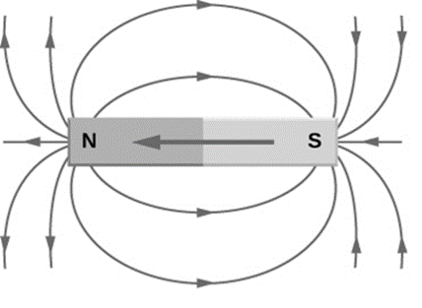
5)

Task 2
1) No
2) Yes
3) Rub a magnet in a single direction against a ferrous metal repeatedly.
4) The magnet pulls the iron particles into alignment.
5) A metal that contains iron.
6) Iron, Nickel, Cobalt and Steel.
7) Any 2 correct places.

Task 3
1) An electric circuit is a few components that are connected together with a conductor, that allows electricity to flow through it.
2) From the positive terminal to the negative terminal.
3) Identify each of the following electrical components.
A) Cells B) Crocodile clips C) Toggle switch

Task 4

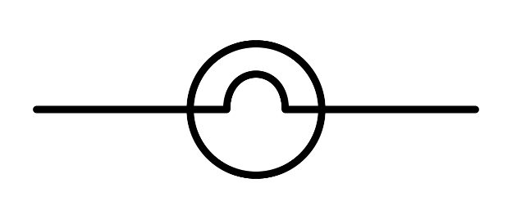
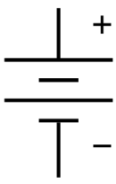
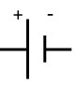
1) Draw the correct symbols for each of the following electrical components.
a) b) c) d)

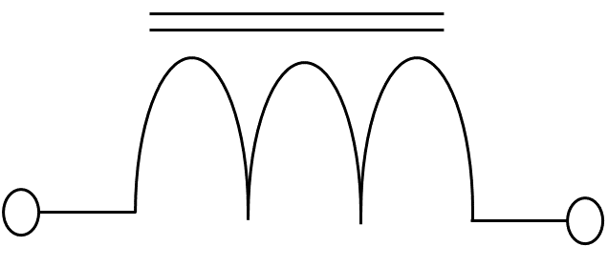
e)

2) Draw an open circuit with a cell, a push switch, a lamp and a buzzer

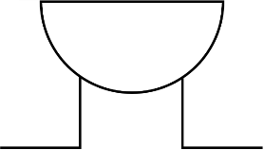
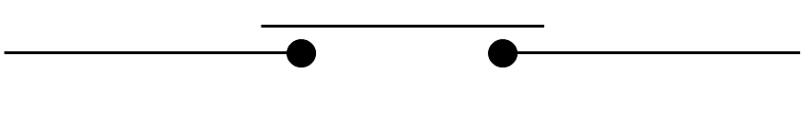
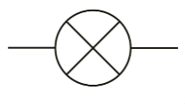

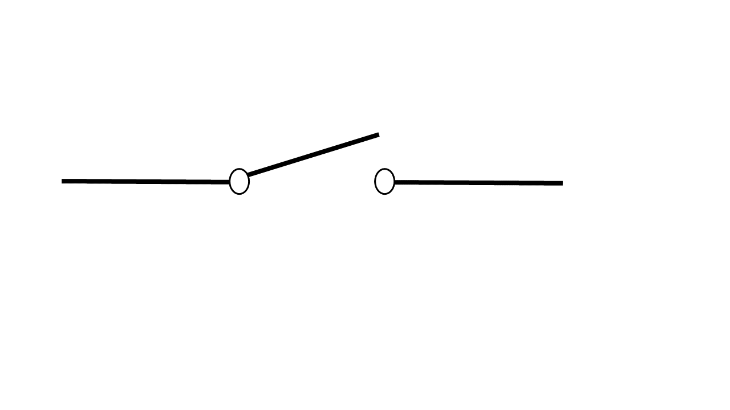
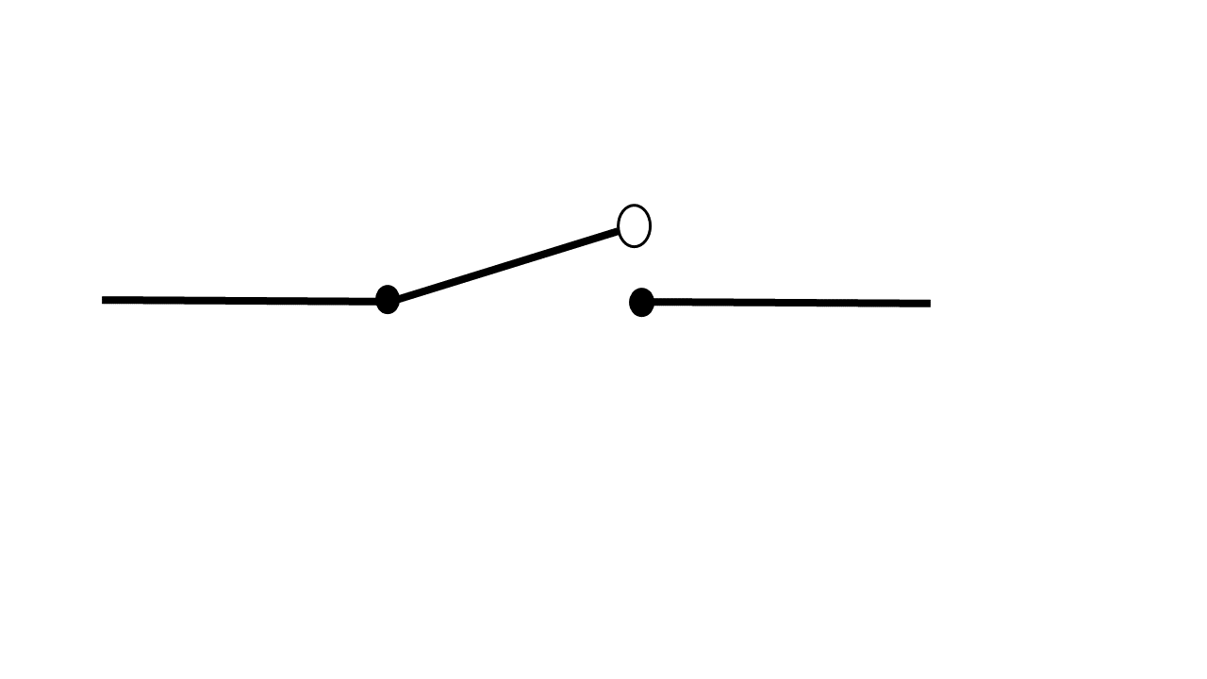
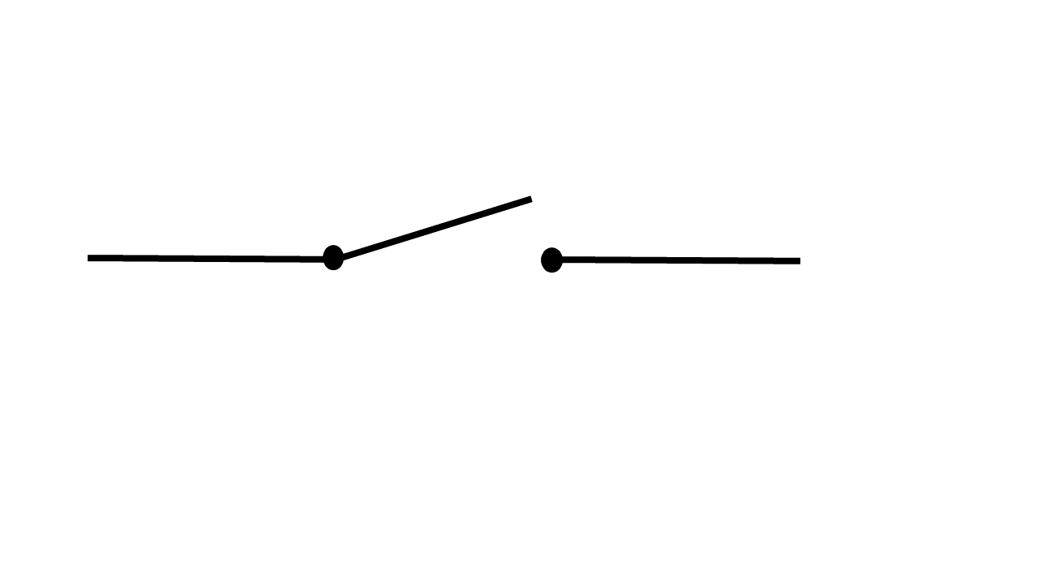
3)
Switch: Wrong switch used : or or
Electro-magnet: correct symbol used
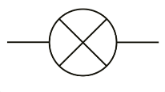
Battery: correct symbol used
Lamp: Incorrect symbol used
Conductors: All correct

Task 5
1) Step 1 - Gather the Materials:
* One iron nail fifteen centimeters long.
* Three meters of 22 gauge insulated (electrical wire), stranded copper wire.
* One or more D-cell batteries.
* A pair of wire strippers.
Step 2 - Remove some Insulation:
Some of the copper wire needs to be exposed so that the battery can make a good electrical connection.
Step 3 - Wrap the Wire Around the Nail
The more wire you wrap around the nail, the stronger your electromagnet will be.
Step 4 - Connect the Battery / cell
Attach one end of the wire to the positive terminal of the battery and the other end of the wire to the negative terminal of the battery.
2) * The more turns of wire your magnet has, the better.
* The more current that passes through the wire, the better

Task 6
1) A simple mechanism consisting of an arm or lever joined to one end of a rotating shaft.
2) Cranks convert rotary motion into linear motion.
3) * Linear movement, Rotary movement, Reciprocating movement, Oscillating movement
4) The longer the crank, the easier it is to turn the axle although a greater distance is needed to turn it.
5) MA > 1

Task 7
1) Single pulleys: A single pulley has one pulley wheel that is fixed.
2.1) Pulleys
2.2) This mechanism has a compound and simple form. Identify which form is given in
Picture 1: Simple pulley
Picture 2: Compound pulley
2.3)
Input force: 25 N
Input distance: 40 cm
2.4) No mechanical advantage

Case study 1: Recycling scrap metal
Questions:
1) Yes, any correct item.
2) Any 2 correct items.
3) Any 2 correct answers.
4) You can contact scrap metal dealers, and they will collect it from your home.
5) By the mass
6) If manhole covers are stolen, then there are holes in the roads that people can drive or fall into. Stolen electricity cables can cause loss of power or electrocute innocent people.
Revision task 1
1)
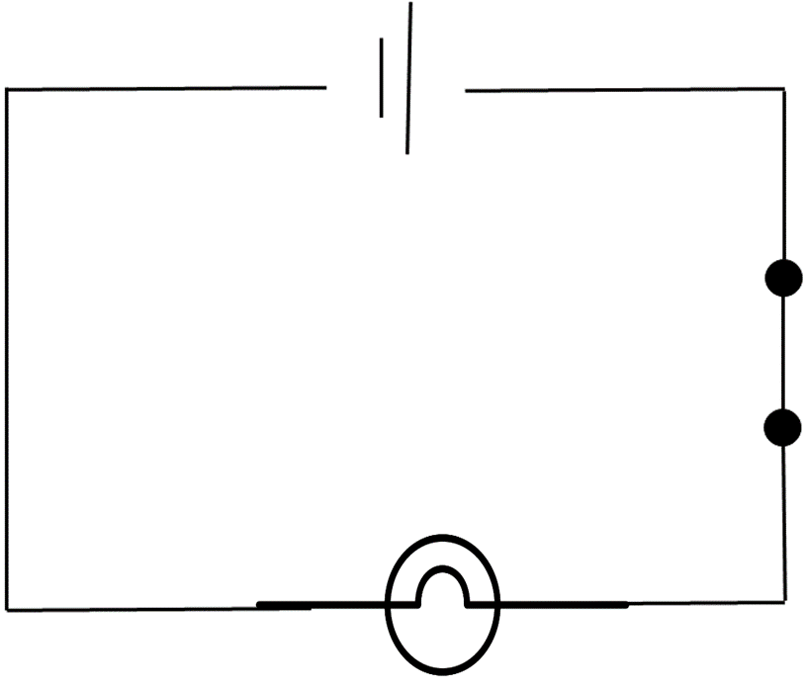
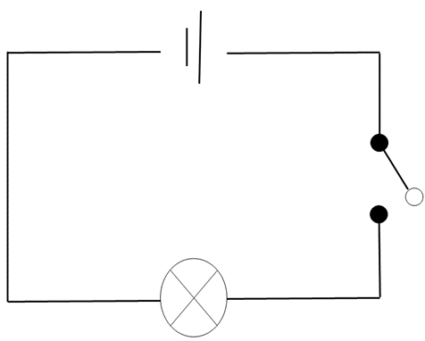
A) B)

2) * Linear movement: Movement in a straight line.
* Rotary movement: Turning movement.
* Reciprocating movement: Up and down movement.
* Oscillating movement: Backwards and forwards movement.
3) Crank
4) Pulley
5) Paper, glass, plastic and metal.

Revision task 2
1) State whether the following statements are true or false.
a) True
b) False
d) False
e) True
f) True
g) True
h) True
2) State whether the following is crocodile clamps, connector strips, a nail, a lamp or a motor.

A) Motor B) Nail C) Connector strips D) Crocodile clamps

3) Even though a pulley decreases the input force the distance that the force has to be apply over is increased by the same amount, thus no mechanical advantage.
4) Drop it, hit it, heat it
5) Write the correct word that completes the sentence in your book.
a) keep
b) quickly
c) North
d) South


Term 4

Task 1
1) Someone who flees from danger in his own country. (Leaves country for other one)
2) Moved from one part of the country to another part inside the country due to dangerous situations.
3) Natural disasters, Environmental deterioration (degradation), Poverty or economic crisis, War
4) The state of being so poor that you cannot provide for yourself or your dependents.
5) State of a country where it can no longer support people to earn a living.
6) The environment where people live can no longer sustain them.

Task 2
1) An area that has been identified by the host to temporarily house internally displaced people or refugees (Usually in tents).
2) Any 4 of the following: A place of safety and shelter, Sanitation, Food, Water, Clothes and blankets
3) A job to earn money, Proper schooling for their children, Homes of their own.
4) The mix of the people present, The need for shelter, The need for food and water

Task 3
1) The food or fuel that living things need to live and grow.
2) * The food must provide nutrients that the body needs to grow and stay healthy.
* It must be easy to prepare, since tools and space to cook are limited.
* It should not spoil easily.
* It must be able to be cook on a fire, as wood is the most common fuel available.
* It must be familiar to the people who must use it.
* It must be cheap.
3) Transport, Storage, Fuel and water.
4) Red cross, red crescent movement and rotary international.

Task 4
1) World food program
2) The United Nations
3) * A staple such as wheat flour or rice;
* Lentils, chickpeas or other pulses;
* Vegetable oil (fortified with vitamin A and D);
* Sugar; and
* Iodized salt
4) Food with extra vitamins and minerals added.

Task 5
1) Any 2 of the following: Fire-resistant, heat-resistant, strong, durable, high melting point.
2) Any cloth or fabric that has been knitted or woven.
3) Turnout gear (Bunker gear), Wildfire suits, Hazmat suits, Fire proximity suits
4) Name the suit you would use in each of the following situations:
a) Wildfire suit
b) Hazmat suit
c) Bunker gear (Sorry let it burn is not an acceptable answer)
d) Fire proximity suit
5) Burning from the fire: Kevlar outer layer (fire-resistant)
The heat of the fire: middle Nomex layer (Heat-resistant)
The build-up of sweat and water on the skin: inner moisture barrier (keeps the fire fighter dry).

Task 6
1) The organs that are essential to life.
2) When your core temperature drops dangerously low
3) Sever shivering, Hunger, Nausea (wanting to vomit)
4) National Sea Rescue Institute
5) Heat insulation, water tight

Practical task 1
Check learners, as everyone’s answer will differ.

Exam prep 1 MEMO
1. Connect the definition with the term by writing the letter of the term next to the definition.
Answer | Definition | Term
1. J | 1. Someone who flees from danger in his/her own country. | A. UN
2. C | 2. The protection given by one country to the citizens of another country. | B. Xenophobia
3. G | 3. People who are forced to leave their homes due to a natural disaster.(Not the country) | C. Asylum
4. H | 4. Tent towns where refugees take shelter. | D. Red Cross
5. B | 5. An intense dislike or fear of people from other countries. | E. WFP
6. I | 6. Recommended Daily Allowance | F. NGO
7. E | 7. World Food Programme | G. Internally displaced
8. F | 8. Non-Government Organisations. | H. Refugee camp
9. A | 9. United Nations. | I. RDA
10. D | 10. A NGO that provides food for refugees. | J. Refugee
11. L | 11. National Sea Rescue Institute. | K. Textile
12. K | 12. Any cloth or fabric that has been knitted or woven. | L. NSRI

2. In what direction does electricity flow outside a cell?
From the positive terminal to the negative terminal.
3. Evaluate the following electric circuit, write your conclusions and fix any errors below. The circuit is an open circuit that consists of a switch, electro magnet, battery, lamp and conductors.
Switch: Wrong switch used : or or
Electro-magnet: correct symbol used
Battery: correct symbol used
Lamp: Incorrect symbol used
Conductors: All correct
4 Use the space below to draw the magnetic field lines of a simple bar magnet. Indicate the poles, field lines, as well of the direction of the field lines inside, and outside of the magnet.
For the correct direction ( Inside South to North)
Or
(Outside North to South)

For indicating South

For indicating North

For the field lines

5. Investigate the following pictures, and answer the questions that follow.
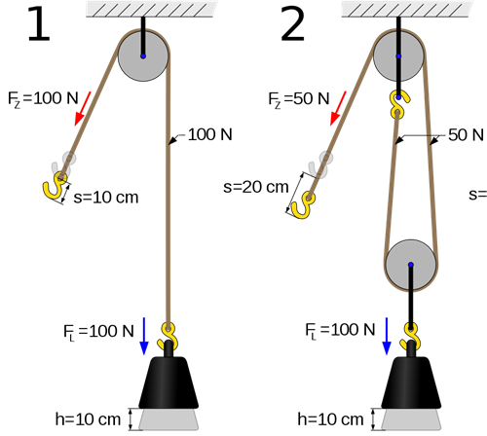

5.1. What kind of mechanism is portrayed by these two pictures?
Pulleys
5.2. This mechanism has a compound and simple form. Identify which form is given in
Picture 1: Simple pulley
5.3. What would the input force and input distance become if we add two more wheels to number 2?
Input force: 25 N
Input distance: 40 cm
5.4. What kind of mechanical advantage does this mechanism have?
No mechanical advantage

Exam prep 2
1.1. Us the “my plate” template below to create a balanced lunch. Also give an example of each nutrient used.
Fruits: Any correct fruits (Name them)
Vegetables: Any correct vegetables (Name them)
Grains: Any correct grains (Name them)
Protein: Any correct protein (Name them)
1.2. Why do you think that fruit and dairy is left out of dinner?
Fruit and dairy contain a lot of sugar, if you get energy so close before bedtime you will be unable to sleep.
2. Imagine that you are a refugee, you just arrived in the new country after fleeing from a war in your own. The government was not expecting refugees and are not yet prepared for you. What do you think will be 4 basic needs that you would have at that moment?
Any 4 of the following: A place of safety and shelter, Sanitation, Food, Water, Clothes and blankets
3. Thinking of the circumstances that firefighters work in, what do you think are 2 properties that their gear should have?
Any 2 of the following: Fire-resistant, heat-resistant, strong, durable, high melting point.
4. Which of the three layers of the bunker gear would you use for protection of each of the following?
Burning from the fire: Kevlar outer layer (fire-resistant)
The heat of the fire: middle Nomex layer (Heat-resistant)
The build-up of sweat and water on the skin: inner moisture barrier (keeps the fire fighter dry).
5. Thinking of the circumstances that the NSRI work in, what do you think are 2 properties that their gear should have?
Any 2 answers in line with: Heat insulation, water tight
6. Name the 4 Types of movements and explain each one.
Linear movement: Movement in a straight line.
Rotary movement: Turning movement.
Reciprocating movement: Up and down movement.
Oscillating movement: Backwards and forwards movement.
7. Describe what hypothermia is and also give it’s symptoms.
When your core temperature drops dangerously low (35⁰C or less). This results in some of the vital organs shutting down. The following symptoms are present:
* Sever shivering.
* Hunger
* Nausea (wanting to vomit)

Exam prep 3
1.1. Do you think that there are metal items that scrap metal dealers should not accept from people trying to sell them? If yes, name them.
Yes, any correct item.
1.2. List two objects that people can collect to sell to scrap metal dealers.
Any 2 correct items.
1.3. Think of and name two things that you would no longer be able to buy if metal ran out.
Any 2 correct answers.
1.4. How can you get home appliances to recycling centres.
You can contact scrap metal dealers, and they will collect it from your home.
1.5. How does the money you make from scrapping get calculated?
By the mass
1.6. What dangers can scrapping lead to?
If manhole covers are stolen, then there are holes in the roads that people can drive or fall into. Stolen electricity cables can cause loss of power or electrocute innocent people.
(Any 3 correct dangers that the learner thinks of, the two above are just examples, and also mentioned in the text)
1.7. What kind of device would help scrap metal dealers to sort these metals that are collected?
(You built it in term 3)
A crane with an electro - magnet
1.8. Why would a permanent magnet not work for the same situation?
Since a permanent magnet’s magnetism cannot be controlled (cannot be switched off), it is difficult to remove metals that are stuck to them.
2. In your own words explain why a pulley does not give a mechanical advantage.
Even though a pulley decreases the input force the distance that the force has to be apply over is increased by the same amount, thus no mechanical advantage.
3. Name 2 nutrients and indicate which one is most important to you and why.
Any 2 nutrients and acceptable reasons
4. Why would an electro magnet be useful at a junk yard?
An electro-magnet’s magnetism can be switched in and off again.
5. Why would a permanent magnet not work for the same situation?
Since the magnetism cannot be switched off the metals will stick to the magnet and be difficult to remove.
6. What are the 4 things we can recycle?
Paper, metal, glass, plastic
7. Explain how you can create an electro magnet. (What you need and how to put it together)
Step 1 - Gather the Materials:
* One iron nail fifteen centimeters long.
* Three meters of 22 gauge insulated (electrical wire), stranded copper wire.
* One or more D-cell batteries.
* A pair of wire strippers.
Step 2 - Remove some Insulation:
Some of the copper wire needs to be exposed so that the battery can make a good electrical connection.
Step 3 - Wrap the Wire Around the Nail
The more wire you wrap around the nail, the stronger your electromagnet will be.
Step 4 - Connect the Battery / cell
Attach one end of the wire to the positive terminal of the battery and the other end of the wire to the negative terminal of the battery.

Exam prep 4
1. What properties do firefighter clothing need?
Any of the following
* Strong
* Tough
* Durable
* Does not wear or tear
* No melting point
* Fire-resistant
2. Name the 3 main problems refugees face.
* The mix of the people present.
* The need for shelter.
* The need for food and water.
3. What are the 6 criteria that make emergency food suitable for refugee camps?
* The food must provide nutrients that the body needs to grow and stay healthy.
* It must be easy to prepare, since tools and space to cook are limited.
* It should not spoil easily.
* It must be able to be cook on a fire, as wood is the most common fuel available.
* It must be familiar to the people who must use it.
* It must be cheap.
4. What are the 3 problems with providing food?
* Transport: Food has to be transported from the shops to the refugee camps, and transport is not cheap.
* Storage: Food must be stored safely and protected from spoiling and theft.
* Fuel and water: In order to prepare food, you need a way to heat it and water to clean and cook it in.
5. What are the 3 layers of a turnout gear, and what is each layer’s properties?
Kevlar outer layer (fire-resistant)
middle Nomex layer (Heat-resistant)
inner moisture barrier (keeps the fire fighter dry).
6. What are the 3 types of clothing NSRI team uses?
* Wetsuits
* Life jackets
* Foul weather gear
7. Mark 3 things you should not do to a magnet with an X.
a) Drop It. | X
b) Hug it.
c) Hit it. | X
d) Heat it. | X

Use the symbols for conductors, lamps, switches, and cells to draw the following.
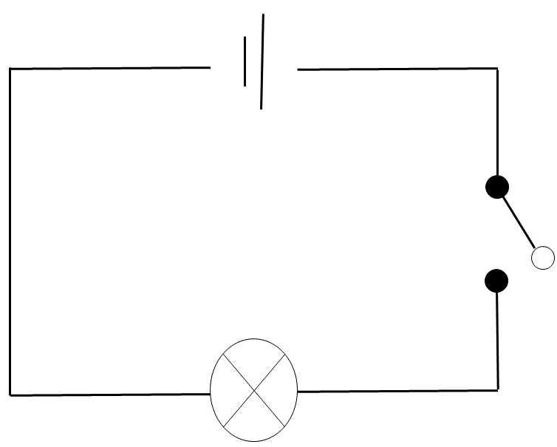
8.

9. State whether the following statements are true or false.
a) True
b) False
10. Name 3 materials we can recycle.
Paper, glass, plastic and metal

11. State whether the following statements are true or false.
a) True
b) False
c) False
d) True
e) True
f) True
g) True
h) False (Fire resistant)

12. Underline the correct word to complete the sentence.
a) Permanent magnets (keep, kill) their magnetism for an indefinite period of time.
b) Temporary magnets lose their magnetism (quickly, powerfully).
c) A bar magnet’s one pole is painted red and has N engraved on its (North, West) Pole.
d) A bar magnet’s one pole is painted grey and has S engraved on its (East, South) Pole.

