

NAME OF LEARNER:
MATHEMATICS CLASS TEST: 29 August 2025
GRADE 7

MARKS: 5
DURATION: 20 MINUTES

This test consists of 5 pages, including the cover page.

Instructions and information to the learner
Read the questions carefully.
Answer ALL the questions.
Circle only the letter for the correct answer, e.g. If the correct answer in 1. is D, you should only circle D
There is only one correct answer in each question.
This question paper consists of 6 questions.
Diagrams are NOT drawn to scale.

 | Given the following triangle ABC.  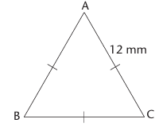  What is the length of AB? |  | (1)
 | A | 12 mm
 | B | 18 mm
 | C | 24 mm
 | D | 36 mm
 | JKLM is a trapezium.  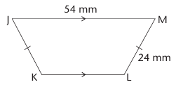  Determine the length of JK. |  | (1)
 | A | 54 mm
 | B | 78 mm
 | C | 30 mm
 | D | 24 mm

 | Triangles ABC and DEF are congruent.  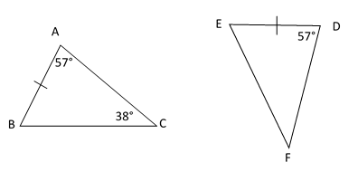  Determine the size of $∠F$. |  | (1)
 | A | 57º
 | B | 95º
 | C | 38º
 | D | 19º
 | Which of the following pairs of figures is NOT similar? |  | (1)
  3  2  4  6  1  2 | 5  3
  Figure A | Figure B
  3
  5
  3
  7
  Figure C | Figure D
 | A | Figure A
 | B | Figure B
 | C | Figure C
 | D | Figure D

 | Which part of a circle is defined as the distance from the center to any point on the circumference? |  | (1)
 | A | Diameter
 | B | Radius
 | C | Sector
 | D | Chord

END

