UMZINYATHI DISTRICT

November Test

2022

NATURAL SCIENCES

Grade 7

Marks: 60 Duration: 1HOUR

NAME:______________________________________ CLASS: _________

______________________________________________________________________________

INSTRUCTIONS:

1): Answer all questions.
2): Read each question carefully.
3): Write neatly and legibly.

This paper is consisting of 9 pages.

Section |  | A |  |  |  | B
Question | 1 | 2 | 3 | 1 | 2 | 3 | 4 | 5
Possible Mark | 5 | 7 | 7 | 9 | 3 | 13 | 5 | 11
Actual Mark

______________________________________________________________________________

Section A

Question 1: (5 marks)

Multiple choice. Read each statement or question carefully and choose the correct answer from the options provided and then circle the corresponding letter.

1.1 The following are examples of non-renewable sources of energy except… (1)
- Uranium
- Petrol
- Hydropower
- Coal

1.2 The type of energy that an object has because of its motion is… (1)
- motion power
- kinetic
- potential
- chemical

1.3 Which of the following statements relate to the law of conservation of energy? (1)
- Energy can either be created or destroyed.
- Energy is always wasted in a process.
- Energy can neither be created nor destroyed.
- Energy is stored in a system as chemical energy.

1.4 If the particles of a substance move faster, then the substance… (1)
- is changing from a gas to a liquid
- has a higher temperature
- has a higher potential energy
- is moving faster

1.5 The pattern of celestial bodies was observed through the… (1)
- calendar
- phases of the moon
- gravity
- telescope

Question 2: (7 marks)

True or False . State whether each of the following is True or False. If False, correct the statement.

  - Nicholaus Copernicus suggested that the sun is the centre of the Solar System.
_____________________________________________________________________
_____________________________________________________________________
  - You can prevent heat energy from being gained on the surface of a car by painting it black.
_____________________________________________________________________
_____________________________________________________________________
  - Energy is measured in units called joule ( ȷ )
_____________________________________________________________________
_____________________________________________________________________

  - Chromatography is a method of separating a mixture of substances with different boiling points.
______________________________________________________________________
______________________________________________________________________
  - The Zulu beehive hut is well insulated because both the walls and roof are made of grass.
______________________________________________________________________
______________________________________________________________________ Question 3: (7 marks)
Match the words in Column A with their meaning in Column B and write the letter representing the correct answer in “Answer Column”
Column A |  | Answer Column |  | Column B
1. | Elliptical |  | A. | The path in which a planet moves around the sun.
2. | Axis |  | B. | Living on land.
3. | Orbit |  | C. | Degree of concentration.
4. | Intensity |  | D. | When the number of hours are at their maximum in one hemisphere and their minimum in the other.
5. | Equinox |  | E. | An imaginary line through the centre of an object.
6. | Solstice |  | F. | Oval shaped.
7. | Marine |  | G. | Centre of an object.
 |  |  | H. | Degree of rotation.
 |  |  | I. | When the days and nights have equal number of hours.
 |  |  | J. | Living in the sea.

Section B

Question 1 (9 marks)
  - Study the diagram below. Identify and label the three different methods of heat transfer.
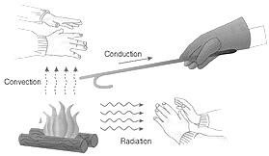

A

B

A: __________________________ (1)
B: __________________________ (1)
C: __________________________ (1)

C
  - Discuss and outline how heat is transferred by:
    - Conduction: ____________________________________________________________
______________________________________________________________________ (2)
    - Convection: ____________________________________________________________
______________________________________________________________________(2)
    - Radiation: _____________________________________________________________
______________________________________________________________________(2)
Question 2 (3 marks)
In the investigation shown in the picture below, one coffee can was painted with matt black and another coffee can was left as shiny silver. Each can have a plastic lid on it with a small hole pierced in it. The cans were placed in the sun and brought into the room after an hour. The temperature in each can was simultaneously taken.
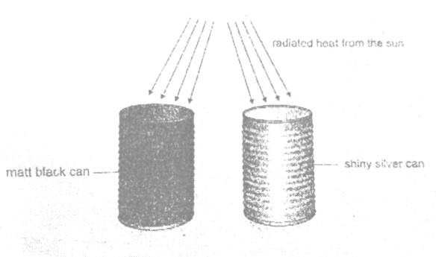
Matt black
can

Radiated heat from
the sun

Shiny silver
can

  - Will a thermometer indicate the same or different temperatures?
_____________________________________________________________________ _____________________________________________________________________ (1)
  - Give a reason for your answer in Question 2.1 above.
_____________________________________________________________________
_____________________________________________________________________
_____________________________________________________________________ (2) Question 3 (13 marks)
Study the diagram below about the energy transfer from a power plant to a light bulb and answer the questions that follow.
39 units enter ________ units lost as
energy moves along
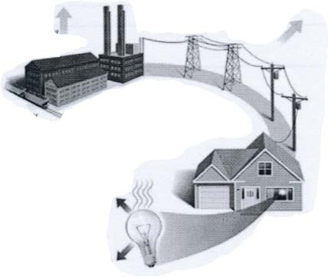
________ power lines lines
units
lost
in
3

units
of
light
33

units transformed
to heat
Take energy content of
coal 100 units
power plant

energy released 36 units used for a
light bulb to work
3.1 What is the percentage of the energy “wasted” during production?
_____________________________________________________________________ (2) 3.2 What percentage of the energy enters the power lines?
_____________________________________________________________________ (1)

  - Calculate the percentage of the energy that enters the power lines that is lost in the movement along the lines.
_____________________________________________________________________ (2)

  - How many units are needed for the bulb to work?
_____________________________________________________________________ (1)
  - Referring to the diagram above, mention 2 ways people living in the house can reduce the amount of electricity they use. (2) 3.5.1 ________________________________________________________________
________________________________________________________________
________________________________________________________________
3.5.2 ________________________________________________________________
________________________________________________________________
________________________________________________________________
  - If the above house is built in a hot environment, what colour would you paint the roof with? _____________________________________________________________________ (1)
  - Give reasons for your choice of colour in 3.6 above.
_____________________________________________________________________
_____________________________________________________________________ (2)
  - A kettle uses 250 joules of energy to heat a sample of water. The water only absorbs 200 joules. The percentage efficiency of the kettle is:
_____________________________________________________________________
_____________________________________________________________________ (2)

Question 4 (5 marks)
The Earth is just the right distance from the Sun for the solar energy to support conditions for life.
  - Explain how plants use energy from the Sun to make food.
_____________________________________________________________________
_____________________________________________________________________
_____________________________________________________________________ (3)

  - How do plants store this food?
_____________________________________________________________________
_____________________________________________________________________ (1)

  - How do animals access this energy from the Sun?
_____________________________________________________________________ (1)

Question 5 (11 marks)

  - Explain one method used to calculate time used by previous civilisations.
___________________________________________________________________ (1)
  - Explain why the Sun’s rays strike different places on Earth at different angles.
___________________________________________________________________
___________________________________________________________________ (2)

  - Draw a diagram to show the alignment of the Moon, Earth and Sun at Full Moon. Label
each object clearly. (3)
  - Shade the unlit part of the Earth and the Moon in your diagram. (2)

  - Draw in the water of the Earth to show where the tide is high and where it is low and
label these tides. (2)

  - What name do we give to the tides at this phase?
_____________________________________________________________________ (1)

Total = 60 Marks

